Supplementary materails
TFAM downregulation contributes to cognitive dysfunction after anesthesia and surgery by activating STING-dependent endoplasmic reticulum stress and neuroinflammation
Yongliang Zhu^{1,†}, Youli Fu^{1,†}, Jiahe Lian^{1,†}, Yinglong Liu¹, Yongxin Liu¹, Jingyao Huang¹, Jie Liu¹, Zhihao Zhang¹, Zhenjiang Zhang^{2,*}, Rui Zhang^{1,*}
¹Laboratory of Anesthesia and Critical Care Medicine in Colleges and Universities of Shandong Province, School of Anesthesiology, Shandong Second Medical University, Wei Fang, China
²Department of Thoracic Surgery, Weifang People's Hospital, Shandong Second Medical University, Wei Fang, China
*Corresponding author: Zhenjiang Zhang, email: zzjzzj-1@163.com; Rui Zhang, email: zhangrui@wfmc.edu.cn
†These authors contributed equally to this work.
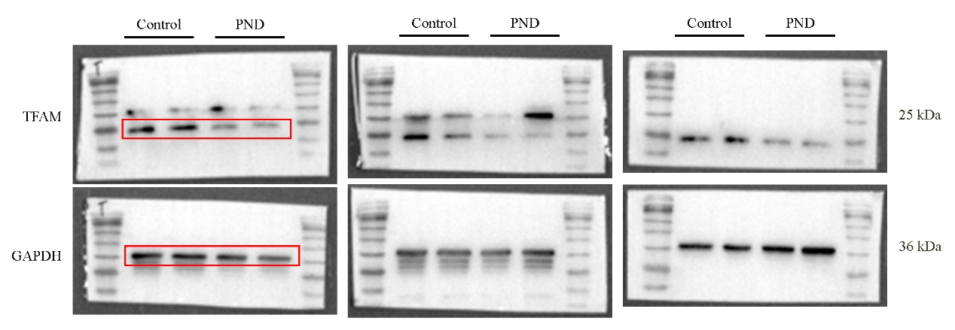
Fig S1. Full uncropped Gels and Blots images corresponding to Fig. 2B, the square refers to the blots cited in the main article.
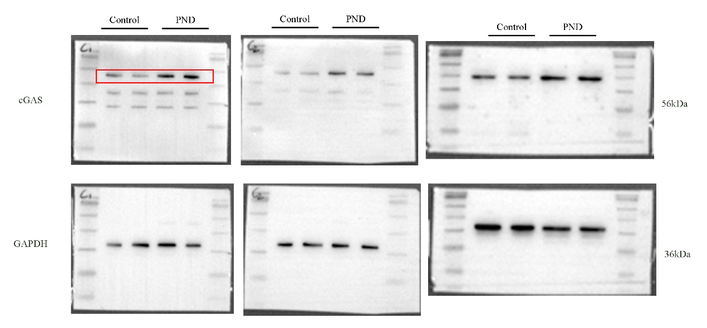
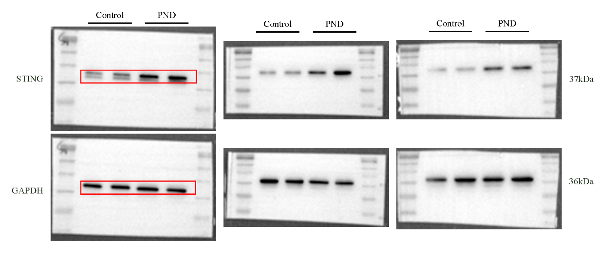
Fig S2. Full uncropped Gels and Blots images corresponding to Fig. 3E, the square refers to the blots cited in the main article.
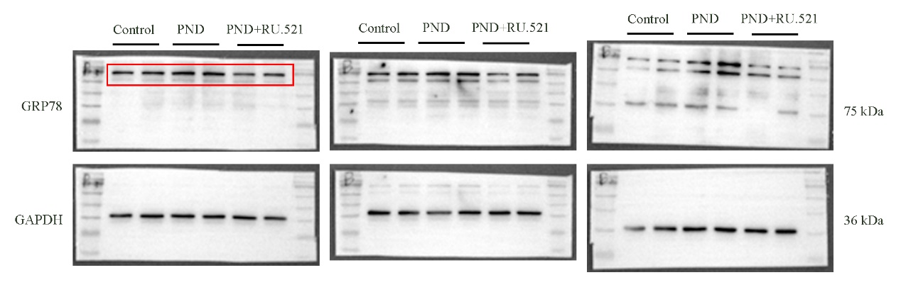
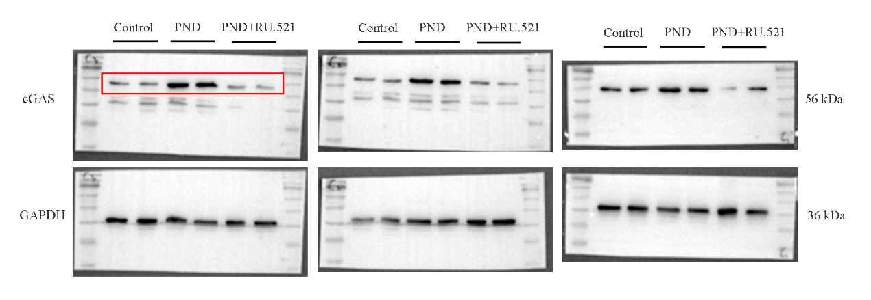
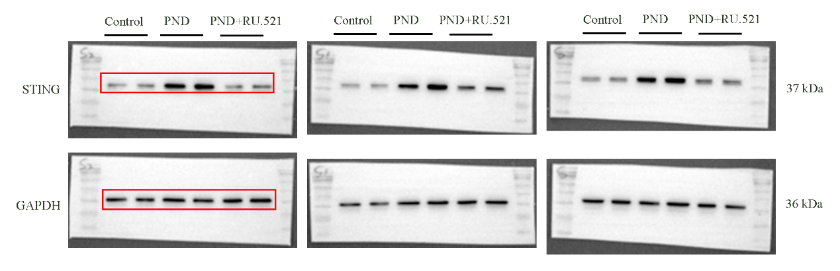
Fig S3. Full uncropped Gels and Blots images corresponding to Fig. 4H, the square refers to the blots cited in the main article.

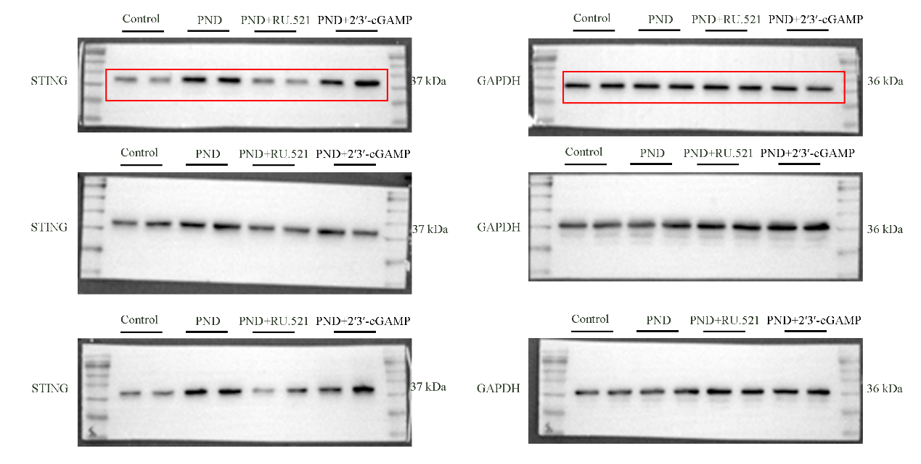
Fig S4. Full uncropped Gels and Blots images corresponding to Fig. 5H, the square refers to the blots cited in the main article.

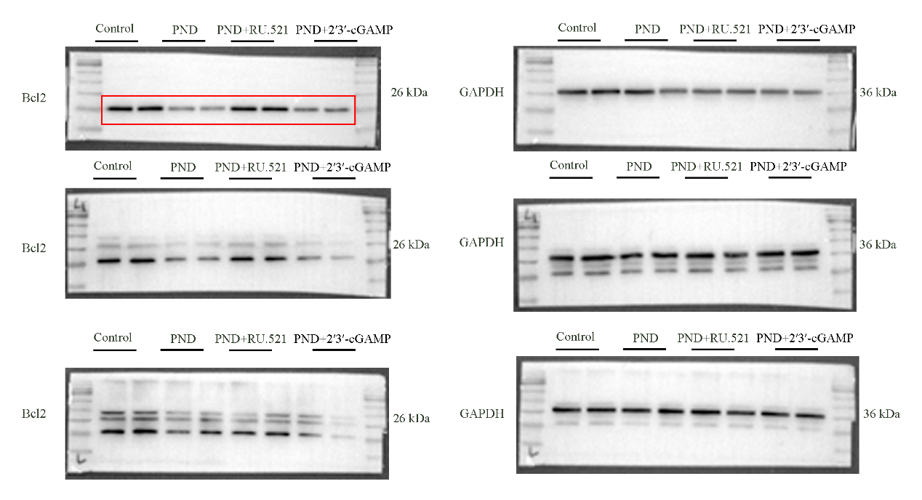
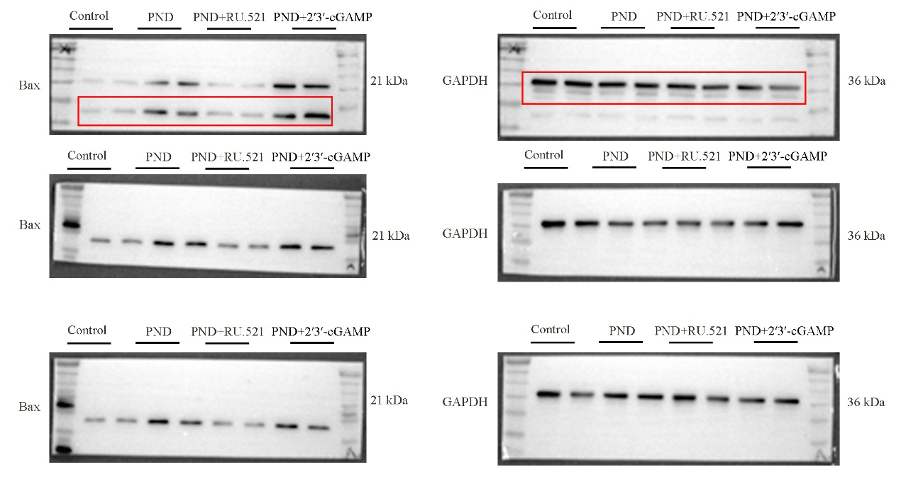
Fig S5. Full uncropped Gels and Blots images corresponding to Fig. 6F, the square refers to the blots cited in the main article.

