Altered expression spectrum and target gene prediction of tRNA-derived small RNAs in clear cell renal cell carcinoma

Shuai Liu^{a,1}, Yimingniyizi Nueraihemaiti^{a,1}, Yuchen Gaoª, Xiangcheng Zhanª, Yanhua Chenª, Hongmin Zhouª, Bowen Chenª, Ding Liuª, Hao Chenª, Xiao Xuª, Tiancheng Xie^{a,}*, Yunze Dong^{a,}*, Yunfei Xu^{a,}*

ªDepartment of Urology, Shanghai Tenth People’s Hospital, School of Medicine in Tongji University, Shanghai, China

*Corresponding authors:
E-mail address: xuyunfeish@163.com (Y. Xu)
¹Equal contribution and first authorship: Shuai Liu and Yimingniyizi Nueraihemaiti contributed equally to this work and share first authorship.
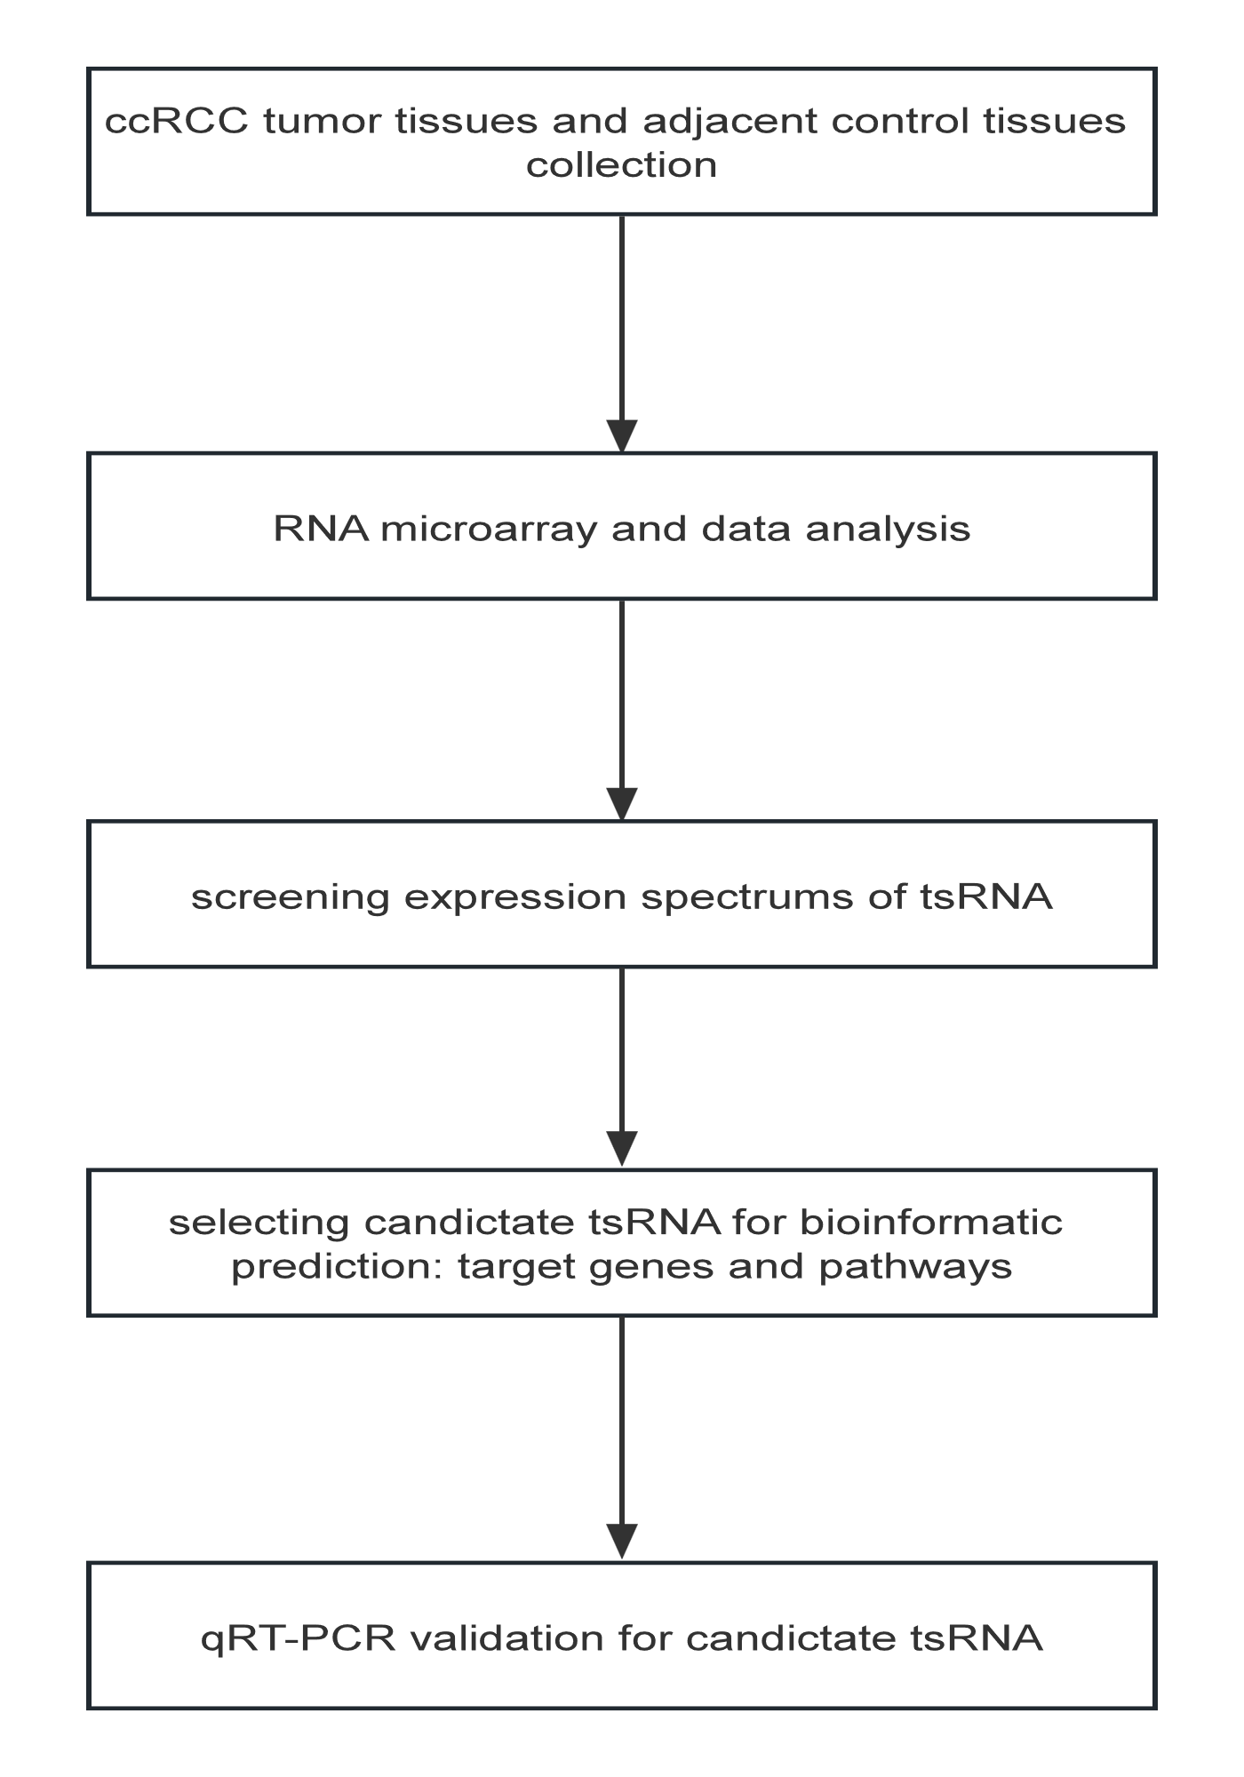
Figure S1. The flowchart depicting the procedural elucidation of the current investigative endeavor.
Figure S2. The binding region and seed sequence interactions between tsRNAs and mRNAs containing SEMA3D, ZNF33B, and MEIS2.
Figure S3. The correlation between the staging of ccRNA and six potential gene of candidate tsRNAs. (A) Derived from the GEPIA, the pathological stage plot delineated the expression levels of ADH6, APLF, and ERCC4 of up-regulated tsRNAs at distinct stages within ccRCC. (B) Derived from the GEPIA, the pathological stage plot revealed the expression levels of SEMA3D, MEIS2, and ZNF33B of down-regulated tsRNAs at distinct stages within ccRCC. log₂(TPM + 1) was used for log-scale. Pr(>F) < 0.05.
Figure S4. The survival plots of IGF1R, GOLGA8G, UGT2B7, PDHB, SACS, GPATCH2L, RMND5A, and RDH11 for ccRCC from GEPIA (p < 0.01).
Figure S5. The pathological stage plot of C2CD2, RDH11, ZNF471, SACS, GOLGA8G, RMND5A, IGF1R, PDHB, UGT2B7, GPATCH2L, and WDR59 for ccRCC. log₂(TPM + 1) was used for log-scale. Pr(>F) < 0.05.
Supplementary Table S1
RNA Quantification and Quality Assurance by NanoDrop ND-1000.
Sample ID | OD260/280  Ratio | OD260/230  Ratio | Conc  (ng/μl) | Volume  (μl) | Quantity  (ng) | OC Purity  Pass or Fai
N1 | 1.98 | 2.20 | 520.64 | 40.00 | 20825.60 | Pass
T1 | 2.00 | 1.94 | 551.30 | 120.00 | 66156.00 | Pass
N2 | 1.91 | 2.14 | 413.39 | 180.00 | 74410.20 | Pass
T2 | 2.02 | 2.19 | 517.81 | 120.00 | 62137.20 | Pass
N3 | 2.02 | 2.20 | 557.25 | 120.00 | 66870.00 | Pass
T3 | 1.92 | 1.91 | 254.01 | 180.00 | 45721.80 | Pass
N4 | 2.02 | 2.22 | 1106.92 | 80.00 | 88553.60 | Pass
T4 | 1.87 | 1.87 | 211.11 | 80.00 | 16888.80 | Pass
*For spectrophotometer, the optical density (O.D.) ratio at A260/A280 should approximate 2.0, indicating the purity of RNA (acceptable ratios range from 1.8 to 2.1). Additionally, the O.D. ratio at A260/A230 should exceed 1.8.
Supplementary Table S2
Primers for Real-time PCR in this study.
Genes | Primer sequence
U6 | F: GGAACGATACAGAGAAGATTAGC
U6 | R: TGGAACGCTTCACGAATTTGCG
mt-tRF3a-AspGTC | (5'-3') GCTGCCATCCTATATATCTTACCA
5'tiRNA-34-AspGTC-4 | (5'-3') TTAGTATGGTGGTGAGTATCCCTGC
tRF5-23-ValAAC-2 | (5'-3') GGTTTCCGTAGTGTAGTGGTCATC
mt-tRF3-23-ArgTCG | (5'-3') GGCACGATAATCATATTTACCAACC
tRF5-16-LeuCAA-6 | (5'-3') GTCAGGATGGCCGAGCAAA
tRF5-22-iMetCAT-1 | (5'-3') AGTGGCGCAGCGGAAGCAA
i-tRF-38:54-Ile-AAT-1 | (5'-3') ACGCCAAGGTCGCGGGTAA
i-tRF-25:40-Gln-CTG-1 | (5'-3') GCCGCTCTGGACTCTGAATC
U6 was used as the internal control. F, forward; R, reverse.

