supporting information

Sulfonated Lignin-based Phenol-formaldehyde Resin: Stability and Aggregation Structure Changes During Aggregation
Dan Zhao^{a,*}, Weili Yangª , Guanglite Shenª , Wenhui Zhangª，Huixia Feng^{a,b}

ª School of petrochemical engineering, Lanzhou University of Technology, Lanzhou,
730050, Gansu, China
^{b} State Key Laboratory of Advanced Processing and Recycling of Nonferrous Metals,
Lanzhou University of Technology, Lanzhou, 730050, Gansu, China

*Corresponding author
- mail: zhaodan765@163.com

- The studies of Microwave depolymerization of lignin
The absorbance of different phenol hydroxyl groups was measured by ultraviolet-visible spectrophotometer at 760 nm. In order to analyze the phenolic hydroxyl content of lignin, a modified Folin-Ciocalteu (FC) reagent assay was used.
To determine the range of independent process variables, the effects of one-factor inquiry experiments on the phenolic content of depolymerized lignins, namely lignin substitution rate, reaction temperature, reaction time, and sodium hydroxide concentration. The ranges of relevant conditions were initially determined as follows: lignin substitution rate (10 wt%, 20 wt%, 30 wt%, 40 wt%, 50 wt%, 60 wt%, 70 wt%, 80 wt%, 90 wt%, 100 wt%), reaction temperature (140℃, 150℃, 160℃, 170℃, 180℃, 190℃), reaction time (10 min, 15 min, 20 min, 30 min, 40 min), NaOH concentration (0.1 mol/L, 0.2 mol/L, 0.3 mol/L, 0.4 mol/L, 0.5 mol/L, 0.6 mol/L).
1.1 Effect of lignin substitution rate on the phenolic content
To explore the effect of lignin substitution rate on the phenolic content in the digestion solution, all conditions remained unchanged in the experiment. The NaOH concentration was set as 0.3 mol/L, the digestion temperature was 170℃, and the digestion time was 20 min.The content of phenolic hydroxyl groups in the digestion solution was investigated when the solid content of lignin was 10 wt%, 20 wt%, 30 wt%, 40 wt%, 50 wt%, 60 wt%, 70 wt%, 80 wt%, 90 wt% and 100 wt%. The effect of different lignin substitution rates on the phenolic hydroxyl content of microwave depolymerizing lignin is shown in Fig. S1.
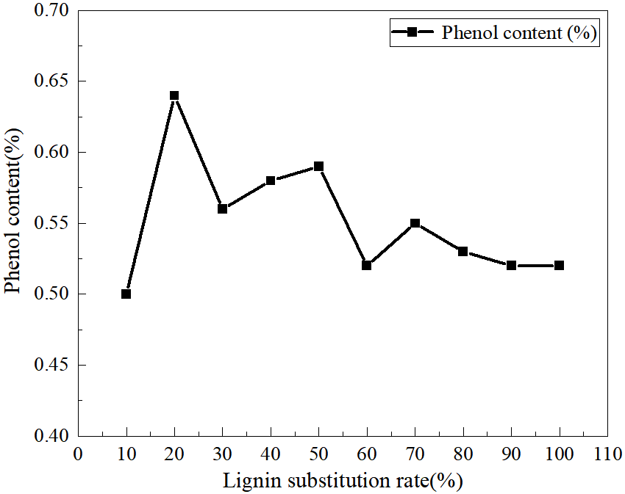
Fig. S1 Effects of different lignin substitution rates on the phenolic hydroxyl content of microwave depolymerizing lignin
As shown in Figure S1, with the increase of lignin substitution rate, the content of phenol increased first and then decreased, and three inflection points occurred at 20 wt%, 50 wt%, and 70 wt%. As shown in Table 2, when the lignin substitution rate is 20 wt%, 50 wt%, 70 wt% and 100 wt%, the phenolic hydroxyl content is not very different, and the difference is 0.05,0.04 and 0.03, and the phenolic content shows this pattern: 20 wt%> 50 wt%> 70 wt%> 100 wt%. Considering various factors such as the dosage and cost performance, the lignin replacement rate is 20 wt%, 50 wt%, 70 wt% and 100 wt%.
1.2 Effect of the microwave depolymerization temperature on the phenolic content
To explore the effect of the digestion temperature on the phenolic content in the digestion solution remained unchanged, except for the temperature. The lignin substitution rate was 20 wt%, 50 wt%, 70 wt% and 100 wt%, the NaOH concentration was 0.3 mol/L, and the digestion time was 20 min. The content of phenolic hydroxyl groups in the digestion solution at 140℃, 150℃, 160℃, 170℃, 180℃, 190℃ were investigated. The effect of different digestion temperatures on the phenolic hydroxyl content of microwave depolymerizing lignin is shown in Fig. S2.
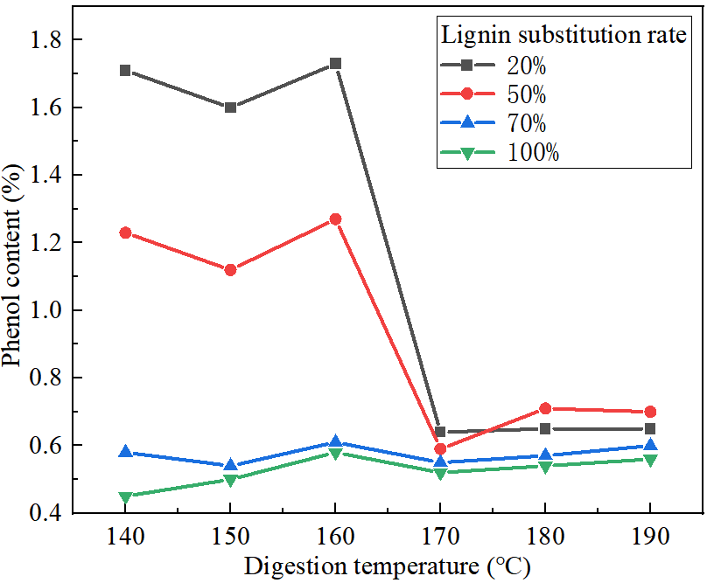
Fig. S2 Effects of different digestion temperature on the phenol hydroxy content of microwave depolymerized lignin
As can be seen from Fig. S2, when the lignin substitution rate is 20 wt%, 50 wt% and 70 wt%, the phenolic content of the digestion lignin with increasing digestion temperature first decreases and then increases to the maximum, and then decreases until flat. When the lignin substitution rate was 100 wt%, the phenolic content of lignin increased to the maximum value, and then gradually increased. In general, the trend was similar, and the phenol content reached the maximum value at 160℃, and the lignin phenol content with different substitution rates showed this pattern: 20 wt%> 50 wt%> 70 wt%> 100 wt%. Therefore, the optimal lignin digestion temperature was determined to be 160℃.
1.3 Effect of the microwave depolymerization time on the phenolic content
To explore the effect of the digestion time on the phenolic content in the digestion solution remained unchanged, except for the time. The lignin substitution rate was 20 wt%, 50 wt%, 70 wt%, 100 wt%, the NaOH concentration was 0.3 mol/L, and the digestion temperature was 160℃. The digestion time was 10 min, 15 min, 20 min, 30 min and 40 min. At the above four lignin substitution rates, the effect of different digestion times on the phenolic hydroxyl content of microwave depolymerizing lignin is shown in Fig. S3.
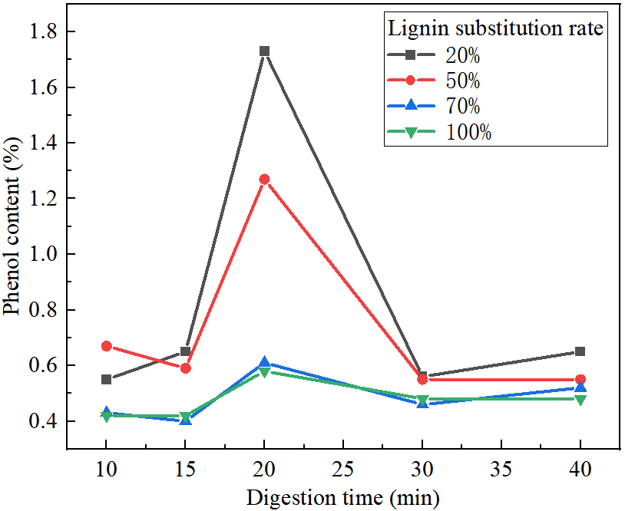
Fig. S3 Effects of different digestion time on the phenol hydroxy content of microwave depolymerized lignin
In Fig. S3, when thelignin substitution rate is 20 wt%, 50 wt%, 70 wt% and 100 wt%, with the increase of digestion time, the phenolic content of digestion lignin first increased to the maximum, then decreased and slowly increased. The phenol content at the beginning and the end was not much different. When the time was 20 min, the lignin phenol content of 4 different substitution rates reached the maximum value, and the phenolic content appeared: 20 wt%> 50 wt%> 70 wt%> 100 wt%. Therefore, the optimal digestion time was 20 min.
1.4 Effect of NaOH concentration of microwave depolymerization on phenolic content
To explore the effect of the NaOH concentration on the phenolic content in the digestion solution, and all the other conditions remained unchanged in the experiment, except for the NaOH concentration. The lignin substitution rate was 20 wt%, 50 wt%, 70 wt% and 100 wt%, the digestion temperature was 160℃ and the digestion time was 20 min. The content of phenol hydroxyl group in the digestion solution was investigated when the NaOH concentration was 0.10 mol/L, 0.20 mol/L, 0.30 mol/L, 0.40 mol/L, 0.50 mol/L and 0.60 mol/L, and the optimal NaOH concentration was analyzed. The effect of different sodium hydroxide concentrations on the phenolic hydroxyl content of microwave depolymerizing lignin is shown in Fig. S4.
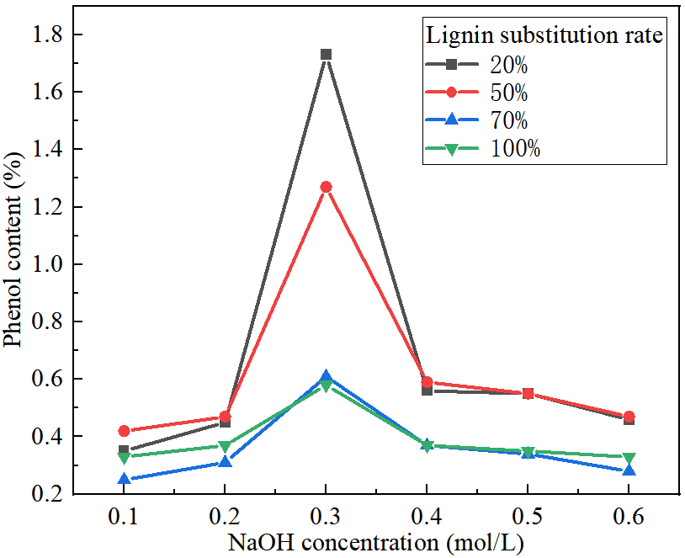
Fig. S4 Effects of different sodium hydroxide concentrations on the phenol hydroxy content of microwave depolymerized lignin
As shown in Fig. S4, when the lignin substitution rate was 20 wt%, 50 wt%, 70 wt%, and 100 wt%, the phenolic content of digested lignin increased first and then decreased with the increase of NaOH concentration. When the NaOH concentration was 0.3 mol/L, the lignin phenol content of four different substitution rates reached the maximum, and the rule was 20 wt%> 50 wt%> 70 wt%> 100 wt%. Therefore, the optimal NaOH concentration is 0.3 mol/L.
After exploring the influence of single factors on the phenolic hydroxyl content of microwave depolymerized lignin, it was found that when the lignin substitution rate was 20 wt%, 50 wt%, 70 wt% and 100 wt%, the maximum reached when the digestion temperature was 160℃, digestion time was 20 min, and NaOH concentration was 0.3 mol/L, and the rule of lignin phenol content of different substitution rates was 20 wt%> 50 wt%> 70 wt%> 100 wt%. Based on all the above one-factor experiments, the results show that the best conditions were: lignin replacement rate is 20 wt%, digestion temperature is 160℃, digestion time is 20 min, and NaOH concentration is 0.3 mol/L. Under these conditions, the content of phenol in digested lignin was 58.46% after depolymerizing the mixed solution of 3.7340 g (equivalent to 20% phenol in SLPFR) lignin, 190 g deionized water and 2.28 g sodium hydroxide.
- The SEM analysis
The SEM can observe the microstructure of the sample cross section or surface. The model SU8010 scanning electron microscope was used in this experiment. The scanning conditions were tested at an operating voltage of 5.0 kV. The dried sample was thoroughly ground before testing and then glued directly to the conductive adhesive for testing. The SEM map of lignin before and after microwave depolymerization, as shown in Fig. S5.
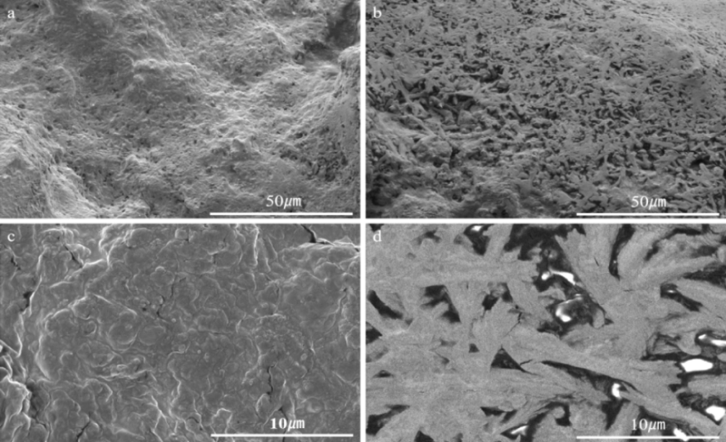
Fig. S5 The SEM morphology of lignin and depolymerized lignin
(a)The SEM morphology of lignin(1000x); (b)The SEM morphology of depolymerized lignin(1000x); (c)The SEM morphology of lignin(5000x); (d)The SEM morphology of depolymerized lignin(5000x)
In Fig. S5, a and c are pure lignin, b and d are depolymerized lignin. It can be seen from the scanning electron microscope that the original lignin surface particles are dense, with complex sheets, smooth and compact, and irregular morphology. The depolymerization lignin has fine particles, fluffy surface, and full of holes, showing an obvious three-dimensional network structure. It shows that microwave depolymerization breaks the lignin structure, increases the surface area of the substance and thus improves the reactivity. It can be concluded that microwave depolymersodium hydroxide catalysis can reduce the relative molecular mass of lignin and make lignin have better dispersion.
- Infrared Spectrum Analysis
The dried samples were taken and mixed with dry KBr powder, ground evenly in agate grinding bowl, and then the samples were pressed. The infrared absorption peak in the range of 4000~500cm⁻¹ was measured by the fourier transform infrared spectrometer (FTIR-850) of Tianjin Port East Science and Technology Co., LTD. FTIR spectrum of lignin and depolymerized lignin, as shown in Fig. S6. FTIR spectrum of PFR and SLPFR, as shown in Fig. S7.
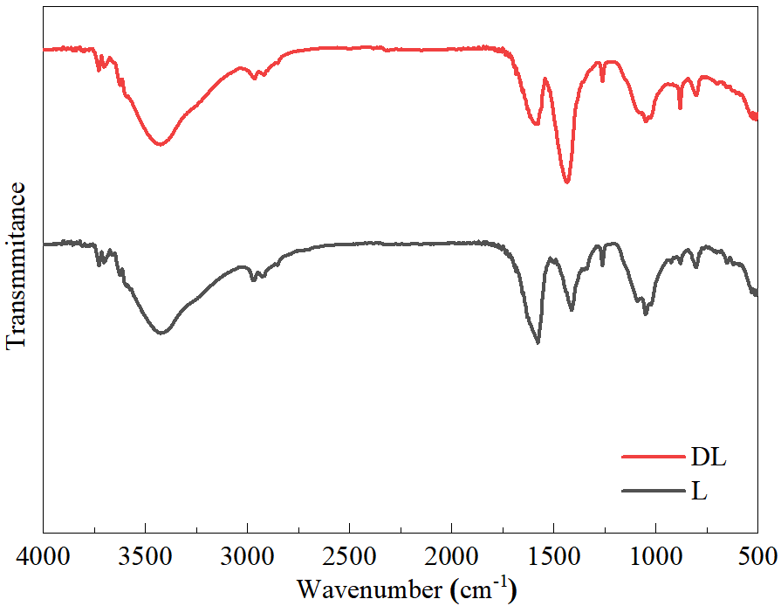
Fig. S6 FTIR spectrum of lignin and depolymerized lignin
In Fig. S6, the lignin infrared spectras were similar before and after microwave depolymerization. The lignin samples showed broad peaks at 3400 cm^{–1}, which were attributed to hydroxyl stretching^{[1]}. Peaks at 1600 cm^{–1} and 1580 cm^{–1} correspond to the aromatic skeleton vibrations of lignin^{[2]}. In the spectrum of DL, the vibration of the aromatic methyl group at 1432 cm⁻¹ decreased, and the relative value of the phenolic hydroxyl group increased. The presence of an absorption band at 1411 cm^{–1} is assigned to the aromatic ring vibration of the phenylpropane skeleton. The peak of the phenolic hydroxyl group could be seen in the range of 1234~1270 cm^{–1}.^{[3]} The peak at 1049 cm⁻¹ can be attributed to the aromatic C-H deformation^{[4]}. The peak at 833 cm⁻¹ is associated with the out-of-plane bending vibration of C-H at positions 2 and 6 of the guaiac ring^{[5]}. Infrared spectra shows that the content of phenolic hydroxyl groups in depolymerized lignin increases, which indirectly indicates that polylignin has more active sites and is more suitable for the synthesis of PFR instead of phenol.
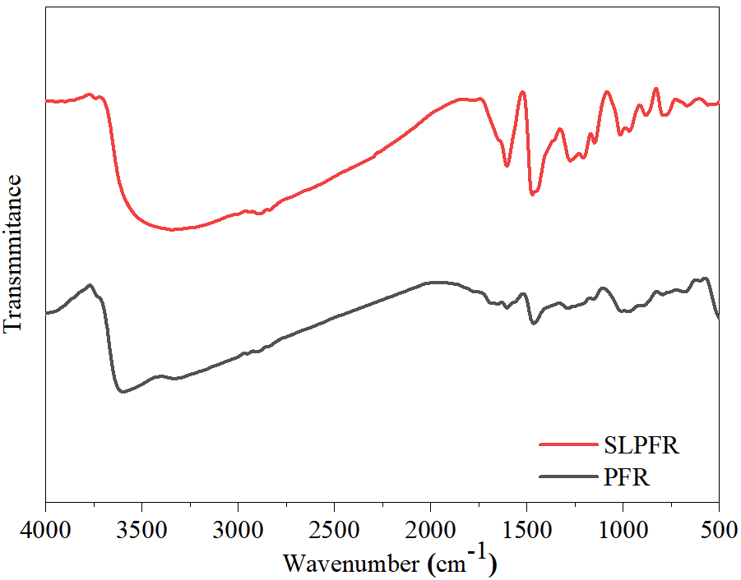
Fig. S7 FTIR spectrum of PFR and SLPFR
As can be seen from Fig. S7, the infrared spectra of PFR and SLPFR are basically consistent, because the differences are usually masked when lignin is incorporated into PFR. 3550 cm⁻¹ is the absorption peak of the phenolic hydroxyl group on the benzene ring for hydrogen bonding, and 2800 cm⁻¹ is the aliphatic-CH₂ asymmetric stretch absorption peak. 1636 cm⁻¹ is the stretching vibration absorption peak of C=C on the benzene ring, 1476 cm⁻¹ is the absorption peak of the beta-methyl bridge, and the two bands also indicate the presence of the aromatic ring^{[6, 7]}. The absorption peak of SLPFR at 1250 cm⁻¹ is stronger than that of PFR, indicating that SLPFR has more phenolic hydroxyl groups than PFR, 1208 cm⁻¹ is the out-plane absorption peak of C-O on the benzene ring, 1016 cm⁻¹ is the C-O stretching vibration peak of hydroxyl methyl group^{[6]}, and 883 cm⁻¹ is the out-of-plane bending absorption peak on the CH-1,2,3,4,5 positions. In short, the FTIR profiles of PFR and SLPFR were basically consistent, and the content of phenolic hydroxyl group in SLPFR was increased, indicating that microwave depolymerization has a positive effect on lignin.
- Analysis of LC-MS
SLPFR samples were filtered through 0.22 μm microfilter and directly loaded for LC-MS analysis. The relative molecular mass and molecular structure were analyzed by Ultimate 3000 UHPLC-Q Exactive liquid (Thermo Scientific, US). Because the resin molecules contain phenolic groups, it is easy to remove a proton to form a negative ion. Therefore, the anion detection method adopted during the mass spectrometry analysis. Chromatographic experiment conditions: chromatograph Dinonex Ultimate 3000 UHPLC, Atlantis T3 column (100 mm×3.0 mm, 3.0 μm). Mobile phase A: 0.1% formic acid in water, B: acetonitrile. Gradient elution conditions are shown in Table S1:
Table S1 The gradient elution conditions of HPLC
elution time/ min | 0~3 | 10 | 15 | 20~25 | 25.1~30
the volume fraction of mobile phase A/ % | 95 | 80 | 30 | 10 | 95
the volume fraction of mobile phase B/ % | 5 | 20 | 70 | 90 | 5
current speed/ mL/min | 0.50
column temperature/ K | 303.15
The experimental conditions of MS spectrometry: HESI ion source, spray voltage of negative ion 3.5 kV, heated capillary temperature 593.15 K, sheath flow rate: 40 arb, full scan MS negative ion mode detection, scanning range: primary scan: resolution 70000, range 200~1,800 m/z; secondary scan: resolution 17,500, starting ion 50 m/z. Therefore, total ion flow diagram of SLPFR liquid chromatography, as shown in Fig. S8.
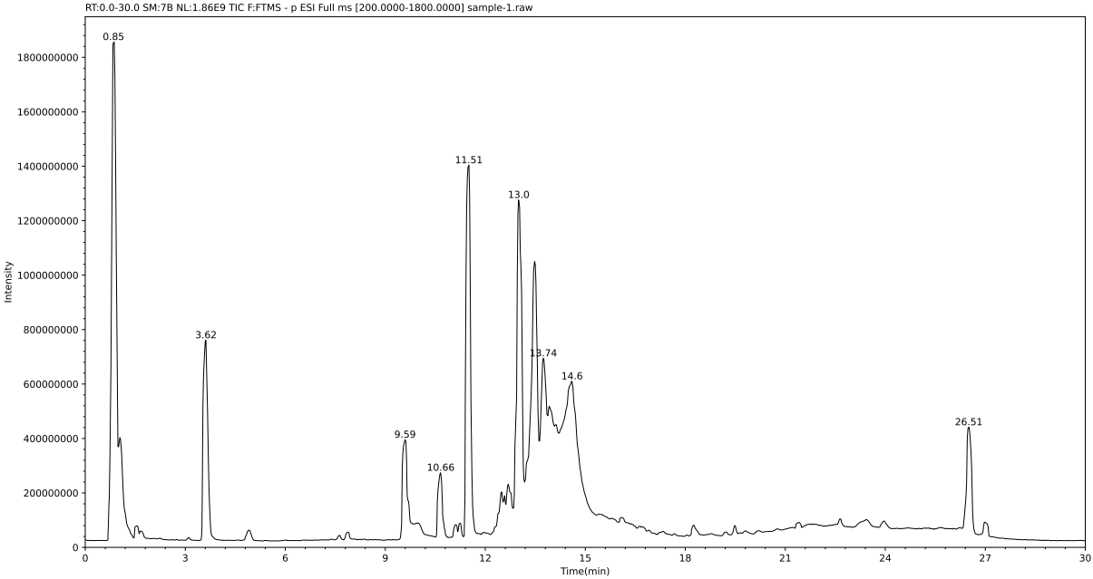
Fig. S8 Total ion flow diagram of SLPFR liquid chromatography
As shown in Fig. S8, the chromatographic peaks of the SLPFR with low relative molecular weight overlapped, and the SLPFR with high relative molecular weight can be separated effectively. SLPFR synthesized under the experimental conditions is a mixture of different components with different structures. When the retention time is from 9 to 15 min, the chromatographic peaks overlap and SLPFR cannot be effectively separated. For mass spectrometry with retention times between 9 to 15 min, SLPFR is mainly a mixture of five components. Combined with the absorption peaks of the FTIR spectrum reveals that the methylene bridges are connected in a neighbor-pair position manner. Compared with the hydroxymethyl group, the sulfomethyl group on the benzene ring tends to be more dispersed. Therefore, combined with the position of the absorption peak in the infrared spectrum and the effect of steric hindrance, the possible molecular structure formula of the sulfomethyl group is deduced.
As shown in Fig. S9(A), starting with m/z of 153.05376, the relative molecular weight of the ion fragment changes to 166, and the molecular structure corresponding to SLPFR is shown in Fig. S10(A). As shown in Fig. S9(B), starting with m/z of 319.11882, the relative molecular weight of the ion fragment is 320, and the molecular structure corresponding to SLPFR is shown in Fig. S10(B). As shown in Fig. S9(C), starting from m/z of 693.17681, the relative molecular weight of each ion fragment varies from small to large by 18, and the molecular structure of the corresponding SLPFR is shown in Fig. S10(C). As shown in Fig. S9(D), starting from m/z of 453.15609, the relative molecular weight of each ion fragment varies from small to large by 136, and the molecular structure of the corresponding SLPFR is shown in Fig. S10(D). As shown in Fig. S9(E), starting from m/z of 679.25734, the relative molecular weight of each ion fragment varies from small to large by 136, and the molecular structure of the corresponding SLPFR is shown in Fig. S10(E).

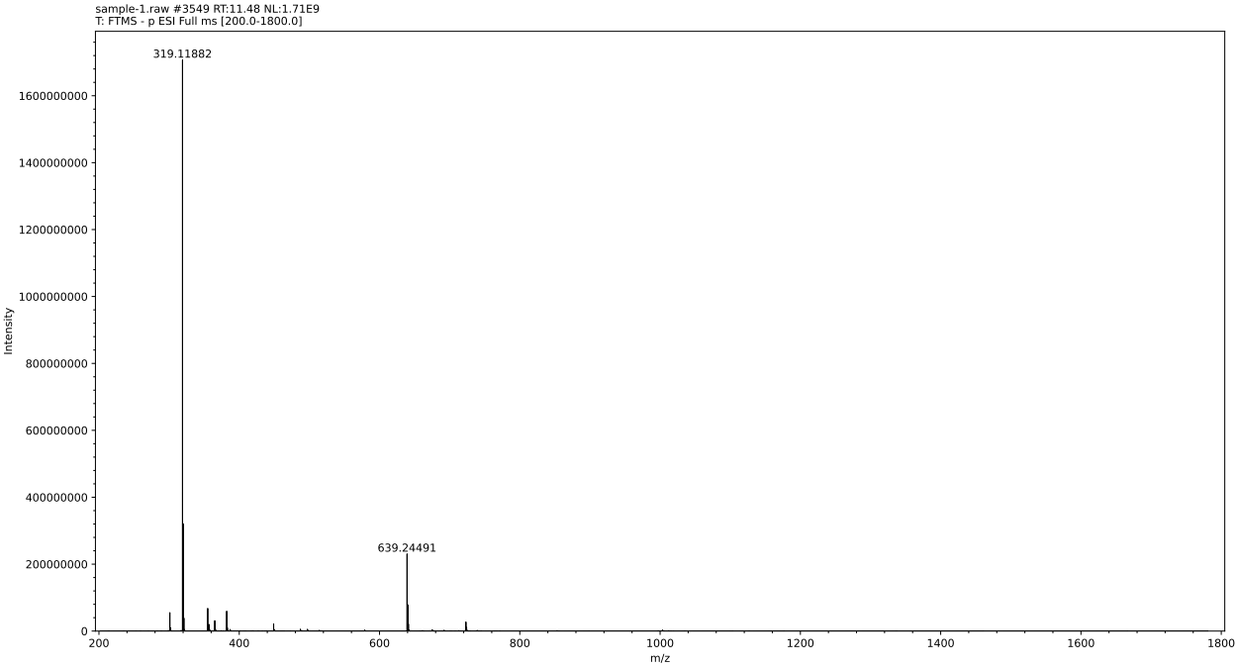
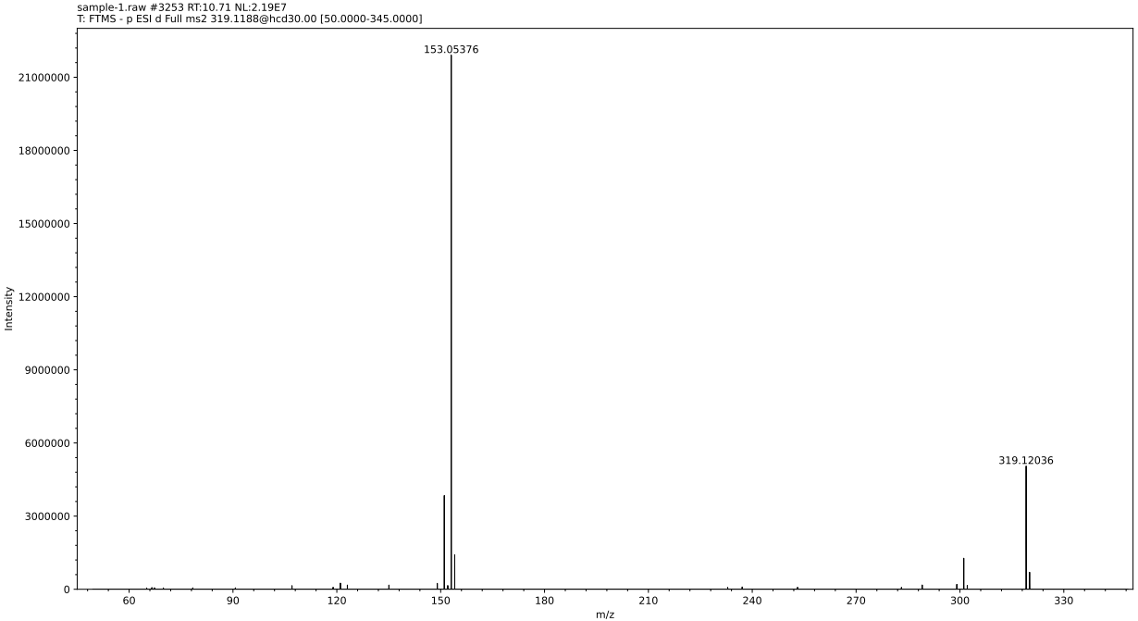
(A)
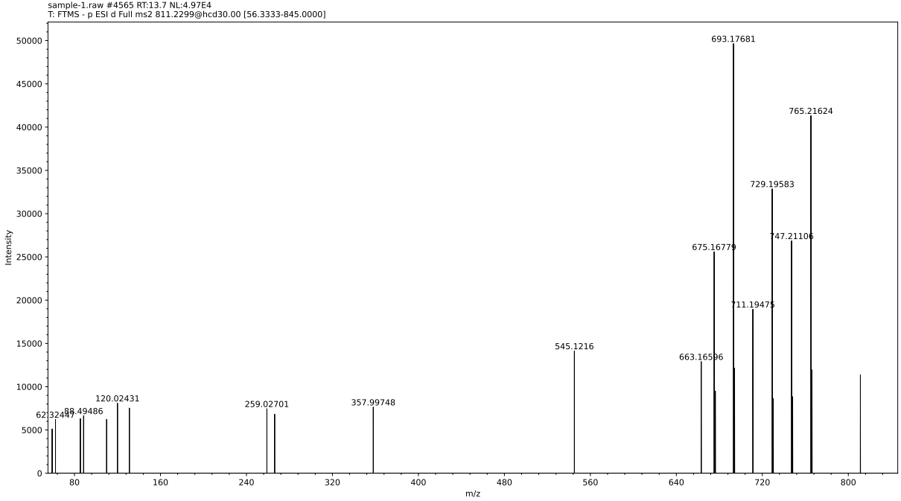
(B)
(C)

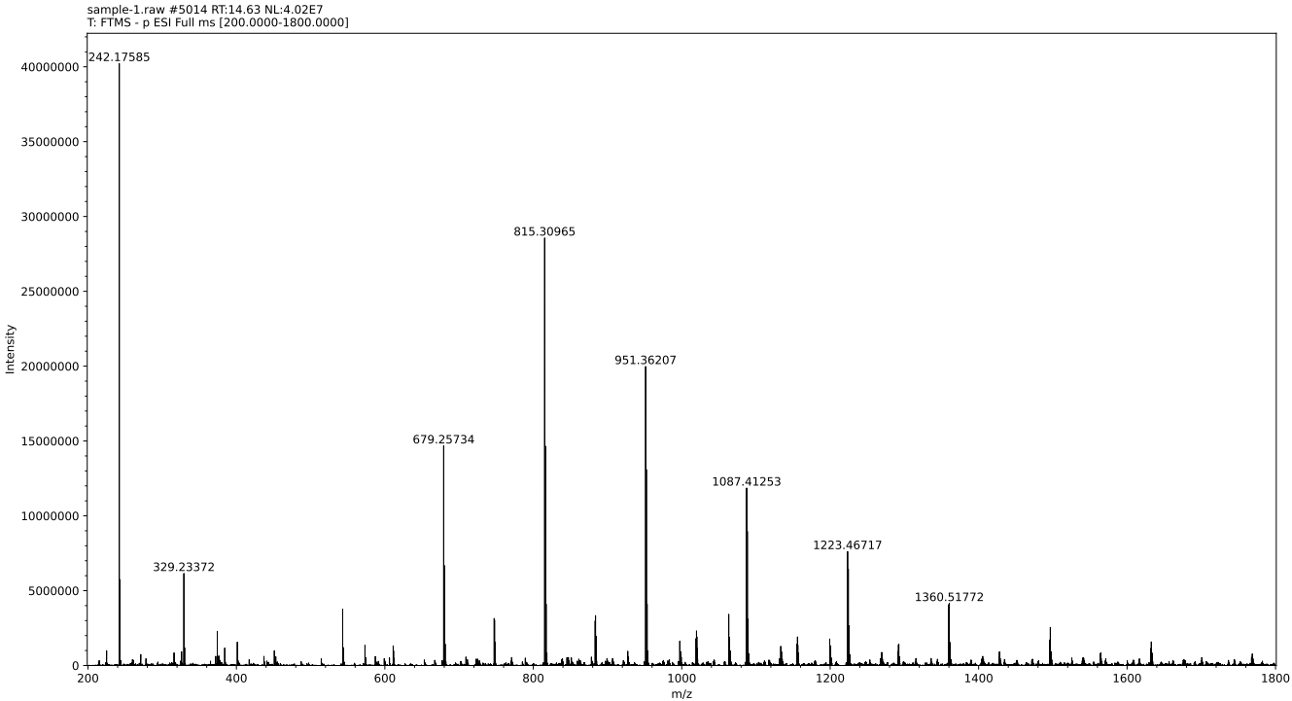
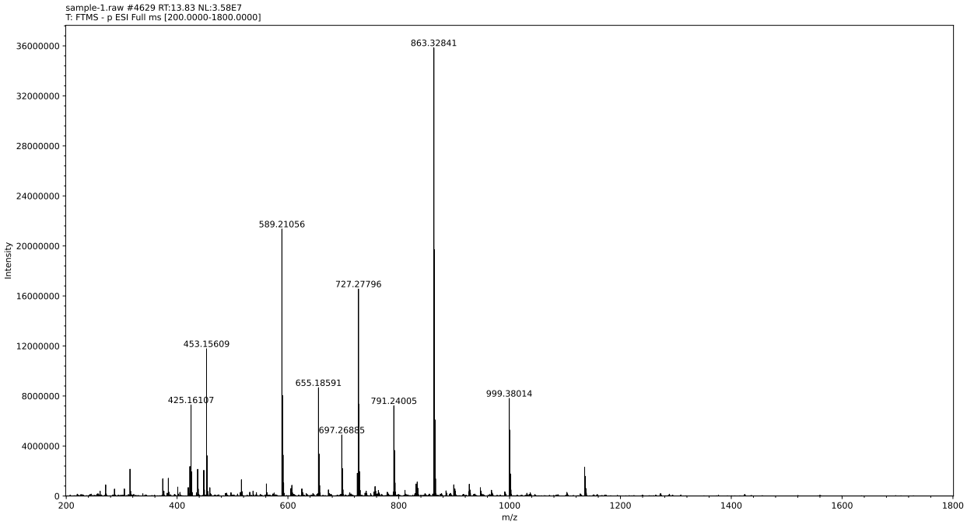
(D)
(E)
Fig. S9 The mass spectrum and molecular structures with retention times ranging from 12~15 min
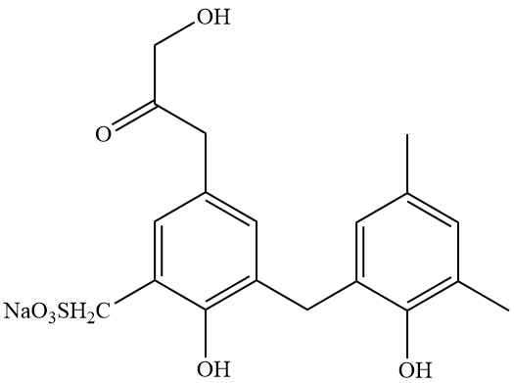
(A)MS spectra within 9.00~11.00 min, (B)MS spectra within 11.00~12.00 min, (C)MS spectra within 12.00~13.70 min, (D)MS spectra within 13.71~13.83 min, (E)MS spectra within 13.84~15.00 min
(A)
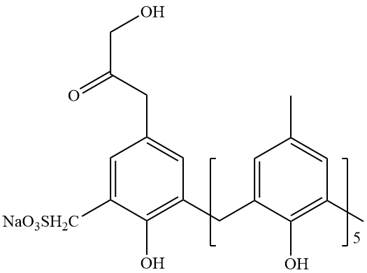
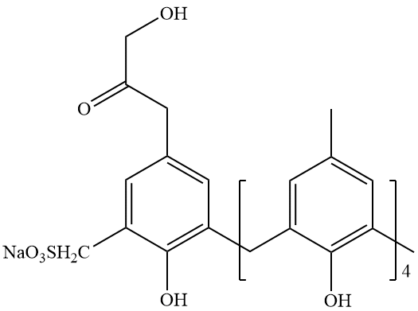
(B)
(C)
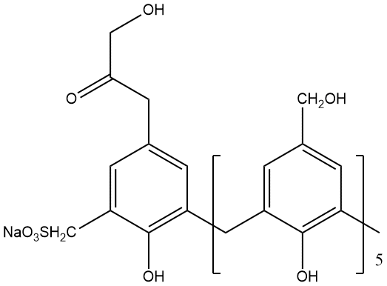
(D)
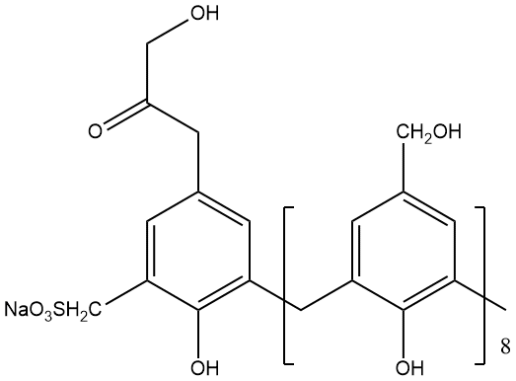
(E)
Fig. S10 Molecular structure of SLPFR with retention time between 9 and 15 minutes
- Molecular structure of the SLPFR within the 9.00~11.00 min; (B)Molecular structure of the SLPFR within the 11.00~12.00 min; (C)Molecular structure of the SLPFR within the 12.00~13.70 min; (D)Molecular structure of the SLPFR within the 13.71~13.83 min; (E)Molecular structure of the SLPFR within the 13.84~15.00 min
- Effect of metal cations on the fractal dimension of the SLPFR system
The double slope method is used to calculate the fractal dimension of aggregates. Cumulative size distributions of fractal aggregates expressed in terms of maximum length or solid volume are provided by^{[8]}:
(S1)
(S2)
For a given population of aggregates, the cumulative size distributions in terms of aggregate length and solid volume are equivalent, according to the definition of cumulative size distributions. Thus, the two slopes of the cumulative size distributions in terms of maximum length and solid volume may then be used to compute the fractal dimension^{[8,9]}:
(S3)
Where A_{L} and A_{V} are empirical constants, S(L) and S(V) are exponents of the cumulative size distributions N(L), and N(V) based on aggregate maximum length L and solid volume V, respectively. N(L) indicates the number distribution and N(V) indicates the volume distribution. D_{f} is the fractal dimension.
As shown in Fig. S11, the N(L) and N(V) of metal cations on the SLPFR system. The number and volume distributions of metal cations on the surfactant+SLPFR systems are shown in Fig. S12. The N(L) and N(V) of the HPAM+SLPFR system in the presence of different molecular weights HPAM, as shown in Fig. S13.
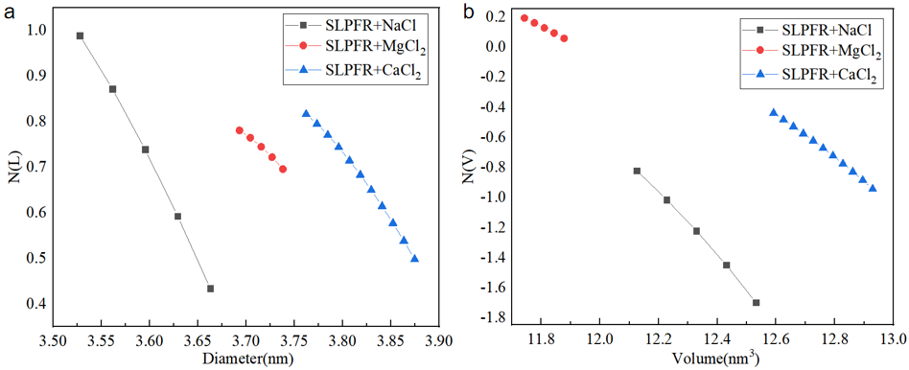
Fig. S11 The N(L) and N(V) of metal cations on the SLPFR system
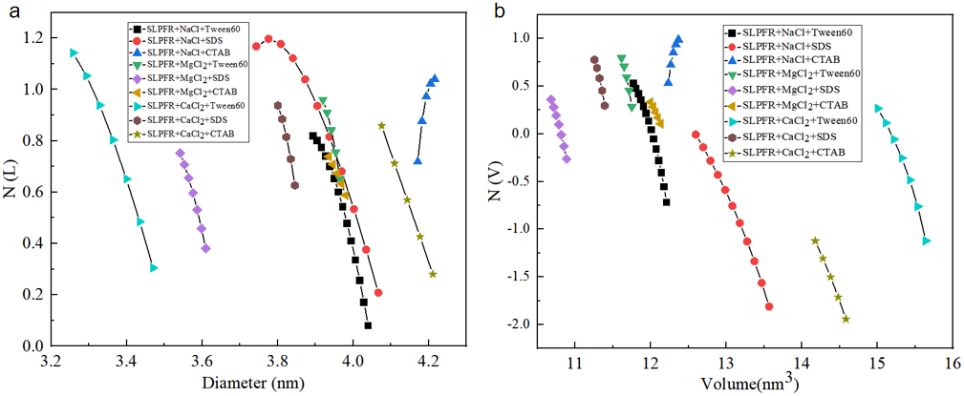
Fig. S12 The N(L) and N(V) of metal cations on the surfactant+SLPFR system
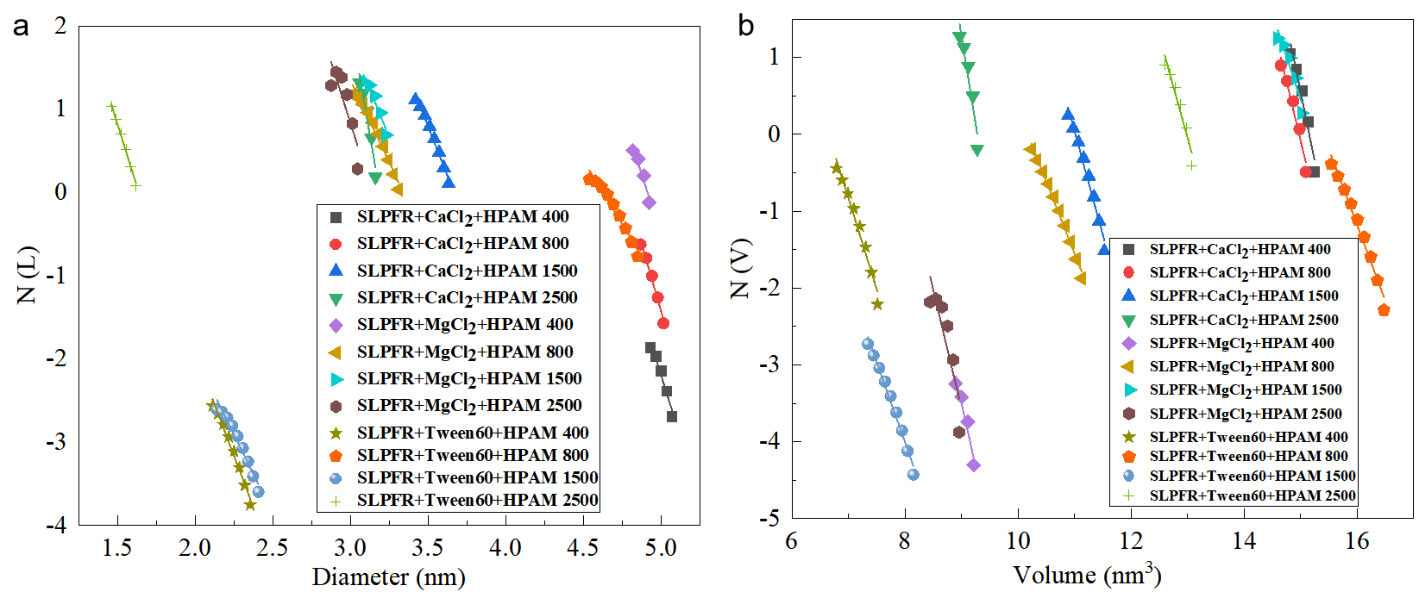
Fig. S13 The N(L) and N(V) of the HPAM+SLPFR system in the presence of different molecular weights HPAM

References
1. Li J, Zhang J, Zhang S, Gao Q, Li J, Zhang W (2018) Alkali lignin depolymerization under eco-friendly and cost-effective NaOH/urea aqueous solution for fast curing bio-based phenolic resin. Industrial Crops and Products 120, 25-33
2. Kalami S, Arefmanesh M, Master E, Nejad M (2017) Replacing 100% of phenol in phenolic adhesive formulations with lignin. Journal of Applied Polymer Science 134 (30)
3. Wang H, Eberhardt T L, Wang C P, Gao S S, Pan H (2019) Demethylation of alkali lignin with halogen acids and its application to phenolic resins. Polymers 11 (11)
4. Yang W J, Fortunati E, Gao D Q, Balestra G M, Giovanale G, He X Y, Torre L, Kenny J M, Puglia D (2018) Valorization of acid isolated high yield lignin nanoparticles as innovative antioxidant/antimicrobial organic materials. ACS Sustainable Chemistry & Engineering 6 (3), 3502-3514
5. Hong S, Lian H L, Sun X, Pan D, Carranza A, Pojman J A, Mota-Morales J D (2016) Zinc-based deep eutectic solvent-mediated hydroxylation and demethoxylation of lignin for the production of wood adhesive. RSC Advances 6 (92), 89599-89608
6. Zhang W, Ma Y F, Wang C P, Li S H, Zhang M M, Chu F X (2013) Preparation and properties of lignin-phenol-formaldehyde resins based on different biorefinery residues of agricultural biomass. Industrial Crops and Products 43, 326-333
7. Zhang W, Ma Y F, Xu Y Z, Wang C P, Chu F X (2013) Lignocellulosic ethanol residue-based lignin-phenol-formaldehyde resin adhesive. International Journal of Adhesion and Adhesives 40, 11-18
8. Tang S, Mcfarlane C M, Paul G C (1999) Characterising latex particles and fractal aggregates using image analysis. Colloid and Polymer Science 277(4): 325-333
9. Tang S, Preece J M, McFarlane C M, Zhang Z (2000) Fractal morphology and breakage of DLCA and RLCA aggregates. Journal of Colloid and Interface Science 221 (1), 114-123

