Supplementary Materials

Phylogenomic analyses and comparative genomic studies of Thermus strains isolated from Tengchong and Tibet hot springs, China
Authors
Inam Ullah Khan^{2,3}, Muhammad Saqib⁴, Arshia Amin⁵, Sadia Manzoor⁶, Iftikhar Ahmed⁶, Rui-Rui Liu¹, Jian-Yu Jiao¹, Xiao-Yang Zhi^{3*}, Wen-Jun Li^{1,7*}
¹State Key Laboratory of Biocontrol, Guangdong Provincial Key Laboratory of Plant Resources and Southern Marine Science and Engineering Guangdong Laboratory (Zhuhai), School of Life Sciences, Sun Yat-Sen University, Guangzhou, 510275, PR China
²Institute of Microbiology, Faculty of Veterinary and Animal Sciences, Gomal University, Dera Ismail Khan, Khyber Pakhtunkhwa, 29050, Pakistan
³Yunnan Institute of Microbiology, School of Life Sciences, Yunnan University, Kunming, 650091, PR China.
⁴Department of Zoology, Tank Campus, Gomal University, Dera Ismail Khan, Khyber Pakhtunkhwa, 29050, Pakistan
⁵Department of Bioinformatics and Biosciences, Capital University of Science and Technology, Islamabad 45500, Pakistan
⁶Institute of Microbial Culture Collection of Pakistan (IMCCP), National Agricultural Research Centre (NARC), Park Road, Islamabad 45500, Pakistan
⁷State Key Laboratory of Desert and Oasis Ecology, Key Laboratory of Ecological Safety and Sustainable Development in Arid Lands, Xinjiang Institute of Ecology and Geography, Chinese Academy of Sciences, Urumqi, 830011, PR China

Table S1. Genome sequences information of all 16 Thermus strains used in present study
Strain ID | Gene Number | Genome size (bp) | Gene Average Length (bp) | G+C content (%) | Total Scaffold | Total Contig
YIM 730264 | 2572 | 2271624 | 883 | 67.27 | 31 | 35
YIM 73052 | 2431 | 2139858 | 880 | 65.03 | 67 | 79
YIM 73518 | 2644 | 2297685 | 869 | 67.29 | 109 | 122
YIM QC2-109 | 2326 | 2111031 | 907 | 69.02 | 58 | 59
YIM 1627 | 2277 | 2078874 | 912 | 69.12 | 21 | 24
YIM 1640 | 2324 | 2109060 | 907 | 69.03 | 59 | 62
77359 | 2328 | 2108874 | 905 | 69.01 | 77 | 95
71206 | 2408 | 2117805 | 879 | 64.90 | 92 | 108
71318 | 2407 | 2139225 | 888 | 67.40 | 51 | 59
72351 | 2608 | 2322411 | 890 | 67.34 | 41 | 46
77311 | 2520 | 2202570 | 874 | 65.08 | 92 | 98
77412 | 2559 | 2244729 | 877 | 65.10 | 95 | 106
77420 | 2441 | 2343085 | 898 | 67.1 | 92 | 126
77838 | 2295 | 2079222 | 905 | 69.07 | 31 | 32
77923 | 2312 | 2108625 | 912 | 69.09 | 29 | 30
77927 | 2479 | 2217678 | 894 | 67.21 | 29 | 34

Table S2. CRISPR elements found in the present study across all Thermus genomes
Species | DR length | Cas types | Cas genes
T. oshimai (YIM 1627) | 29-36 | I, III | cas1, cas6e, cas5, cas7  cse2gr11, cas8e, cas3HD  WYL, casR, unk, csx1,  cas6, csm3gr7, csm2gr11,  cas10, cas2
T. oshimai (YIM 1640) | 29-36 | I, III | cas1, csx1, unk, casR, cas2, cas10, csm3gr7, cas6, csa3, WYL, cas3HD, cas8e, cse2gr11, cas7, cas5, cas6e, cas1
T. antranikianii (71206) | 29 | I | WYL, cas3HD, cas8e, cse2gr11  cas7, cas5, cas6e, cas1, cas2, cas4, csa3
T. brockianus (71318) | 23-36 | I, III | cas2, cas5, cas7b, cas8b1, cas6, cas3HD, cas4, cas7, cas6e,cas1, csm3gr7, cmr5gr11, cmr4gr7, cmr3gr5, cas10, csx1, unk, csx1, csm2gr11
T.brockianus (72351) | 23-36 | I, III | cas2, cas5, cas7b, cas8b1, cas6, cas3HD, cas4, cas1, csm3gr7, cmr5gr11, cmr4gr7, csm3gr7, cmr3gr5, cas10, unk, csx1, cas1, cas2, csm4gr5, csm2gr11, cas1, cas6e, cas5, cas7, cse2gr11, cas8e
T. antranikianii (77311) | 28-36 | I, III | cas1, csx1, cas6, unk, cas2, cas5, cas7b, cas8b1, cas3HD, cas4, csa3, cas10, cmr3gr5, csm3gr7, cmr4gr7, cmr5gr11, csm3gr7, csm4gr5, csm2gr11
T. oshimai (77359) | 23-37 | I, III | casR, unk, csx1, cas1, WYL, cas3HD, cas8e, cse2gr11, cas7, cas5, cas6e, cas2, cas10, csm3gr7, cas6, csa3
T. antranikianii (77412) | 28-36 | I, III | csa3, cas10, csm2gr11, csm3gr7, csm4gr5, csm3gr7, csx1, cmr5gr11, cmr4gr7, cmr3gr5, cas10, cas2, unk, cas6, cas1, cas2, cas5, cas7b, cas8b1, cas6, cas3HD, cas4
T. thalpophilus 77420 | 26-36 | IV, III, I | DinG, unk, csx1, cas1, csm3gr7, csm4gr5, csm2gr11, cas10, cas6, WYL, cas3HD, cas8e, cse2gr11, cas7, cas5, cas6e, cas1, cmr5gr11,  cmr4gr7, cmr3gr5, cas10
T. oshimai (77838) | 29-37 | I, III | WYL, cas3HD, cas8e, cse2gr11, cas7, cas5, cas6e, cas1, csa3, casR, unk, csx1, cas1, cas2, cas10, csm3gr7, csm4gr5, cas6
T. oshimai (77923) | 29-36 | I, III, | csa3, cas6, csx1, csm3gr7, csm4gr5, csm3gr7, csm2gr11, cas10, cas2, cas1, unk, casR, WYL, cas3HD, cas8e, cse2gr11, cas7, cas5, cas6e
T. hydrothermalis (77927) | 37 | I | cas6, csx1, unk
T. oshimai (YIM QC2-109) | 29-36 | III, I | cas1, csx1, unk, casR, cas2, cas10, csm3gr7, cas6, csa3, WYL, cas3HD, cas8e, cse2gr11, cas7, cas5, cas6e
T. hydrothermalis (YIM 730264) | 29-36 | I | cas6, csx1, unk, cas4, cas2, cas1, cas6e, cas5, cas7, cse2gr11, cas8e, cas3HD, WYL
T. antranikianii (YIM 73052) | 29 | I | WYL, cas3HD, cas8e, cse2gr11, cas7, cas5, cas6e, cas1, cas2, cas4, csa3, casR, unk
T. brockianus (YIM 73518) | 28-36 | I, III | cas7b, cas1, cas2, cas6e, cas5, cas7, cas7b, cas8b1, cas6, cas3HD, cas3, cas4, cas6, cas10, csm2gr11, csm3gr7, csm4gr5, csm3gr7, csx1, cas1, unk, cas10, cmr3gr5, cmr4gr7, cmr5gr11, csm3gr7, cas5, cas8c, cas7b

Table S3. Proteins involved in natural transformation of Thermus strains, isolated from Tibet &Tengchong hot springs, China
Thermus strains | Competence proteins
 | pilM | pilQ | pilN | pilC | pilF | dprA | pilT | comZ | comEC | pilW
YIM 730264 | + | + | + | + | + | + | + | - | + | -
YIM 73052 | + | + | - | + | + | - | + | - |  | -
YIM 73518 | + | + | + | + | + | + | + | - | + | +
YIM QC2-109 | + | + | + | + | + | + | + | + | - | +
YIM 1627 | + | + | + | + | + | + | + | + | - | +
YIM 1640 | + | + | + |  | + | + | + | + | - | +
77359 | + | + | + | + | + | + | + | + | - | +
71206 | + | + | - | + | + | - | + | - | - | -
71318 | + | + | + | + | + | + | + | - | + | +
72351 | + | + | + | + | + | + | + | - | + | +
77311 | + | + | - | + | + | - | + | - | - | -
77412 | + | + | - | + | + | - | + | - | - | -
77420 | + | + | + | + | + | + | + | - | + | -
77838 | + | + | + | + | + | + | + | + | - | +
77923 | + | + | + | + | + | + | + | + | - | +
77927 | + | + | + | + | + | + | + | - | + | +

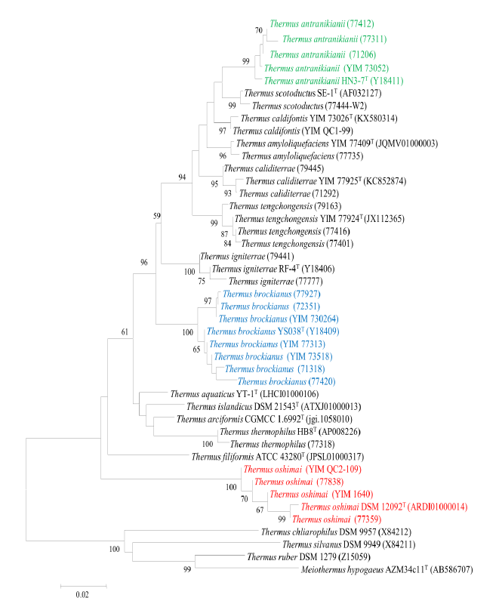
Figure S1. NJ tree constructed based on 16S rRNA gene sequences obtained from all Thermus isolates and the colored strains in tree were selected for whole genome sequences

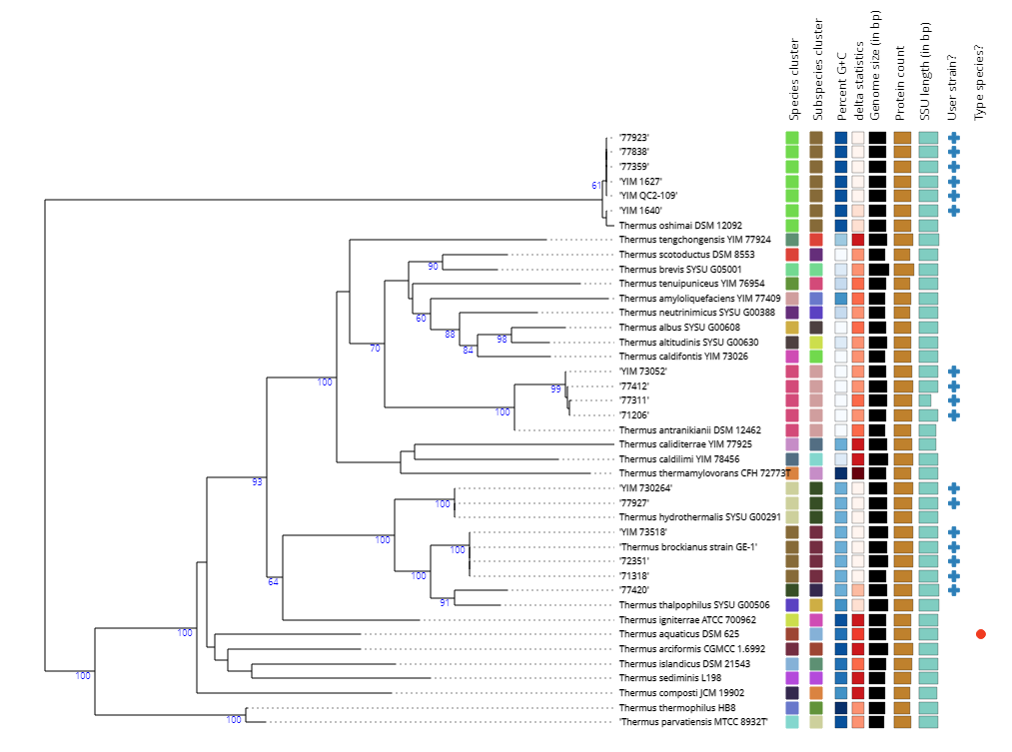
Figure S2. NJ Phylogenetic tree generated based on 16S rRNA gene sequences extracted from whole genome by using Type Strain Genome server

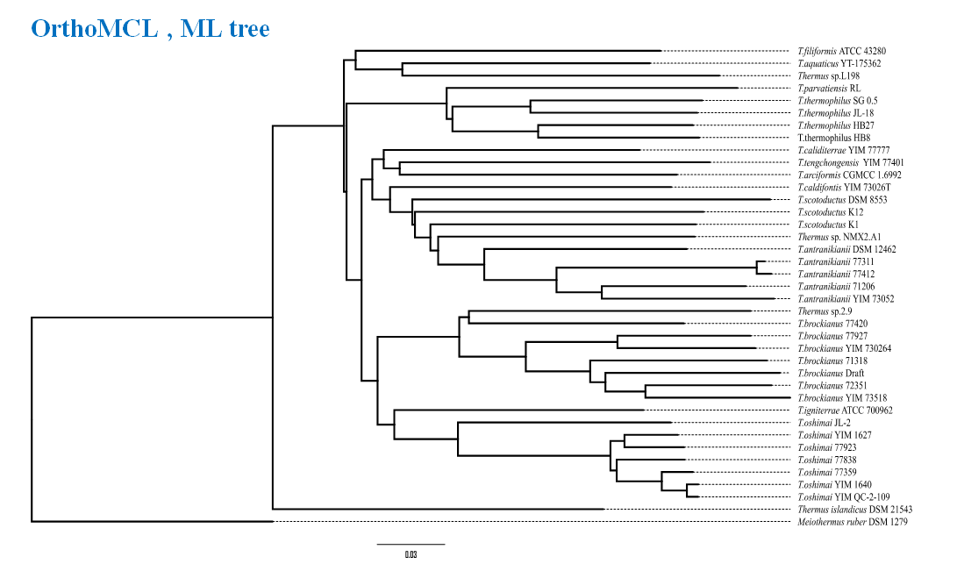
Figure S3. Gene content tree: concatenated by 971 conserved proteins. ML method, of genus Thermus and relative strains

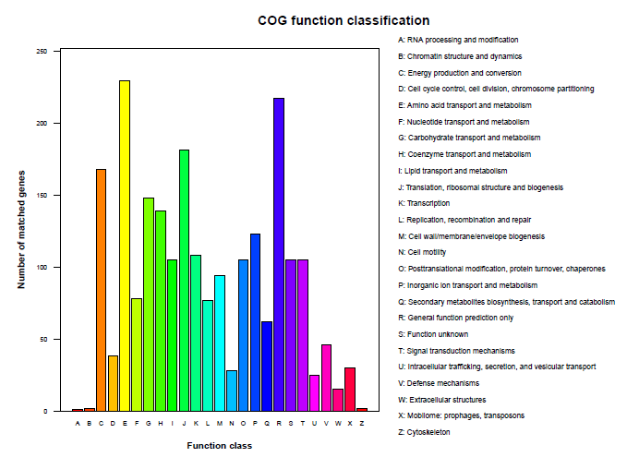

Figure S4. COG function classification for all Thermus isolates from Tibet and Tengchong hot springs

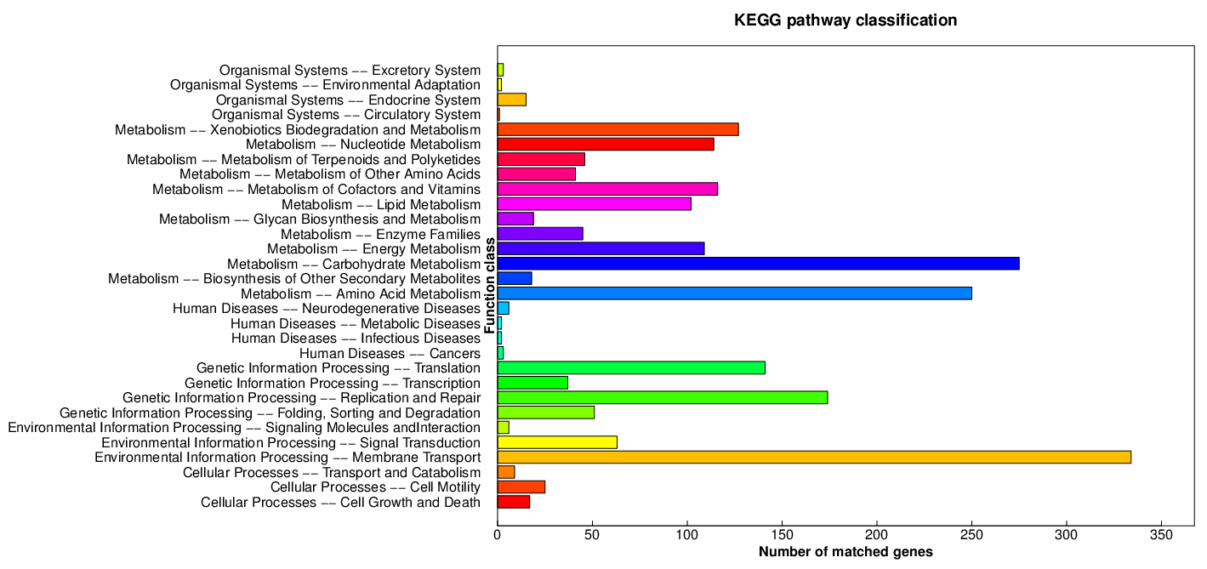
Figure S5. KEGG pathway classification for all Thermus isolates from Tibet and Tengchong hot springs

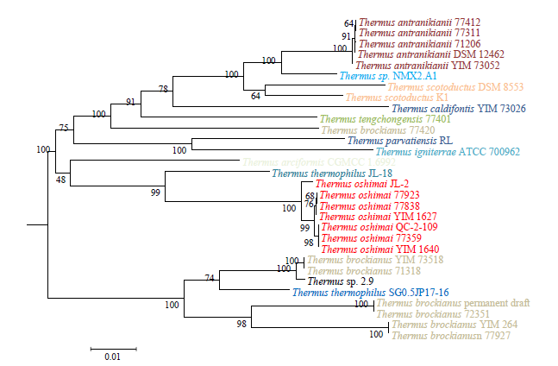
Figure S6. NJ phylogenetic tree showing the relationship of narG nucleotide sequences from Thermus strains. Bar indicates 0.01 substitutions per nucleotide position
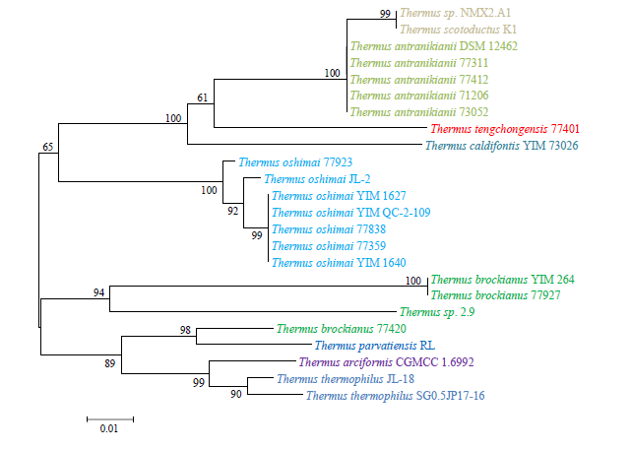 Figure S7. NJ phylogenetic tree showing the relationship of nirS nucleotide sequences from Thermus strains

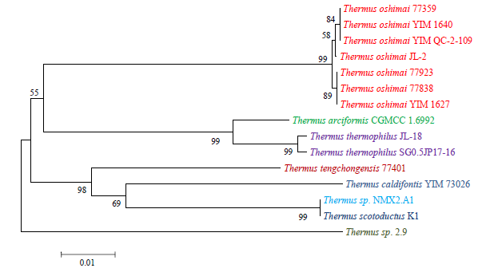
Figure S8. NJ phylogenetic tree showing the relationship of norB nucleotide sequences from Thermus strains. Bar indicates 0.01 substitutions per nucleotide position

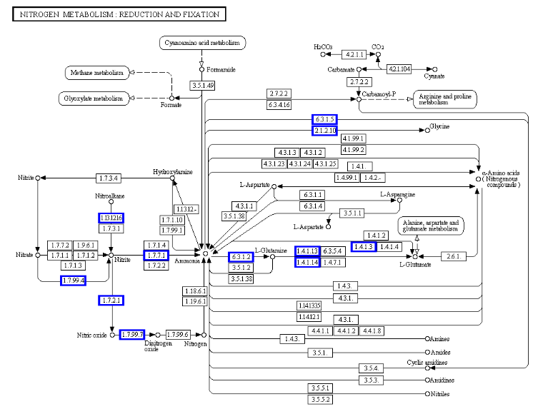
A
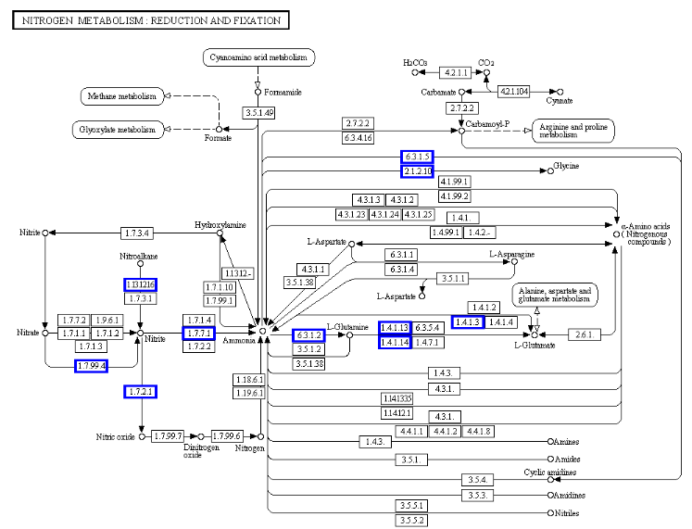
B
Figures S9. A & B showing incomplete Nitrogen metabolic pathway for Thermus strains. Green-shaded boxes indicate presence of respective gene in a given metabolic pathway

