Supporting Material

La-doped Ti/Sb-SnO₂ electrode enhanced removal of microplastics by advanced electrocatalysis oxidation process (AEOP) strategy
Weikang Zheng^{,b}, Boyan Wang ^{a,b}, Zhenzhong Liu ^{a,b*}, Hongwei Yang ^{a,b*}
ªKey Laboratory of Poyang Lake Environment and Resource Utilization, Ministry of Education, Nanchang University, Nanchang 330031,China
^{b}School of Resources and Environment, Nanchang University, Nanchang 330031, China
E-mail addresses: liuzz79@ncu.edu.cn ( Z.Z. Liu) , yanghw@ncu.edu.cn. ( H.W. Yang).

Figures
Fig. S1 Surface morphology of titanium substrate before and after acid etching

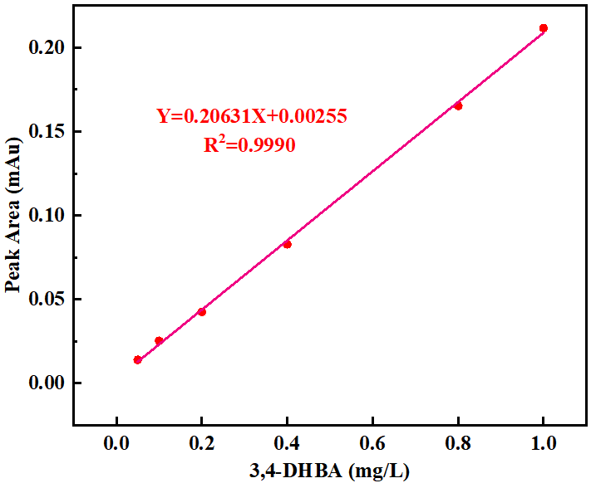
Fig. S2 Standard curve of 3,4-DHBA

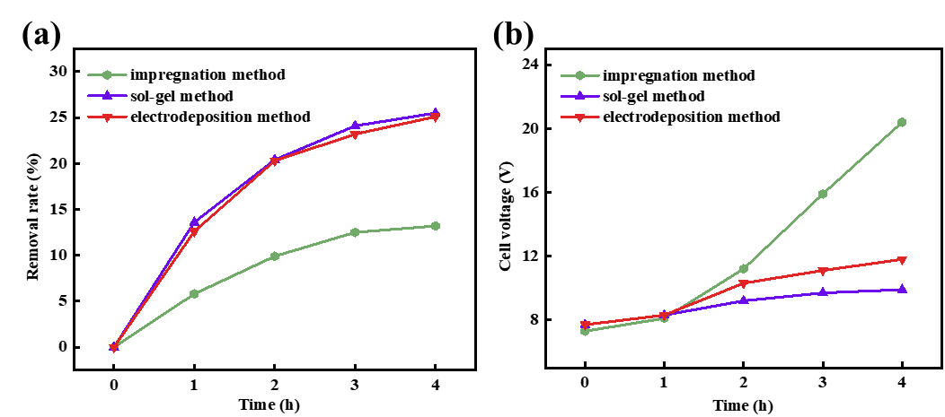
Fig. S3 (a) Effect of coating preparation method on degradation of PS microplastics removal by Ti/La-Sb-SnO₂ electrode. (b) Change of the cell voltage during the AEOP.

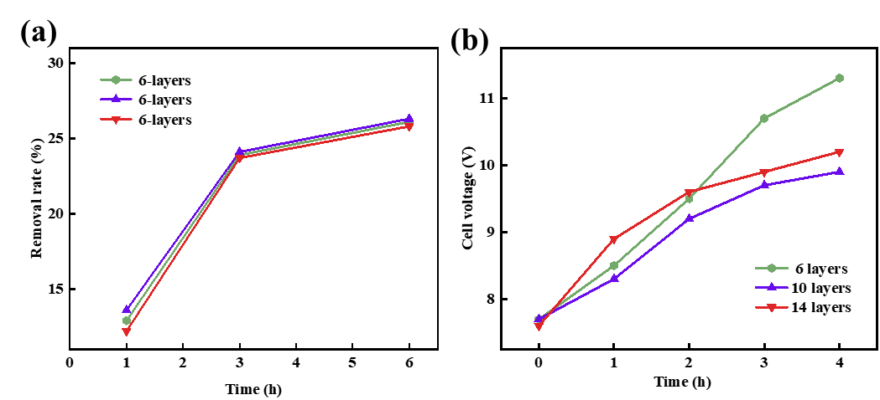
Fig. S4 (a) Effect of the number of coating layers on PS microplastics removal by Ti/La-Sb-SnO₂ electrode. (b) Change of the cell voltage during the AEOP.
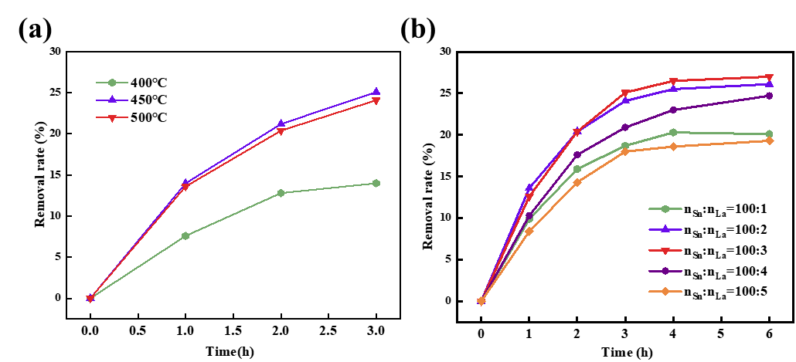
Fig. S5 (a) Effect of heat treatment temperature on PS microplastics removal by Ti/La-Sb-SnO2
electrode. (b) Effect of La-doped ratios on PS microplastics removal by Ti/La-Sb-SnO2 electrode.

* Corresponding authors. E-mail addresses: liuzz79@ncu.edu.cn ( Z.Z. Liu) , yanghw@ncu.edu.cn. ( H.W. Yang).

