Supplementary Material

Table S1: PCR mastermix volumes
Item | Volume (µL)
10X ExTaq Buffer | 2
DNTPs | 1.6
Forward Primer | 0.8
Reverse Primer | 0.8
ExTaq HS Enzyme | 0.1
Nuclease-Free Water | 13.7
Template | 1
Total Volume | 20

Table S2: PCR conditions
Stage | Temperature (°C) | Time (Mins) | Number of cycles
Initial Denaturation | 95 | 5
Denaturation | 95 | 1 | 35
Annealing | 58 | 1
Extension | 72 | 1
Final Extension | 72 | 1
Hold | 4

Table S3: Primer sequences for the 3 target genes encoding resistance
Primers | Sequence (5’-3’) | Annealing Temperature | Expected Band Size
TetA (Forward) | GTAATTCTGAGCACTGTCGC | 58 | 494
TetA (Reverse) | CTGCCTGGACAACATTGCTT | 58 | 494
Sul1 (Forward) | TGAGATCAGACGTATTGCGC | 58 | 793
Sul2 (Reverse) | TTGAAGGTTCGACAGCACGT | 58 | 793
CtxM (Forward) | CGATGTGCAGTACCAGTAA | 55 | 585
CtxM (Reverse) | TAAGTGACCAGAATCAGCGG | 58 | 585

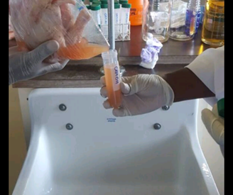
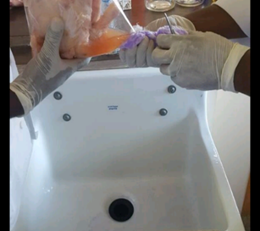
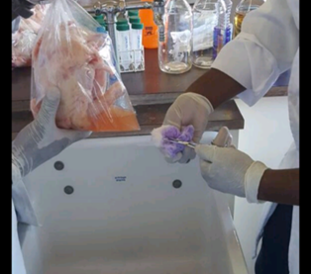

a b c
Figure S1. Stages of the carcass rinse technique

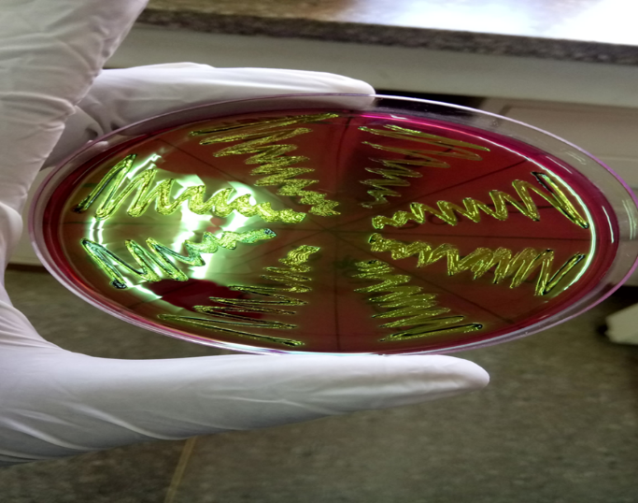

Figure S2. Colonies showing a metallic green sheen

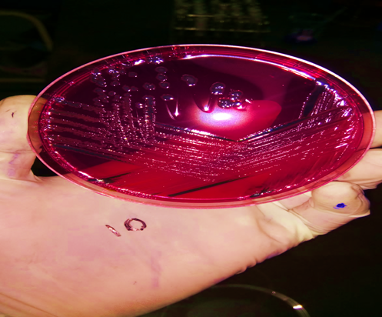

Figure S3. Black Salmonella colonies on XLD

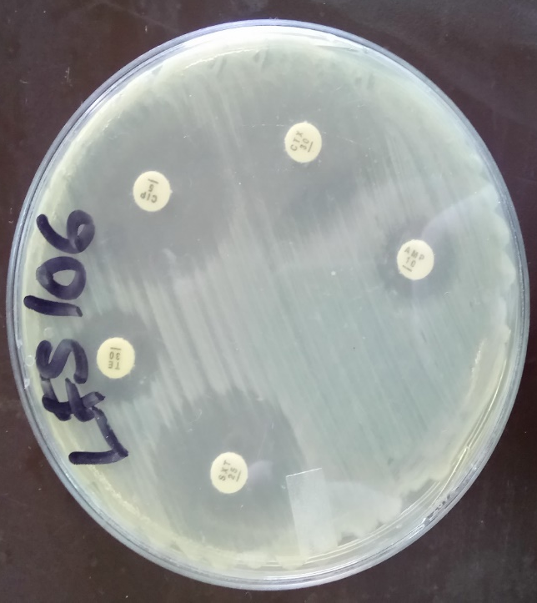
Figure S4. Kirby Bauer disc diffusion showing zones of inhibition
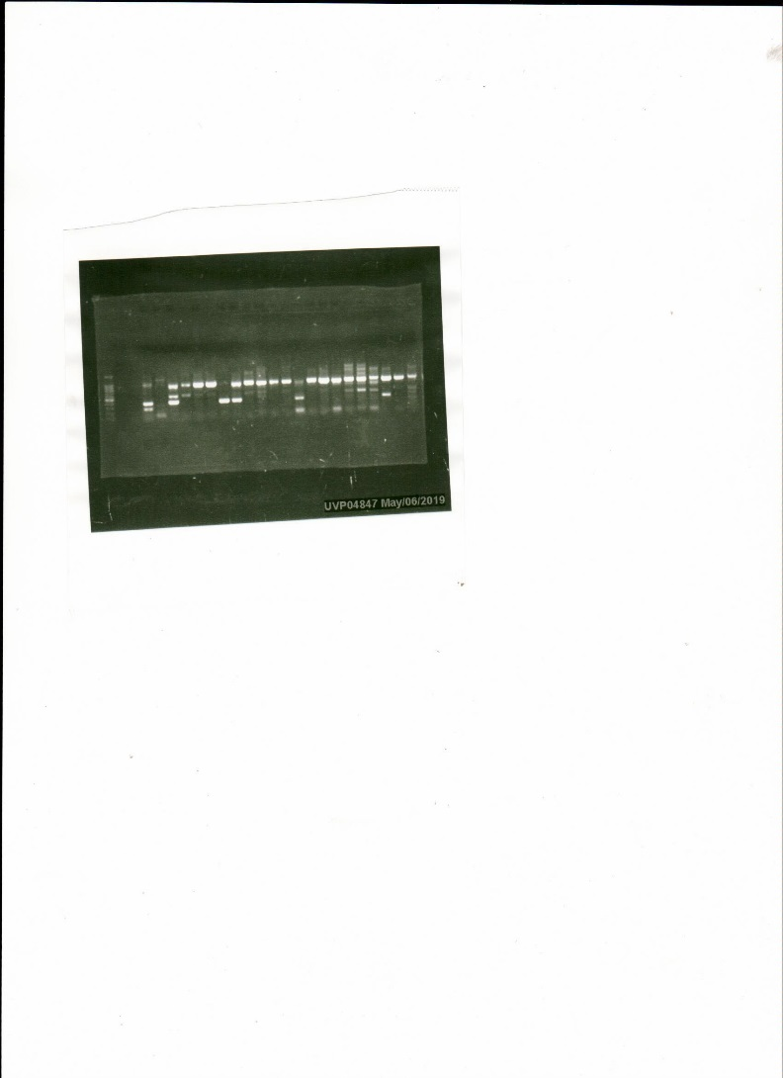

sul1
Ctx-M
tet1

Figure S5. PCR image

