Supplementary Information
EPRS1-mediated fibroblast activation and mitochondrial dysfunction promote kidney fibrosis
Table of Contents
Supplementary Information
- Supplementary Table 1. Baseline clinical characteristics of patients
- Supplementary Table 2. Small-interfering RNA sequences
- Supplementary Table 3. List of primers
- Supplementary Figure 1. Clinical index and mRNA expression levels in FA mice.
- Supplementary Figure 2. Basic data on effects of pharmacological EPRS1 inhibition in FA mice.
- Supplementary Figure 3. Upregulated signaling pathway in FA compared to control.
- Supplementary Figure 4. EPRS1 inhibitor suppresses fibroblast activation and proliferation in NIH3T3 cells.
- Supplementary Figure 5. The KEGG pathway in injured PT1 compared to PT.
- Supplementary Figure 6. Genetic EPRS1 inhibition decreases collagen and STAT3 pathway in HK-2 cells.
- Supplementary Figure 7. Pharmacological EPRS1 inhibition decreases collagen and STAT3 pathway in HK-2 cells.
- Supplementary Figure 8. Mitochondrial related KEGG pathway in single cell analysis and gene expression of mitochondrial dysfunction markers in EPRS1 inhibitor treated mice.
- Supplementary Figure 9. Full blots of Figure 1.
- Supplementary Figure 10. Full blots of Figure 4.
- Supplementary Figure 11. Full blots of Figure 6.
- Supplementary Figure 12. Full blots of Figure 7.
- Supplementary Figure 13. Full blots of Supplementary Figure 4.
- Supplementary Figure 14. Full blots of Supplementary Figure 6.
- Supplementary Figure 15. Full blots of Supplementary Figure 7.

Supplementary Tables
Supplementary Table 1. Baseline clinical characteristics of patients
Case | Sex | Age  (years) | BP  (mmHg) | Serum creatinine  (mg/dl) | Proteinuria  (mg/day) | eGFR  (ml/min) | Tubular  atrophy (%) | Pathologic diagnosis | Interstitial  fibrosis | Fibrosis  index
1 | M | 18 | 110/60 | 1.0 | 78 | 109 | 0 | Minor glomerular change | Absent | 0
2 | F | 21 | 100/60 | 0.7 | 913 | 118 | 20 | Minor glomerular change | Absent | 0
3 | M | 24 | 120/80 | 0.5 | 345 | 146 | 1 | Minor glomerular change | Absent | 0
4 | M | 62 | 120/70 | 1.1 | 3284 | 69 | 30 | FSGS | Moderate | 2
5 | F | 44 | 180/100 | 3.5 | 2394 | 14 | 60 | FSGS | Severe | 3
6 | F | 51 | 130/80 | 1.8 | 613 | 31 | 60 | FSGS | Severe | 3

Fibrosis index criteria: absent, 0; mild, 1; moderate, 2; severe, 3. M, male; F, female; FSGS, focal segmental glomerulosclerosis.

Supplementary Table 2. Small-interfering RNA sequences
Number | Gene | Anti-sense
 | Human
1 | siEPRS1 | CUAAUUCCUCAGCAAGUAU
2 | siEPRS1 | CCAACCCUUUAUCGCUGCA

Supplementary Table 3. List of primers
qPCR | Forward Primer | Reverse Primer
Mouse
Col1a1 | TCATCGTGGCTTCTCTGGTC | GACCGTTGAGTCCGTCTTTG
Col3 | GACCAAAAGGTGATGCTGGACAG | CAAGACCTCGTGCTCCAGTTAG
Col4 | ATGGCTTGCCTGGAGAGATAGG | TGGTTGCCCTTTGAGTCCTGGA
Fn | TGGTGGCCACTAAATACGAA | GGAGGGCTAACATTCTCCAG
Acta2 | GGCTCTGGGCTCTGTAAGG | CTCTTGCTCTGGGCTTCATC
Tgf-β | CTCCCGTGGCTTCTAGTGC | GCCTTAGTTTGGACAGGATCTG
Eprs1 | AAGCGGAAAAGGCTCCTAAG | CCCAGTCTTTTCTTTATACTCAGCTT
Rpl13a | CGATAGTGCATCTTGGCCTTT | CCTGCTGCTCTCAAGGTTGTT
Ctgf | TGCGAAGCTGACCTGGAGGAAA | CCGCAGAACTTAGCCCTGTATG
Fap | CCGCGTAACACAGGATTCACTG | CACACTTCTTGCTCGGAGGAGA
ATP synthase | TCCATCAAAAACATCCAGAAAA | GAGGAGTGAATAGCACCACAAA
ND1 | ATCCTCCCAGGATTTGGAAT | ACCGGTAGGAATTGCGATAA
Human
EPRS1 | AGGAAAGACCAACACCTTCTC | CTCCTTGAACAGCCACTCTATT
COL1A1 | CCTGGCCCCATTGGTAATGTT | CCCCCTCACGTCCAGATTCAC
ACTA2 | GATCTGGCACCACTCTTTCTAC | CAGGCAACTCGTAACTCTTCTC
FN | CAAGCCAGATGTCAGAAGC | GGATGGTGCATCAATGGCA
GAPDH | ATCAAGAAGGTGGTGAAGCAG | GTCGCTGTTGAAGTCAGAGG

Supplementary Figures
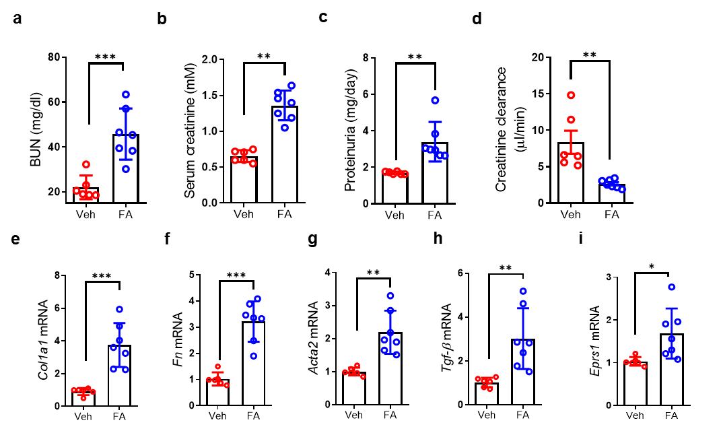

Supplementary Figure 1. Clinical index and mRNA expression levels in FA mice. a-d Folic acid (FA) induced blood urea nitrogen (BUN) (a), serum creatinine (b), proteinuria (c), and creatinine clearance (d) in two groups as indicated (n = 6-7). e-i Quantitative analysis of Col1a1 (f), Fn (g), Acta2 (h), Tgf-β (i), and Eprs1 (j) mRNA expression by quantitative polymerase chain reaction (qPCR) and normalized to Rpl13a (n = 6-7). Data are presented as mean ± standard deviation. Statistical data were analyzed by a two-tailed t-test. * P < 0.05, ** P < 0.01, and *** P < 0.001. Veh, Vehicle.
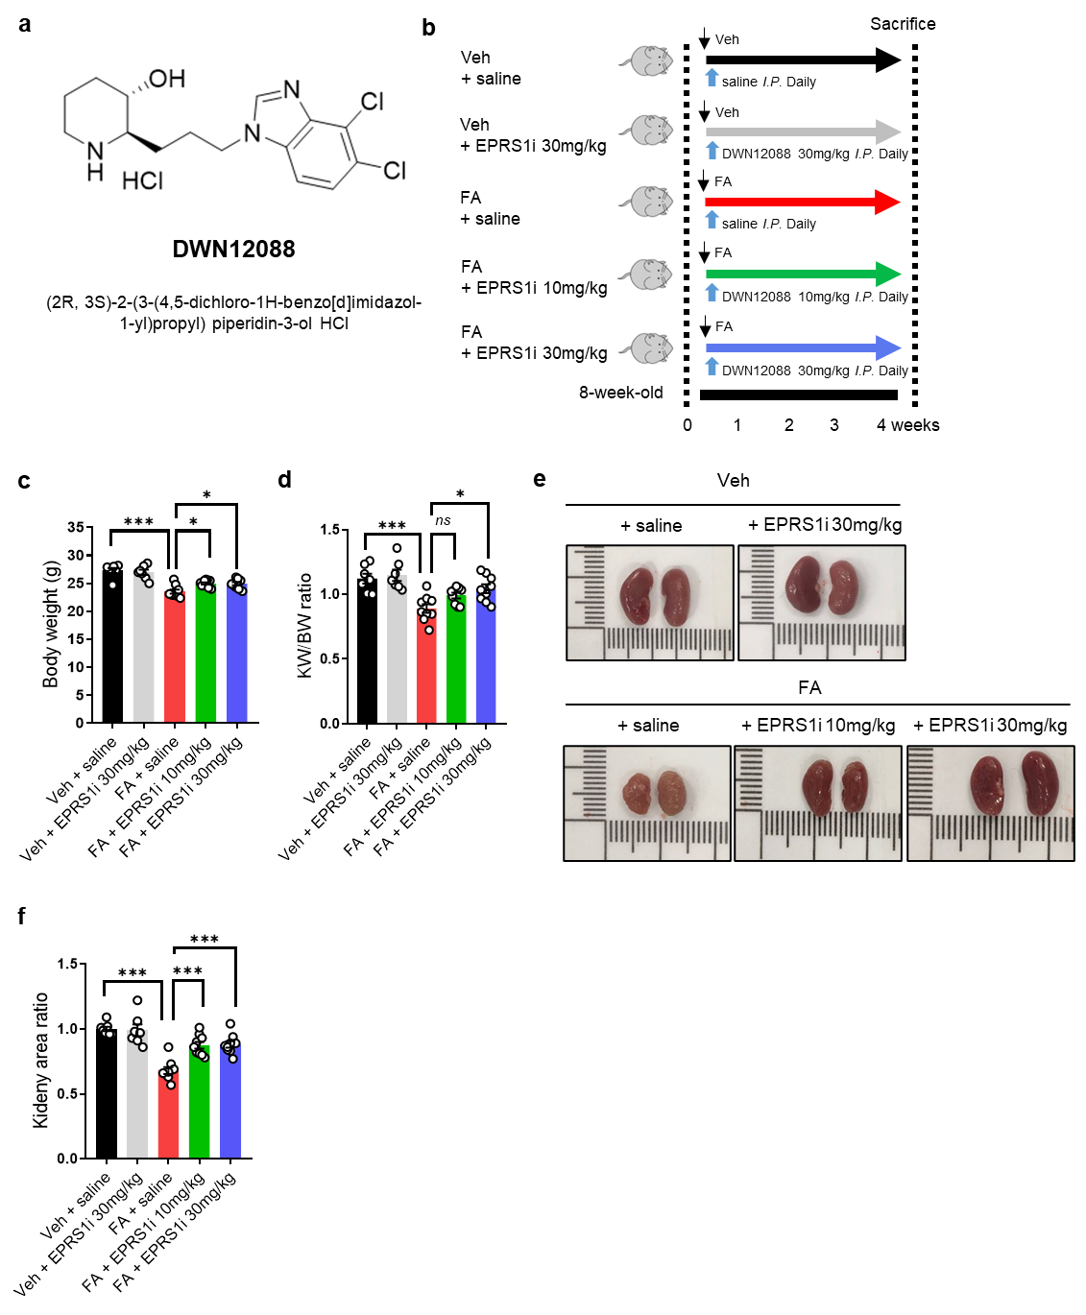

Supplementary Figure 2. Basic data on effects of pharmacological EPRS1 inhibition in FA mice. a Chemical structure of DWN12088, (2R, 3S)-2-(3-(4,5-dichloro-1H-benzo[d]imidazol-1-yl)propyl) piperidin-3-ol HCl. b Study design for examining the effect of EPRS1 inhibitor (EPRS1i) in FA mice (n = 7-9). c, d Body weight (c) at 28 days and ratio (d) of kidney weight (KW)-to-body weight (BW) (n = 7-9). e, f Gross anatomy (e) of kidney and kidney area ratio (f) measured using ImageJ (n = 7-9). Data are presented as mean ± standard deviation. Statistical data were analyzed by ANOVA with Tukey post-hoc test. * P < 0.05, ** P < 0.01, and *** P < 0.001.

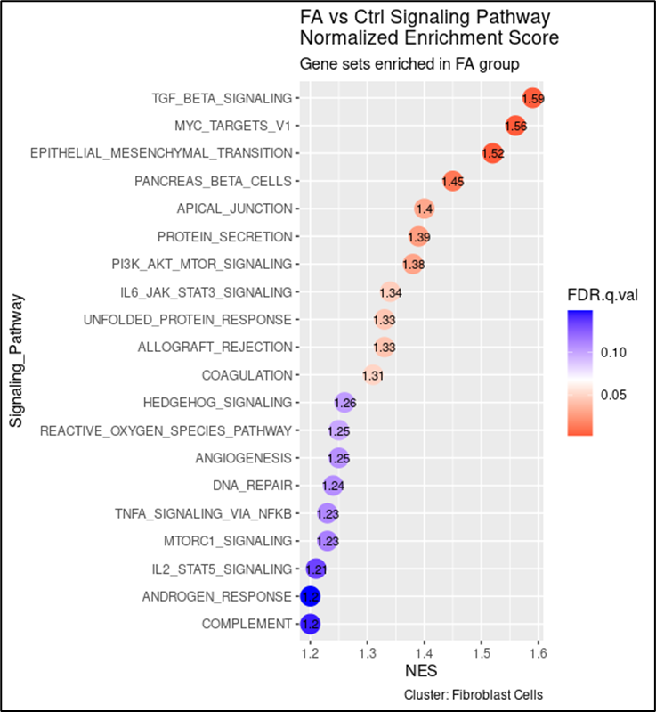
Supplementary Figure 3. Upregulated signaling pathway in FA compared to control. Normalized enrichment score for indicated pathways up-regulated in FA compared control (Ctrl) in total single-cell data is shown.

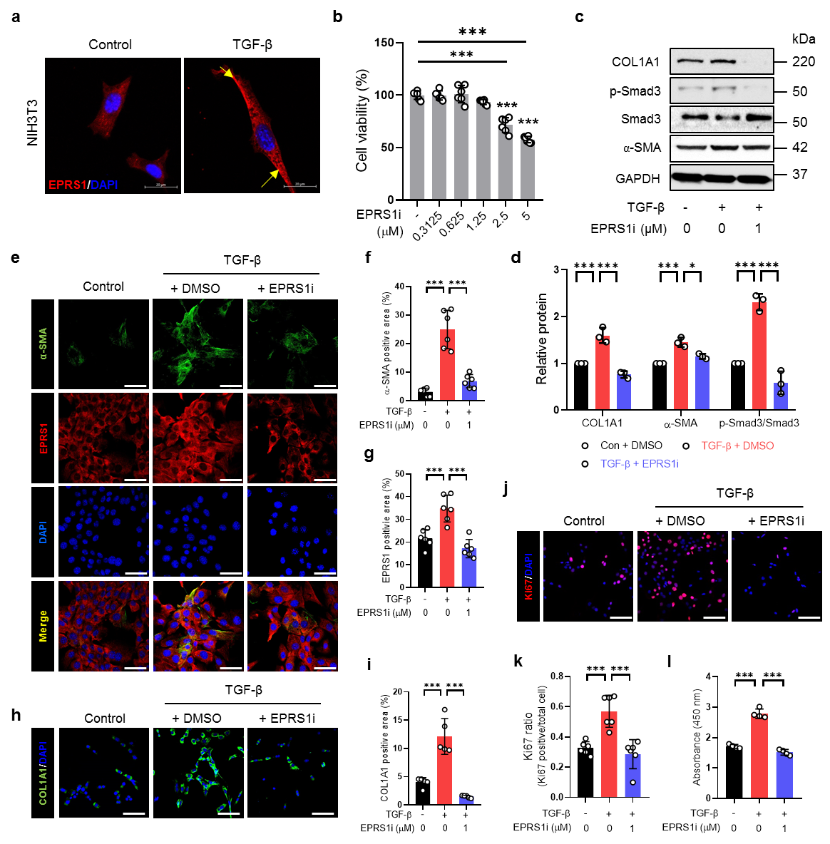

Supplementary Figure 4. EPRS1 inhibitor suppresses fibroblast activation and proliferation in NIH3T3 cells. a Representative confocal images of EPRS1 (red) in TGF-β (5 ng/ml)-induced NIH3T3 cells for 24 h. Yellow arrow indicates plasma membrane portion. Scale bar = 20 μm. b Cells were treated with various concentrations of EPRS1i and cell viability was determined by water-soluble tetrazolium 1 (WST-1) assay (n = 6). c, d Representative Western blot (c) and quantitative data (d) of fibrosis marker protein (COL1A1, and α-SMA) and Smad associated proteins (p-Smad3, and Smad3) expressed in EPRS1i-treated cells under TGF-β (5 ng/ml) treatment condition for 24 h (n = 3). e-i Representative confocal images of α-SMA, EPRS1, and COL1A1 in EPRS1i-treated cells under TGF-β (5 ng/ml) treatment condition for 24 h. Yellow arrow indicates co-localization. α-SMA positive area (e), EPRS1 positive area (f), and COL1A1 positive area (h) were quantified by ImageJ analysis (n = 6). Scale bar of α-SMA and EPRS1 is 100 μm. Scale bar of COL1A1 is 50 μm. j, k Representative confocal images of Ki67 (j) in EPRS1i-treated cells under TGF-β (5 ng/ml) treatment condition for 24 h. The Ki67 (k) was quantified by ImageJ analysis (n = 5). Scale bar = 50 μm. l Cells were treated with EPRS1i and TGF-β (5 ng/ml) for 72 h and cell proliferation was determined by WST-1 assay. Data are presented as mean ± standard deviation. Statistical data were analyzed by ANOVA with Tukey post-hoc test. * P < 0.05, ** P < 0.01, and *** P < 0.001.

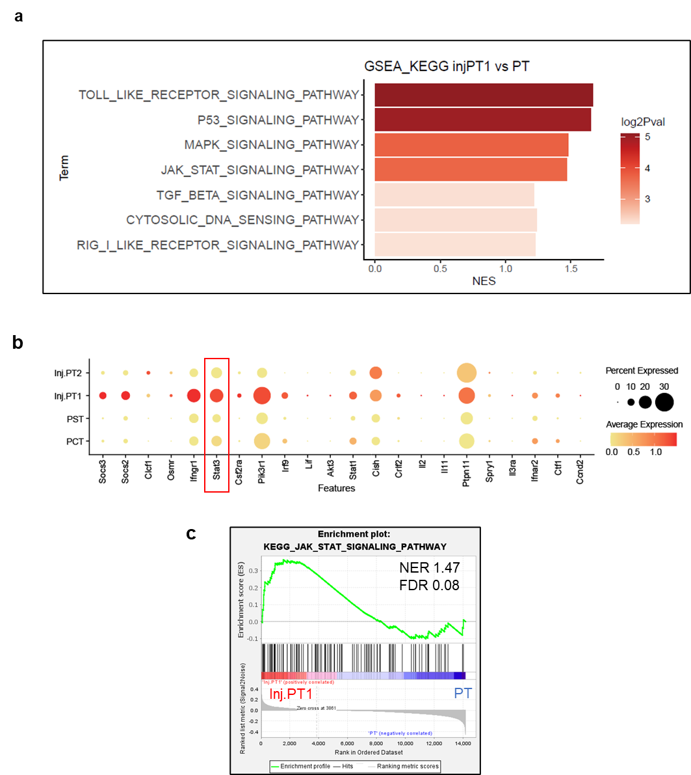
Supplementary Figure 5. STAT3 signaling related KEGG pathway in injured PT1 compared to PT. a KEGG pathway of Inj.PT1 and PT (PST + PCT). b Gene expression features showing differentially expressed genes (DEGs) (FA mice were compared with vehicle mice) in every cell type. c Gene set enrichment analysis software (GSEA) plots for indicated pathways up-regulated in Inj.PT1 cells compared to PT cells in total single-cell data. Inj.PT1, injured proximal tubule 1; PT, Proximal tubule; PST, proximal straight tubule; PCT, proximal convoluted tubule.

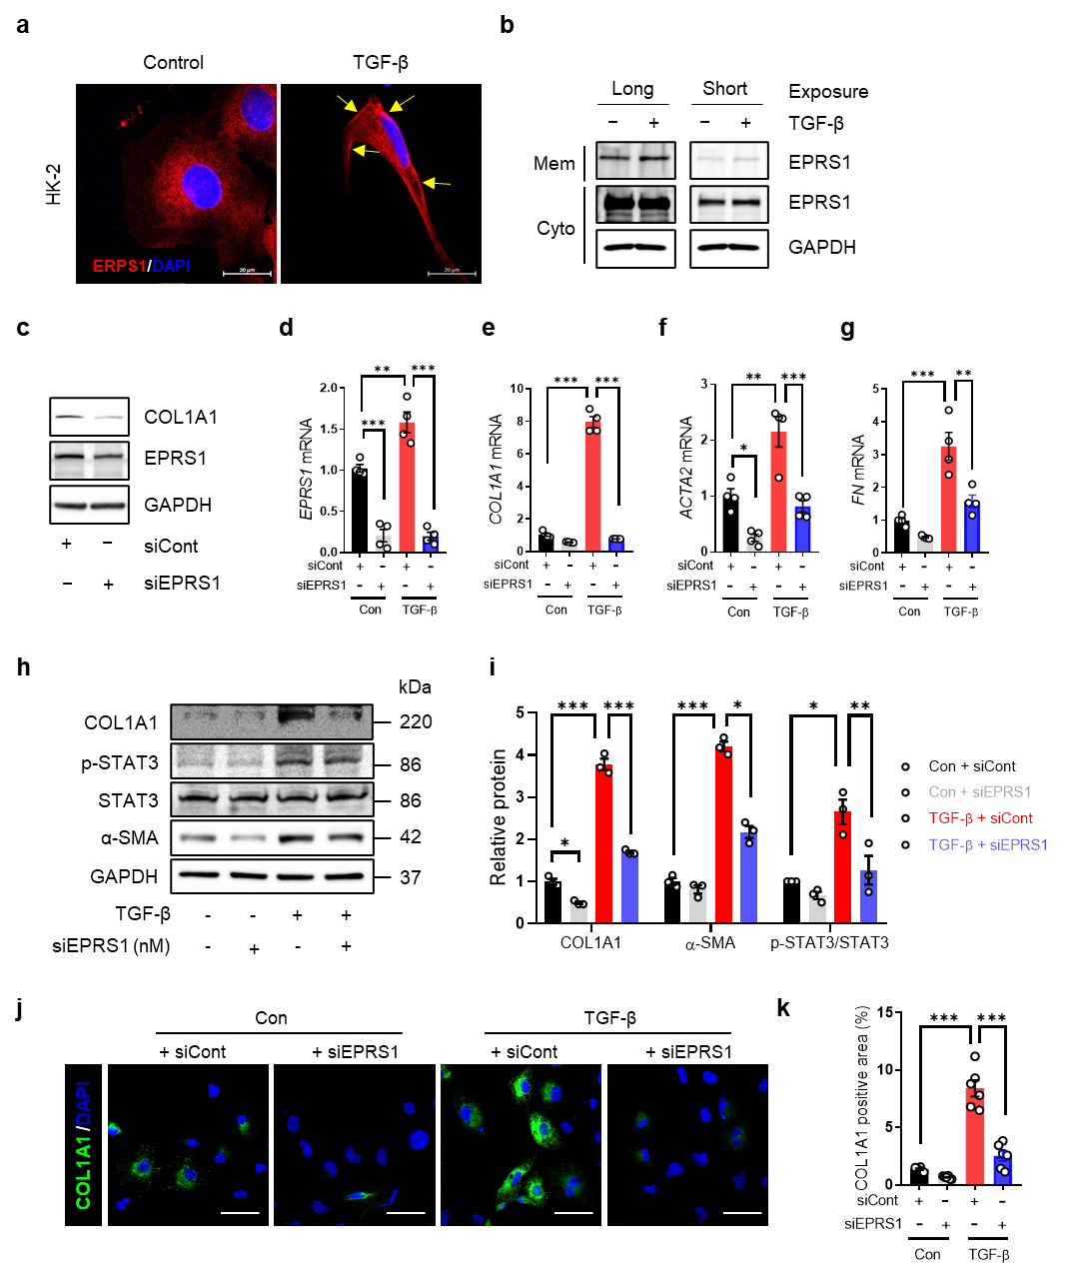
Supplementary Figure 6. Genetic EPRS1 inhibition decreases collagen and STAT3 pathway in HK-2 cells. a Representative confocal image of EPRS1 (red) in TGF-β (10 ng/ml)-induced HK-2 cells for 24 h. Yellow arrow indicates plasma membrane portion. Scale bar = 20 μm. b HK-2 cells were incubated in the absence or presence of TGF-β for 24 h and cells were separated to membrane and cytosol. Mem, membrane fraction; Cyto, cytosolic fraction. c Expression levels of COL1A1 and EPRS1 were determined by Western blot after 24 h of different treatments in siRNA-mediated EPRS1 (siEPRS1) treated HK-2 cells. d-g Representative data show mRNA expression levels of EPRS1 and fibrosis markers (COL1A1, ACTA2, and FN) in siEPRS1 (20 nM)-treated cells under TGF-β (10 ng/ml) treatment condition for 24 h. Gene expression levels were analyzed by qPCR and normalized to GAPDH (n = 4). h, i Representative Western blot (h) and quantitative data (i) of fibrosis marker protein (COL1A1 and α-SMA) and STAT3 associated proteins (p-STAT3 and STAT3) expressed in siERPS1 (20nM)-treated cells under TGF-β (10 ng/ml) treatment condition for 24 h (n = 3). j, k Representative confocal images (j) of COL1A1 in siERPS1 (20nM)-treated cells under TGF-β (10 ng/ml) treatment condition for 24 h. COL1A1 positive area (k) was quantified by ImageJ analysis (n = 6). Data are presented as mean ± standard deviation. Statistical data were analyzed by ANOVA with Tukey post-hoc test. * P < 0.05, ** P < 0.01, and *** P < 0.001.

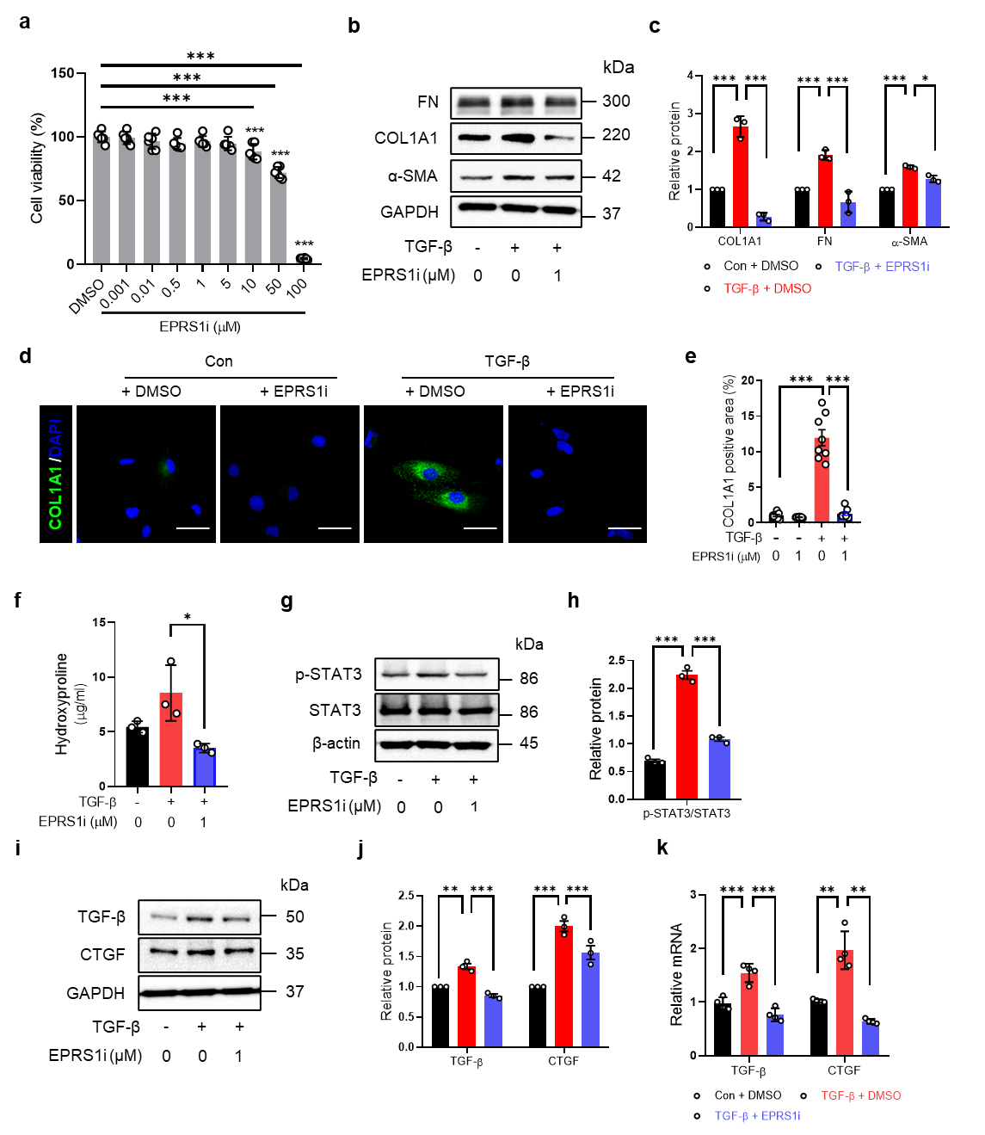

Supplementary Figure 7. Pharmacological EPRS1 inhibition decreases collagen and STAT3 pathway in HK-2 cells. a HK-2 cells were treated with various concentrations of EPRS1i and cell viability was determined by WST-1 assay (n = 6). b, c Representative Western blot (b) and quantitative data (c) of fibrosis marker proteins (FN, COL1A1, and α-SMA) in EPRS1i-treated cells under TGF-β (10 ng/ml) treatment condition for 24 h (n = 3). d, e Representative micrographs (d) and quantitative data (e) show COL1A1 in EPRS1i-treated cells under TGF-β (10 ng/ml) treatment condition for 24 h (n = 6). Scale bars = 50 μm. f Levels of hydroxyproline in cultured cells were quantified using colorimetric assay (n = 3). g, h Representative Western blot (g) and quantitative data (h) of Smad3 associated proteins in EPRS1i-treated cells under TGF-β (10 ng/ml) treatment condition for 24 h (n = 3). i, j Representative Western blot (i) and quantitative data (j) showing effects of EPRS1i on profibrotic marker proteins (TGF-β and CTGF) in EPRS1i-treated cells under TGF-β (10 ng/ml) treatment condition for 24 h (n = 3). k Relative mRNA levels of profibrotic marker genes were analyzed by qPCR (n = 3). Data are presented as mean ± standard deviation. Statistical data were analyzed by ANOVA with Tukey post-hoc test. * P < 0.05, ** P < 0.01, and *** P < 0.001.

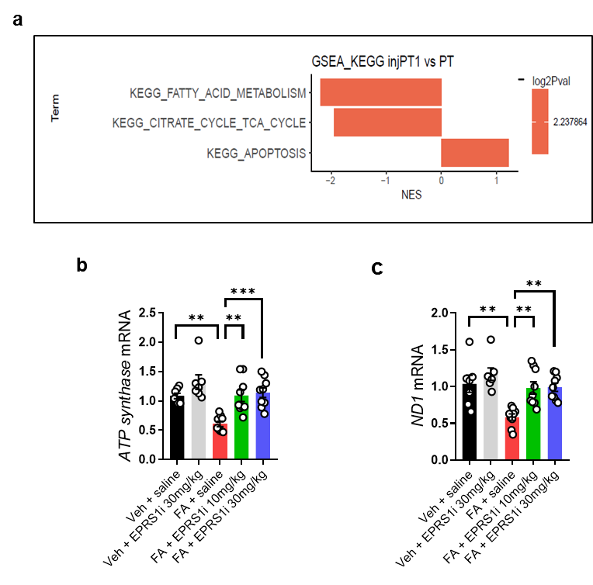

Supplementary Figure 8. Mitochondrial related KEGG pathway in single cell analysis and gene expression of mitochondrial dysfunction markers in EPRS1 inhibitor treated mice. a KEGG pathway of Inj.PT1 and PT (PCT + PST). b, c Quantitative analysis of ATP synthase (b) and ND1 (c) expression normalized to 18S rRNA by qPCR (n = 7-9). Data are presented as mean ± standard deviation. Statistical data were analyzed by ANOVA with Tukey post-hoc test. ** P < 0.01 and *** P < 0.001. Inj.PT1, injured proximal tubule 1; PT, Proximal tubule; PST, proximal straight tubule; PCT, proximal convoluted tubule; ND1, NADH dehydrogenase 1.

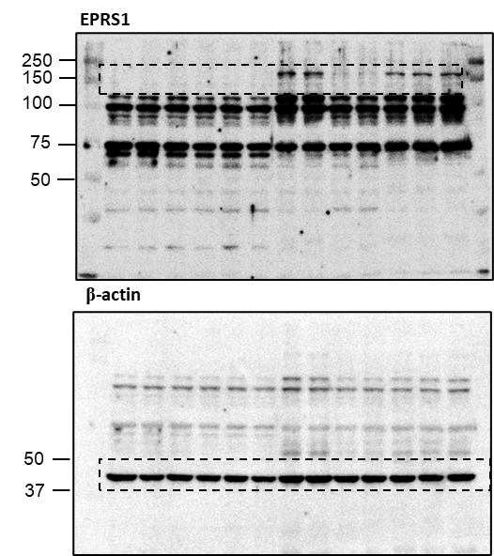

Supplementary Figure 9. Full blots of Figure 1.

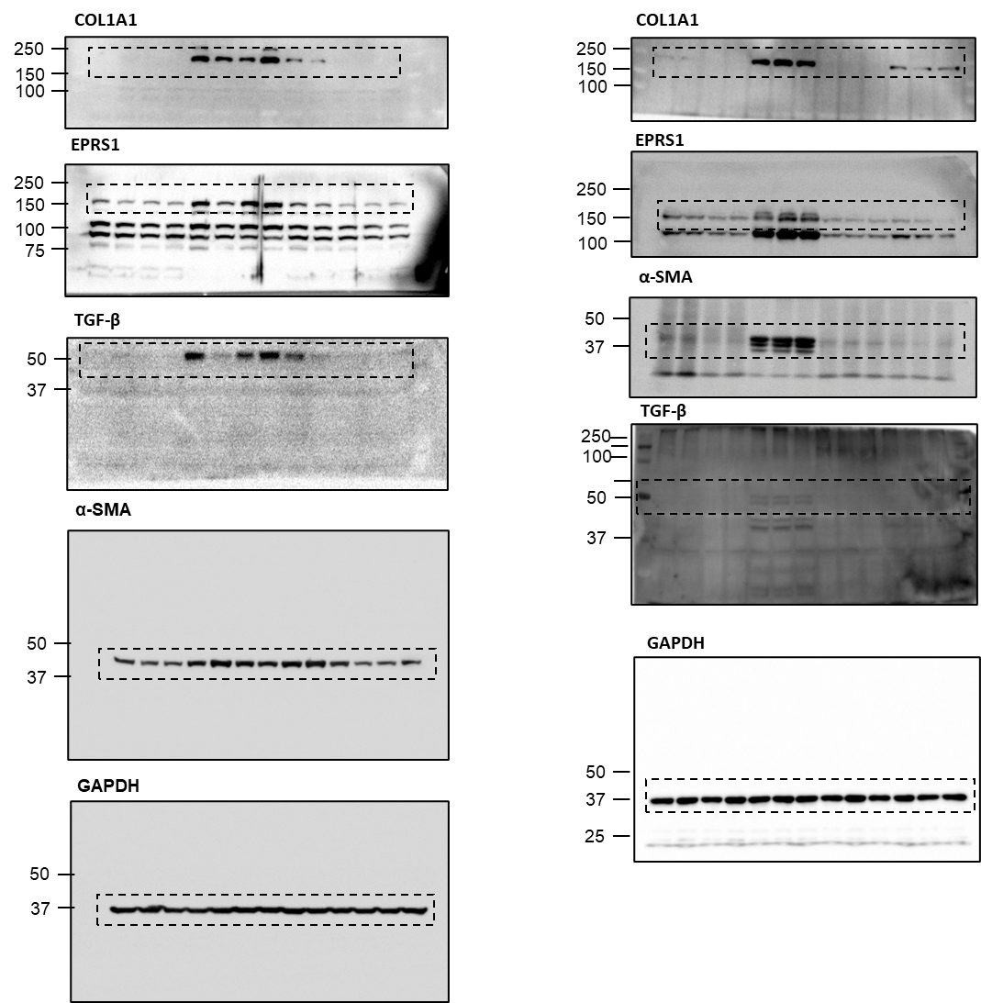

Supplementary Figure 10. Full blots of Figure 4.

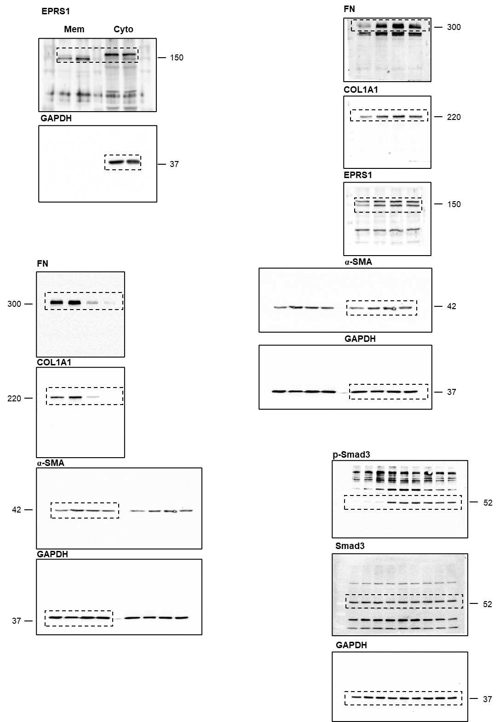
Supplementary Figure 11. Full blots of Figure 6.

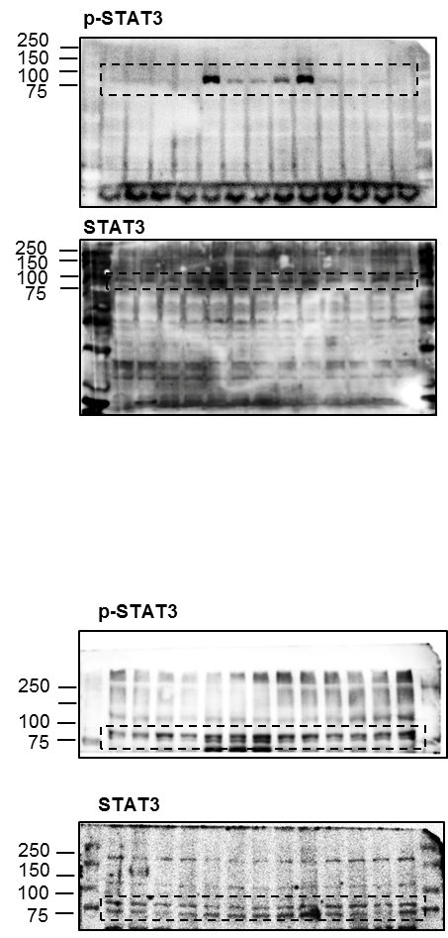

Supplementary Figure 12. Full blots of Figure 7.

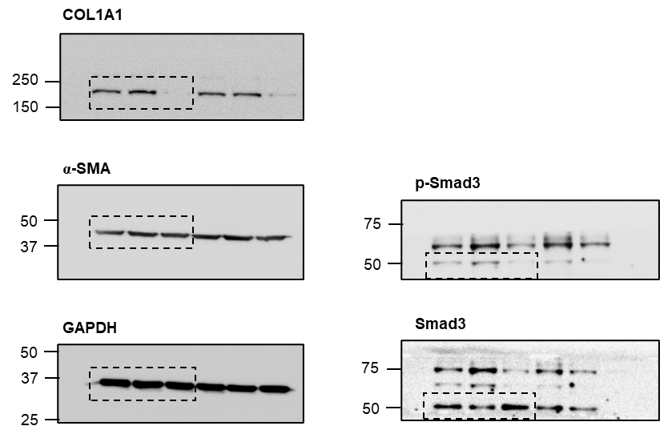
Supplementary Figure 13. Full blots of Supplementary Figure 4.

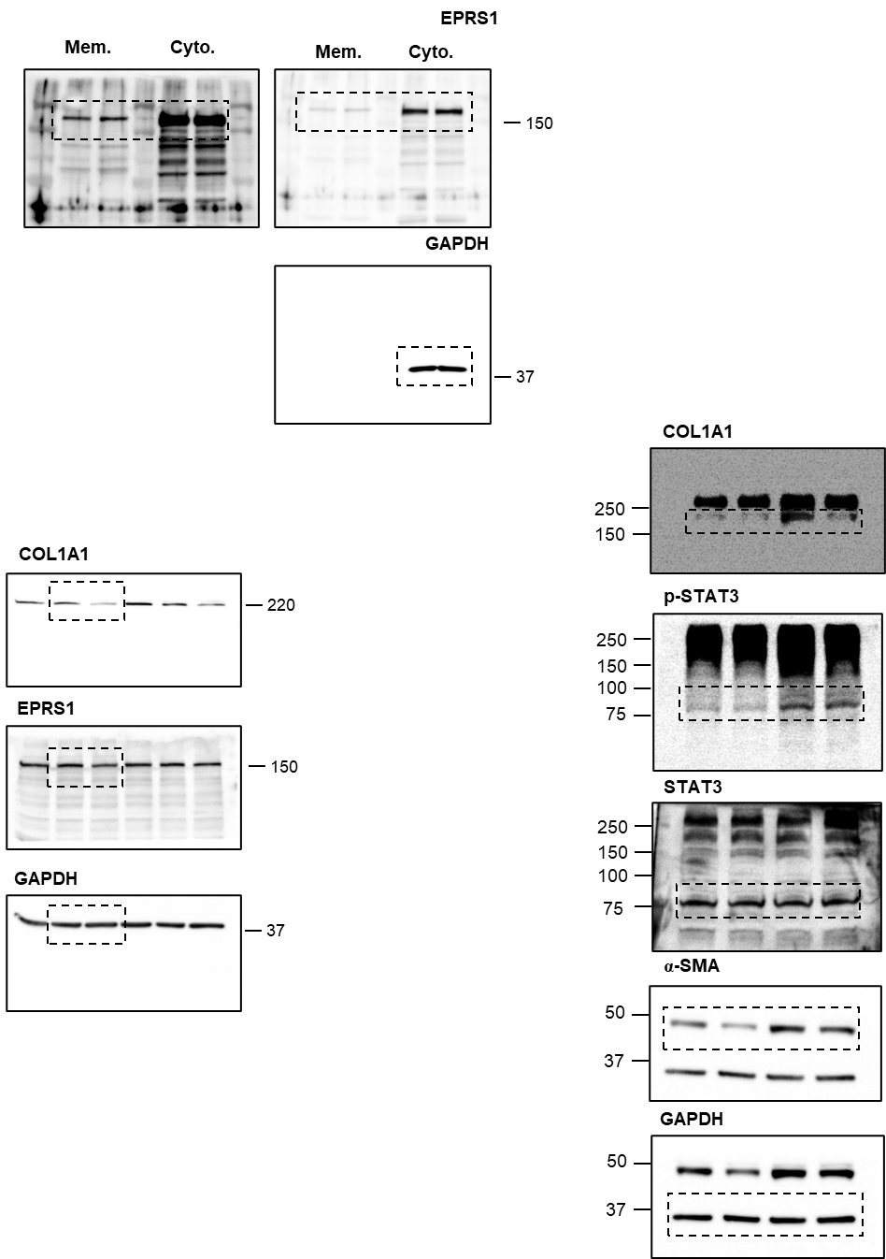
Supplementary Figure 14. Full blots of Supplementary Figure 6.
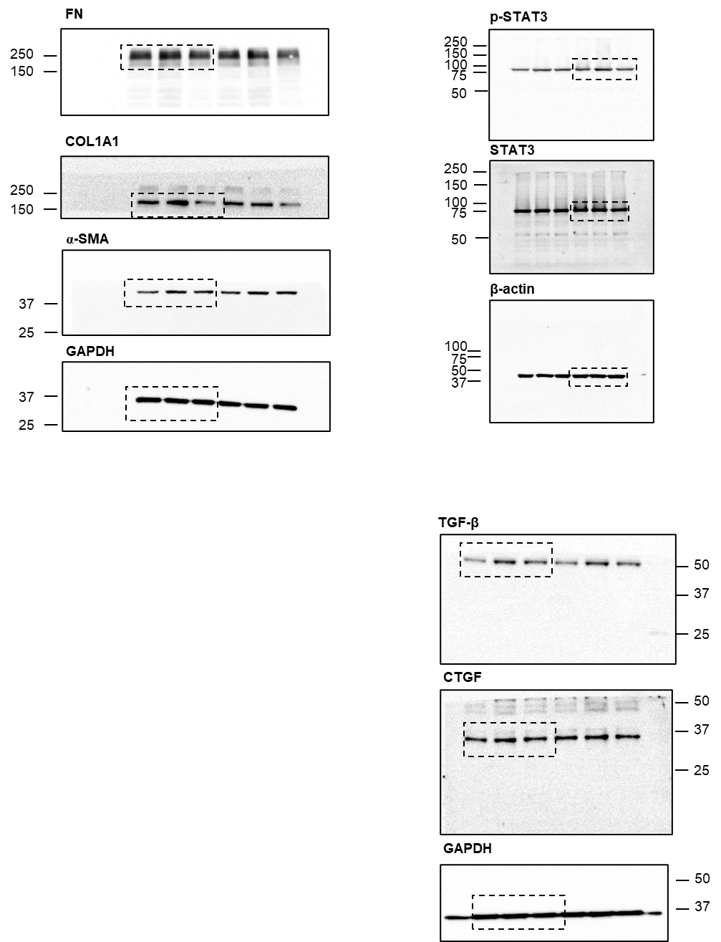
Supplementary Figure 15. Full blots of Supplementary Figure 7.

