Additional files
Appendices
Supplementary Figure 1 (a) Overall survival in all patients according to PSA decrease 30% or not
Supplementary Figure 1 (b) Overall survival in all patients according to PSA decrease 50% or not
Supplementary Figure 1 (c) Overall survival in all patients according to PSA decrease 90% or not
Supplementary Figure 1 (d) The hazard ratios for death associated with a 30%, 50%, and 90% PSA response
Supplementary Figure 2. the cumulative percentage of time to 90% PSA response
Supplementary Figure 3. the cumulative percentage of time to PSA nadir

Supplementary Figure 1.
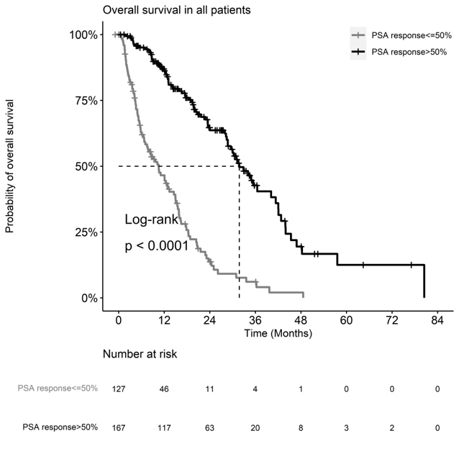
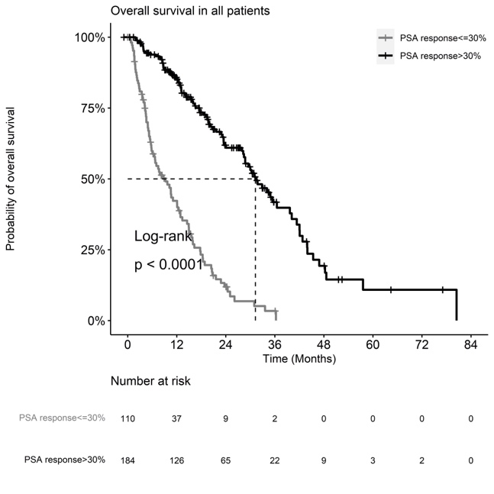
- b.
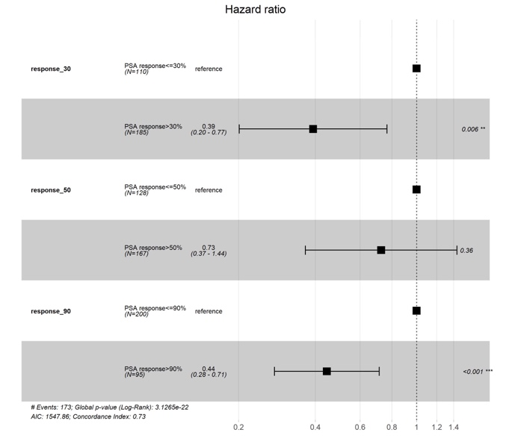
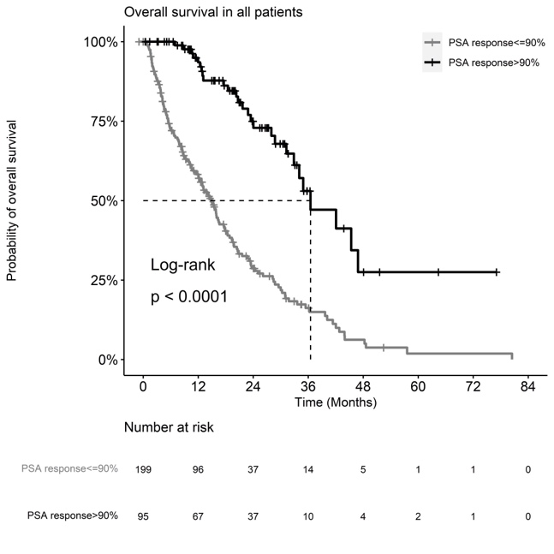
- d.
a. Overall survival in all patients according to PSA decrease 30% or not. b. Overall survival in all patients according to PSA decrease 50% or not. c. Overall survival in all patients according to PSA decrease 90% or not. d. The hazard ratios for death associated with a 30%, 50%, and 90% PSA response.

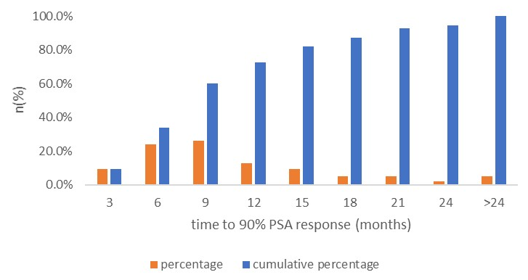
Supplementary Figure 2. the cumulative percentage of time to 90% PSA response

Supplementary Figure 3. the cumulative percentage of time to PSA nadir
