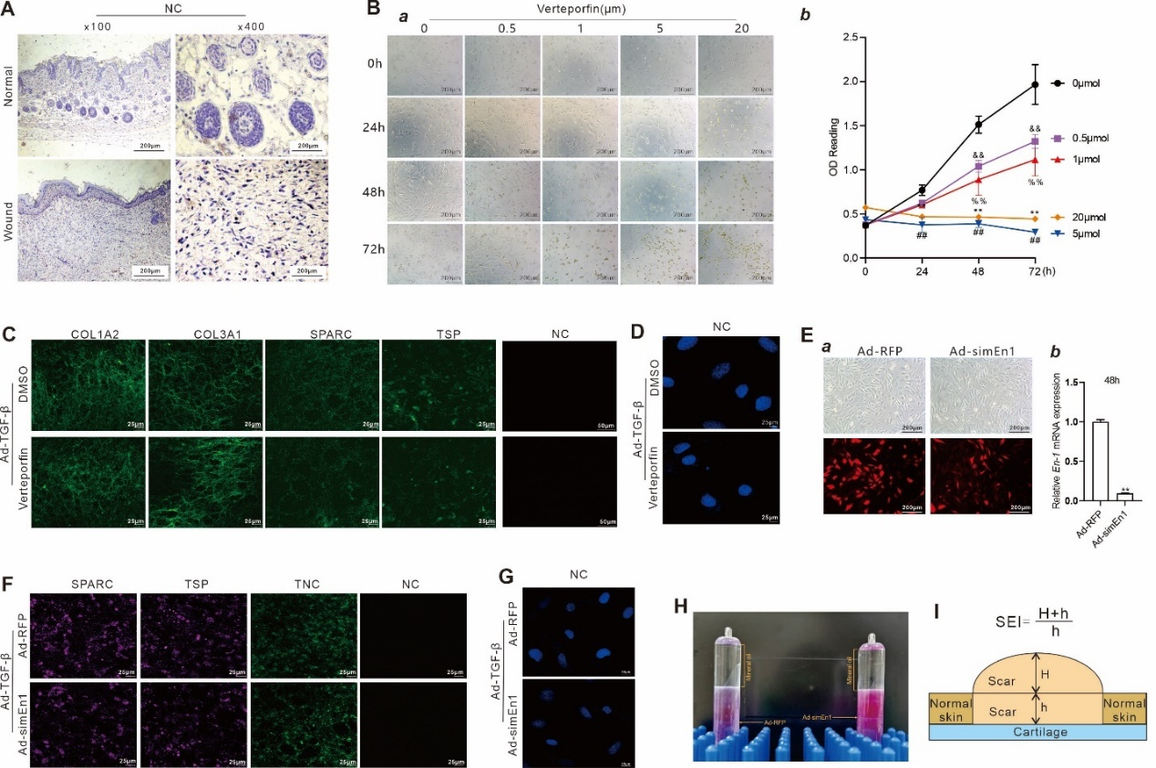

Fig. S1 (A) IHC negative control (NC) of Fig. 1A. (B) Dose-dependent morphological changes and cell survival of Verteporfin treatment in mDFs were observed under bright field at 0, 24, 48, and 72 h after treatment. Representative gross images are shown (a), while WST-1 assay was used to assess mDFs proliferation at 0, 24, 48, and 72 h. “&&” p < 0.01, 0.5µmol Verteporfin group vs DMSO group; “%%” p < 0.01, 1μmol Verteporfin group vs DMSO group; “##” p < 0.01, 5μmol Verteporfin group vs DMSO group; “**” p < 0.01, 20μmol Verteporfin group vs DMSO group (b). (C) IF staining was used to evaluate the expression of COL1A2, COL3A1, SPARC, and TSP in ECM. (D) IF negative control (NC) of Fig. 2D, panel c. (E) mDFs were infected with Ad-RFP or Ad-simEn1, respectively. The fluorescence signals were observed at 36 h after infection (a), and total RNA was isolated for TqPCR analysis of the expression of En-1 in mDFs at 48 h after infection (b). (F) IF staining was used to evaluate the expression of SPARC, TSP and TNC in ECM. (G) IF negative control (NC) of Fig. 3D, panel c. (H) Ad-simEn1 and Ad-RFP were purified by using CsCl gradient ultracentrifugation for the in vivo treatment of the rabbit model of ear skin injury model. (I) Calculation formula and schematic diagram for the determination of scar elevation index used in the study.

