Organohydrogels with Adaptive Surface Wettability Enabled by Polyacrylamide/Polysiloxane Emulsion-based Heteronetworks

Shaohua Wang, Peng Yu, Xinjin Li, Huijuan Lin, Shasha Song, Zengdian Zhao, Yunhui Dong, Xiangye Li*

College of Chemistry and Chemical Engineering, Shandong University of Technology, 266 West Xincun Road, Zibo, 255000, PR China
*Corresponding author: Xiangye Li
E-mail: lixiangye@sdut.edu.cn

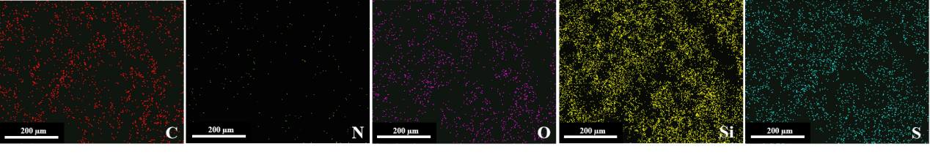
Fig.S1 Elements mapping on the surface of OHG1 after being equilibrated in water.
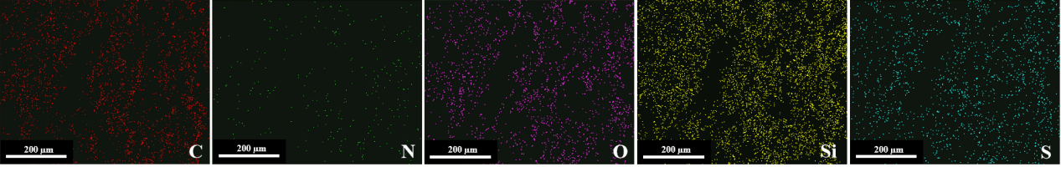
Fig.S2 Elements mapping in the inner section of OHG1 after being equilibrated in water.
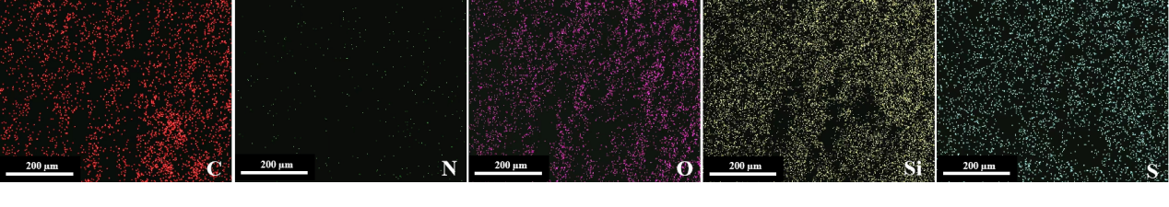
Fig.S3 Elements mapping on the surface of OHG1 after being equilibrated in oil.
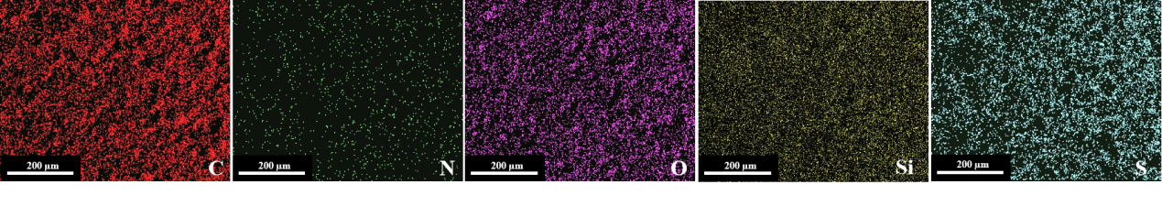
Fig.S4 Elements mapping in the inner section of OHG1 after being equilibrated in oil.

