APPENDIX Circuit’s setting and description.
The final seven movement sections are marked by (*).

Movement Section | Description
1) Waiting for turn  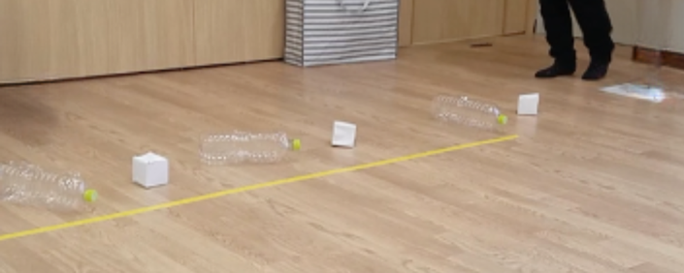 | The child stands at the “start” card and waits for the physiotherapist to tell them “Go!” as an auditory starting signal.
2) Obstacles run  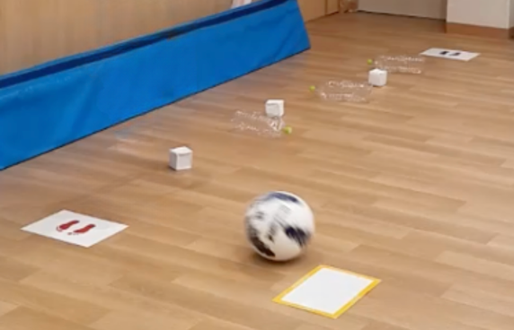 | After the “Go!” signal, the child runs from the “start” card (blue footprints) to the “stop” card (red footprints) which is a distance of two meters long, avoiding the static obstacles placed on the ground. The teacher lightly rolls a ball towards the child as they reach the “stop” card as a moving obstacle which the child also avoids.
3) Ball catch (*)  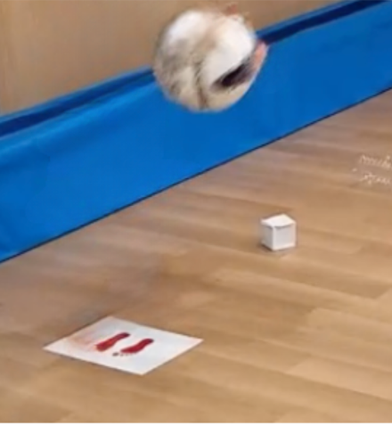 | The child stops on the red footprints and gets ready to catch the ball thrown by the teacher who is standing two meters away (mark on the floor for reference).  Trapping the ball with the body or losing it after catching it deduces checklist item points.  The tester is encouraged to tell the child that they are about to throw the ball, and to aim the ball at the child’s hands.
4) Ball kick (*)  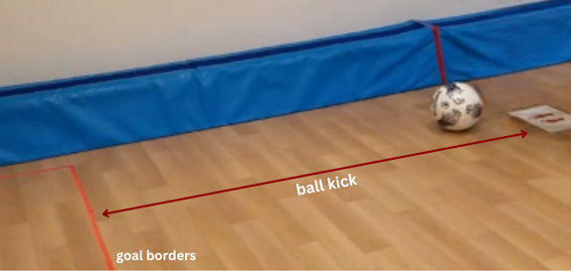 | As the child catches the ball, they then place it on the floor and kick it towards the wall. The goal is marked on the floor using tape and is at two meters, with a width and length of one meter each.  The tester is encouraged to remind the child where the goal is.
5) Walking backwards  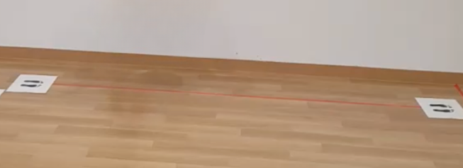 | After that, the child walks to a different card where they are asked to walk backwards facing the front.
6) Wheelbarrow (*)  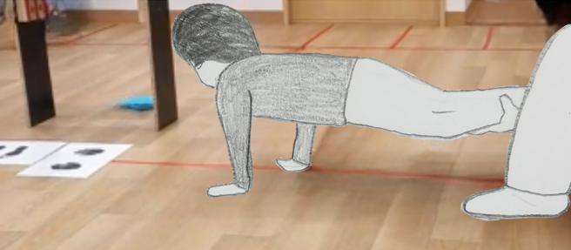 | At the end of “Walking backwards” cards, there are hand-shaped cards indicating to the child to place their hands on the floor. The teacher holds the child’s leg at ankle level and the child does the wheelbarrow walk for two meters. If the child cannot move forwards when their legs are supported on the ankles, the teacher supports the knees or the pelvis instead. In this case, checklist item points will be deduced.
7) Bean bag grasp  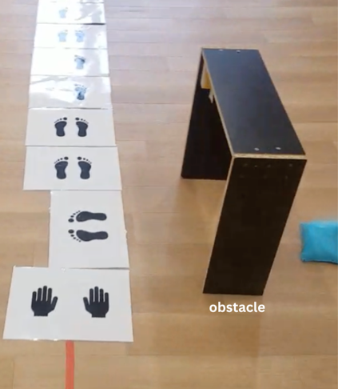 | Then the child grasps two bean bags from under a standing obstacle.
8) Bean bag throw (*)  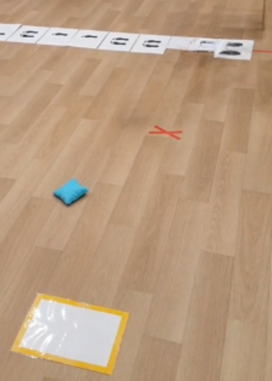 | And then they stand on the foot-shaped card and throw the bean bags one by one to the white and yellow goal on the floor, which is also two meters away. The teacher prompts the child to stay standing on the card, but points are deduced if the child steps out of it. A bean bag is considered to have reached the goal if any parts of it touch the borders of the goal or if it lands on the goal before skimming out of it.  The tester is encouraged to remind the child where the goal is.
9) Jumping on foot shapes (*)  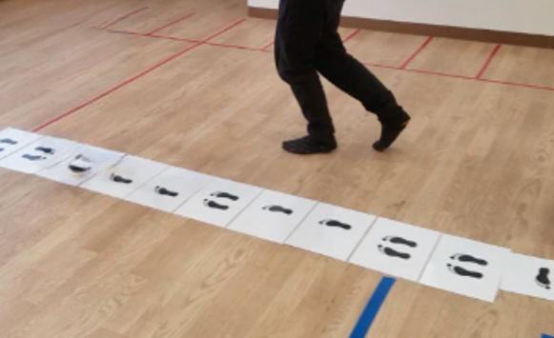 | After “Bean bag throw”, the child jumps on a series of foot shapes combining double leg jumps, single leg jumps on the right foot, single leg jumps on the left foot and rotational jumps. The teacher encourages the child to look at the foot shapes carefully.  The tester is encouraged to remind the child to look carefully at each card. A4 papers and footprints from Microsoft PowerPoint (Version 16.74) are used as these tools were available in the classroom.
10) Long jump (*)  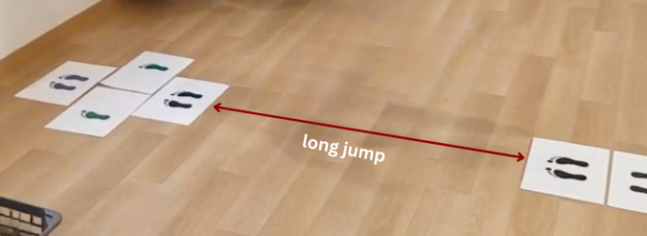 | Then the child jumps horizontally aiming to reach the foot-shaped card placed one meter ahead.  The checklist item “reached the goal or its borders” is assessed based on the heel of the last foot to land, in case landing does not happen on both feet.
11) Balance on one leg (*)  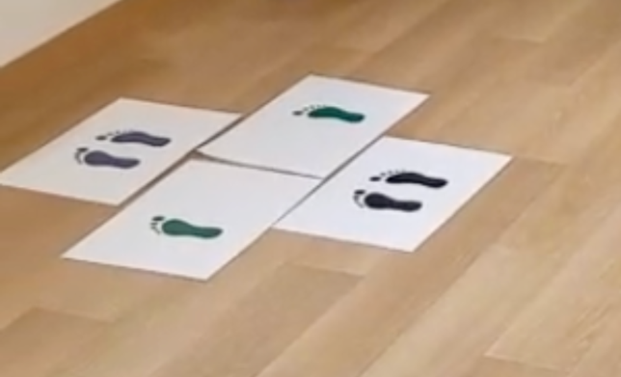 | At the end of the jumping series comes single leg balance exercise where the child balances on both feet separately. They are encouraged to keep their posture stable for as long as possible.  Scoring the time of balancing on one leg is based on motor milestones.  Loosing stability of the trunk deduces checklist item points.  Touching the floor with the other leg or touching the support leg with the other leg, or touching the surroundings with the hands, or change in forefoot or heel positions leads to stopping the timer and therefore the time count for “Balance on one leg”.
12) Rules | “Rules” section is about the use of prompts by the teacher to remind the child of the next step or if the child completely forgot about any steps, and whether the child ignored the rule and created their own.
Note: all items used in the circuit were originally handmade by the first author, except for the empty pet bottles and the soccer ball.

