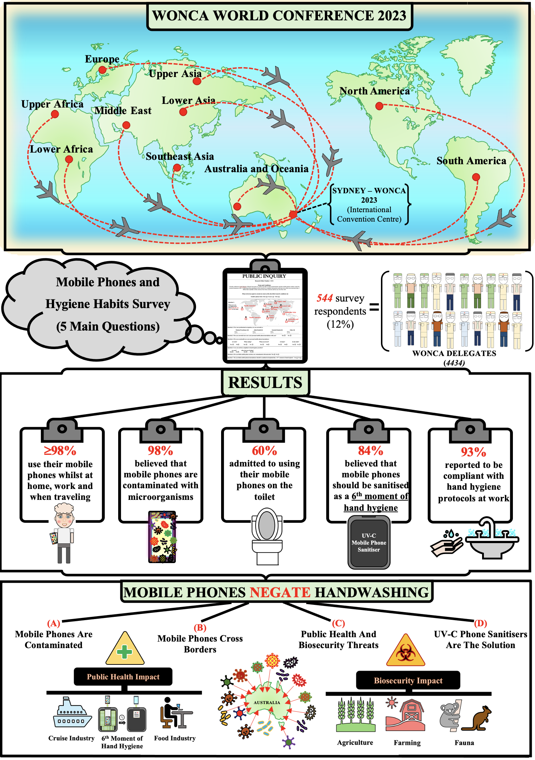

Infographic 1. Overview of study illustrating the 5 key results and associated implications of non-sanitised mobile phones entering Australia.

