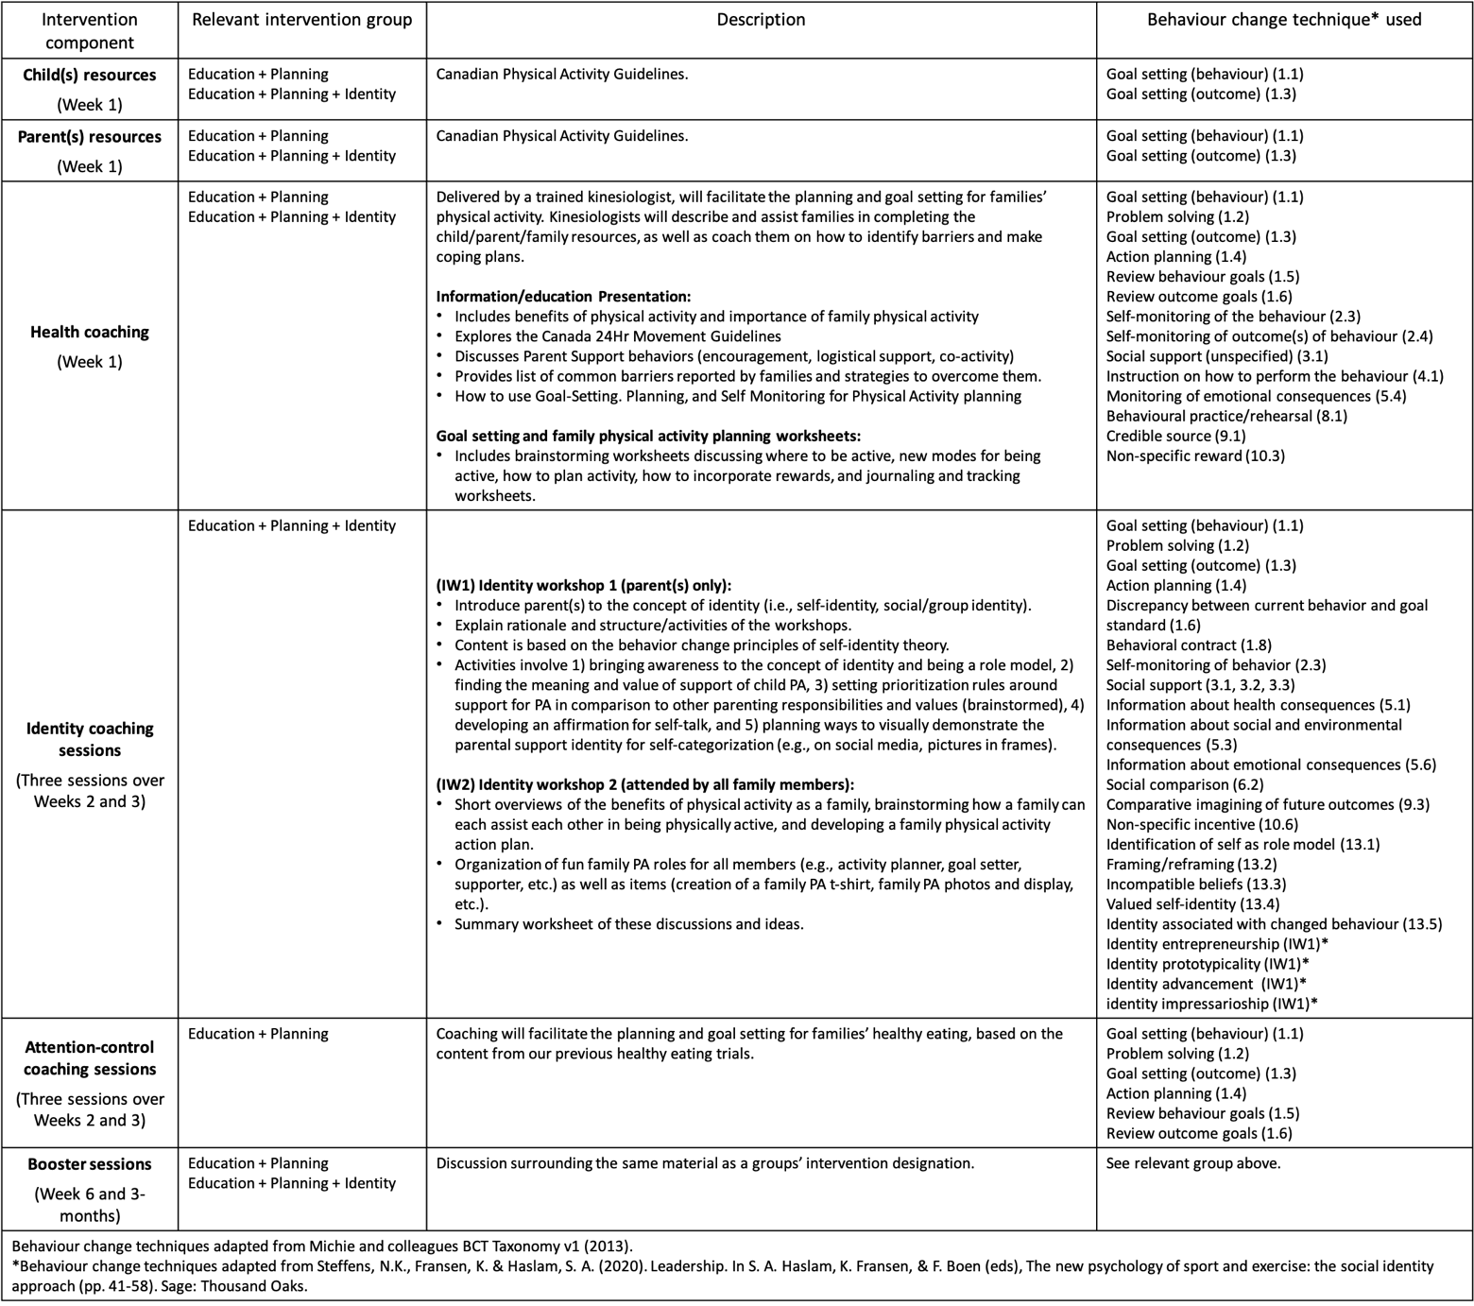
Table 1: Overview of Intervention Content

