Supplementary Tables and Figures

Supplementary Table S1: Four Chromosome-9 MTHFD1L-like Pseudogenes have Significant Differential Expression in TNBC
Gene Name | Chromosome | Log₂ Fold Change | FDR-Corrected p-value
* MTHFD1L | 6 | 1.47 | 1.07 x 10⁻¹⁸
FO082814.1 | 9 | -8.05 | 5.82 x 10⁻⁵⁷
FP325317.2 | 9 | -5.93 | 3.77 x 10⁻³⁷
AL591379.1 | 9 | -2.73 | 6.75 x 10⁻¹⁹
AL445665.1 | 9 | -2.25 | 1.21 x 10⁻⁰⁷
* MTHFD1L: Methylenetetrahydrofolate Dehydrogenase (NADP+ dependent) 1 like, FDR: False Discovery Rate.

Supplementary Table S2: Detailed SPIA Pathway Modulation Results
 | Name | * pSize | NDE | pNDE | tA | pPERT | pG | pGFdr | pGFWER | Status | SourceDB
1 | integrin signaling pathway | 37 | 28 | 0.591409 | -58.1885 | 5.00E-06 | 4.06E-05 | 0.006984 | 0.006984 | Inhibited | BioCarta
2 | PLK1 signaling events | 44 | 42 | 0.00054 | 307.6052 | 5.00E-06 | 5.60E-08 | 8.62E-06 | 8.62E-06 | Activated | NCI
* pSize: pathway size (number of genes), NDE: Number of Differentially Expressed genes in pathway, pNDE: probability to observe at least NDE genes on the pathway using a hypergeometric model, tA: total perturbation Accumulation in the pathway (also indicates modulation directionality), pPERT: the probability to observe a total accumulation more extreme than tA only by chance, pG: the p-value obtained by combining pNDE and pPERT, pGFdr: False Discovery Rate adjusted global p-value, pGFWER: Bonferroni adjusted global p-value, SourceDB: Source Database of pathway, PLK1: Polo-Like Kinase 1, NCI: National Cancer Institute.
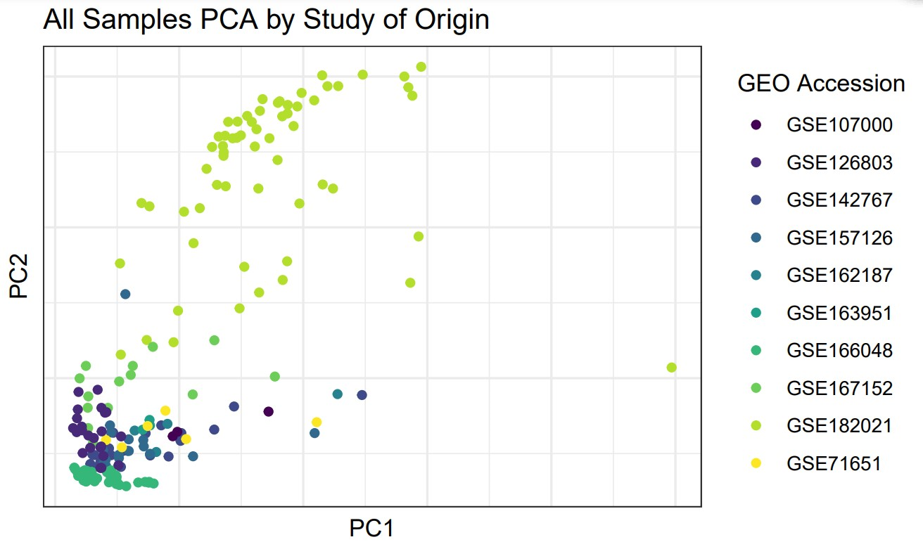
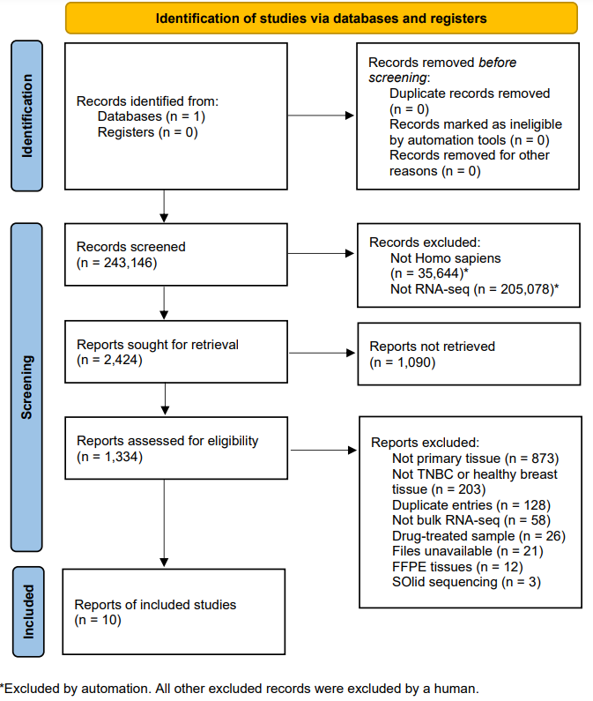
A) B)

Supplementary Figure S1: Overview of Studies and Samples Included in Analysis. A) The PRISMA flow diagram for transparent reporting of joint secondary analyses. This chart indicates the search procedures we used to obtain and define our dataset. B) Principal component analysis (PCA) chart showing relatedness of samples, colored by study of origin.

Supplementary Table S3: Tree-based Biomarker Prediction Results for All 196 Samples
Prediction | Reference
0 | 1
0 | 70 | 2
1 | 0 | 85

Supplementary Table S4: Tree-based Biomarker Prediction Summary Statistics for All 196 Samples
Label | Value
Accuracy | 0.987261146
95% Confidence Interval | 0.954742240094415 - 0.998453525367956
No Information Rate | 0.554140127
* P-Value [Accuracy > NIR] | 4.51E-37
Kappa | 0.974291796
Mcnemar's Test P-Value | 0.479500122
Sensitivity | 1
Specificity | 0.977011494
Positive Predictive Value | 0.972222222
Negative Predictive Value | 1
Precision | 0.972222222
Recall | 1
F1 (harmonic mean of precision and recall) | 0.985915493
Prevalence | 0.445859873
Detection Rate | 0.445859873
Detection Prevalence | 0.458598726
Balanced Accuracy | 0.988505747
'Positive' Class | 0
* NIR: No Information Rate.

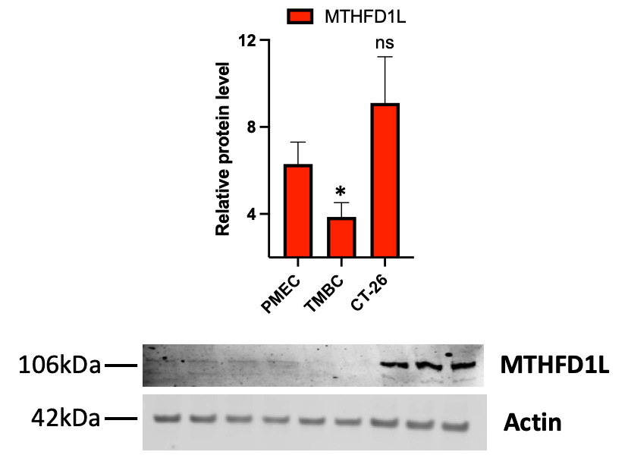
TNBC
Supplementary Figure S2: Triple-Negative Breast Cancer Shows Dysregulation of MTHFD1L. Immunoblot for MTHFD1L was done from lysates of primary human breast epithelial cells (PMEC), triple negative breast cancer cell line MDA-MB-231 (TNBC) and colorectal cancer cell line (CT-26). A student’s t-test was used to compare each group against the control primary cells. Asterisks denote the level of significance observed, as follows: *, P ≤ 0.05; “ns” indicates not significant.

