SYNTHESIS OF NOVEL ACETAMIDOBENZANILIDES DERIVATIVES AS POTENCIAL TRYPANOCIDAL AGENTS

Valentín I. Ortellado, Carlos U. Molfesa Kaczoruk, Lucio A. Guaymas, Ezequiel Parisi, Guido G. Fraga, Gisela C. Muscia, Fernanda M. Frank, Ana M. Bruno, Agustín Ponzinibbio, and Leandro D. Sasiambarrena

Supplementary Information

1.1 ADME predictions of compounds 5

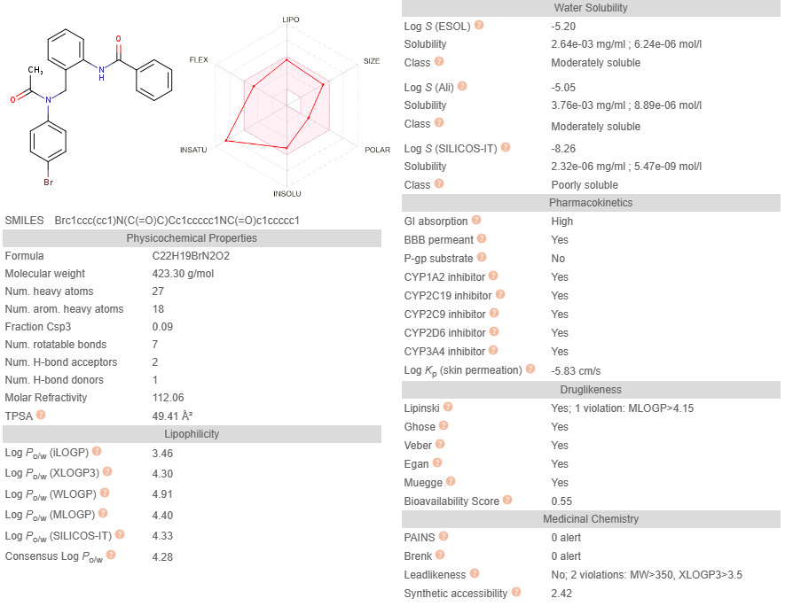

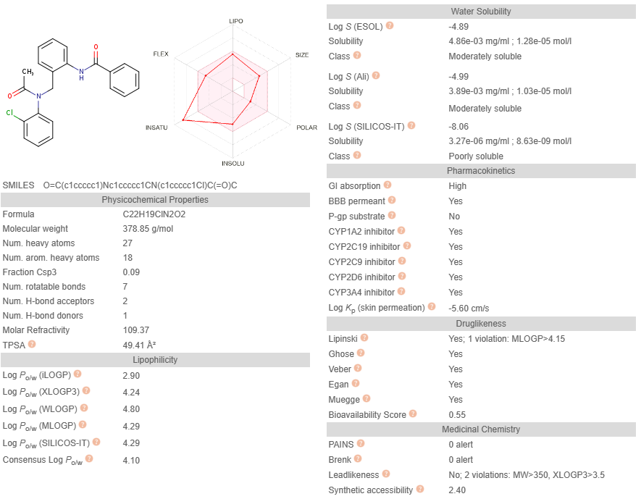
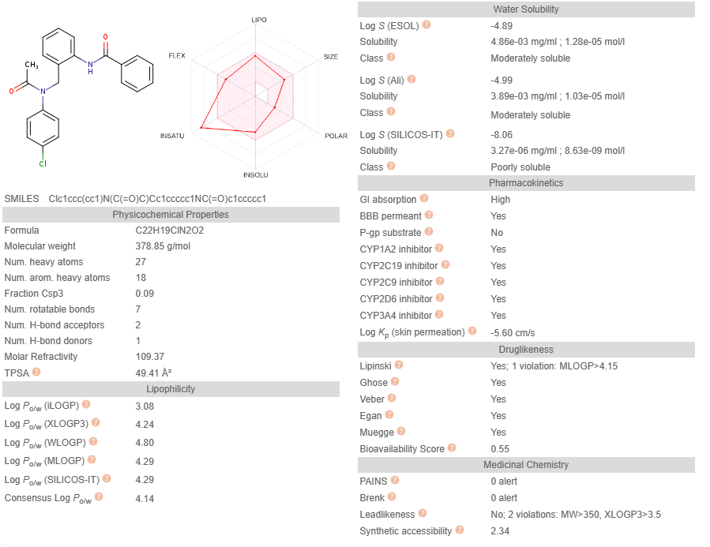
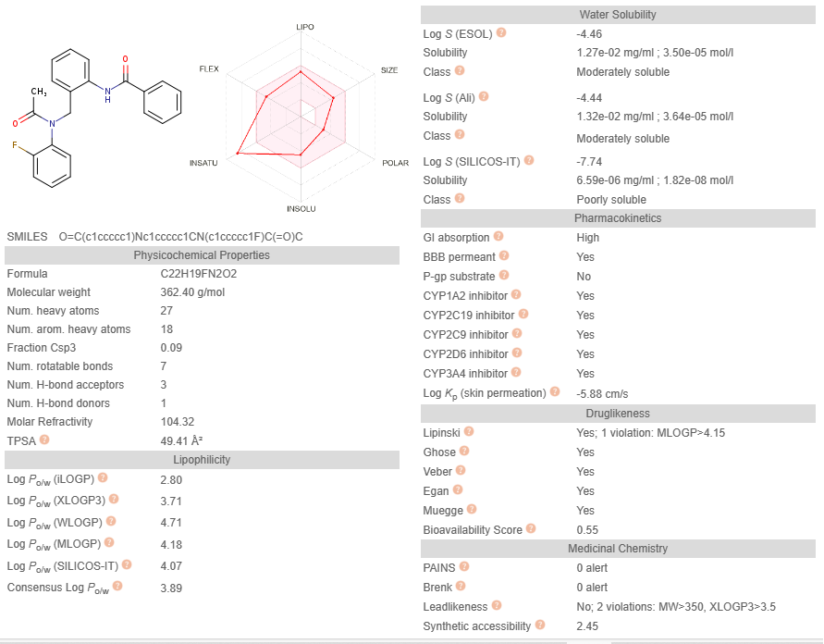
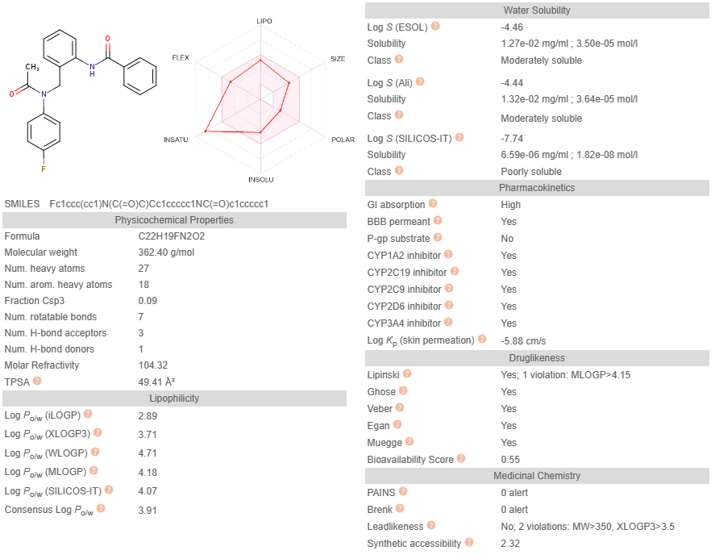
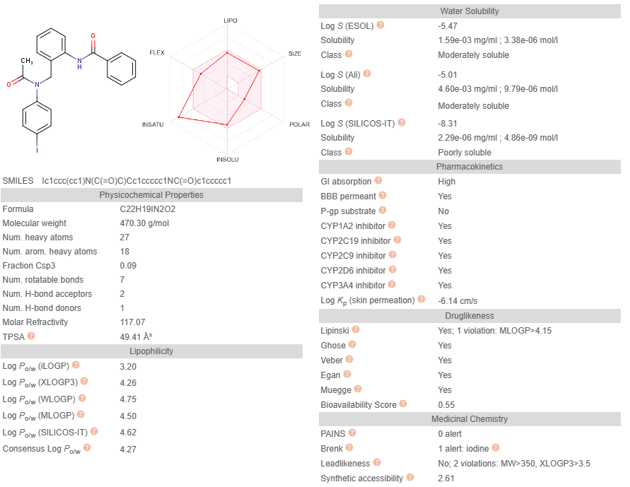
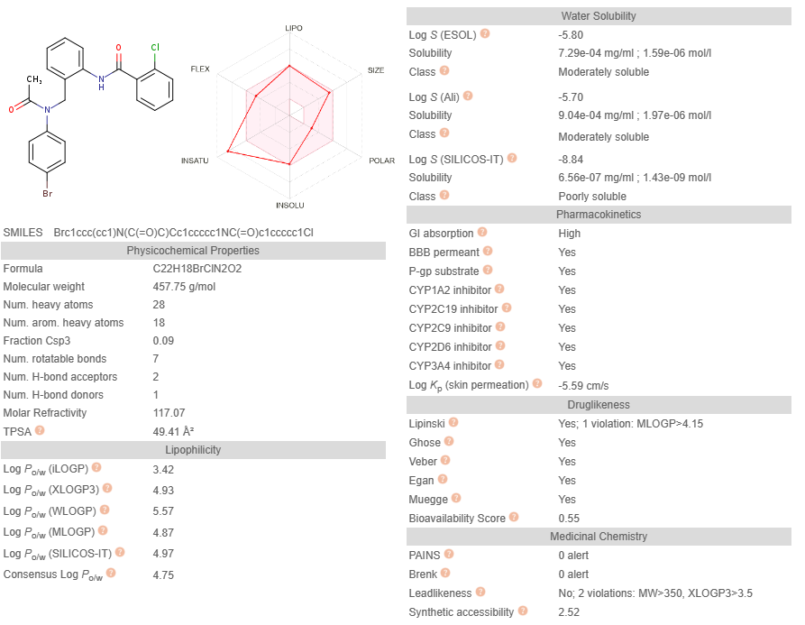
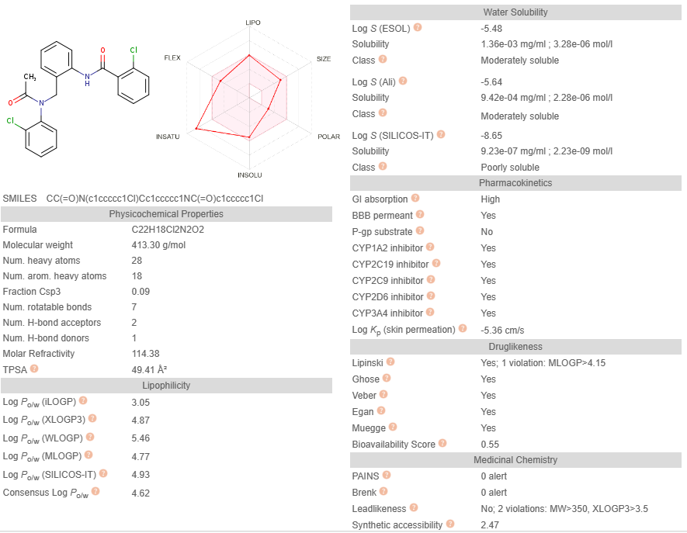

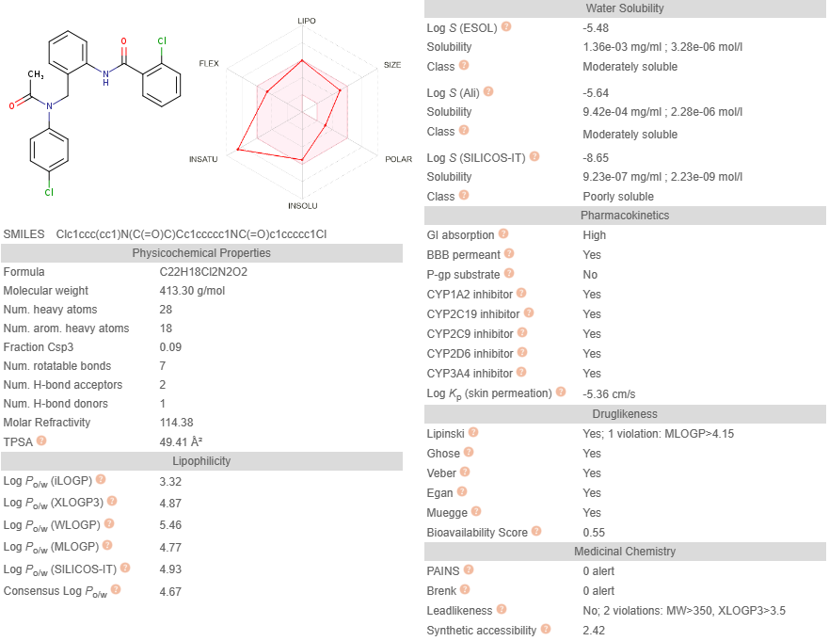

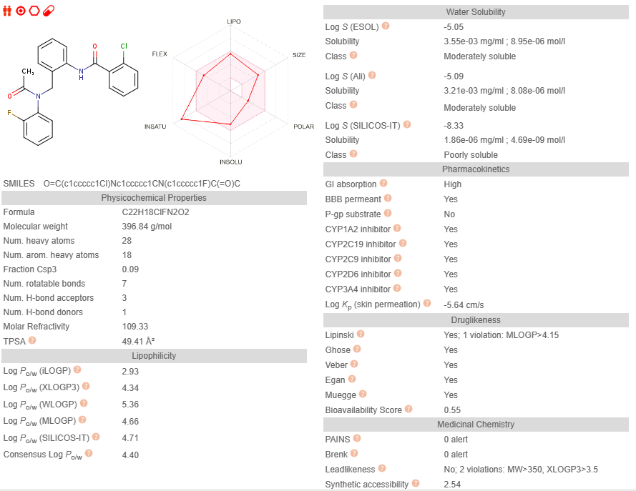
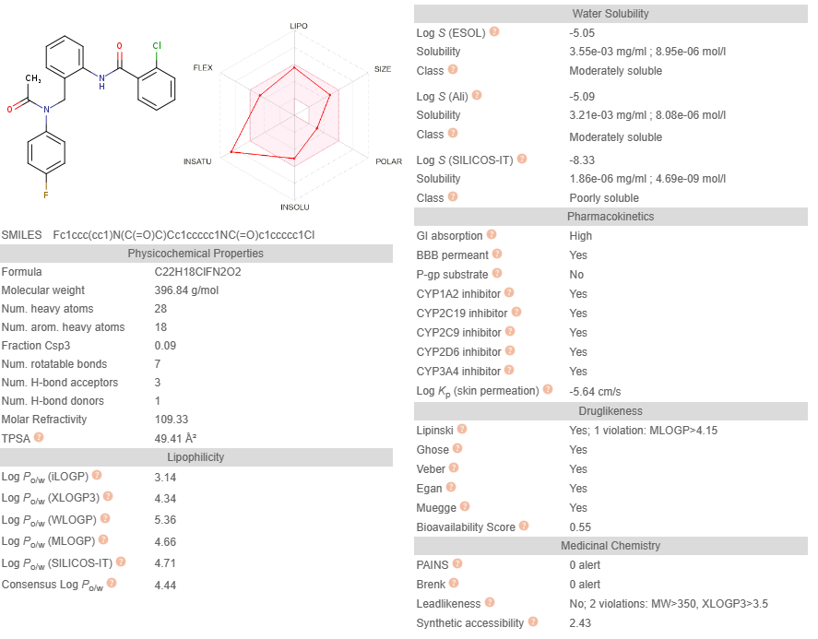

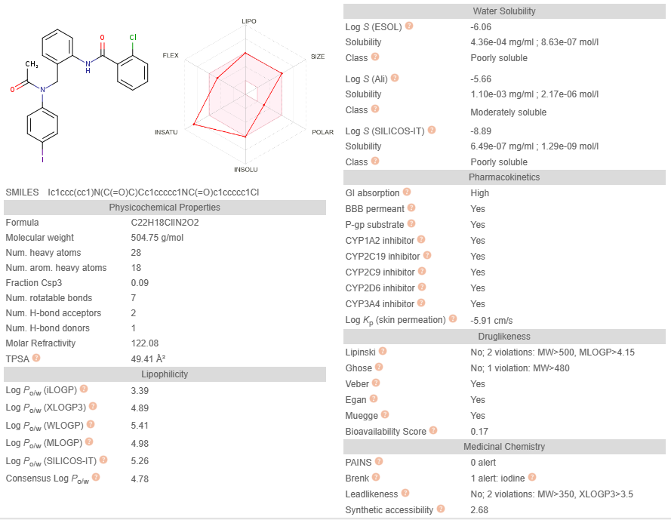
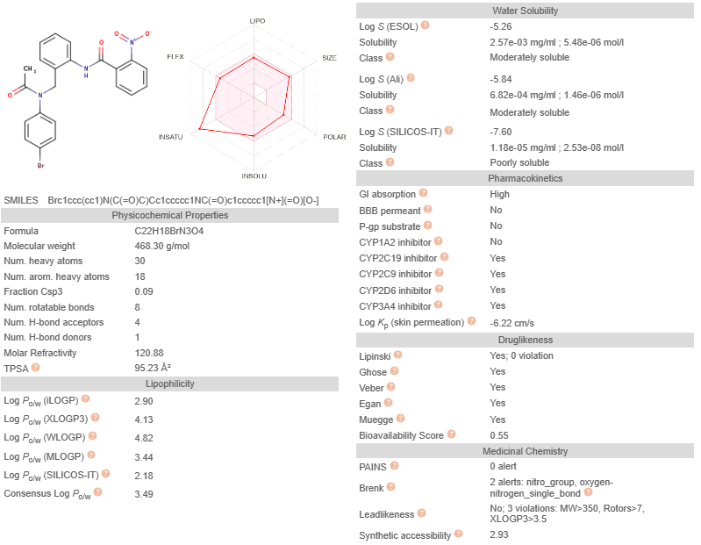
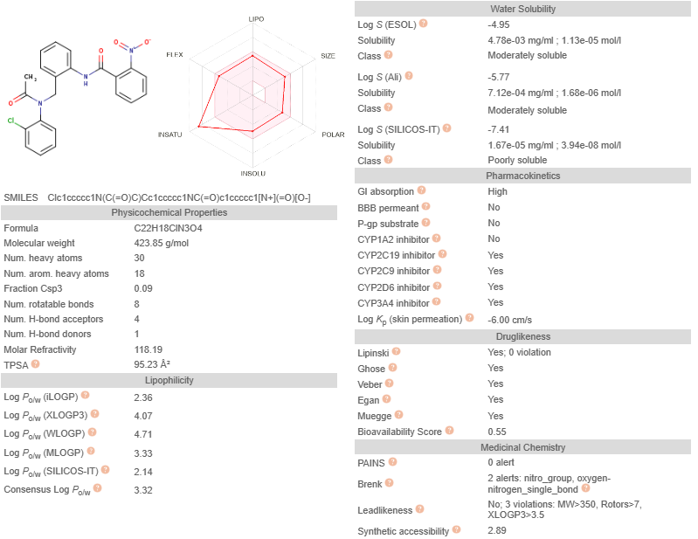

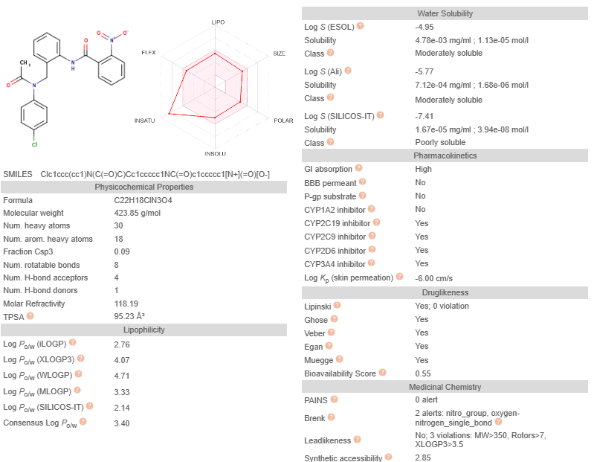
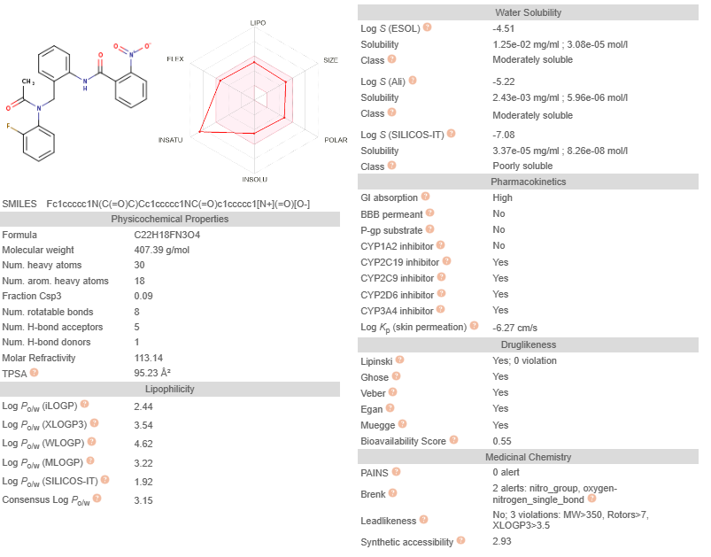
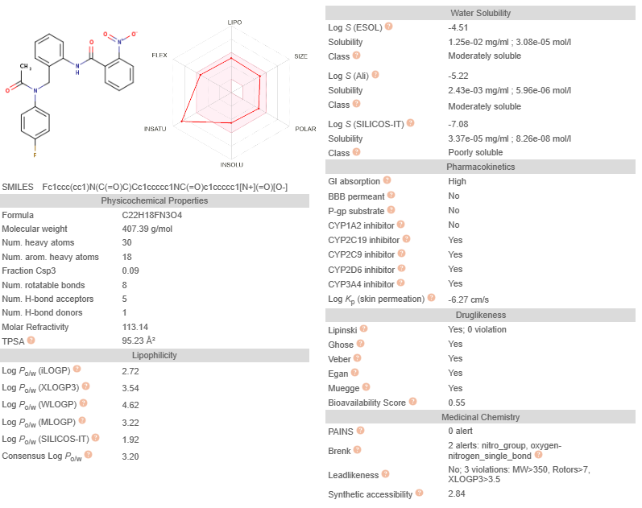
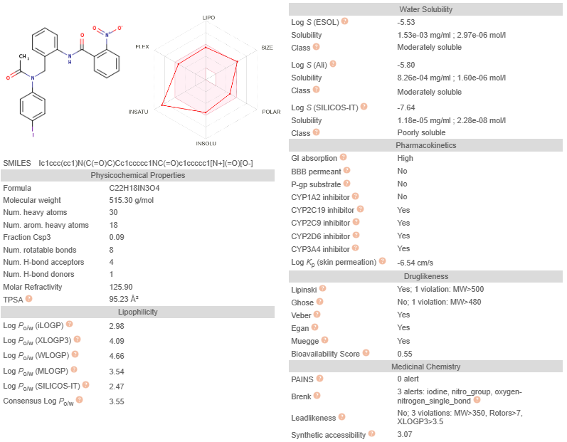

1.2. Table: most significant ADME predictions

R²: | H |  |  |  |  |  | o-Cl
R¹: | p-Br | o-Cl | p-Cl | o-F | p-F | p-I | p-Br | o-Cl | p-Cl | o-F | p-F | p-I
 | a | b | c | d | e | f | g | h | i | j | k | l
Physicochemical properties
Molecular weight | 423.30 | 378.85 | 378.85 | 362.40 | 362.40 | 470.30 | 457.75 | 413.30 | 413.30 | 396.84 | 396.84 | 504.75
Num. H-bond acceptors | 2 | 2 | 2 | 2 | 2 | 2 | 2 | 2 | 2 | 2 | 2 | 2
Num. H-bond donors | 1 | 1 | 1 | 1 | 1 | 1 | 1 | 1 | 1 | 1 | 1 | 1
Molar refractivity | 112.06 | 109.37 | 109.37 | 104.32 | 104.32 | 117.07 | 117.07 | 114.38 | 114.38 | 109.33 | 109.33 | 122.08
TPSA (Å2) | 49.41 | 49.41 | 49.14 | 49.41 | 49.41 | 49.41 | 49.41 | 49.41 | 49.41 | 49.41 | 49.41 | 49.41
Lipophilicity
Consensus log Po/w | 4.28 | 4.10 | 4.14 | 3.89 | 3.91 | 4.27 | 4.75 | 4.62 | 4.67 | 4.40 | 4.44 | 4.78
Druglikeness
Lipinski's rule | Yes* | Yes* | Yes* | Yes* | Yes* | Yes* | Yes* | Yes* | Yes* | Yes* | Yes* | No
Ghose | Yes | Yes | Yes | Yes | Yes | Yes | Yes | Yes | Yes | Yes | Yes | No
Veber | Yes | Yes | Yes | Yes | Yes | Yes | Yes | Yes | Yes | Yes | Yes | Yes
Egan | Yes | Yes | Yes | Yes | Yes | Yes | Yes | Yes | Yes | Yes | Yes | Yes
Muegge | Yes | Yes | Yes | Yes | Yes | Yes | Yes | Yes | Yes | Yes | Yes | Yes
Bioavailability score | 0.55 | 0.55 | 0.55 | 0.55 | 0.55 | 0.55 | 0.55 | 0.55 | 0.55 | 0.55 | 0.55 | 0.55
Pharmacokinetics
GI absorption | High | High | High | High | High | High | High | High | High | High | High | High
BBB permeant | Yes | Yes | Yes | Yes | Yes | Yes | Yes | Yes | Yes | Yes | Yes | Yes
P-gp substrate | No | No | No | No | No | No | Yes | Yes | Yes | Yes | Yes | Yes
CYP1A2 inhibitor | Yes | Yes | Yes | Yes | Yes | Yes | Yes | Yes | Yes | Yes | Yes | Yes
CYP2C19 inhibitor | Yes | Yes | Yes | Yes | Yes | Yes | Yes | Yes | Yes | Yes | Yes | Yes
(-)Log Kp (cm/s) | 5.83 | 5.60 | 5.60 | 5.88 | 5.88 | 6.14 | 5.59 | 5.36 | 5.36 | 5.64 | 5.64 | 5.91
Medicinal Chemistry
PAINS | 0 alert | 0 alert | 0 alert | 0 alert | 0 alert | 0 alert | 0 alert | 0 alert | 0 alert | 0 alert | 0 alert | 0 alert
Brenk | 0 alert | 0 alert | 0 alert | 0 alert | 0 alert | 1 alert | 0 alert | 0 alert | 0 alert | 0 alert | 0 alert | 1 alert
Synthetic accessibility | 2.42 | 2.40 | 2.34 | 2.45 | 2.32 | 2.61 | 2.62 | 2.47 | 2.42 | 2.54 | 2.43 | 2.68
 | * 1 Violation: MLOGP>4.15 |  |  |  |  |  | * 1 Violation: MLOGP>4.15

R²: | o-NO₂
R¹: | p-Br | o-Cl | p-Cl | o-F | p-F | p-I
 | m | n | o | p | q | r
Physicochemical properties
Molecular weight | 468.30 | 423.85 | 423.85 | 407.39 | 407.39 | 515.30
Num. H-bond acceptors | 2 | 2 | 2 | 2 | 2 | 2
Num. H-bond donors | 1 | 1 | 1 | 1 | 1 | 1
Molar refractivity | 120.88 | 118.19 | 118.19 | 113.14 | 113.14 | 125.90
TPSA (Å2) | 95.23 | 95.23 | 95.23 | 95.23 | 95.23 | 95.23
Lipophilicity
Consensus log Po/w | 3.49 | 3.32 | 3.40 | 3.15 | 3.20 | 3.55
Druglikeness
Lipinski's rule | Yes | Yes | Yes | Yes | Yes | Yes*
Ghose | Yes | Yes | Yes | Yes | Yes | No
Veber | Yes | Yes | Yes | Yes | Yes | Yes
Egan | Yes | Yes | Yes | Yes | Yes | Yes
Muegge | Yes | Yes | Yes | Yes | Yes | Yes
Bioavailability score | 0.55 | 0.55 | 0.55 | 0.55 | 0.55 | 0.55
Pharmacokinetics
GI absorption | High | High | High | High | High | High
BBB permeant | No | No | No | No | No | No
P-gp substrate | No | No | No | No | No | No
CYP1A2 inhibitor | No | No | No | No | No | No
CYP2C19 inhibitor | Yes | Yes | Yes | Yes | Yes | Yes
(-)Log Kp (cm/s) | 6.22 | 6.00 | 6.00 | 6.27 | 6.27 | 6.54
Medicinal Chemistry
PAINS | 0 alert | 0 alert | 0 alert | 0 alert | 0 alert | 0 alert
Brenk | 2 alerts | 2 alerts | 2 alerts | 2 alerts | 2 alerts | 3 alerts
Synthetic accessibility | 2.93 | 2.89 | 2.85 | 2.93 | 2.84 | 3.07
 | * 1 Violation: MW>500

2. ¹HNMR and ¹³CNMR spectra

2.1. N-(2-(N’-(4-bromophenyl)acetamidomethyl)benzanilide 5a

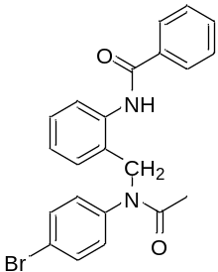
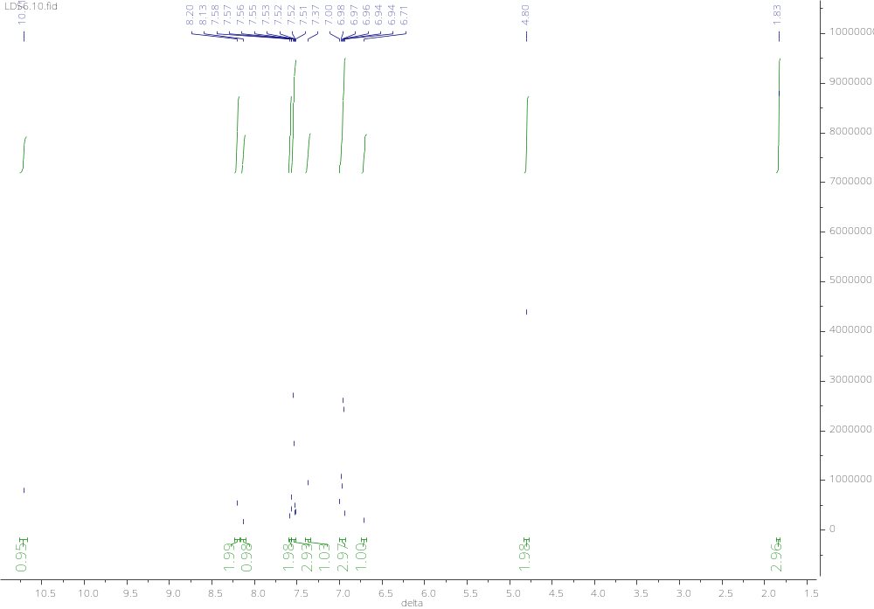

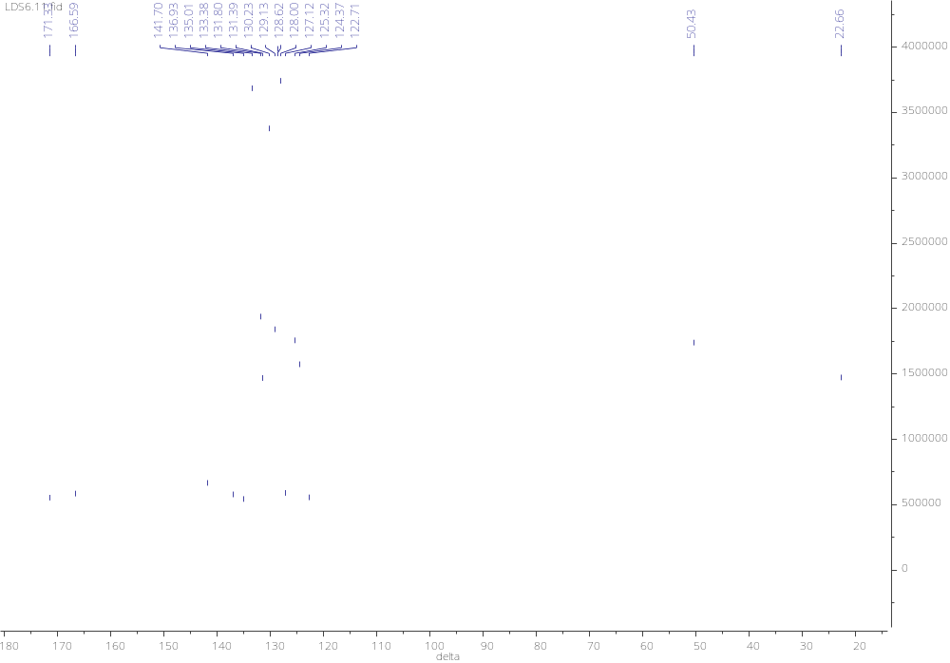
2.2. N-(2-(N’-(2-chlorophenyl)acetamidomethyl)benzanilide 5b

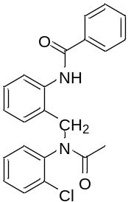

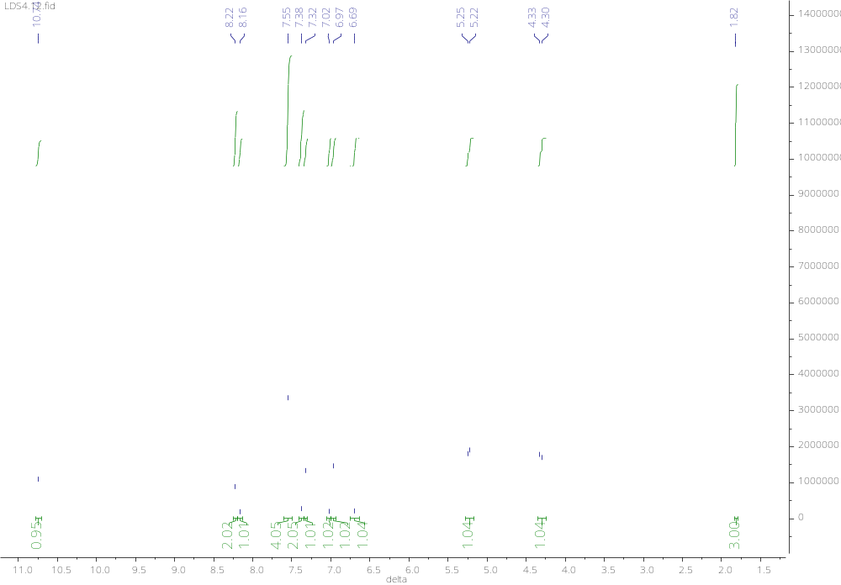

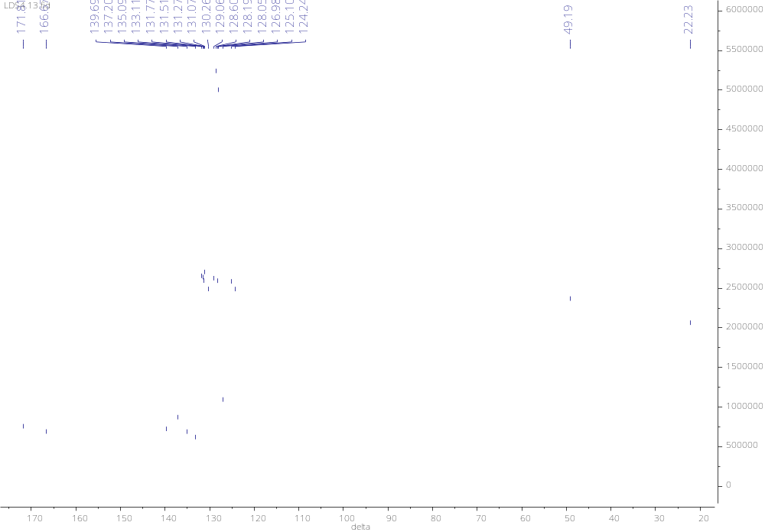
2.3. N-(2-(N’-(4-chlorophenyl)acetamidomethyl)benzanilide 5c

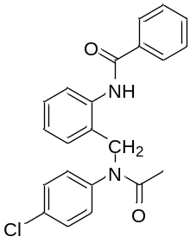

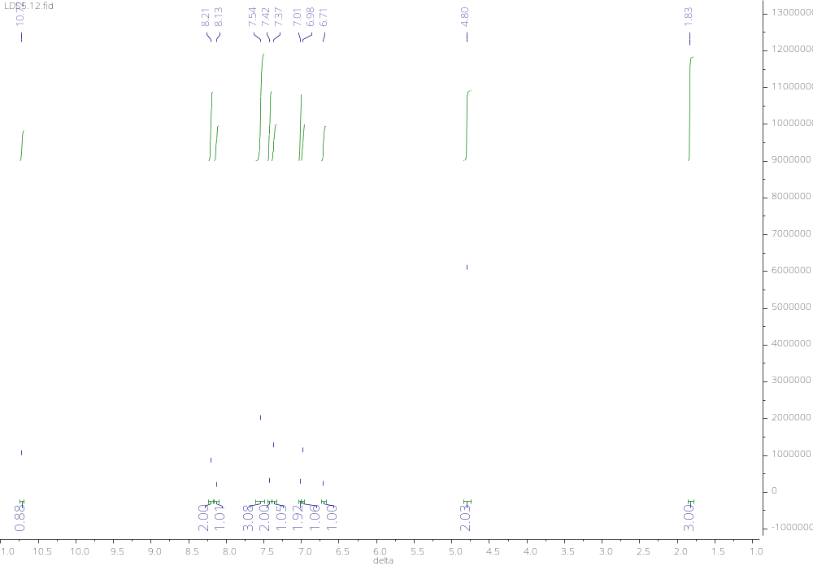

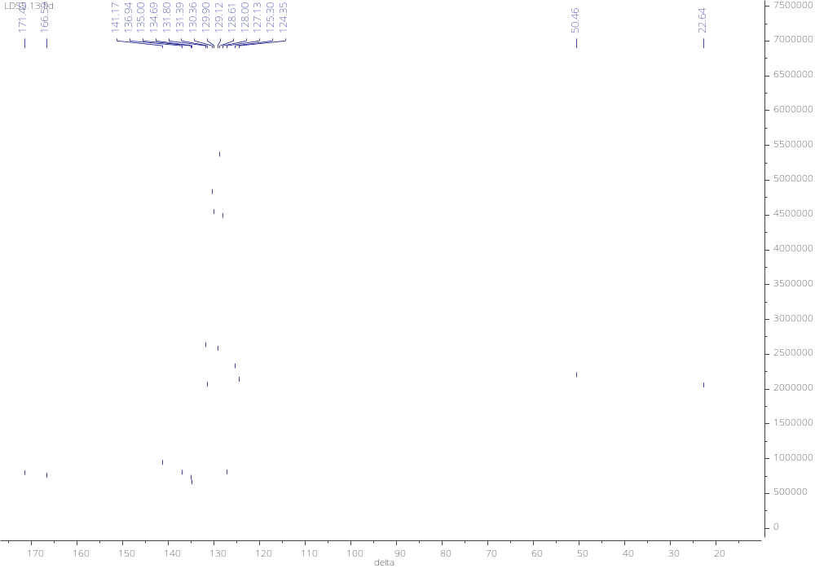
2.4. N-(2-(N’-(2-fluorophenyl)acetamidomethyl)benzanilide 5d

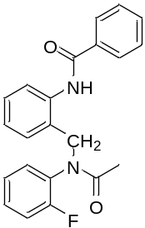

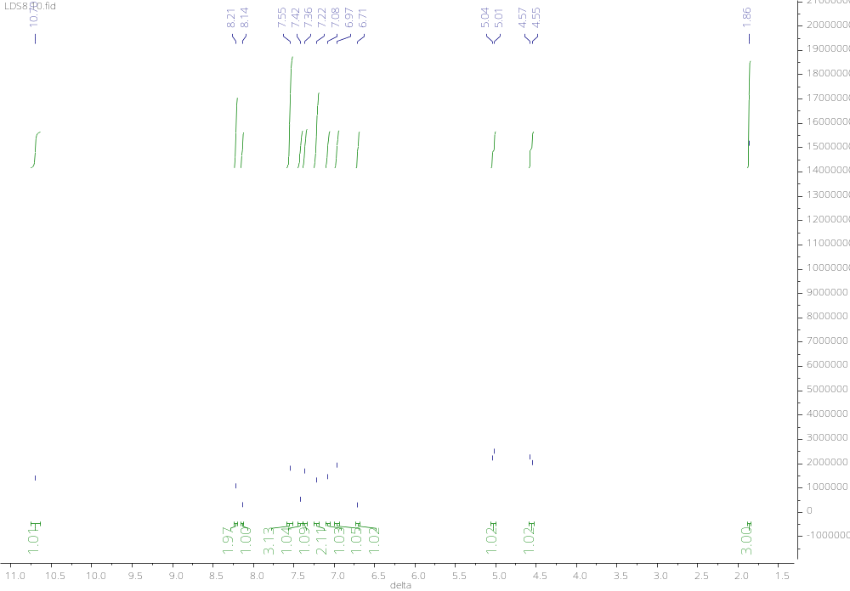

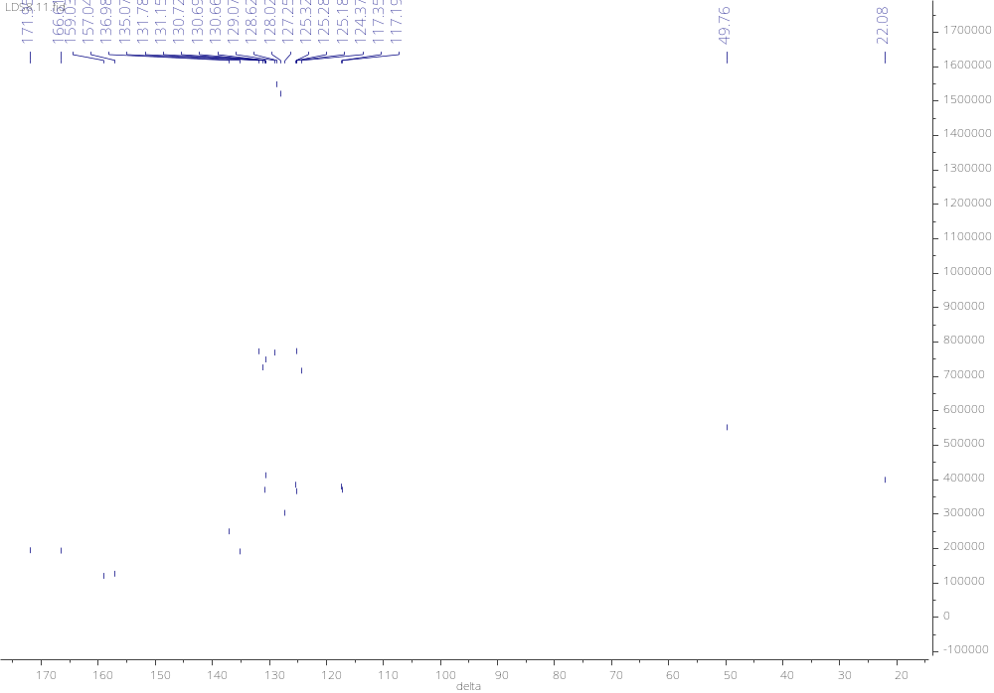
2.5. N-(2-(N’-(4-fluorophenyl)acetamidomethyl)benzanilide 5e

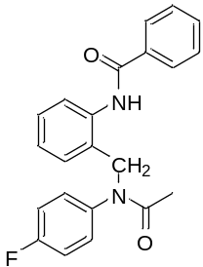

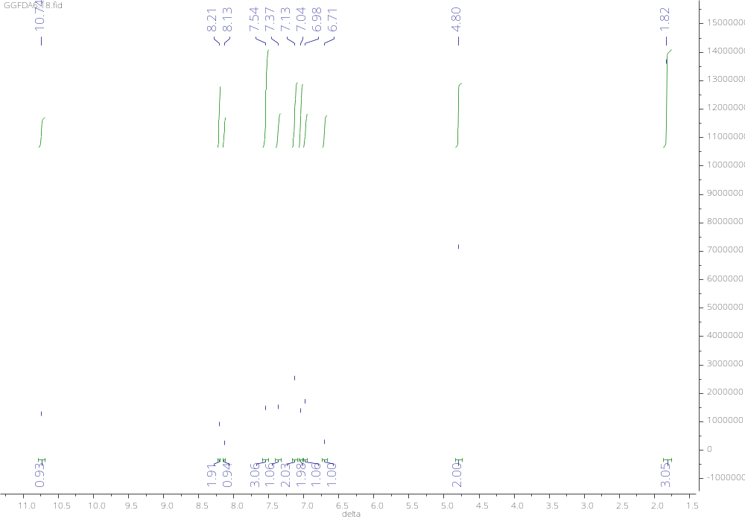

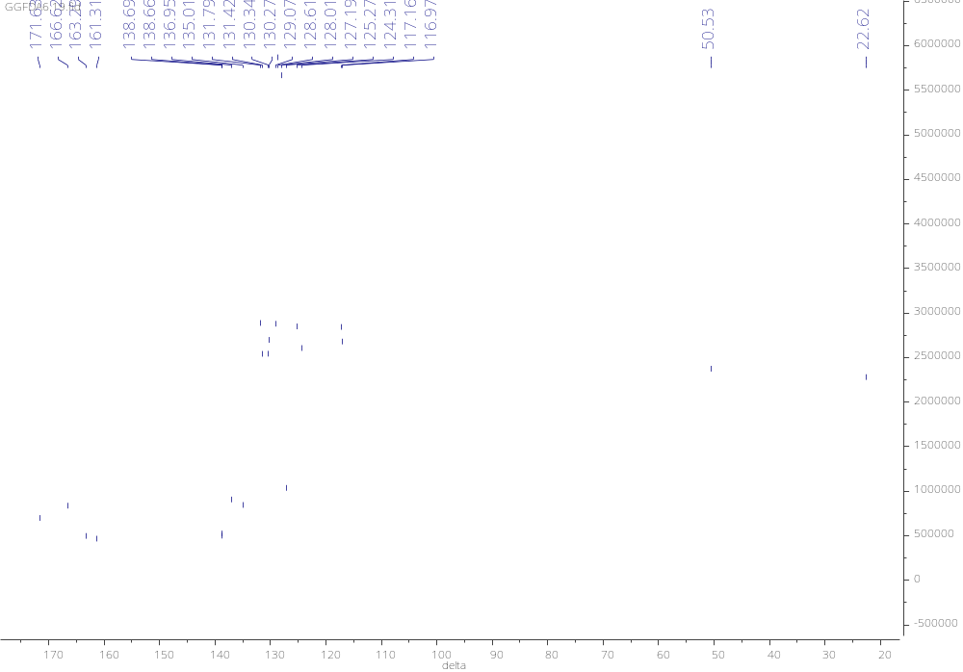
2.6. N-(2-(N’-(4-yodophenyl)acetamidomethyl)benzanilide 5f

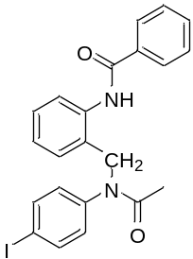

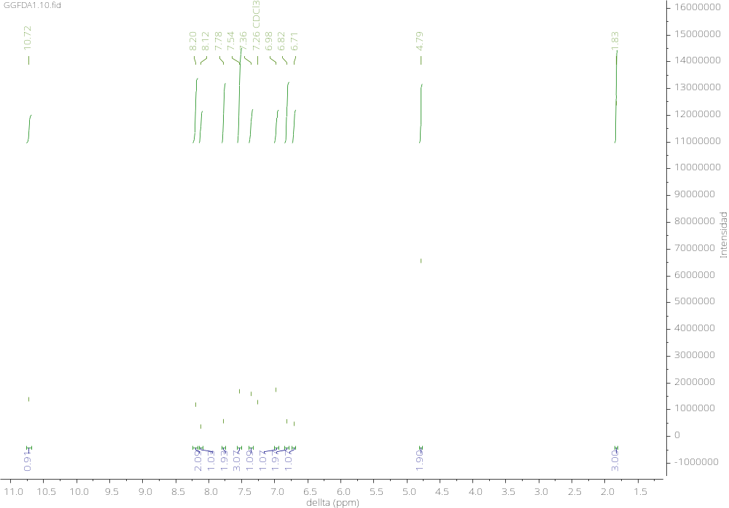

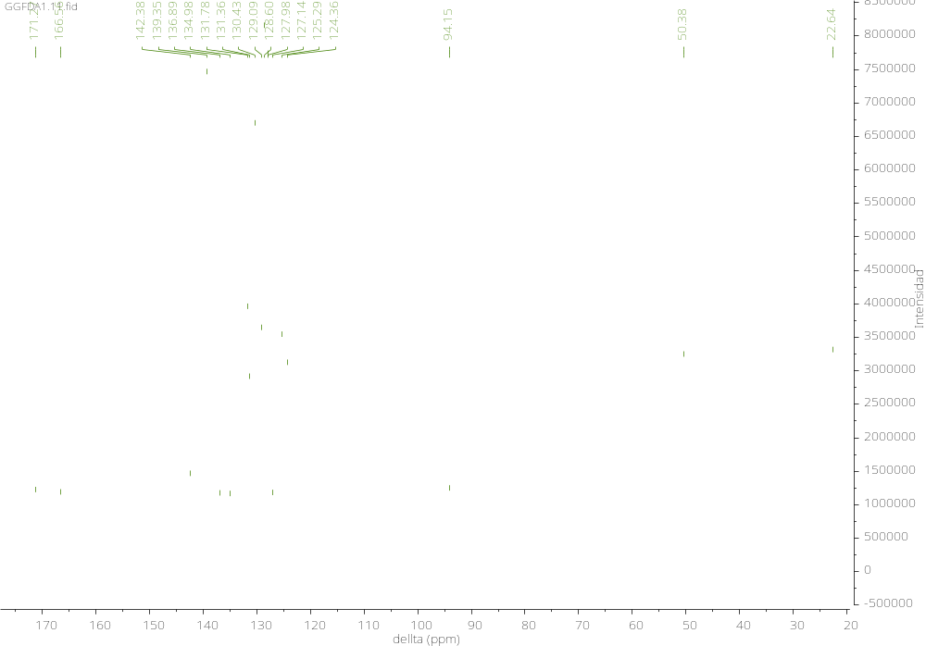
2.7. 2-Chloro-N-(2-(N’-(4-bromophenyl)acetamidomethyl)benzanilide 5g

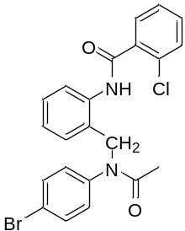

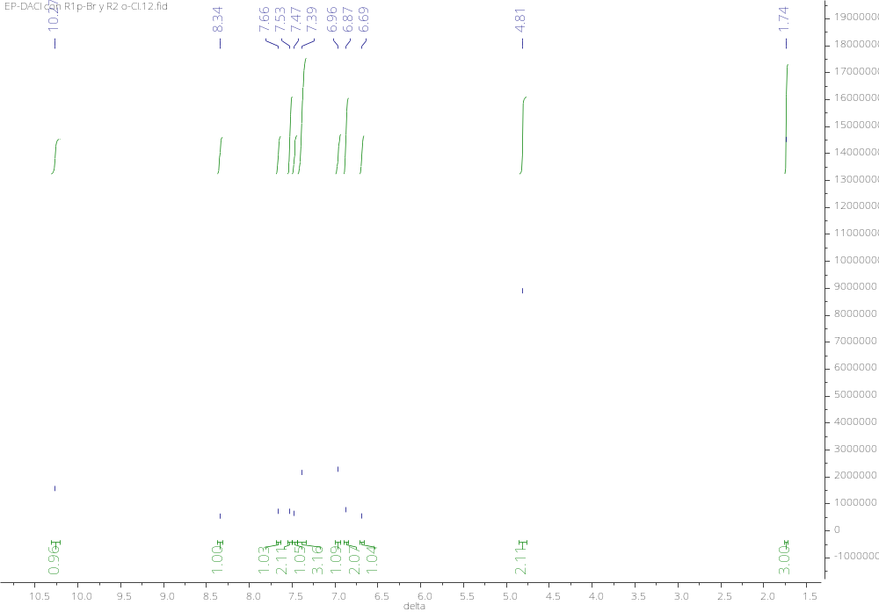

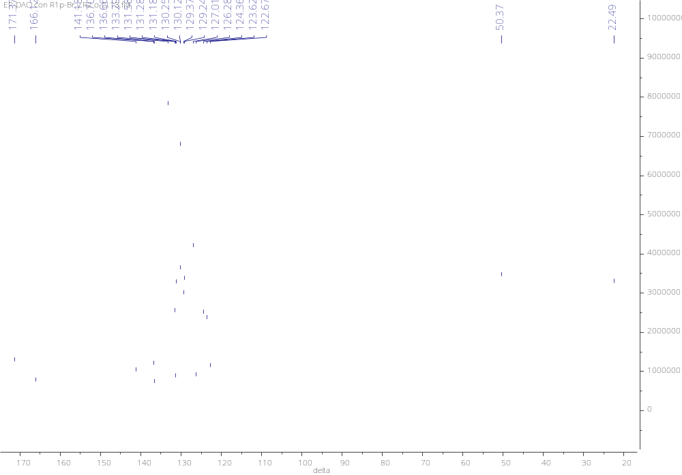

2.8. 2-Chloro-N-(2-(N’-(2-chlorophenyl)acetamidomethyl)benzanilide 5h

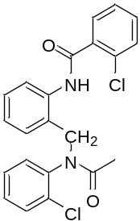

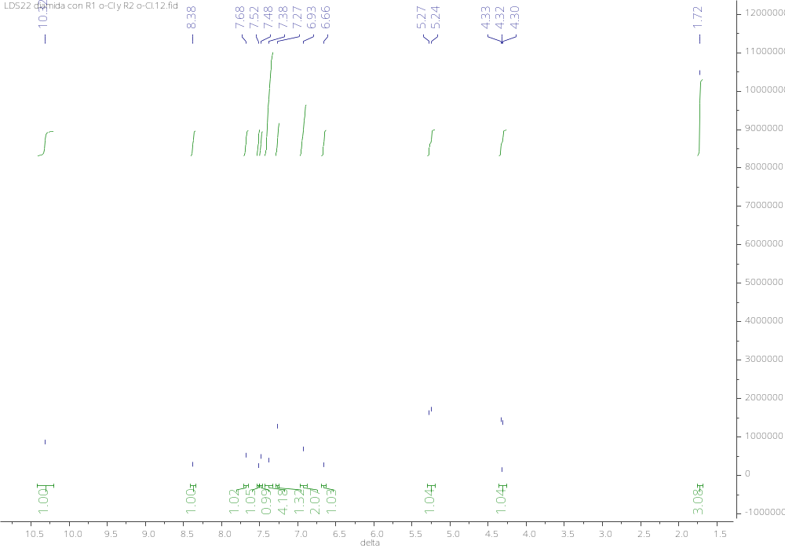

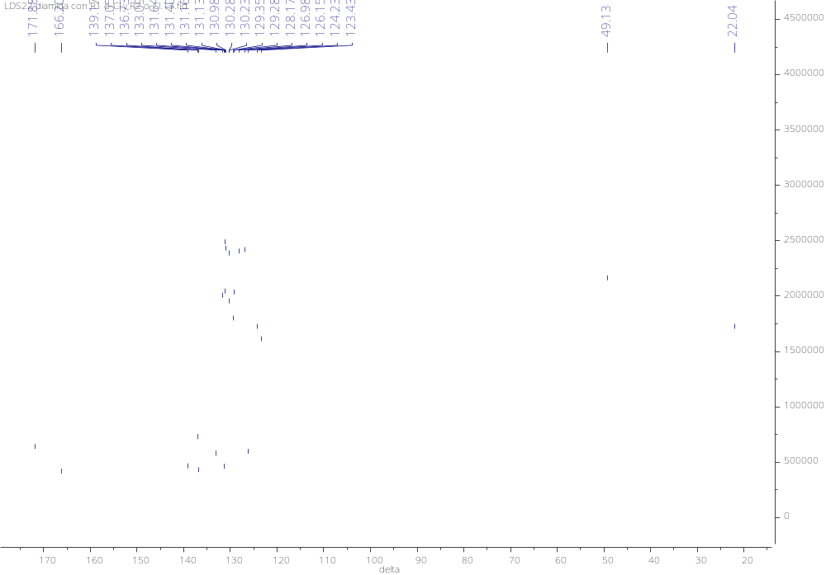
2.9. 2-Chloro-N-(2-(N’-(4-chlorophenyl)acetamidomethyl)benzanilide 5i

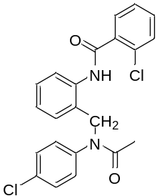

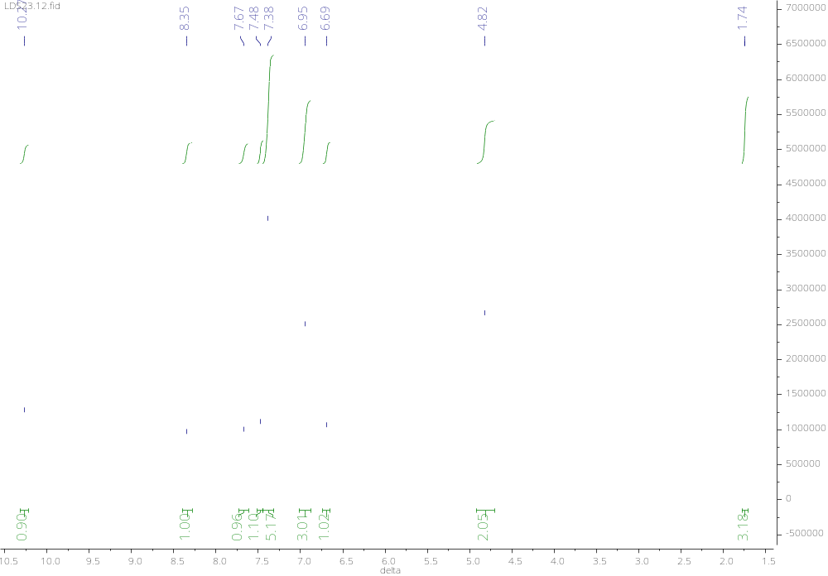

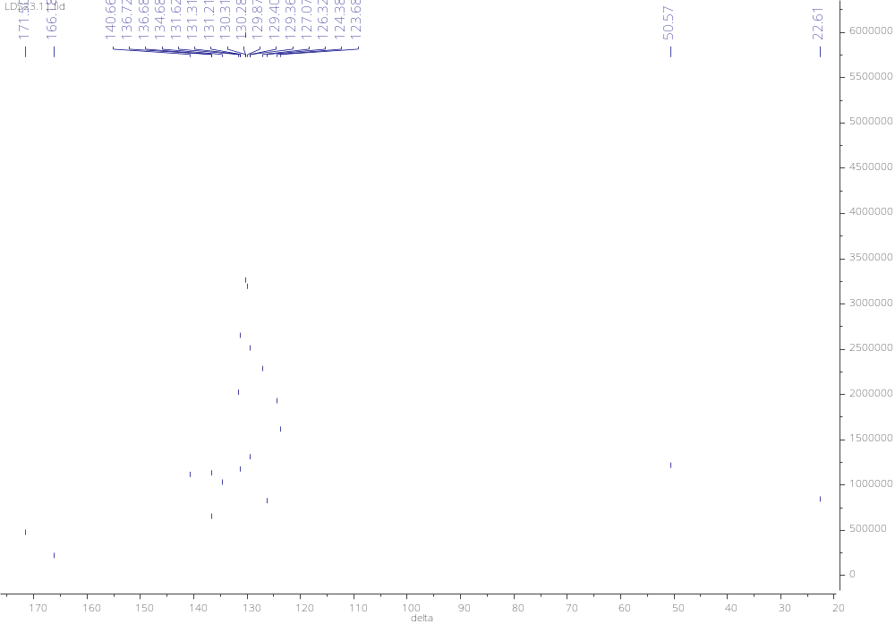

2.10. 2-Chloro-N-(2-(N’-(2-fluorophenyl)acetamidomethyl)benzanilide 5j

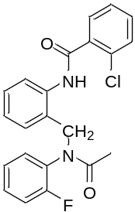

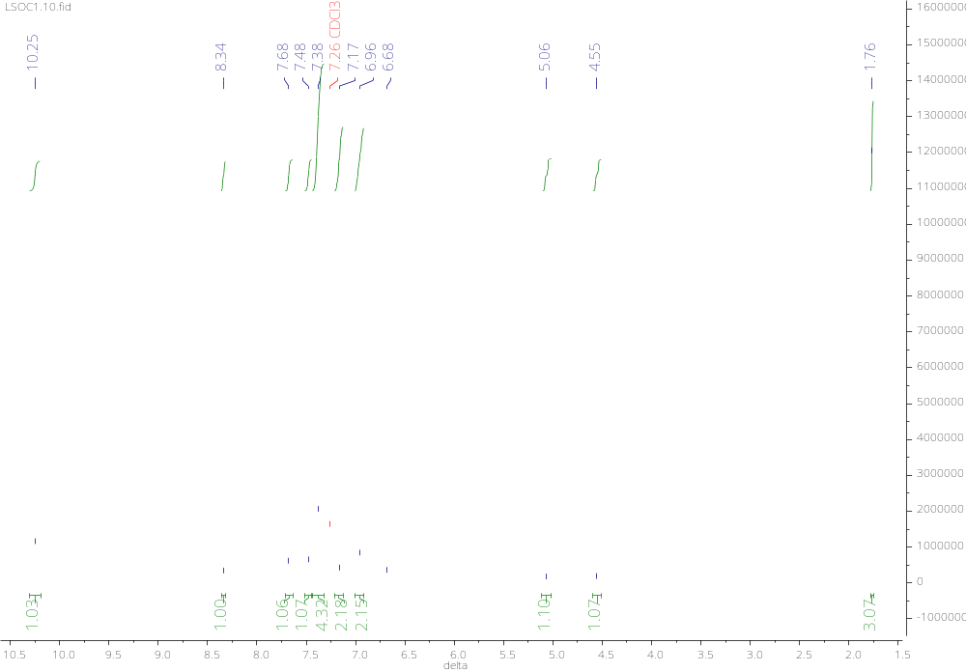

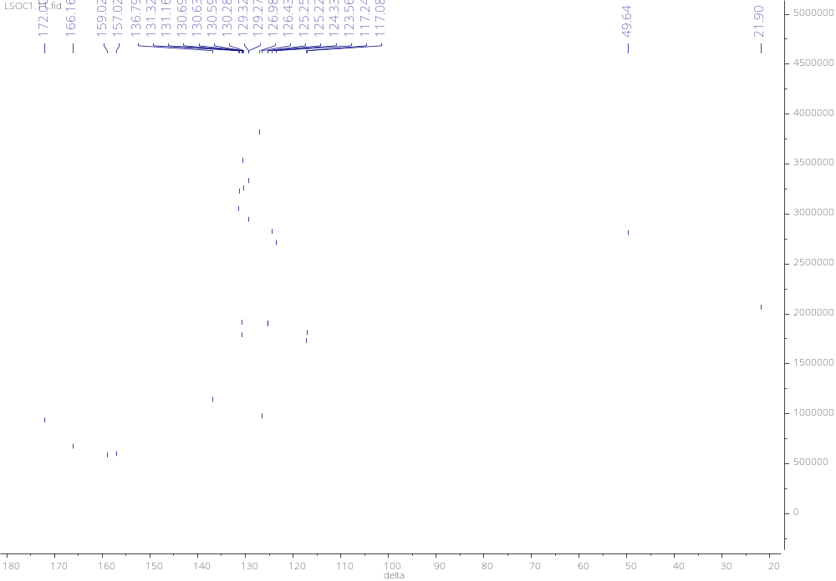
2.11. 2-Chloro-N-(2-(N’-(4-fluorophenyl)acetamidomethyl)benzanilide 5k

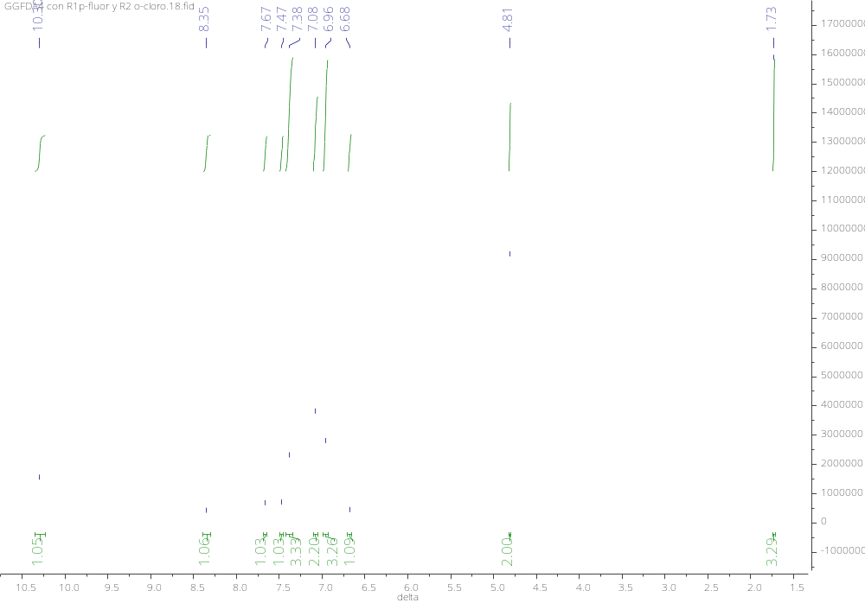

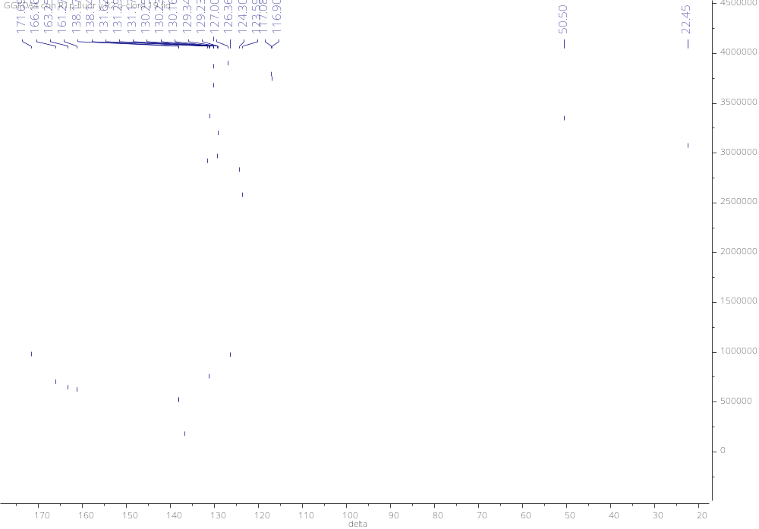
2.12. 2-Chloro-N-(2-(N’-(4-yodophenyl)acetamidomethyl)benzanilide 5l

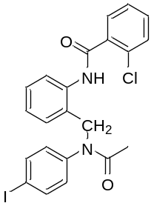

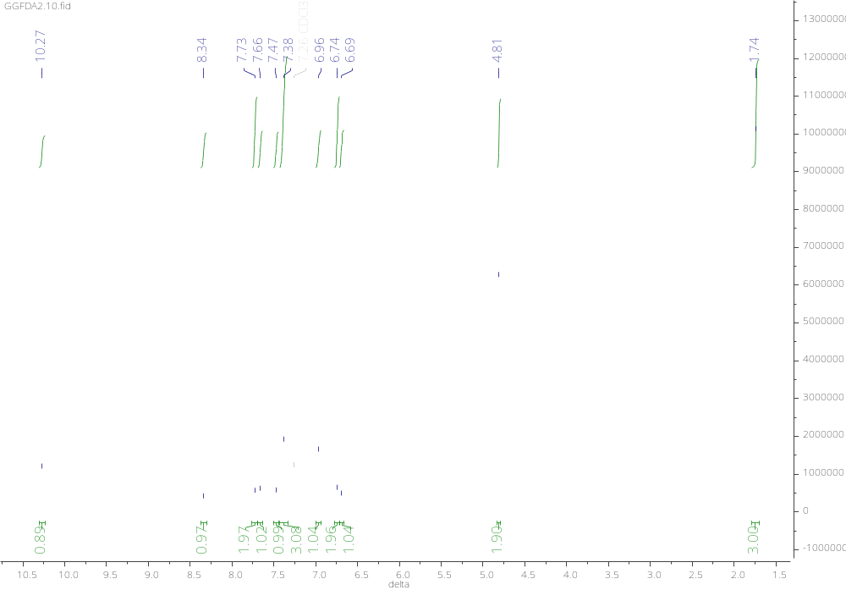

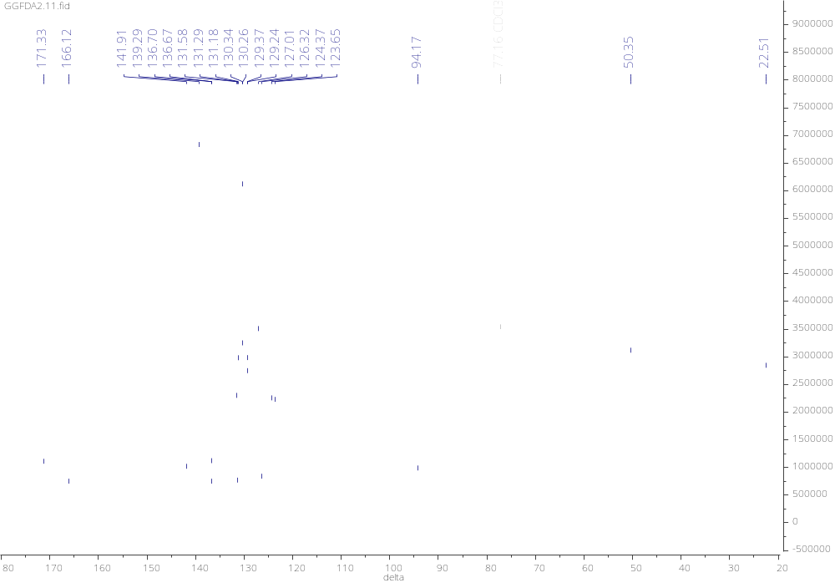
2.13. 2-Nitro-N-(2-(N’-(4-bromophenyl)acetamidomethyl)benzanilide 5m

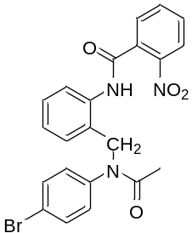

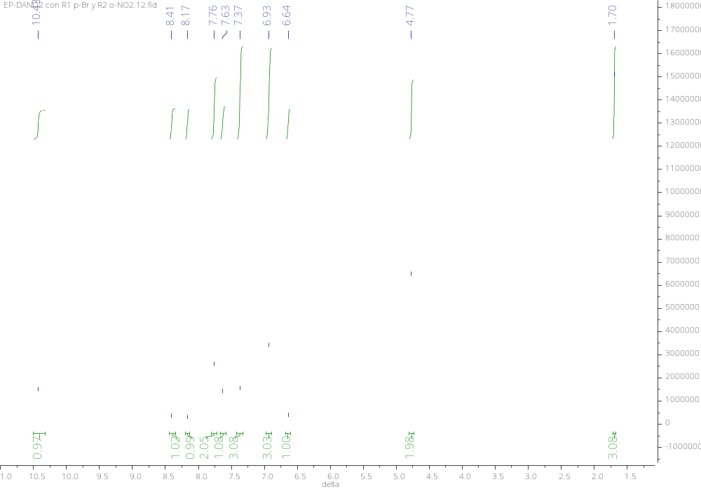

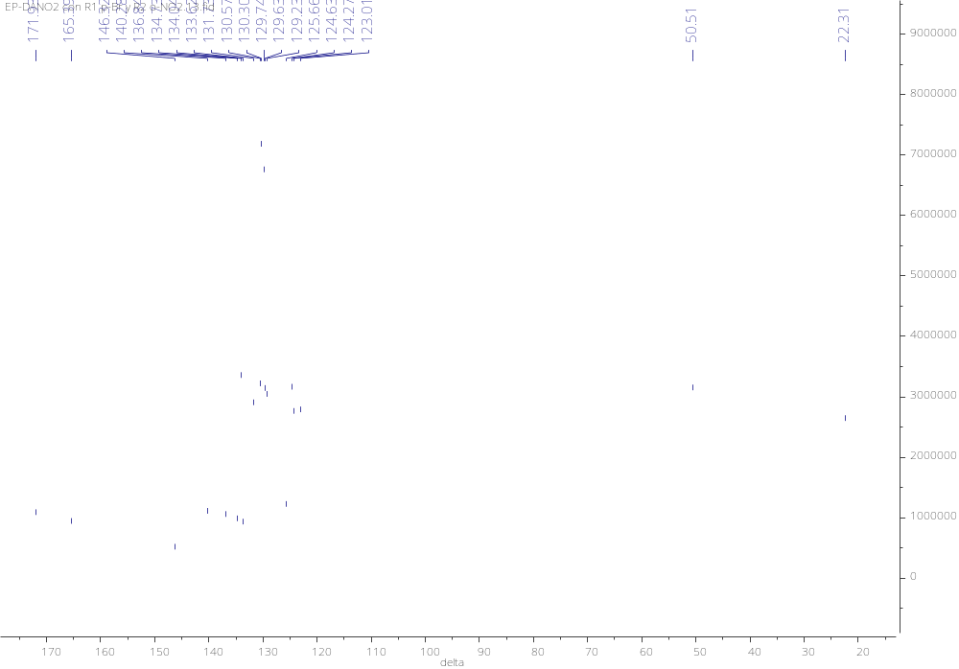
2.14. 2-Nitro-N-(2-(N’-(2-chlorophenyl)acetamidomethyl)benzanilide 5n

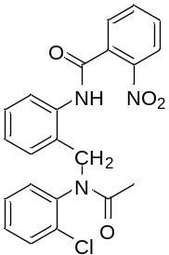

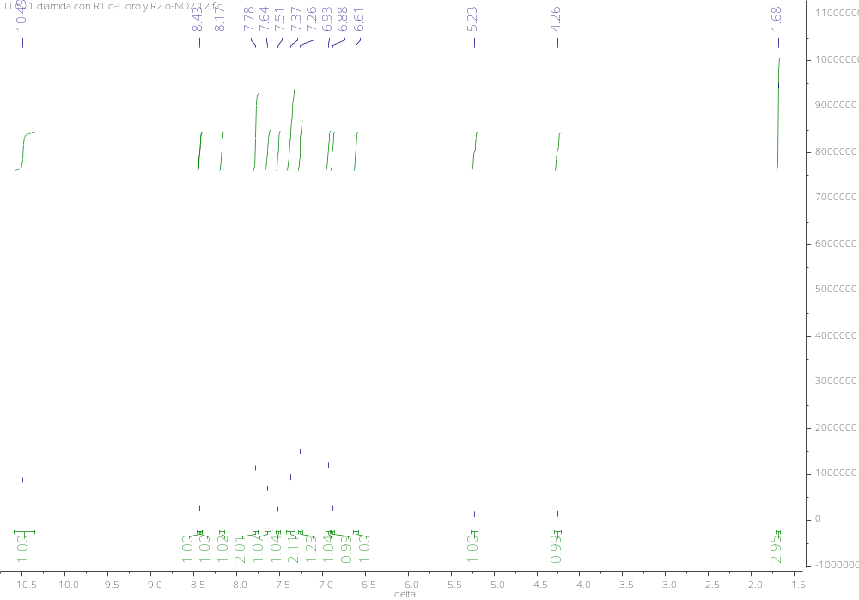

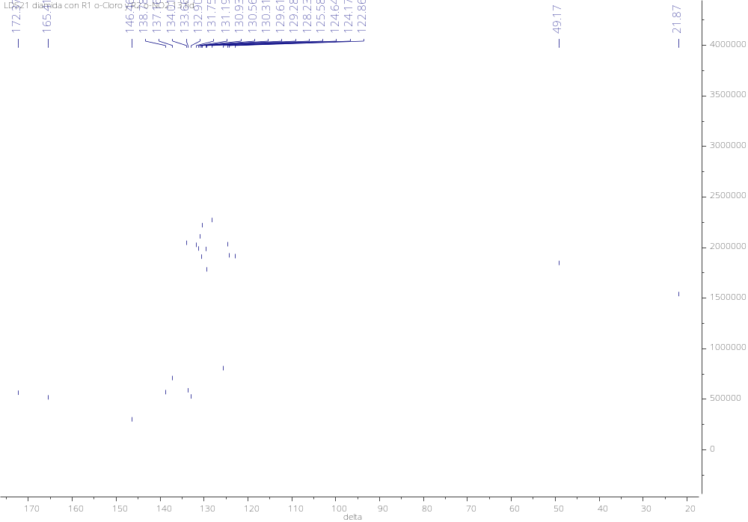
2.15. 2-Nitro-N-(2-(N’-(4-chlorophenyl)acetamidomethyl)benzanilide 5o

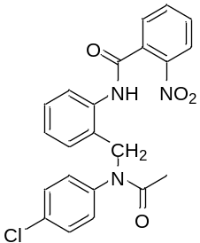

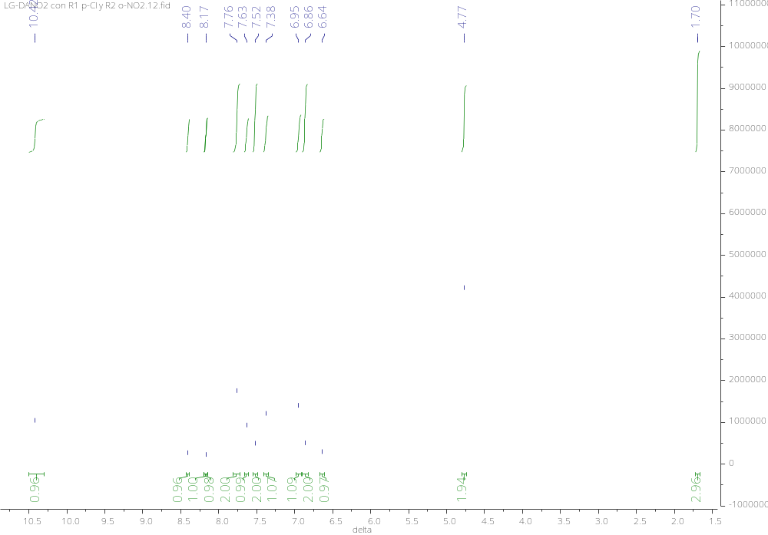

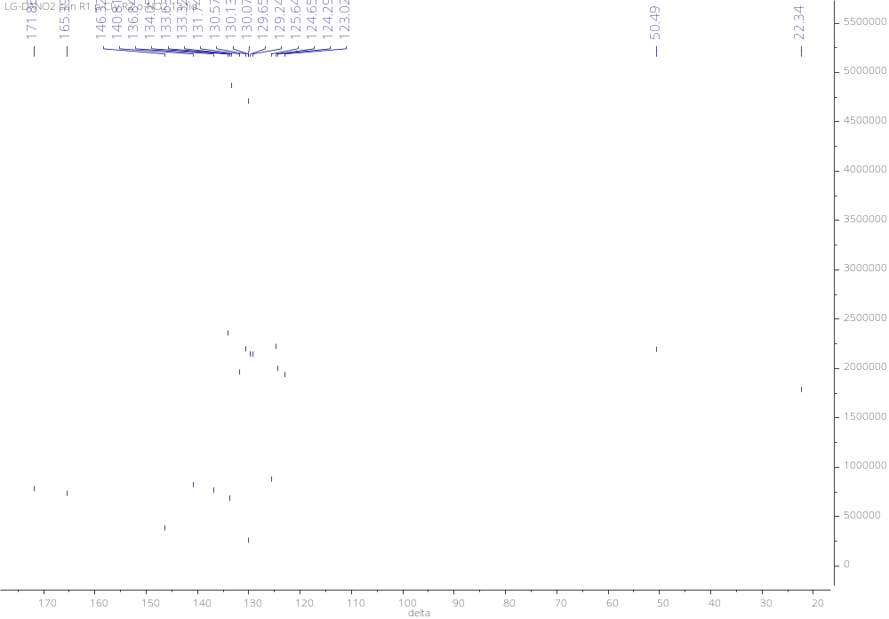
2.16. 2-Nitro-N-(2-(N’-(2-fluorophenyl)acetamidomethyl)benzanilide 5p

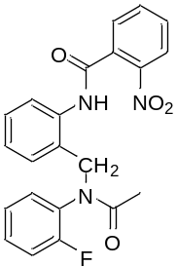

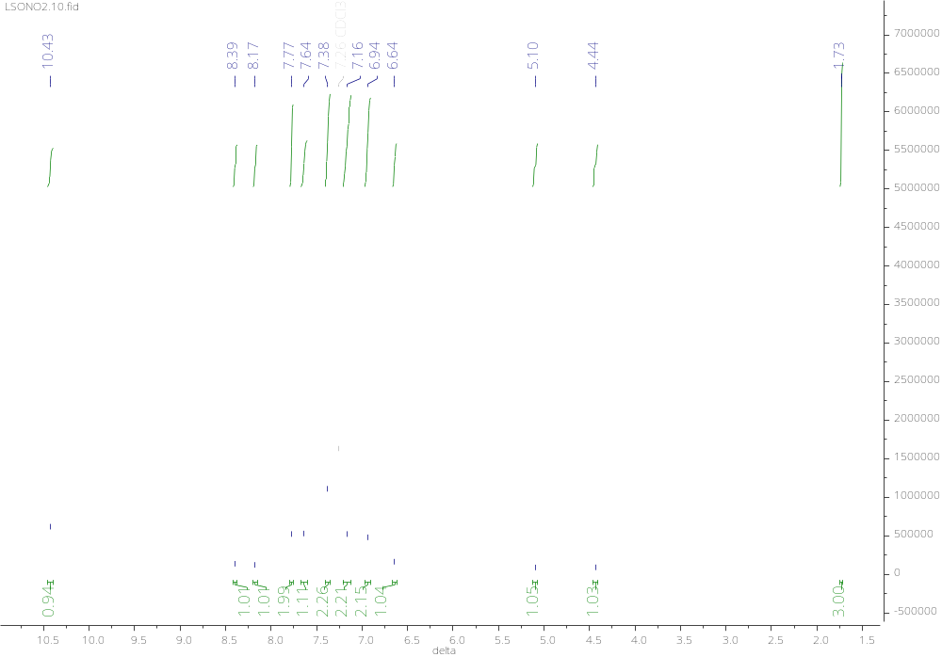

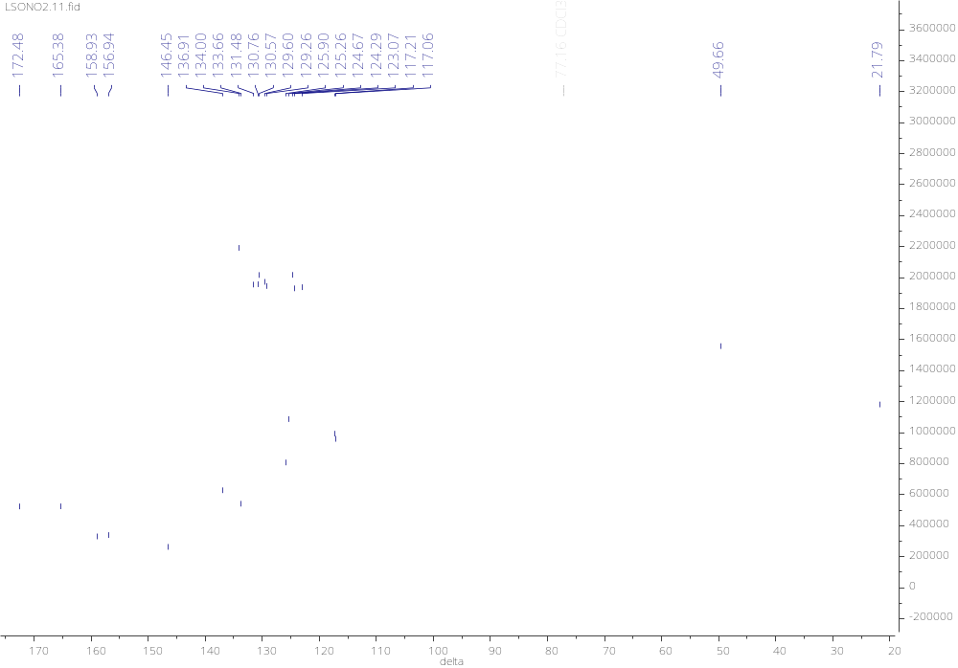
2.17. 2-Nitro-N-(2-(N’-(4-fluorophenyl)acetamidomethyl)benzanilide 5q

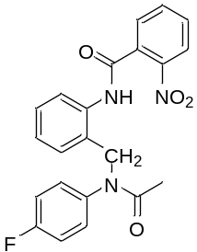

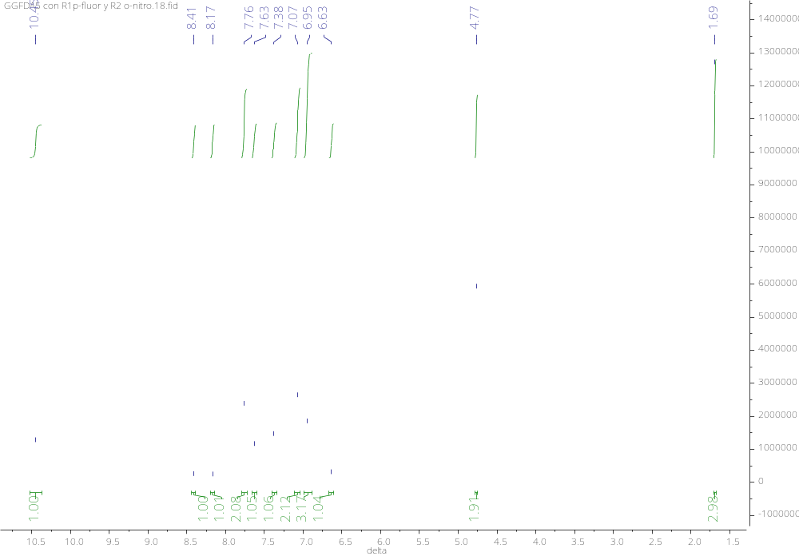

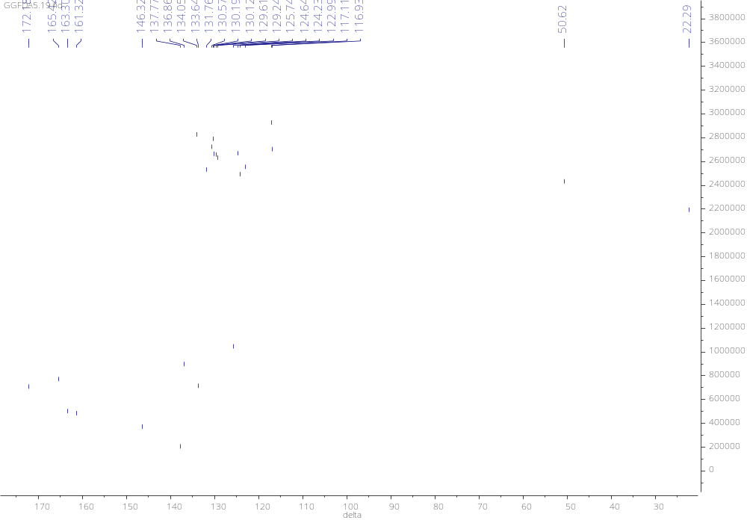
2.18. 2-Nitro-N-(2-(N’-(4-yodophenyl)acetamidomethyl)benzanilide 5r

