SUPPLEMENTAL FIGURES and TABLES
ALZET pump implantation in mice for chronic drug delivery to the cochlea
Frederic Depreux¹, Donna Whitlon¹⁻³, Claus-Peter Richter^{1, 2, 4, 5, *}

¹ Department of Otolaryngology, Northwestern University Feinberg School of Medicine, Chicago, Illinois, 60611, United States of America.
² The Hugh Knowles Center for Clinical and Basic Science in Hearing and Its Disorders, Northwestern University, Evanston, Illinois, 60208, United States of America.
³ Interdepartmental Neurosciences Program. Northwestern University, Chicago IL 60611, United States of America.
⁴ Department of Communication Sciences and Disorders, Northwestern University, Evanston, Illinois, 60208, United States of America.
⁵ Department of Biomedical Engineering, Northwestern University, Evanston, Illinois, 60208, United States of America.

Fabrication of the catheter
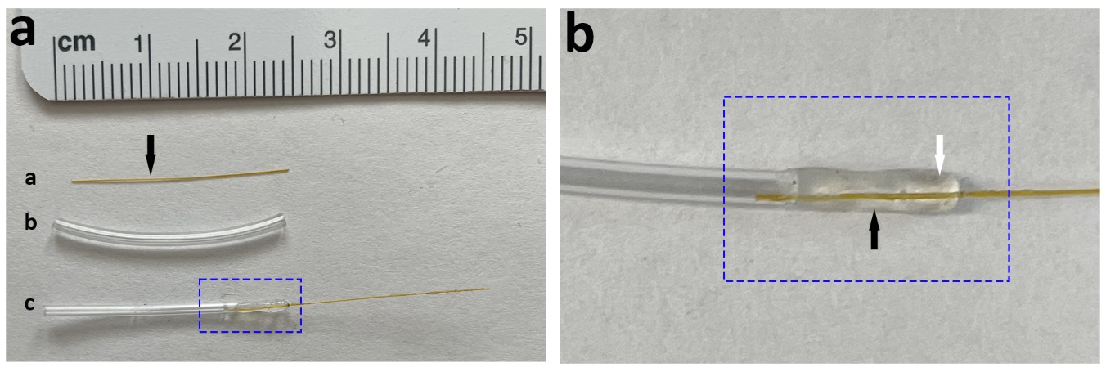
Supplemental Figure 1. Segments of polyimide (Figure (a) “a”) and Tygon® tubing were cut (Figure (a) “b”), approximately two centimeters long. After mixing 9 parts of SILASTIC® MDX4-4210 Medical grade elastomer base with 1 part of curing agent (w/w), a small drop of this mixture was applied on the polyimide tubing, approximately 0.5 cm from one end of the polyimide tubing (arrow in (a) “a”). The Tygon® tubing was then slid over the polyimide tubing until it reached the silicone droplet, and the silicone entered the Tygon tubing by capillary action (Figure a “c”). Additional silicone was needed to seal it completely. Figure (b) is a magnified view of the left panel’s dashed area on “c”; the white arrow delimits the end of the Tygon® tubing. Bending or deforming the polyimide tube with forceps during this operation will result in the permanent closure of or abnormal liquid flow through the polyimide tubing and should be avoided. Newly mounted catheters are placed standing upward. The polyimide tubing might slide sideways, especially if the silicone is not sufficiently viscous. Catheters are placed in an oven for overnight silicone polymerization at 50⁰C. Before sterilization, each catheter is individually tested for leaks and liquid flow. The test is performed using a 1-mL syringe filled with purified water. A filling needle from the ALZET® micro-osmotic pump system is attached to the syringe and inserted into the end of the Tygon® part of the catheter. The forced ejection of the fluids through the catheter should produce a jet of water from the catheter’s orifice but no leak. Water was removed from the system with forced air and subsequent ethylene oxide sterilization following the manufacturer's recommendations for the selected catheters.

Tools used for surgery
Supplemental Figure 2. Recommended surgical tools, which are needed for osmotic pump implantation. An essential factor for a successful surgery is assembling the correct tools. Instruments are autoclaved before the surgery. The tool's name and numbers are described in Supplemental Table 2.

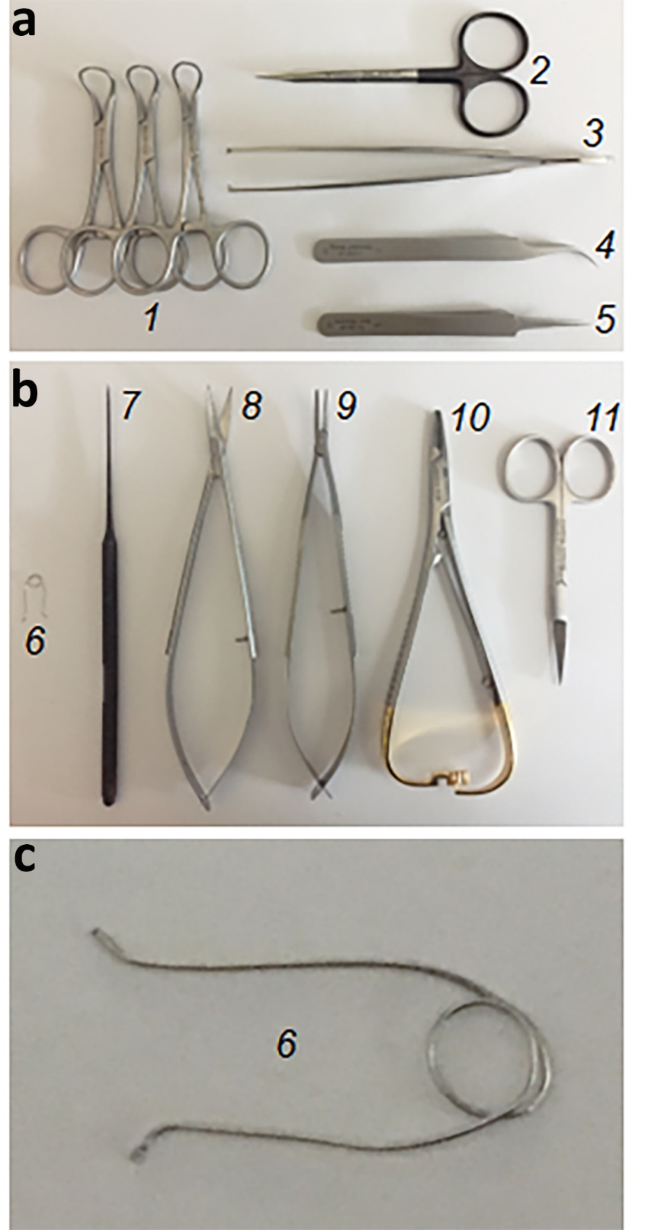
The head holder
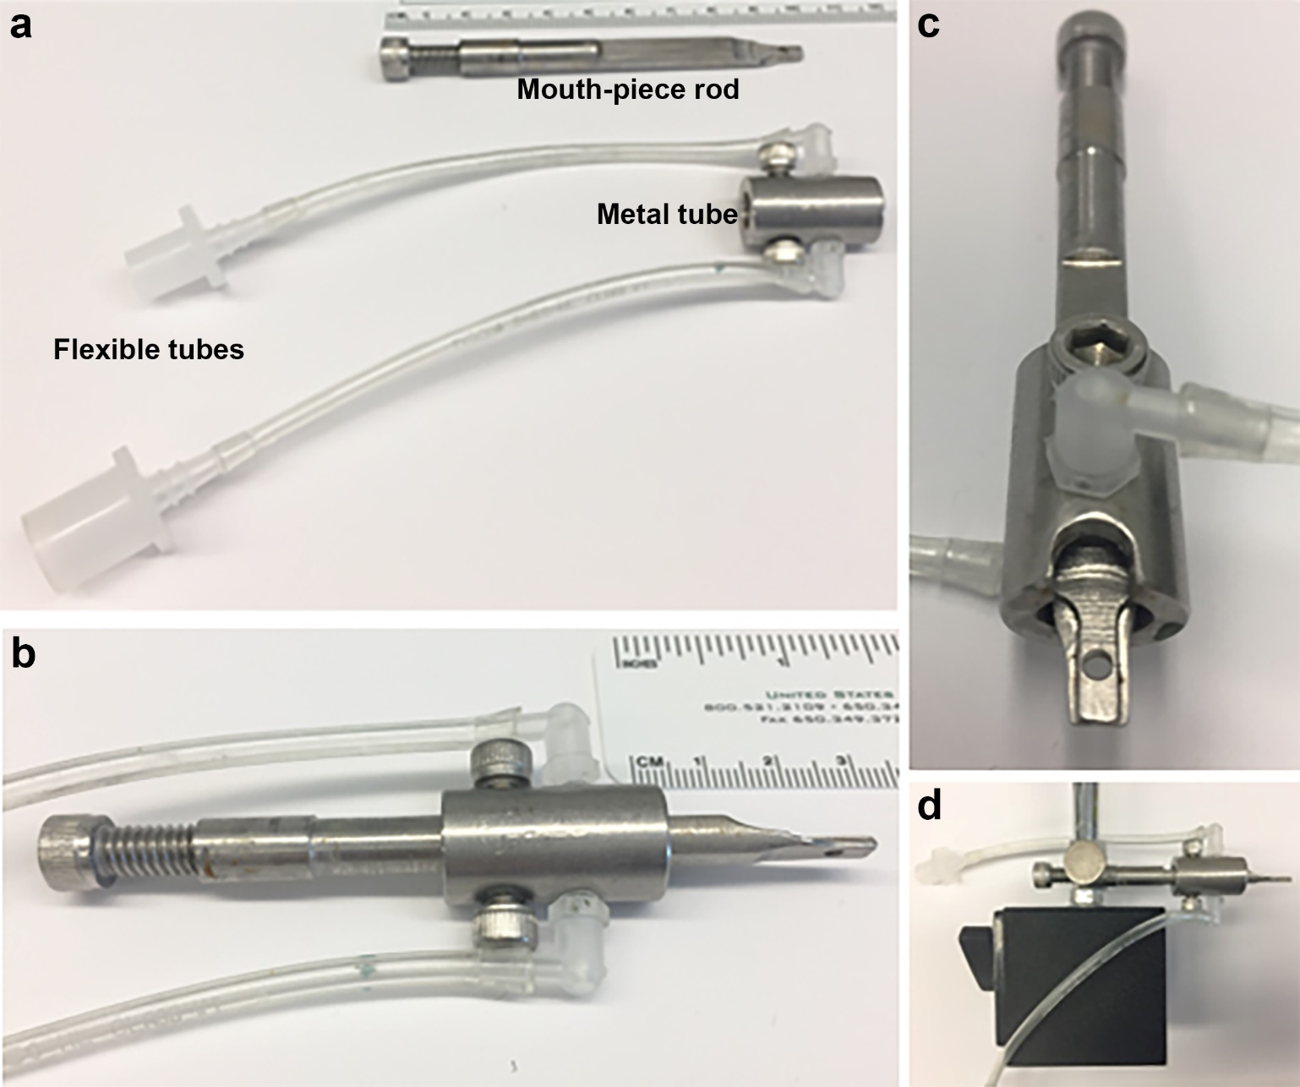
Supplemental Figure 3. The head holder is a custom-made modification of that sold commercially. (a) The nasal holder includes the mouthpiece rod (top near the ruler, bite bar) and a metal tube connected to two flexible tubes. One flexible tube is connected to an anesthesia system and the second to an anesthetic gas capture system (Charcoal canister). (b) Lateral view of the head holder. The metal tube slides into the bite bar and can be secured using two screws placed on each side of the metal tube. (c) Front view of the head holder. The bite bar has a flat mouthpiece with a hole to allow the insertion of the anesthetized mouse front incisor. (d) The head holder is mounted onto the magnetic base of a stand with rod and locking system, which in turn is mounted on the metallic table. Blueprint of the head holder is available upon request.

Catheter and osmotic pump assembly
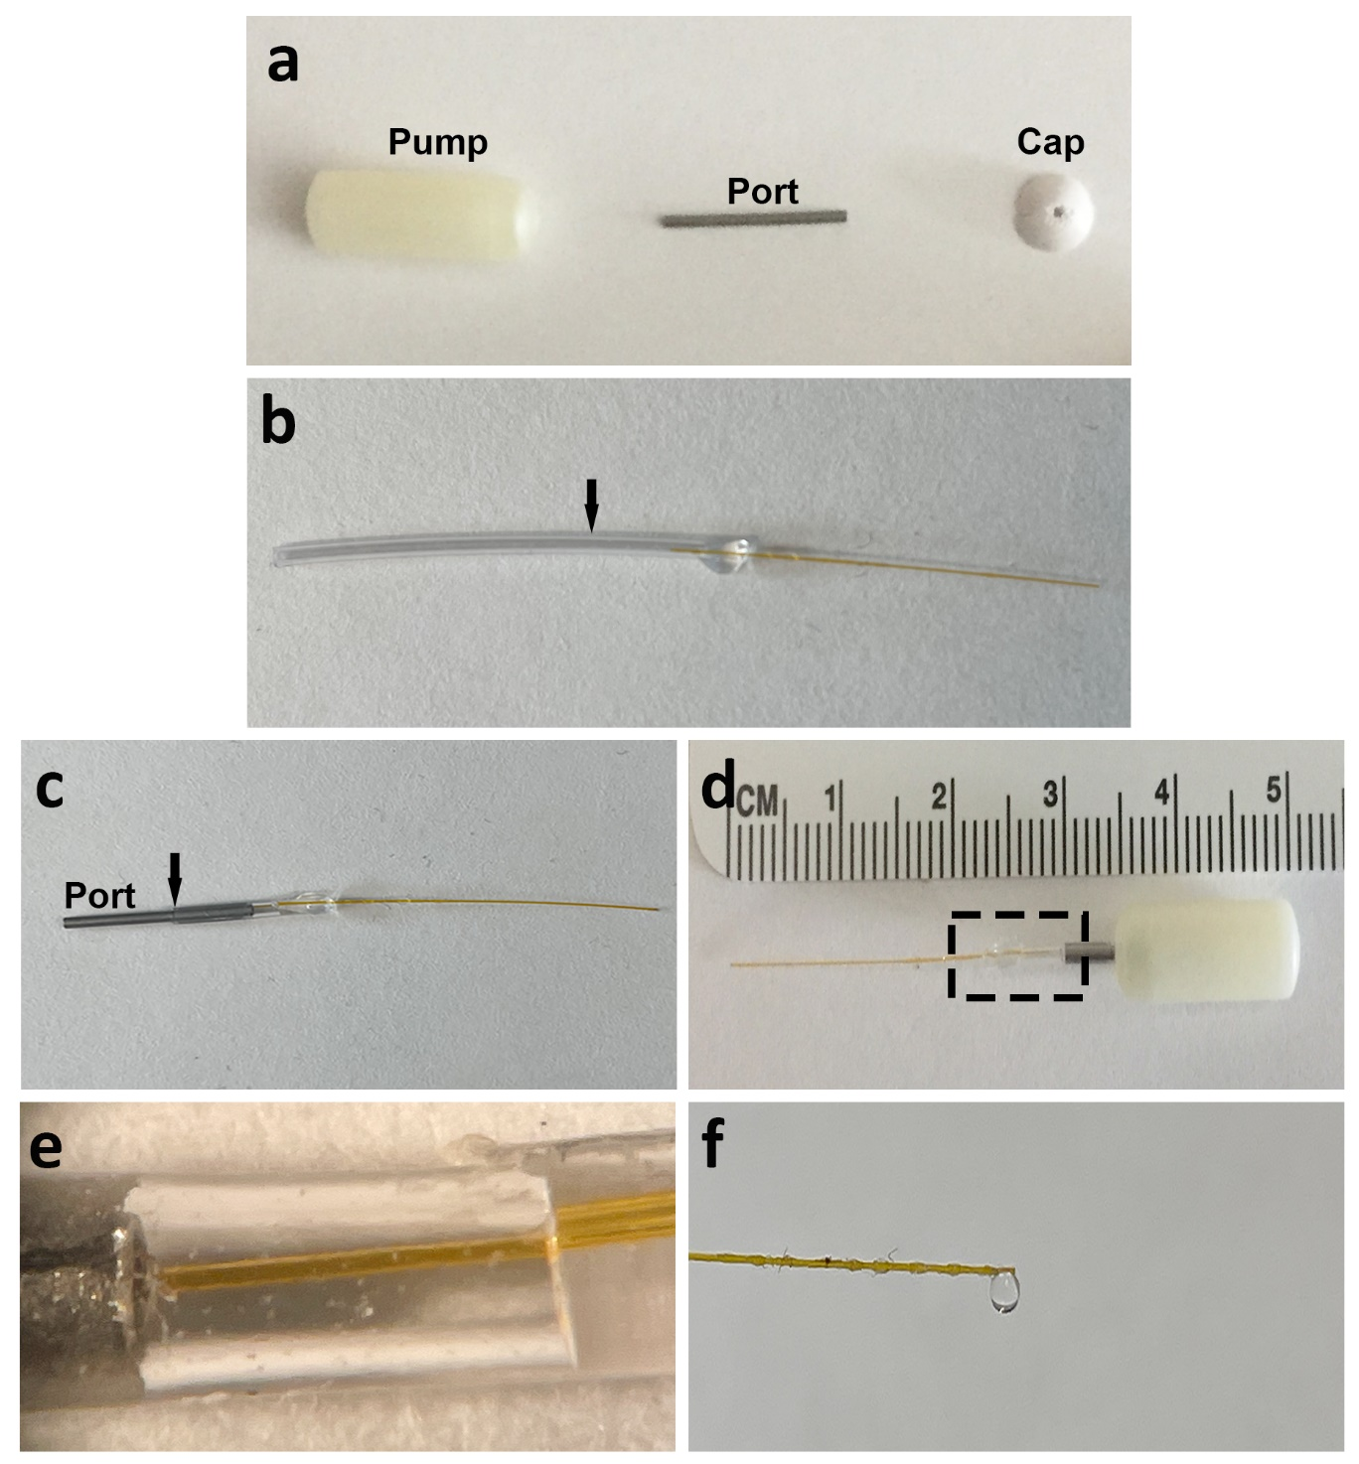
Supplemental Figure 4. (a) The cap of filling port is removed using Mathieu needle holder (Supplemental Figure 2 and Supplemental Table 2: Tool # 9). Three parts of the ALZET® mini-osmotic pump: pump, filling port also called flow moderator, and cap. The pump is filled with drug through the filling port attached to a 1 mL syringe equipped with a 0.22 µm Micropore filter as recommended by the ALZET® manufacturer (not shown). (b) The Tygon catheter part is cut (arrow) shorter approximately the half size of the filling port. (c) The filling port is first inserted into the Tygon part of the catheter (Black arrow point to extremity end of the Tygon tubing) with a spring needle holder (Supplemental Figure 2 and Supplemental Table 2: Tool #9), and catheter is then filled up with drug until the liquid can be seen to flow from the other end of the catheter. (d) Using the spring needle holder, the catheter + filling port set is inserted into the Alzet pump. The combined length of the pump and catheter is about 5 cm long but will be shortened as needed during placement of the pump inside the animal. (e) Enlarged view of boxed area from (d) showing the catheter within the Tygon tubing as close as possible of the filling port end. (f) Due to the pressure of the insertion, a liquid droplet must form at the opposite end of the catheter to verify the absence of air inside the system.
Supplemental Figure 5: Histology of implanted right cochlea. (A) Most of the cochleae showed absence of cellular stress due to catheter implantation. A localized epithelial growth can be observed around the site of cochleostomy in scala tympany (asterisk) of the basal turn. The cochlear apex is clear of epithelial growth. The Scale bar equals 500 µm. (B) The integrity of basilar lamina is preserved in the basal turn of the cochlea with presence of inner and outer hair cell both at the basal turn in vicinity of cochleostomy and for all other turns. Scale bar is 50 µm. (C) in two samples, hyperplasia of epithelium of the cochlea periosteum (asterisk) could be found in scala media (SM) and tympani (ST) compared to panel cochleae like in panel A. Scale bar equals 50 µm. Other abbreviation: SA, stapedial artery.

Vital data analysis

Supplemental Figure 6: Weight monitoring. All the surgical groups presented similar weight at baseline [before surgery] (a), 24 hours (b) or 1 week (c) or 2 weeks (d) post-surgery. Moreover, at one-week post-surgery, VD group had a significant lower weight compared to “fine” group*, P< 0.05. The significance is associated to the body weight of two animals dropping by more than 25% and consequently were euthanized (red square). One-way ANOVA Dunnett multiple comparison test. Statistical analysis was performed using statistical software PRISM7 (GraphPad Software, San Diego, CA). ns = non-significant.

 | Supplemental table 1: The Drug Delivery System
 | Materials | Company
1 | SILASTIC® MDX4-4210 Medical grade elastomer base | Dow Corning Corporation, Midland, MI
1 | SILASTIC® MDX4-4210 curing agent | Dow Corning Corporation, Midland, MI
1 | Polyimide tube 100 µm ID, 130 µm OD | Generous gift of Microlument, Oldsmar, FL
1 | TYGON™ tube 1 mm ID, 1.2 mm OD | Tygon, Saint-Gobin USA, Malvern, PA

Supplemental table 2: Surgical TOOLBOX
Suppl Fig 1 annotation | Number suggested | Tools | Company
1 | 3 | Backhaus clamp towel hemostat 3.5” | Medline Industries, Mundelein, IL
2 | 1 | Fine Scissors- tough cut, straight, 11.5 cm | Fine Science Tools, Foster City, CA
3 | 1 | Tissue Forceps 1x2 Teeth 15 .5 cm | Fine Science Tools, Foster City, CA
4 | 1 | Dumont #7 curved 11.5 cm 0.07 x 0.04 mm Tip Dumostar Forceps | Fine Science Tools, Foster City, CA
5 | 2 | Dumont #5 straight 11 cm, 0.05 x 0.02 mm Tip Inox Forceps | Fine Science Tools, Foster City, CA
6 | 1 | Handmade retractor made from , spring of a pen | Not applicable
7 | 1 | Richards 13-0361 ENT Round Knurled Large Angled Pick 6" of which the knob was removed by sharpening to generate around 150 µm tip | Gyrus ENT, LLC. Olympus Company, Bartlett, TN
8 | 1 | Spring curved German 14 cm CVD scissors 8 mm blades | World Precision Instruments, Sarasota, FL
9 | 1 | Castroveijo without lock 12 mm jaws 14 cm spring needle holder | GloMed Inc, Phoenix, AZ
10 | 1 | Mathieu 5 ½” Needle Holder | Sklar, West Chester, PA
11 | 1 | Iris Scissors Miltex® 3-1/2’ Finger Ring Handle Straight Blade Sharp/Sharp | Integra Life sciences, Plainsboro, NJ
Not shown | 1 | Wahl clipper Model 9307 | Wahl, Sterling, IL
Not shown | 1 | Autoclave case instrument 1.75x4.2x1.25” | World Precision Instruments, Sarasota, FL
Laser replacement option (tool not shown) | 1 | Drill burr 1mm of OmniDrill35 electric drill | World Precision Instruments, Sarasota, FL
Extra tool not frequently used (tool not shown) | 1 | Hemostatic Forceps Miltex® Halsted-Mosquito 5” Ratchet Lock Finger Ring Handle Straight Serrated Tips | Integra Life sciences, Plainsboro, NJ

Supplemental table 3: Sterilization
N | Materials | Company
1 | ANPROLENE® sterilizing gas ampoules | Andersen Sterilizers Inc., Haw River, NC
1 | Gas Sterilizer chamber AN74i | Andersen Sterilizers Inc., Haw River, NC
1 | Steam Autoclave Tuttnauer 2850E | Tuttnauer USA, Hauppauge, NY
As needed | Chex-all II instant sealing sterilization pouches for Ethylene Oxide or steam sterilization (sizes as needed) | Propper Manufacturing Company Inc., Long Island City, NY

Supplemental table 4: Anesthesia System
N | Material | Company
1 | Calibrated V-9 Wall Mount Laboratory Animal Anesthesia System | VetEquip Inc., Livermore, CA
1 | Induction chamber | VetEquip Inc., Livermore, CA
1 | Isoflurane USP ISOTHESIA™ | Henry Schein Animal Health, Covetrus, Portland, ME
1 | VaporGuard activated charcoal absorption filter | VetEquip Inc., Livermore, CA
1 | Oxygen compressed USP gas cylinder | Airgas, Air Liquide Company, Paris, France

Materials and instruments in the non-sterile field
 | Supplemental table 5: Disposable Materials and Other Instruments
N | Materials | Company
1 | Stryker T-pump professional | Stryker, Kalamazoo, MI
1 | Cincinnati Sub-Zero Maxi-therm 273 small (12" x 18") pad | Engler Engineering Corporation, Hialeah, FL
1+ | Ansell Encore surgical latex textured gloves | Medline Industries, Mundelein, IL
1+ | PALL Acrodisc®0.2 µm HT Tuffryn Membrane Syringe filter | Pall, Nottingham, MD
1+ | ETHICON™ 6-0 PDS*II polydioxanone suture violet monofilament Z487G | Henry Schein Animal Health, Covetrus, Portland, ME
1+ | ETHICON™ 6-0 PS-3 polyamide 6 black monofilament non-absorbable suture 1665G | Henry Schein Animal Health, Covetrus, Portland, ME
1+ | Alzet micro-osmotic pump Model 1004 0.11 µl/hr, 28 days | Braintree Scientific Inc., Braintree, MA
3 | Gemini single ply sterilization wrap medium weight cut to the suggested size 27” x 27” | Medline Industries, Mundelein, IL
4 | Gemini single ply sterilization wrap medium weight cut to suggested size 13” x 13” | Medline Induestries, Mundelein, IL
2 | BD 1 ml TB Syringe slip tip | Becton Dickinson, Franklin Lakes, NJ
1 | BD ½ cc U-100 Insulin Syringe 28G½ | Becton Dickinson, Franklin Lakes, NJ
1+ | BD hypodermic needle 25G | Becton Dickinson, Franklin Lakes, NJ
1+ | BD hypodermic needle 22G | Becton Dickinson, Franklin Lakes, NJ
1 | 0.9% Sodium Chloride injection USP (1 liter bag) | Baxter, Deerfield, IL
5 | Autoclaved Kimwipes Kimtech sciences | Kimberly-Clark Worldwide Inc., Roswell, GA
1+ | Sterile cotton tipped applicators | Puritan Medical product company, Guilford, MN
1 | BETADINE®, Povidone-iodine 5% bottle | Purdue Products LP, Stamford, CT
1+ | Convertors Astound standard surgical Gown | Cardinal Health, McGaw Park, IL
1+ | Ansell EDGE™ Face mask ear loop style | Ansell, Iselin, NJ
1 | TEETS denture material | Co-oral-ite Dental MFG. Co., Diamond Spring, CA
1 | TEETS denature material crosslinking methyl methacrylate | Co-oral-ite Dental MFG. Co., Diamond Spring, CA
1 | CO2 laser Sharplan 20C | Sharplan, Allendale, NJ
1 | Omniguide OTO laser fiber 100 µm ID | Omniguide, Lexington, MA
1 | OmniDrill35 electric drill | World Precision Instruments, Sarasota, FL
1 | buprenorphine hydrochloride | Reckitt Benckiser Group, Slough, UK
1 | Cellpoint Scientific Germinator 500 glass bead sterilizer | Braintree Scientific Inc., Braintree, MA
1 | 3M Micropore Hypoallergenic Surgical Tape 5 cm X 9.1 m to seal surgical mask | 3M Deutschland GmbH Health Care Business, Neuss, Germany
1 | Disposable Polypropylene Bouffant Scrub Hair Net Caps | Grainger Industrial Supply, Chicago, IL
1+ | Covidien Maxicare Underpads 7134 | Covidien, Dublin, Ireland
1 | Andis 317G clipper | Andis, Sturtevant, WI
1 | Oster 40 cryogen-x Blade | Oster Company, Boca Raton, FL
1 | Wall mounted Zeiss surgical microscope | Carl Zeiss AG, Oberkochen, Germany
1 | Handmade mouse nasal holder | See figure
1 | 75% ethanol
5+ | Autoclaved aluminum folds

