Supplementary Material
Methods and Materials

Participants
Legal guardians provided written informed consent and participants aged over 7 years provided complementary written assent. The Stanford University School of Medicine Institutional Review Board approved all procedures in this work involving human subjects. All procedures comply with the ethical standards of the national and institutional committees on human experimentation and with the Helsinki Declaration of 1975, as revised in 2008.

Inclusion criteria
Neurofibromatosis type 1 (NF1) and Noonan syndrome (NS)
Proof of genetic testing was required for individuals with NS or NF1 to demonstrate the presence of appropriate mutations. The inclusion criteria for all NF1 and NS participants is as follows: a) age from 5 years, 0 months to 17 years, 11 months; b) IQ criterion ≥ 70; and c) gestational age > 34 weeks. Participants with NF1 and focal areas of signal intensity with no mass effect and/or low-grade optic pathway glioma are not excluded.

Typical developing (TD)
TD participants are group-matched to participants with NF1 and NS based on age, sex, handedness, socioeconomic status, pubertal status, and ethnicity. Subjects are included if their full-scale IQ is greater than 80.

Exclusion criteria
For all participants, the exclusion criteria includes: a) presence of neurological or psychiatric disease (e.g., psychotic symptoms); b) sensory deficits that would preclude participation in assessments or imaging; c) history of significant head trauma with loss of consciousness; d) use of psychotropic medications or currently taking medications with central nervous system effects within 5 half-lives of the scan; e) contraindications to MRI (e.g., metal implants, orthodontia, claustrophobia); f) history of alcohol or drug use; g) premature birth (<34 weeks); h) low birth weight (<2000g); i) history of head trauma with loss of consciousness; neurological disorders known to affect cognitive development or brain structure; j) known presence of gliomas in cerebellum, brainstem, or basal ganglia; and k) contraindications to MRI.

Additionally, participants with NF1 were excluded if they received an MEK inhibitor or chemotherapy, and/or show presence of cerebellar, brainstem, tectal plate, and basal ganglia gliomas. Participants with NF1 and NS are not excluded if they show clinical symptoms associated with typical syndromic cognitive-behavioral features (e.g., inattention, anxiety, learning disorder, or autistic traits).

Pubertal status was determined using Tanner staging (1,2). A full-scale intelligence quotient (IQ) ≥ 70 was required to maximize study compliance. Full-scale, performance, and verbal IQs were acquired using the Wechsler Abbreviated Scale of Intelligence 2nd Edition (3).

Imaging Protocol
All participants completed behavioral training in a mock MRI scanner to familiarize themselves with the environment and minimize motion-related artifacts (4). Structural data were collected using a whole-brain high-resolution T1-weighted magnetization-prepared rapid gradient-echo (MPRAGE) sequence: repetition time (TR)=7ms; echo time (TE)=2.83ms; inversion time (TI)=900ms; flip angle=8°; field of view (FOV)=240×240×180mm³; voxel size=1.0×1.0×1.2mm³; acquisition time (TA)=4 minutes 22 seconds. The standard Freesurfer 7.2.0 recon-all pipeline (https://surfer.nmr.mgh.harvard.edu) was used to preprocess the T1-weighted images. The Freesurfer reconstruction and segmentation were examined by independent raters (MR, CM) and re-run if necessary, until both raters agreed that the surfaces for each T1 met quality standards. Structural images (including T2-weighted images not described here) were visually inspected by a trained radiologist for the presence of T2-hyperintensities.

DWI data were collected using a multi-shell acquisition with b=500s/mm² (6 directions), b=1000s/mm² (15 directions), b=2000s/mm² (15 directions) and b=3000s/mm² (60 directions). A b=0s/mm² scan was acquired between each 10 diffusion volumes (6 blip up) for subject bulk motion correction, and three additional b=0s/mm² were collected with reverse phase encoding polarity (3 blip down) for distortion correction. Other parameters included: TR=8300ms; TE=70.5ms; FOV=240×240 mm²; voxel size=1.7×1.7×1.7mm³; slice number=75; multiband factor=3; TA=15 minutes 5 seconds. DWI data were preprocessed by MR using FSL 6.0.5 (FMRIB Analysis Group, Oxford, UK). The topup tool corrected susceptibility-induced distortions and the eddy tool corrected eddy currents-induced distortions (5,6). The eddy tool included options to replace outliers and correction for slice-to-volume motion (7,8). The corrected images were examined by independent raters prior to analysis (MR, JP).

Image Analysis
TRACULA combines distortion-corrected DWI data with T1-weighted images to reconstruct white matter tracts for each subject. 3D reconstructions of the tracts were visually examined (JP, MR) and any tracts that failed or only partially reconstructed were rerun using the reinit function. Tracts that failed to reconstruct or did so partially following reinit were excluded from analysis. Weighted means of NDI, ODI, and MK were extracted from each of the 42 tracts following the 3D tract reconstruction by TRACULA. Weighted means refer to the means of the diffusion scalars in each voxel weighted by the probability that the voxel is part of a specific tract.

Statistical Analysis
Power analysis and sample size justification
Few studies have been conducted previously using NODDI and DKI on NS and NF1, therefore the sample size justification is instead based on prior DTI studies. Power calculations were conducted using the pwr package in R. A prior study from our group analyzed DTI data in 17 subjects with NS and 17 TD individuals (9). At an alpha level of 0.05 and power of 0.8, the estimated minimum detectable effect size is d=0.99. For NF1, we found a DTI study of 18 children with NF1 compared to 26 TD individuals (10). At α=0.05 and 1-β=0.8, the estimated minimum detectable effect size is d=0.88. To meet a minimum detectable effect size of d=0.88 in the present study, we would need a sample size of at least 18 subjects per group (54 subjects total).

Multivariate analysis
Principal components analysis is a data-driven technique designed to capture the most significant sources of variability in the data. The weights of the loadings in the principal components may also reveal the patterns or combinations of variables that contribute most to the variability in the data (feature extraction). Prior to principal components analysis, missing data were imputed using a predictive mean matching algorithm performed by the Multiple Imputation by Chained Equations (MICE) package in R. 2.92% of data were imputed. The data were then normalized and PCA was conducted using the prcomp function in R, which performs principal components analysis using the singular value decomposition approach.

Linear discriminant analysis was chosen for the subcortical diffusion values for the purpose of group classification (NS, NF1, or TD). Linear discriminant analysis determines the extent to which two or more groups can be separated by maximizing the ratio of between-class variance to the within-class variance. Linear discriminant analysis was used to predict the probability of belonging to a group (TD, NF1, NS) based on continuous predictor variables (NDI, ODI, MK). The data were centered and linear discriminant analysis was then conducted using the lda function within the MASS package in R. Leave-one-out cross-validation was used to test the linear discriminant functions. Leave-one-out cross-validation is performed by using all the observations except the nth to construct the discriminant function, and then said discriminant function is used to classify the nth observation. This procedure is repeated for all observations in the dataset.

Results
Participants
23 participants were confirmed to have a mutation in the Nf1 gene. The remaining participants in the NF1 group had a mutation in chromosome 17q11.2 (n=1) or presented clinically with NF1 but did not have the genetic Nf1 mutation (n=1). Of the 31 participants in the NS group, the majority had a mutation in PTPN11 (n=22) while the remaining participants had a mutation in SOS1 (n=8) or RAF1 (n=1).

Power calculation
Our final sample following exclusions (as detailed in the main text) included 25 NF1, 31 NS, and 32 TD. At an α=0.05 and 1-β=0.8, the minimum detectable effect size is therefore d=0.767.

T2-hyperintensities
T2-hyperintensities were identified in 18 participants with NF1. The results of a sensitivity analysis are shown in Supplementary Table 2.

Tract-based analysis
Four subjects were excluded from tract-based analysis as the tracts did not form correctly in TRACULA according to visual inspection. Three tracts were excluded from all tract-based analysis due to a low number of subjects with acceptable reconstructions: the anterior commissure (52/84 tracts [62%] excluded), left fornix (23/84 [27%] excluded), and right fornix (25/84 [30%] excluded). The number of participants included in analysis for each tract are shown in Supplementary Table 3.

Supplementary Table 1. Statistical comparisons of demographic and behavioral outcomes.

 | ANOVA/χ² |  | Post-hoc p-values
 | F/χ²(df) | p | TD vs NF1 | TD vs NS | NF1 vs NS
Age | F(1,86)=2.94 | .090
FSIQ | F(1,86)=21.3 | <.001 | <.001 | <.001 | .570
VIQ | F(1,86)=13.1 | <.001 | <.001 | <.001 | .848
PIQ | F(1,86)=6.61 | .012 | <.001 | .009 | .192
Sex (M/F) | χ²(2)=2.71 | .259
Tanner 1 | χ²(6)=11.6 | .171
Tanner 2 | χ²(6)=11.8 | .067

p-values are not corrected for multiple comparisons.
Tanner 1 refers to Tanner Pubic Hair Scale. Tanner 2 refers to Female Breast Development/Male External Genitalia Scale.

ANOVA= analysis of variance; FSIQ= Full-Scale Intelligence Quotient; NF1= neurofibromatosis type 1; NS= Noonan syndrome; PIQ= Performance Intelligence Quotient; TD= typical developing; VIQ= Verbal Intelligence Quotient.

Supplementary Table 2. Comparison of t-test p-values using different methods to account for T2 hyperintensities in subcortical regions.

 |  | TD – NF1 p |  |  | TD – NS p |  |  | NF1 – NS p
 | ROI | None | Covariate | Exclude | None | Covariate | Exclude | None | Covariate | Exclude
NDI | Amygdala | <.001 | <.001 | <.001 | .067 | .067 | .054 | <.001 | .008 | .009
NDI | Caudate | <.001 | .164 | .164 | .119 | .088 | .098 | .113 | .899 | .879
NDI | Hippocampus | <.001 | <.001 | <.001 | .012 | .006 | .007 | <.001 | <.001 | <.001
NDI | Pallidum | <.001 | .030 | .028 | .021 | .003 | .002 | <.001 | .929 | .938
NDI | Putamen | .115 | .985 | .984 | .004 | .003 | .003 | .505 | .057 | .056
NDI | Thalamus | <.001 | <.001 | <.001 | <.001 | <.001 | <.001 | <.001 | <.001 | <.001
ODI | Amygdala | .942 | .689 | .686 | .727 | .825 | .808 | .918 | .463 | .448
ODI | Caudate | .175 | .911 | .908 | .473 | .241 | .252 | .015 | .323 | .330
ODI | Hippocampus | .148 | .828 | .824 | .974 | .999 | .989 | .236 | .819 | .873
ODI | Pallidum | <.001 | .762 | .757 | .137 | .716 | .787 | <.001 | .462 | .503
ODI | Putamen | .017 | .411 | .418 | .997 | .014 | .019 | .018 | .826 | .862
ODI | Thalamus | <.001 | .025 | .024 | .010 | .276 | .249 | <.001 | .002 | .001
MK | Amygdala | .201 | .848 | .853 | .804 | .655 | .578 | .065 | .516 | .476
MK | Caudate | .969 | .986 | .987 | .958 | .996 | .984 | .872 | .975 | .963
MK | Hippocampus | <.001 | <.001 | <.001 | .271 | .234 | .282 | <.001 | .014 | .012
MK | Pallidum | <.001 | .242 | .236 | .137 | .109 | .090 | <.001 | .954 | .964
MK | Putamen | .017 | .044 | .042 | .997 | .926 | .939 | .018 | .027 | .027
MK | Thalamus | <.001 | <.001 | <.001 | .010 | .011 | .015 | <.001 | .009 | .008

None= no method was used to account for T2-hyperintensities, n=88. Covariate= the presence of T2-hyperintensity (1=yes, 0=no) was included as a covariate in the model, n=88. T2-hyperintensities were entered as covariates in the final analysis presented in the manuscript. Exclude= 18 subjects with T2-hyperintensities were excluded from the analysis, n=70 (NS=30, NF1=8, TD=32).
p= Tukey-Kramer corrected p-value from pairwise comparison between two groups.
L= left; R= right; ROI= region-of-interest; SE= standard error.

Supplementary Table 3. Number and percentages of participants included in analysis of each white matter tract.
Tract | Total (n=84) | Total (%) | TD (n=31) | Total TD (%) | NF1 (n=22) | Total NF1 (%) | NS (n=31) | Total NS (%)
anterior commissure* | 32 | 38 | 12 | 38 | 7 | 32 | 13 | 42
arcuate fasciculus (L) | 83 | 99 | 30 | 97 | 22 | 100 | 31 | 100
arcuate fasciculus (R) | 83 | 99 | 31 | 100 | 22 | 100 | 30 | 97
acoustic radiation (L) | 83 | 99 | 31 | 100 | 22 | 100 | 30 | 97
acoustic radiation (R) | 83 | 99 | 31 | 100 | 22 | 100 | 30 | 97
anterior thalamic radiation (L) | 84 | 100 | 31 | 100 | 22 | 100 | 31 | 100
anterior thalamic radiation (R) | 82 | 98 | 30 | 97 | 22 | 100 | 30 | 97
cingulum bundle-dorsal (L) | 84 | 100 | 31 | 100 | 22 | 100 | 31 | 100
cingulum bundle-dorsal (R) | 84 | 100 | 31 | 100 | 22 | 100 | 31 | 100
cingulum bundle-ventral (L) | 72 | 86 | 28 | 90 | 19 | 86 | 25 | 81
cingulum bundle- ventral (R) | 77 | 92 | 29 | 94 | 20 | 91 | 28 | 90
corpus callosum body-central | 81 | 96 | 31 | 100 | 20 | 91 | 30 | 97
corpus callosum body-parietal | 84 | 100 | 31 | 100 | 22 | 100 | 31 | 100
corpus callosum body-prefrontal | 84 | 100 | 31 | 100 | 22 | 100 | 31 | 100
corpus callosum body-premotor | 84 | 100 | 31 | 100 | 22 | 100 | 31 | 100
corpus callosum body-temporal | 83 | 99 | 31 | 100 | 22 | 100 | 30 | 97
corpus callosum genu | 84 | 100 | 31 | 100 | 22 | 100 | 31 | 100
corpus callosum rostrum | 77 | 92 | 30 | 97 | 21 | 95 | 26 | 84
corpus callosum splenium | 83 | 99 | 31 | 100 | 22 | 100 | 30 | 97
corticospinal tract (L) | 82 | 98 | 31 | 100 | 21 | 95 | 30 | 97
corticospinal tract (R) | 81 | 96 | 30 | 97 | 21 | 95 | 30 | 97
extreme capsule (L) | 82 | 98 | 30 | 97 | 22 | 100 | 30 | 97
extreme capsule (R) | 77 | 92 | 28 | 90 | 22 | 100 | 27 | 87
frontal aslant tract (L) | 83 | 99 | 31 | 100 | 22 | 100 | 30 | 97
frontal aslant tract (R) | 83 | 99 | 31 | 100 | 22 | 100 | 30 | 97
fornix (L)* | 61 | 73 | 26 | 84 | 13 | 59 | 22 | 71
fornix (R)* | 59 | 70 | 24 | 77 | 13 | 59 | 22 | 71
inferior longitudinal fasciculus (L) | 83 | 99 | 31 | 100 | 22 | 100 | 30 | 97
inferior longitudinal fasciculus (R) | 83 | 99 | 31 | 100 | 22 | 100 | 30 | 97
middle cerebellar peduncle | 83 | 99 | 30 | 97 | 22 | 100 | 31 | 100
middle longitudinal fasciculus (L) | 81 | 96 | 31 | 100 | 22 | 100 | 28 | 90
middle longitudinal fasciculus (R) | 80 | 95 | 31 | 100 | 21 | 95 | 28 | 90
optic radiation (L) | 82 | 98 | 31 | 100 | 22 | 100 | 29 | 94
optic radiation (R) | 81 | 96 | 29 | 94 | 22 | 100 | 30 | 97
superior longitudinal fasciculus I (L) | 83 | 99 | 31 | 100 | 22 | 100 | 30 | 97
superior longitudinal fasciculus I (R) | 83 | 99 | 31 | 100 | 22 | 100 | 30 | 97
superior longitudinal fasciculus II (L) | 82 | 98 | 31 | 100 | 22 | 100 | 29 | 94
superior longitudinal fasciculus II (R) | 82 | 98 | 31 | 100 | 22 | 100 | 29 | 94
superior longitudinal fasciculus III (L) | 81 | 96 | 31 | 100 | 22 | 100 | 28 | 90
superior longitudinal fasciculus III (R) | 83 | 99 | 31 | 100 | 22 | 100 | 30 | 97
uncinate fasciculus (L) | 77 | 92 | 28 | 90 | 22 | 100 | 27 | 87
uncinate fasciculus (R) | 80 | 95 | 31 | 100 | 22 | 100 | 27 | 87

*=tract excluded from analysis. Total number of subjects included in tract-based analysis n=84.
L = left; NF1 = neurofibromatosis type 1; NS = Noonan syndrome; R = right; ROI = region-of-interest; TD = typical developing.

Supplementary Table 4. Top 10 components in principal components analysis of tracts.

Component | Proportion of variance | Cumulative proportion | Standard deviation
PC1 | 0.495 | 0.495 | 7.61
PC2 | 0.115 | 0.611 | 3.68
PC3 | 0.047 | 0.658 | 2.35
PC4 | 0.032 | 0.690 | 1.94
PC5 | 0.027 | 0.717 | 1.77
PC6 | 0.023 | 0.740 | 1.66
PC7 | 0.018 | 0.758 | 1.45
PC8 | 0.016 | 0.775 | 1.39
PC9 | 0.016 | 0.791 | 1.38
PC10 | 0.015 | 0.806 | 1.33

Supplementary Table 5. Training and cross-validation parameters for linear discriminant analysis of the subcortical regions.

 |  |  | TD (n=32) | NF1 (n=25) | NS (n=31)
Training |  | Precision % | 77.1 | 100 | 82.8
 |  | Sensitivity % | 84.4 | 96.0 | 77.4
 |  | Specificity % | 85.7 | 100 | 91.2
 |  | Accuracy % | 85.0 | 98.0 | 84.3
Cross-validation |  | Precision % | 62.5 | 96.0 | 61.3
 |  | Sensitivity % | 62.5 | 96.0 | 61.3
 |  | Specificity % | 78.6 | 98.4 | 79.0
 |  | Accuracy % | 70.5 | 97.2 | 70.1

NF1 = neurofibromatosis type 1; NS = Noonan syndrome; TD = typical developing.

Supplementary Table 6. Coefficients of linear discriminant functions.

 |  | Coefficients
 |  | LD1 | LD2
NDI | Pallidum | 0.135 | 0.102
 | Caudate | 0.008 | 0.078
 | Amygdala | 0.559 | -0.117
 | Thalamus | -1.921 | -0.768
 | Hippocampus | -0.913 | 0.193
 | Putamen | 0.609 | -0.735
ODI | Pallidum | 0.280 | 0.055
 | Caudate | 0.513 | 0.007
 | Amygdala | 0.356 | -0.193
 | Thalamus | -0.428 | 0.434
 | Hippocampus | -0.414 | -0.075
 | Putamen | -0.390 | 0.676
MK | Pallidum | 0.338 | -0.331
 | Caudate | 0.161 | 0.633
 | Amygdala | 0.269 | -0.364
 | Thalamus | -0.850 | 0.020
 | Hippocampus | 0.036 | 0.563
 | Putamen | -0.466 | 0.001

MK = mean kurtosis; NDI = neurite density index; ODI = orientation dispersion index.

Supplementary References
1. Marshall WA, Tanner JM. Variations in pattern of pubertal changes in girls. Arch Dis Child. 1969 Jun;44(235):291–303.
2. Marshall WA, Tanner JM. Variations in the pattern of pubertal changes in boys. Arch Dis Child. 1970 Feb;45(239):13–23.
3. Wechsler D. Wechsler Abbreviated Scale of Intelligence [Internet]. 1999. Available from: https://psycnet.apa.org/fulltext/9999-15170-000.pdf
4. de Bie HMA, Boersma M, Wattjes MP, Adriaanse S, Vermeulen RJ, Oostrom KJ, et al. Preparing children with a mock scanner training protocol results in high quality structural and functional MRI scans. Eur J Pediatr. 2010 Sep 1;169(9):1079–85.
5. Andersson JLR, Skare S, Ashburner J. How to correct susceptibility distortions in spin-echo echo-planar images: application to diffusion tensor imaging. Neuroimage. 2003 Oct;20(2):870–88.
6. Andersson JLR, Sotiropoulos SN. An integrated approach to correction for off-resonance effects and subject movement in diffusion MR imaging. Neuroimage. 2016 Jan 15;125:1063–78.
7. Andersson JLR, Graham MS, Zsoldos E, Sotiropoulos SN. Incorporating outlier detection and replacement into a non-parametric framework for movement and distortion correction of diffusion MR images. Neuroimage. 2016 Nov 1;141:556–72.
8. Andersson JLR, Graham MS, Drobnjak I, Zhang H, Filippini N, Bastiani M. Towards a comprehensive framework for movement and distortion correction of diffusion MR images: Within volume movement. Neuroimage. 2017 May 15;152:450–66.
9. Fattah M, Raman MM, Reiss AL, Green T. PTPN11 Mutations in the Ras-MAPK Signaling Pathway Affect Human White Matter Microstructure. Cereb Cortex. 2021 Feb 5;31(3):1489–99.
10. Tam LT, Ng NN, McKenna ES, Bruckert L, Yeom KW, Campen CJ. Effects of Age on White Matter Microstructure in Children With Neurofibromatosis Type 1. J Child Neurol. 2021 Sep;36(10):894–900.

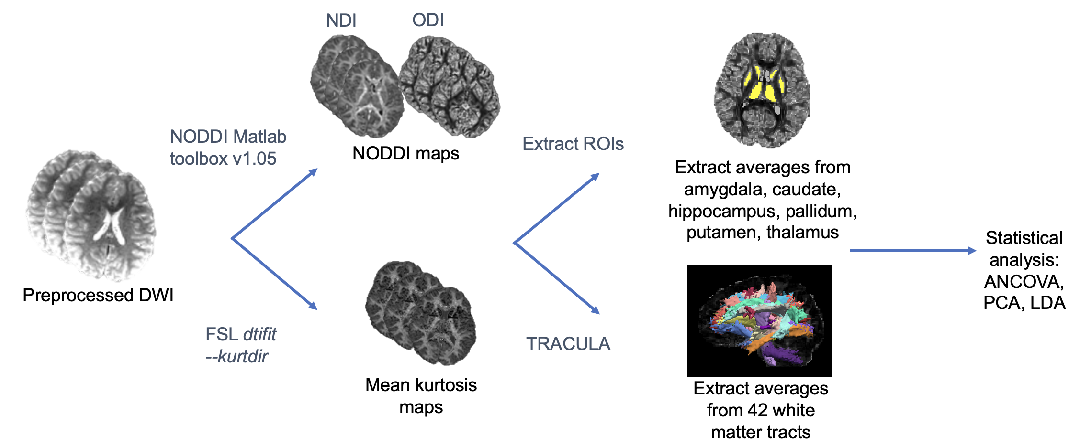

Supplementary Figure 1. Flowchart of data analysis pipeline.
ANOVA = analysis of covariance; DWI = diffusion-weighted imaging; LDA = linear discriminant analysis; NDI = neurite density index; NODDI = neurite orientation dispersion and density imaging; ODI = orientation dispersion index; PCA = principal components analysis; ROI = region-of-interest; TRACULA = TRActs Constrained by UnderLying Anatomy.

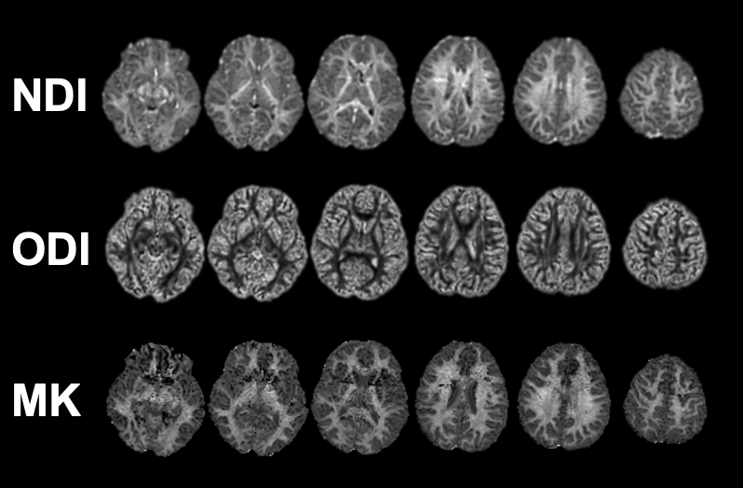
Supplementary Figure 2. NDI, ODI, and MK maps selected from a single participant showing identical slices.

NDI = neurite density index; ODI = orientation dispersion index; MK = mean kurtosis.

Supplementary Figure 3. A) NDI, B) ODI, and C) MK in each of the subcortical regions by diagnosis TD (blue), NF1 (pink), and NS (orange). * = p <.05; ** = .009 > p > .001; *** = p<.001. All p’s are Tukey-Kramer corrected.
NDI = neurite density index; NF1 = neurofibromatosis type 1; NS = Noonan syndrome; ODI = orientation dispersion index; MK = mean kurtosis; TD = typical developing.
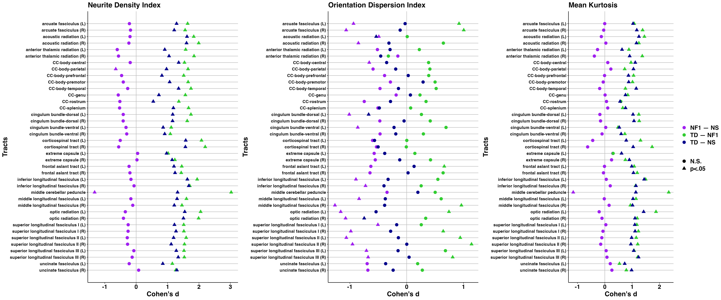
Supplementary Figure 4. Cohen’s d effect sizes for the NDI, ODI, and MK comparisons in each tract. Comparisons shown are NF1 vs NS (purple), TD vs NF1 (green), and TD vs NS (blue). Circles indicate the comparison is non-significant, whereas triangles indicate the comparison is significant at p<.05 Tukey-Kramer corrected.
CC = corpus callosum; L = left; NF1 = neurofibromatosis type 1; NS = Noonan syndrome; R = right; TD = typical developing.

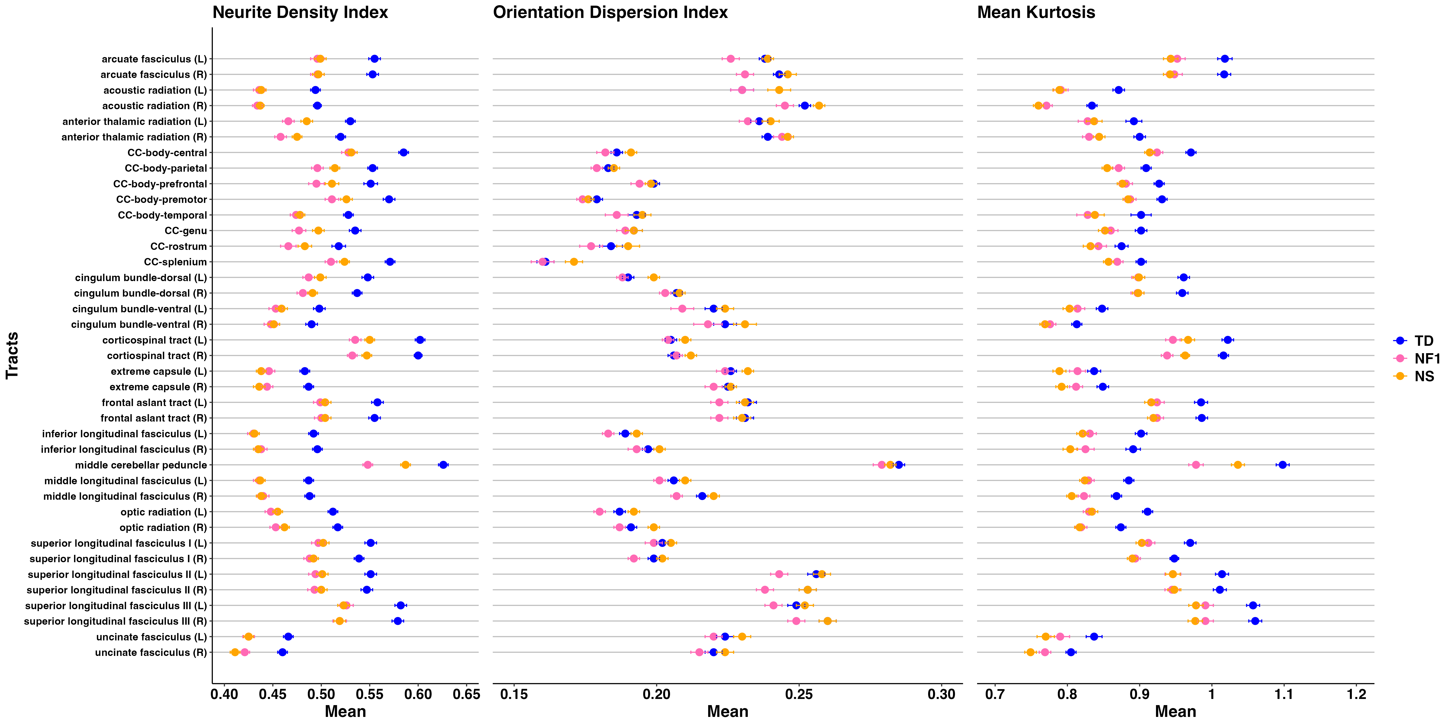
Supplementary Figure 5. Average values and standard errors in each tract for NDI, ODI, and MK.
Data points represent least square means and standard errors. CI = confidence interval; L = left; MK = mean kurtosis; NDI = neurite density index; NF1 = neurofibromatosis type 1; NS = Noonan syndrome; ODI = orientation dispersion index; R = right; TD = typical developing.

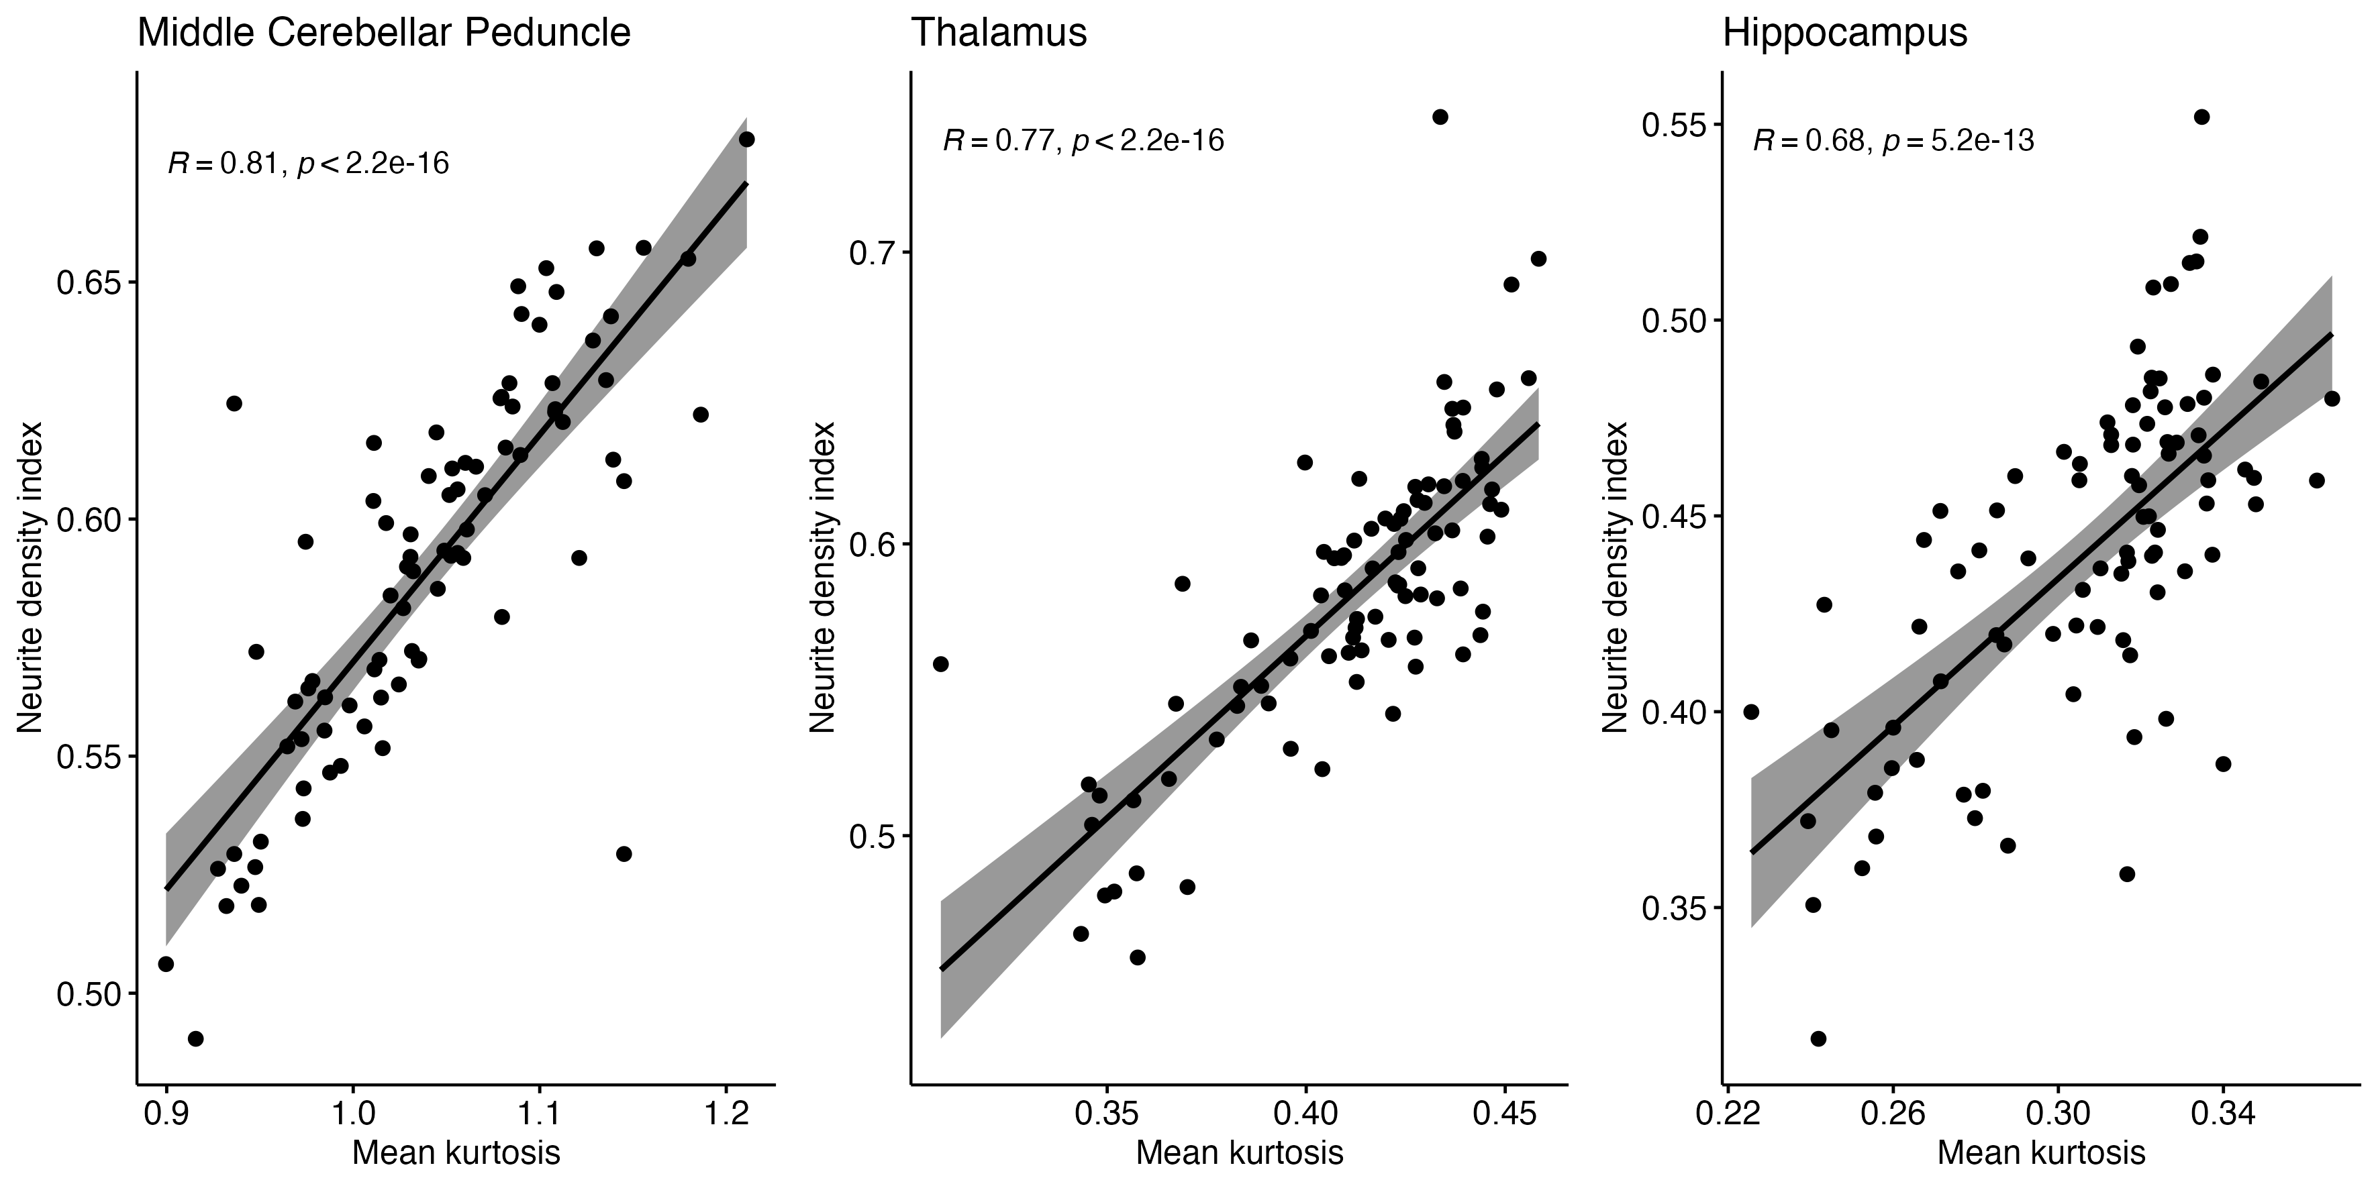

Supplementary Figure 6. Neurite density index plotted against mean kurtosis values from the middle cerebellar peduncle, thalamus, and hippocampus.

