Supplementary Figure 1: OPCs contribute to the phagocytosis of Aβ.
Low magnification image of OPCs (PDGFRα in green, Olig2 in red) surrounding CypHer5e-labeled Aβ oligomers 12 hours after they were injected into the parenchyma (representative image of n=6; from one independent experiment).

Supplementary Figure 2: VEGF does not mediate the effect of clusterin on OPC differentiation.
Expression of Mbp (A), Plp1 (B), and Myrf (C), measured by qPCR in OPCs cultured in proliferation media (OPC CTL), differentiation media (OLG CTL), differentiation media supplemented with 8µg/ml of clusterin (OLG CLU), differentiation media supplemented with 10µg/ml VEGF function-blocking antibody (OLG α-VEGF), or differentiation media supplemented with 8µg/ml of clusterin and 10µg/ml VEGF function-blocking antibody (OLG CLU α-VEGF) for 72 hours (n=5 for all conditions; from one independent experiment). Statistics calculated using a repeated measures one-way ANOVA with a Tukey’s post-hoc analysis; Mbp F(4,16)=28.66, Plp1 F(4,16)=49.31, Myrf F(4,16)=74.58. *p<0.05, **p<0.01, ***p<0.001 ****p<0.0001. All error bars represent SEM.
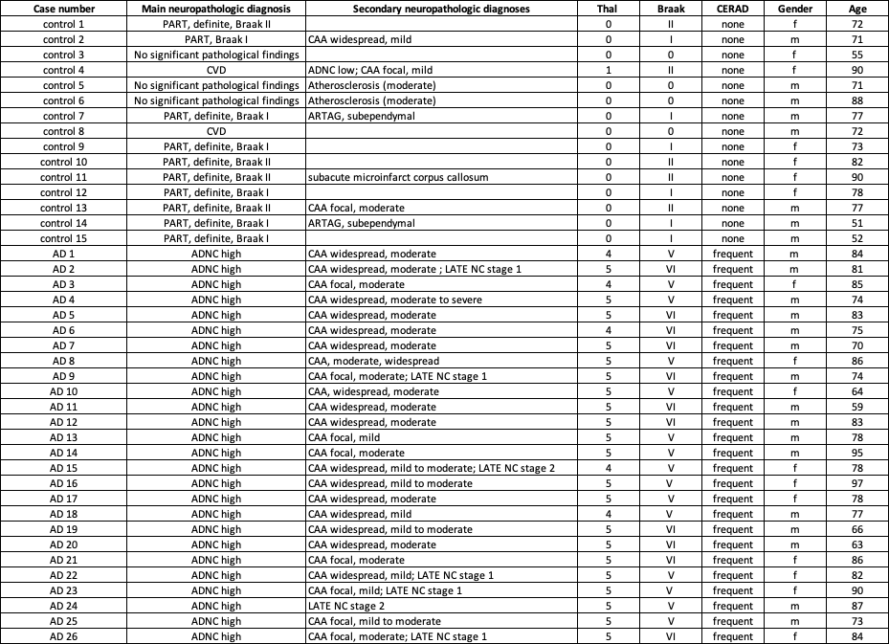
Supplementary Table 1: List of human cases used for Clusterin analysis (Fig 1A-B). Cases were analyzed by a board-certified neuropathologist according to current diagnostic guidelines for Alzheimer’s disease neuropathologic change (ADNC, PMID: 22101365, 22265587), Cerebral amyloid angiopathy (CAA, PMID: 25716356), Aging-related tau astrogliopathy (ARTAG, PMID: 26659578), Limbic-predominant age-related TDP-43 encephalopathy neuropathologic change (LATE NC, PMID: 31039256) and primary age-related tauopathy (PART, PMID: 25348064). Additional abbreviations used in the table: Braak – Braak stage; CVD – Cerebrovascular disease; Thal – Thal phase; CERAD - Consortium to establish a registry for Alzheimer's disease.

