Supplementary data
#1 | Lymphangitis [MeSH]
#2 | Carcinoma [MeSH]
#3 | #1 AND #2
#4 | “Lymphangitic carcinomas” [TIAB] OR “lymphangitic carcinomatosis” [TIAB] OR “Lymphangitis carcinomatosa” [TIAB] OR “lymphatic carcinomatosis” [TIAB] OR “carcinomatous lymphangitis” [TIAB] OR “cancerous lymphangitis” [TIAB]
#5 | #3 OR #4
PubMed search performed on Oct 12, 2020
Table 1. The search strategy for identifying studies relative to lymphangitic carcinomastosis
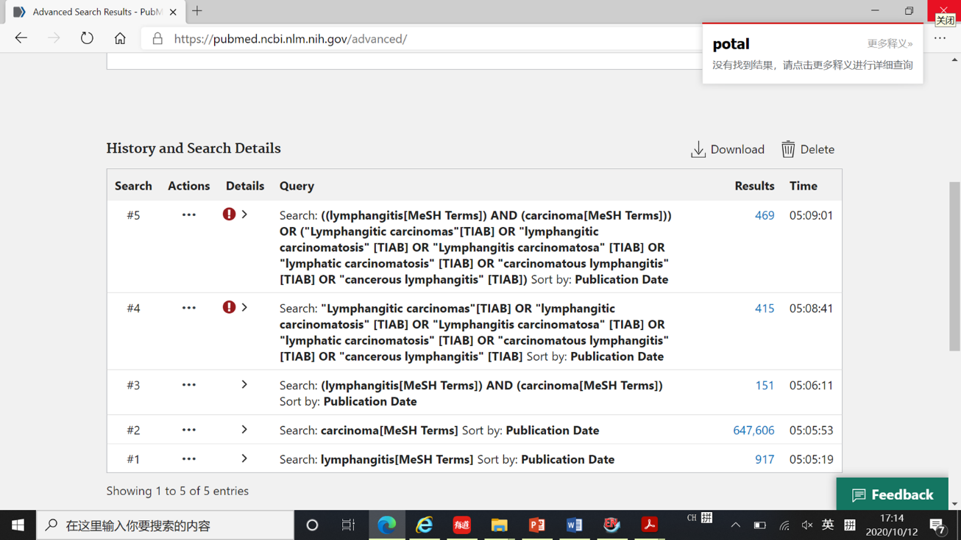
Figure 1. The screenshot of the retrieving page

Studies involving lymphangitic carcinomatosis identified through PubMed searching (469)
PLC secondary to known malignancies (73)
Without available abstracts or full-text to confirm the detailed information (57)
Case series related to PLC which did not record necessary information for each case (42)
PLC without clinical symptoms confirmed after malignancy diagnosis (19)
Review (14)
Comment (3)
Preclinical study (1)
Images (1)
Unrelated to PLC (181)
288 studies involving PLC for further assessment
Full-text studies (66) and abstracts (12) reporting PLC as the initial presentation of malignancy were included
Full-text studies (6) and abstract (1) eligible identified by hand-search
10 patients included in 8 studies and 2 patients reported in case series without definite/probable primary sites
1 case was repeatedly reported in two studies
1 case reported in this study
78 studies including 96 patients were identified
Pooled data from 97 cases for analysis
A total of 86 studies including 109 cases for further assessment

Figure 2. Flow diagram of the study

