Supplementary Data
Biological evaluation and synthesis of hexahydro-11H-benzo[a]xanthen-11-one and chromeno[2,3-b]pyridine-3-carbonitrile derivatives Using recyclable and an Engineered Palladium Based Nano Magnetic Catalyst (Fe₃O₄@SiO₂/Si(CH₂)₃NH/HMPO/Pd(OAc)₂)
Mohammad Reza Poor Heravi^{1,2*}, Mahdi Lashgari², Esmail Vessally², Bagher Mohammadi²
¹Department of Chemistry, College of Arts and Sciences, Drexel University, 32 South 32nd St, Disque Hall 305, Philadelphia, PA 19104, USA.
²Department of Chemistry, Payame Noor University, P.O. Box 19395-3697, Tehran, Iran

12-(4-methoxyphenyl)-9,9-dimethyl-8,9,10,12-tetrahydro-11H-benzo[a]xanthen-11-one (13b) White solid; mp=203-205 ºC; IR (KBr, cm⁻¹): 3051, 2948, 1645, 1509, 1377, 1224; ¹H NMR (400 MHz, DMSO-d₆): 0.90 (s, 3H, CH₃), 1.07 (s, 3H, CH₃), 2.10 (d, 1H, J=16 Hz, CH₂), 2.14 (s, 3H, CH₃), 2.34 (d, 1H, J=16 Hz, CH₂), 2.58 (d, 1H, J=17.6 Hz, CH₂), 2.69 (d, 1H, J=17.6 Hz, CH2), 5.52 (s, 1H, CH), 6.73-8.05 (m, 10Ar-H); ¹³C NMR (100 MHz, DMSO-d₆): 26.87, 26.94, 29.35, 32.49, 33.88, 50.78, 55.32, 105.74, 113.13, 115.08, 116.34, 118.48, 126.96, 128.47, 129.64, 131.70, 134.94, 139.69, 149.27, 158.69, 159.84, 162.25, 197.56; MS m/z (%): 384 (M+)⁺, 293, 237, 209, 181, 91.
12-(4-chlorophenyl)-9,9-dimethyl-8,9,10,12-tetrahydro-11H-benzo[a]xanthen-11-one (13c) White solid; mp=207-209 ºC; IR (KBr, cm⁻¹): 3057, 2948, 1642, 1509, 1371, 1221; ¹H NMR (400 MHz, DMSO-d₆): 0.88 (s, 3H, CH₃), 1.07 (s, 3H, CH₃), 2.14 (d, 1H, J=16 Hz, CH₂), 2.35 (s, 3H, CH₃), 2.59 (d, 1H, J=16 Hz, CH₂), 2.70 (d, 1H, J=17.6 Hz, CH₂), 5.59 (s, 1H, CH), 7.24-8.02 (m, 10Ar-H); ¹³C NMR (100 MHz, DMSO-d₆): 25.48, 27.47, 28.88, 31.10, 51.60, 107.03, 111.39, 114.42, 114.93, 114.61, 116.33, 117.45, 119.31, 126.83, 128.07, 131.46, 132.09, 134.41, 150.28, 153.01, 155.68, 157.84, 164.22, 195.69; MS m/z (%):388 (M+)⁺, , 307, 293, 237, 209, 151.
12-(2-hydroxyphenyl)-9,9-dimethyl-7a,8,11a,12-tetrahydro-11H-9l5-benzo[j]xanthen-11-one (13d) White solid; mp=221-223 ºC; IR (KBr, cm⁻¹): 3198, 3048, 2958, 1625, 1594, 1373, 1228; ¹H NMR (400 MHz, DMSO-d₆): 0.94 (s, 3H, CH₃), 1.08 (s, 3H, CH₃), 2.11 (d, 1H, J=16.4 Hz, CH₂), 2.35 (d, 1H, J=16.4 Hz, CH₂), 2.58 (d, 1H, J=17.2 Hz, CH₂), 2.72 (d, 1H, J=17.2 Hz, CH₂), 5.75 (s, 1H, CH), 6.60-8.33 (m, 10Ar-H), 9.69 (s, 1H, OH); ¹³C NMR (100 MHz, DMSO-d₆): 23.48, 29.47, 29.88, 35.10, 51.60, 106.03, 110.39, 113.42, 114.03, 116.61, 118.33, 119.45, 121.31, 124.83, 129.07, 131.46, 132.99, 135.41, 145.28, 157.01, 158.68, 159.84, 167.22, 195.69; MS m/z (%):370 (M+)⁺, 293, 237, 209, 181.

12-(4-bromophenyl)-9,9-dimethyl-8,9,10,12-tetrahydro-11H-benzo[a]xanthen-11-one (13e) White solid; mp=290-292 ºC; IR (KBr, cm⁻¹): 3057, 2948, 1640, 1509, 1371, 1221; ¹H NMR (400 MHz, DMSO-d₆): 0.88 (s, 3H, CH₃), 1.07 (s, 3H, CH₃), 2.14 (d, 1H, J=16.2 Hz, CH₂), 2.35 (s, 3H, CH₃), 2.59 (d, 1H, J=16.2 Hz, CH₂), 2.70 (d, 1H, J=17.6 Hz, CH₂), 5.59 (s, 1H, CH), 7.24-8.02 (m, 10Ar-H); ¹³C NMR (100 MHz, DMSO-d₆): 26.48, 29.47, 29.88, 32.10, 50.60, 106.03, 110.39, 112.42, 114.03, 115.61, 117.33, 117.45, 118.31, 125.83, 129.07, 130.46, 132.99, 133.41, 148.28, 154.01, 156.68, 156.84, 165.22, 196.69; MS m/z (%): 436 (M+2)⁺, 434 (M+)⁺, 307, 237, 181.
2-hydroxy-9,9-dimethyl-12-(p-tolyl)-8,9,10,12-tetrahydro-11H-benzo[a]xanthen-11-one (13f) White solid; mp=204-206 ºC; IR (KBr, cm⁻¹): 3173, 3060, 2955, 1625, 1543, 1378 1228; ¹H NMR (400 MHz, DMSO-d₆): 0.89 (s, 3H, CH₃), 1.07 (s, 3H, CH₃), 2.12 (d, 1H, J=16.5 Hz, CH₂), 2.34 (d, 1H, J=16.5 Hz, CH₂), 2.55 (d, 1H, J=17.4 Hz, CH₂), 2.68 (d, 1H, J=17.4 Hz, CH₂), 5.30 (s, 1H, CH), 6.90-7.77 (m, 9Ar-H), 9.91 (s, 1H, OH); ¹³C NMR (100 MHz, DMSO-d₆): 20.97, 26.64, 29.33, 32.32, 34.24, 50.55, 105.64, 113.83, 114.08, 116.14, 117.47, 125.96, 128.47, 129.15, 130.70, 132.97, 135.69, 142.27, 148.04, 156.69, 156.84, 164.25, 196.46; MS m/z (%): 386 (M+2)⁺, 384 (M+)⁺, 237, 209, 181, 152, 91.
9,9-dimethyl-12-(p-tolyl)-8,9,10,12-tetrahydro-11H-benzo[a]xanthen-11-one (13g) Cream solid; mp=153-155 ºC; IR (KBr, cm⁻¹): 3008, 2947, 1644, 1370, 1232; ¹H NMR (400 MHz, DMSO-d₆): 0.89 (s, 3H, CH₃), 1.07 (s, 3H, CH₃), 2.11 (d, 1H, J=16 Hz, CH₂), 2.14 (s, 3H, CH₃), 2.34 (d, 1H, J=16 Hz, CH₂), 2.58 (d, 1H, J=17.6 Hz, CH₂), 2.70 (d, 1H, J=17.6 Hz, CH₂),5.53 (s, 1H, CH), 6.97-8.05 (m, 10Ar-H); ¹³C NMR (100 MHz, DMSO-d₆): 26.48, 29.47, 29.88, 32.10, 50.60, 106.03, 110.39, 112.42, 114.03, 115.61, 117.33, 117.45, 118.31, 125.83, 129.07, 130.46, 132.99, 133.41, 148.28, 154.01, 156.68, 156.84, 165.22, 196.69; MS m/z (%):368 (M+)⁺, 293, 209, 181.
2-hydroxy-12-(4-methoxyphenyl)-9,9-dimethyl-8,9,10,12-tetrahydro-11H-benzo[a]xanthen-11-one (13h) yellow solid; mp=283-285 ºC; IR (KBr, cm⁻¹): 3193, 3085, 2965, 1625, 1443, 1378 1233; ¹H NMR (400 MHz, DMSO-d₆): 0.87 (s, 3H, CH₃), 1.07 (s, 3H, CH₃), 2.12 (d, 1H, J=16.6 Hz, CH₂), 2.34 (d, 1H, J=16.6 Hz, CH₂), 2.55 (d, 1H, J=17.2 Hz, CH₂), 2.68 (d, 1H, J=17.2 Hz, CH₂), 3.64 (s, 3H, OCH₃), 5.31 (s, 1H, CH), 6.75-7.79 (m, 9Ar-H), 9.21 (s, 1H, OH); ¹³C NMR (100 MHz, DMSO-d₆): 26.97, 26.34, 29.33, 32.39, 33.84, 50.75, 55.32, 105.64, 113.93, 114.08, 116.34, 117.48, 125.96, 129.47, 129.64, 130.70, 132.94, 137.69, 146.27, 156.69, 157.84, 164.25, 196.56; MS m/z (%): 402 (M+2)⁺, 400 (M+)⁺, 316, 293, 237, 209, 91, 181, 152, 91.
12-(4-chlorophenyl)-2-hydroxy-9,9-dimethyl-8,9,10,12-tetrahydro-11H-benzo[a]xanthen-11-one (13i) yellow solid; mp=307-309 ºC; IR (KBr, cm⁻¹): 3050, 3015, 2961, 1626, 1553, 1378 1230; ¹H NMR (400 MHz, DMSO-d₆): 0.87 (s, 3H, CH₃), 1.07 (s, 3H, CH₃), 2.12 (d, 1H, J=16.5 Hz, CH₂), 2.34 (d, 1H, J=16.5 Hz, CH₂), 2.55 (d, 1H, J=17.5 Hz, CH₂), 2.68 (d, 1H, J=17.5 Hz, CH₂), 5.36 (s, 1H, CH), 6.96-7.79 (m, 9Ar-H), 9.94 (s, 1H, OH); ¹³C NMR (100 MHz, DMSO-d₆): 26.65, 29.32, 32.39, 33.84, 34.112, 50.75, 105.64, 113.23, 114.08, 115.34, 117.48, 125.96, 129.97, 129.44, 130.50, 131.94, 134.69, 145.27, 148.10, 156.69, 157.84, 164.65, 196.53; MS m/z (%): 406 (37Cl, M+2)⁺, 404 (35Cl, M+)⁺, 293, 237, 209, 91, 181, 152.
12-(2-chlorophenyl)-2-hydroxy-9,9-dimethyl-8,9,10,12-tetrahydro-11H-benzo[a]xanthen-11-one (13j) yellow solid; mp=279-283 ºC; IR (KBr, cm⁻¹): 3396, 3156, 2848, 1625, 1590, 1375, 1228;; ¹H NMR (400 MHz, DMSO-d₆): 0.90 (s, 3H, CH₃), 1.07 (s, 3H, CH₃), 2.09 (d, 1H, J=16.2 Hz, CH₂), 2.34 (d, 1H, J=16.2 Hz, CH₂), 2.57 (d, 1H, J=17.2 Hz, CH₂), 2.71 (d, 1H, J=17.2 Hz, CH₂), 5.62 (s, 1H, CH), 7.01-7.77 (m, 9Ar-H), 9.92 (s, 1H, OH); ¹³C NMR (100 MHz, DMSO-d₆): 26.54, 29.42, 32.18, 34.84, 50.61, 106.04, 112.63, 114.03, 115.14, 117.48, 125.90, 129.87, 131.44, 132.50, 133.94, 134.69, 135.27, 142.10, 148.98, 156.69, 157.84, 157.87, 158.65, 164.75, 196.03; MS m/z (%): 406 (37Cl, M+2)⁺, 404 (35Cl, M+)⁺, 369, 293, 237, 209, 181, 152.
2-hydroxy-12-(2-hydroxyphenyl)-9,9-dimethyl-8,9,10,12-tetrahydro-11H-benzo[a]xanthen-11-one (13k) white solid; mp=267-278 ºC; IR (KBr, cm⁻¹): 3316, 3053, 2956, 1626, 1587, 1384, 1224; ¹H NMR (400 MHz, DMSO-d₆): 0.94 (s, 3H, CH₃), 1.07 (s, 3H, CH₃), 2.11 (d, 1H, J=16.3Hz, CH₂), 2.34 (d, 1H, J=16 .2 Hz, CH₂), 2.56 (d, 1H, J=17.2 Hz, CH₂), 2.69 (d, 1H, J=17.2 Hz, CH₂),5.52 (s, 1H, CH), 6.61-7.73 (m, 9Ar-H), 9.55 (s, 1H, OH), 9.80 (s, 1H, OH); ; ¹³C NMR (100 MHz, DMSO-d₆): 26.61, 29.47, 32.32, 40.86, 50.61, 106.27, 113.27, 114.03, 116.43, 117.27, 119.59, 125.86, 127.73, 128.73, 130.38, 130.63, 131.42, 133.52, 148.28, 154.28, 156.55, 165.13, 190.03; MS m/z (%):386 (M+)⁺, 293, 227, 227, 109, 171, 152.
2-hydroxy-12-(2-hydroxy-3-methoxyphenyl)-9,9-dimethyl-8,9,10,12-tetrahydro-11H-benzo[a]xanthen-11-one (13l) white solid; mp=269-271 ºC; IR (KBr, cm⁻¹): 3450, 3115, 3060, 2941, 1636, 1593, 1388 1228; ¹H NMR (400 MHz, DMSO-d₆): 0.91 (s, 3H, CH₃), 1.07 (s, 3H, CH₃), 2.10 (d, 1H, J=16.0 Hz, CH₂), 2.34 (d, 1H, J=16.0 Hz, CH₂), 2.53 (d, 1H, J=17.5 Hz, CH₂), 2.68 (d, 1H, J=17.5 Hz, CH₂), 5.56 (s, 1H, CH), 6.75-7.73 (m, 8Ar-H), 8.72 (s, 1H, OH), 9.79 (s, 1H, OH); ¹³C NMR (100 MHz, DMSO-d₆): 26.64, 28.88, 29.45, 32.14, 32.32, 50.65, 55.92, 106.21, 109.74, 113.32, 114.06, 116.67, 117.33, 119.33, 121.96, 125.84, 128.78, 130.38, 132.02, 133.52, 143.16, 148.12, 156.55, 158.42, 165.14, 197.11; MS m/z (%):416 (M+)⁺, 312, 293, 257, 241, 209, 181, 160, 152, 131.
12-(4-bromophenyl)-2-hydroxy-9,9-dimethyl-8,9,10,12-tetrahydro-11H-benzo[a]xanthen-11-one (13m) Cream solid; mp=309-312 ºC; IR (KBr, cm⁻¹): 3381, 3040, 2953, 1625, 1588, 1376, 1222; ¹H NMR (400 MHz, DMSO-d₆): 0.94 (s, 3H, CH₃), 1.07 (s, 3H, CH₃), 2.11 (d, 1H, J=16.0 Hz, CH₂), 2.34 (d, 1H, J=16 Hz, CH₂), 2.56 (d, 1H, J=17.4 Hz, CH₂), 2.69 (d, 1H, J=17.4 Hz, CH₂),5.47 (s, 1H, CH), 6.66-7.73 (m, 8Ar-H), 9.88 (s, 1H, OH), 9.94 (s, 1H, OH); ¹³C NMR (100 MHz, DMSO-d₆): 26.48, 29.47, 29.88, 32.10, 50.60, 106.03, 110.39, 112.42, 114.03, 115.61, 117.33, 117.45, 118.31, 125.83, 129.07, 130.46, 132.99, 133.41, 148.28, 154.01, 156.68, 156.84, 165.22, 196.69; MS m/z (%):466 (M+)⁺, 464, 307, 293, 237, 209, 181.

2,4-diamino-5-(1-hydroxynaphthalen-2-yl)-5H-chromeno[2,3-b]pyridine-3-carbonitrile (14a) Cream solid; mp=151-153 ºC; IR (KBr, cm⁻¹): 3425, 3358, 3262, 2924, 2207, 1611, 1403, 1218; ¹H NMR (400 MHz, DMSO-d₆): 5.74 (s, 1H, methine C-H), 6.23 (s, 2H, NH₂), 6.94-8.32 (m, 10H, ArH), 10.12 (s, 1H, OH); ¹³C NMR (100 MHz, DMSO-d₆): 71.14, 90.70, 116.77, 116.86, 119.84, 121.79, 122.78, 124.59, 125.01, 126.01, 126.49, 126.81, 127.80, 128.08, 128.52, 129.84, 133.74, 145.37, 150.44, 155.19, 157.19, 159.35, 159.96; MS m/z (%):380 (M+)⁺, 287, 237(100%), 171, 144, 115.
2,4-diamino-5-(1,5-dihydroxynaphthalen-2-yl)-5H-chromeno[2,3-b]pyridine-3-carbonitrile (14g) white solid; mp=290-292 ºC; IR (KBr, cm⁻¹): 3465, 3361, 3229, 2924, 2302, 1622, 1402, 1232; ¹H NMR (400 MHz, DMSO-d₆): 5.70 (s, 1H, methine C-H), 6.23 (s, 2H, NH₂), 6.46 (s, 2H, NH₂), 6.61-8.32 (m, 9H, ArH), 10.09 (s, 2H, OH); ¹³C NMR (100 MHz, DMSO-d₆): 70.87, 91.06, 114.96, 116.73, 119.59, 121.95, 122.58, 124.50, 125.83, 126.19, 126.56, 126.64, 127.76, 128.11, 133.39, 139.19, 145.46, 146.91, 154.83, 156.76, 157.04, 159.32, 159.61; MS m/z (%):396 (M+)⁺, 339, 313, 264, 237 (100%), 171, 160, 131.
2,4-diamino-5-(7-hydroxynaphthalen-1-yl)-9-methoxy-4H,5H-1l2-chromeno[2,3-b]pyridine-3-carbonitrile (14c) white solid; mp=206-208 ºC; IR (KBr, cm⁻¹): 3556, 3440, 3382, 3324, 3267, 3185, 2205, 1660, 1579, 1483, 1220; ¹H NMR (400 MHz, DMSO-d₆): 3.85 (s, 3H, OCH₃), 5.71 (s, 1H, methine C-H), 6.23 (s, 2H, NH₂), 6.47 (s, 2H, NH₂), 6.47-8.32 (m, 10H, ArH), 10.10 (s, 2H, OH); ¹³C NMR (100 MHz, DMSO-d₆): 56.22, 71.14, 90.60, 110.97, 116.80, 120.88, 121.74, 122.79, 124.21, 125.64, 125.97, 126.45, 126.83, 127.66, 128.07, 133.48, 139.09, 147.32, 147.93, 157.09, 157.16, 159.30, 159.93, 162.70; MS m/z (%):410 (M+)⁺, 287, 267 (100%), 261, 224, 195, 144, 115.
2,4-diamino-5-(2,7-dihydroxynaphthalen-1-yl)-9-methoxy-4H,5H-1l2-chromeno[2,3-b]pyridine-3-carbonitrile (14j) white solid; mp=315-317 ºC; IR (KBr, cm⁻¹): 3356, 3247, 3181, 2926, 2206, 1608, 14.04, 1224; ¹H NMR (400 MHz, DMSO-d₆): 3.85 (s, 3H, OCH₃), 6.09 (s, 1H, methine C-H), 6.23 (s, 2H, NH₂), 6.42 (s, 2H, NH₂), 6.67-7.82 (m, 14H, ArH), 10.69 (s, 2H, OH); ¹³C NMR (100 MHz, DMSO-d₆): 56.23, 71.09, 89.72, 110.86, 134.14, 140.08, 147.55, 155.13, 155.02, 155.68, 157.20, 158.87, 159.76, 162.82; MS m/z (%):426 (M+)⁺, 330, 303 (100%), 267, 252, 237, 224, 160 (100%), 131.
2,4-diamino-9-hydroxy-5-(1-hydroxynaphthalen-2-yl)-5H-chromeno[2,3-b]pyridine-3-carbonitrile (14b) white solid; mp=243-244 ºC; IR (KBr, cm⁻¹): 3465, 3361, 3229, 2824, 2202, 1622, 1402, 1232; ¹H NMR (400 MHz, DMSO-d₆): 5.71 (s, 1H, methine C-H), 6.24 (s, 2H, NH₂), 6.42 (s, 2H, NH₂), 6.60-7.82 (m, 10H, ArH), 9.70 (s, 2H, OH), 10.10 (s, 1H, Ar-OH); ¹³C NMR (100 MHz, DMSO-d₆): 71.27, 90.81, 114.93, 114.98, 116.87, 119.41, 121.61, 122.85, 124.18, 125.91, 126.00, 126.39, 126.82, 127.86, 128.02, 133.44, 139.34, 145.83, 147.29, 157.08, 157.13, 159.46, 159.81, 159.87; MS m/z (%):396 (M+)⁺, 287, 253 (100%), 237, 187, 144, 115.
2,4-diamino-5-(1,5-dihydroxynaphthalen-2-yl)-9-hydroxy-5H-chromeno[2,3-b]pyridine-3-carbonitrile (14i) white solid; mp=315-317 ºC; IR (KBr, cm⁻¹): 3356, 3247, 3181, 3324, 2926, 2206, 1608, 1404, 1224; ¹H NMR (400 MHz, DMSO-d₆): 6.07 (s, 1H, methine C-H), 6.03 (s, 2H, NH₂), 6.40 (s, 2H, NH₂), 6.41-7.58 (m, 8H, ArH), 9.95 (s, s, 3H, OH); ¹³C NMR (100 MHz, DMSO-d₆): 71.22, 90.83, 114.98, 116.88, 119.43, 121.63, 122.58, 124.18, 125.93, 126.05, 126.39, 126.85, 127.86, 128.08, 133.48, 139.36, 145.85, 147.29, 157.09, 157.14, 159.47, 159.82, 159.88; MS m/z (%):412 (M+)⁺, 303 (100%), 287, 253, 225, 211, 197.
2,4-diamino-7-bromo-5-(1-hydroxynaphthalen-2-yl)-5H-chromeno[2,3-b]pyridine-3-carbonitrile (14f) white solid; mp=186-188 ºC; IR (KBr, cm⁻¹): 3455, 3375, 3311, 3172, 2202, 1639, 1402, 1232; ¹H NMR (400 MHz, DMSO-d₆): 5.73 (s, 1H, methine C-H), 6.23 (s, 2H, NH₂), 6.54 (s, 2H, NH₂), 6.95-8.32 (m, 10H, ArH), 10.09 (s, 1H, OH); ¹³C NMR (100 MHz, DMSO-d₆): 71.14, 90.70, 116.74, 116.89, 119.84, 121.70, 122.81, 124.49, 125.03, 126.01, 126.52, 126.83, 127.79, 128.08, 128.47, 129.84, 133.44, 147.35, 150.44, 155.17, 157.15, 159.38, 159.96; MS m/z (%):460 (M+2)⁺, 458 (M⁺), 317, 227, 237, 144 (100%), 115.

2,4-diamino-7-bromo-5-(1,5-dihydroxynaphthalen-2-yl)-5H-chromeno[2,3-b]pyridine-3-carbonitrile (14h) white solid; mp=319-321 ºC; IR (KBr, cm⁻¹): 3465, 3375, 3311, 3152, 2201, 1654, 1407, 1222; ¹H NMR (400 MHz, DMSO-d₆): 5.62 (s, 1H, methine C-H), 6.17 (s, 2H, NH₂), 6.32 (s, 2H, NH₂), 6.52-7.77 (m, 8H, ArH), 10.00 (s, 1H, OH), 10.04 (s, 1H, OH); ¹³C NMR (100 MHz, DMSO-d₆): 70.87, 91.06, 114.96, 116.73, 119.59, 121.95, 122.58, 124.50, 125.83, 126.19, 127.76, 128.11, 133.39, 139.19, 145.46, 146.91, 154.83, 156.76, 157.04, 159.32, 159.61; MS m/z (%): 476 (M+2)⁺, 474 (M⁺), 456, 454, 317 (100%), 299, 237, 160, 131.
2,4-diamino-5-(1-hydroxynaphthalen-2-yl)-7-nitro-5H-chromeno[2,3-b]pyridine-3-carbonitrile (14d) white solid; mp=177-179 ºC; IR (KBr, cm⁻¹): 3465, 3361, 3229, 2202, 1622, 1402, 1232; ¹H NMR (400 MHz, DMSO-d₆): 5.83 (s, 1H, methine C-H), 6.31 (s, 2H, NH₂), 6.64 (s, 2H, NH₂), 7.04-8.32 (m, 9H, ArH), 10.19 (s, 1H, ArOH); ¹³C NMR (100 MHz, DMSO-d₆): 71.14, 90.73, 116.71, 116.88, 116.98, 121.79, 122.79, 124.59, 125.03, 126.01, 126.49, 126.83, 127.79, 128.08, 129.84, 133.48, 147.38, 150.45, 157.79, 155.45, 157.19, 159.38, 159.99; MS m/z (%):425 (M)⁺, 458 (M⁺), 282, 266, 144, 115.
(hydrazineylidenemethyl)pyridin-3-ol (HMPO) (7) White solid; mp=186-188 ºC; IR (KBr, cm⁻¹): 3451,3321, 3074, 1675, 1551, 1503, 1377, 1224; ¹H NMR (400 MHz, DMSO-d₆): 7.94-7.53 (t, 1H, HC=C), 1.07 (s, 3H, CH₃), 2.10 (d, 1H, J=16 Hz, CH₂), 2.14 (s, 3H, CH₃), 2.34 (d, 1H, J=16 Hz, CH₂), 7.90-7.96 (t, 1H, Ar-H), 8.09-8.20 (t, 1H, Ar-H), 8.54 (s, 2H, NH₂), 8.62-8.70 (s, 1H, Ar-H), 11.10 (s, 1H, OH); ¹³C NMR (100 MHz, DMSO-d₆): 117.75, 121.73, 133.12, 145.96, 148.10, 157.24; MS m/z (%): 137 (M+)⁺,91,

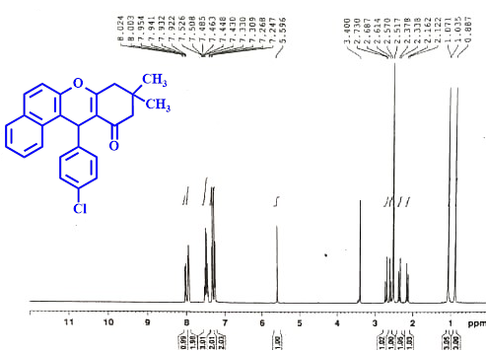
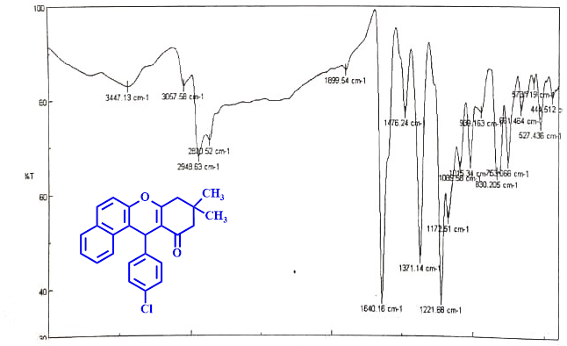

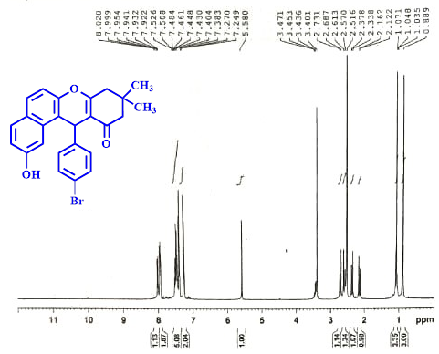
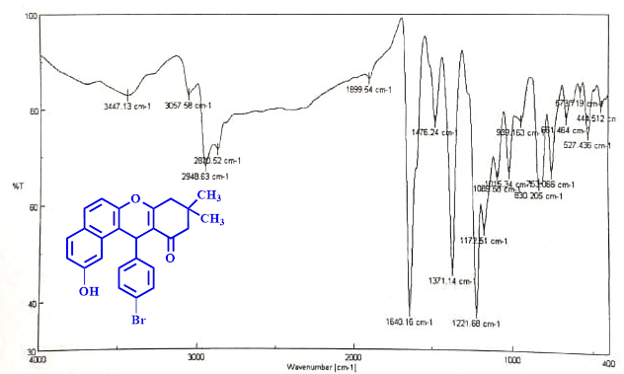
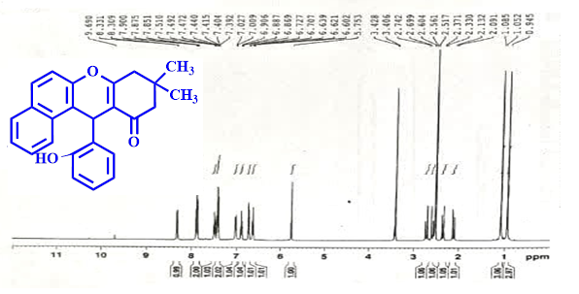
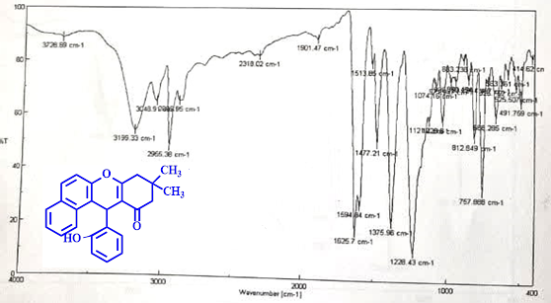
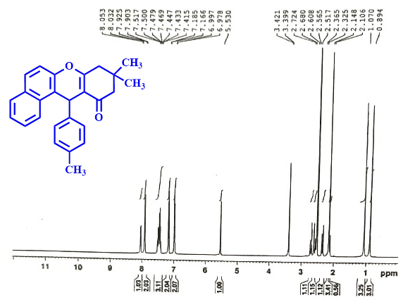
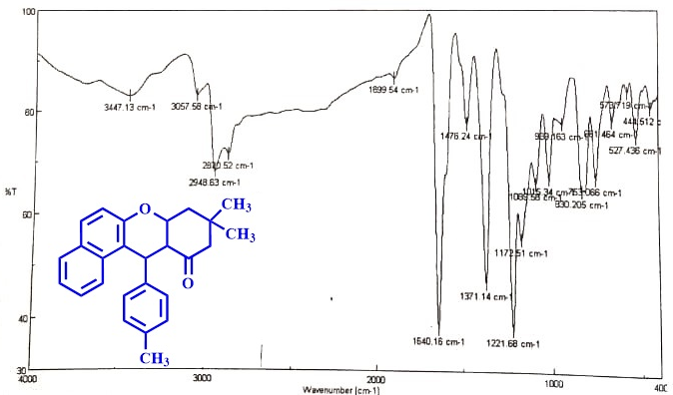

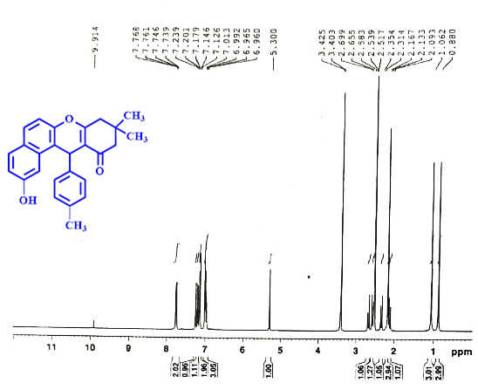
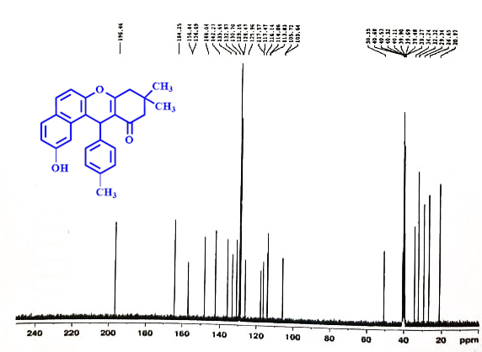
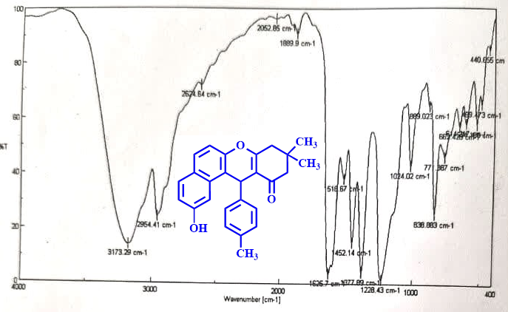

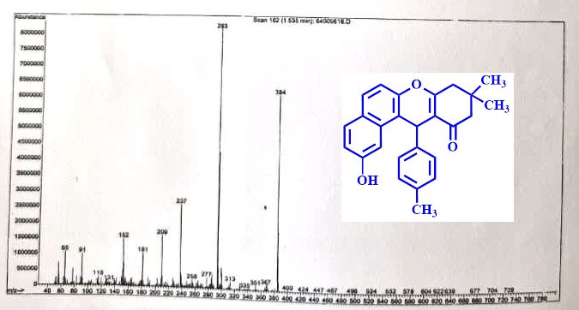

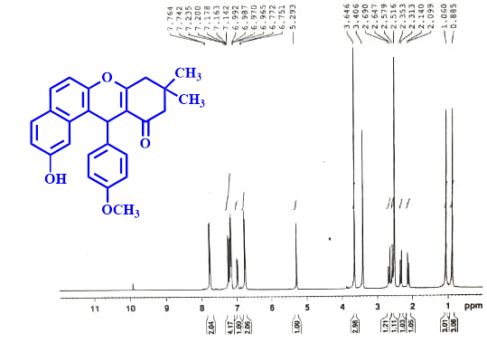
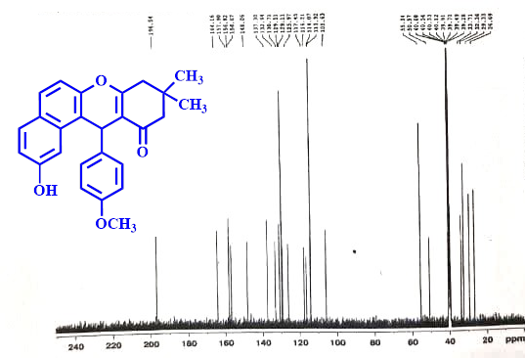

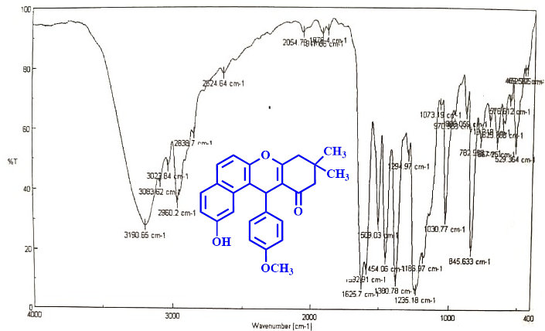

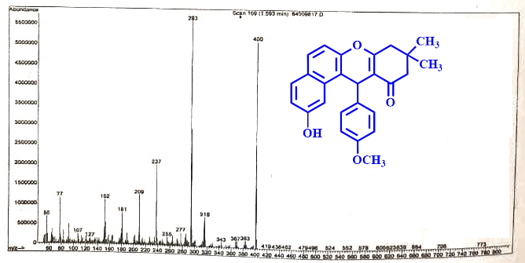

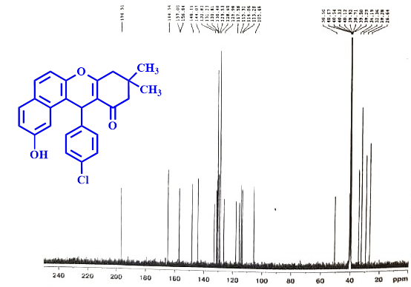
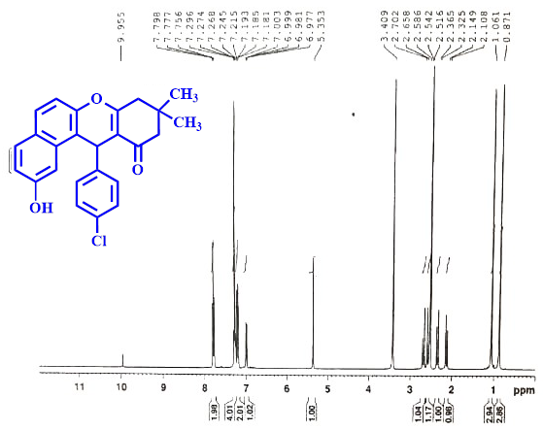

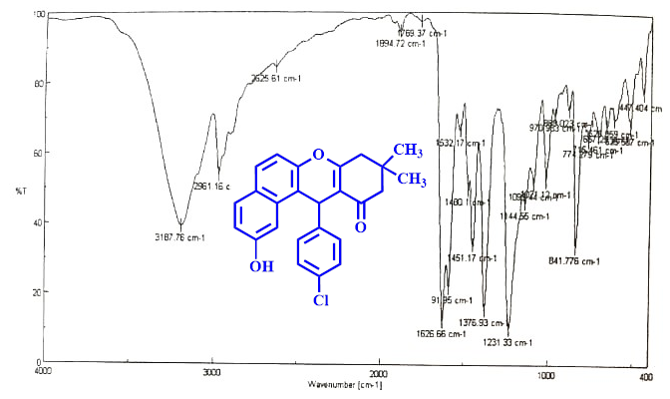

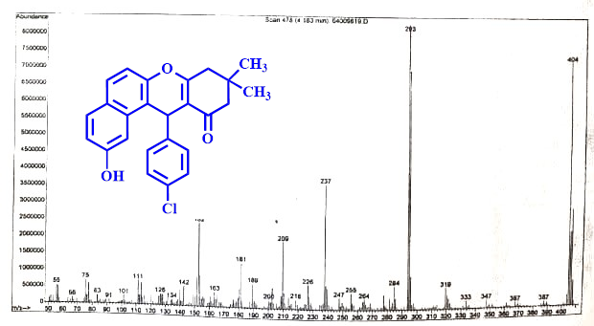

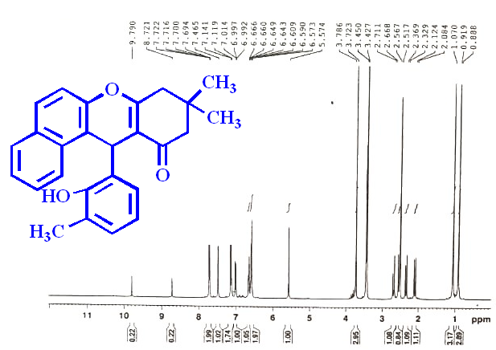
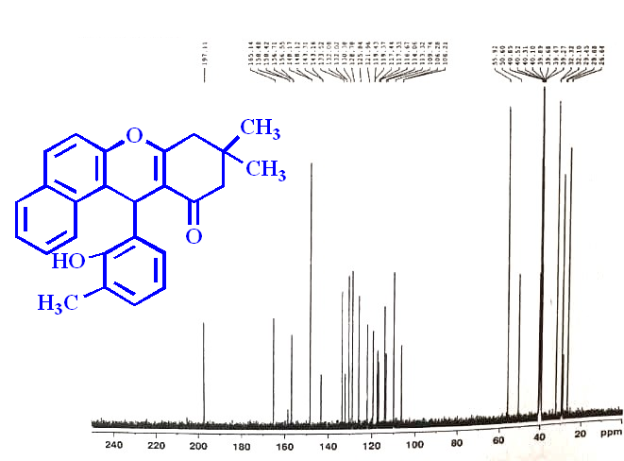

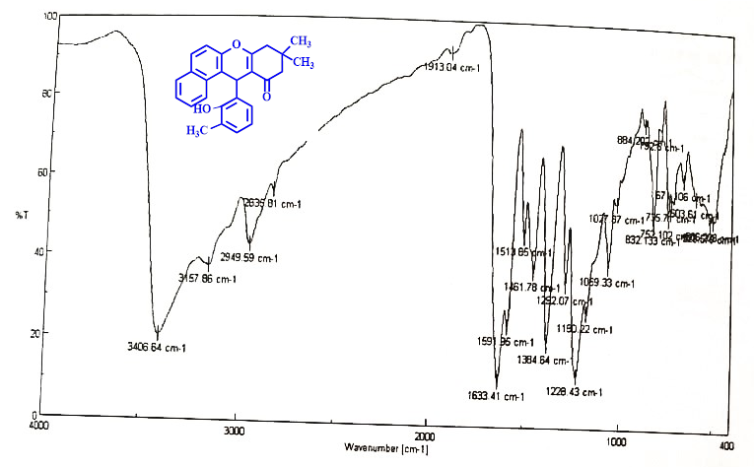

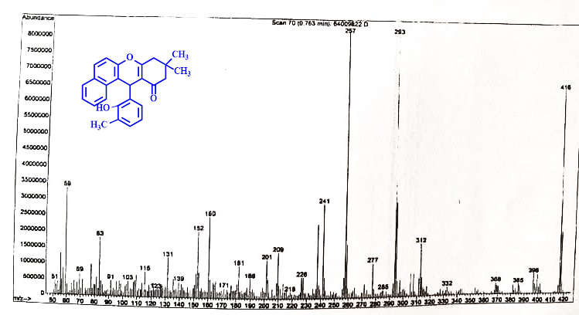

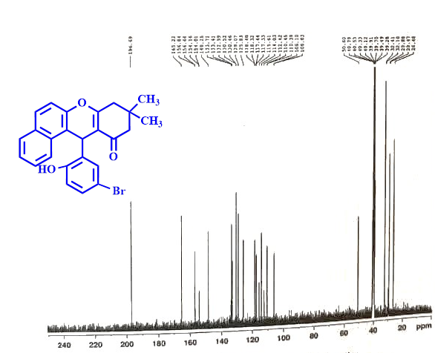
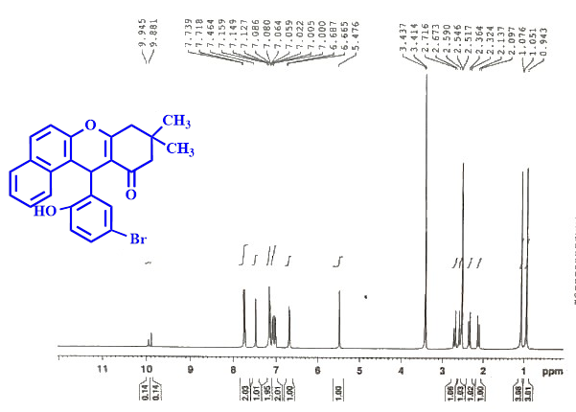
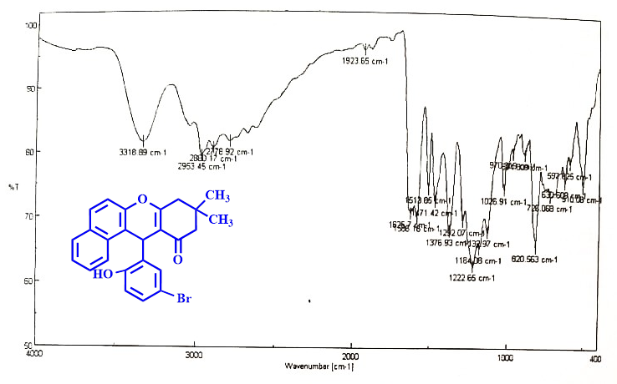

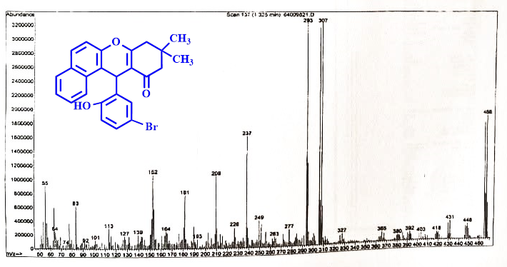

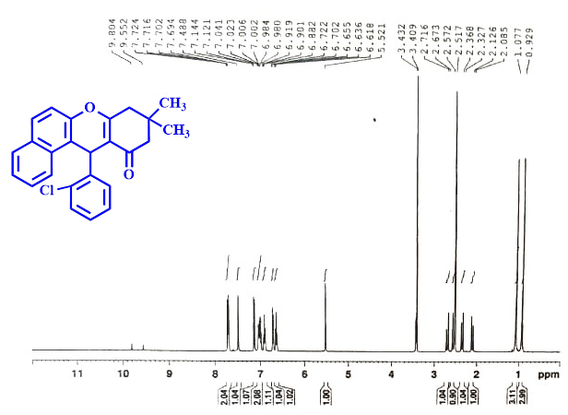
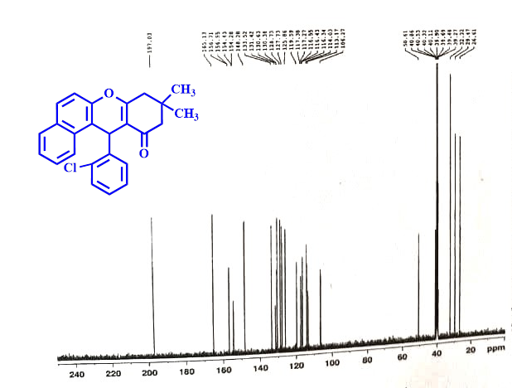
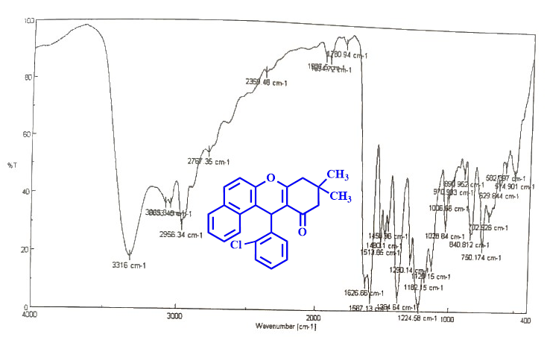
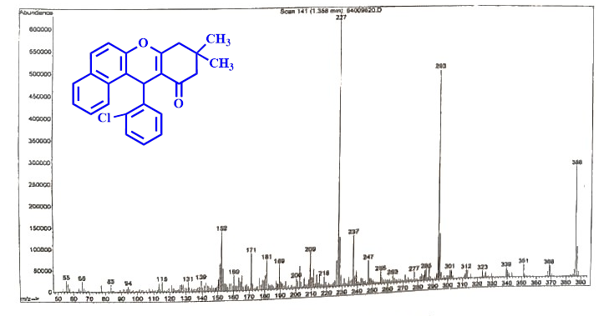

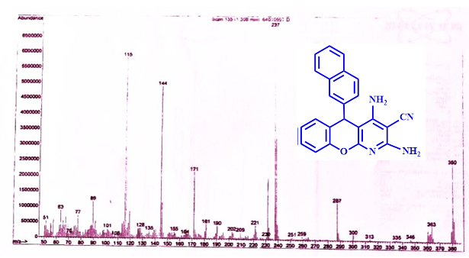
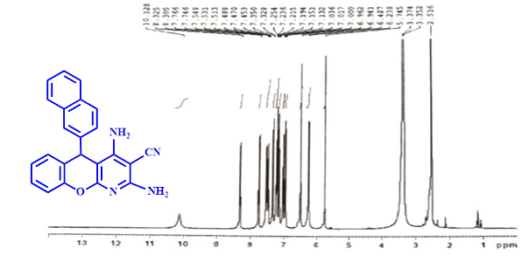

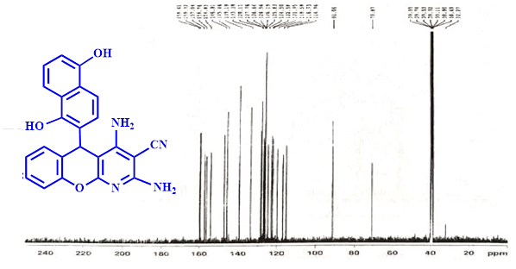
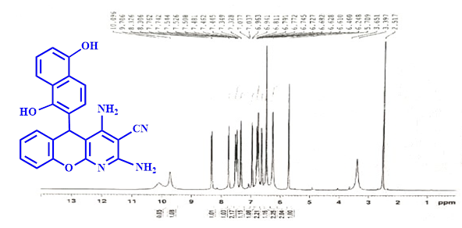

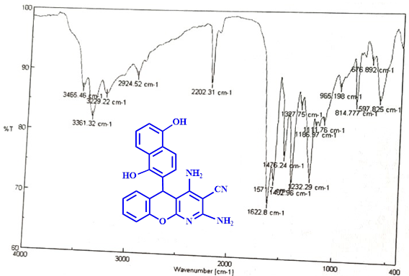

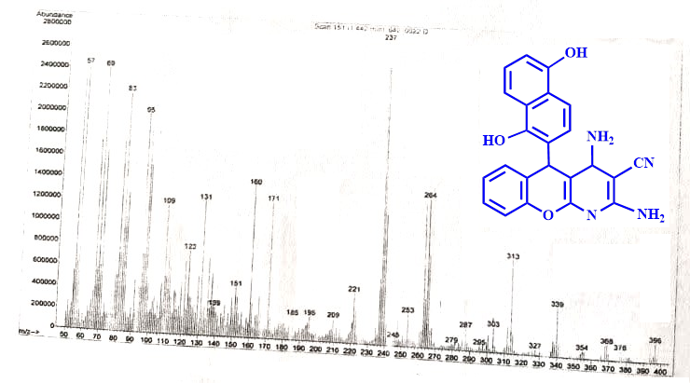

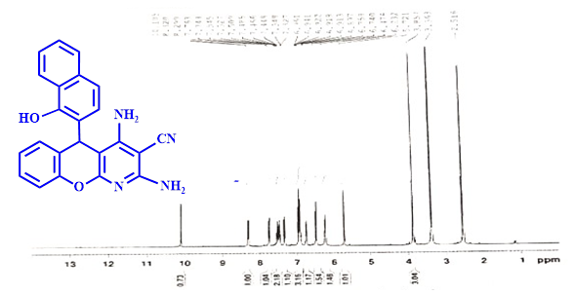

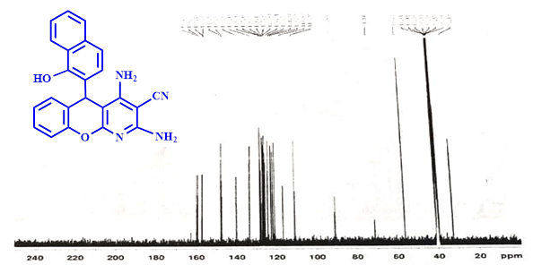

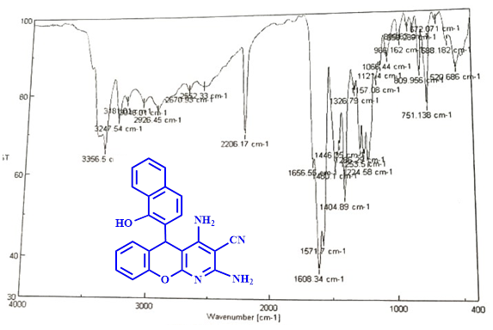
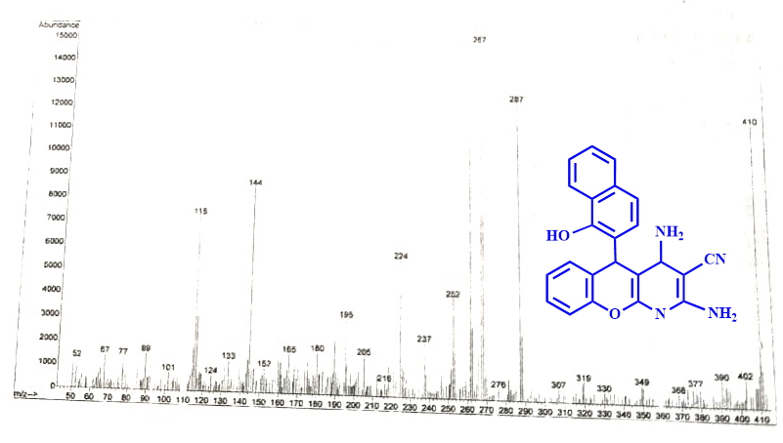
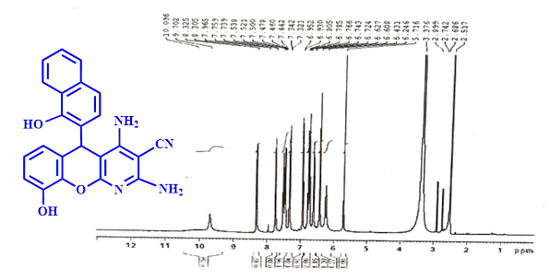

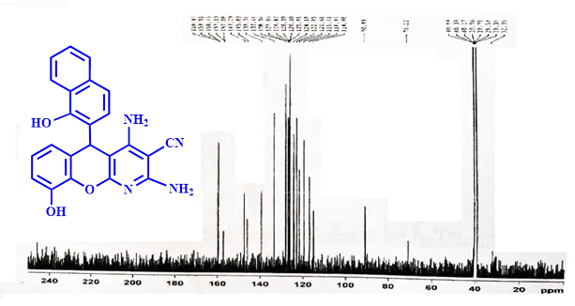
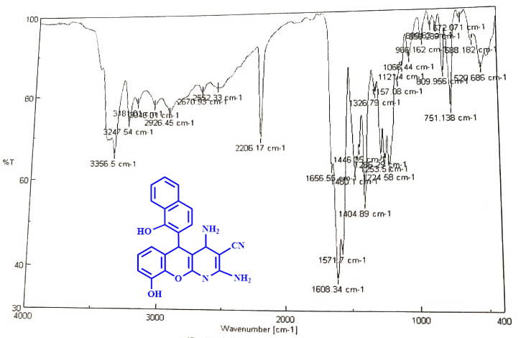
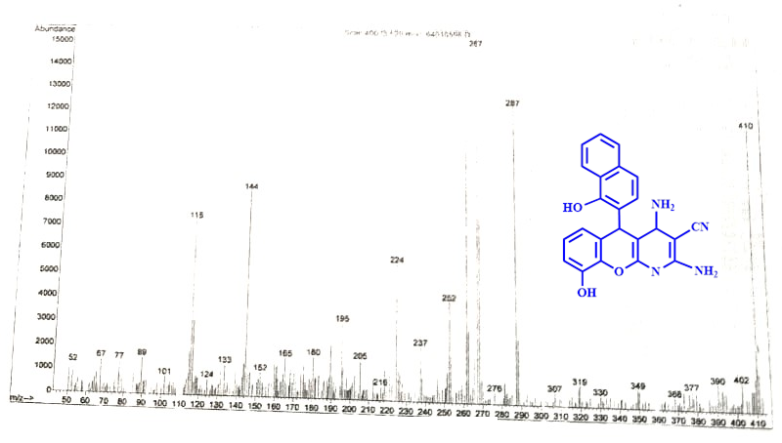
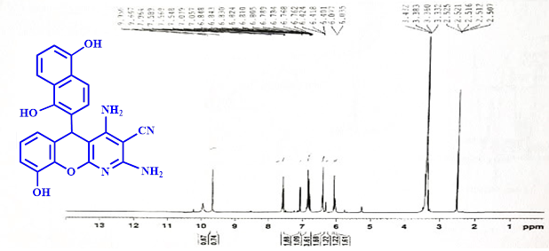
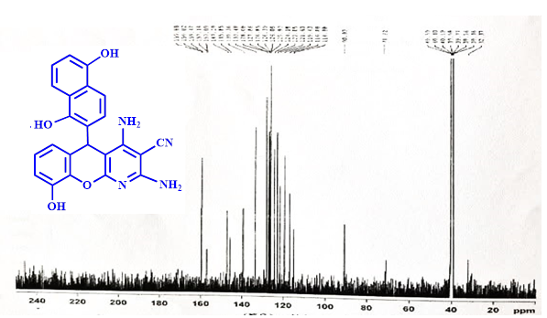

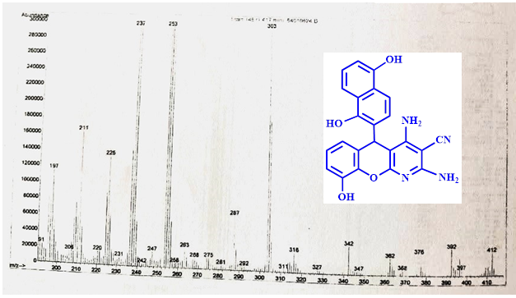
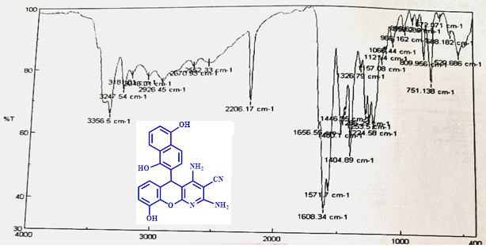

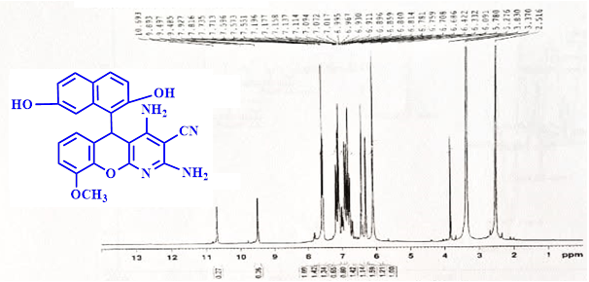
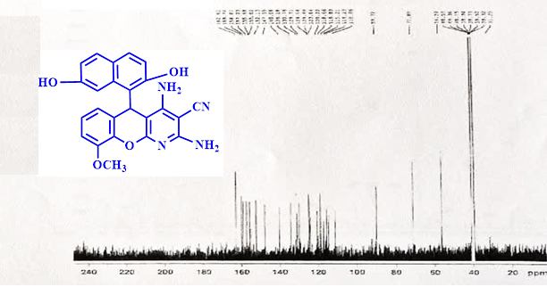
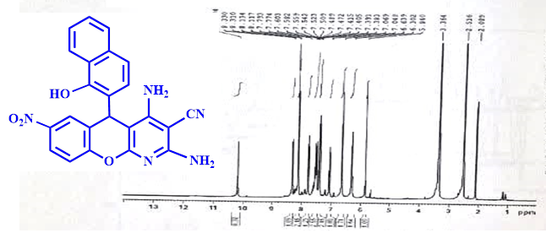
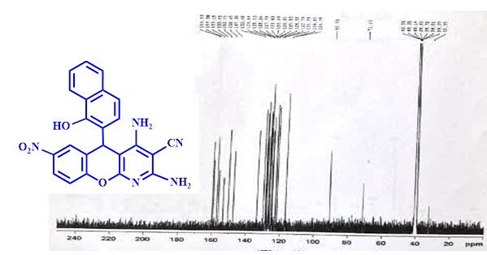

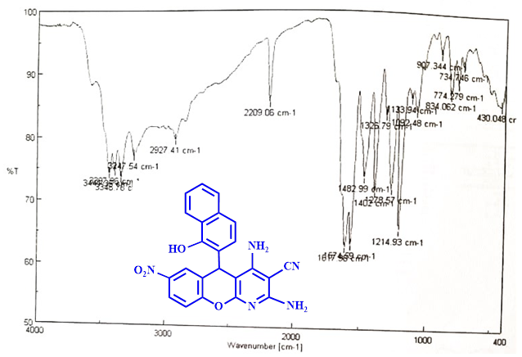
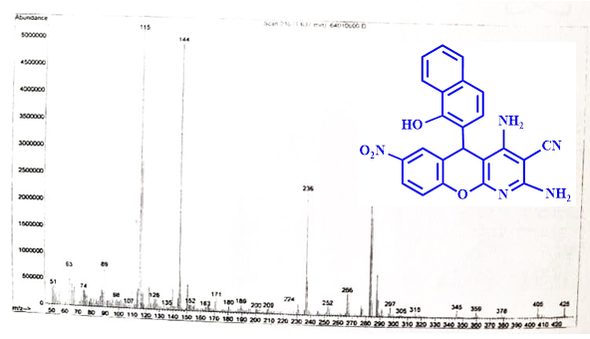
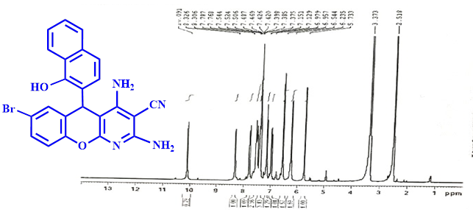
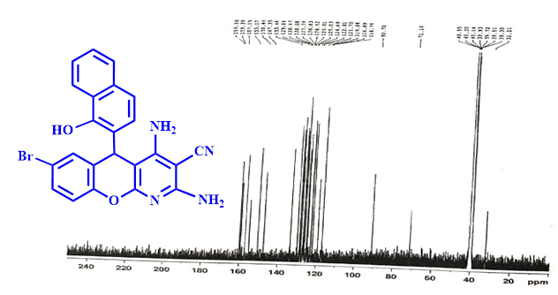
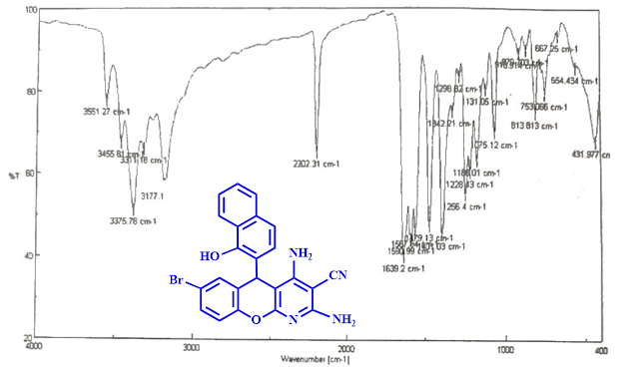
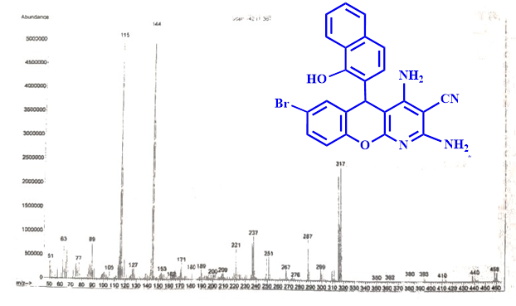

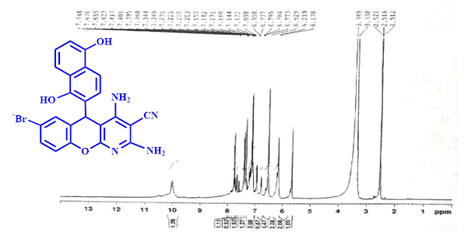
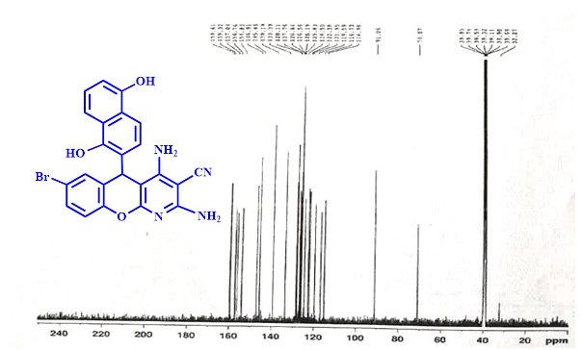
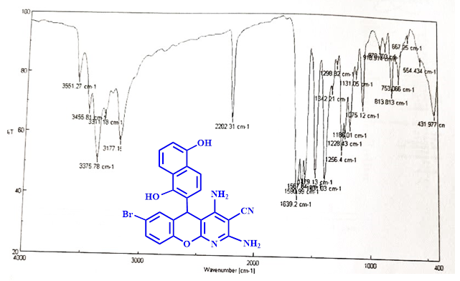

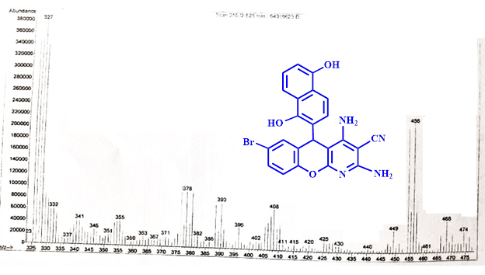
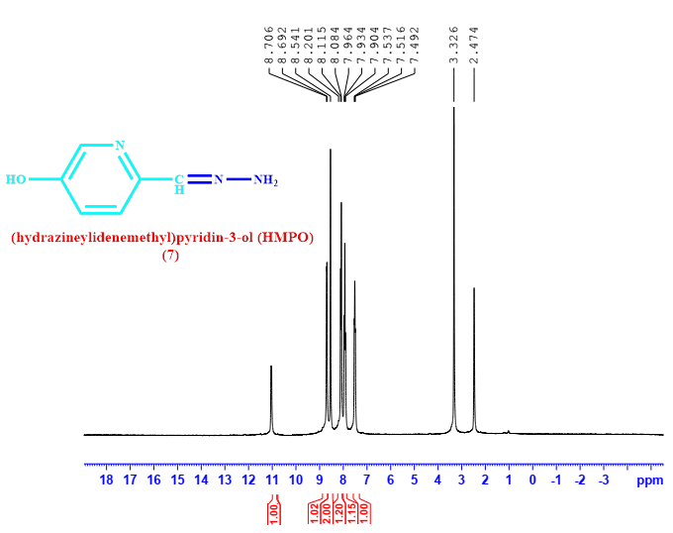
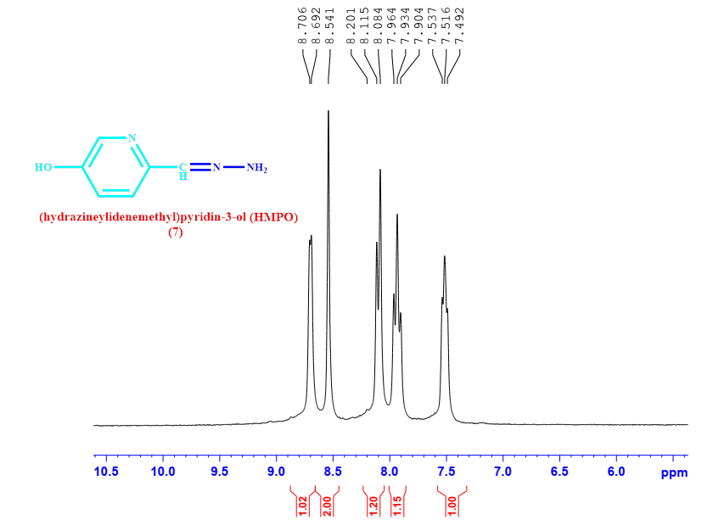

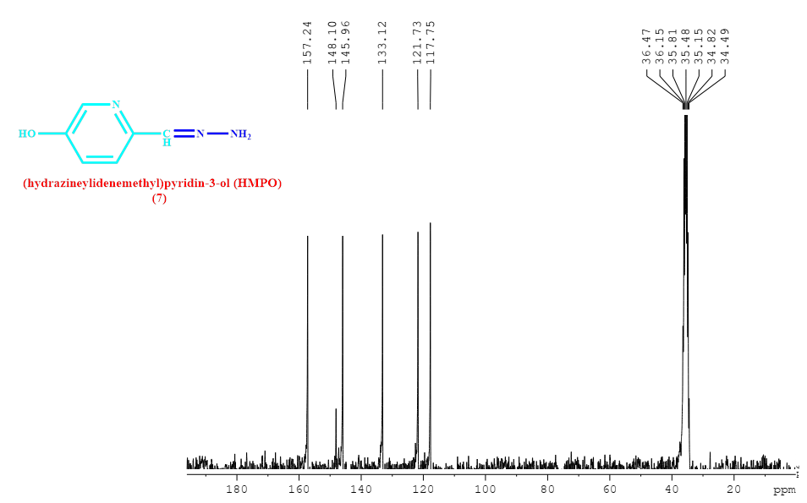
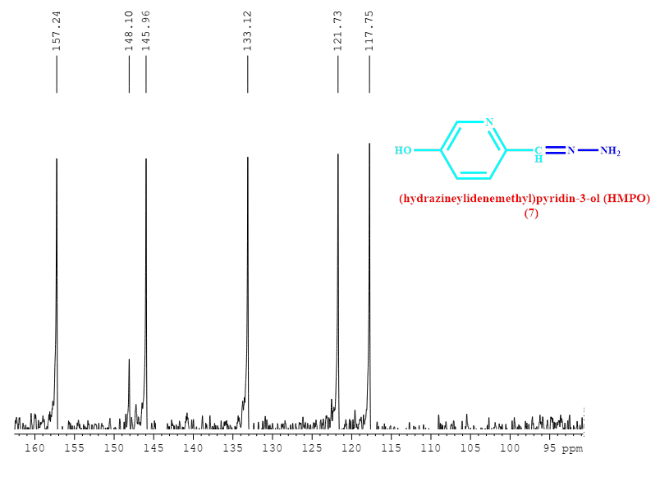

Calculated value:
Atom economy (AE):
AE = Molecular Weight of product ÷ Σ (Molecular Weight of stoichiometric reactants) × 100%

Atom efficiency (AEf):
Atom efficiency = (Yield × AE)/100
S6
E-factor or environmental (E) factor:
E-factor = [Total mass of wastes]/ Mass of product
Total mass of waste = Total mass of raw materials - Total mass of product For compound 4g

Reaction mass efficiency (RME):
RME = Mass of isolated product / Σ (Mass of stoichiometric reactants) × 100%

Process mass intensity (PMI):
PMI = Σ (Mass of stoichiometric reactants + solvent) / Mass of product

Carbon efficiency (CE):
CE = (Amount of carbon in the product/Total carbon present in reactant) × 100%

