APPENDIX
Appendix A: Sensitivity of the Multi-Lens-based SPECT
The sensitivity was studied for the array of Laue lenses by means of dedicated Monte Carlo simulations performed in MATLAB. We set a ray counter at the entrance and exit of the Laue lens plane to study the contribution of the array of Laue lenses for different shifts and depths of the gamma ray source. The ray counter counts the rays incident on the lenses (N₀) and the diffracted photons emerging from the lenses (N*). Then, the sensitivity is calculated as the ratio N*/N₀. The phantom under study (the three-point sphere depicted in Figure. 2a) was placed at various axial shifts and depths within the lenses’ FOV, representing possible experimental scenarios for the analysis. The order of the Laue lenses is shown in Figure. A.1. The sensitivity counter for the nine Laue lenses is shown in Figure. A.2, the figure shows the percentage of the diffracted/incident ration for the 9 Laue lenses, the symmetry between the lenses is considered.
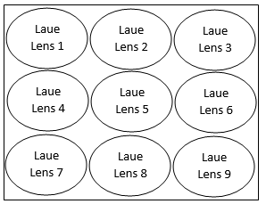
Figure. A.1. The lenses order in the multi-Laue-lens geometry. The counter records for the diffracted photons per each lens is recorded in Table A.2:

Figure. A.2. The sensitivity counter for the nine Laue lenses.

Appendix B: The Forward Projection Algorithm
The pseudo-code for the lens-based SPECT forward projection algorithm is shown in Figure. B.1. The ray tracing in the forward projection is conditional on identifying the radiation to be traced based on Laue lens Bragg's angle requirement. The algorithm generates random points within the spherical phantom. The algorithm uses a custom function to generate random azimuthal and polar angles for every arbitrary point. These angles are critical in determining the ray’s cosine direction. The angles between the randomly generated rays and the outer and inner rings of the Laue lens are used to calculate the maximum and minimum divergence from the lens axis. Despite having an isotropic source, we only considered photons generated towards the lens to shorten the simulation execution time. The ray vector of photons incident on the Laue lens with a random direction is determined, the deviation of the ray vector from.
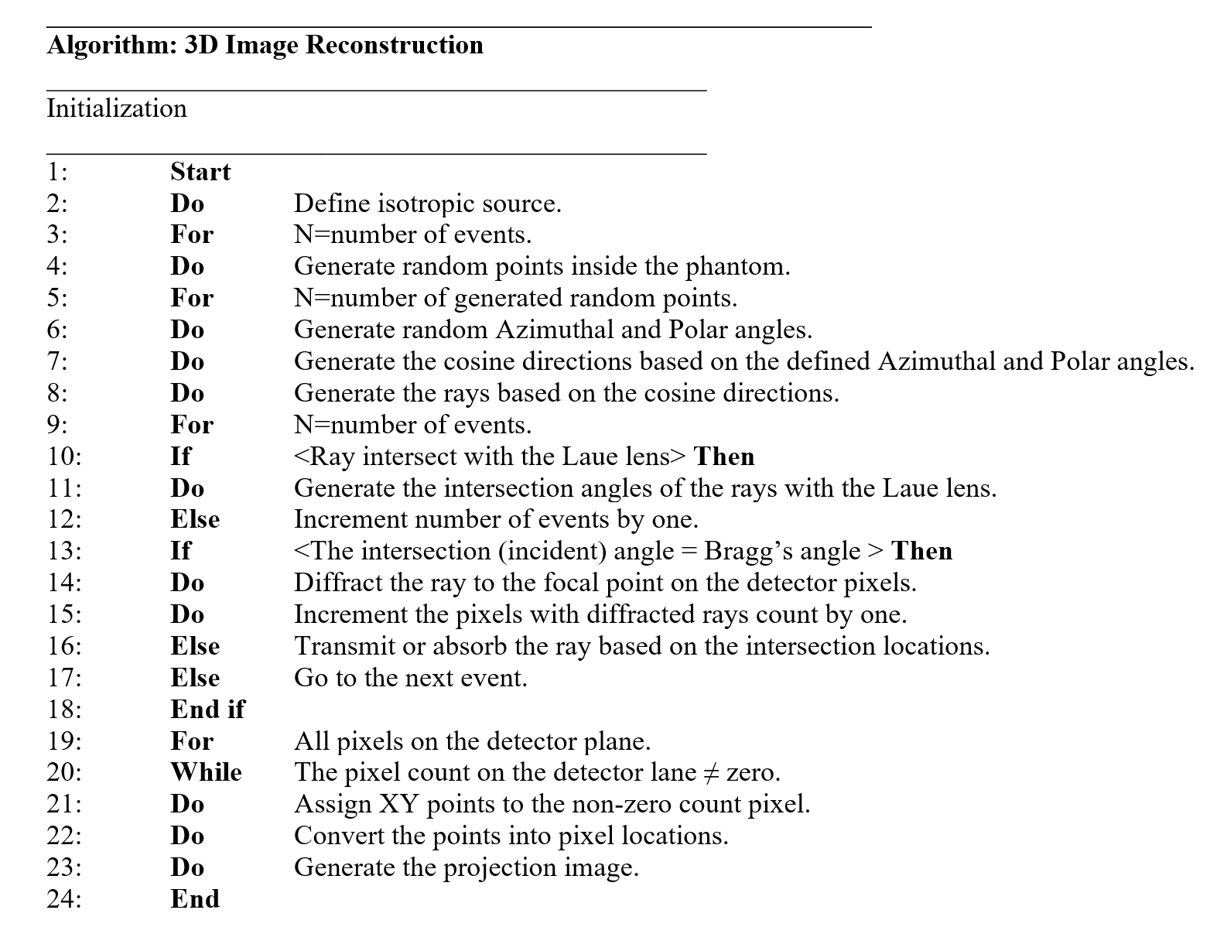
Figure. B.1. The Pseudo-Code for the Lens-based SPECT forward projection.

Appendix C: 3D Image Reconstruction
The algorithm generates random points inside each lens. This is followed by generating radiations back projected towards the random points within the Laue lens plane by assigning each point (X, Y, Z) on the sensor plane with a randomly generated azimuthal and polar angle using a custom-made random function comparable to the one used for the forward projection. These angles are crucial in determining the cosine directions of the generated rays. It is vital to propagate the rays according to the defined deviation limits to project back towards the Laue collimator plane. At the Laue lenses’ plane, the algorithm determines two main critical criteria for radiation. First, ascertain from which lens the radiation originates. The second, to determine the direction probability for the back-projected beams towards the voxel, to be either absorbed, diffracted or transmitted. The direction probability involves searching for the likelihood angle for the generated lines towards the voxel of origin, using a custom fit based on the Laue lens ray propagation behaviour. Those rays fulfilling the criterion of hitting the Laue crystals with an angle equal to Bragg’s angle would have been highly likely diffracted from that specific lens. Once a probable diffracted ray is identified, the algorithm back projects the rays, which is not straightforward. It projects back to the identified position of origin of interest based on the Bragg’s angle instead. Otherwise, if the rays do not satisfy Bragg’s angles, they are automatically neglected and considered to be diffracted from another lens. A fast voxel traversal algorithm and Siddon’s tracing algorithm are used to trace the intersected voxels' ray intersection lengths. The tracing will return the indices of the intersected voxels as well as the length of the intersections. The product of the origin projection pixel value multiplied by the normalized intersection length is used to update the values of intersected voxels. Figure. C.1. shows he flowchart of the 3D reconstruction algorithm.
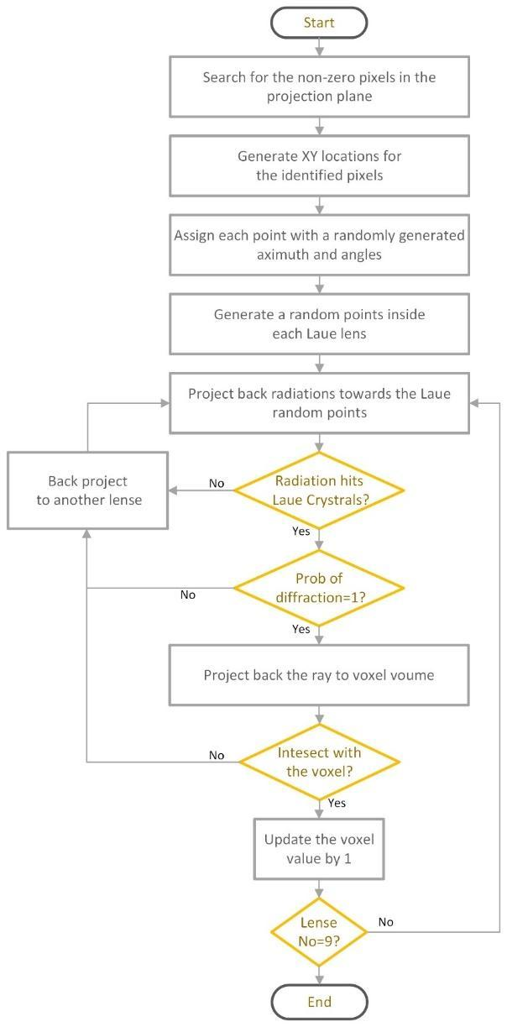
Figure. C.1. The flowchart of the 3D reconstruction algorithm.

Appendix D: A Vision to Image Refocusing in SPECT
The Laue lenses would collect gamma rays from a wide area and focus them onto their respective focal points on the detector plane; the locations of the focal points are determined by the source’s shifts from the lenses’ axes. Any shift in the source’s position relative to a lens axis is replicated on the detector plane but in the opposite direction. By encoding the angular resolution with a higher spatial resolution, Laue lenses in SPECT systems enable sampling of the radiation. This method allows for the refocusing of SPECT images while preserving the spatial resolution, in an approach akin to light field imaging.
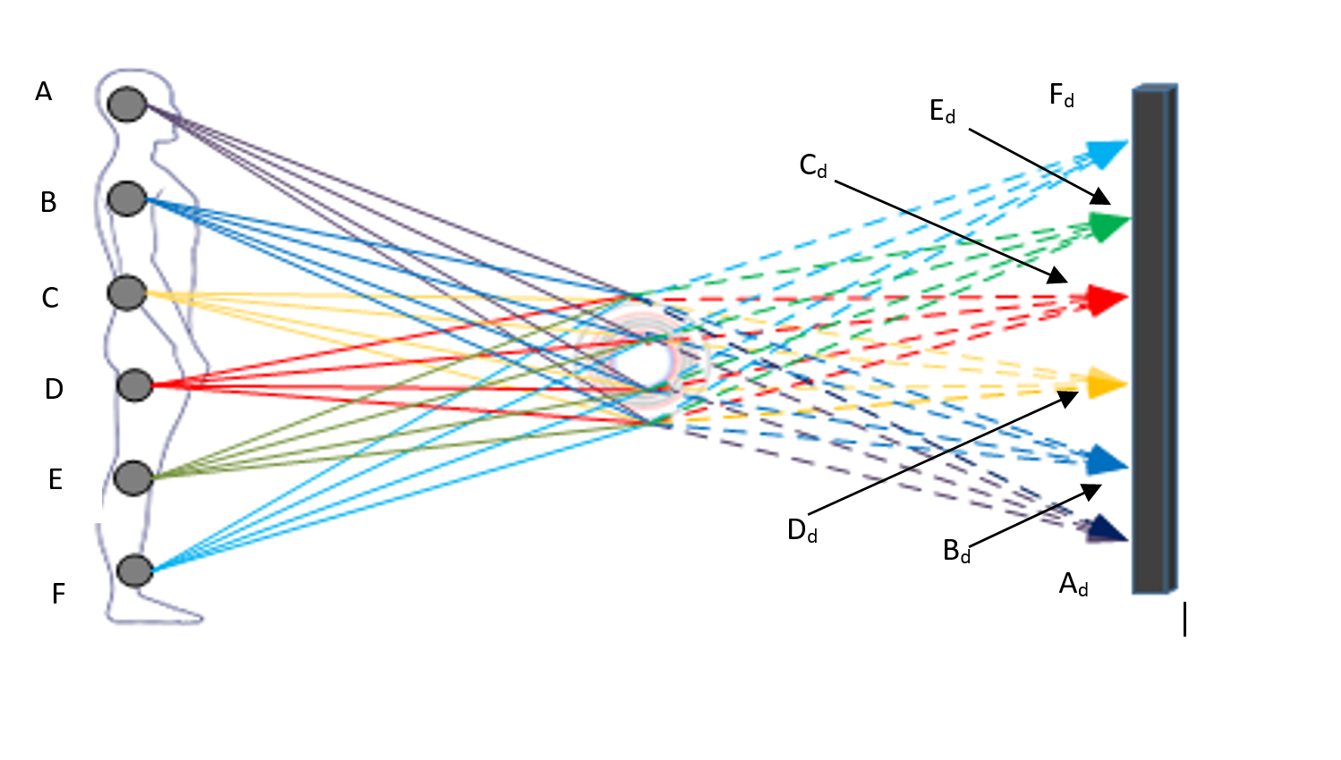
Figure. D.1. The locations of the focal points are determined by the source’s shifts from the lenses’ axes, where A, B, C, D, E and F are the radiation points, and A_{d}, B_{d}, C_{d}, D_{d}, E_{d} and F_{d} are the locations of the diffracted points

