SUPPLEMENTARY INFORMATION

Supplementary Table S1: Summary of missing data in the original dataset
Missing data: | N (%)
Age | 49 (7.6%)
Years employed in current role | 5 (0.8%)
Current smoker | 2 (0.3%)
Current drinker | 1 (0.2%)
Current illicit drug user | 1 (0.2%)
Ever diagnosed with a mental health condition | 1 (0.2%)
Feel need to use drink to manage WRS | 3 (0.5%)
Feel need to use illicit drugs to manage WRS | 5 (0.8%)

The range of missingness in the dataset is between 0.2% and 7.6%. Age was the only factor with greater than 1% of the data missing; as such, it was the only factor for which imputation was performed.

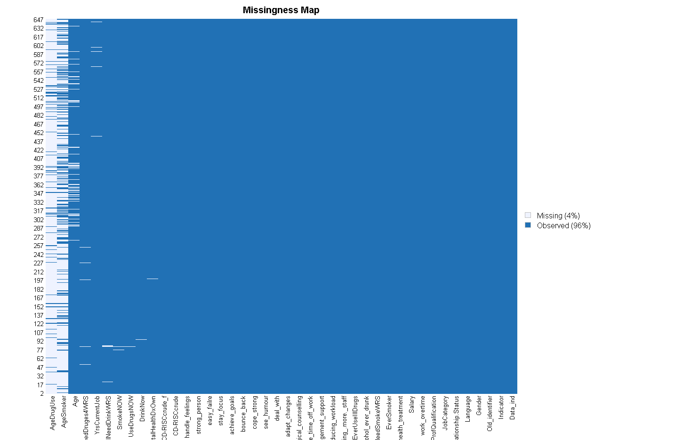
Supplementary Fig. S1: Missingness map of the dataset

Supplementary Table S2: Summary statistics of Age covariable following imputation
 | Missing values | Minimum | First quartile | Median | Mean | Third quartile | Maximum
Original | 49 | 1 | 1 | 2 | 2.216 | 3 | 5
Predictive mean matching | 0 | 1 | 1 | 2 | 2.234 | 3 | 5
Classification and regression tree | 0 | 1 | 1 | 2 | 2.232 | 3 | 5
Lasso linear regression | 0 | 0.574 | 1 | 2 | 2.401 | 3 | 5

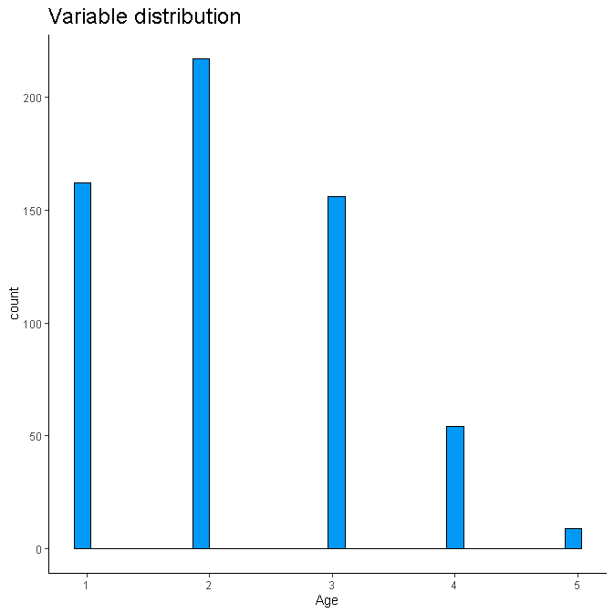
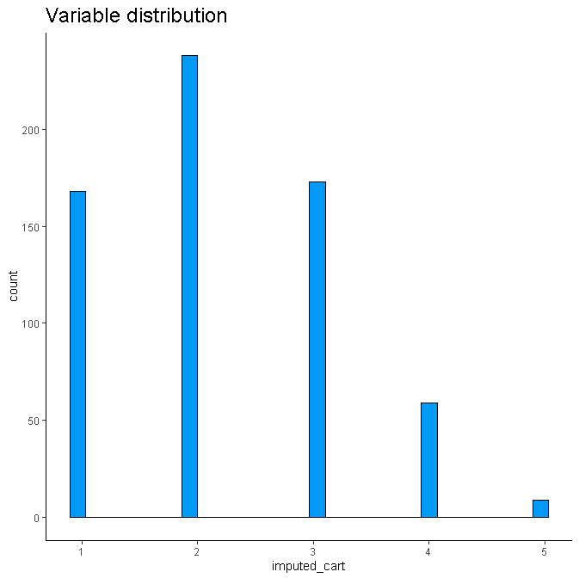
Supplementary Fig. S2: Distribution of Age factor before and after CART imputation

Supplementary Table S3: Unadjusted logistic regression analysis of the predictors of CD-RISC-10 score (all variables)
Predictors | Doctors |  |  |  | Ambulance personnel |  |  |  | Overall
Predictors | OR* | 95% | CI | P value * | OR* | 95% | CI | P value * | OR* | 95% | CI | P value *
Gender (Male)
Female | 2.45 | 1.44 | 4.26 | 0.001 | 0.92 | 0.60 | 1.42 | 0.711 | 1.40 | 1.01 | 1.95 | 0.045
Age (20 - 29)
30 – 39 | 0.99 | 0.53 | 1.82 | 0.969 | 1.30 | 0.66 | 2.65 | 0.459 | 0.94 | 0.62 | 1.44 | 0.782
40 – 49 | 0.95 | 0.47 | 1.89 | 0.877 | 1.89 | 0.95 | 3.92 | 0.078 | 1.20 | 0.77 | 1.88 | 0.424
> 50 | 0.75 | 0.29 | 1.83 | 0.535 | 1.39 | 0.57 | 3.39 | 0.463 | 0.91 | 0.49 | 1.65 | 0.751
Home language (English)
Afrikaans | 0.81 | 0.41 | 1.53 | 0.522 | 0.84 | 0.51 | 1.40 | 0.498 | 0.77 | 0.53 | 1.11 | 0.165
IsiXhosa | 1.45 | 0.66 | 3.14 | 0.348 | 1.23 | 0.68 | 2.21 | 0.494 | 1.20 | 0.76 | 1.87 | 0.432
Other | 0.88 | 0.04 | 9.36 | 0.917 | 2.21 | 0.26 | 19.00 | 0.436 | 1.45 | 0.28 | 6.69 | 0.633
Relationship Status (Married)
Never married | 1.56 | 0.92 | 2.66 | 0.100 | 0.82 | 0.52 | 1.29 | 0.389 | 1.09 | 0.77 | 1.53 | 0.638
Divorced/Separated/Widowed | 1.50 | 0.47 | 4.48 | 0.472 | 0.92 | 0.43 | 1.87 | 0.822 | 1.06 | 0.57 | 1.93 | 0.839
Professional health qualification (No)
Yes | N/A | N/A | N/A | N/A | 1.22 | 0.69 | 2.25 | 0.512 | 1.35 | 0.78 | 2.43 | 0.304
Job category (Operational services/EMS)
Support staff/EMS |  |  |  |  | 0.69 | 0.42 | 1.12 | 0.142 | 0.69 | 0.42 | 1.12 | 0.142
Junior doctors † |  |  |  |  |  |  |  |  | 1.23 | 0.74 | 2.04 | 0.415
Senior doctors | 0.92 | 0.54 | 1.58 | 0.752 |  |  |  |  | 1.13 | 0.76 | 1.68 | 0.544
Years employed in current role | 1.00 | 0.95 | 1.04 | 0.832 | 1.03 | 1.00 | 1.07 | 0.056 | 1.01 | 0.99 | 1.04 | 0.379
Overtime (No)
Yes | 4.12 | 0.72 | 77.60 | 0.189 | 0.92 | 0.58 | 1.46 | 0.708 | 1.13 | 0.75 | 1.73 | 0.559
Predictors | Doctors |  |  |  | Ambulance personnel |  |  |  | Overall
 | OR* | 95% | CI | P value * | OR* | 95% | CI | P value * | OR* | 95% | CI | P value *
Monthly Salary (ZAR) (R0 - R15 000)
R15 001 - R30 000 |  |  |  |  | 0.84 | 0.54 | 1.31 | 0.440 | 0.84 | 0.54 | 1.31 | 0.440
R30 001 - R50 000 † |  |  |  |  | 0.61 | 0.23 | 1.44 | 0.283 | 1.15 | 0.70 | 1.88 | 0.588
> R50 001 | 0.74 | 0.44 | 1.26 | 0.268 |  |  |  |  | 1.03 | 0.65 | 1.62 | 0.910
Age started smoking | 1.01 | 0.93 | 1.09 | 0.812 | 1.01 | 0.93 | 1.09 | 0.812 | 1.01 | 0.94 | 1.08 | 0.729
Age started illicit drugs | 1.24 | 0.91 | 1.81 | 0.193 | 1.05 | 0.95 | 1.16 | 0.315 | 1.07 | 0.97 | 1.17 | 0.171
Smoking history (Never used)
Previous smoker | 1.23 | 0.50 | 2.92 | 0.642 | 1.16 | 0.53 | 2.41 | 0.702 | 1.16 | 0.65 | 2.02 | 0.617
Current smoker | 0.15 | 0.02 | 0.54 | 0.012 | 0.90 | 0.55 | 1.45 | 0.664 | 0.65 | 0.42 | 0.98 | 0.046
Alcohol history (Never used)
Previous alcohol use | 0.73 | 0.31 | 1.67 | 0.452 | 0.40 | 0.19 | 0.79 | 0.011 | 0.52 | 0.30 | 0.87 | 0.015
Current drinker | 0.56 | 0.30 | 1.05 | 0.069 | 1.04 | 0.64 | 1.71 | 0.878 | 0.83 | 0.57 | 1.22 | 0.349
Illicit drug use (Never used)
Previous illicit drug use | 0.50 | 0.11 | 1.67 | 0.297 | 0.65 | 0.27 | 1.42 | 0.305 | 0.58 | 0.28 | 1.12 | 0.124
Current Drug user | 0.28 | 0.01 | 1.65 | 0.237 | 1.26 | 0.32 | 4.25 | 0.722 | 0.75 | 0.24 | 2.02 | 0.589
Substance use to manage work related stress
Feel need to smoke to manage WRS (No)
Yes | 0.67 | 0.32 | 1.32 | 0.258 | 1.16 | 0.71 | 1.87 | 0.548 | 0.93 | 0.63 | 1.38 | 0.731
Feel need to drink alcohol to manage WRS (No)
Yes | 1.32 | 0.71 | 2.44 | 0.379 | 1.67 | 0.86 | 3.16 | 0.121 | 1.53 | 0.98 | 2.38 | 0.060
Feel need to use illicit drugs to manage WRS (No)
Yes | 1.11 | 0.33 | 3.42 | 0.863 | 1.03 | 0.32 | 2.90 | 0.959 | 1.08 | 0.47 | 2.32 | 0.850
Predictors | Doctors |  |  |  | Ambulance personnel |  |  |  | Overall
Predictors | OR* | 95% | CI | P value * | OR* | 95% | CI | P value * | OR* | 95% | CI | P value *
Mental health
Ever diagnosed with a mental health condition (No)
Yes | 1.73 | 0.97 | 3.06 | 0.061 | 1.74 | 0.90 | 3.31 | 0.094 | 1.81 | 1.18 | 2.75 | 0.006
Currently on treatment for mental health condition (No)
Yes | 1.51 | 0.78 | 2.90 | 0.213 | 1.77 | 0.80 | 3.86 | 0.151 | 1.69 | 1.03 | 2.77 | 0.037
* Statistically significant results are indicated in bold; † Reference or base group for doctor
N/A: not applicable; ZAR/R: South African Rand
Note: Content in brackets is the reference or base group

Supplementary Table S4: Adjusted logistic regression analysis of the predictors of CD-RISC-10 score (all variables)
Predictors |  | Doctors |  |  |  | Ambulance personnel |  |  |  |  | Overall
 |  | aOR*† | 95% | CI | P value *† | aOR*† | 95% | CI | P value*† | aOR*† |  | 95% |  | CI |  |  | P value *†
Home language (English)
Afrikaans |  | 0.78 | 0.39 | 1.51 | 0.477 | 0.83 | 0.50 | 1.38 | 0.467 | 0.76 |  | 0.52 |  | 1.11 |  |  | 0.153
IsiXhosa |  | 1.51 | 0.67 | 3.36 | 0.310 | 1.31 | 0.72 | 2.38 | 0.384 | 1.18 |  | 0.75 |  | 1.85 |  |  | 0.475
Other |  | 0.80 | 0.04 | 9.04 | 0.858 | 2.21 | 0.25 | 19.40 | 0.442 | 1.58 |  | 0.30 |  | 7.40 |  |  | 0.561
Relationship Status (Married)
Never married |  | 1.39 | 0.73 | 2.69 | 0.318 | 0.98 | 0.59 | 1.65 | 0.948 | 1.10 |  | 0.74 |  | 1.63 |  |  | 0.653
Divorced/Separated/Widowed |  | 1.19 | 0.36 | 3.72 | 0.773 | 0.99 | 0.46 | 2.07 | 0.980 | 1.00 |  | 0.54 |  | 1.83 |  |  | 0.991
Professional health qualification (No) |  |  |  |  |  |  |  |  |  | - |  | - |  | - |  |  | -
Yes |  | N/A | N/A | N/A | N/A | 1.09 | 0.60 | 2.06 | 0.784 | 1.40 |  | 0.80 |  | 2.56 |  |  | 0.254
Job category (Operational services/EMS)
Support staff/EMS |  | - | - | - | - | 0.73 | 0.43 | 1.22 | 0.237 | 0.65 |  | 0.39 |  | 1.07 |  |  | 0.099
Junior doctors ‡ |  | - | - | - | - | - | - | - | - | 1.32 |  | 0.69 |  | 2.53 |  |  | 0.394
Senior doctors |  | 0.99 | 0.45 | 2.17 | 0.982 | - | - | - | - | 1.09 |  | 0.72 |  | 1.64 |  |  | 0.679
 |  | Doctors |  |  |  | Ambulance personnel |  |  |  | Overall
Predictors |  | aOR*† | 95% | CI | P value *† | aOR*† | 95% | CI | P value*† | aOR*† |  | 95% |  | CI |  |  | P value *†
Years employed in current role |  | 1.00 | 0.93 | 1.08 | 0.930 | 1.03 | 0.99 | 1.07 | 0.184 | 1.02 |  | 0.99 |  | 1.05 |  |  | 0.284
 | Overtime (No)
 | Yes | 0.21 | 0.01 | 1.27 | 0.155 | 0.96 | 0.60 | 1.56 | 0.879 | 1.13 |  | 0.74 |  | 1.74 |  |  | 0.582
Monthly Salary (ZAR) (R0 - R15 000)
R15,001 - R30,000 |  | - | - | - | - | 0.77 | 0.48 | 1.22 | 0.266 | 0.83 |  | 0.52 |  | 1.30 |  |  | 0.409
R30 001- R50 000 ‡ |  | - | - | - | - | 0.54 | 0.19 | 1.35 | 0.206 | 1.22 |  | 0.71 |  | 2.09 |  |  | 0.475
> R50 001 |  | 0.72 | 0.36 | 1.44 | 0.358 | - | - | - | - | 1.01 |  | 0.64 |  | 1.61 |  |  | 0.950
Age started smoking |  | 1.11 | 0.90 | 1.39 | 0.315 | 1.01 | 0.93 | 1.08 | 0.897 | 1.01 |  | 0.94 |  | 1.08 |  |  | 0.782
Age started illicit drugs |  | 1.36 | 0.90 | 2.80 | 0.231 | 1.05 | 0.94 | 1.18 | 0.403 | 1.07 |  | 0.97 |  | 1.20 |  |  | 0.195
Smoking history (Never used)
Previous smoker |  | 1.68 | 0.66 | 4.25 | 0.273 | 1.06 | 0.48 | 2.27 | 0.873 | 1.26 |  | 0.69 |  | 2.24 |  |  | 0.442
Current smoker |  | 0.21 | 0.03 | 0.77 | 0.042 | 0.91 | 0.55 | 1.49 | 0.714 | 0.77 |  | 0.45 |  | 1.09 |  |  | 0.127
Alcohol history (Never used)
Previous alcohol user |  | 0.78 | 0.32 | 1.84 | 0.568 | 0.39 | 0.18 | 0.78 | 0.010 | 0.52 |  | 0.30 |  | 0.88 |  |  | 0.015
Current drinker |  | 0.64 | 0.33 | 1.23 | 0.180 | 1.12 | 0.68 | 1.88 | 0.657 | 0.91 |  | 0.62 |  | 1.36 |  |  | 0.654
Illicit drug use (Never used)
Previous illicit drug user |  | 0.73 | 0.16 | 2.61 | 0.651 | 0.64 | 0.26 | 1.42 | 0.296 | 0.63 |  | 0.30 |  | 1.25 |  |  | 0.206
Current illicit drug user |  | 0.31 | 0.02 | 1.91 | 0.283 | 1.24 | 0.32 | 4.22 | 0.736 | 0.76 |  | 0.24 |  | 2.07 |  |  | 0.611
Substance use to manage work related stress
Feel need to smoke to manage WRS (No)
Yes |  | 0.76 | 0.36 | 1.54 | 0.449 | 1.21 | 0.73 | 1.97 | 0.456 | 1.00 |  | 0.66 |  | 1.48 |  |  | 0.980
Feel need to drink alcohol to manage WRS (No)
Yes |  | 1.17 | 0.61 | 2.20 | 0.628 | 1.73 | 0.89 | 3.33 | 0.100 | 1.56 |  | 0.99 |  | 2.43 |  |  | 0.053
Feel need to use illicit drugs to manage WRS (No)
Yes |  | 1.07 | 0.31 | 3.41 | 0.909 | 1.06 | 0.33 | 3.00 | 0.921 | 1.07 |  | 0.47 |  | 2.30 |  |  | 0.872
Predictors |  | Doctors |  |  |  | Ambulance personnel |  |  |  | Overall
 |  | aOR*† | 95% | CI | P value *† | aOR*† | 95% | CI | P value*† | aOR*† |  | 95% |  | CI |  |  | P value *†
Mental health
Ever diagnosed with a mental health condition (No)
Yes |  | 1.56 | 0.87 | 2.81 | 0.136 | 1.75 | 0.90 | 3.35 | 0.095 | 1.77 |  | 1.15 |  | 2.70 |  |  | 0.009
Currently on treatment for mental health condition (No)
Yes |  | 1.38 | 0.70 | 2.69 | 0.348 | 1.80 | 0.80 | 3.95 | 0.145 | 1.70 |  | 1.03 |  | 2.80 |  |  | 0.037
* Statistically significant results are indicated in bold; † Data adjusted for age and gender; ‡ Reference or base group for doctor
N/A: not applicable; ZAR/R: South African Rand
Note: Content in brackets is the reference or base group

Supplementary Table S5: Average CD-RISC-10 score by job category, salary and overtime status
Job Category | Over-time work | R30 001-R50 000 | > R50 000 | Grand Total
Junior doctors | No | 29.00 | N/A | 29.00
Junior doctors | Yes | 26.28 | 27.50 | 26.34
Junior doctors | All Junior doctors | 26.35 | 27.50 | 26.40
Senior doctors | No | 23.00 | 33.00 | 29.67
Senior doctors | Yes | 20.00 | 27.52 | 27.30
Senior doctors | All Senior doctors | 20.86 | 27.65 | 27.38
All doctors |  | 25.91 | 27.65 | 27.06
N/A: not applicable; R: South African Rand

When considering participants who indicated not working overtime and in the R30 001 - R50 000 salary band, junior doctors had higher average resilience scores than did senior doctors. This pattern is observed for each combination of overtime work and salary bands.

