Polydopamine Surface Engineering of Iron Single-Atom Nanozyme: a Novel Strategy for Doxorubicin Immobilization, Tumor Microenvironment Remodeling and Synergistic Multimodel Therapy
Jing Liu ª, Minjuan Wang ^{b}, Haoyu Chen ª, Xing Yang ª, Mingjie Wei ^{b*}, Xingfeng Wang ª, Shigang Shan ^{c}, Xiaohua Zhu ª, Youyu Zhang ª, Meiling Liu ^{a*}, Shouzhuo Yao ª

[a] J. Liu, H. Chen, X. Yang, Dr. X. Zhu, Prof. Y. Zhang, Prof. M. Liu, Prof. S. Yao
Key Laboratory of Chemical Biology & Traditional Chinese Medicine Research (Ministry of Education, China), College of Chemistry and Chemical Engineering, Hunan Normal University
Changsha 410081, P. R. China
E-mail: liumeilingww@126.com, liuml@hunnu.edu.cn
[b] M. Wang, Dr. M. Wei, Dr. X. Wang
School of Pharmacy, Xianning Medical College, Hubei University of Science and Technology
Xianning 437100, P. R. China
E-mail: weimj5@mail3.sysu.edu.cn
[c] Dr. S. Shan
School of Public Health, Xianning Medical College, Hubei University of Science and Technology
Xianning, 437100, P. R. China.

Supporting information for this article is given via a link at the end of the document.

* Corresponding author: Email: liumeilingww@126.com, liuml@hunnu.edu.cn
Jing Liu and Minjuan Wang contribute equally to this work.
Contents
Figure S1. TEM imaging of Fe SAN. 5
Figure S2. SEM image of Fe SAN. 6
Figure S3. HRTEM image of Fe SAN. 7
Figure S4. SAED image of Fe SAN. 8
Figure S5. TEM image of Fe SAN-PDA. 9
Figure S6. SEM image of Fe SAN-PDA. 10
Figure S7. Fe 2p XPS spectrum of Fe SAN. 11
Figure S8. C1s XPS spectrum of Fe SAN-PDA. 12
Figure S9. O1s XPS spectrum of Fe SAN-PDA. 13
Figure S10. EXAFS fitting curves of Fe SAN at k space. 14
Figure S11. The UV absorbance of ox-TMB at 652 nm at different pH values (5.5, 6.5, 7.4) with different time. 15
Figure S12. The degradation of MB with different time. 16
Figure S13. (a) Reaction principle of coumarin with hydroxyl radical (·OH). (b) Fluorescence spectrum evolution for detection of ·OH radicals catalyzed by H₂O₂ (1), coumarin (2), coumarin+Fe SAN-PDA (3), coumarin+ H₂O₂ (4), coumarin+Fe SAN-PDA+ H₂O₂ (5) using coumarin as the trapping agent. pH= 5.5, Fe SAN-PDA (200 µg mL⁻¹), H₂O₂ (10 mM), coumarin (5 mM), Ex = 332 nm. 17
Figure S14. OXD-like activity of (a-b) Steady-state kinetic assay of the Fe SAN-PDA by using TMB as the substrate, pH = 4.0. 18
Figure S15. The UV absorbance of ox-TMB with various pH (5.5, 6.5, 7.4) 19
Figure S16. Normalized intensity of RDPP at different time in the presence of H₂O₂ (10 mM), Fe SAN/Fe SAN-PDA (20 μg·mL⁻¹), RDPP (30 μg·mL⁻¹), PBS (6.5). 20
Figure S17. Fluorescence reduction of RDPP catalyzed by CAT-like activity of Fe SAN-PDA for 15 min in PBS at different pH. 21
Figure S18. The photograph of bubble at different groups, control (1), Fe SAN (2) and Fe SAN-PDA (3). 22
Figure S19. CAT-like activity of Fe SAN-PDA (a) Steady-state kinetic assay in different H₂O₂ concentrations (b) Corresponding double reciprocal plots. 23
Figure S20. UV-vis absorption spectra of Ti(SO₄)₂ solutions after incubation with Fe SAN-PDA, (a) Ti(SO₄)₂+H₂O₂, (b) Ti(SO₄)₂+H₂O₂+ Fe SAN-PDA. 24
Figure S21. The UV spectra of NADPH in different conditions: 0.1 mM NADPH, 1U GR, 50 μg/mL Fe SAN-PDA, 1 mM H₂O₂, 0.5 mM GSH, pH 7.4 PBS. 25
Figure S22. Cells viability of LO2 after incubation with various concentrations of (i) DOX, (ii) Fe SAN-PDA@HA, (iii) Fe SAN-PDA@DOX@HA and (iv) Fe SAN-PDA@DOX@HA+ 808 nm. 26
Figure S23. Corresponding FL intensity of DOX with different incubation time. 27
Figure S24. Flow cytometry analysis of apoptotic HepG2 cells after various treatments using Annexin V-APC/7-AAD staining. 28
Figure S25. Fe element content of different organs for Fe SAN-PDA@HA by ICP-OES. 29
Table S1. Atomic ratios of different elements of Fe SAN and Fe SAN-PDA. 30
Table S2. EXAFS fitting parameters at the Fe K-edge for various samples（Ѕ₀²=0.85） 31
Table S3. Comparison of steady-state kinetic parameter for Fe SAN-PDA 32
References 34

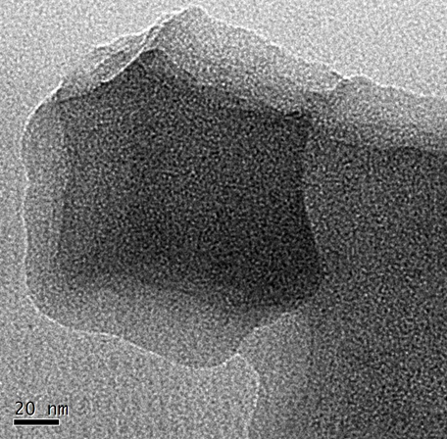

Figure S1. TEM imaging of Fe SAN.

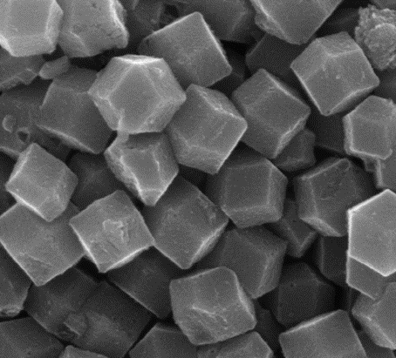

Figure S2. SEM image of Fe SAN.

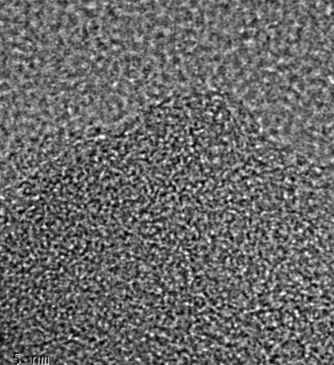

Figure S3. HRTEM image of Fe SAN.

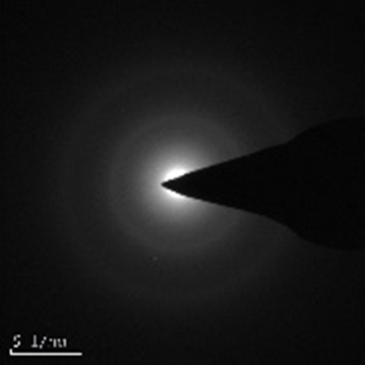

Figure S4. SAED image of Fe SAN.

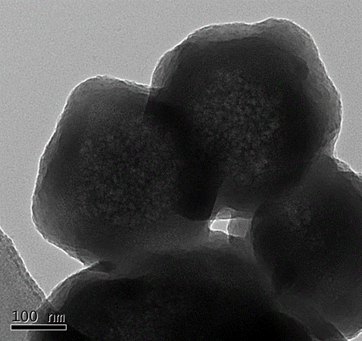

Figure S5. TEM image of Fe SAN-PDA.

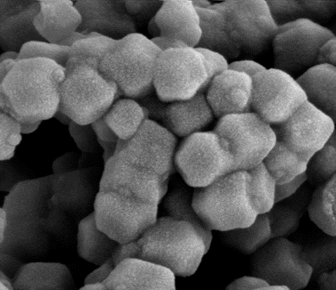

Figure S6. SEM image of Fe SAN-PDA.

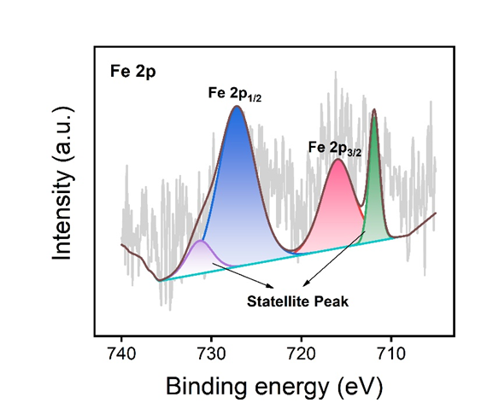

Figure S7. Fe 2p XPS spectrum of Fe SAN.

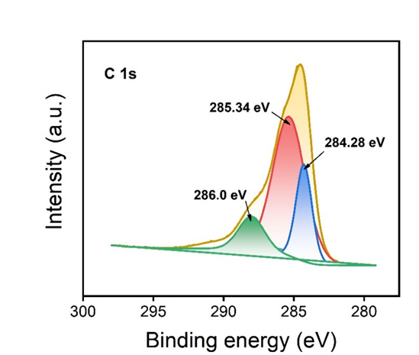

Figure S8. C1s XPS spectrum of Fe SAN-PDA.

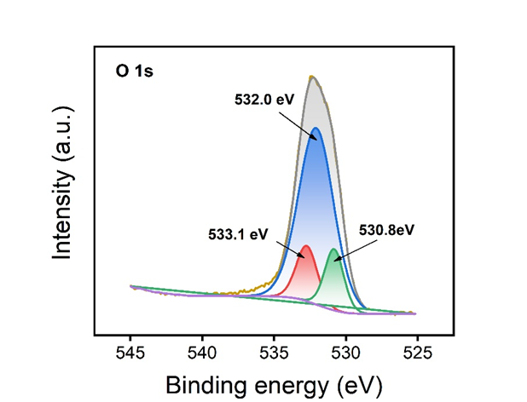

Figure S9. O1s XPS spectrum of Fe SAN-PDA.

Figure S10. EXAFS fitting curves of Fe SAN at k space.

Figure S11. The UV absorbance of ox-TMB at 652 nm at different pH values (5.5, 6.5, 7.4) with different time.

Figure S12. The degradation of MB with different time.

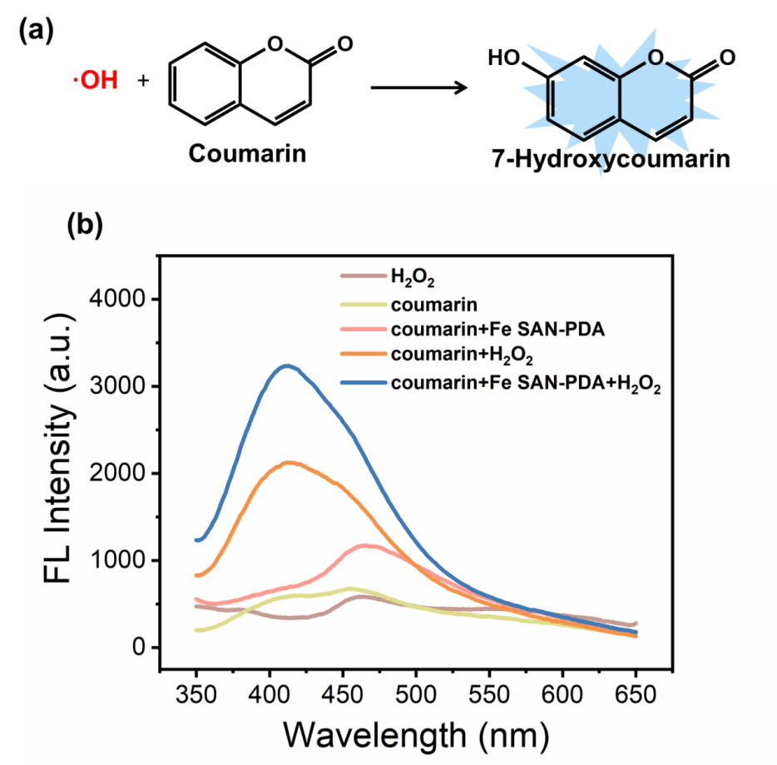

Figure S13. (a) Reaction principle of coumarin with hydroxyl radical (·OH). (b) Fluorescence spectrum evolution for detection of ·OH radicals catalyzed by H₂O₂ (1), coumarin (2), coumarin+Fe SAN-PDA (3), coumarin+ H₂O₂ (4), coumarin+Fe SAN-PDA+ H₂O₂ (5) using coumarin as the trapping agent. pH= 5.5, Fe SAN-PDA (200 µg mL⁻¹), H₂O₂ (10 mM), coumarin (5 mM), Ex = 332 nm.

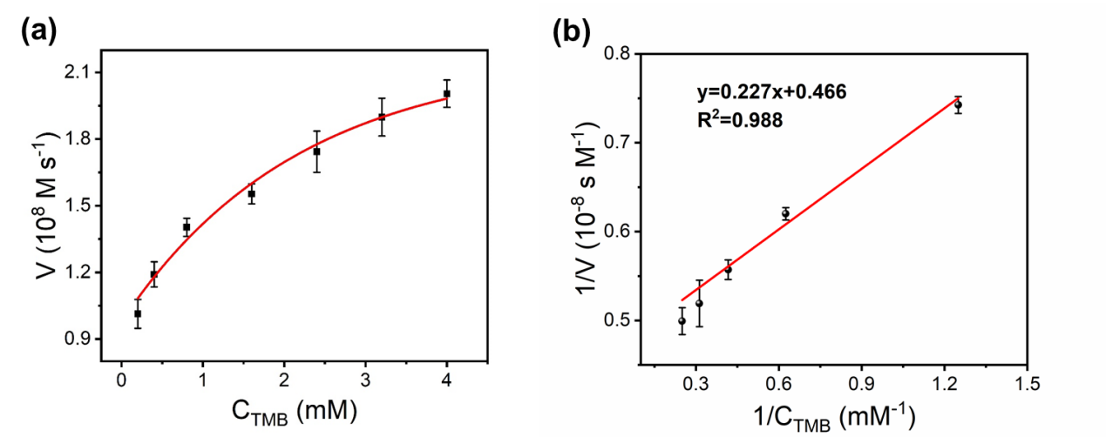

Figure S14. OXD-like activity of (a-b) Steady-state kinetic assay of the Fe SAN-PDA by using TMB as the substrate, pH = 4.0.
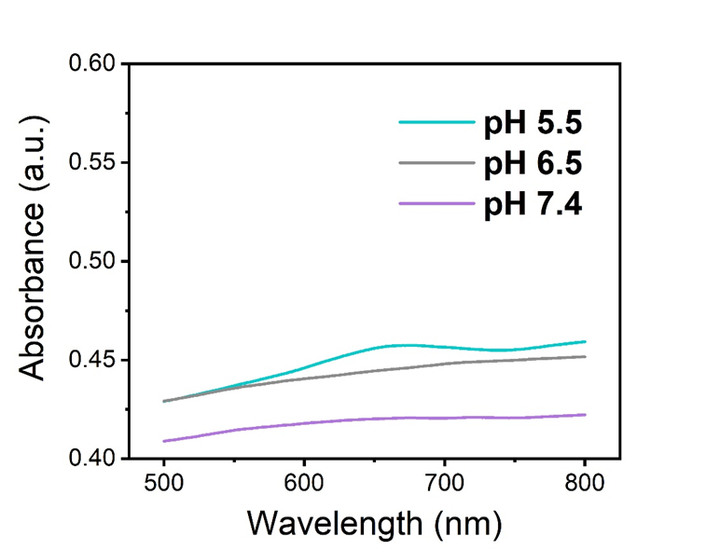

Figure S15. The UV absorbance of ox-TMB with various pH (5.5, 6.5, 7.4)

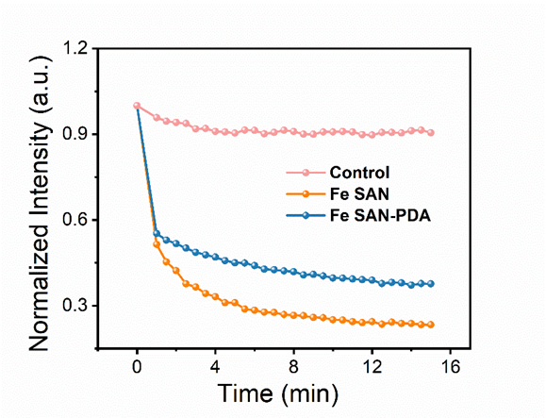

Figure S16. Normalized intensity of RDPP at different time in the presence of H₂O₂ (10 mM), Fe SAN/Fe SAN-PDA (20 μg·mL⁻¹), RDPP (30 μg·mL⁻¹), PBS (6.5).

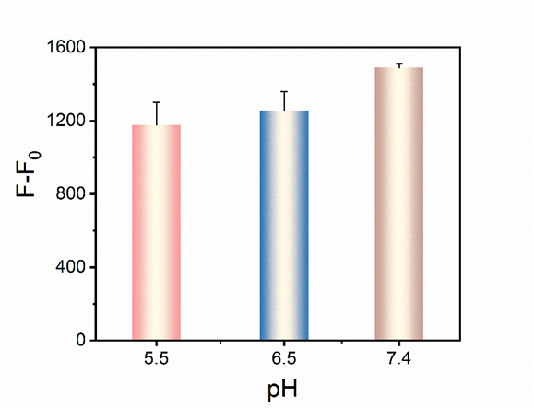

Figure S17. Fluorescence reduction of RDPP catalyzed by CAT-like activity of Fe SAN-PDA for 15 min in PBS at different pH.

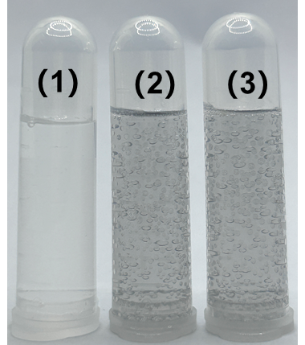

Figure S18. The photograph of bubble at different groups, control (1), Fe SAN (2) and Fe SAN-PDA (3).
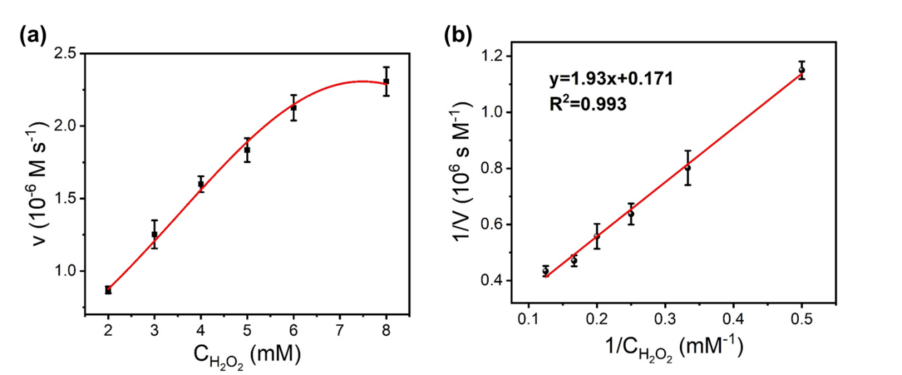

Figure S19. CAT-like activity of Fe SAN-PDA (a) Steady-state kinetic assay in different H₂O₂ concentrations (b) Corresponding double reciprocal plots.

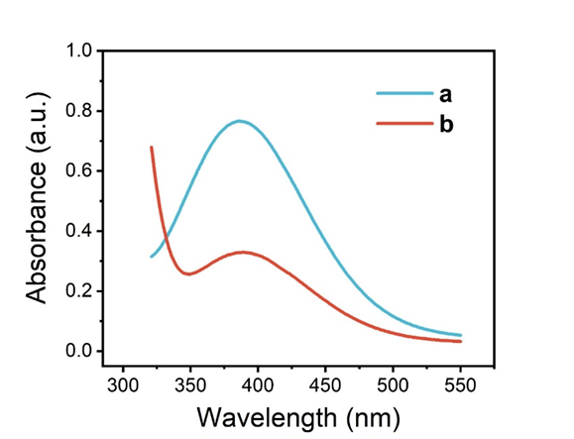

Figure S20. UV-vis absorption spectra of Ti(SO₄)₂ solutions after incubation with Fe SAN-PDA, (a) Ti(SO₄)₂+H₂O₂, (b) Ti(SO₄)₂+H₂O₂+ Fe SAN-PDA.

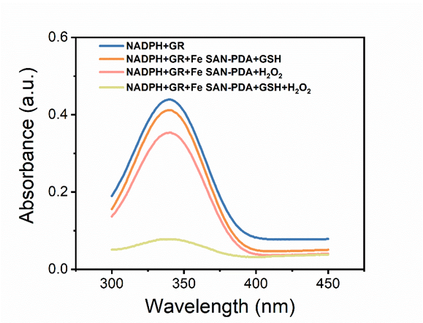

Figure S21. The UV spectra of NADPH in different conditions: 0.1 mM NADPH, 1U GR, 50 μg/mL Fe SAN-PDA, 1 mM H₂O₂, 0.5 mM GSH, pH 7.4 PBS.
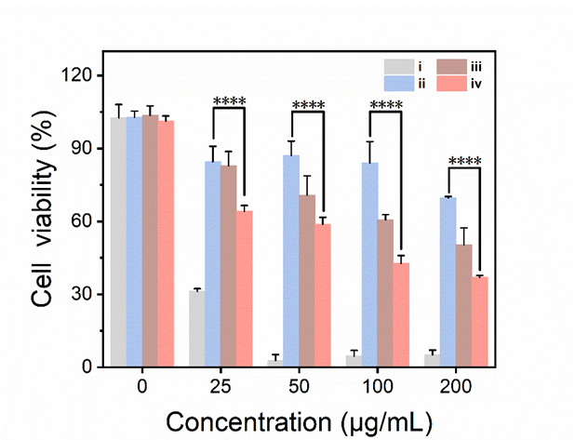

Figure S22. Cells viability of LO2 after incubation with various concentrations of (i) DOX, (ii) Fe SAN-PDA@HA, (iii) Fe SAN-PDA@DOX@HA and (iv) Fe SAN-PDA@DOX@HA+ 808 nm.

Figure S23. Corresponding FL intensity of DOX with different incubation time.

Figure S24. Flow cytometry analysis of apoptotic HepG2 cells after various treatments using Annexin V-APC/7-AAD staining.

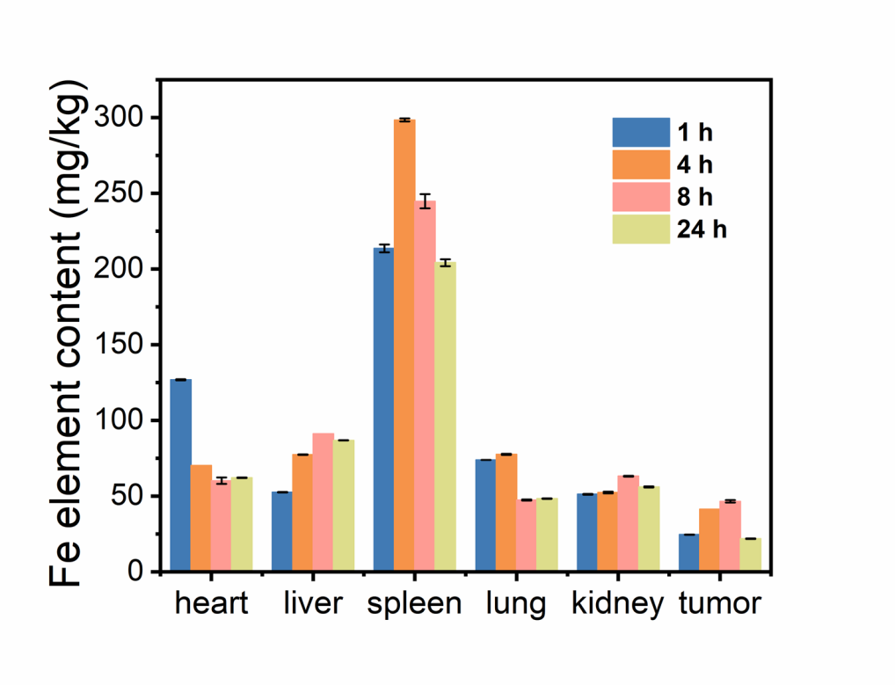

Figure S25. Fe element content of different organs for Fe SAN-PDA@HA by ICP-OES.

Table S1. Atomic ratios of different elements of Fe SAN and Fe SAN-PDA.
Sample | Fe Atomic (%) | C Atomic (%) | N Atomic (%) | O Atomic (%)
Fe SAN | 0.25 | 76.45 | 11.59 | 11.67
Fe SAN-PDA | 0.19 | 67.54 | 8.69 | 23.58

Table S2. EXAFS fitting parameters at the Fe K-edge for various samples（Ѕ₀²=0.85）
 | shell |  | CNª | R^{b}(Å) |  |  | σ^{2c}(Å²) | ΔE₀^{d}(eV) | R factor
Fe-foil | Fe-Fe1 | 8 |  |  | 2.47±0.01 | 0.0048 |  | 6.0±1.6 | 0.0036
Fe-foil | Fe- Fe2 | 6 |  |  | 2.85±0.01 | 0.0062 |  | 6.0±1.6 | 0.0036
Fe SAN | Fe-C/N | 4.04±0.1 |  |  | 1.99±0.05 | 0.0098 |  | -1.2±1.0 | 0.0038

Table S3. Comparison of steady-state kinetic parameter for Fe SAN-PDA
POD-like
Catalyst | K_{m} (mM)  TMB/H₂O₂ | V_{max} (10⁻⁷ M s⁻¹)  TMB/H₂O₂ | Reference
Mo-CDs | 0.245 /0.176 | 0.320 /0.476 | ¹
MIL-53 (Fe) | 1.08/0.04 | 3.12/1.39 | ²
Mo-Co₃O₄ nanotubes | 0.0558 /22.48 | 0.954/0.523 | ³
Fe-PCN-222 | 0.78/1.49 | 3.06/4.46 | ⁴
CZIF/Au | 0.21/22.27 | 0.508/1.37 | ⁵
Fe SAN-PDA | 0.9/0.62 | 4.01/0.97 | This work
OXD-like
Catalyst | K_{m} (mM)  TMB | V_{max} (10⁻⁷ M s⁻¹)  TMB | Reference
Co₃O₄/CoFe₂O₄ HNCs | 0.028 | 8.30 | ⁶
Fe-N-C nanozyme | 0.21 | 14.0 | ⁷
Mn₃O₄ | 0.02715 | 1.267 | ⁸
Fe-N/C | 0.134 | 1.96 | ⁹
Fe-PCN-222 | 0.78 | 3.06 | ⁴
Fe SAN-PDA | 0.215 | 4.88 | This work
CAT-like
Catalyst | K_{m} (mM)  H₂O₂ | V_{max} (10⁻⁶ M s⁻¹)  H₂O₂ | Reference
Fe-SANzyme | 18.80 | 9.317 | ¹⁰
Co-N₃PS SAzyme | 6.10 | 52.0 | ¹¹
CuO NPs-POM | 0.12 | 0.0187 | ¹²
Fe SAN-PDA | 0.0113 | 5.85 | This work

References
1. Lu, W. et al. Smartphone-assisted colorimetric sensing platform based on molybdenum-doped carbon dots nanozyme for visual monitoring of ampicillin. Chem. Eng. J. 468, 143165 (2023).
2. Zheng, H.-Q. et al. MOF-808: a metal-organic framework with intrinsic peroxidase-like catalytic activity at neutral pH for colorimetric biosensing. Inorg. Chem. 57, 9096-9104 (2018).
3. Gao, M. et al. Enhanced peroxidase-like activity of Mo⁶⁺-doped Co₃O₄ nanotubes for ultrasensitive and colorimetric L-cysteine detection. ACS Applied Nano Materials. 1, 4703-4715 (2018).
4. Shu, Y. et al. Metalloporphyrin-based metal-organic framework nanorods for peroxidase-like catalysis. ACS Applied Nano Materials. 5, 17909-17918 (2022).
5. Li, Y. et al. Skillfully manipulating electron transitions of Au nanoparticles for the modulation of nanozyme functions. New. J. Chem 47, 11222-11231 (2023).
6. Jiang, S. et al. Co₃O₄/CoFe₂O₄ hollow nanocube multifunctional nanozyme with oxygen vacancies for deep-learning-assisted smartphone biosensing and organic pollutant degradation. ACS Appl. Mater. Interfaces. 15, 11787–11801 (2023).
7. Pan, M. et al. Construction of metal organic framework-derived Fe-N-C oxidase nanozyme for rapid and sensitive detection of alkaline phosphatase. Nanomaterials. 13, 2496 (2023).
8. Xi, J., Zhu, C., Wang, Y., Zhang, Q. & Fan, L. Mn₃O₄ microspheres as an oxidase mimic for rapid detection of glutathione. Rsc Advances. 9, 16509-16514 (2019).
9. Ge, J. et al. A colorimetric smartphone-based platform for pesticides detection using Fe-N/C single-atom nanozyme as oxidase mimetics. J. Hazard. Mater. 436, 129199 (2022).
10. Zhang, R. et al. Edge-site engineering of defective Fe-N₄ nanozymes with boosted catalase-like performance for retinal vasculopathies. Adv. Mater. 34, 2205324 (2022).
11. Chen, Y. et al. Atomic-level regulation of cobalt single-atom nanozymes: engineering high-efficiency catalase mimics. Angew. Chem. Int. Ed. 135, e202301879 (2023).
12. Xu, Y. et al. Polyoxometalate nanostructures decorated with CuO nanoparticles for sensing ascorbic acid and Fe²⁺ ions. ACS Applied. Nano. Materials. 4, 8302-8313 (2021).

