METHODS
SeptiCyte® RAPID assay
As soon as possible after admission to the ICU, a blood sample was obtained from the patient for determination of PCT and CRP levels and for the SeptiCyte® RAPID assay. Blood samples for the SeptiCyte® RAPID assay were collected in PAXgene® Blood RNA tubes, and cooled to 2-8º C, according to the manufacturer´s instructions. These PAXgene® Blood RNA samples were gently inverted 10 times to ensure homogeneity of tube contents. Samples were processed in less than five days. A 0.9 mL aliquot was pipetted into the SeptiCyte® RAPID cartridge, and processed according to SeptiCyte® RAPID instructions for use. Analysis to produce the SeptiCyte® RAPID scores (SeptiScore) was performed automatically on the Idylla™ platform, which is capable of fully automated nucleic acid testing, including extraction, amplification, and detection, all in approximately one hour.
The performance of the SeptiCyte® RAPID assay was compared with the clinical diagnosis made by the research team. CRP and PCT levels were measured in the clinical laboratory in each participating hospital. CRP was determined by immunoturbidimetric assay on a Modular P Chemistry analyzer (Roche Diagnostics, GmbH, Mannheim, Germany). The reference limit for this method is less than 0.5 mg/dL. PCT was measured by immunofluorescence assay using the BRAHMS PCT kit (Roche, Zurich, Switzerland) following the manufacturer’s protocols. The lower detection limit for this method is 0.05 ng/mL.

RESULTS
Comparison of SeptiCyte® RAPID performance with PCT in patients with bacteremia.
When the performance of the SeptiCyte® RAPID was compared with PCT in patients with positive blood cultures (n=106), no significant differences were observed between the two in differentiating between sepsis and sterile inflammation.
Correlation between SeptiScore and biomarkers or clinical scores
Statistically significant correlations were shown between SeptiScore and procalcitonin (log-transformed) and CRP (p<0.001) but not with the severity scoring systems (APACHE II and SOFA), age or BMI, as shown in S-Table 5 and S-Figure 5.

Supplemental Table 1. Final diagnoses in patients with sterile inflammation.
Diagnoses | n
Acute respiratory failure | 17
Heart failure | 17
Metabolic disorders | 9
Hypovolemic shock | 7
COPD exacerbation | 6
Postoperative SIRS | 6
Neurological disorders | 5
Drug toxicity | 5
Acute pancreatitis | 3
Other causes sterile inflammation | 11
SIRS: Systemic inflammatory response syndrome; COPD: Chronic obstructive Pulmonary disease

Supplemental Table 2. Analysis of laboratory data differences between patients with sepsis/sterile inflammation established at ICU discharge
Variable* | All patients  (n=353) | Sepsis  (n=267) | Sterile inflammation  (n=86) | p
Leucocytes | 12.4 (7.3-18.7) | 12.2 (6.5 – 19.0) | 12.9 (10.1 – 17.4) | 0.085
Neutrophils | 10.6 (6.0-15.5) | 10.4 (5.0 - 15.8) | 10.9 (7.6 - 14.5) | 0.156
Platelets | 198 (117-298) | 181 (110 - 277) | 256 (177 - 333) | <0.001
Creatinine | 1.50 (0.91-2.52) | 1.50 (0.96 - 2.40) | 1.36 (0.87 - 2.72) | 0.950
Lactate | 1.80 (1.00-3.20) | 2 (1.2 - 3.3) | 1.2 (0.8 - 2.8) | 0.001
Procalcitonin | 4.08 (0.54-24.0) | 9.2 (1.2 – 35.0) | 0.4 (0.1 – 1.6) | <0.001
C Reactive protein | 171.6 (86.1-290.4) | 211.5 (122.7 - 307.4) | 82.0 (22.7 – 170.7) | <0.001
*Result expressed with median (p25-p75) or number (percentage) as appropriate.

Supplemental Table 3. Micro-organisms isolated in blood cultures.
 | n | %
Acinetobacter baumannii | 2 | 0.6%
Bacillus spp | 1 | 0.3%
Bacteroides grupo fragilis | 1 | 0.3%
Candida albicans | 3 | 0.8%
Candida glabrata | 1 | 0.3%
Candida spp | 1 | 0.3%
Enterobacter cloacae | 1 | 0.3%
Enterobacter spp | 1 | 0.3%
Enterococcus faecalis | 5 | 1.4%
Enterococcus faecium | 1 | 0.3%
Escherichia coli | 38 | 10.8%
Klebsiella pneumoniae | 14 | 4.0%
Morganella morgagnii | 1 | 0.3%
Proteus mirabilis | 4 | 1.1%
Proteus spp | 1 | 0.3%
Pseudomonas aeruginosa | 2 | 0.6%
Salmonella spp | 2 | 0.6%
Staphylococcus aureus meticilín sensible | 5 | 1.4%
Staphylococcus aureus meticilín resistente | 4 | 1.1%
Staphylococcus coagulasa negativo | 5 | 1.4%
Staphylococcus epidermidis | 3 | 0.8%
Staphylococcus spp | 1 | 0.3%
Streptococcus pneumoniae | 13 | 3.7%
Streptococcus pyogenes | 5 | 1.4%
Streptococcus spp | 7 | 2.0%
Other microorganisms* | 6 | 1.7%
* Aeromonas veronii; Fusobacterium necrophorum; Klebsiella aerogenes; Gramnegative bacillus.

Supplemental Table 4. Micro-organisms isolated in focus of infection.
 | n | %
Acinetobacter baumannii | 2 | 0.6%
Aspergillus spp | 4 | 1.1%
Candida albicans | 9 | 2.5%
Citrobacter spp | 1 | 0.3%
Chlamydophila pneumoniae | 2 | 0.6%
Clostridium spp | 2 | 0.6%
Enterobacter cloacae | 4 | 1.1%
Enterobacter spp | 1 | 0.3%
Enterococcus faecalis | 8 | 2.3%
Enterococcus faecium | 11 | 3.1%
Enterococcus spp | 1 | 0.3%
Escherichia coli | 37 | 10.5%
Haemophilus influenzae | 3 | 0.8%
Haemophilus spp | 1 | 0.3%
Klebsiella oxytoca | 2 | 0.6%
Klebsiella pneumoniae | 15 | 4.2%
Klebsiella spp | 1 | 0.3%
Legionella pneumophila | 2 | 0.6%
Mycobacterium tuberculosis | 1 | 0.3%
Proteus mirabilis | 6 | 1.7%
Pseudomonas aeruginosa | 9 | 2.5%
Salmonella spp | 2 | 0.6%
Staphylococcus aureus meticilín sensible | 7 | 2.0%
Staphylococcus aureus meticilín resistente | 4 | 1.1%
Staphylococcus coagulasa negativo | 4 | 1.1%
Staphylococcus epidermidis | 1 | 0.3%
Stenotrophomonas maltophilia | 3 | 0.8%
Streptococcus pneumoniae | 23 | 6.5%
Streptococcus pyogenes | 3 | 0.8%
Streptococcus spp | 11 | 3.1%
HVS virus | 1 | 0.3%
Influenza virus | 3 | 0.8%
SARS-CoV-2 virus | 6 | 1.7%
Other microorganisms* | 27 | 7.6%
* Enteroviridae; Aerococcus urinae; Bacteroides faecalis; Fusobacterium nucleatum; Parabacteroides distanosis; Plasmodium falciparum; Veillonella; Rinovirus; HVS virus 1+2; Gramnegative bacillus.

Supplemental Table 5. Cutoff-point of maximum sensitivity and specificity of Septiscore.
 | Septiscore ≥ 6.9 |  |  |  | For sepsis |  | CI 95%
 | SEPSIS | STERILE INFLAMMATION |  |  | Se | 85.4% | 80.5%-89.4%
YES | 228 | 20 | 248 |  | Sp | 76.7% | 65.5%-84.4%
NO | 39 | 66 | 105 |  | PPV | 91.9% | 88.2%-94.0%
 | 267 | 86 | 353 |  | NPV | 62.9% | 55.2%-69.8%
 |  |  |  |  | LR+ | 3.67 | 2.43-5.15
 |  |  |  |  | LR- | 0.19 | 0.14-0.26
 |  |  |  |  | AC | 83.3% | 78.7%-86.8%
 |  |  |  |  | PREV | 75.6% | 70.5%-80.0%

Supplemental Table 6. Correlation between Septiscore and other markers and scores
Variable |  |  |  | Septiscore
1. Septiscore |  | Pearson's r |  | —
 |  | p-value |  | —
2. Log PCT |  | Pearson's r |  | 0.489 | ***
 |  | p-value |  | < .001
3. CRP |  | Pearson's r |  | 0.612 | ***
 |  | p-value |  | < .001
4. Age |  | Pearson's r |  | -0.163 | **
 |  | p-value |  | 0.002
5. BMI |  | Pearson's r |  | -0.106 | *
 |  | p-value |  | 0.047
6. APACHEII |  | Pearson's r |  | -0.055
 |  | p-value |  | 0.307
7. SOFA |  | Pearson's r |  | -0.012
 |  | p-value |  | 0.818
* p < .05, ** p < .01, *** p < .001
APACHE II: Acute Physiology and Chronic Health disease Classification System II; BMI: Body Mass Index; CNS: Central nervous system; CRP: C reactive protein; PCT: Procalcitonin; SOFA: Sequential Organ Failure Assessment Score.

Supplemental Table 7. Demographics, clinical and analytical characteristics of patients with sepsis and Band 1 and sterile inflammation and Band 4 established at ICU discharge.
Variable* |  | All patients  (n=353) | Sepsis and Band 1  (n=9) | Sterile inflammation and Band 4  (n=18)
Age |  | 63 (54 - 71) | 66 (60 - 76) | 54 (47 - 60) | 0.023
Gender | Male | 219 (62.0%) | 6 (66.7%) | 15 (83.3%) | 0.326
BMI |  | 27.3 (24.2-32.0) | 26.8 (24.2 – 28.4) | 23.8 (22.2 – 26.3) | 0.375
Comorbidities | Diabetes mellitus | 117 (33.1%) | 2 (22.2%) | 3 (16.7%) | 0.553
Comorbidities | Renal insufficiency | 49 (13.9%) | 1 (11.1%) | 2 (11.1%) | 0.750
Comorbidities | Immunosuppression | 47 (13.3%) | 0 (0%) | 3 (16.7%) | 0.279
Comorbidities | Neutropenia | 8 (2.3%) | 0 (0%) | 0 (0%) | NA
Comorbidities | Solid neoplasm | 61 (17.3%) | 2 (22.2%) | 1 (5.6%) | 0.250
Comorbidities | Hepatic cirrhosis | 17 (4.8%) | 0 (0%) | 0 (0%) | NA
Comorbidities | COPD | 48 (13.6%) | 1 (11.1%) | 3 (16.7%) | 0.593
Comorbidities | Cardiac insufficiency | 23 (6.5%) | 0 (0%) | 4 (22.2%) | 0.174
Comorbidities | Autoimmune diseases | 18 (5.1%) | 0 (0%) | 0 (0%) | NA
Comorbidities | SARS - CoV2 infection | 17 (4.8%) | 0 (0%) | 0 (0%) | NA
Comorbidities | None of previous | 124 (35.1%) | 6 (66.7%) | 7 (38.9%) | 0.171
Type of ICU admission | Medical condition | 280 (79.3%) | 9 (100%) | 15 (83.3%) | 0.430
Type of ICU admission | Scheduled surgery | 8 (2.3%) | 0 (0%) | 1 (5.6%) | 0.430
Type of ICU admission | Urgent surgery | 65 (18.4%) | 0 (0%) | 2 (11.1%) | 0.430
Acquisition of infection | Community | 267 (75.6%) | 5 (55.6%) | 16 (88.9%) | 0.073
Acquisition of infection | Nosocomial | 86 (24.4%) | 4 (44.4%) | 2 (11.1%) | 0.073
Heart rate |  | 110 (90-120) | 92 (80 - 110) | 100 (85 - 120) | 0.275
Respiratory rate |  | 22 (18-28) | 22 (18 - 26) | 24 (18 - 28) | 0.561
Mean arterial pressure |  | 64 (54-77) | 60 (49 - 85) | 76 (70 - 92) | 0.059
APACHE II score |  | 18 (14 – 24) | 21 (17 - 23) | 16 (9 - 25) | 0.253
SOFA score |  | 7 (5 - 9) | 7 (6 - 10) | 5 (3 - 8) | 0.076
Leucocytes |  | 12.4 (7.3-18.7) | 12.6 (9.7 – 21.4) | 11.8 (10.1 – 17.4) | 0.900
Neutrophils |  | 10.6 (6.0-15.5) | 9.9 (7.5 – 17.3) | 9.5 (7.5 - 14.5) | 0.860
Platelets |  | 198 (117-298) | 225 (145 - 302) | 209 (168 - 326) | 0.940
Creatinine |  | 1.50 (0.91-2.52) | 1.64 (1.28 - 2.16) | 0.98 (0.74 – 2.71) | 0.322
Lactate |  | 1.80 (1.00-3.20) | 2.4 (0.5 - 3.5) | 1.2 (0.7 – 2.7) | 0.348
Procalcitonin |  | 4.08 (0.54-24.0) | 0.7 (0.6 – 7.3) | 1.2 (0.2 – 15.1) | 0.940
C Reactive protein |  | 171.3 (85.2-290.0) | 91.2 (61.9 – 113.0) | 227.2 (140.4 – 323.6) | 0.005
Septiscore |  | 8.4 (6.5-10.1) | 4.1 (3.7 – 4.6) | 9.2 (8.4 – 10.2) | <0.001
Band of Septiscore | BAND 1 (0-4.9) | 35 (9.9%) | 9 (100%) | 0 (0%) | NA
Band of Septiscore | BAND 2 (5.0-6.1) | 40 (11.3%) | 0 (0%) | 0 (0%) | NA
Band of Septiscore | BAND 3 (6.2-7.3) | 48 (13.6%) | 0 (0%) | 0 (0%) | NA
Band of Septiscore | BAND 4 (7.4-15) | 230 (65.2%) | 0 (0%) | 18 (100%) | NA
Inflammatory response at ICU admission | Sepsis | 131 (37.1%) | 1 (11.1%) | 8 (44.4%) | 0.094
Inflammatory response at ICU admission | Septic shock | 222 (62.9%) | 8 (88.9%) | 11 (55.6%) | 0.094
Sepsis probability at ICU admission | < 30% | 40 (11.3%) | 0 (0%) | 5 (27.8%) | 0.022
Sepsis probability at ICU admission | 30-70% | 97 (27.5%) | 3 (33.3%) | 10 (55.6%) | 0.022
Sepsis probability at ICU admission | >70% | 216 (61.2%) | 6 (66.7%) | 3 (16.7%) | 0.022
Blood culture at admission | Positive | 105 (29.7%) | 1 (11.1%) | 0 ** | 0.617
Suspected Focus | Abdominal | 116 (32.9%) | 1 (11.1%) | 4 (22.2%) | 0.447
Suspected Focus | Bacteremia | 19 (5.4%) | 0 (0.0%) | 1 (5.6%) | 0.667
Suspected Focus | Cardiovascular | 7 (2.0%) | 0 (0.0%) | 2 (11.1%) | 0.436
Suspected Focus | Catheter related | 5 (1.4%) | 0 (0.0%) | 0 (0.0%) | NA
Suspected Focus | Gynaecological | 4 (1.1%) | 0 (0.0%) | 0 (0.0%) | NA
Suspected Focus | Surgical wound | 2 (0.6%) | 0 (0.0%) | 1 (5.6%) | 0.667
Suspected Focus | Ophthalmologic | 0 (0.0%) | 0 (0.0%) | 0 (0.0%) | NA
Suspected Focus | Ear, nose and throat | 3 (0.8%) | 0 (0.0%) | 0 (0.0%) | NA
Suspected Focus | Bones | 2 (0.6%) | 0 (0.0%) | 0 (0.0%) | NA
Suspected Focus | Other foci | 3 (0.8%) | 0 (0.0%) | 0 (0.0%) | NA
Suspected Focus | Unknown focus | 12 (3.4%) | 0 (0.0%) | 0 (0.0%) | NA
Suspected Focus | Soft tissue | 13 (3.7%) | 0 (0.0%) | 0 (0.0%) | NA
Suspected Focus | Respiratory | 110 (31.2%) | 4 (44.4%) | 9 (50.0%) | 0.555
Suspected Focus | CNS | 19 (5.4%) | 0 (0.0%) | 0 (0.0%) | NA
Suspected Focus | Urological | 38 (10.8%) | 4 (44.4%) | 1 (5.6%) | 0.030
RRT first 72 h | Yes | 77 (21.8%) | 2 (22.2%) | 6 (33.3%) | 0.450
IMV first 72 h | Yes | 186 (52.7%) | 5 (55.6%) | 10 (55.6%) | 0.657
Vasopressors first 72 h | Yes | 228 (64.6%) | 9 (100%) | 6 (33.3%) | 0.001
ICU stays (days) |  | 5 (2 – 12) | 8 (5 - 12) | 3 (1 - 13) | 0.176
Hospital stays (days) |  | 16 (8 – 35) | 17 (13 - 42) | 15 (8 - 24) | 0.194
ICU death | Yes | 76 (21.5%) | 2 (22.2%) | 2 (11.1%) | 0.407
Hospital death | Yes | 93 (26.4%) | 2 (22.2%) | 2 (11.1%) | 0.407
*Result expressed with median (p25-p75) or number (percentage) as appropriate.
** 1 coagulase-negative Staphylococci, considered contaminant by the researches.
APACHE II: Acute Physiology and Chronic Health disease Classification System II; BMI: Body Mass Index; CNS: Central nervous system; COPD: Chronic obstructive pulmonary disease; ICU: Intensive Care Unit; IMV: Invasive mechanical ventilation; RRT: Renal replacement therapy; SOFA: Sequential Organ Failure Assessment Score.

Supplemental Table 8. Multivariate analysis for sepsis
 | OR (CI 95%) | p
Estimated probability of sepsis | 8.02 (4.50-14.28) | <0.001
Septiscore | 1.64 (1.35-1.99) | <0.001
Log procalcitonin | 1.68 (1.09-2.59) | 0.020
C reactive protein | 1.00 (0.99-1.00) | 0.541
Lactate | 0.92 (0.80-1.07) | 0.273
Neutrophils proportion | 7.26 (0.43-122.51) | 0.169
Leucocytes | 0.98 (0.95-1.01) | 0.116

Supplemental Figure 1. STARD list.
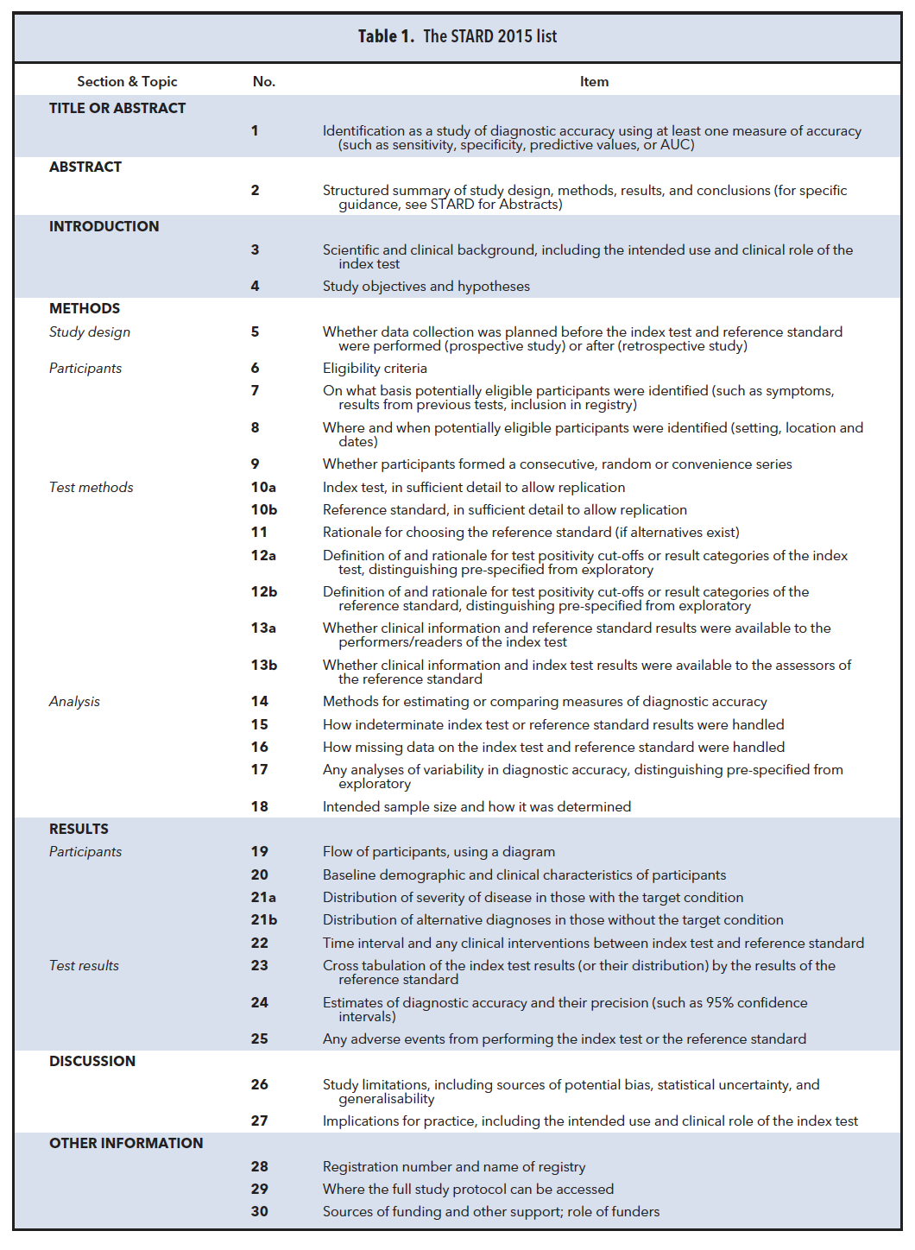
Adapted from Bossuyt PM, et al. Clin Chem. 2015 Dec;61(12):1446-52

Supplemental Figure 2. Flowchart of the patients include in this study.

Supplemental Figure 3. Number of valid cases in every hospital.

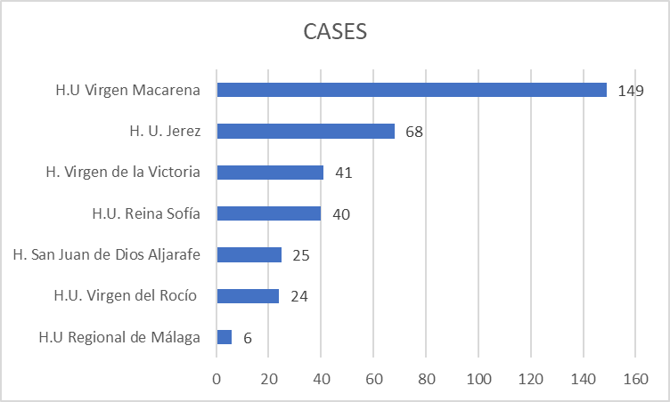

Supplemental Figure 4. Clinical performance of the 4 bands for the diagnosis of sepsis.

Supplemental Figure 5. Correlation between Septiscore and other markers and scores

