Supplemental data
A
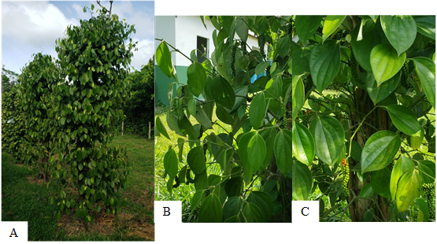
A
A
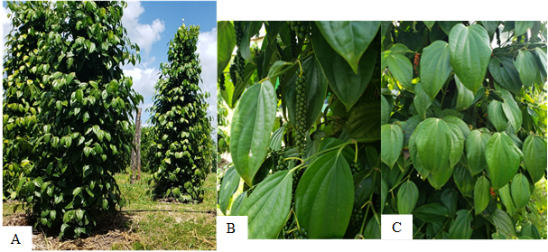
C
B
B
B
Figure S1. Canopy characteristics of cultivars Clonada [A] and Uthirankota [B].

Figure S2. Temperature (T_{air}) [A], global radiation (RG) [A], relative humidity (RH) [B] and precipitation (PREC) [B] over the first five months of 2022. The meteorological variables were obtained from the platform of the National Institute of Meteorology (INMET) automatic station A202, located in the municipality of Castanhal, PA, Brazil.

B
Figure S3. Total leaf area (TLA) [A] and specific leaf area (SLA) [B] in two black pepper cultivars (Clonada and Uthirankotta) cultivated upon 100% field capacity. Means followed by the same letters do not differ from each other, using the Tukey test (P>0.05).

