Table 1
Characteristics R. damascena in two stages of flower growth (S1 = bud, S2 = full open flower)

Accession number | Flower color |  | Genotype | Place of collection
ACC.1 | dark-pink |  | East Azarbaijan | Kashan Distillery Co
ACC.1 | 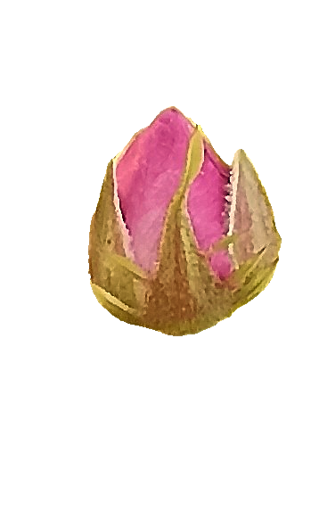 | 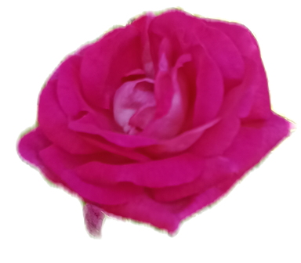 | East Azarbaijan | Kashan Distillery Co
ACC.1 | S1 | S2 | East Azarbaijan | Kashan Distillery Co
ACC.26 | white |  | East Azarbaijan | Tabriz
ACC.26 | 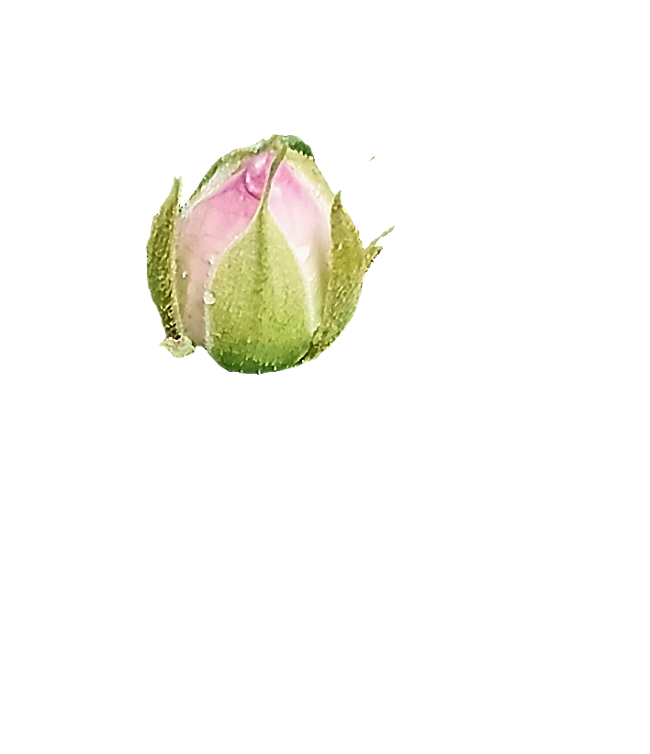 | 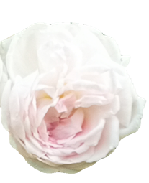 | East Azarbaijan | Tabriz
ACC.26 | S1 | S2 | East Azarbaijan | Tabriz

Table 2
Characteristics of primers used in molecular expression by qRT-PCR
Accession Number (Gene Bank) | Sequence in 5′-3’direction | Gene name
KT965025.1 | F: GTATCCATGAGACCACCTACAAC  R: GTCAGCAATACCAGGGAACATA | Actin
AB201048.1 | F: TCACAATCCTCGCCTCAACT  R: AGGACTTGGAGGATGTTGGG | RhGT1
MG922976.1 | F: GAGTACAGGAAGCCAGTGGT  R: CCACCATAGCTGTCCGTACCCTT | PAL
AB426519 | F: ACAGACCCAAAGGCAGAAC  R: TCATCAACCACTACATCAGGAG | PAR
AB038247.1 | F: AAGGGTGGGTGGATCATCTG  R: CATCACCACCAACTGCCTTC | FLS
XM_024319816.2 | F: GGGAGATGGGTTGGTCATGA  R: CGATCAACAGAGTTGCCACC | CER1
EU082130.1 | F: CTATGTCAAGACTCGCACGC  R: CAACGAGTGCAGGTGAGATG | MYB1
EU327776.1 | F: CGAAAATTGAGGTTGGAGGA  R: GCATGGAACCCATATGGAAC | CCD1
BI977949 | F: GCTCGTCAACAAGGAGAAGG  R: GGTAGAGGCGAGAGCTTCCT | ANS
KX661005.1 | F: CACAAAACTGCGGCTCTTCT  R: AGTCCTTCCCAGCAGTCTTC | GGPPS

Table 3
Percentage composition of the essential oils isolated from samples of R. damascena petals
No. | Compound | RT (min) | White | Methyl White | Dark-pink | Methyl Pink
No. | Compound | RT (min) | % Area WR | % Area MW | % Area PR | % Area MP
1 | α-Pinene | 15.286 | 1.57 | 4.60 | 2.56 | 1.87
2 | Sabinene | 17.1 | 0.03 | 0.10 | 0.09 | 0.06
3 | β-Pinene | 17.324 | 0.30 | 0.94 | 0.54 | 0.37
4 | β-Myrcene | 17.836 | 0.20 | 0.54 | 0.48 | 0.33
5 | Linalool | 23.477 | 0.65 | 0.93 | 1.67 | 1.59
6 | Phenethyl alcohol | 24.546 | 0.24 | 0.44 | 0.53 | 0.48
7 | Nerol | 29.792 | 0.81 | 0.8 | 3.38 | 1.94
8 | β-Citronellol | 30.158 | 4.17 | 1.92 | 7.98 | 6.42
9 | Geraniol | 31.372 | 9.22 | 11.94 | 21.98 | 23.54
10 | Geranyl acetate | 36.711 | 3.59 | 6.55 | 5.29 | 5.88
11 | α-Humulene | 40.004 | 0.05 | 0.08 | 0.08 | 0.06
12 | GERMACRENE-D | 41.159 | 0.32 | 1.04 | 1.16 | 1.22
13 | δ-Cadinene | 42.717 | 0.1 | 0.14 | 0.06 | 0.06
14 | n-Hexadecane | 45.188 | 0.08 | 0.11 | 0.14 | 0.10
15 | n-Heptadecane | 49.202 | 2.41 | 3.94 | 4.55 | 4.48
16 | 2z,6e Farnesol | 50.372 | 1.23 | 0.88 | 0.36 | 0.39
17 | n-Octadecane | 52.550 | 0.13 | 0.13 | 0.19 | 0.17
18 | 1-Nonadecene | 55.370 | 3.73 | 5.07 | 3.69 | 4.09
19 | n-Nonadecane | 56.649 | 18.80 | 16.39 | 19.40 | 16.67
20 | n-Eicosane | 59.306 | 0.78 | 0.80 | 0.98 | 1.25
21 | n-Heneicosane | 62.809 | 12.46 | 11.11 | 6.68 | 8.09
22 | n-Docosane | 65.296 | 0.28 | 0.18 | 0.18 | 0.23
23 | 9-Tricosene | 67.396 | 3.51 | 3.40 | 0.53 | 0.67
24 | n-Tricosane | 67.698 | 8.58 | 5.43 | 2.53 | 3.53
25 | n-Tetracosane | 68.946 | 0.33 | 0.16 | 0.07 | 0.12
26 | n-Pentacosane | 70.441 | 3.94 | 2.23 | 0.70 | 1.59
WR: White flower, MW: methylated white flower, PR: dark-pink flower, MP: methylated dark-pink flower

