Supplementary Figures and Fables

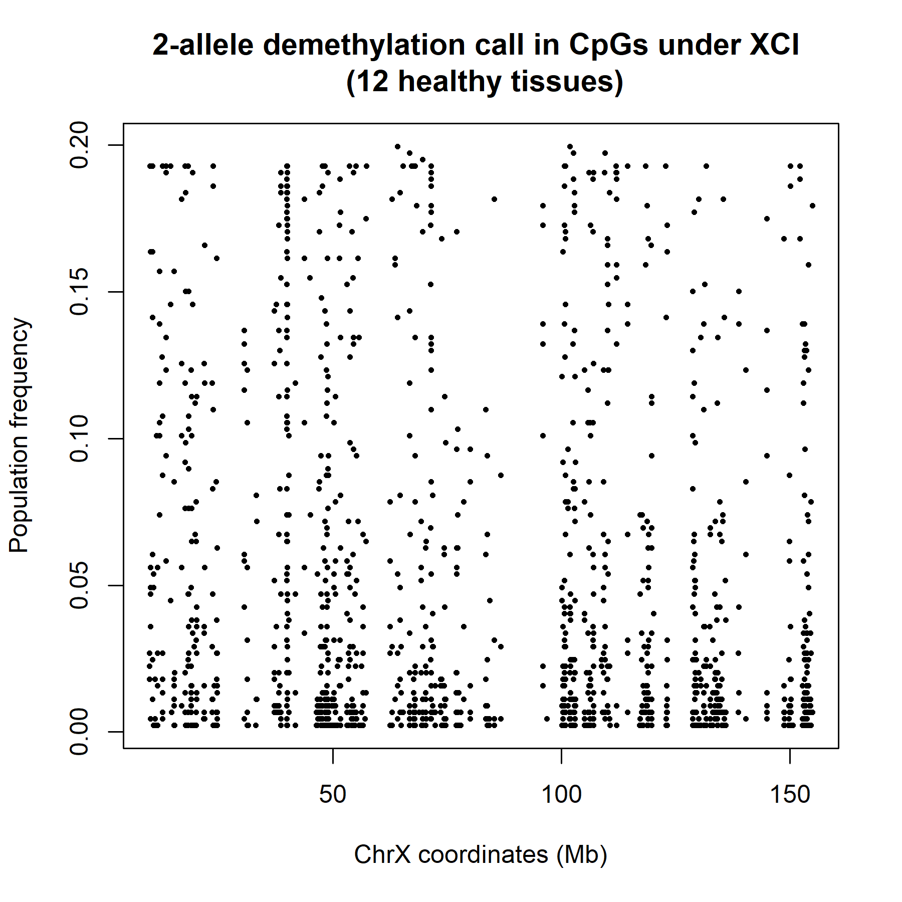

Figure S1. X chromosome coordinates of 1573 XCI CpGs that were observed with 2-allele demethylation in 446 samples that included12 healthy tissues from the TCGA.

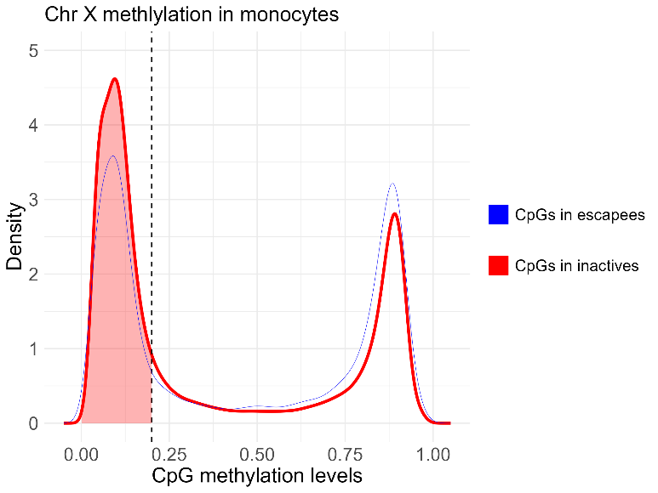

Figure S2. Methylation patterns of chr X CpGs in men. The red line represents the distribution of methylation levels for CpGs labeled as XCI in females. The blue line represents the distribution of methylation levels for CpGs of genes that would escape XCI in females.

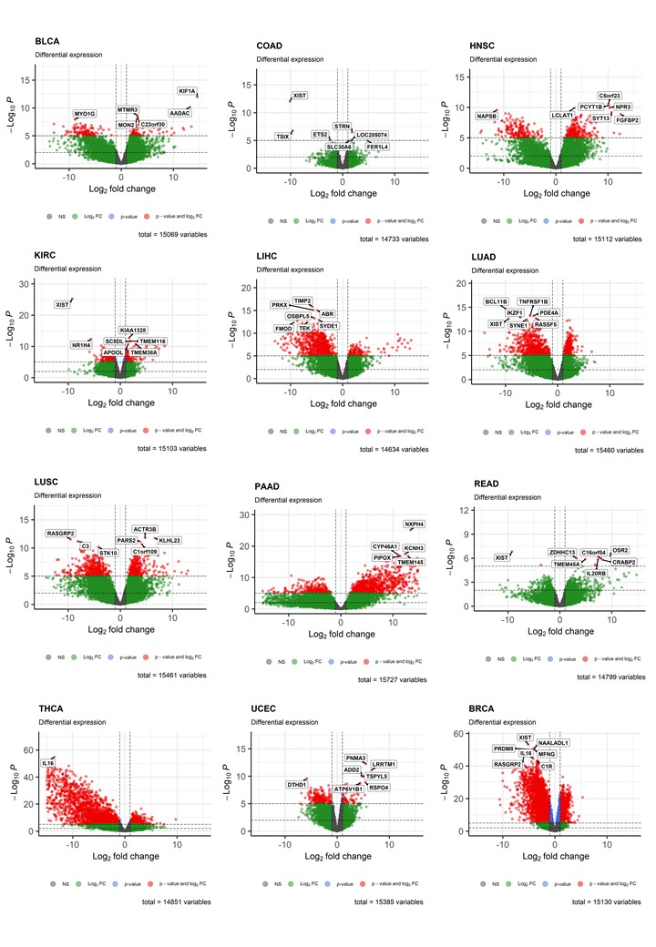 Figure S3. Differential expression analysis of X-Ra in tumor tissue across 12 cancer sites from the TCGA. Cancer sites included: breast (BRCA), bladder (BLCA), colon (COAD) head and neck (HNSC), kidney (KIRC), liver (LIHC), lung adenocarcinoma (LUAD), lung squamous cell carcinoma (LUSC), pancreas (PAAD), rectum (READ), thyroid (THCA) and uterus (UCEC).

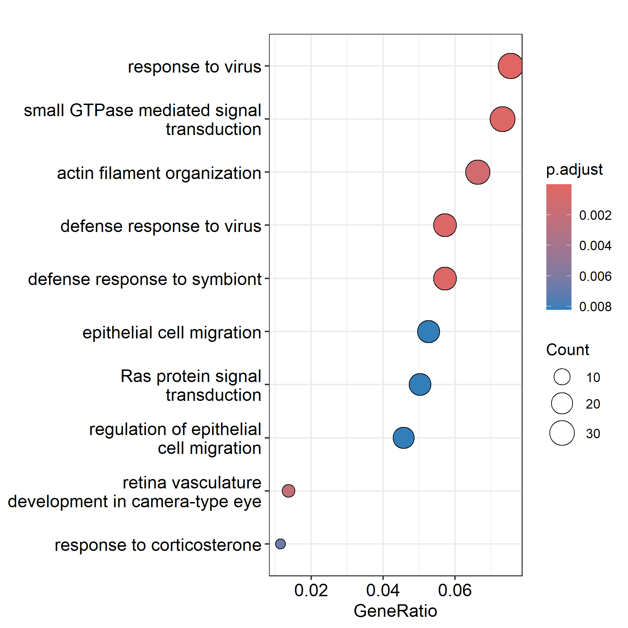
Figure S4. Enrichment analysis of meta-analyzed differentially expressed genes by X-Ra in tumor tissue across 12 cancer sites from the TCGA.

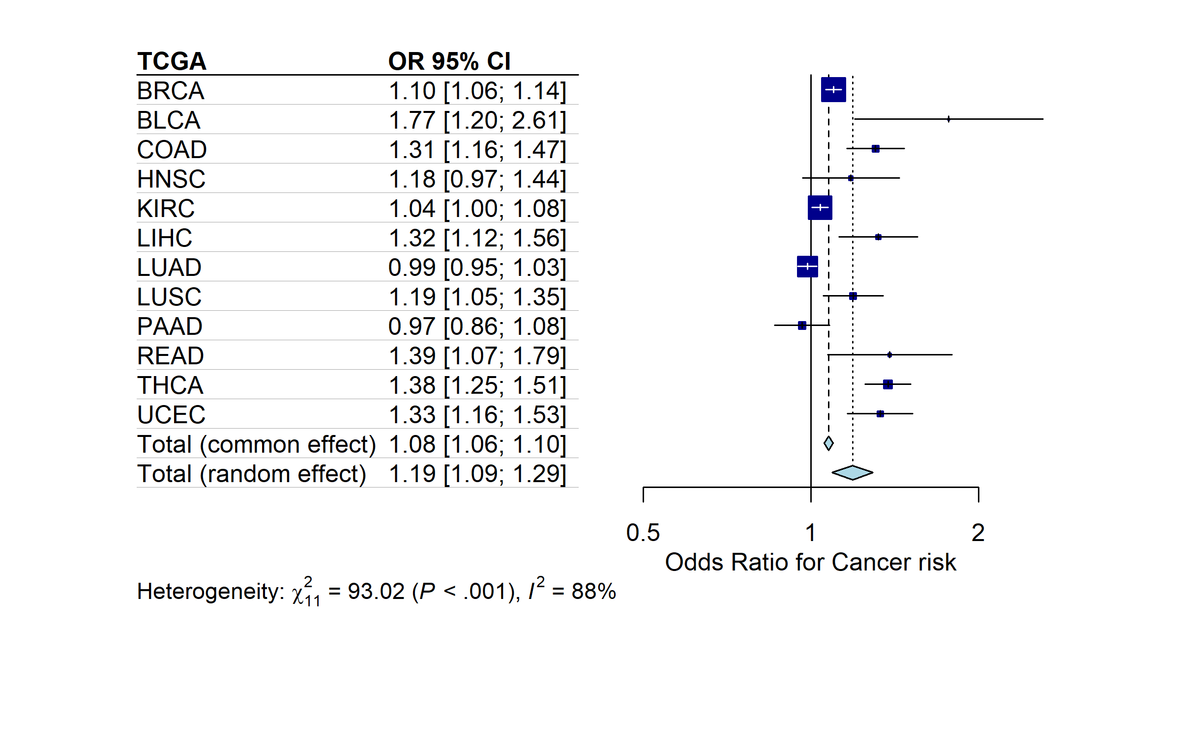

Figure S5. Meta-analysis across 12 different cancer types from the TCGA for the effect of X-Ra (%) on cancer risk.

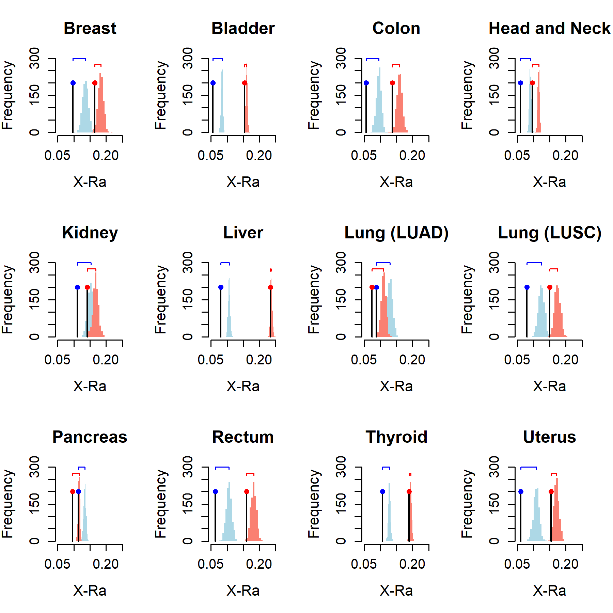 Figure S6. The dot shows the mean X-Ra (as a fraction) across women in cancer tissues of each TCGA study. In red, the distribution of mean X-Ra for random permutations of the XCI levels of CpGs. The blue dot and distributions are similar estimates in undiseased tissues. Overall, cancer reduces the distance of the observed X-Ra to the null. The amount reduction of this distance between cancer and normal tissue is correlated with the risk estimates of X-Ra for each cancer (Pearson’s R:0.64, P=0.01).

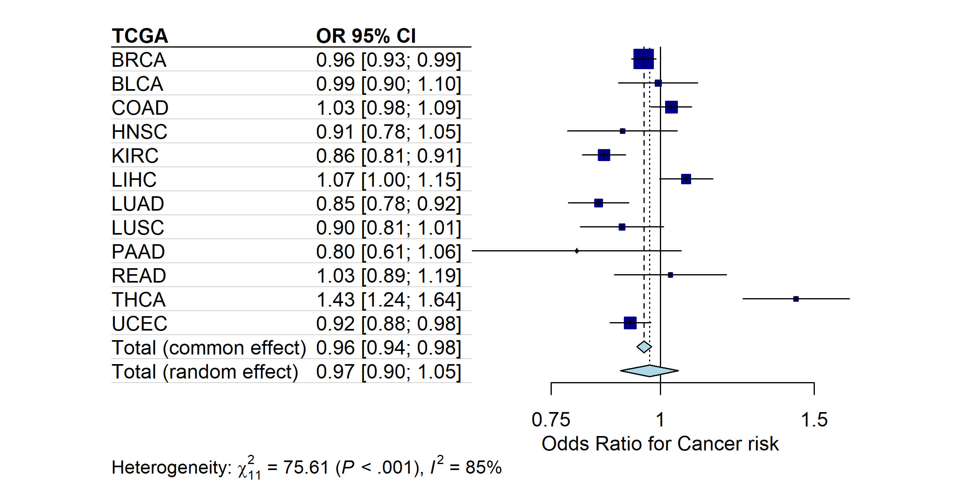

Figure S7. Meta-analysis across 12 different cancer types from the TCGA for the effect of cancer status of samples on the percentage of 2-allele demethylation in CpGs in escapees.

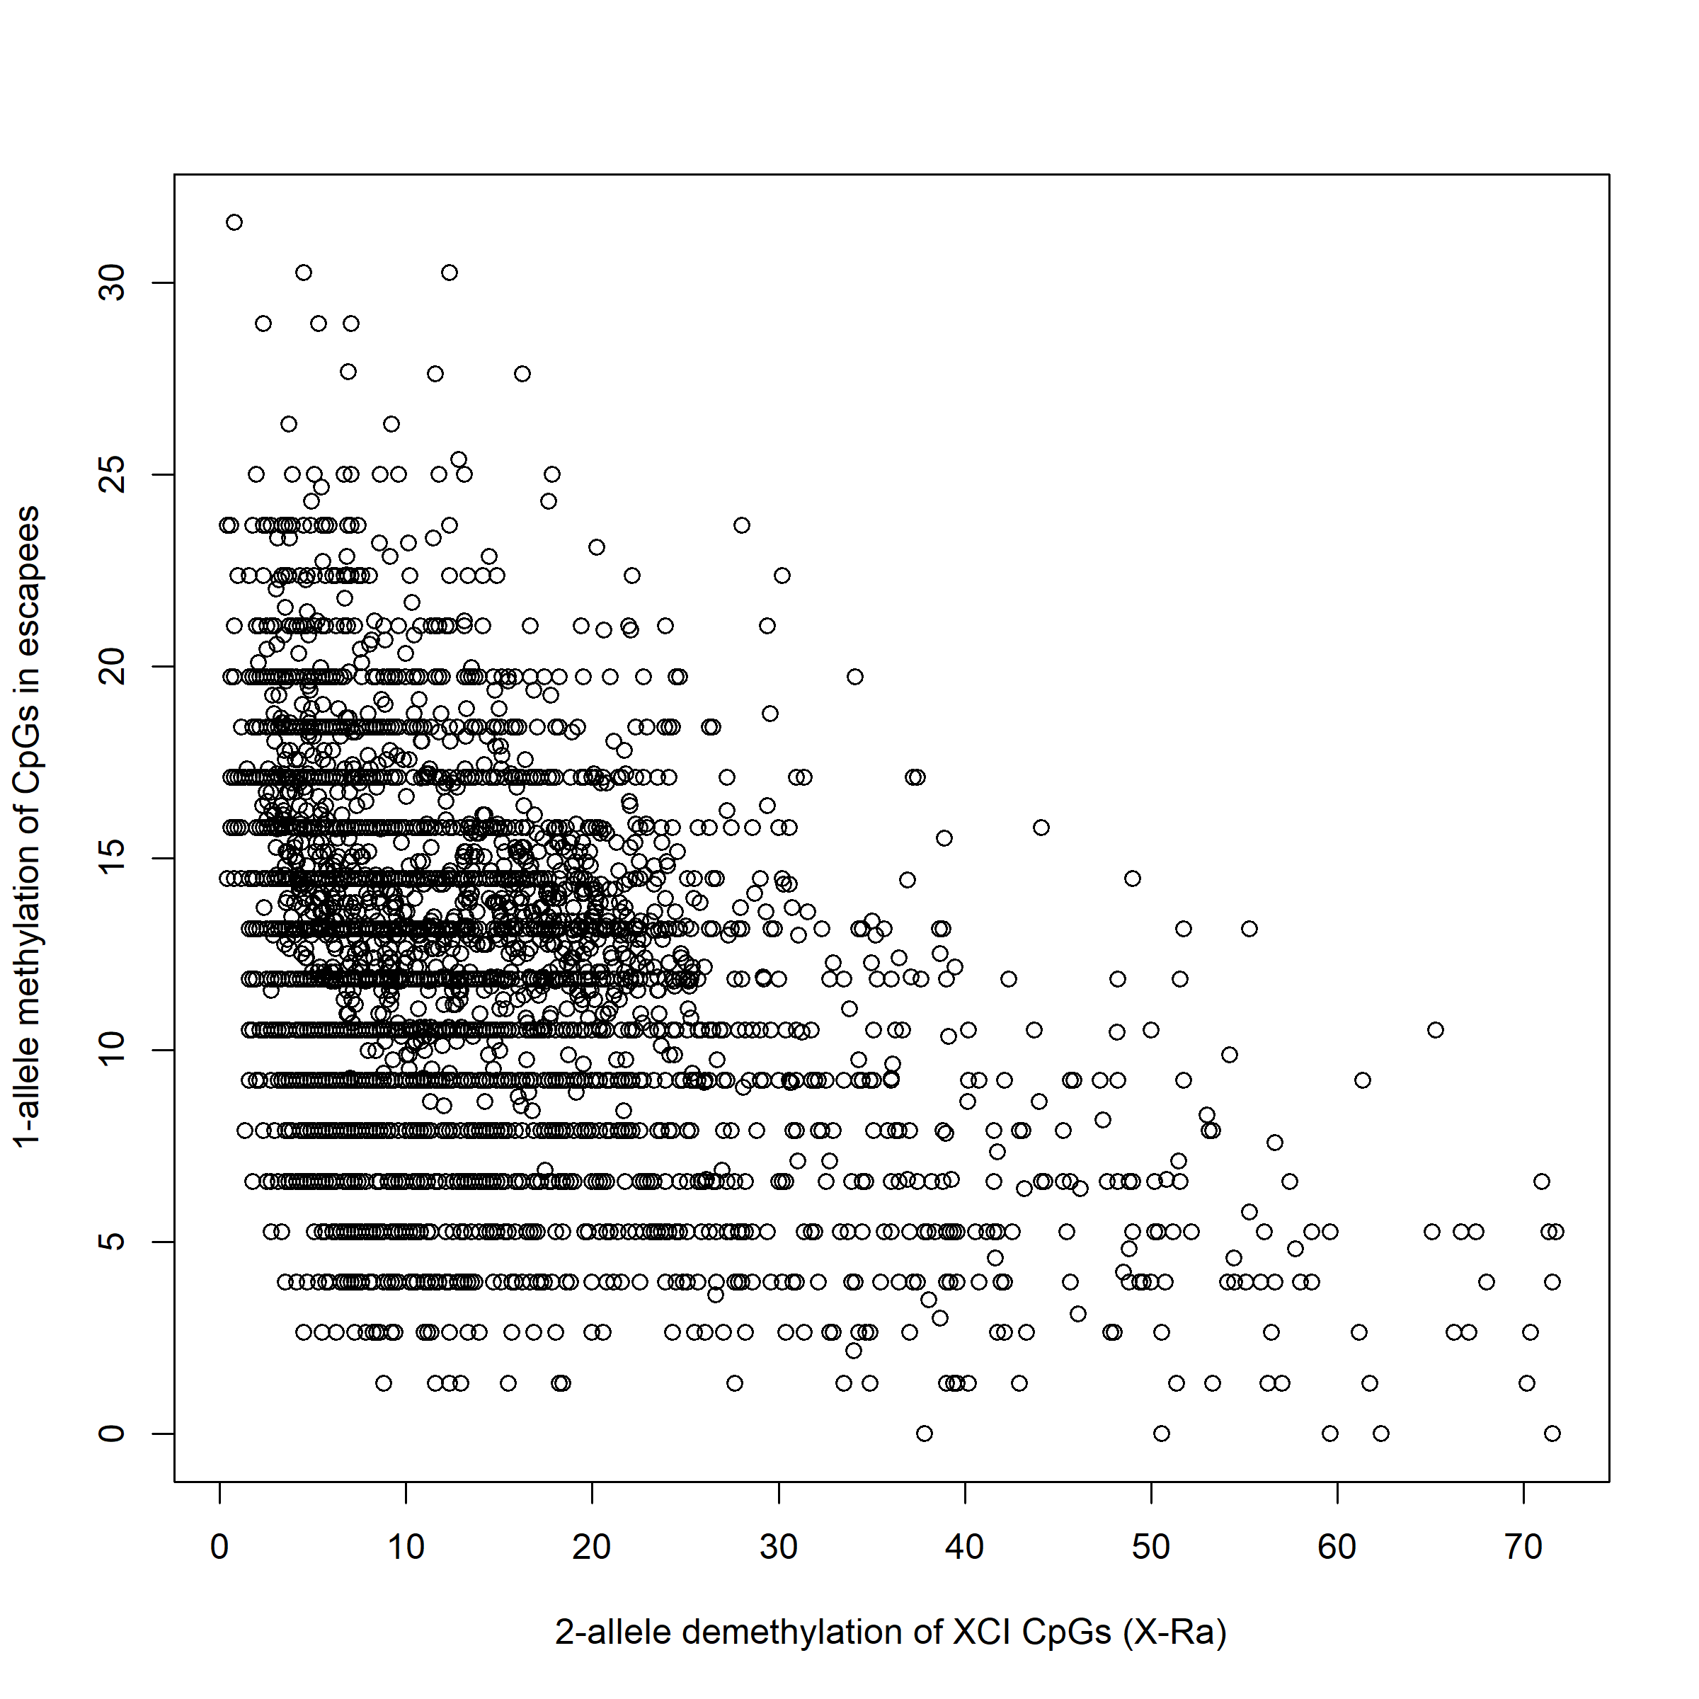
Figure S8. Correlation between 2-allele demethylation of XCI CpGs (X-Ra) and 1-allele methylation of CpGs in escapees, across 12 different cancer types from the TCGA.

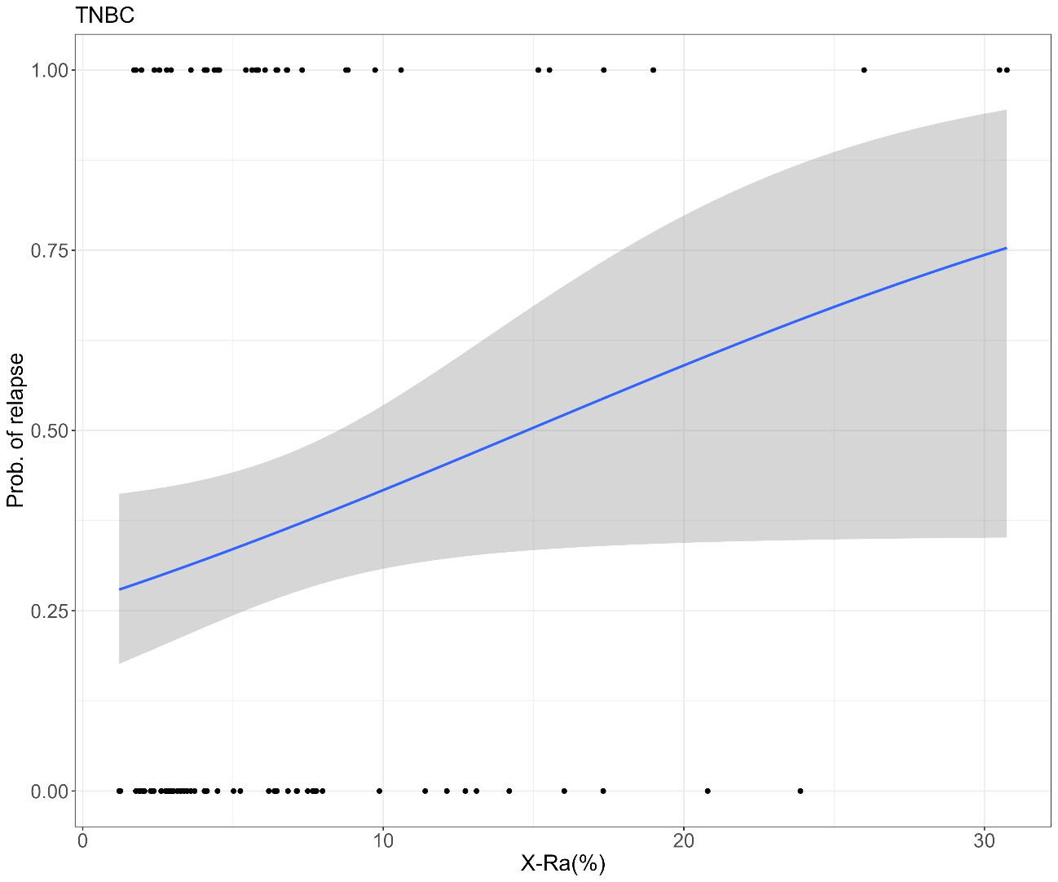

Figure S9. Association between relapse and X-Ra adjusted by chemotherapy in patients with no surgery (GSE141441).

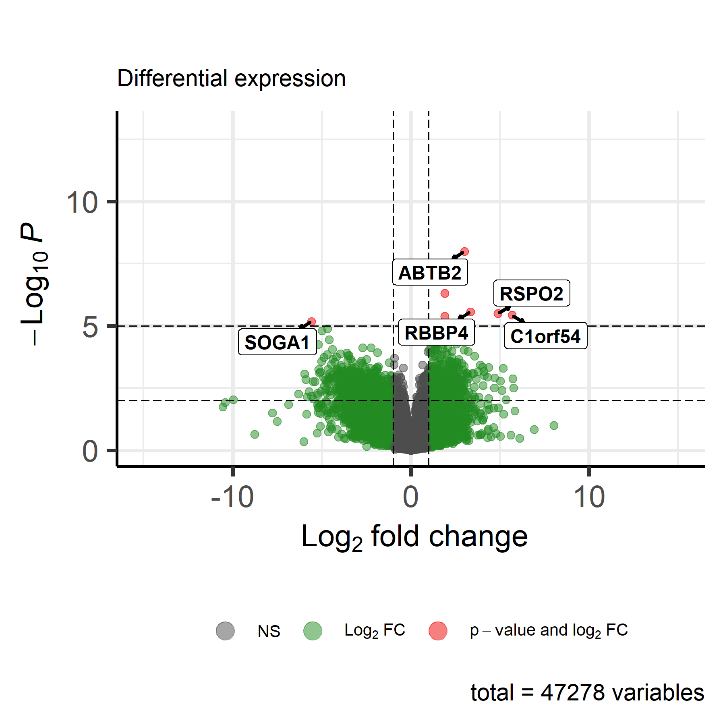

Figure S10. Volcano plot for the differential expression associated with XRa in the MESA study (GSE56046).

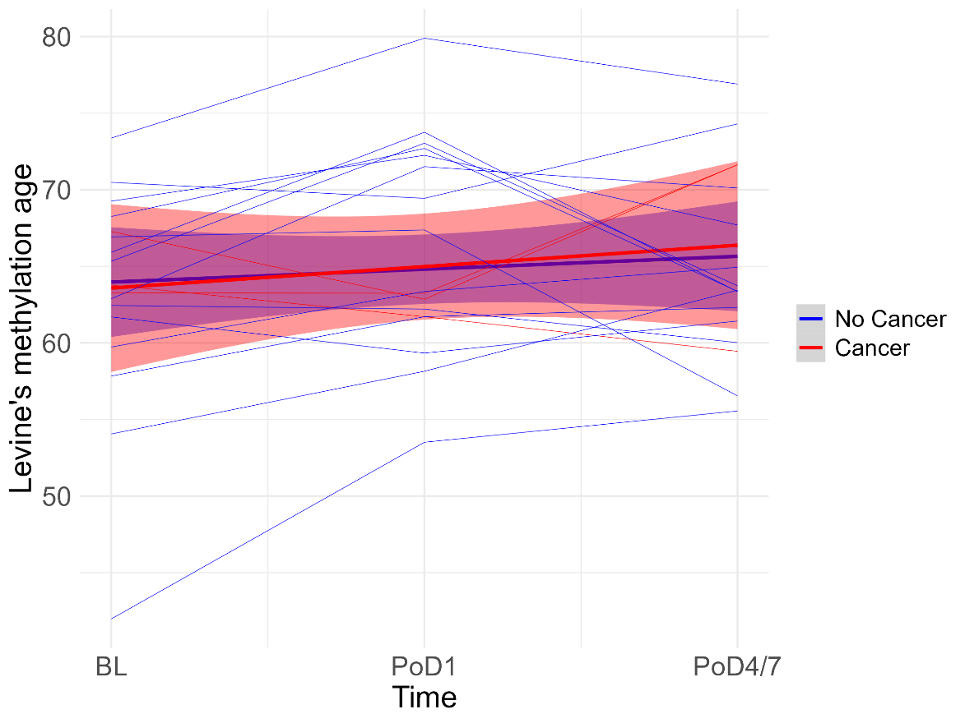

Figure S11. Longitudinal study (GSE142536) of blood DNA methylation changes of women undergoing major surgical intervention. Methylation was assessed at one day before intervention (BL), one day post-operative intervention (PoD1) and 4-7 days post-operative intervention (PoD4/7). Levine’s methylation age was not significantly higher in cancer patients than others.

Supplementary tables

Table S1.
Studies included in the analysis of X-Ra and its biological correlations. The number of women in the study and CpGs in chromosome X are shown in the first column. In the second column, we show the clinical outcome that was used to correlate with X-Ra, and in the last column, the tissue where X-Ra was assessed.

STUDY | N samples/chr-X CpGs | Clinical Outcomes | Tissue
TCGA | BRCA:1228/961  BLCA: 434/11232  COAD: 535/961  HNSC:580/11232  KIRC:898/961  LIHC: 429/11232  LUAD: 581/961  LUSC: 572/961  PAAD: 195/11232  READ: 179/961  THCA: 567/11232  UCEC: 584/961 | Survival, cancer type, transcriptomic, CNVs | 12 different cancer types and healthy tissues
GSE78754 | 70/11232 | Survival | Breast cancer
GSE141441 | 95/11232 | Recurrence | Breast cancer
GSE184159 | 63/9364 | Chemotherapy Response | Breast Cancer
GSE225845 | 224/8816 | TNBC status | Brest Cancer
TruDiagnostic | 1414/4471 | Age, cancer | Blood
GENOA | 986/10125 | Age | Blood
MESA | 605/11648 | Age, transcriptomic | Neutrophils (Blood)
GSE142536 | 51/11203 | Cancer | Blood
GSE207460 | 290/10158 | Chemotherapy Response | Breast Cancer

Table S2.
Characteristics of TruDiagnostic DNA Biobank.

Female population in TruDiagnostic DNA Biobank | N= 1414
Age in years, mean (range) | 52.4 (13.2- 97.8)
Cancer diagnosis any | 167 (11.8%)
Height (m), mean (range) | 1.65 (1.47-1.98)
Weight (kg), mean (range) | 64.5 (25.8-170.5)
BMI (kg/m²), mean (range) | 23.66 (10.10, 57.16)

BMI: Body Mass Index.

Table S6.
Loci with overlapping gains and deletions in BRCA that are the most significantly associated with X-Ra at each chromosome. Highlighted in bold are candidate genes for breast cancer.

CHR | Start | End | Beta | P | Freq | N | Genes
Gains
chr20 | 63580664 | 64080664 | 2.37676788 | 1.87E-17 | 121 | 1054 | RTEL1,RTEL1-TNFRSF6B,TPD52L2,DNAJC5,  PRPF6,GMEB2,ARFRP1,OPRL1,SLC2A4RG,  ZBTB46,SAMD10,RGS19,TCEA2,ABHD16B,  LINC00176,ZNF512B,ZGPAT,STMN3,UCKL1,  MIR1914,SOX18,LIME1,MIR647,MIR941-2,  MIR941-4,MHENCR,TNFRSF6B,RTEL1,ZGPAT,  MIR6813,MIR941-5,UCKL1-AS1,MIR941-1,  MIR941-3
chr8 | 127581254 | 128081254 | 1.77486774 | 4.66E-16 | 319 | 1054 | MYC,MIR1207,MIR1205,CASC11,PVT1,  MIR1204,TMEM75,MIR1206
chr10 | 2045792 | 2545792 | 2.27321571 | 6.05E-10 | 68 | 1054 | MIR6072
chr7 | 38043355 | 38543355 | 1.90854827 | 8.19E-10 | 116 | 1054 | STARD3NL,AMPH,TARP,TRG-AS1
chr16 | 9010777 | 9510777 | 1.9223649 | 4.70E-9 | 102 | 1054 | C16orf72,LINC01195,LINC01177,LINC02177
chr5 | 20515532 | 21015532 | 2.70884711 | 5.65E-9 | 40 | 1054 | CDH18
chr1 | 156562920 | 157062920 | 1.59226549 | 8.39E-9 | 221 | 1054 | INSRR,SH2D2A,NES,BCAN,ARHGEF11,  HAPLN2,PRCC,RRNAD1,MRPL24,ISG20L2,  CRABP2,HDGF,GPATCH4,LRRC71,NAXE,  IQGAP3,PEAR1,TTC24,NTRK1,MIR765
chr17 | 65650733 | 66150733 | 1.74274884 | 1.40E-7 | 115 | 1054 | CEP112
chr2 | 39012784 | 39512784 | 4.26267069 | 1.48E-7 | 16 | 1054 | MAP4K3,SOS1,CDKL4,LOC728730
chr12 | 69051460 | 69551460 | 2.15133587 | 1.56E-7 | 56 | 1054 | LYZ,CPSF6,YEATS4,FRS2,MIR1279
chr14 | 22239283 | 22739283 | 1.92105814 | 2.03E-7 | 78 | 1054 | ABHD4,DAD1,OR6J1,LINC02332
chr21 | 45854168 | 46354168 | 2.80953912 | 3.78E-7 | 28 | 1054 | COL6A1,COL6A2,FTCD,SPATC1L,LSS,  MCM3AP,C21orf58,PCNT,YBEY,PCBP3,  MCM3AP-AS1
chr6 | 23649661 | 24149661 | 2.41040764 | 1.47E-6 | 36 | 1054 | NRSN1
chr11 | 47698510 | 48198510 | 2.82952552 | 2.07E-6 | 24 | 1054 | NUP160,FNBP4,PTPRJ,AGBL2,MIR3161
chr15 | 86811075 | 87311075 | 2.70089533 | 2.50E-6 | 27 | 1054 | AGBL1,LOC102724452,LOC105370954,
chr19 | 28090910 | 28590910 | 2.50406612 | 4.44E-6 | 29 | 1054 | LOC100420587
chr3 | 5020930 | 5520930 | 2.32680533 | 5.08E-6 | 34 | 1054 | ARL8B,EDEM1,MIR4790
Deletions
chr8 | 3081254 | 3581254 | 2.093597 | 8.58E-9 | 77 | 1054 | CSMD1

Table S7.
Genes under XCI with expression levels in monocytes enriched in associations with X-Ra (P<0.001).

ID | logFC | AveExpr | t | P-Value
HSD17B10 | 2.55 | 8.71 | 4.28 | 2.18E-05
LAMP2 | 2.09 | 11.36 | 3.99 | 7.58E-05
ARMCX1 | 2.98 | 7.32 | 3.93 | 9.38E-05
BCOR | -4.69 | 8.81 | -3.83 | 1.40E-04
LAMP2 | 1.89 | 10.57 | 3.67 | 2.65E-04
SCML1 | 5.19 | 6.15 | 3.49 | 5.11E-04
MED12 | -3.58 | 6.58 | -3.49 | 5.27E-04
UPF3B | -5.18 | 7.15 | -3.47 | 5.59E-04
RLIM | 1.93 | 5.28 | 3.39 | 7.39E-04
SPIN2A | 1.47 | 5.20 | 3.35 | 8.53E-04
FLNA | -3.98 | 7.77 | -3.33 | 9.14E-04

