EFFECT OF BODY IMAGE ON SELF-ESTEEM AMONG UNDERGRADUATE STUDENTS IN A KENYAN PUBLIC UNIVERSITY

Supplementary File 1:

Data Collection Tool:
Anthropometrics
Weight …………………………
Height …………………………
Sociodemographic Information
- Name of your institution …………………………………
Sex: [ ] Male [ ] Female

- Year of study [ ] I [ ] II [ ] III [ ] IV [ ] V [ ] VI
- Course studied ………………………………
- Nationality ………………………………………
- Religion [ ] Christian [ ] Muslim [ ] Hindu
Any Other (Specify)……………………
- Marital Status [ ] Single [ ] Married [ ] Cohabiting (Living-together)
[ ] Separated/Divorced [ ] Widowed
- If single, separated, divorced, or widowed, are you currently in a long-term relationship? (Relationship lasting more than 6 months).
[ ] Yes [ ] No
- Number of Children [ ] None [ ] 1 [ ] ≥2
- Source of Income [ ] Student Loan [ ] Study leave [ ] Scholarship
[ ] Parent/Guardian
Specify any other if none of the above…………………………………….
- Do you take alcohol [ ] Yes [ ] No
- Do You smoke [ ] Yes [ ] No
If yes, Please specify…………………………………………………….
…………………………………………………….
- Physical activity level ( Circle the level that best applies to you)
- Sedentary
- Lightly active
- Active
- Very active
MULTIDIMENSIONAL BODY SELF-RELATIONS QUESTIONNAIRE (MBSRQ)
Please answer each statement below by circling the number that best applies to you.
1 2 3 4 5

Definitely Mostly Disagree Neither agree Mostly agree Definitely
Disagree nor disagree agree

- Before going out in public, I always notice how I look. | 1 | 2 | 3 | 4 | 5
- I am careful to buy clothes that will make me look at my best | 1 | 2 | 3 | 4 | 5
- I would pass most physical – fitness tests | 1 | 2 | 3 | 4 | 5
- It is important that I have superior physical strength. | 1 | 2 | 3 | 4 | 5
- My body is sexually appealing. | 1 | 2 | 3 | 4 | 5
- I am not involved on a regular exercise program. | 1 | 2 | 3 | 4 | 5
- I am in control of my health | 1 | 2 | 3 | 4 | 5
- I know a lot about things that affect my physical health | 1 | 2 | 3 | 4 | 5
- I have deliberately developed a healthy lifestyle. | 1 | 2 | 3 | 4 | 5
- I constantly worry about becoming fat. | 1 | 2 | 3 | 4 | 5
- I like my looks just the way they are. | 1 | 2 | 3 | 4 | 5
- I check my appearance on the mirror whenever I can | 1 | 2 | 3 | 4 | 5
- My physical endurance is good. | 1 | 2 | 3 | 4 | 5
- Before going out, I usually spend a lot of time getting ready | 1 | 2 | 3 | 4 | 5
- Participating in a sport is unimportant to me. | 1 | 2 | 3 | 4 | 5
- I do not actively do things to keep physically fit. | 1 | 2 | 3 | 4 | 5
- My health is a matter of unexpected ups and downs. | 1 | 2 | 3 | 4 | 5
- Good health is one of the most important things in my life. | 1 | 2 | 3 | 4 | 5
- I don’t do anything that I know might threaten my health. | 1 | 2 | 3 | 4 | 5
- I am very conscious of even small changes of my weight. | 1 | 2 | 3 | 4 | 5
- Most people would consider me good looking | 1 | 2 | 3 | 4 | 5
- It is important that I always look good | 1 | 2 | 3 | 4 | 5
- I use very few grooming products | 1 | 2 | 3 | 4 | 5
- I easily learn physical skills | 1 | 2 | 3 | 4 | 5
- Being physically fit is not a strong priority in life. | 1 | 2 | 3 | 4 | 5
- I do things to increase my physical strength. | 1 | 2 | 3 | 4 | 5
- I am seldom physically ill. | 1 | 2 | 3 | 4 | 5
- I take my health for granted. | 1 | 2 | 3 | 4 | 5
- I often read books and magazines that pertain to health. | 1 | 2 | 3 | 4 | 5
- I like the way I look without my clothes on. | 1 | 2 | 3 | 4 | 5
- I am self-conscious if my grooming isn’t right. | 1 | 2 | 3 | 4 | 5
- I usually whatever is handy without caring how it looks. | 1 | 2 | 3 | 4 | 5
- I do poorly in physical sports and games. | 1 | 2 | 3 | 4 | 5
- I seldom think about my athletic skills. | 1 | 2 | 3 | 4 | 5
- I work to improve my physical stamina. | 1 | 2 | 3 | 4 | 5
- From day to day, I never know how my body will feel | 1 | 2 | 3 | 4 | 5
- If I am sick, I don’t pay much attention to my symptoms. | 1 | 2 | 3 | 4 | 5
- I make no special efforts to eat a balanced and nutritious diet | 1 | 2 | 3 | 4 | 5
- I like the way my clothes fit me | 1 | 2 | 3 | 4 | 5
- I don’t care what people think about my appearance. | 1 | 2 | 3 | 4 | 5
- I take special care with my hair grooming. | 1 | 2 | 3 | 4 | 5
- I dislike my physique. | 1 | 2 | 3 | 4 | 5
- I don’t care to improve my abilities in physical activity. | 1 | 2 | 3 | 4 | 5
- I try to be physically active | 1 | 2 | 3 | 4 | 5
- I often feel vulnerable to sickness | 1 | 2 | 3 | 4 | 5
- I pay close attention for my body for any signs of illness | 1 | 2 | 3 | 4 | 5
- If I’m coming down with cold and flu, I just ignore it and go on as usual | 1 | 2 | 3 | 4 | 5
- I am physically unattractive. | 1 | 2 | 3 | 4 | 5
- I never think about my appearance. | 1 | 2 | 3 | 4 | 5
- I am always trying to improve my physical appearance | 1 | 2 | 3 | 4 | 5
- I am very well coordinated. | 1 | 2 | 3 | 4 | 5
- I know a lot about physical fitness. | 1 | 2 | 3 | 4 | 5
- I play sports regularly throughout the year | 1 | 2 | 3 | 4 | 5
- I am a physically healthy person. | 1 | 2 | 3 | 4 | 5
- I am very aware of small changes in my physical health. | 1 | 2 | 3 | 4 | 5
- At first sign of illness, I seek medical advice. | 1 | 2 | 3 | 4 | 5
- I am on a weight loss diet. | 1 | 2 | 3 | 4 | 5
Please circle your answer
- I have tried to lose weight by fasting or going on crash diet
- Never
- Rarely
- Sometimes
- Often
- Very often
- I think I am:
- very underweight
- somewhat underweight
- normal weight
- somewhat overweight
- Very overweight.
- From looking at me, most people think I am:
- Very underweight
- Somewhat underweight
- Normal weight
- Somewhat overweight
- Very overweight
For questions 61-68, choose 1-5 scale to choose how satisfied or dissatisfied you are with each of the following areas of your body.
- Face (features and complexions). 1 2 3 4 5
- Hair (color,thickness,texture) 1 2 3 4 5
- Lower torso (buttocks, hips, thighs, legs). 1 2 3 4 5
- Mid torso (waist, stomach). 1 2 3 4 5
- Upper torso (chest or breasts, shoulders, arms). 1 2 3 4 5
- Muscle tone. 1 2 3 4 5
- Weight. 1 2 3 4 5
- Height. 1 2 3 4 5
- Overall appearance. 1 2 3 4 5
Contour Drawing Rating Scale (CDRS)
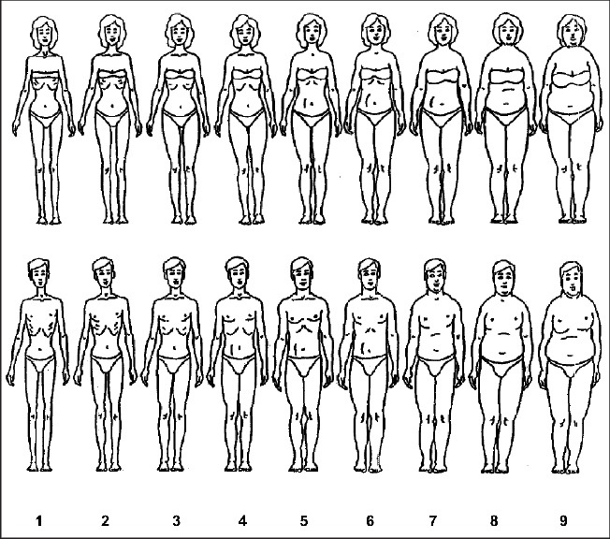

THE ROSENBERG SELF-ESTEEM SCALE (RSBS)
