Glu, Asp121 Hydrogen bonds
Distance Glu, Asp121 to Zn1388 and Cu1156
RCY/ Cyc₁ Complex
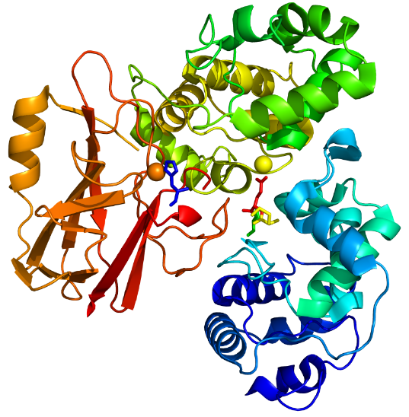
Zn 1388 of Cyc₁ (Chain B)

RCY
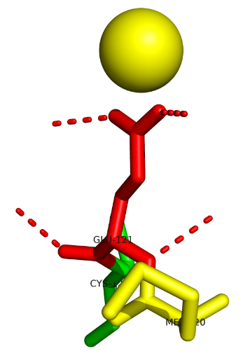
Cyc₁ (Chain B)

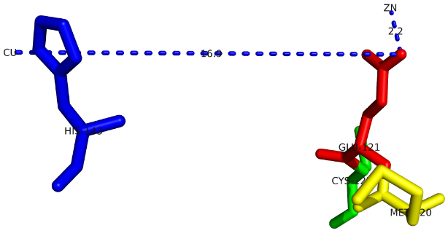

His143 RCY
Cyc₁ (Chain A)

↓ Decrease of distance Asp121 in cytochrome c₅₅₂ to Cu1156 in RCY → ↑ stability of the RCY / Cytochrome c₅₅₂ complex
↑ Increase in hydrogen bonds between aspartate 121 in chain A and zinc 1388 in chain B →↑ stronger binding of two Cytochrome c₅₅₂ chains
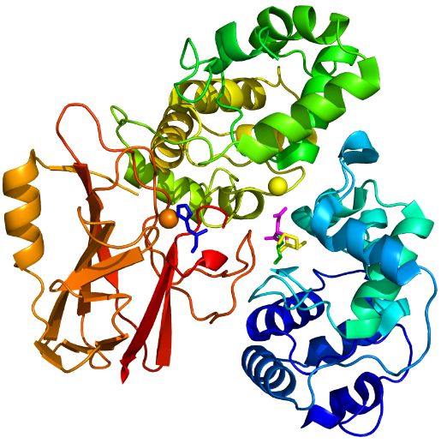
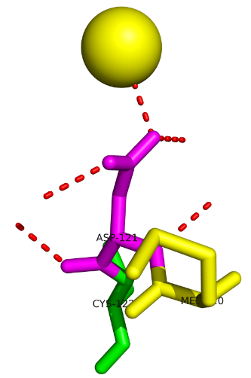
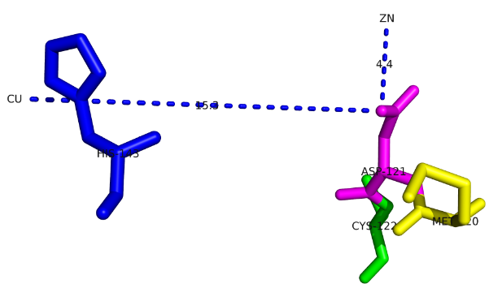
↑ RMSF→↓ Active site stability→↓ ΔG →↑ E₀ and improving electron transfer to Cytochrome c₅₅₂ protein
His143 RCY
Cyc₁ (Chain A)
Cyc₁ (Chain B)

RCY

