Supplementary materials
Serum starvation induces cytosolic DNA trafficking via exosome and autophagy-lysosome pathway in microglia
Liyan Zhou¹ · Zilong Wu¹ · Xiaoqing Yi¹ · Dongxue Xie¹ · Jufen Wang¹ · Wenhe Wu¹
¹ Key Laboratory of Laboratory Medicine, Ministry of Education, Wenzhou Key Laboratory of Cancer Pathogenesis and Translation, School of Laboratory Medicine and Life Sciences, Wenzhou Medical University, Wenzhou, Zhejiang 325035, China
Corresponding author Wenhe Wu, wuwenhe2000@163.com

Supplementary Figure 1

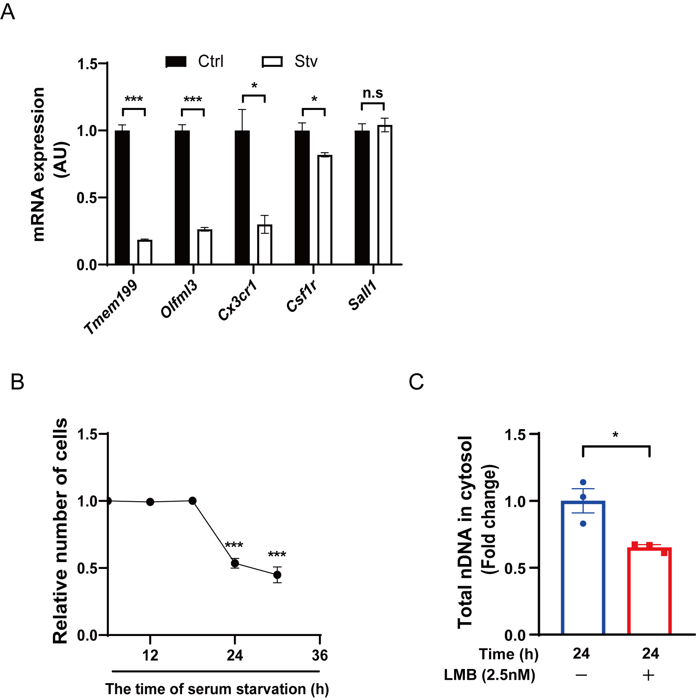
Fig. S1 BV2 microglia are treated with serum starvation during the indicated times. A RT-qPCR analysis showing the mRNA levels of homeostasis genes including Tmem199, Olfml3, Cx3cr1, Csf1r, Sall1 in BV2 microglia under serum starvation for 12 h. B The relative proliferation of cells after serum starvation for 6, 12, 18, 24 and 30 h was determined by MTT assay. C Relative quantitative analysis of the total nDNA in the cytosol. Multigroup comparisons were performed by using one way ANOVA with Tukey’s post hoc test. *P < 0.05; **P < 0.01; ***P < 0.001, n = 4 cell samples per group (A), n = 6 cell samples per group (B), Error bars reflect mean ± s.e.m.

Supplementary Figure 2

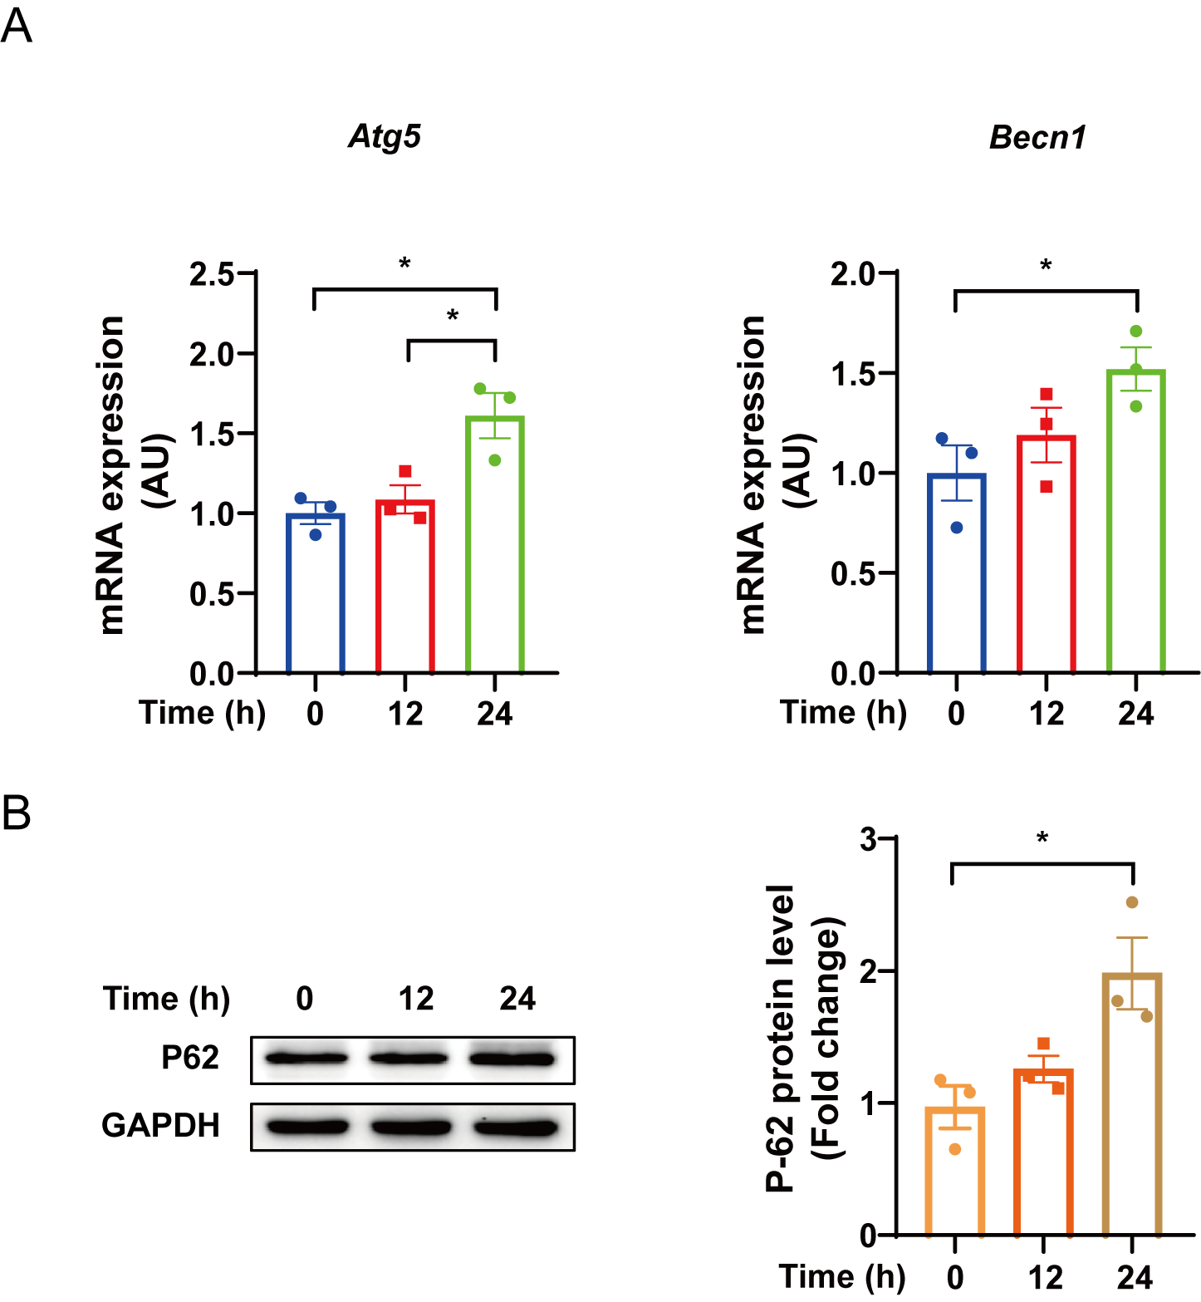
Fig. S2 BV2 microglia are treated with serum starvation during the indicated times (0, 12, 24 h). A RT-qPCR analysis showing the mRNA levels of Atg5, Becn1. B Western blotting analysis of P62 in BV2 microglia treated with serum starvation during the indicated times. Multigroup comparisons were performed by using one way ANOVA with Tukey’s post hoc test. *P < 0.05; **P < 0.01; ***P < 0.001, n = 3 cell samples per group, Error bars reflect mean ± s.e.m.

Supplementary Figure 3
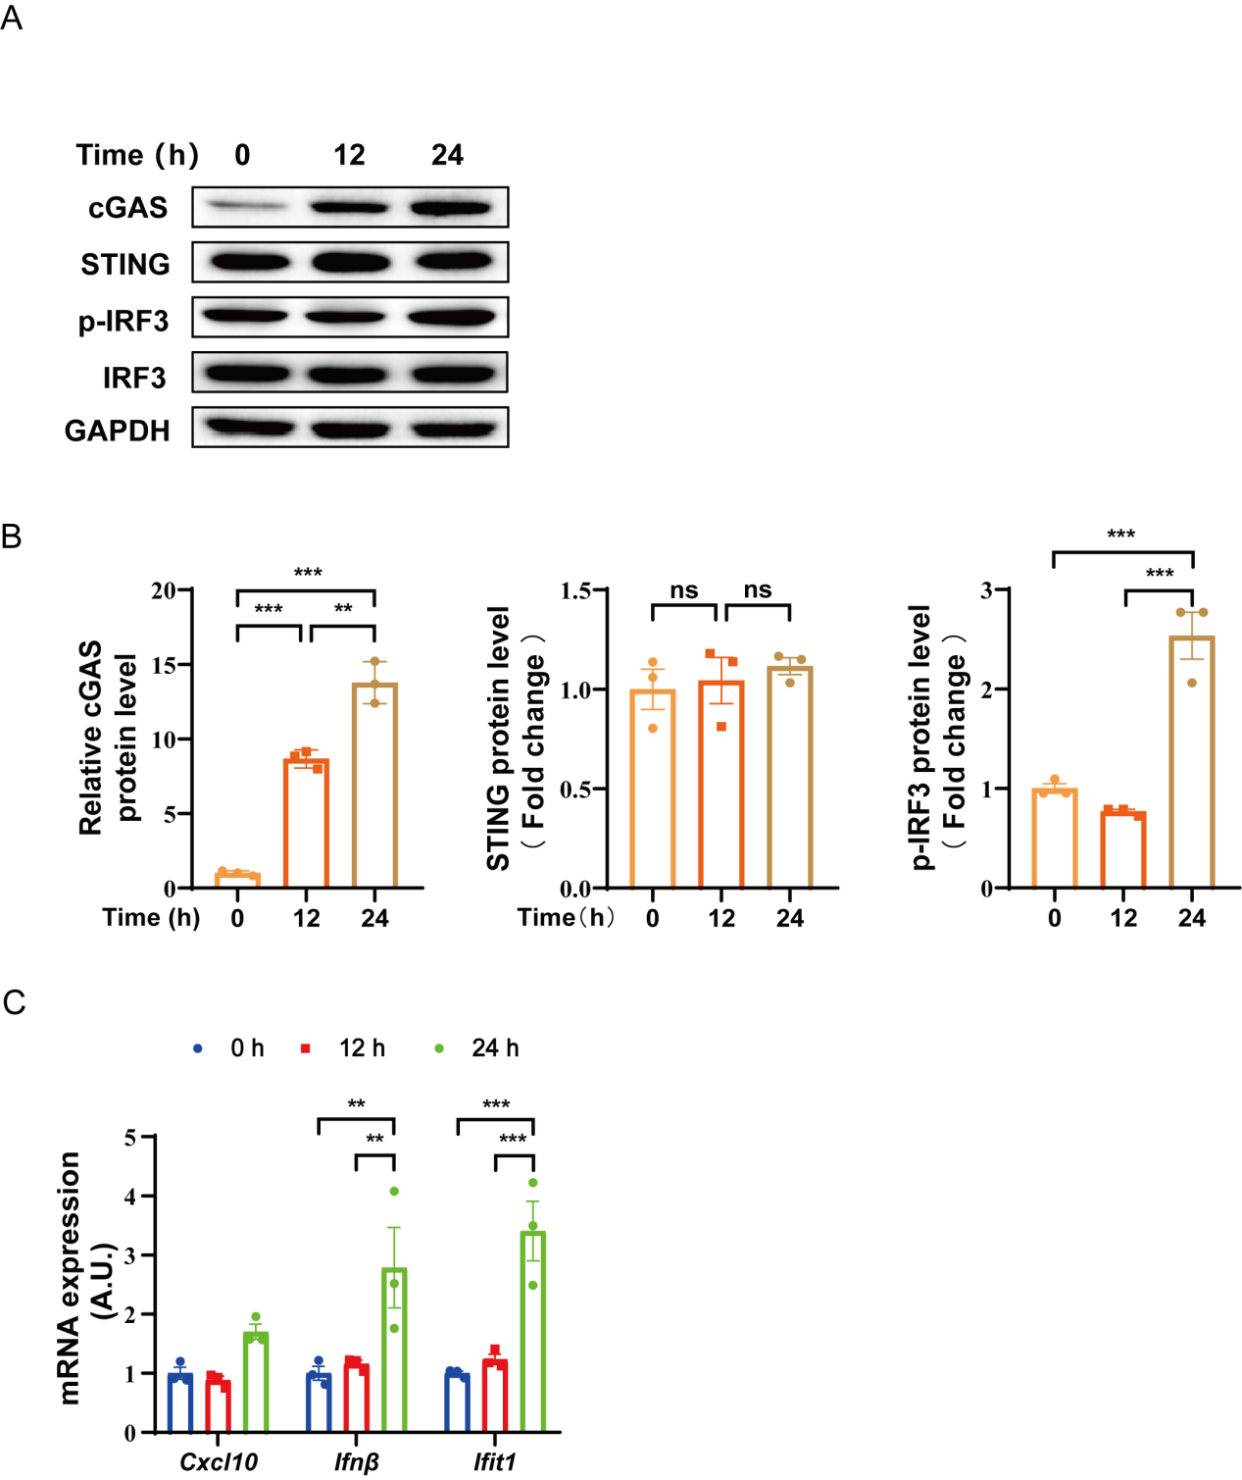
Fig. S3 BV2 microglia are treated with serum starvation during the indicated times (0, 12, 24 h). A-B Western blotting analysis of the protein levels of cGAS, p-IRF3, IRF3 and STING. C RT-qPCR analysis showing mRNA levels of cGAS/STING responsive genes (Cxcl10, Ifnb, and Ifit1). Multigroup comparisons were performed by using one way ANOVA with Tukey’s post hoc test. *P < 0.05; **P < 0.01; ***P < 0.001, n = 3 cell samples per group (A-C), Error bars reflect mean ± s.e.m.

Supplementary Figure 4

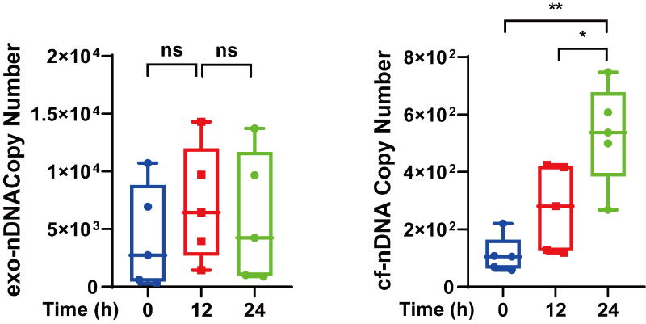
Fig. S4 Absolute quantification of the nDNA within exosomes extracted from cellular supernatant of BV2 microglia and the cell-free nDNA in the cellular supernatant of BV2 microglia. β-globin gene was applied to represent nDNA. Multigroup comparisons were performed by using one way ANOVA with Tukey’s post hoc test. *P < 0.05; **P < 0.01; ***P < 0.001, n = 5 cell samples per group, Error bars reflect mean ± s.e.m.

