Supporting Information

Observing Dendrite Growth in Solid-State Sodium Batteries Using Fluorescence Tomography Technology

Shuaishuai Yang¹, Na Li⁴, Enyue Zhao⁴, Chengzhi Wang^{1, 2}*, Jingxin He¹, Xiong Xiao¹, Debao Fang^{1, 2}, Qing Ni¹, Xile Han³, Xiaobin Xue³, Lai Chen¹ ²*, Ning Li^{1, 2}, Jingbo Li¹, Tuan Guo³, Yuefeng Su^{1, 2}, Haibo Jin^{1, 2}*

¹School of Materials Science and Engineering, Beijing Key Laboratory of Construction Tailorable Advanced Functional Materials and Green Applications, Beijing Key Laboratory of Environmental Science and Engineering, Beijing Institute of Technology, Beijing 100081, China. ²Chongqing Innovation Center, Beijing Institute of Technology, Chongqing 401120, China. ³Guangdong Key Laboratory of Optical Fiber Sensing and Communications, Institute of Photonics Technology, Jinan University, Guangzhou, Guangdong 511443, China. ⁴Songshan Lake Materials Laboratory, Dongguan 523808, China.

*Correspondence: wang_cz@bit.edu.cn (C.Z Wang), chenlai144@sina.com (L. Chen), hbjin@bit.edu.cn (H.B. Jin)

Fig. S1. Photoluminescence mechanism of Eu³⁺ ions under UV light excitation.

Fig. S2. Photoluminescence spectra of the NZSP-xEO solid electrolytes with the blank NZSP as comparison.

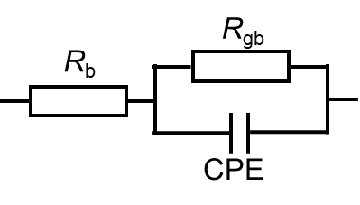
Fig. S3. Equivalent circuit containing the bulk resistance (R_{b}) and the grain boundary resistance (R_{gb}) for conductivity analysis of the solid electrolytes.

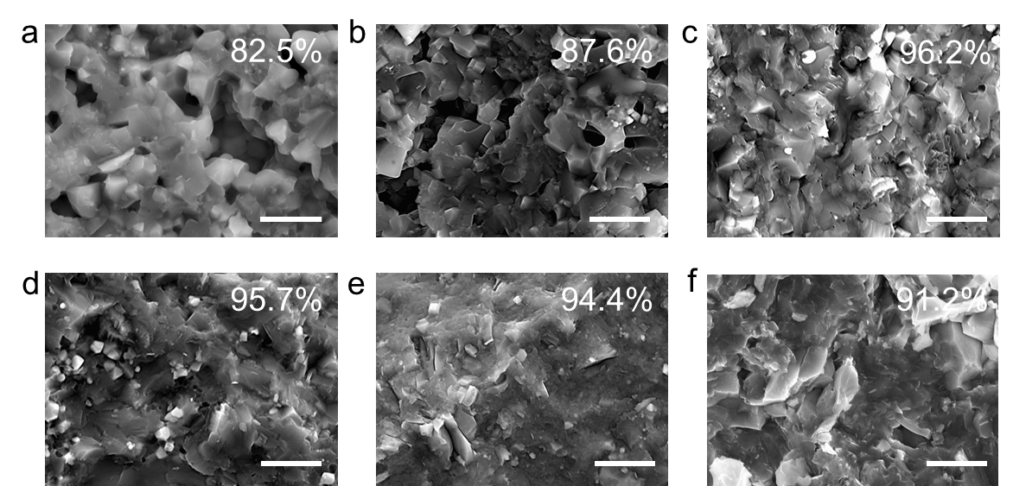
Fig. S4. Cross-sectional SEM images and relative densities of the NZSP-xEO solid electrolytes with the blank NZSP as comparison. (a) NZSP, (b) NZSP-2%EO, (c) NZSP-5%EO, (d) NZSP-7%EO, (e) NZSP-10%EO, (f) NZSP-15%EO. The relative densities were determined by an Archimedes drainage method.

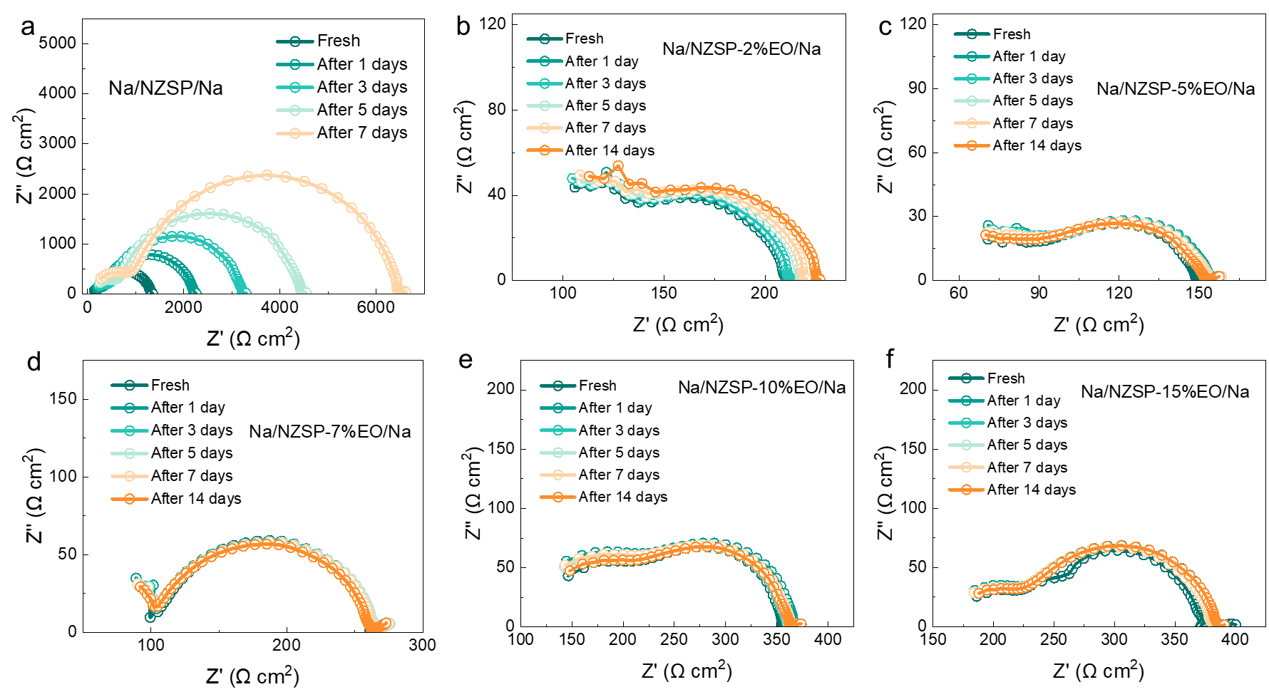
Fig. S5. Time-resolution Nquist plots of the symmetric Na//Na cells using the various NZSP-x%EO solid electrolytes for 14 days. (a) NZSP, (b) NZSP-2%EO, (c) NZSP-5%EO, (d) NZSP-7%EO, (e) NZSP-10%EO, (f) NZSP-15%EO.

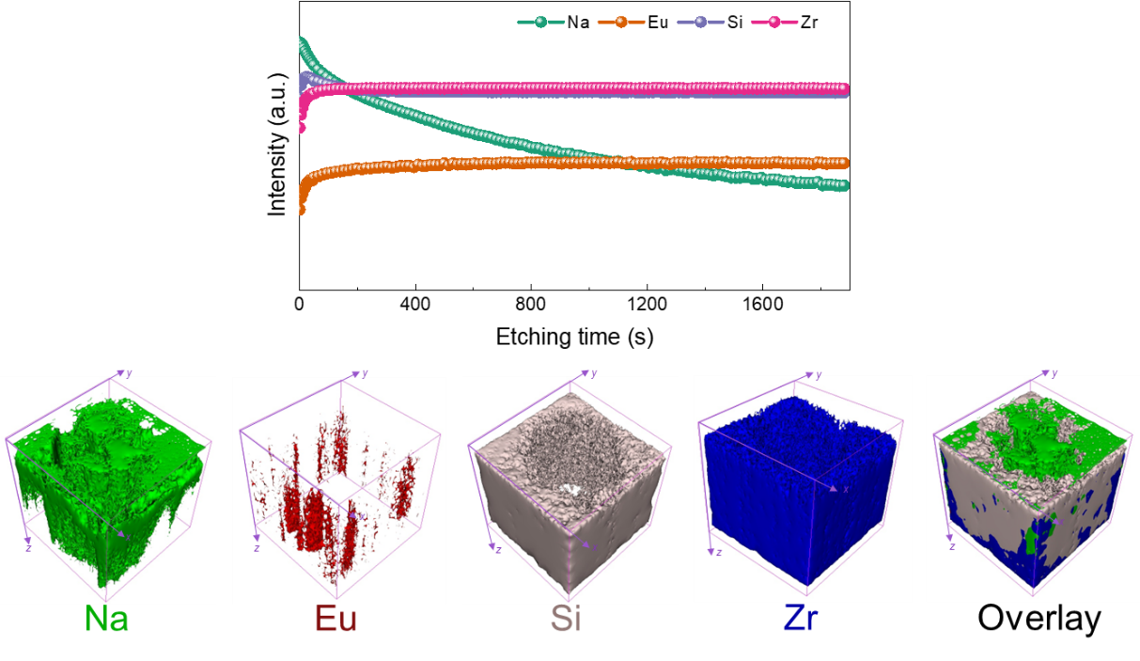
Fig. S6. In-depth ToFSIMs profile of the NZSP-5%EO after short circuit and the derived 3D models of Na, Eu, Si, Zr species and their overlay.

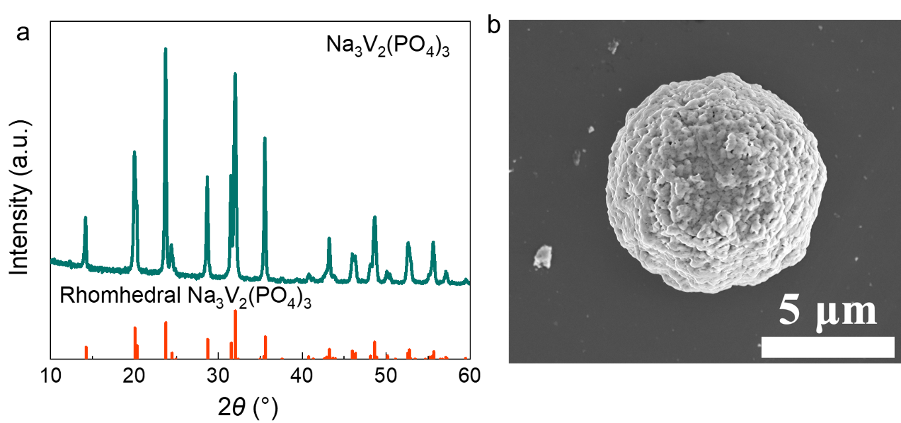
Fig. S7. (a) XRD patterns and (b) SEM image of the commercial Na₃V₂(PO₄)₃ cathode materials.

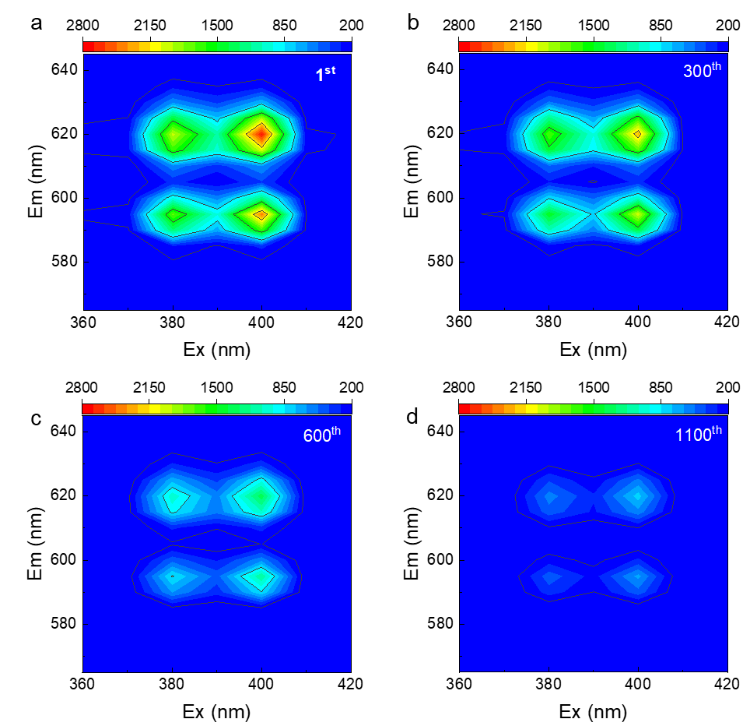
Fig. S8. Fluorescence emission maps of the NZSP-5%EO solid electrolytes after different charge/discharge cycles. (a) 1st, (b) 300th, (c) 600th, (d) 1100th.

Composition | Space group | a (Å) | b (Å) | c (Å) | beta（deg） | Volume (Å)
NZSP | C2/c | 15.625774 | 9.038793 | 9.212119 | 123.7010 | 1082.441
NZSP-5%EO | C2/c | 15.627126 | 9.037405 | 9.215243 | 123.6705 | 1083.124
Table S1. The comparative crystalline parameters of NZSP and NZSP-5%EO from Rietveld refinement results.

