Table S1. The oligonucleotides used in this study.
IL-6 F | TAGTCCTTCCTACCCCAATTTCC
IL-6 R | TTGGTCCTTAGCCACTCCTTC
TNF-α F | CCCTCACACTCAGATCATCTTCT
TNF-α R | GCTACGACGTGGGCTACAG
TGR5 F | CCTGGCAAGCCTCATCGTC
TGR5 R | AGCAGCCCGGCTAGTAGTAG
FXR F | GCTTGATGTGCTACAAAAGCTG
FXR R | CGTGGTGATGGTTGAATGTCC
IL-1β F | CCTGGGCTGTCCTGATGAGAG
IL-1β R | TCCACGGGAAAGACACAGGTA
GAPDH F | CAATGTGTCCGTCGTGGATCT
GAPDH R | GTCCTCAGTGTAGCCCAAGATG

Table S2. OPLS-DA model parameter.
 | R2X | R2X(cum) | R2Y | R2Y(cum) | Q2 | Q2(cum)
p1 | 0.237 | 0.237 | 0.918 | 0.918 | 0.786 | 0.786
o1 | 0.144 | 0.381 | 0.0713 | 0.0713 | 0.0556 | 0.0556
sum |  | 0.381 |  | 0.989 |  | 0.841

Table S3. Identified number of differential metabolites in GP.100 and LPS samples
Compared Sample | Number of total identified | Number of total significant | Number of significant Up | Number of significant Down
GP.100 vs LPS | 1447 | 97 | 11 | 86

Table S4. Metabolites significantly up-regulated in SARA cows and ranked according to the P-value
Name | FC | log2FC | P-value | VIP
1-Stearoyl-2-linoleoyl-sn-glycero-3-phosphocholine | 2.251042348 | 1.170593198 | 0.004393406 | 1.021326835
5-Hydroxyindole-3-acetic acid | 2.461246532 | 1.299389173 | 0.004971844 | 1.546549894
(2E)-4-Anilino-4-oxo-2-butenoic acid | 2.461246532 | 1.299389173 | 0.004971844 | 1.546549894
Hypoxanthine | 2.685224603 | 1.425042766 | 0.010023775 | 2.446270595
Allopurinol | 2.685224603 | 1.425042766 | 0.010023775 | 2.446270595
3,4-Dihydro-3-oxo-2H-(1,4)-benzoxazin-2-ylacetic acid | 2.894994042 | 1.533560379 | 0.000912501 | 2.739207878
Ganoderic acid A | 3.957703563 | 1.984663557 | 0.040548064 | 1.036389041
PC(18:0) | 4.455951255 | 2.155733451 | 0.017327894 | 1.443843174
2'-Deoxyuridine | 5.399943605 | 2.43294434 | 0.02394675 | 1.393462302
Chenodeoxycholic acid | 8.635526396 | 3.110284123 | 0.015889169 | 1.965049059
Deoxycholic acid | 10.21898459 | 3.353179945 | 0.003912285 | 4.285381049
FC, fold change; VIP, variable importance in the projection

Table S5. Metabolites significantly down-regulated in SARA cows and ranked according to the P-value
Name | FC | log2FC | P-value | VIP
3-Hydroxy-4,4,6a,9,12b-pentamethyl-3,4,4a,6,6a,12,12a,12b-octahydro-2H,9H-benzo[f]pyrano[2,3-b]chromene-1,11(5H,10H)-dione | 0.014626732 | -6.095248722 | 0.028062818 | 1.022019937
M363T99 | 0.014626732 | -6.095248722 | 0.028062818 | 1.022019937
D-Pinitol | 0.024786318 | -5.334312224 | 0.014655035 | 1.37600308
Prolylhydroxyproline | 0.034232492 | -4.868489864 | 0.003970493 | 2.558746525
M243T119 | 0.040433162 | -4.628317152 | 0.003338093 | 1.192720896
PyroGlu-Val | 0.076217508 | -3.713733745 | 0.023059769 | 1.036605889
Indoxyl sulfate | 0.078313275 | -3.674599308 | 0.006968889 | 9.043530541
alpha-Ketoisovaleric acid | 0.082384627 | -3.601481037 | 0.047643272 | 4.563901217
Pyruvate | 0.087401984 | -3.516190157 | 0.003248306 | 8.978685046
3-Methoxy-4-hydroxyphenylglycol sulfate | 0.09352945 | -3.418435491 | 0.014830997 | 1.137267459
Hydroxyphenyllactic acid | 0.101288563 | -3.303456819 | 0.00283589 | 1.644657324
3,4-Dimethoxybenzoic acid | 0.101288563 | -3.303456819 | 0.00283589 | 1.644657324
4-Ethoxybenzoic acid | 0.109494803 | -3.191065693 | 0.000132329 | 5.321294176
Desaminotyrosine | 0.109494803 | -3.191065693 | 0.000132329 | 5.321294176
2-Phenyllactic acid | 0.109494803 | -3.191065693 | 0.000132329 | 5.321294176
Tropic acid | 0.109494803 | -3.191065693 | 0.000132329 | 5.321294176
Acetylcarnitine (Car(2:0)) | 0.109588695 | -3.189829116 | 0.005623244 | 1.186779889
Formiminoglutamic acid | 0.11123995 | -3.168253095 | 0.00908866 | 1.089587322
Name | FC | log2FC | P-value | VIP
Trigonelline | 0.128871483 | -2.955995044 | 0.001099468 | 1.622519208
3-Pyridylacetic acid | 0.128871483 | -2.955995044 | 0.001099468 | 1.622519208
Allantoin | 0.145042942 | -2.785448001 | 0.002716901 | 4.419460154
N1-Methyl-2-pyridone-5-carboxamide | 0.148655838 | -2.749951973 | 0.016128497 | 1.812989117
N1-Methyl-4-pyridone-3-carboxamide | 0.148655838 | -2.749951973 | 0.016128497 | 1.812989117
Hydroxyisocaproic acid | 0.149923906 | -2.737697649 | 0.000148353 | 9.375418381
2-Ethyl-2-hydroxybutyric acid | 0.149923906 | -2.737697649 | 0.000148353 | 9.375418381
2-Hydroxyhexanoic acid | 0.149923906 | -2.737697649 | 0.000148353 | 9.375418381
Carnitine | 0.172310613 | -2.536916528 | 0.004309171 | 3.167945887
2-Hydroxyethanesulfonic acid | 0.186831844 | -2.420187725 | 0.027499537 | 3.001216823
Hippuric acid | 0.189523555 | -2.399550933 | 0.013801373 | 2.371329175
3-Succinoylpyridine | 0.189523555 | -2.399550933 | 0.013801373 | 2.371329175
2-Hydroxy-2-methylbutyric acid | 0.192403251 | -2.377794922 | 0.00151841 | 4.135525905
2-Hydroxy-3-methylbutyric acid | 0.192403251 | -2.377794922 | 0.00151841 | 4.135525905
Tryptophan | 0.200088612 | -2.321289033 | 0.001544669 | 1.412939776
5-(Hydroxymethyl)-1-methyl-2-phenyl-2,3-dihydro-1H-pyrazol-3-one | 0.200088612 | -2.321289033 | 0.001544669 | 1.412939776
Proline | 0.200604783 | -2.317572088 | 8.83E-08 | 1.559560051
M432T234 | 0.201173535 | -2.313487569 | 0.003347355 | 1.39922231
FC, fold change; VIP, variable importance in the projection

Figure S1: Gut dysbiosis caused by LPS-induced mastitis. A. Relative abundance at the level of Firmicutes in each group (n = 5).B. Bacteroidetes ratio in each group (n = 5) C. Firmicutes/Bacteroidetes ratio in each group (n = 5). D. Escherichia-Shigella ratio in each group(n = 5). E-F. Richness and Shanon_e index in each group (n = 5)

Figure S2: DCA was the key differentiator in GP experiment. A-C. DCA levels in each group compared with LPS group. D. PCA data quality check. The PCA score plots for six groups samples containing QC samples (n=6). QC, quality control; PCA, Principal component analysis.

Figure S3: FMT.LPS induced Gut dysbiosis. A. Relative abundance at the level of Firmicutes in each group (n = 5). B-C. Richness and Shanon_e index in each group (n = 5).
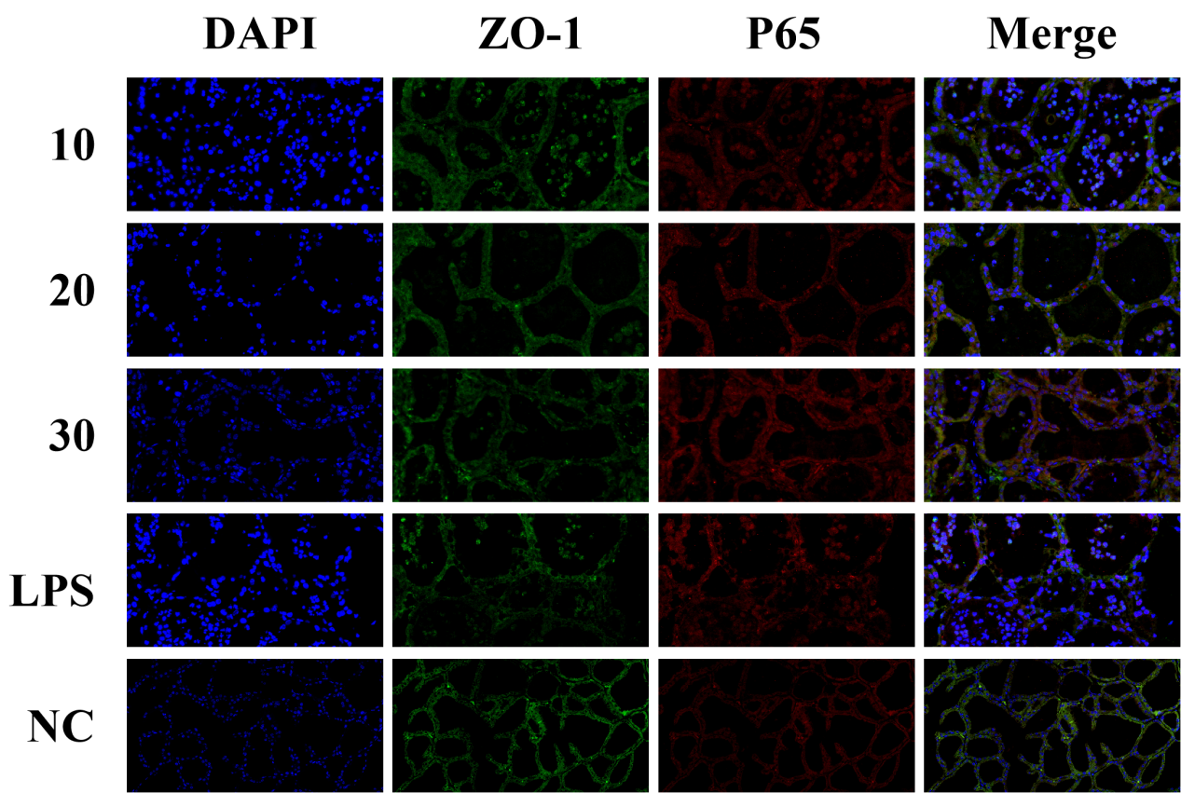
Figure S5: DCA inhibited NF-κB expression. ZO-1 and P65 antibody staining immunofluorescence. Scale bar: 20 μm.

Figure S5: DCA relieved LPS-induced inflammation in MMECs by activating TGR5. A-C. Cells were pretreated with DCA (10, 20 and 30 μM) and mRNA levels of pro-inflammatory related factors IL-1β, IL-6, and TNF-α were detected by qRT-PCR. D. Cells were treated with DCA (30 μM) and the relative mRNA levels of TGR5 and FXR were determined by qRT-PCR. E-G. Cells were pretreated with H89 and the relative mRNA levels of pro-inflammatory IL-1β, IL-6 and TNF-α were detected by qRT-PCR. H-J. Cells were pretreated with siRNA-TGR5, MDL12330A, and H89 and the relative mRNA levels of pro-inflammatory IL-1β, IL-6 and TNF-α levels were detected by qRT-PCR. All data are expressed as mean ± SD, and One-way analysis of variance (ANOVA) was performed, followed by Tukey’s test. *p < 0.05, **p < 0.01, ***p < 0.001 indicate significance.

