Supplementary Materials

Supplementary Tables
TABLE A1
Supplementary Tables
Table A.1The details of the clinical characteristics of the POAG patients
patient ID | Sex | Age | MD |  |  | CDR |  | GCC
patient ID | Sex | Age | R | L | mMD | R | L | TTR | TSR | TIR | TTL | TSL | TIL
1 | M | 52 | -9.59 | -8.63 | -9.11 | 0.23 | 0.63 | 84.79 | 91.39 | 78.2 | 70.66 | 78.89 | 62.44
2 | M | 40 | -29.5 | -3.6 | -16.55 | 0.8 | 0.36 | - | - | - | 86.81 | 91.22 | 82.41
3 | F | 56 | -29.67 | -1.5 | -15.59 | 0.98 | 0.5 | 67.25 | 68.52 | 65.99 | 99.93 | 102.7 | 97.16
4 | F | 33 | -1.5 | -6 | -3.75 | 0.8 | 0.94 | 82.65 | 84.07 | 81.22 | 79.94 | 86.19 | 73.69
5 | F | 35 | -1.8 | -0.2 | -1 | 0.70 | 0.6 | 65.05 | 65.64 | 64.46 | 78.56 | 77.63 | 67.29
6 | F | 24 | -3.46 | -5.2 | -4.33 | 0.89 | 0.94 | 68.58 | 76.06 | 61.07 | 66.41 | 72.36 | 60.44
7 | M | 65 | -5.48 | -7.91 | -6.7 | 0.65 | 0.88 | 78.73 | 71.89 | 85.6 | 70.88 | 67.06 | 74.67
8 | F | 25 | -32.71 | -31.74 | -32.23 | 0.99 | 0.97 | 61.36 | 56.0 | 66.72 | 72.15 | 66.96 | 75.4
9 | F | 34 | -2.59 | -4.68 | -3.64 | 0.71 | 0.61 | 86.08 | 85.52 | 86.65 | 93.88 | 95.27 | 92.48
10 | M | 42 | -4.88 | -3.14 | -4.01 | 0.69 | 0.72 | 88.22 | 84.61 | 91.85 | 93.79 | 97.68 | 89.92
11 | F | 56 | -13.5 | -14.53 | -14.02 | 0.81 | 0.64 | 85.72 | 95.82 | 75.60 | 87.81 | 105.18 | 70.46
12 | F | 40 | -17.53 | -21.58 | -19.56 | 0.76 | 0.77 | 55.15 | 54.71 | 55.60 | 53.09 | 53.31 | 52.87
13 | F | 65 | -4.68 | -2.92 | -3.8 | 0.61 | 0.65 | 86.06 | 97.67 | 74.46 | 93.55 | 95.73 | 91.37
14 | F | 33 | -5.74 | -22.13 | -13.94 | 0.74 | 0.74 | 74.42 | 81.41 | 67.46 | 59.73 | 60.08 | 59.39
15 | F | 41 | -8.49 | -6.33 | -7.41 | 0.60 | 0.43 | 73.46 | 89.37 | 57.54 | 80.25 | 96.8 | 63.69
16 | F | 28 | -4.75 | -17.66 | -11.21 | 0.54 | 0.82 | 82.9 | 85.99 | 79.8 | 61.19 | 58.95 | 63.43
17 | M | 32 | -1.56 | -18.73 | -10.15 | 0.26 | 0.83 | 97.01 | 90.98 | 103.06 | 66.28 | 56.95 | 75.64
18 | F | 26 | -8.40 | -15.87 | -12.14 | 0.75 | 0.81 | 67.09 | 76.87 | 57.32 | 65.16 | 68.63 | 61.69
19 | F | 25 | -22.15 | -14.82 | -18.49 | - | - | - | - | - | - | - | -
20 | F | 30 | -1.2 | -0.78 | -0.99 | 0.61 | 0.66 | 73.95 | 81.74 | 66.16 | 74.64 | 73.29 | 75.99
21 | F | 54 | -17.06 | -22.39 | -19.73 | 0.79 | 0.75 | - | - | - | - | - | -
22 | F | 26 | -0.4 | -29.53 | -14.97 | 0.45 | 0.85 | 87.68 | 87.85 | 87.51 | 59.43 | 59.44 | 59.43
23 | F | 35 | -5.36 | -3.12 | -4.24 | 0.86 | 0.84 | - | - | - | - | - | -
24 | F | 33 | -11.33 | -4.08 | -7.71 | 0.53 | 0.17 | - | - | - | - | - | -
25 | F | 34 | -26.17 | -26.81 | -26.49 | 0.91 | 0.92 | - | - | - | - | - | -
26 | F | 30 | -2.03 | -3.88 | -2.96 | - | - | 99.84 | 99.76 | 99.94 | 91.98 | 89.5 | 94.47
27 | F | 36 | -3.25 | -1.21 | -2.23 | - | - | - | - | - | - | - | -
28 | M | 28 | -8.98 | -3.39 | -6.19 | - | - | - | - | - | - | - | -
29 | M | 57 | -0.97 | -0.28 | -0.63 | 0.32 | 0.40 | 85.22 | 85.81 | 84.64 | 85.58 | 88.02 | 83.15
30 | M | 49 | -23.38 | -26.97 | -25.18 | 0.7 | 0.85 | 63.29 | 65.45 | 61.11 | 59.91 | 61.96 | 57.86
31 | F | 44 | -0.04 | -0.97 | -0.47 | 0.64 | 0.65 | - | - | - | - | - | -
32 | F | 61 | -1 | -1.2 | -1.1 | 0.87 | 0.73 | 78.66 | 78.68 | 81.66 | 81.41 | 75.33 | 87.48
33 | M | 40 | 1.21 | -8.56 | -3.68 | 0.48 | 0.71 | 94.13 | 94.71 | 93.55 | 69.72 | 81.6 | 57.86
34 | F | 35 | -16.43 | -5.79 | -11.11 | 0.96 | 0.68 | 56.16 | 55.79 | 56.53 | 67.56 | 62.27 | 72.86
35 | F | 31 | -10.46 | -2.66 | -6.56 | 0.74 | 0.7 | 71.97 | 83.01 | 60.92 | 77.28 | 79.64 | 74.92
36 | F | 39 | -2.67 | -4.99 | -3.83 | - | 0.46 | 77.02 | 87.46 | 66.84 | 91.58 | 80.72 | 102.17
37 | M | 21 | -4.87 | -13.77 | -9.32 | 0.69 | 0.72 | 84.59 | 88.76 | 80.46 | 70.57 | 80.89 | 60.24
38 | F | 38 | -1.97 | -20.68 | -11.33 | 0.53 | 0.69 | 88.75 | 91.44 | 86.08 | 59.56 | 58.71 | 60.41
39 | M | 34 | -8.9 | -20.9 | -14.9 | 0.61 | 0.62 | 75.28 | 80.3 | 70.26 | 62.4 | 67.01 | 57.8
40 | M | 31 | -3.03 | -4.64 | -3.84 | 0.55 | 0.43 | 93.27 | 94.01 | 92.54 | 93.35 | 91.99 | 94.71
41 | M | 54 | -10.3 | -5.8 | -8.05 | 0.6 | 0.55 | 77.96 | 95.28 | 60.67 | 81.02 | 95.8 | 66.25
42 | M | 49 | -5 | -5 | -5 | 0.8 | 0.79 | 76.5 | 85.89 | 67.1 | 83.69 | 83.69 | 83.69
43 | M | 38 | -3.86 | -2.51 | -3.19 | 0.73 | 0.8 | 80.1 | 86.98 | 73.22 | 83.99 | 94.55 | 73.41
44 | F | 32 | -3.42 | -1.47 | -2.45 | - | - | - | - | - | - | - | -
45 | F | 42 | -7 | -7.22 | -7.11 | 0.59 | 0.62 | 75.97 | 82.73 | 69.2 | 68.68 | 77.06 | 60.3
46 | M | 43 | -14.34 | -6.18 | -10.26 | 0.78 | 0.55 | 61 | 62.3 | 59.3 | 78 | 81.3 | 74.7
47 | F | 47 | -22.71 | -18.64 | -20.68 | 0.78 | 0.73 | 62.41 | 65.05 | 59.77 | 64.76 | 72.09 | 57.42
48 | F | 61 | -5.74 | -6.96 | -6.35 | 0.66 | 0.76 | 93 | 97 | 89 | 78 | 79 | 78
49 | F | 63 | -19.99 | -24.91 | -22.45 | 0.87 | 0.81 | 70.11 | 73.49 | 66.73 | 121.64 | 137.19 | 106.04
50 | M | 32 | -4.98 | -6.37 | -5.68 | 0.63 | 0.68 | 76.79 | 73.46 | 80.13 | 62.34 | 58.94 | 65.76
51 | F | 40 | -17.18 | -22.19 | -19.69 | 0.65 | 0.64 | - | - | - | - | - | -
52 | M | 45 | -1.89 | -6.68 | -4.29 | 0.55 | 0.68 | 70.91 | 80.05 | 61.79 | 72.1 | 79.52 | 64.68
53 | M | 46 | -10.23 | -1.26 | -5.75 | 0.7 | 0.77 | 73.33 | 81.43 | 65.23 | 82.72 | 82.93 | 82.5
54 | M | 53 | -0.84 | -0.98 | -0.91 | 0.57 | 0.56 | 87.15 | 90.79 | 83.52 | 91.39 | 95.9 | 86.91
55 | M | 65 | -11.76 | -5.48 | -8.62 | 0.75 | 0.65 | 74.63 | 87.32 | 61.93 | 73.78 | 89.74 | 57.84
56 | M | 72 | -14.68 | -21.41 | -18.05 | 0.81 | 0.73 | 60.44 | 60.55 | 60.32 | 56.21 | 55.38 | 57.05
57 | M | 49 | -4.76 | 8.18 | 1.71 | 0.5 | 0.61 | 74.93 | 79.6 | 70.27 | 76.56 | 88.11 | 65.02
58 | F | 36 | -0.73 | -10.46 | -5.6 | 0.48 | 0.7 | 79.84 | 82.23 | 77.46 | 68.52 | 74.14 | 62.91
59 | M | 36 | -6.23 | -7.8 | -7.02 | 0.86 | 0.85 | 68.32 | 72.24 | 64.43 | 65.02 | 67.53 | 62.53
60 | F | 61 | -7.45 | -10.97 | -9.21 | 0.47 | 0.65 | 91.01 | 89.55 | 92.48 | 82.94 | 89.54 | 76.34
61 | M | 64 | -13.86 | -28.82 | -21.34 | 0.75 | 0.84 | 76.54 | 69.06 | 83.99 | 63.78 | 68.53 | 59.04
62 | M | 69 | -26.63 | -14.67 | -20.65 | 0.82 | 0.72 | 58.32 | 62.33 | 54.26 | 71.48 | 85.24 | 57.76
63 | F | 30 | -13.37 | -7.9 | -10.64 | 0.63 | 0.6 | 65.12 | 69.39 | 60.85 | 70.07 | 82.45 | 57.71
64 | F | 46 | 0.86 | -1.28 | -0.21 | 0.54 | 0.46 | 90.06 | - | - | - | - | -
65 | F | 54 | -5.36 | -4.34 | -4.85 | 0.4 | 0.28 | 96.25 | 94.72 | 97.8 | 99.97 | 97.17 | 102.79
66 | M | 65 | -20.97 | -23.63 | -22.3 | - | - | - | - | - | - | - | -
67 | F | 34 | -20.55 | -24.79 | -22.67 | 0.7 | 0.78 | 73.77 | 81.29 | 66.35 | 64.46 | 66.52 | 62.39
68 | F | 37 | -10.78 | -20.05 | -15.42 | - | - | - | - | - | - | - | -
69 | M | 50 | -3.42 | 2.81 | -0.31 | - | - | - | - | - | - | - | -
70 | M | 52 | -22.34 | -15.93 | -19.14 | 0.68 | 0.45 | 52 | - | - | - | - | -
Median |  |  | -8.445 | -6.35 | -7.56 | 0.695 | 0.69 | 72.965 | 79.64 | 67.29 | 76.52 | 82.48 | 69.73
Range |  |  | [-32.71~1.21] | [-31.74~8.81] | [-32.23~1.71] | [0.17~0.97] | [0.23~0.99] | [53.09~121.64] | [53.31~137.19] | [52.87~106.04] | [52.00~99.84] | [54.71~99.76] | [54.26~103.06]
Note: The data are presented as median (range). POAG, primary open-angle glaucoma; HC, healthy control; MD, mean deviation (an index of visual deficits derived from Humphrey visual feld); CDR, cup-to-disc ratio; GCC, ganglion cell complex; TTL, temporal top left; TSL, temporal superior left; TIL, temporal inferior left; TTR, temporal top right; TSR, temporal superior right; TIR, temporal inferior right.

Supplementary Figures
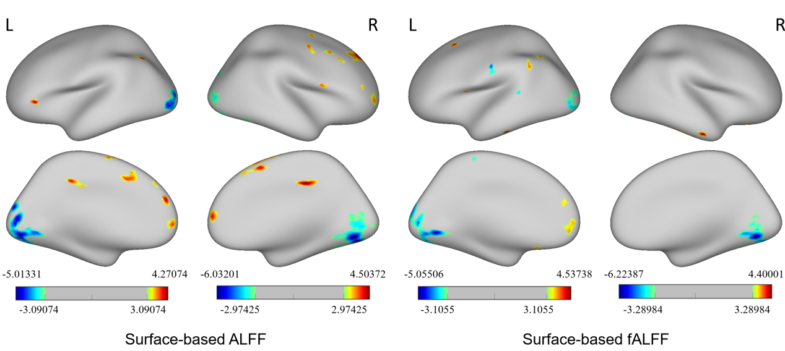
FIGURE S1 The effects of the full­width at half maximum (FWHM) of spatial smoothing on the ALFF and fALFF values. The main findings of the between-group comparison can be replicated by performing the analyses of ALFF and fALFF values according to FWHM (8 mm), indicating that FWHM does not significantly influence the results.
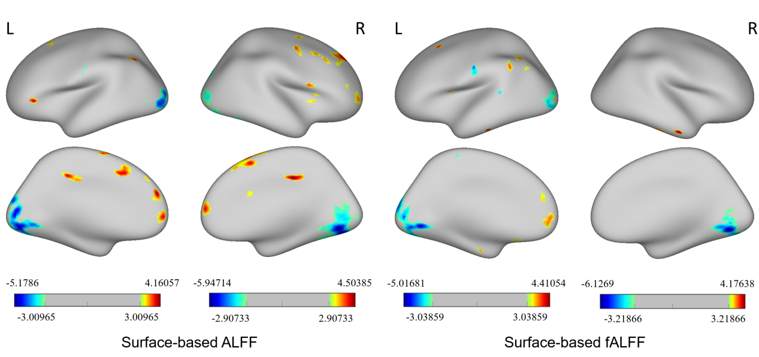
FIGURE S2 The effects of the full­width at half maximum (FWHM) of spatial smoothing on the ALFF and fALFF value. The main findings of the between-group comparison can be replicated by performing the analyses of ALFF and fALFF values according to FWHM (10 mm), indicating that FWHM does not significantly influence the results.

