Supplementary Information
Fig. S1
a. Community Bar graph presents the composition and proportions of the top N abundant species in all samples, with other low-abundance species categorized as "Others."
b. Bar graph shows the LDA values of different differential bacteria.
c. Bar graph shows the LDA values of different differential fungi.
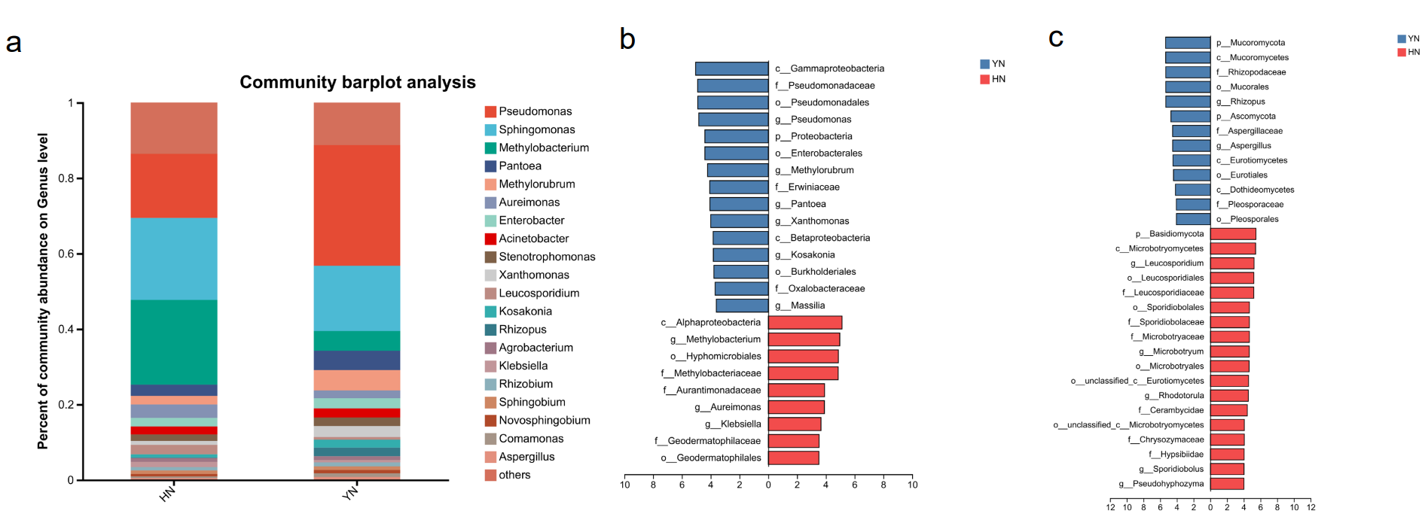

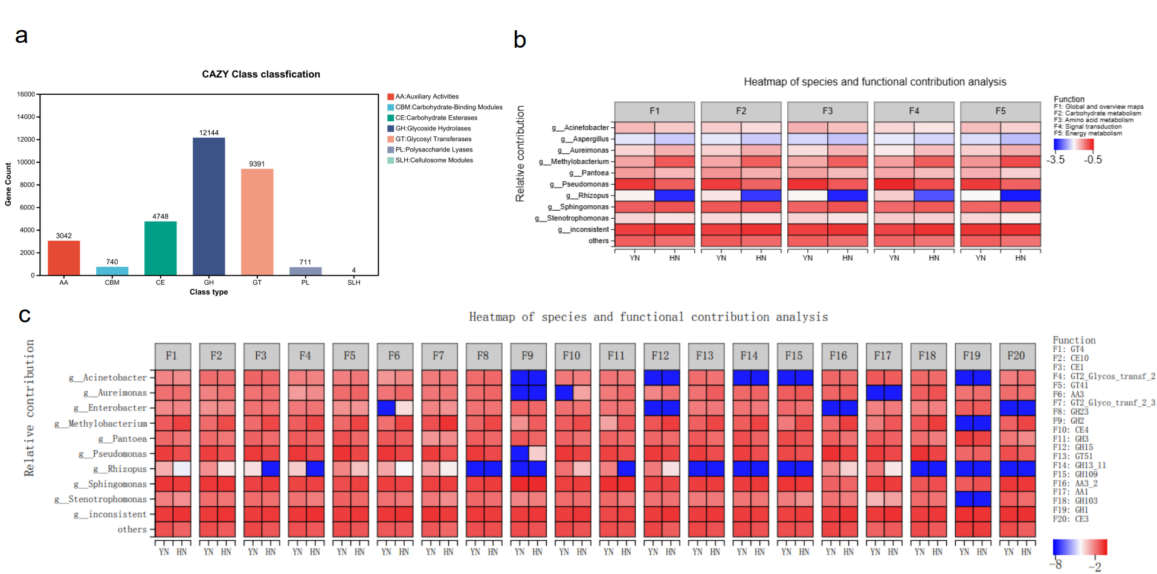
Fig. S2
a. Statistical graph of the number of CAZy annotated genes.
b. Heatmap analysis of the contribution relationship between the top 10 species by total abundance and the top 5 KEGG level 2 functions by total abundance.
c. Heatmap analysis of the contribution relationship between the top 10 species by total abundance and the top 20 CAZy functions by total abundance.

