Material and methods: A randomized prospective comparative study carried out from January 2018 and November 2019. This work included 186 infertile couples due to male infertility. All subjects were attendants of the ART unit. This study was conducted to evaluate the influence of bacterial infection on human sperm parameters (count, motility, progressive normality, vitality, and sperm function (Acrosin Activity, HOST and ROS).

All males subjected to:
- Semen specimen’s collection and Examination:
The semen specimens were collected under sterile condition by masturbation after 2 – 5 abstinence days. Patients avoid taken any antibiotic 1 week before collection of semen specimens. Semen analysis was performed after liquefied within 60 min of collection to evaluated sperm count, motility, vitality, normality and sperm function tests. Human sperm parameters were evaluated according to world Health organization guidelines (15).

- Microbiological studies:
2.1-Bacterial culture: Each specimen was immediately inoculated on blood agar plates, and Mac Conkey׳s media plates. All plates were incubated aerobically at 37 °C for 24 -48hours (16).
2.2- Isolation and Identification of microbial Isolates: The isolation and identification of microbial opportunistic pathogens in patient׳s semen were performed through three main conventional steps:
- Morphological characteristics: On MacConky᾿s medium, we can differentiate the enteric bacteria into two groups; the lactose fermenters (Coli forms) by their pink colonies and the non-lactose fermenters, whose colonies are pale (Proteus) (17).
- Microscopic Gram stain investigation:The film of each pure bacterial isolate was prepared from a 24 h. bacterial culture and stained using crystal violet as a basic dye and safranin as a counter stain. Gram stained films were microscopically examined to differentiate both Gram-positive and Gram-negative bacteria as well as the shape and arrangement of cells (18).
- Biochemical tests: Microscopic examinations and biochemical test used for identification were carried out according to Bergey's Manual of Determinative Bacteriology Identifications were accepted from either system if the likelihood of that identification was greater than or equal to 85% (19). Further identification was carried through molecular 16S RNA.
- Sperm concentration and motility estimation:
Sperm concentration and motility were evaluated by using the makler counting chamber (sefi- medicals instruments Lts), 5 µl of semen sample was transferred to the Makler counting chamber after liquefied semen specimen. The cover glass is then placed over the semen. On to the microscopic stage and viewed using phase contrast optics at magnification of 200x (20x objective X 10x ocular). Sperm count was calculated by dividing the total number of sperm count in 100 squares on 10 x 1 million / ml, and motility was estimated as the following:
Total Sperm Motility % = the total number of motile sperm divided on total sperm count x 100 Sperm progressive = total number of Spermatozoa moving in one direction divided on sperm concentration (15).

- Evaluation of sperm vitality:
Eosin staining was used for sperm vitality assessment. Staining was performed by {dissolved 0.5 g of eosin in 100 ml of 0.9 % Nacl}.10 µl of semen sample after mix and liquefaction on dry and clean of glass microscopic slide to equal volume of eosin stain, then mixed by pipette tip, swirling the sample on the slide, then coverslip and leaved for 30 second. Examined was performed by Phase-contrast optic {400} Magnification. Unstained head sperm signified {live sperm} and pink or red colors {dead sperm}. Calculation of the mean percentage of sperm vitality:
Percent vitality = (number sperm unstained) / (number sperm unstained) + (number sperm with pink color) x100
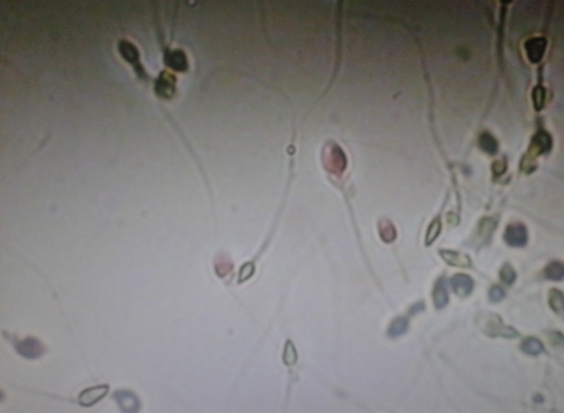

Figure 1: Photograph of bright filed HPF (40-x), Represented sperm vitality
Pink cells: non-vital (dead)/ Greenish cells: vital

- Evaluation of sperm morphology:

To prepare sperm smear for sperm morphology estimation, 10 µl of sperm suspension transferred to clean a glass slide, allowed to air dry in room temperature, then the slide smear was stained in diff-Quik stain. About 200 spermatozoa per slide were examined under oil immersion with magnification of 1000x (100x objective X 10x ocular) to differentiated between normal and abnormal spermatozoa according to (15). Morphologically abnormal spermatozoa often have multiple defects. In earlier protocols. When multiple defects were present. Only one was recorded-with priority given to defects of the sperm head over those of the Midpiece and to defects of the Midpice over those of the tail.
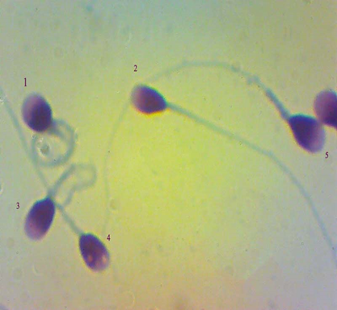
Figure

Figure 2: Photograph of bright filed HPF (100-x), Represented sperm morphology
Sperm No 2&5: normal in each (Head, Midpiece & tail). Sperm No.1: abnormal in each (Head, Midpiece &tail). Sperm No 3: abnormal in (Midpiece & tail).and Sperm No 4: abnormal only in Head

- Measurement of Reactive oxygen species (ROS) in semen by (MDA):

Malondialdehyde (MDA) levels in semen an accepted measurement of oxidative stress (ROS). MDA was estimated by using the thiobarbituric acid method. Centrifuged the semen specimen after liquefied for 7 minutes at 2000 g, and then take 100 µl of supernatants,0.9 ml of distilled water and 0.5 ml of thiobarbituric acid reagent{0.67 g of 2-Thiobarbituric acid mixed in 100 ml of distilled water with 0.5 g NaoH and added 100 ml glacial acetic acid} to each tubes was added in boiling water for 1 hour and then cooling tubes under tap water, centrifuged all tubes for 10 min at 400 g , and then calculate the absorbance of supernatant by spectrophotometer at 534 nm (20).

- Assessment of Acrosin activity in human sperm:

Acrosin, a sperm specific acrosomal proteinase, has an essential role in the fertilization process. Low levels of Acrosin appear to be associated with subfertility and infertility, and the Acrosin activity of spermatozoa may potentially be a useful indicator of semen quality. This test was performed according to (21).

- Evaluation of Hypo-Osmotic Swelling Test (HOST):

The Hypo-Osmotic swelling (HOS) test done to evaluate the sperm membrane integrity (sperm vitality) and was described as a test for sperm function. This test was performed according to (15,22), Add 10 µl of the liquefied semen sample to 1 ml of HOS Solution (dissolved 0.735 g sodium citrate dehydrate and 1.351 g fructose mix in 100 ml of distilled water), incubated at 37 ֺC for 30 - 60 minutes, the transferred 10 µl of sperm suspension to microscopic slide and place a cover slip, a total of 200 spermatozoa was examined by a phase contrast microscope at magnification 400x (40x objective X 10x ocular), observed of tail swelling sperm.
Calculation of the mean percentage of swollen tail sperm:

Percent swelling =
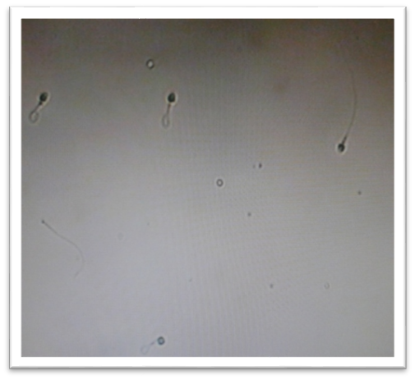

Figure 3: Photograph by HPF.Represented the membrane integrity of human sperm
1-Swelling tail (live) cells
2-Non-swelling tail (dead) cells

Statistical analysis: Data were coded and entered using the statistical package for the Social Sciences (SPSS) version 28 (IBM Corp., Armonk, NY, USA). The student´s t.test was used to compare means between different groups. Fisher’s exact test was used to compare percentages values were considered significant when P. Value ≤ 0.05.

