Supplementary Materials for “Kekulé-modulated Topological Bulk Cavity for Intrinsic Lateral Beam Shifting of High-purity Linear-polarized Light Emission”
Zichen Li^{1, 2, 3, 4, #}, Bofeng Zhu^{5, 6, #}, Ying Li^{1, 2, 3, 4}, Yihao Yang^{1, 2, 3, 4}, Yidong Chong⁶, Qi Jie Wang^{5, 6}, Hongsheng Chen^{1, 2, 3, 4,} *, Song Han^{1, 2, 3, 4,} *
¹Interdisciplinary Center for Quantum Information, State Key Laboratory of Extreme Photonics and Instrumentation, ZJU-Hangzhou Global Scientific and Technological Innovation Center, Zhejiang University, Hangzhou 310027, China
²International Joint Innovation Center, The Electromagnetics Academy at Zhejiang University, Zhejiang University, Haining 314400, China
³Key Lab. of Advanced Micro/Nano Electronic Devices & Smart Systems of Zhejiang, Jinhua Institute of Zhejiang University, Zhejiang University, Jinhua 321099, China
⁴Shaoxing Institute of Zhejiang University, Zhejiang University, Shaoxing 312000, China
⁵Centre for OptoElectronics and Biophotonics, School of Electrical and Electronic Engineering & The Photonics Institute, Nanyang Technological University, 639798, Singapore
⁶School of Physical and Mathematical Sciences, Nanyang Technological University, 637371, Singapore
*Correspondence to: song.han@zju.edu.cn (S. Han); hansomchen@zju.edu.cn (H. Chen)
#These authors contributed equally to this work.

- Kekulé-modulated honeycomb lattice
In this section we provide the comprehensive derivation for the Kekulé-modulated honeycomb (graphene) lattice.
- Basic parameters for the honeycomb lattice
The geometric supercell is shown in Fig. S1(A), where we can define the basic parameters as follow:
atom site: $r=na_{1}+ma_{2} (n,m∈Z)$
original lattice vectors: $a_{1}=\left(-\frac{\sqrt{3}}{2},\frac{3}{2}\right), a_{2}=(\frac{\sqrt{3}}{2},\frac{3}{2})$
C-C bond length $a_{0}≡1$
C-C nearest-neighbor connecting vectors: $s_{j} (j=1, 2 and 3)$, $s_{1}=\left(\frac{\sqrt{3}}{2},-\frac{1}{2}\right)$, $s_{2}=\left(-\frac{\sqrt{3}}{2},-\frac{1}{2}\right)$ and $s_{3}=\left(0,1\right)$
pristine lattice’s hopping amplitude: $t_{0}$
modulated lattice’s hopping amplitude: $t_{r,j}$
C-C bond modulation strength: $Δ_{0}$
pristine lattice’s Dirac points (modulated lattice’s reciprocal vectors): $K_{±}=\left(±\frac{2π}{3\sqrt{3}},\frac{2π}{3}\right)$
pristine lattice’s BZ center: $Γ=(0,0)$
Kekulé wave vector: $G≡K_{+}-K_{-}=(\frac{4π}{3\sqrt{3}},0)$
the field operators in A and B sites: $a_{r}, b_{r}$

- Real space Hamiltonian
The tight-binding Hamiltonian in the nearest-neighbor approximation can be written as
$H=[-\sum_{r}{\sum_{j=1}^{3}{t_{r,j}a_{r}^{\text{†}}b_{r+s_{j}}}}+H.c.]+\frac{u_{1}}{3}\sum_{r}{a_{r}^{\text{†}}a_{r}}+u_{2}\sum_{r}{b_{r+s_{j}}^{\text{†}}b_{r+s_{j}}}$ (1)
The band structure of pristine lattice is given by
$E\left(k\right)=±\left|ε\left(k\right)\right|$, (2)
where
$ε\left(k\right)=t_{0}\sum_{j=1}^{3}{e^{ik∙s_{j}}}$, (3)
The modulated lattice’s hopping amplitude has the form
$\frac{t_{r,j}}{t_{0}}=1+2Re\left[Δe^{i\left(pK_{+}+qK_{-}\right)s_{j}+iG∙r}\right]=1+2Δ_{0}cos⁡[φ+\left(pK_{+}+qK_{-}\right)s_{j}+G∙r]=1+2Δ_{0}cos⁡[φ+\frac{2π}{3}(N_{j}+m-n)]$, (4)
where
$∆=∆_{0}e^{iφ}$, (5)
$N_{1}=-q$, $N_{2}=-p$, $N_{3}=p+q$ $(p,q∈Z)$. (6)

- Momentum space Hamiltonian
The first Brillouin zone of pristine honeycomb (graphene) lattice can be represented through three copies of that of modulated(graphene) supercell, which are set to be centered at wave vectors of $Γ$, $K^{'}$ and $K$ points as displayed in Fig. S1(B). Therefore, the operators $a_{r}$ and $b_{r}$ can be expanded in momentum space as
$a_{r}=\frac{1}{\sqrt{N}}\sum_{k}{e^{ik∙r}a_{k}}$, $b_{r}=\frac{1}{\sqrt{N}}\sum_{k}{e^{ik∙r}b_{k}}$, (7)
$a_{r}=\frac{1}{\sqrt{N}}\sum_{k}{e^{i(k-G)∙r}a_{k-G}}$, $b_{r}=\frac{1}{\sqrt{N}}\sum_{k}{e^{i(k-G)∙r}b_{k-G}}$, (8)
$a_{r}=\frac{1}{\sqrt{N}}\sum_{k}{e^{i(k+G)∙r}a_{k+G}}$, $b_{r}=\frac{1}{\sqrt{N}}\sum_{k}{e^{i(k+G)∙r}b_{k+G}}$, (9)
where $N$ is a normalization factor.
We rewrite the modulated lattice’s hopping amplitude as
$t_{r,j}=t_{0}+t_{0}[Δe^{i\left[\left(pK_{+}+qK_{-}\right)s_{j}+G∙r\right]}+{Δ^{*}e}^{-i\left[\left(pK_{+}+qK_{-}\right)s_{j}+G∙r\right]}]$. (10)
Through Fourier transform, Hamiltonians of modulated honeycomb (graphene) lattice with first Brillouin zone set to be centered at wave vectors of $Γ$, $K^{'}$ and $K$ points can be respectively expressed in momentum space as
$H_{1}(k)=-\sum_{k}{ε\left(k\right)a_{k}^{\text{†}}b_{k}}-∆\sum_{k}{ε\left(k+pK_{+}+qK_{-}\right)a_{k+G}^{\text{†}}b_{k}}-Δ^{*}\sum_{k}{ε\left(k-pK_{+}-qK_{-}\right)a_{k-G}^{\text{†}}b_{k}}+H.c.$ (11)
$H_{2}(k)=-\sum_{k}{ε\left(k-G\right)a_{k-G}^{\text{†}}b_{k-G}}-∆\sum_{k}{ε\left(k-G+pK_{+}+qK_{-}\right)a_{k}^{\text{†}}b_{k-G}}-Δ^{*}\sum_{k}{ε\left(k-G-pK_{+}-qK_{-}\right)a_{k+G}^{\text{†}}b_{k-G}}+H.c.$ (12)
$H_{3}(k)=-\sum_{k}{ε\left(k+G\right)a_{k+G}^{\text{†}}b_{k+G}}-∆\sum_{k}{ε\left(k+G+pK_{+}+qK_{-}\right)a_{k-G}^{\text{†}}b_{k+G}}-Δ^{*}\sum_{k}{ε\left(k+G-pK_{+}-qK_{-}\right)a_{k}^{\text{†}}b_{k+G}}+H.c.$ (13)
Note that the momentum $k$ varies over the original Brillouin zone. The full Hamiltonian can be written as
$H\left(k\right)=H_{1}\left(k\right)+H_{2}\left(k\right)+H_{3}\left(k\right)$, (14)
Written in matrix form
$H\left(k\right)=-\sum_{k}{c_{k}^{\text{†}}\left[\begin{matrix}H_{11} & H \\ H^{\text{†}} & H_{22}\end{matrix}\right]c_{k}}$, (15)
where
$c_{k}=[a_{k}, a_{k-G},a_{k+G},b_{k}, b_{k-G},b_{k+G}]$, (16)
$H=\left[\begin{matrix}ε\left(k\right) & ∆ε\left(k-G+pK_{+}+qK_{-}\right) & Δ^{*}ε\left(k+G-pK_{+}-qK_{-}\right) \\ Δ^{*}ε\left(k-pK_{+}-qK_{-}\right) & ε\left(k-G\right) & ∆ε\left(k+G+pK_{+}+qK_{-}\right) \\ ∆ε\left(k+pK_{+}+qK_{-}\right) & Δ^{*}ε\left(k-G-pK_{+}-qK_{-}\right) & ε\left(k+G\right)\end{matrix}\right]$, (17)
$ε\left(k\right)=t_{0}\sum_{j=1}^{3}{e^{ik∙s_{j}}}$. (18)
$H_{11}=\left[\begin{matrix}\frac{u_{1}}{3} & 0 & 0 \\ 0 & \frac{u_{1}}{3} & 0 \\ 0 & 0 & \frac{u_{1}}{3}\end{matrix}\right]$, $H_{22}=\left[\begin{matrix}u_{2} & 0 & 0 \\ 0 & u_{2} & 0 \\ 0 & 0 & u_{2}\end{matrix}\right]$ (19)
The solved hopping amplitudes and corresponding band structures as function of the Kekulé modulation phase are shown in Fig. S1(C) and S1(D). In the following sections we’ll show the perfect match between such Kekulé-modulated tight-binding model and Kekulé-modulated photonic lattices.

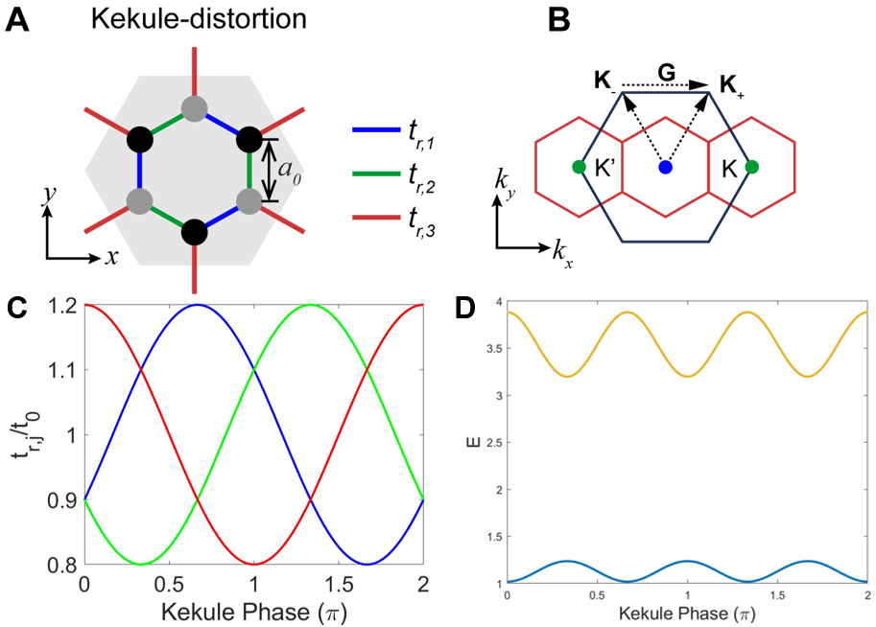
Fig. S1. Kekulé-modulated honeycomb lattice. (A) The modulated Kekulé-O texture. (B) The reciprocal lattices for pristine (in black) and modulated Kekulé-O (in red) lattice. (C), (D) The hopping strengths t_{r,1}/t₀ (black), t_{r,2}/t₀ (red), t_{r,3}/t₀ (blue) and the corresponding band structure at the Г-point as a function of the Kekulé modulation phase.

- Kekulé-modulated photonic lattice for Refs. [2] and [3]
In addition to the photonic lattice investigated in the main text, we also calculate the well-known lattices, i.e., the Wu-Hu model, as shown in Figs. S2 and S3 for the TM-like polarization and TE-polarization, respectively. Figs. S2(A) shows the TM-polarized photonic lattice, where the gray cylinders are dielectric material (silicon with refractive index of 3.48), and the white background indicates the air surrounding. The side length of the hexagonal supercell is a, and the radius of the six identical cylinders is $0.1925a$. Three cylinders at azimuthal angle of 0, 2π/3, and 4π/3 are pristine with their distance to the center of the hexagon supercell as R= a/3. The other three dielectric cylinders with azimuthal angle of π/3, π, and 5π/3 are modulated in addition to their distance to the center of the hexagon supercell as R= a/3. The modulation follows Ref. [4], where the modulation mass term $m_{0}=0.08a$. As we consider 3D structure, the thickness of the dielectric pillars is $\sqrt{3}a$. Fig. S3 shows the TE-polarized photonic lattice, where six identical triangular air holes are patterned in the dielectric materials (silicon with refractive index of 3.48). The Kekulé modulation for such a photonic supercell exactly follows the Ref. [4], where the modulation mass term $m_{0}=0.08a$ and the radius of the triangular air holes is $0.3248a$. The thickness of this lattice is $\sqrt{3}a$/2. With the Kekulé modulation phase continuously varying from 0 to 2π, we observe that both lattices show similar trends for the two-by-two degenerated bands and their radiative Q-factors (at the Г-point) as the results shown in the main text. Compared to the main text, the Q-factors shown here have obvious reduction due to the reason that the two lattices shown here only have C_{3v} rotation symmetry. The lattice in the main text has C_{3v} rotation symmetries and left-right mirror symmetries. Therefore, these two-by-two degenerated bands at the Г-point are all leaky modes. In the next sections, we’ll discuss the topological bulk cavity constructed by these two types of Kekulé-modulated supercells. The lateral beam manipulation will also be included.
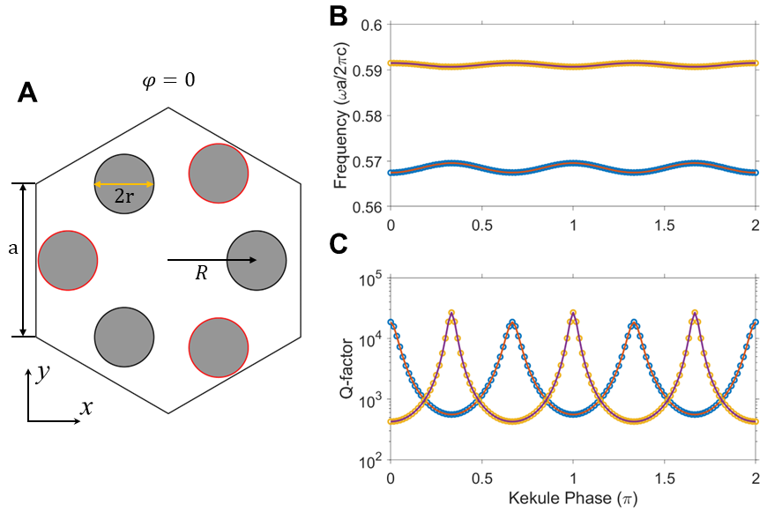
Fig. S2. Kekulé-modulated photonic lattice from Ref. [2]. (A) The supercell layout. (B), (C) The corresponding band structures and radiative Q-factors at the Г-point as a function of the Kekulé modulation phase.
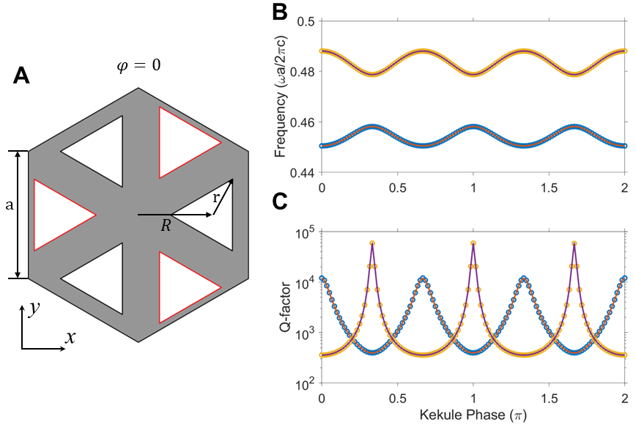
Fig. S3. Kekulé-modulated photonic lattice Ref. [3]. (A) The supercell layout. (B), (C) The corresponding band structures and radiative Q-factors at the Г-point as a function of the Kekulé modulation phase.

- 3D numerical simulations for the Kekulé-modulated topological bulk cavity for the Arm-chair interface
The 3D numerical simulations were conducted by employing finite element based COMSOL Multiphysics. The 3D perspective view of the simulated light beam is shown in Fig. S4(A), where the cut planes (xOz, yOz, and xy) can be separated to show the emitted beam quality. The cut plane above the cavity (>5λ_{mode}) is set to observe the far-field beam profiles and polarizations, which are shown in the main text. The xz-cross sections (B, C) show that the beams for two degenerated modes for the lower band edges don’t have beam shift in this cut plane. However, the yz-cross sections (B, C) show that the beams for two degenerated modes show lateral shift in the opposite directions along y-axis.
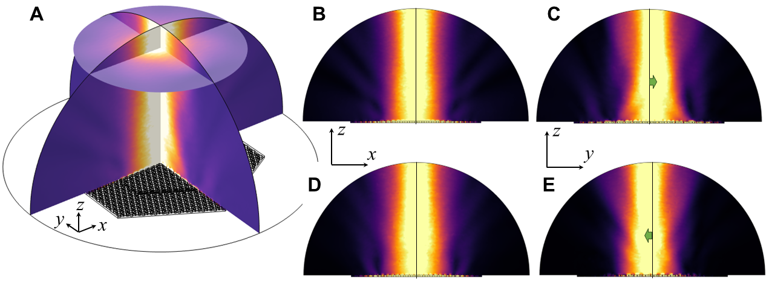
Fig. S4. The 3D numerical simulations for the Kekulé-modulated Topological Bulk Cavity. (A) The perspective view of the emitted beam. (B), (C) The cut views on the xz-plane and yz-plane for the mode 1. (D), (E) The cut views on the xz-plane and yz-plane for the mode 2. Mode 1 and 2 are two degenerated modes.

- 3D the Kekulé-modulated topological bulk cavity for the Zig-Zag interface
To show the mode stability, we also investigate the Kekulé-modulated topological bulk cavity (the inner domain has modulation phase of 30° and the outer domain has phase of 210°), as shown in Fig. S5. The near fields, as expected, are highly localized inside the core region, as shown in Figs. S5(A) and S5(D). The far-field intensities, also as expected, show lateral beam shifts with well-preserved polarizations, as shown in Figs. S5(B) and S5(E), respectively. Specifically, the topological bulk mode 1 shows positive beam shift with y-axis polarization, while the the topological bulk mode 1 shows negative beam shift with x-axis polarization. The cut-views for yz-plane are shown in Figs. S5(C) and S5(F), respectively, which further confirm the lateral beam shift is independent from the choice of the boundary between two domains.
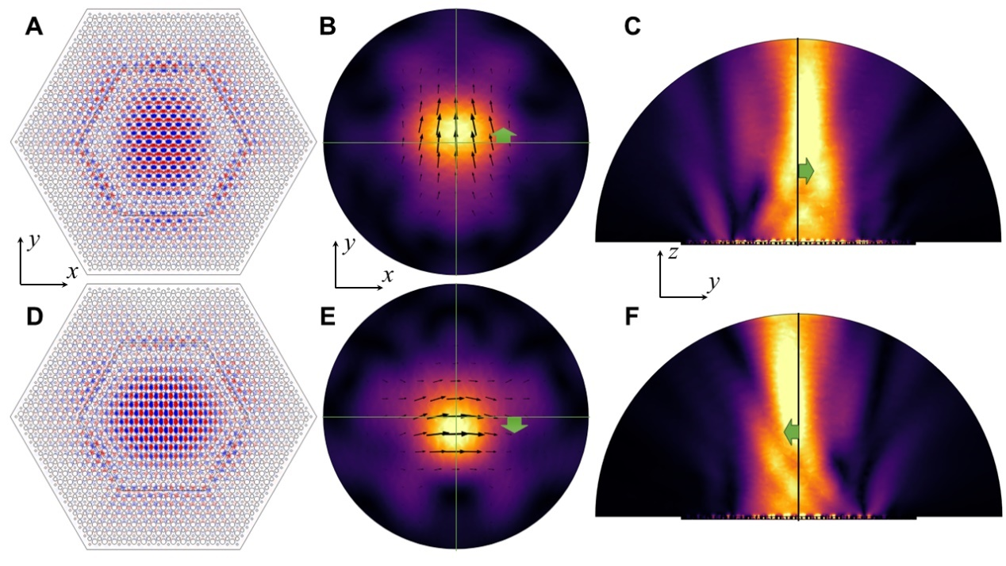
Fig. S5. The Kekulé-modulated topological bulk cavity for the Zig-Zag interface. (A), (D) The electric near field, z-components for the two degenerated modes at lower band edges. (B), (E) The corresponding far-field intensities of the two modes under investigating for the xy-cut plane above the cavity. (B), (E) The field intensities for the yz-cut plane.

- Kekulé-modulated topological bulk cavities for the TE polarization
Following the same methodology, we constructed similar topological bulk cavities for the Ref. [3]. The Kekulé-modulation phase is 30° for the inner domain and it is 210° for the outer domain. The numerical Q-factors for these two degenerated modes at lower band edges are around 300. Even through, we still observe the field localization inside the inner domain, and the far-field intensities show opposite beam shift in the lateral direction along the x-axis. The polarizations of the emitted beams are also linear polarized and orthogonal to each other for the degenerated modes under investigating.

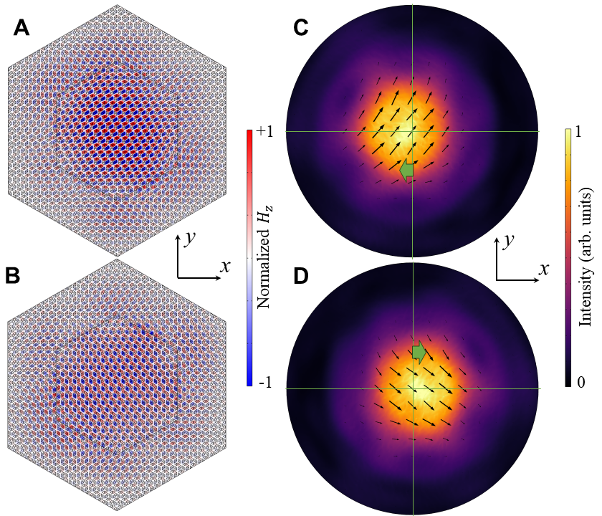
Fig. S6. The 3D numerical simulations for the Kekulé-modulated topological bulk cavity under TE polarization. (A), (B) The magnetic near field, z-components for the two degenerated modes at lower band edges. (C), (D) The corresponding far-field intensities of the two modes under investigating for the xy-cut plane above the cavity.

References
[1] Gamayun, O. V., et al. “Valley-momentum locking in a graphene superlattice with Y-shaped Kekulé bond texture.” New J. Phys. 20, 023016 (2018).
[2] Wu, L. H., & Hu, X. “Scheme for Achieving a Topological Photonic Crystal by Using Dielectric Material.” Phys. Rev. Lett. 114, 223901 (2015).
[3] Barik, S., et al. “Two-dimensionally confined topological edge states in photonic crystals.” New J. Phys. 18, 113013 (2016).
[4] Gao, X., et al. “Dirac-vortex topological cavities.” Nat. Nanotech. 15, 1012-1018 (2020).

