Supplementary Material

Figure S1. Survival analysis of ESTIMATE, immune and stromal score in TCGA-gliomas, and differentially expressed genes among low and high-risk scores groups.

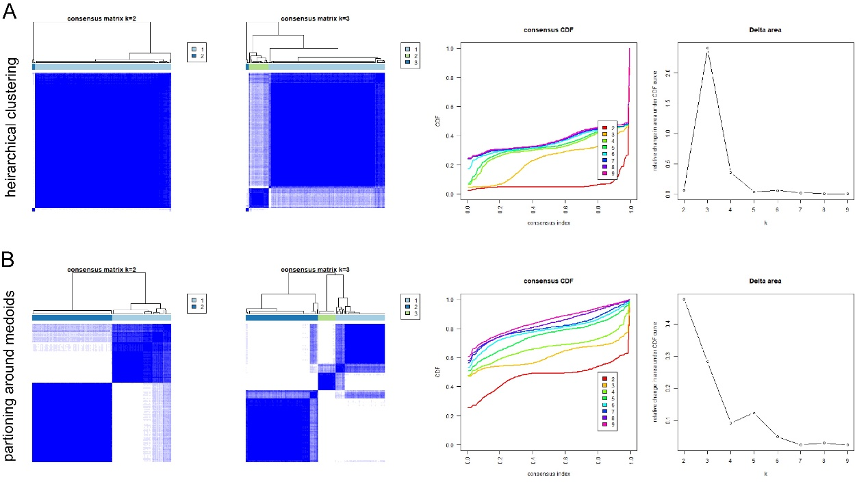
Figure S2. Lipid metabolism typing based on other clustering methods. (A) hierarchical clustering; (B) partioning around medoids.

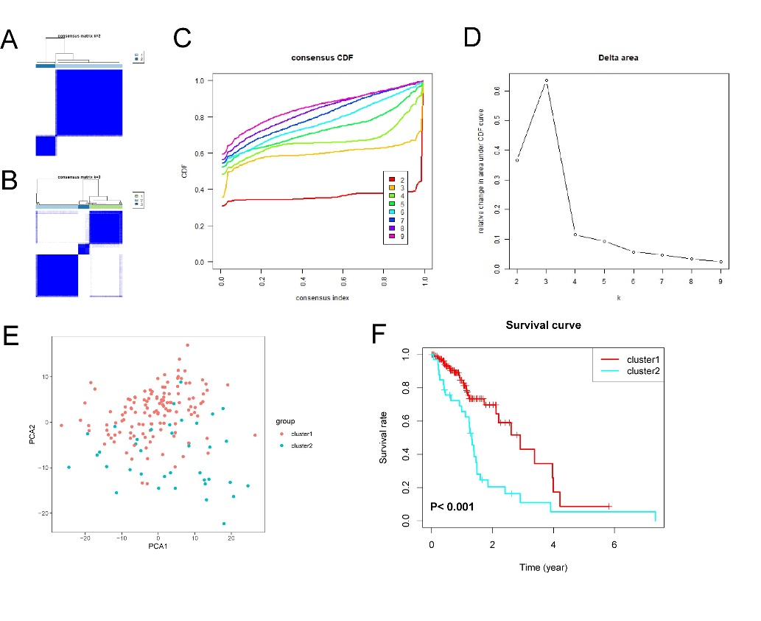
Figure S3. Lipid metabolism typing in CGGA cohort.

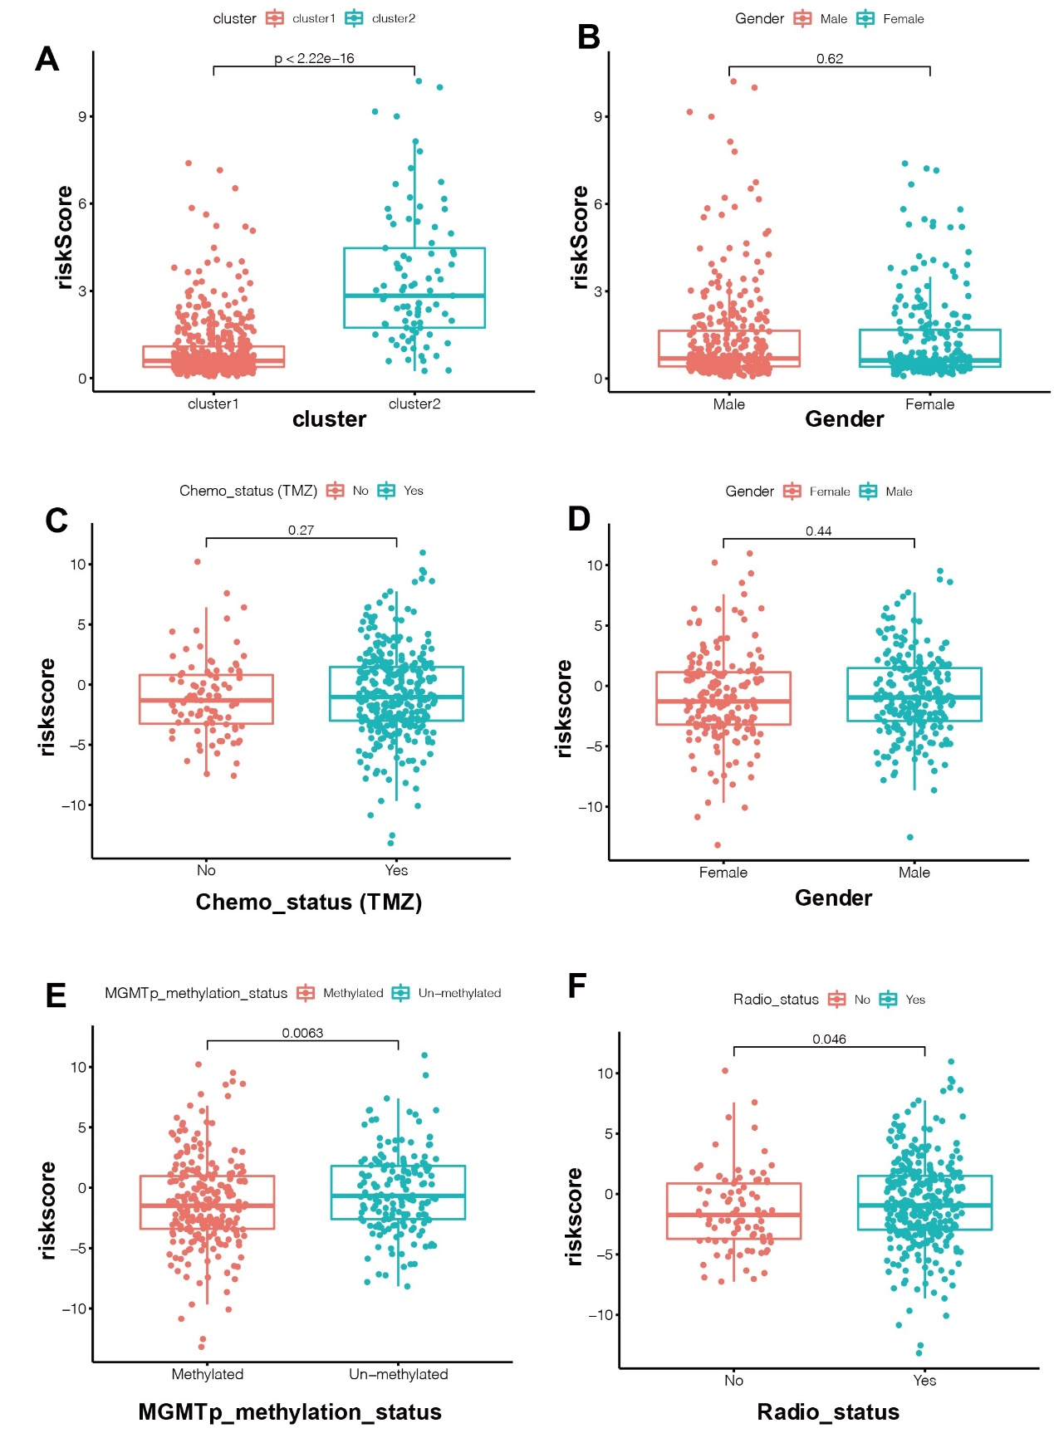
Figure S4. Associations between the risk signature and other clinical features in TCGA and CGGA-B cohorts.

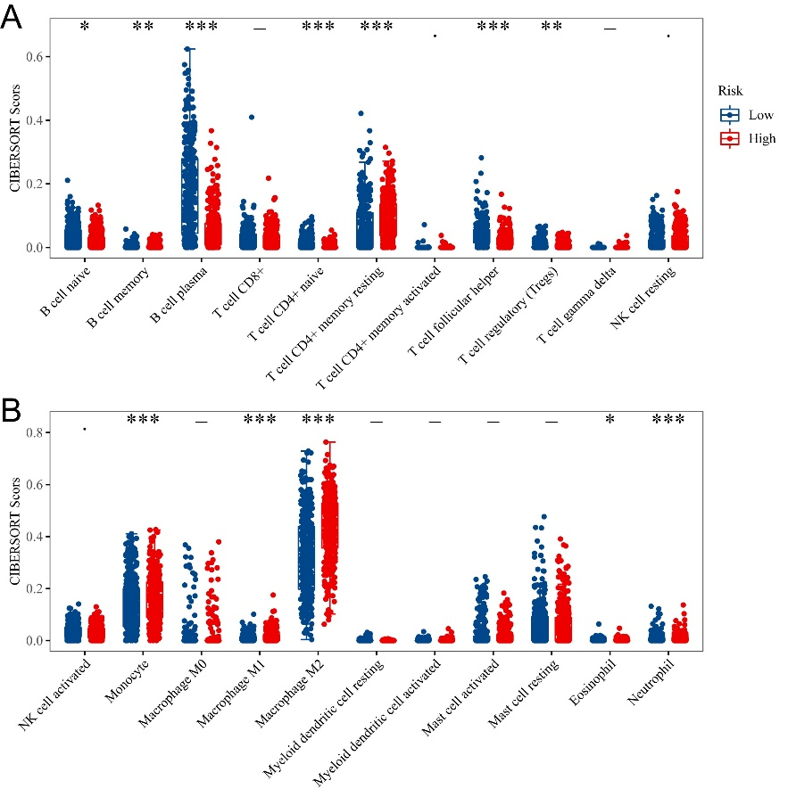
Figure S5. The TIICs proportion among low and high risk groups in CGGA cohort.

