Supplementary Materials
The variables
Region | Area
Nation | Nationality
Gender | Gender sex
Age | Age in years
Culture | Education level (1=illiteracy 2=Primary school 3=Junior high school 4=Senior high school 5=University 6=Master and above) (we made 3 levels for this ) Level 1 = 1=illiteracy 2=Primary school  Level 2 = 3=Junior high school , and Level 3 = Senior high school 5=University 6=Master and above
Marry | Marital status (1=married/cohabiting 2=widowed 3=divorced/separated 4=single) we made two level from it , Level 1 = married/cohabiting  And level 2 = 2=widowed 3=divorced/separated 4=single
Income | Per capita monthly income (1=<500 RMB 2=500~RMB 3=1000~RMB4=2000~RMB 5=>3000元 RMB)  We made 3 level for it . Level 1= 1=<500 RMB, Level 2= 2=500~RMB 3=1000~RMB and Level 3= RMB4=2000~RMB 5=>3000元 RMB
Smoking | Smoking Status
Drinking | Drinking status
HF-total | High fat diet
Vegetables intake | Plenty of vegetables and fruit intake
T-salt | Salt intake
Exercise | Physical activity grouping
HTN | Hypertension
HTN-medicine use | Hypertension medicine use
WC | Waist circumference
WCgrp | Central obesity
Hip | Hip circumference
BFP（Body fat percent） | Body fat percent
BMR（Basal metabolic rate） | Basal metabolic rate
VFI（Visceral fat index） | Visceral fat index
aBFP | Boby fat percentage（%）
aBMR | Basal Metabolic Rate（kCal）
aVFI | Visceral fat index
BEE | Basal Energy Expenditure（kCal）  Calculate with formula
BMI | Body mass index （kg/m²）
BMIgrp | systematic obesity
WHR | Waist/Hip
WHRgrp | Waist/Hip abnormal
WHtR | Waist/Height
WHtRgrp | Waist/Height abnormal
HR | Heart rate (beats/minute)
SBP | Systolic blood pressure (mmHg)
DBP | Diastolic blood pressure (mmHg)

Supplementary Table 1 Comparison of change in 95% CI prevalence in age groups from both surveys
Age Group | Prevalence of HTN in 2015-2017 (%) (95% CI) | Prevalence of HTN in 2018-2022 (%) (95% CI) | Change in prevalence (%) (95% CI)
18-39 | 0.97 (0.84-1.10) | 0.83 (0.71-0.95) | -0.14 (-0.29-0.01)
40-59 | 12.39 (11.65-13.13) | 14.40 (13.67-15.13) | 2.01 (1.02-3.00)
60 and above | 19.37 (18.54-20.21) | 28.80 (27.97-29.63) | 9.43 (8.40-10.46)
This Supplementary table 1 examines how HTN prevalence changed between two surveys conducted across different timeframes (2015-2017 vs. 2018-2022) for various age groups. While initially, the data suggested a potential upward trend in HTN across all age categories, a closer look reveals a more nuanced picture. The table divides the population into ages 18-39, 40-59, and 60 and above. Each age group has data for HTN prevalence during each survey period, along with 95% confidence intervals (CI) which indicate the likely range where the true prevalence falls. An additional column shows the change in prevalence between the surveys, also with a confidence interval.
The "Change in prevalence" column shows a more interesting pattern. The youngest age group (18-39) experienced a decrease in HTN prevalence of -0.14% (95% CI: -0.29% to 0.01%). In contrast, the 40-59 and 60 and above age groups showed increased HTN prevalence. The 40-59 age group had a moderate increase of 2.01% (95% CI: 1.02% to 3.00%), while the 60 and above age group had the most significant increase of 9.43% (95% CI: 8.40% to 10.46%).
The data suggests a potential shift in HTN prevalence patterns between the two surveys. While the youngest age group might slightly decrease, the middle-aged and older adults show concerning increases in HTN.
Supplementary Table 2(a) Age-wise Prevalence Distribution of HTN 2015-2017
No of Classes | Age | frequency | With HTN(%) | Without HTN
1 | 18 - 39 | 4104 | 381(0.97) | 3723
2 | 40 - 59 | 18079 | 4862(12.39) | 13217
3 | 60 and over | 17041 | 7596(19.37) | 9445
 | Total | 39224 | 12839 | 26385

Supplementary Table 2 (b) Age-wise Prevalence Distribution of HTN 2018-2022
No of Classes | Age | frequency | With HTN(%) | Without HTN
1 | 18 - 39 | 1540 | 118(0.83) | 1422
2 | 40 - 59 | 12118 | 3047(14.40) | 9071
3 | 60 and over | 14963 | 6525(28.80) | 8438
 | Total | 28621 | 9690 | 18931

Supplementary Tables 2 (a&b), These two tables compare the prevalence of HTN across different age groups between two surveys conducted during different timeframes (2015-2017 vs. 2018-2022). The data is presented for ages 18-39, 40-59, and 60 and above. Each table shows the number of people in each age group (frequency), the percentage with HTN (With HTN(%)), and the number without HTN (Without HTN) for the respective survey period.
Looking across the two tables, we can see some interesting trends. While the total number of participants differed (39,224 in 2015-2017 vs. 28,621 in 2018-2022), the age distribution seems relatively consistent. However, the prevalence of HTN appears to have changed in some age groups. Notably, the percentage of people with HTN in the youngest age group (18-39) shows a slight decrease between the surveys (0.97% in 2015-2017 vs. 0.83% in 2018-2022). Conversely, the 40-59 and 60 and above age groups show increases in HTN prevalence (12.39% to 14.40% and 19.37% to 28.80% respectively). It's important to note that these are percentages based on the sample sizes in each survey, and further analysis would be needed to confirm the generalizability of these trends to the broader population.

Supplementary Figure 1 HTN prevalence, awareness, treatment, and control in rural Henan, China 2015 to 2022
In Supplementary Figure 1 graphs ((a) Men, (b) Women, (c) Overall) depict trends in HTN prevalence across different groups for several years (2015-2022). All three graphs show a similar pattern: HTN prevalence increases with time, and there might be a slight increase across all groups between 2015 and 2022.
The fourth graph (d) titled "Standardized rate 2018-2022" displays percentages for Control, Treatment, Awareness, and HTN (35.35%). It's standardised by age 40.

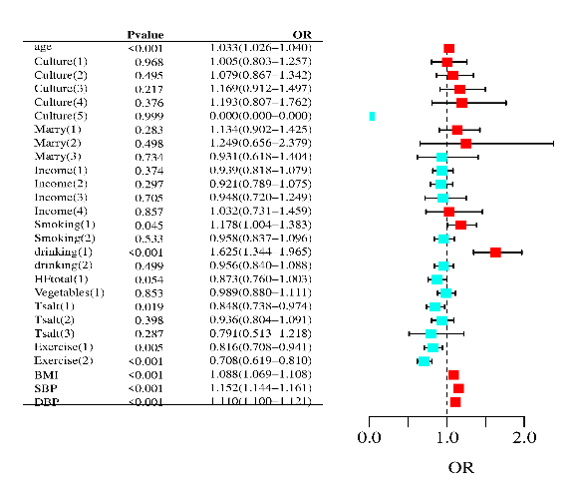  - Male OR 2015-2017 | 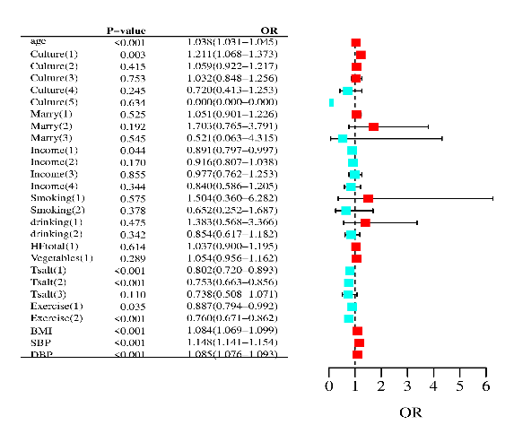  - Female OR 2015-2017
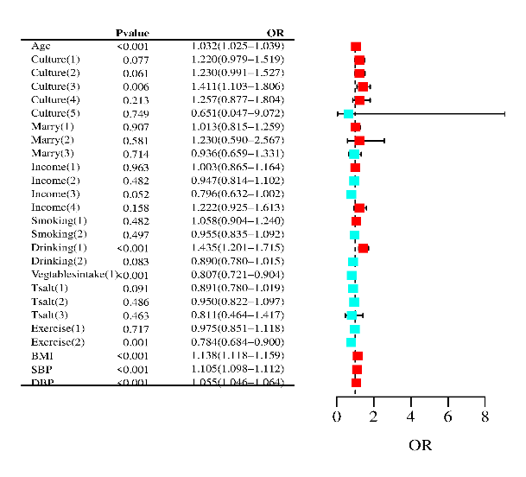  - Male OR 2018-2022 | 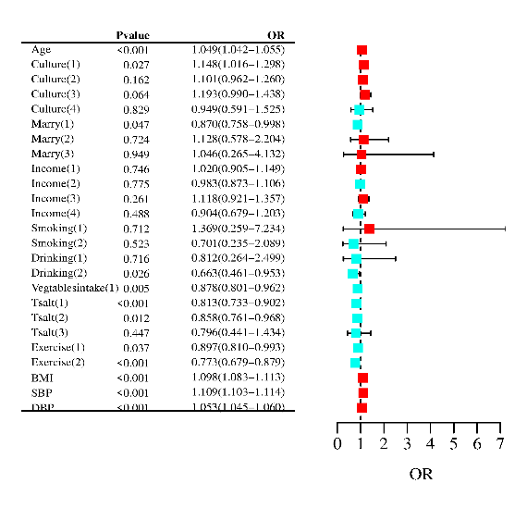  - Female OR 2018-2022
Supplementary Figure 2 Comparison of Risk Factors with Prevalence of HTN according to Gender Group in the Henan Rural Population 2015-2022
Supplementary figure 2 show, the risk factors for hypertension (HTN) differed by gender (Sex) and period in this study. For both genders across all periods, age was a strong risk factor (OR exceeding 1.0 for each year increase in age). Among males in 2015-2017, lower education (Culture(1)) with an OR of 1.005 (95% CI: 0.803-1.257) and smoking (Smoking(1)) with an OR of 1.178 (95% CI: 1.004-1.383) were significantly associated with HTN. Conversely, females in the same period showed a positive association with higher education (Culture(5)) with an OR of 6.584 (although the wide confidence interval, 0.003-15577.609, suggests the need for further investigation), and a negative association with being married (Marry(1)) with an OR of 1.051 (95% CI: 0.901-1.226). Interestingly, the effect of education on HTN risk became less clear for males in 2018-2022, while vegetable intake (Vegetables(1)) emerged as a protective factor for females with an OR of 0.878 (95% CI: 0.801-0.962). Finally, for both genders and across all periods, high salt intake (Tsalt categories), increased BMI, Systolic Blood Pressure (SBP), and Diastolic Blood Pressure (DBP) were significantly associated with HTN (all p-values were 0, indicating very strong statistical significance). These findings highlight the importance of considering sex-specific risk factors and potential changes over time when developing strategies for HTN prevention and management.
Supplementary Table 3(a): Descriptive Statistics of Study Participants by Hypertension Status
Factors | Levels | Baseline HTN |  | Follow-up HTN
Factors | Levels | No | Yes | No | Yes
Gender | Male | 10349 (39.2) | 5128 (39.9) | 7140 (37.7) | 3579 (36.9)
 | Female | 16036 (60.8) | 7711 (60.1) | 11791 (62.3) | 6111 (63.1)
Age | Mean (SD) | 53.3 (12.4) | 60.4 (10.1) | 57.6 (12.1) | 64.0 (9.9)
Culture | Illiterate | 3747 (14.2) | 2783 (21.7) | 2886 (15.3) | 2200 (22.7)
 | Basic Education | 18186 (68.9) | 8471 (66.0) | 12779 (67.7) | 6225 (64.3)
 | Higher Education | 4452 (16.9) | 1585 (12.3) | 3219 (17.0) | 1250 (12.9)
Marry | Cohabiting | 24023 (91.0) | 11187 (87.1) | 16785 (88.9) | 8169 (84.5)
 | Not Cohabiting | 2362 (9.0) | 1652 (12.9) | 2095 (11.1) | 1502 (15.5)
Income | <500 RMB | 8925 (33.8) | 5080 (39.6) | 5587 (29.6) | 3382 (35.1)
 | 500-1000 RMB | 15284 (57.9) | 7017 (54.7) | 10839 (57.5) | 5279 (54.8)
 | ≥1000 RMB | 2176 (8.2) | 742 (5.8) | 2433 (12.9) | 968 (10.1)
Smoking | Never | 19145 (72.6) | 9409 (73.3) | 14213 (75.1) | 7441 (76.8)
 | Ever | 1844 (7.0) | 1346 (10.5) | 1388 (7.3) | 905 (9.3)
 | Current | 5396 (20.5) | 2084 (16.2) | 3329 (17.6) | 1341 (13.8)
Drinking | Never | 20496 (77.7) | 9825 (76.5) | 15128 (79.9) | 7756 (80.1)
 | Ever | 1114 (4.2) | 717 (5.6) | 868 (4.6) | 589 (6.1)
 | Current | 4775 (18.1) | 2297 (17.9) | 2932 (15.5) | 1342 (13.9)
HF.total | No | 20924 (79.3) | 10827 (84.3) | 14823 (78.5) | 8040 (83.3)
 | Yes | 5461 (20.7) | 2012 (15.7) | 4057 (21.5) | 1613 (16.7)
Vegetables | No | 14635 (55.5) | 8212 (64.0) | 9788 (51.9) | 5631 (58.4)
 | Yes | 11749 (44.5) | 4626 (36.0) | 9070 (48.1) | 4007 (41.6)
T.salt | Mean (SD) | 2.0 (0.8) | 1.9 (0.8) | 1.9 (0.8) | 1.8 (0.8)
Exercise | Low | 7857 (29.8) | 4844 (37.7) | 7001 (37.0) | 4156 (42.9)
 | Moderate | 10409 (39.5) | 4386 (34.2) | 6907 (36.5) | 3629 (37.5)
 | High | 8119 (30.8) | 3609 (28.1) | 5013 (26.5) | 1898 (19.6)
WC | Mean (SD) | 82.3 (9.9) | 87.8 (10.4) | 83.9 (9.9) | 88.8 (9.9)
WCgrp | No | 14487 (55.0) | 4436 (34.7) | 9166 (48.7) | 2867 (29.9)
 | Yes | 11866 (45.0) | 8363 (65.3) | 9668 (51.3) | 6732 (70.1)
Hip | Mean (SD) | 93.7 (6.6) | 96.1 (7.2) | 93.4 (6.5) | 95.3 (7.0)
BEE | Mean (SD) | 1337.1 (185.5) | 1341.8 (204.0) | 1305.7 (182.4) | 1305.4 (197.2)
BFP | Mean (SD) | 29.1 (6.6) | 32.1 (6.3) | 29.4 (6.5) | 31.8 (6.2)
BMR | Mean (SD) | 1359.9 (205.6) | 1403.7 (226.7) | 1350.8 (210.2) | 1383.3 (222.7)
VFI | Mean (SD) | 8.6 (4.2) | 11.3 (4.9) | 8.8 (4.3) | 11.2 (4.8)
aBFP | Mean (SD) | 29.1 (6.6) | 32.1 (6.3) | 29.4 (6.5) | 31.8 (6.2)
aBMR | Mean (SD) | 1359.9 (205.3) | 1403.5 (224.7) | 1350.5 (205.4) | 1383.3 (222.6)
aVFI | Mean (SD) | 8.5 (4.2) | 11.3 (4.8) | 8.8 (4.3) | 11.2 (4.8)
BMI | Mean (SD) | 24.2 (3.4) | 26.0 (3.7) | 24.3 (3.4) | 25.9 (3.6)
BMIgrp | Underweight | 810 (3.1) | 142 (1.1) | 652 (3.5) | 137 (1.4)
 | Normal | 12083 (45.9) | 3657 (28.6) | 8491 (45.0) | 2840 (29.6)
 | Overweight | 9988 (37.9) | 5484 (42.9) | 7230 (38.3) | 4174 (43.5)
 | Obesity | 3451 (13.1) | 3491 (27.3) | 2488 (13.2) | 2447 (25.5)
WHR | Mean (SD) | 0.9 (0.1) | 0.9 (0.1) | 0.9 (0.1) | 0.9 (0.1)
WHRgrp | No | 11524 (43.7) | 3110 (24.3) | 6701 (35.6) | 1819 (19.0)
 | Yes | 14826 (56.3) | 9686 (75.7) | 12108 (64.4) | 7772 (81.0)
WHtR | Mean (SD) | 0.5 (0.1) | 0.6 (0.1) | 0.5 (0.1) | 0.6 (0.1)
WHtRgrp | No | 10209 (38.7) | 2268 (17.7) | 6336 (33.6) | 1471 (15.3)
 | Yes | 16140 (61.3) | 10528 (82.3) | 12495 (66.4) | 8123 (84.7)
SBP | Mean (SD) | 115.8 (11.9) | 146.8 (16.9) | 115.1 (12.2) | 141.0 (17.4)
DBP | Mean (SD) | 72.6 (8.1) | 88.2 (10.7) | 71.4 (8.2) | 83.4 (10.9)
HR | Mean (SD) | 75.7 (10.8) | 75.8 (11.9) | 75.6 (10.8) | 75.8 (12.0)

Supplementary Table 3(a) summarizes the characteristics of the study participants, categorised by whether they have HTN at baseline and follow-up surveys. It provides insights into potential differences between these group

Supplementary Table 3(b): Association between Explanatory Variables and HTN GLMM-based Mixed-Effects Logistic Regression Model Results
Variable | Odds Ratio (OR) | Lower Limit OR | Upper Limit OR | Model Estimates | Std. Error | p-value
(Intercept) | 0.001 | 0 | 0 | -24.517 | 0.388 | <0.001
Gender Female | 1.882 | 1.669 | 2.121 | 0.632 | 0.06 | <0.001
Age | 1.036 | 1.031 | 1.04 | 0.035 | 0.002 | <0.001
Culture Basic Education | 1.088 | 1.013 | 1.17 | 0.085 | 0.036 | 0.018
Culture Higher Education | 1.114 | 1.006 | 1.234 | 0.108 | 0.051 | 0.033
Income500-1000 RMB | 0.94 | 0.889 | 0.994 | -0.062 | 0.028 | 0.028
Income2000-3000 RMB | 0.954 | 0.863 | 1.054 | -0.047 | 0.05 | 0.349
DrinkingEver | 1.519 | 1.342 | 1.719 | 0.418 | 0.062 | <0.001
Drinking Current | 0.937 | 0.862 | 1.019 | -0.065 | 0.042 | 0.12
Vegetables Yes | 0.938 | 0.887 | 0.992 | -0.064 | 0.028 | 0.022
T.salt | 0.928 | 0.899 | 0.958 | -0.075 | 0.016 | <0.001
Exercise Moderate | 0.89 | 0.839 | 0.946 | -0.116 | 0.03 | <0.001
Exercise High | 0.772 | 0.721 | 0.826 | -0.259 | 0.034 | <0.001
WCgrp Yes | 1.115 | 1.027 | 1.21 | 0.109 | 0.041 | 0.008
Hip | 0.984 | 0.976 | 0.992 | -0.016 | 0.004 | <0.001
BMR | 0.999 | 0.999 | 0.999 | -0.001 | 0 | 0.039
a BMR | 1.002 | 1.002 | 1.002 | 0.002 | 0 | <0.001
a VFI | 1.051 | 1.041 | 1.062 | 0.05 | 0.005 | <0.001
WHRgrpYes | 1.161 | 1.076 | 1.252 | 0.149 | 0.038 | <0.001
SBP | 1.127 | 1.125 | 1.13 | 0.12 | 0.001 | <0.001
DBP | 1.073 | 1.069 | 1.078 | 0.071 | 0.002 | <0.001
HR | 0.997 | 0.995 | 0.999 | -0.003 | 0.001 | 0.036
time_point Followup | 1.476 | 1.398 | 1.557 | 0.389 | 0.027 | <0.001
Supplementary Table 3(b) provides detailed results from the GLMM-based mixed-effects logistic regression model used to predict HTN in this study. It shows the effect of various factors on the odds of developing HTN.

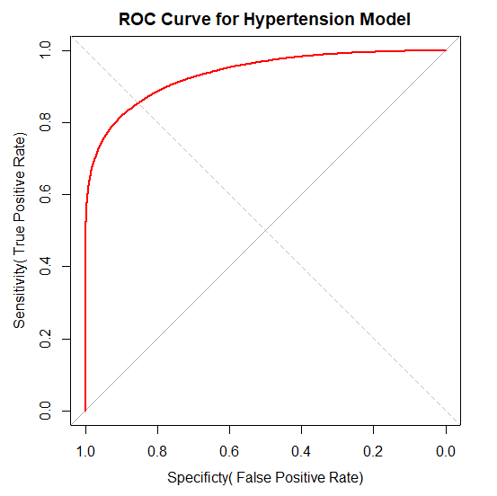
Supplementary Figure 3: Receiver Operating Characteristic (ROC) Curve Analysis for GLMM-based HTN Prediction
Supplementary Figure 3 of the study depicts a Receiver Operating Characteristic (ROC) curve, which visually assesses the performance of a model designed to predict hypertension. The ROC curve plots sensitivity (correctly identified hypertensive cases) against 1-specificity (false positives) and shows a generally positive trend. This suggests the model has good potential for distinguishing between hypertensive and non-hypertensive individuals within this population.

Supplementary Material 4 (Background for the development of a novel 7-category blood pressure system)
The American College of Cardiology and American Heart Association (ACC/AHA) developed a grading scale for HTN category recommendation Several established guidelines exist for classifying blood pressure and recommending treatment strategies for hypertension (HTN). The American College of Cardiology and American Heart Association (ACC/AHA) have recently updated their recommendations, suggesting a target blood pressure of 130/80 mmHg for individuals with high cardiovascular (CV) risk [12]. However, some variations exist across international guidelines, highlighting the need for further research on optimal target blood pressure levels, particularly for Asian populations. Screening and treatment guidelines have changed over the past 20 years, with new recommendations for certain at-risk groups [13]. The old guidelines set the target blood pressure for HTN at 140/90 mmHg before the 2017 ACC/AHA guidelines [14]. The more recent 2018 European Society of Cardiology/European Society of Hypertension's (ESC/ESH),[9] Canadian,[10] and Latin American guidelines, and the American Diabetes Association (ADA) guidelines, propose 140/90 mmHg for adults and 130/80 mmHg for individuals with high CV risk [11]. The 2013 Korean Society of Hypertension (KSH) standards classify prehypertension into two stages based on BP readings. Stage 1 is indicated by an systolic blood pressure (SBP) range of 120-129 mmHg and Diastolic blood pressure (DBP) range of 80-84 mmHg. Stage 2 is indicated by an SBP range of 130-139 mmHg and DBP range of 85-89 mmHg [10]. There are few well-controlled RCTs on target BP among Asians, although there are some cohort data on target BP in certain Asian groups. A recent analysis from the China Stroke Primary Prevention Trial (CSPPT) showed that among adult patients with HBP and no history of stroke, heart attack, diabetes, or kidney problems, aiming for a lower SBP (–120-130 mmHg) resulted in the lowest risk of experiencing a first stroke [11]. According to several studies, these HBP categories are significantly associated with other disorders. The 2018 Chinese and ESC/ESH of HTN guidelines have maintained the usual threshold and target of 140/90 mmHg for patients) [15, 16]. A study of elderly hypertensive patients from northern China found that an SBP range of 130–140 mm Hg had the lowest incidence of cardiovascular disease. However, no specific SBP value has been linked to a reduced risk of negative outcomes [17]. According to a recent WHO report in 2023, China has a higher prevalence of hypertension in rural areas and among men [18]. It is a leading risk factor for CVD, and further action is needed to reduce its burden.
Supplementary Material 5
Early Detection Protocol of HTN in Patients
Regular BP checks help identify HTN and serve as a valuable baseline test for patients with normotension. Table 1 presents the BP classifications and suggestions for the frequency of BP checking. Please refer to Figure 1 in Module 1 for proper BP measurements. BP classification in the workplace^{Note1} refers to the WHO declaration^{1a} and the ESC/ESH guideline^{1b} and advice for frequent BP monitoring and intervention.
Supplementary Table 4: The Classification of BP and Suggestions for How Frequently to Check BP
BP/HTN GROUPS | SBP^{Note3}  mmHg | DBP^{Note4}  mmHg | The recommended minimum review period^{Note3} | Action
Optimal | <120 | <80 | Recheck in 2 years | Encourage to adopt  healthy lifestyle
Normal | 120-129 | 80-84 | Recheck in 1 year | Lifestyle modification
High Normal | 130-139 | 85-89 | Recheck in 6 months | Lifestyle modification
Stage 1 HTN (mild) | 140-159 | 90-99 | Confirm within  2 months | Lifestyle modification
Stage 2 HTN (moderate) | 160-179 | 100-109 | Evaluate within  1 month | • Treat within 1 month  • Lifestyle modification
Stage 3 HTN (severe) | 180-209 | 110-119 | Further evaluation  within 1 week | • If high blood pressure  is confirmed, the drug  treatment should be  commenced Note 5  • May warrant urgent  Referral: If the patient  presents features  suggestive of malignant  hypertension (Refer to Box 2)  • Lifestyle modification
Stage 4 HTN (very severe) | ≥ 210 | ≥ 120 | Evaluation every second day | • Drug treatment  •Lifestyle modification
Note 1. A classification was made based on seated clinic BP. The higher category should be used to identify BP levels if SBP and DBP fall into separate ranges. Three seated clinic BP readings taken one–two minutes apart were recorded. Additional readings should be taken only if the first two readings are > 10 mmHg. The last two BP values were averaged to determine the BP. Except in cases where BP is markedly elevated (e.g., grade 3 HTN) and there is undeniable proof of organ damage caused by HTN, an HTN diagnosis should not be made based solely on a single set of BP readings taken during a single office visit. 1b Calculate a person's BP7 using the average of two readings taken on two different dates.
Note 2. The guidelines should be followed for a shorter review time if the systolic and diastolic categories differ.
Note 3. The review interval should be changed after obtaining accurate information on previous BP readings, additional cardiovascular risk factors, or disorders affecting the target organ.
Note 4. Check BP in both arms to determine whether HTN is the cause⁷:
- Measurements were taken if there was a discrepancy of more than 15 mmHg between the two arms.
- Perform another reading of BP If there is a substantial difference between the two readings, the arm with the higher reading is greater than 15 mmHg.
- Patients at a high risk of mortality with asymptomatic peripheral vascular disease, such as subclavian stenosis, could be identified by a difference in SBP of at least 15 mmHg across arms and could benefit from additional testing. ^{7a}
Note 5. If there is convincing evidence of organ damage caused by HBP (such as hypertensive retinopathy with exudates and hemorrhages, left ventricular hypertrophy, or vascular or renal damage), grade 3 HTN can be diagnosed and treated with medication during a single clinic visit.^{1b}

