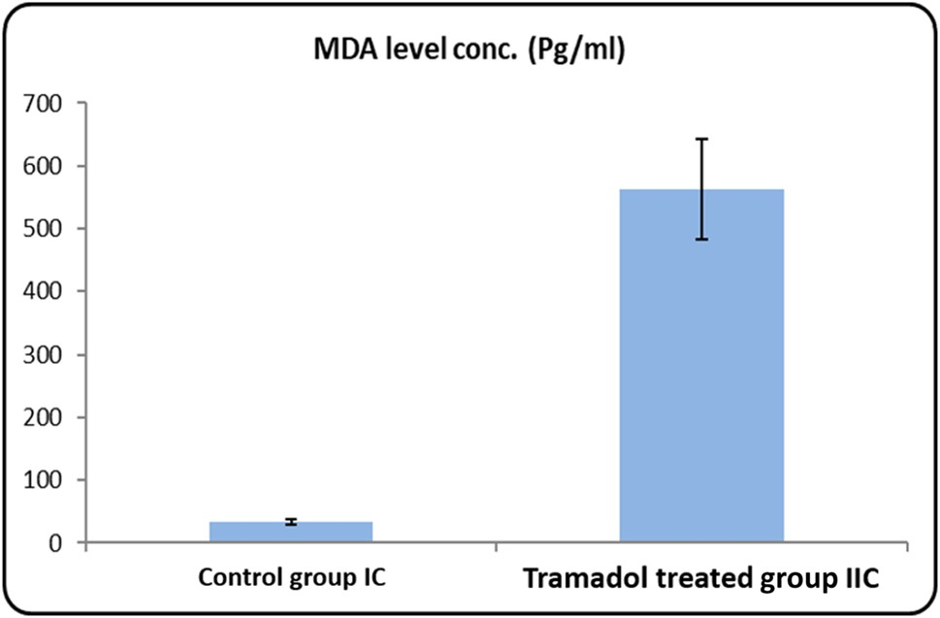
Histogram 1 MDA levels concentration (Pg/ml) in serum of rats from control group Ic and tramadol group IIc
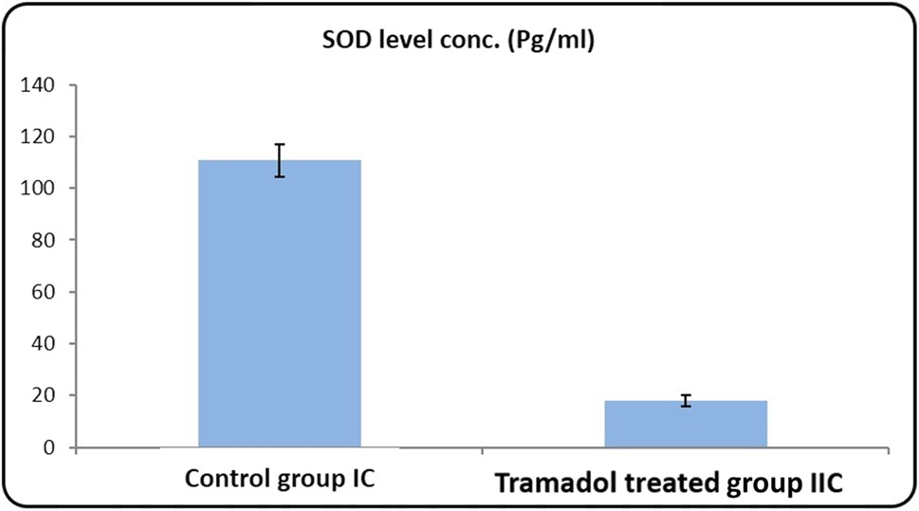
Histogram 2 SOD levels concentration (Pg/ml) in serum of rats from control group Ic and tramadol group IIc
0
5
10
15
20
25
30
35
40
Day 7
Day 14
Day 21
Es
m
ated thi
ckness in µm
Control group
Tramadol group
Histogram 3 Comparison between control and tramadol groups regarding the estimated thickness of external granular cell layer (µm)
0
20
40
60
80
100
120
140
160
Day 7
Day 14
Day 21
Es
m
ated thi
ckness in (µm)
Control group
Tramadol group
Histogram 4 Comparison between control and tramadol treated groups regarding the thickness of molecular cell layer (µm)
0
20
40
60
80
100
120
Day 7
Day 14
Day 21
Es
m
ated thi
ck
ne
ss in µm
Control group
Tramadol group
Histogram 5 Comparison between control and tramadol groups regarding the thickness of internal granular cell layer (µm)
0.0
0.5
1.0
1.5
2.0
2.5
3.0
3.5
4.0
Day 7
Day 14
Day 21
Tunel im
mu
no
hi
st
ochemi
st
ry
%
Control group
Tramadol group
Histogram 6 Comparison between control and tramadol groups regarding the area% of immune stain (TUNEl immunohistochemistry)
0
1
2
3
4
5
6
7
Day 7
Day 14
Day 21
GFAP
im
mu
no
hi
st
ochemi
st
ry

%
Control group
Tramadol group
Histogram 7 Contrast between control and tramadol groups regarding the area % GFAP immunohistochemistry
0
20
40
60
80
100
120
Day 7
Day 14
Day 21
Control group
Tramadol group
Histogram 8 Comparison between control and tramadol groups regarding Micro-RNA7 gene expression in cortical cerebellar layer

