Supplementary Information

Extended Data
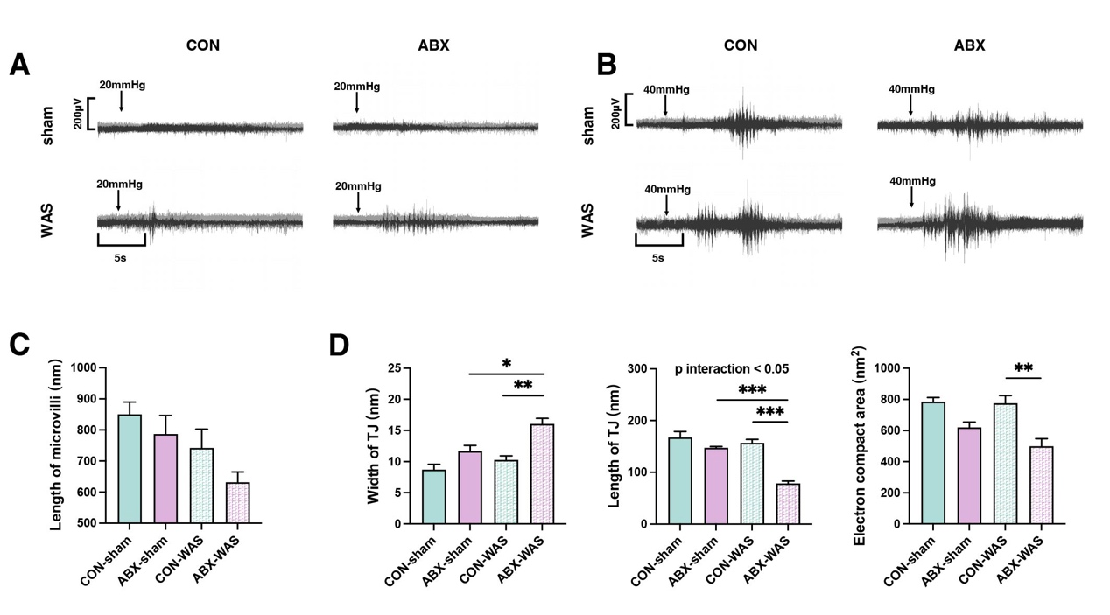
Extended Data Fig. 1 Adults offspring of preconception antibiotics exposure dams exhibit alterations in visceral sensation and colonic mucosal ultrastructure. A. Representative trace of CRD-EMG in adult offspring at 20mmHg. B. Representative trace of CRD-EMG in adult offspring at 40mmHg. C. Measurement of colon epithelial microvilli length in adult offspring (n=3). D. Width, length, and electron-dense area of colon epithelial tight junctions in adult offspring (n=3). Mean ± SEM, statistical analysis performed using two-way ANOVA followed by Tukey's multiple comparison test

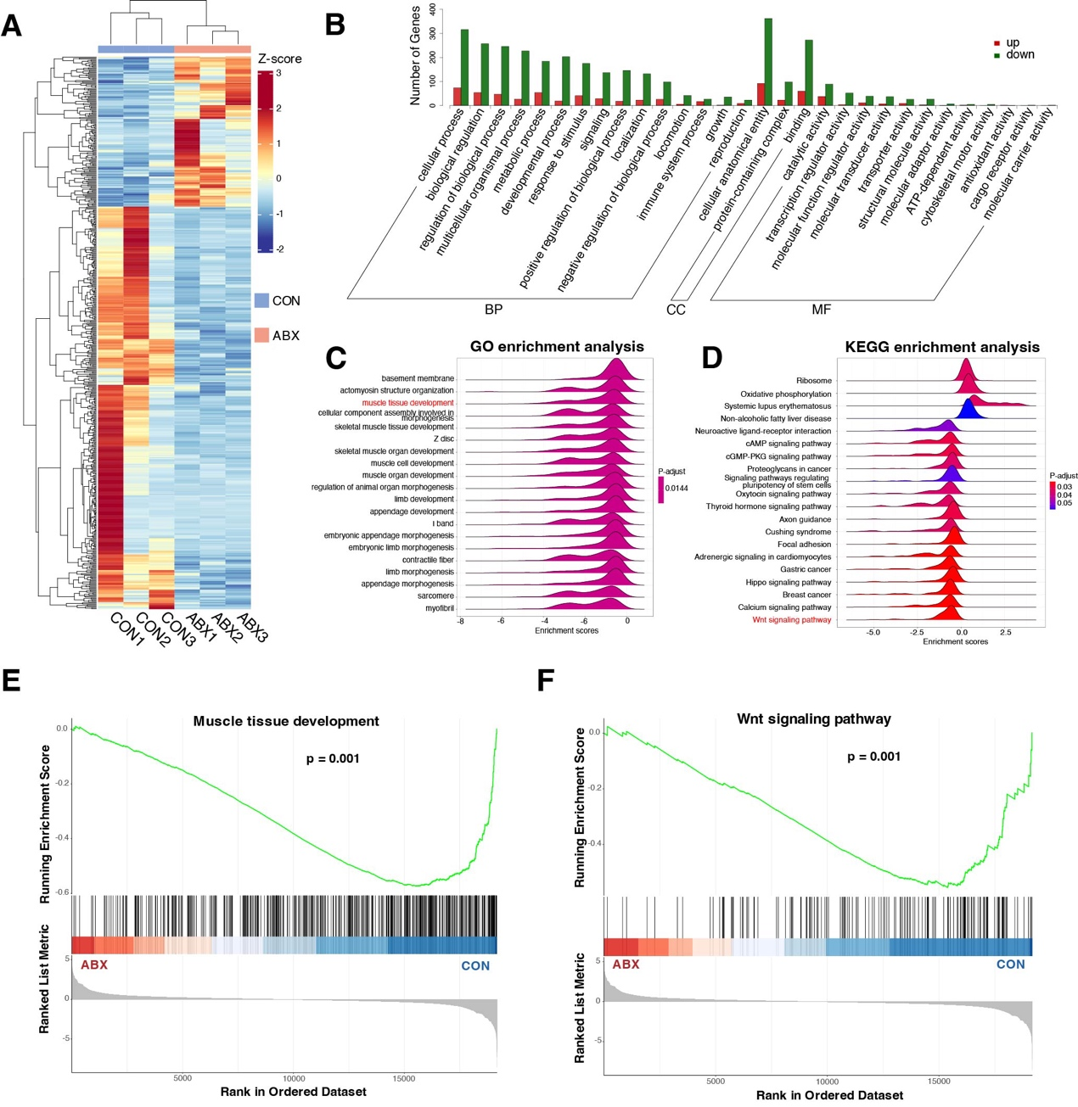
Extended Data Fig. 2 Alterations in gene expression occur within the embryonic colon of offspring from ABX dams. A. Differential genes were standardized using Z-scores and two-group clustering heatmaps were plotted. B. Presentation of level 2 GO terms from the GO enrichment analysis. C. GSEA enrichment analysis using the GO database for the two groups, displaying the 20 entries with the smallest adjusted p-values. D. GSEA enrichment analysis using the KEGG database for the two groups, showing the 20 entries with the smallest adjusted p-values. E. GSEA enrichment analysis demonstrates the downregulation of "muscle tissue development" in the ABX group. F. GSEA illustrates the downregulation of the "Wnt signaling pathway" in the ABX group.
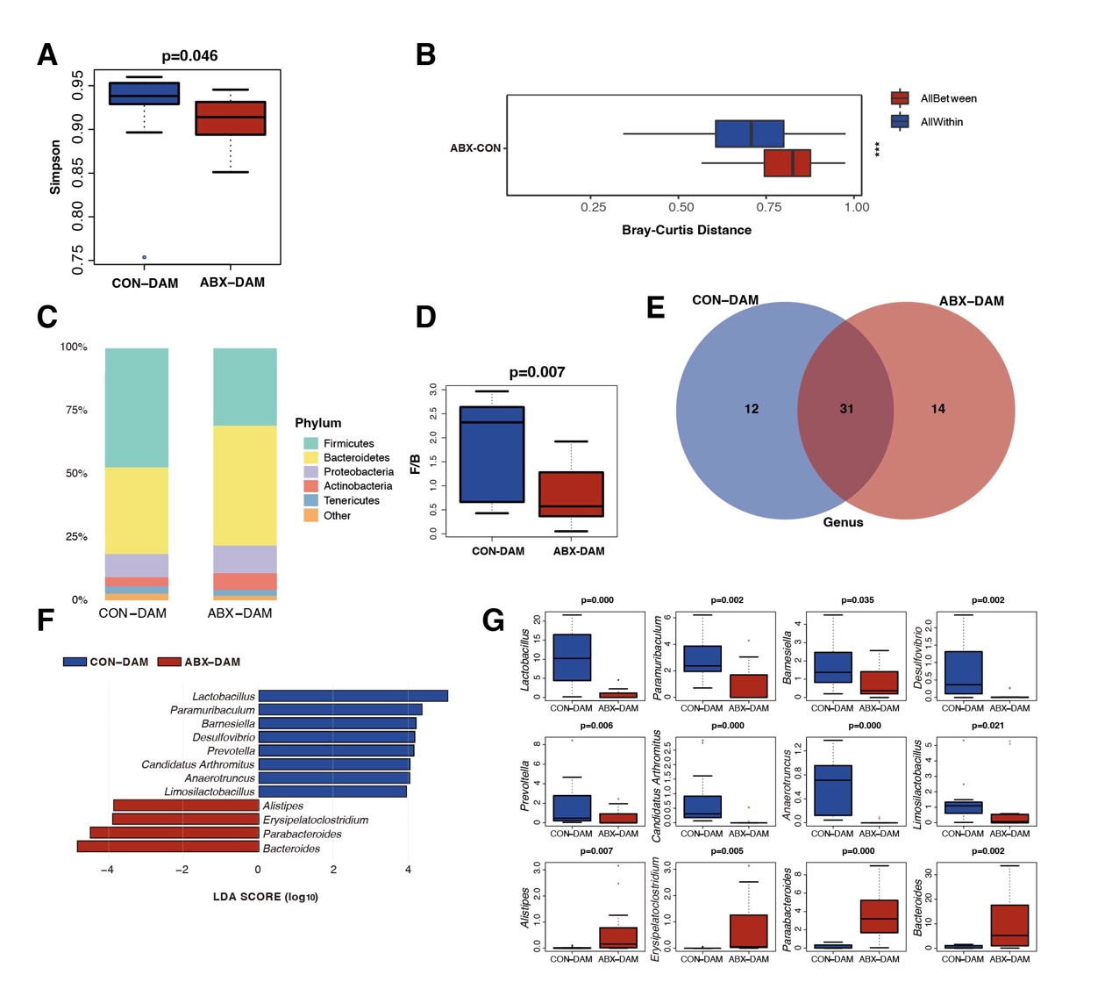
Extended Data Fig. 3 Preconception exposure to antibiotics alters the gut microbiota composition of the dams throughout gestation. A. The Simpson indices of the maternal gut microbiota at the species level on embryonic day 18.5 (E18.5). The differences were calculated using the Wilcoxon test with FDR correction (n=12-13). B. Bray-Curtis distance of the maternal gut microbiota. C. Stacked bar graph showing the average abundance of dominant bacterial phyla within each group. D. Ratio of Bacteroidetes to Firmicutes in the maternal gut microbiota. The differences were computed using the Wilcoxon test with FDR correction(n=12-13). E. Venn diagram revealing shared and differentially abundant genera between the two groups. F. LEfSe analysis performed on the 31 shared genera, identifying species with significant differences in abundance between the groups. The differences were computed using the Wilcoxon test with FDR correction. Linear discriminant analysis (LDA) scores were calculated to estimate the effect size of each species' abundance on the observed differences (n=12-13). G. Display of the average abundance of differentially abundant genera between the two groups.

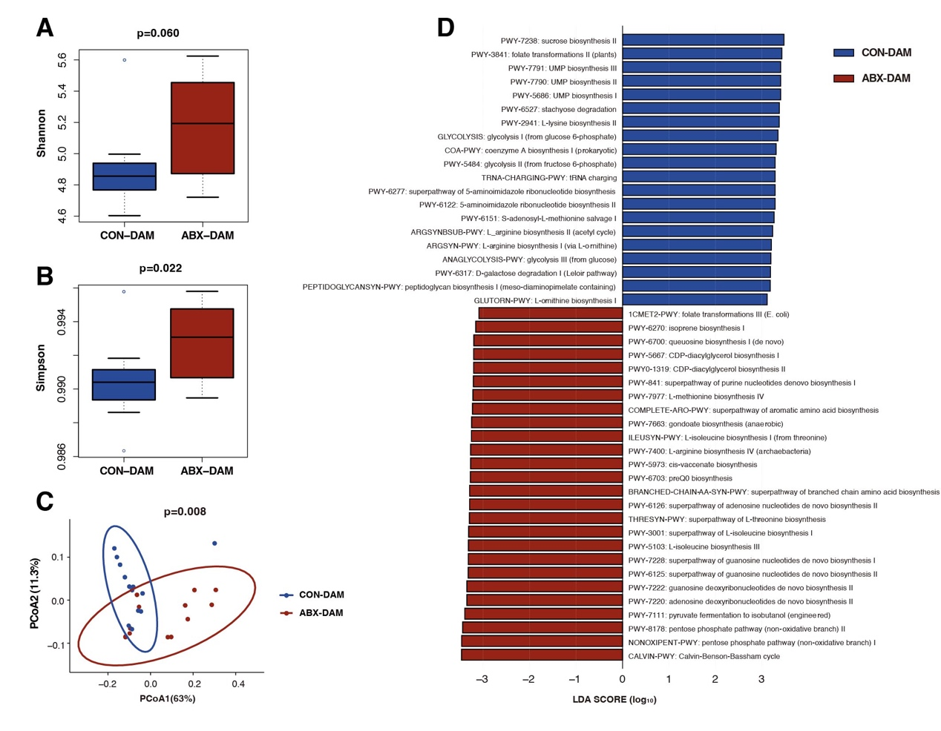
Extended Data Fig. 4 Maternal mice in the ABX group reveal altered functional pathway profiles of the gut microbiota during gestation. A-B. The Shannon and Simpson indices of the maternal gut microbiota functional pathways profile at embryonic day 18.5 (E18.5) using the MetaCyc database (n=12-13). C. PCoA analysis of the maternal gut microbiota functional pathways profile using Bray-Curtis distance. Differences were calculated using the PERMANOVA test (n=12-13). D. LEfSe analysis performed on the 31 shared genera, identifying species with significant differences in abundance between the groups. The differences were computed using the Wilcoxon test with FDR correction. Linear discriminant analysis (LDA) scores were calculated to estimate the effect size of each species' abundance on the observed differences.

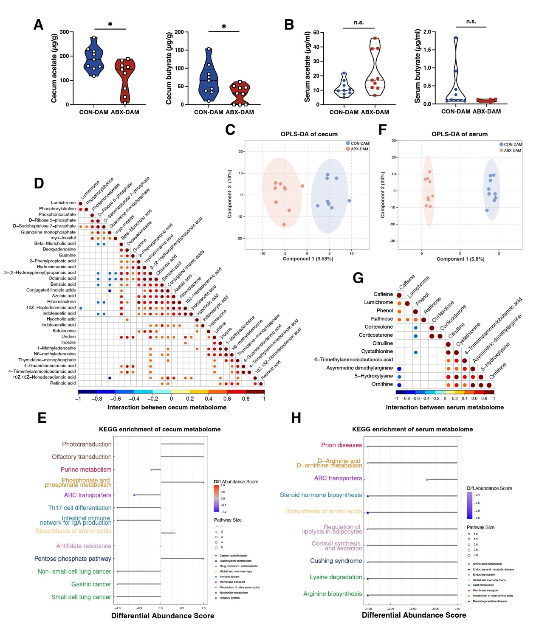
Extended Data Fig. 5 Alteration in the metabolome in both the cecum and serum of dams in the antibiotics treatment group. A. Concentration of acetate and butyrate in the cecum of E18.5 maternal mice (n=9). B. Concentration of acetate and butyrate in the serum of E18.5 maternal mice (n=9). C. Orthogonal partial least squares discriminant analysis (OPLS-DA) used to observe differences in cecal metabolites between the two groups of maternal mice (n=9). D. Correlation plot showing the correlation between differentially abundant metabolites in the cecum of maternal mice. Correlation analysis was performed using the Spearman test, and points with p<0.05 were selected. Larger points indicate smaller p-values. E. Differential abundance scores of metabolites in the cecum of maternal mice using the KEGG database. Larger points at the ends of the lines indicate a higher number of metabolites in that pathway. F. OPLS-DA used to observe differences in serum metabolites between the two groups of maternal mice (n=9). G. Similar to D, correlation plot showing the correlation between differentially abundant metabolites in the serum of maternal mice. H. Similar to E, calculation of differential abundance scores of metabolites in the serum of maternal mice using the KEGG database.

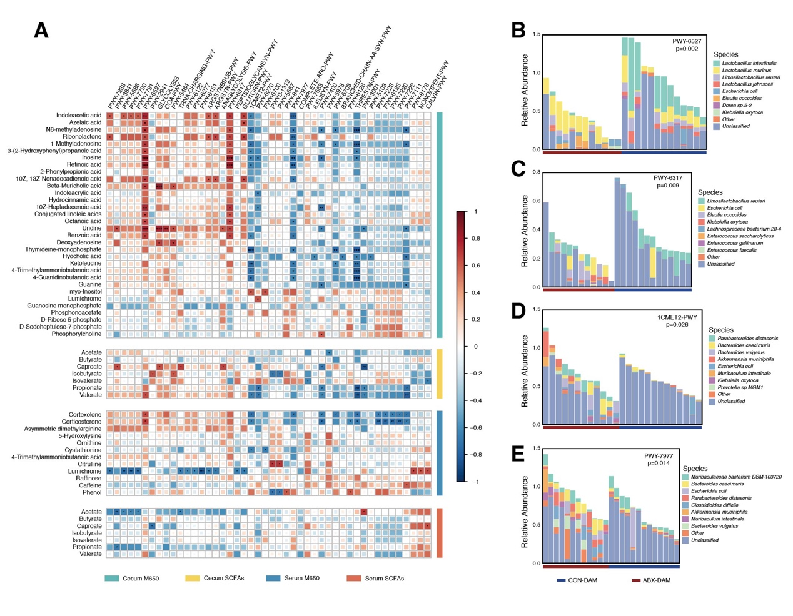
Extended Data Fig. 6 Multi-omics analysis unveils pivotal functional pathways of maternal gut microbiota. A. Construct heatmaps of differential functional pathway spectra and differential cecal and serum metabolites in E18.5 maternal mice (n=11). Perform correlation analysis using the Spearman test. Larger squares with darker colors indicate higher |r| values. Significance levels: *p<0.05, **p<0.01, ***p<0.005. B-E. Core functional pathways annotated by their taxonomic contributors. The Y-axis represents the relative abundance of MetaCyc pathways, while the X-axis represents dams (n=12-13). Detect p-values using the FDR-corrected Wilcoxon test.
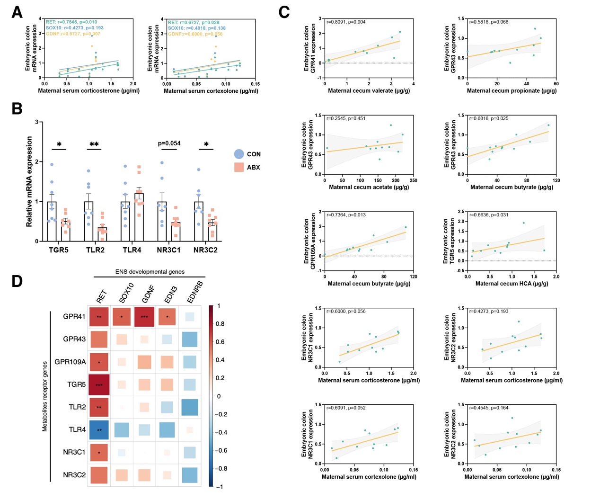
Extended Data Fig. 7 Correlation analysis targets potential metabolites that affect ENS development. A. Scatter plots and linear regression analysis showing the correlation between the concentration of cortexolone and corticosterone in the serum of E18.5 maternal mice and mRNA expression of RET, GDNF, SOX10 in the embryonic gut. Correlation analysis was performed using the Spearman test (n=11). B. Scatter plots and linear regression analysis showing the correlation between the concentration of selected differentially abundant metabolites in maternal mice and their respective receptors. Correlation analysis was performed using the Spearman test (n=11). C. Relative mRNA expression of metabolite and bacterial component receptors, including TGR5, TLR2, TLR4, NR3C1, NR3C2, in the colons of fetal mice. Mean ± SEM, *p<0.05, **p<0.01, ***p<0.001 by unpaired Student's t-test (n=7-8). D. Heatmap showing the correlation between the relative mRNA expression of receptors and important genes involved in ENS development in the colons of E18.5 fetal mice. Correlation analysis was performed using the Spearman test. The larger the square and the darker the color, the larger the |r| value. *p<0.05, **p<0.01, ***p<0.005.

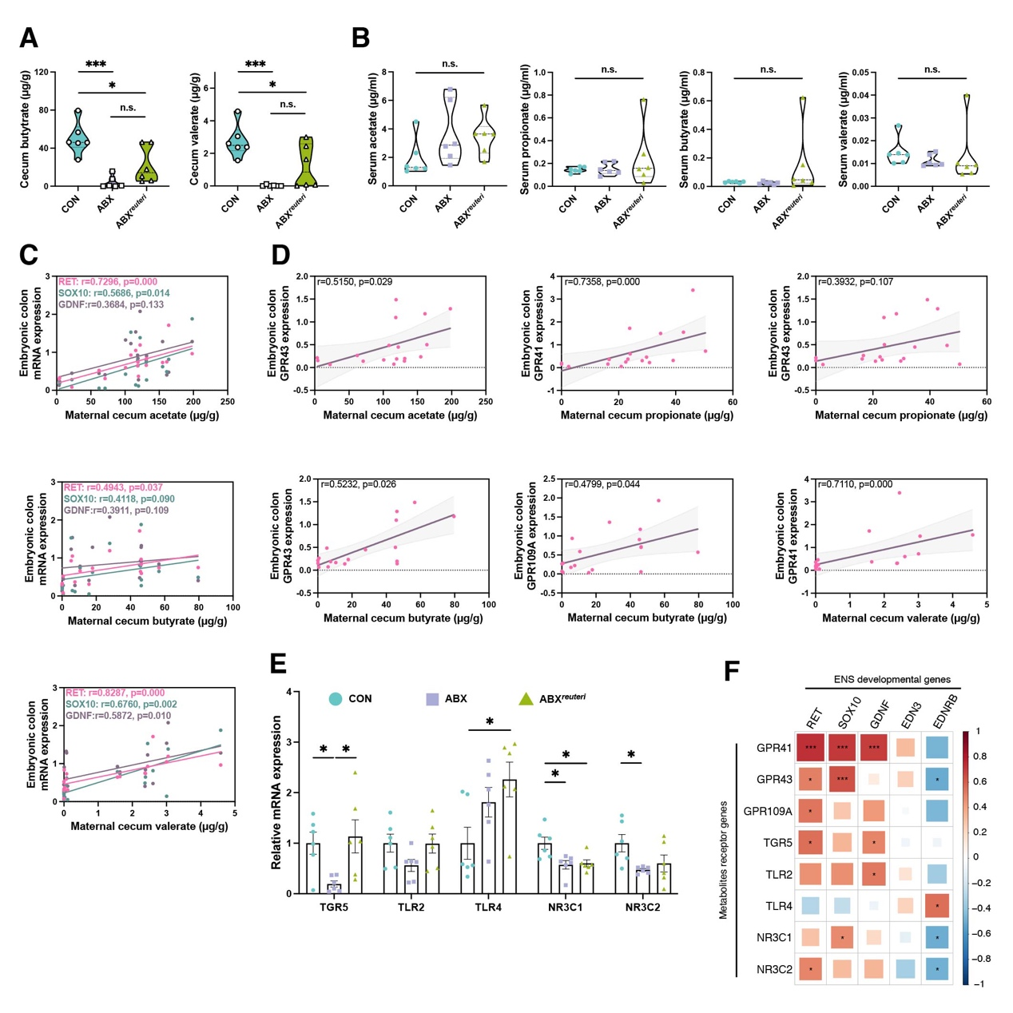
Extended Data Fig. 8 Correlation analysis uncovers metabolites underlying affection of Limosilactobacillus reuteri on ENS development. A. Concentration of butyrate and valerate in the cecum of maternal mice (n=6). B. Concentration of acetate, propionate, butyrate, and valerate in the cecum of maternal mice (n=6). C. Scatter plots and linear regression analysis showing the correlation between the concentration of acetate, butyrate, and valerate in the cecum of E18.5 maternal mice and mRNA expression of RET, GDNF, SOX10 in the embryonic gut (n=18). D. Scatter plots and linear regression analysis showing the correlation between the concentration of selected differentially abundant metabolites in maternal mice and their respective receptors. Correlation analysis was performed using the Spearman test (n=18). E. Relative mRNA expression of metabolite and bacterial component receptors, including TGR5, TLR2, TLR4, NR3C1, NR3C2, in the colons of fetal mice. Mean ± SEM, *p<0.05, **p<0.01, ***p<0.001 by unpaired Student's t-test (n=6). F. Heatmap showing the correlation between the relative mRNA expression of metabolite receptors and important genes involved in ENS development in the colons of E18.5 fetal mice. The larger the square and the darker the color, the larger the |r| value. Short-chain fatty acid concentrations were analyzed using one-way ANOVA followed by Tukey's multiple comparison test (A, B). *p<0.05, **p<0.01, ***p<0.005. Correlation analysis was performed using the Spearman test.

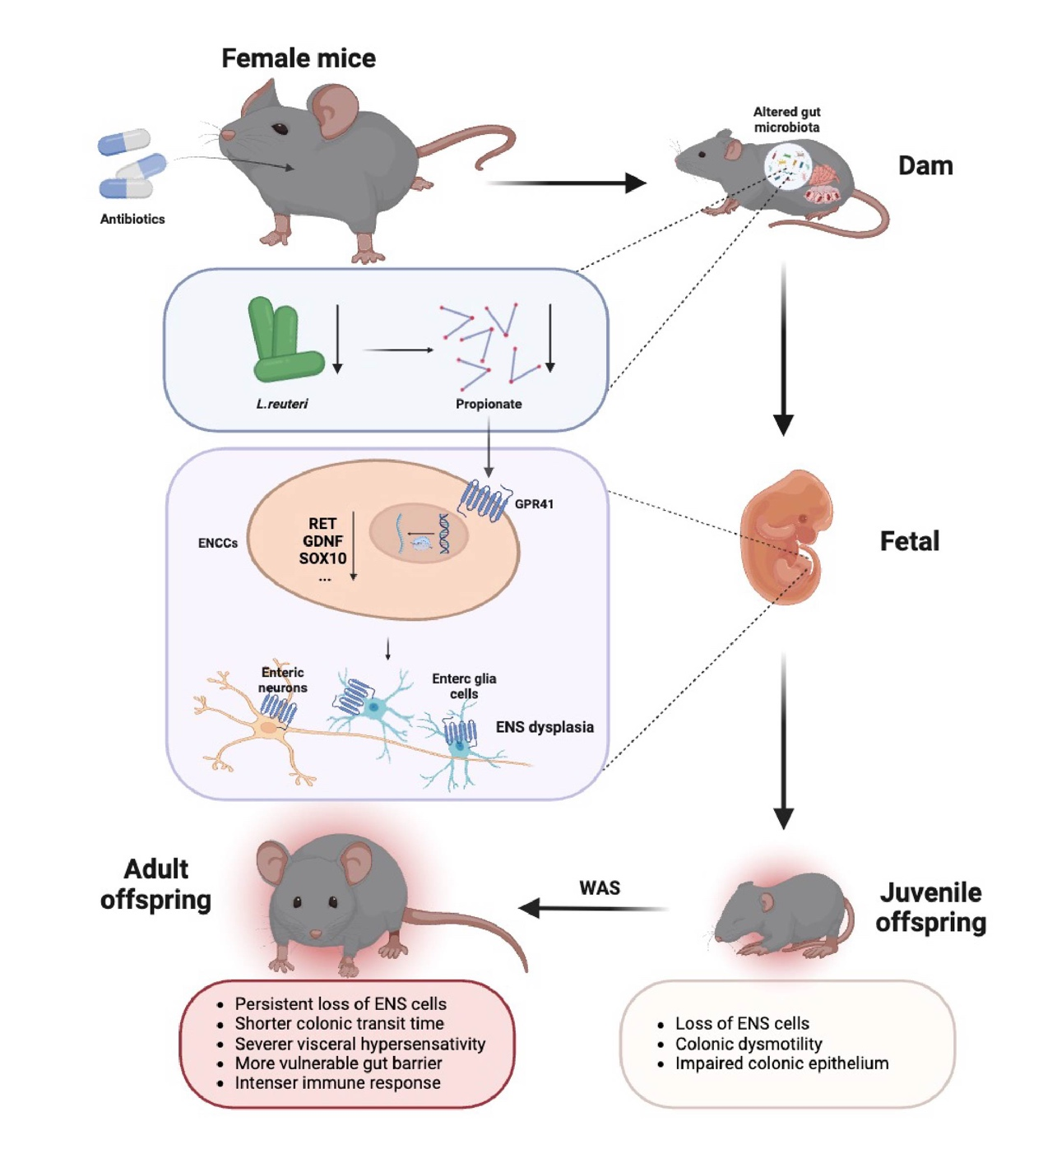
Extended Data Fig. 9 The potential mechanisms by which preconception antibiotic (ABX) treatment may lead to the occurrence of ENS dysplasia and increased susceptibility to WAS in offspring.

