Table S1. The information of selected SNPs from GWAS.
Chr | SNP ID | Closest Gene | Allele  (Major/Minor) | Risk Allele | OR (95%CI) | Sample (Cases/controls) | Ref.
1 | rs3818361 | CR1 | G/A | A | 1.18(1.13-1.24) | 19807/39846 | [1]
1 | rs6656401 | CR1 | G/A | A | 1.18(1.14-1.22) | 25580/48466 | [2]
2 | rs35349669 | INPP5D | C/T | T | 1.08(1.05-1.11) | 25580/48466 | [2]
2 | rs4663105 | BIN1 | A/C | C | 1.19(1.13-1.24) | 19504/38410 | [3]
2 | rs4676049 | RANBP2 | C/A | A | 1.76(1.44-2.15) | 931/1104 | [4]
2 | rs744373 | BIN1 | A/G | G | 1.17(1.12-1.21) | 19807/39846 | [1]
2 | rs7561528 | BIN1 | G/A | A | 1.17(1.13-1.22) | 18832/35579 | [5]
5 | rs190982 | MEF2C | A/G | A | 1.08(1.05-1.11) | 25580/48466 | [2]
6 | rs11754661 | MTHFD1L | G/A | A | 2.10(1.67-2.64) | 931/1104 | [4]
6 | rs9271192 | HLA-DRB1 | A/C | C | 1.11(1.08-1.18) | 25580/48466 | [2]
6 | rs9349407 | CD2AP | G/C | C | 1.11(1.07-1.15) | 19807/39846 | [1]
7 | rs11767557 | EPHA1 | T/C | T | 1.11(1.08-1.16) | 18832/35579 | [5]
7 | rs11771145 | EPHA1 | G/A | G | 1.11(1.08-1.14) | 25580/48466 | [2]
7 | rs1476679 | ZCWPW1 | T/C | T | 1.10(1.06-1.12) | 25580/48466 | [2]
7 | rs2718058 | NME8 | A/G | A | 1.08(1.05-1.11) | 25580/48466 | [2]
8 | rs11136000 | CLU | C/T | C | 1.18(1.14-1.22) | 15440/15565 | [6]
8 | rs28834970 | PTK2B | T/C | C | 1.10(1.08-1.13) | 25580/48466 | [2]
8 | rs569214 | CLU | G/T | G | 1.14 (NA) | 10181/14341 | [7]
11 | rs10838725 | CELF1 | T/C | C | 1.08(1.05-1.11) | 25580/48466 | [2]
11 | rs11218343 | SORL1 | T/C | T | 1.30(1.22-1.39) | 25580/48466 | [2]
11 | rs17817600 | PICALM | A/G | NA | 1.33(NA) | 4018/4274 | [8]
11 | rs2373115 | GAB2 | C/A | C | 4.06(2.81-14.69) | 861/550 | [9]
11 | rs3851179 | PICALM | C/T | C | 1.16(1.09-1.23) | 15440/15565 | [10]
11 | rs4938933 | MS4A4A | T/C | T | 1.12(1.09-1.15) | 18832/35579 | [5]
11 | rs610932 | MS4A6A | G/T | G | 1.11(1.09-1.15) | 19807/39846 | [1]
11 | rs983392 | MS4A6A | A/G | A | 1.11(1.09-1.15) | 25580/48466 | [2]
14 | rs10498633 | SLC24A4 | G/T | G | 1.10(1.06-1.14) | 25580/48466 | [2]
14 | rs17125944 | FERMT2 | T/C | C | 1.14(1.09-1.19) | 25580/48466 | [2]
19 | rs157580 | TOMM40 | A/G | A | 1.59(1.41-1.82) | 931/1104 | [4]
19 | rs2075650 | TOMM40 | A/G | G | 2.23(2.04-2.44) | 15440/15565 | [6]
19 | rs3764650 | ABCA7 | T/G | G | 1.23(1.18-1.30) | 19807/39846 | [1]
19 | rs3865444 | CD33 | C/A | C | 1.1(1.08-1.14) | 19807/39846 | [1]
19 | rs4147929 | ABCA7 | N/A | A | 1.15(1.11-1.19) | 25580/48466 | [2]
19 | rs6859 | PVRL2 | G/A | A | NA | 1082/2639 | [11]
20 | rs7274581 | CASS4 | T/C | T | 1.14(1.09-1.19) | 25580/48466 | [2]
SNP, single nucleotide polymorphism; GWAS, genome-wide association studies; HWE, Hardy-Weinberg equilibrium; Chr, chromosome; OR, odd ratio; CI, confidence interval; CHB, Han Chinese in Beijing, China; MAF, minor allele frequency; Ref., reference; NA, not available.

References:
1. Hollingworth P, Harold D, Sims R, et al. Common variants at ABCA7, MS4A6A/MS4A4E, EPHA1, CD33 and CD2AP are associated with Alzheimer's disease. NATURE GENETICS 2011;43:429-435.
2. Lambert JC, Ibrahim-Verbaas CA, Harold D, et al. Meta-analysis of 74,046 individuals identifies 11 new susceptibility loci for Alzheimer's disease. NATURE GENETICS 2013;45:1452-1458.
3. Jun G, Ibrahim-Verbaas CA, Vronskaya M, et al. A novel Alzheimer disease locus located near the gene encoding tau protein. Mol Psychiatry 2016;21:108-117.
4. Naj AC, Beecham GW, Martin ER, et al. Dementia revealed: novel chromosome 6 locus for late-onset Alzheimer disease provides genetic evidence for folate-pathway abnormalities. PLoS Genetics 2010;6:e1001130.
5. Naj AC, Jun G, Beecham GW, et al. Common variants at MS4A4/MS4A6E, CD2AP, CD33 and EPHA1 are associated with late-onset Alzheimer's disease. NATURE GENETICS 2011;43:436-441.
6. Seshadri S, Fitzpatrick AL, Ikram MA, et al. Genome-wide analysis of genetic loci associated with Alzheimer disease. JAMA 2010;303:1832-1840.
7. Antunez C, Boada M, Gonzalez-Perez A, et al. The membrane-spanning 4-domains, subfamily A (MS4A) gene cluster contains a common variant associated with Alzheimer's disease. Genome Medicine 2011;3:33.
8. Kamboh MI, Demirci FY, Wang X, et al. Genome-wide association study of Alzheimer's disease. Transl Psychiatry 2012;2:e117.
9. Reiman EM, Webster JA, Myers AJ, et al. GAB2 alleles modify Alzheimer's risk in APOE epsilon4 carriers. NEURON 2007;54:713-720.
10. Harold D, Abraham R, Hollingworth P, et al. Genome-wide association study identifies variants at CLU and PICALM associated with Alzheimer's disease. NATURE GENETICS 2009;41:1088-1093.
11. Abraham R, Moskvina V, Sims R, et al. A genome-wide association study for late-onset Alzheimer's disease using DNA pooling. BMC Medical Genomics 2008;1:44.

Table S2. Effects of PVRL2 rs6859 genotypes on the MCI-AD progression among APOE ε4- subjects.
Rs6859 genetype | Model 1 ª |  |  | Model 2 ^{b}
Rs6859 genetype | HR | 95%CI | P value | HR | 95%CI | P value
Rs6859 GG (12/119) | 1(Ref.) |  |  | 1(Ref.)
Rs6859 AG/AA(25/102) | 2.14 | 1.03-4.46 | 0.042 | 3.09 | 1.41-6.75 | 0.005
ª model 1: adjusted factors are age, gender, education year.
^{b} model 2: adjusted factors are age, gender, education year, coronary heart disease, diabetes mellitus, hypertension, stroke, smoking, drinking.

Table S3. Association between PVRL2 rs6859 genotypes and TG levels.
TG levels | rs6859 GG genotypes  (n=131) |  | rs6859 AG genotypes  (n=118) |  | rs6859 AA genotypes  (n=47) |  | P value ª | rs6859 AG/AA genotypes  (n=165) |  | P value^{b}
TG levels | Mean ± Std | Median (IQR) | Mean ± Std | Median (IQR) | Mean ± Std | Median (IQR) |  | Mean ± Std | Median (IQR) | P value^{b}
TG | 1.72±1.06 | 1.60(1.10) | 1.46±0.62 | 1.30(0.59) | 1.88±1.54 | 1.34(1.31) | 0.150 | 1.58±0.99 | 1.32(0.77) | 0.122
LnTG | 0.41±0.50 | 0.47(0.74) | 0.30±0.39 | 0.26(0.44) | 0.43±0.61 | 0.29(0.84) | 0.150 | 0.33±0.46 | 0.28(0.54) | 0.197
ª P value for rs6859 GG vs. AG vs. AA. For TG: Kruskal-Wallis equality-of-populations rank test. For ln TG: Kruskal-Wallis equality-of-populations rank test (because of heteroscedasticity).
^{b} P value for rs6859 GG vs. AG/AA. For TG: Two-sample Wilcoxon rank-sum (Mann-Whitney) test. For lnTG: Two-sample t test with equal variances.
Table S4. Association between APOE ε4 genotypes and TG levels.
TG levels | APOE ε4- subjects  (n=227) |  | APOE ε4 heterozygote  (n=54) |  | APOE ε4 homozygote  （n=3） |  | P value ª | At least one APOE ε4+  subjects (n=60) |  | P value ^{b}
TG levels | Mean ± Std | Median (IQR) | Mean ± Std | Median (IQR) | Mean ± Std | Median (IQR) | P value ª | Mean ± Std | Median (IQR)
TG | 1.63±0.96 | 1.40(1.00) | 1.64±1.29 | 1.40(0.79) | NA | NA | 0.418 | 1.61±1.26 | 1.37(0.79) | 0.564  0.774
Ln TG | 0.36±0.49 | 0.34(0.69) | 0.36±0.47 | 0.34(0.58) | NA | NA | 0.461 | 0.34±0.47 | 0.31(0.59) | 0.564  0.774
ª P value for APOE ε4- subjects vs. ε4 heterozygote subjects vs. ε4 homozygote subjects. For TG: Kruskal-Wallis equality-of-populations rank test. For ln TG: Analysis of Variance.
^{b} P value for APOE ε4- subjects vs. at least one ε4 subjects. For TG: Two-sample Wilcoxon rank-sum (Mann-Whitney) test. For ln TG: Two-sample t test with equal variances.

Table S5. Association between APOE ε2/ε3 genotypes and TG levels.
TG levels | APOE ε2ε2/ε2ε3(n=38) |  | APOE ε3ε3(n=189) |  |  | P value
TG levels | Mean ± Std | Median (IQR) | Mean ± Std | Median (IQR) |  | P value
TG | 1.79±1.56 | 1.30(0.81) | 1.59±0.79 | 1.43(1.00) | 0.951ª
lnTG | 0.40±0.52 | 0.26(0.55) | 0.35±0.48 | 0.36(0.69) | 0.568^{b}
ª Two-sample Wilcoxon rank-sum (Mann-Whitney) test
^{b} Two-sample t test with equal variances

Table S6. APOE ε4 strafied analysis of triglyceride’s effect on progression of MCI to AD.
Ln (TG) | Model 1ª |  |  | model 2^{b}
Ln (TG) | HR | 95%CI | P | HR | 95%CI | P
Ln (TG)*APOE ε4 | 9.72 | 3.04-31.07 | <0.001 | 9.60 | 2.87-32.04 | <0.001
APOE ε4 non-carrier | 0.44 | 0.21-0.92 | 0.029 | 0.49 | 0.22-1.12 | 0.091
APOE ε4 carrier | 4.19 | 1.51-11.59 | 0.006 | 5.14 | 1.17-22.57 | 0.030
ª model 1: adjusted factors are age, gender, education year.
^{b} model 2: adjusted factors are age, gender, education year, BMI, coronary heart disease, diabetes mellitus, hypertension, stroke, smoking, drinking.

Table S7. Correlation between APOE genotypes and PVRL2 rs6859
Variable |  | APOE genotypes
 |  | APOE ε4- subjects | APOE ε4+ subjects | Total
PVRL2 rs6859 | GG | 119 (53.85) | 6 (10.34) | 125 (44.80)
PVRL2 rs6859 | GA/AA | 102 (46.15) | 52 (89.66) | 154 (55.20)
PVRL2 rs6859 | Total | 221 (100) | 58 (100)
Pearson chi2 = 35.16 P<0.001
Values are shown as number (percent).

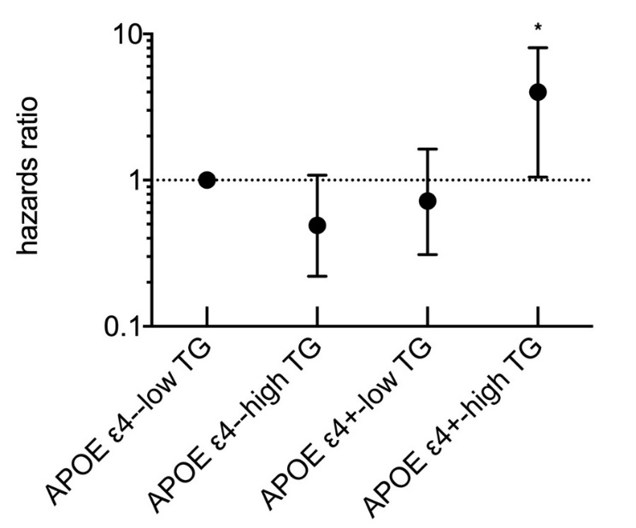
Figure S1. The association between TG and MCI-AD progression in subgroups stratified by APOE ε4. Model was adjusted for age, gender and education years, APOE genotype, BMI, coronary heart disease, diabetes mellitus, hypertension, stroke, smoking, drinking. TG concentration was classified two categories according to the Guidelines for Prevention and Treatment of Adult Dyslipidemia in China (2016): low: TG <1.7 mmol/L, high: TG ≥1.7 mmol/L.

