Trace amine associated receptor 1: Predicted effects of single nucleotide variants on structure-function in geographically diverse populations

Britto Shajan¹, Shashikanth Marri², Tarun Bastiampillai^{3,4}, Karen J. Gregory^{5,6} , Shane D. Hellyer⁵ , Pramod C. Nair^{1,2,7,8}
¹Discipline of Clinical Pharmacology, College of Medicine and Public Health, Flinders University, Adelaide, SA, Australia
²Flinders Health and Medical Research Institute (FHMRI) College of Medicine and Public Health, Flinders University, Adelaide, SA, Australia
³Department of Psychiatry, Monash University, Parkville, Melbourne, VIC, Australia
⁴Discipline of Psychiatry, College of Medicine and Public Health, Flinders University, Adelaide, SA, Australia
⁵Drug Discovery Biology, Monash Institute of Pharmaceutical Sciences, Monash University, 381 Royal Parade, VIC 3052, Australia.
⁶ARC Centre for Cryo-electron Microscopy of Membrane Proteins, Monash Institute of Pharmaceutical Sciences, Monash University, Parkville, VIC, 3052, Australia
⁷South Australian Health and Medical Research Institute, University of Adelaide, Adelaide, South Australia, Australia
⁸Discipline of Medicine, Adelaide Medical School, University of Adelaide, Adelaide, South Australia, Australia

Corresponding author:
Dr Pramod Nair - Discipline of Clinical Pharmacology,
Flinders Medical Centre, College of Medicine and Public Health,
Flinders University, Adelaide, Australia.
Phone: 61-8-82043155

Email: pramod.nair@flinders.edu.au

rsID | SNV
rs772197554 | L72^{2.52}P
rs753020921 | S80^{2.61}G
rs372879305 | H99^{3.28}R
rs759733834 | D103^{3.32}N
rs1777662264 | I104^{3.33}S
rs774612586 | I104^{3.33}V
rs1421620750 | S108^{3.37}P
rs1562202086 | F112^{3.41}L
rs1199836460 | V150^{4.52}A
rs1235033813 | V150^{4.52}I
rs774487833 | P151^{4.53}A
rs763035708 | F154^{4.56}L
rs1317154735 | S183^{ECL2}F
rs530743674 | V184^{ECL2}L
rs1360810948 | T194^{5.42}A
rs772535179 | T197^{5.45}I
rs772535179 | T197^{5.45}S
rs748878284 | S198^{5.46}Y
rs779799468 | W264^{6.48}L
Supplementary table 1: Orthosteric SNVs identified from analysis of human TAAR1 cryo-EM structures.

Supplementary table 2: Microswitch SNVs identified in DRY, PIF, CWxP and NPxxY domains of human TAAR1.
rsID | Microswitch | SNV
rs1275786770 | DRY | D120^{3.49}E
rs1306244133 | DRY | D120^{3.49}G
rs750088922 | DRY | R121^{3.50}H
rs750088922 | DRY | R121^{3.50}L
rs199758150 | DRY | R121^{3.50}C
rs199758150 | DRY | R121^{3.50}S
rs142991502 | DRY | Y122^{3.51}C
rs1777653302 | PIF | P202^{5.50}S
rs142169206 | CWxP | C263^{6.47}R
rs142169206 | CWxP | C263^{6.47}G
rs779799468 | CWxP | W264^{6.48}L
rs778737689 | CWxP | P266^{6.50}A
rs778737689 | CWxP | P266^{6.50}S
rs1427520356 | CWxP | P266^{6.50}L
rs748356783 | NPxxY | N300^{7.49}S
rs147691560 | NPxxY | N300^{7.49}K

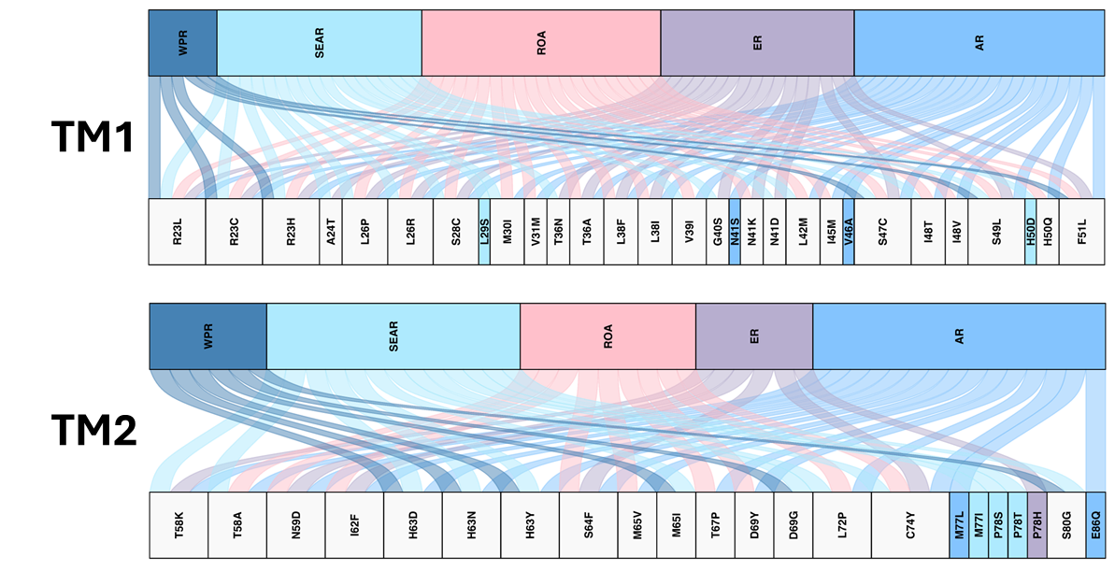

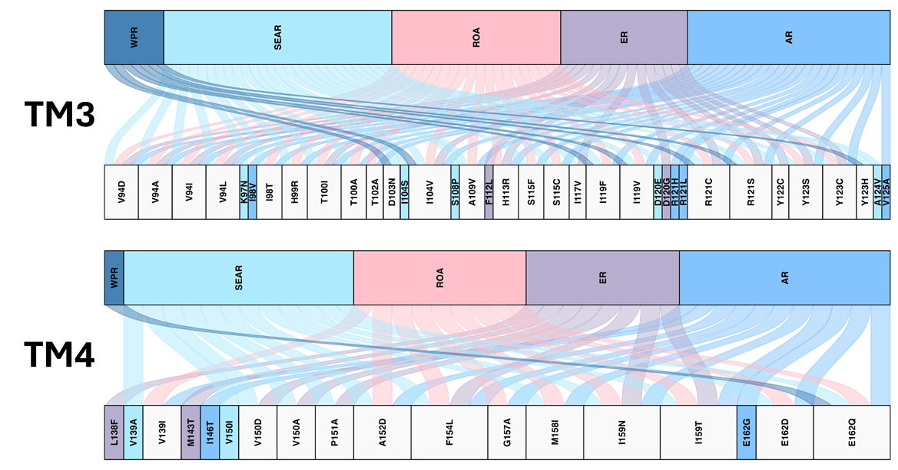

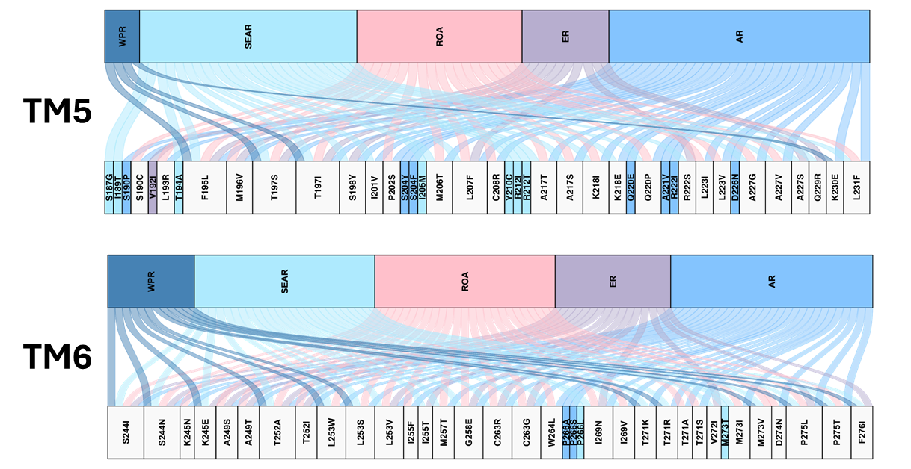

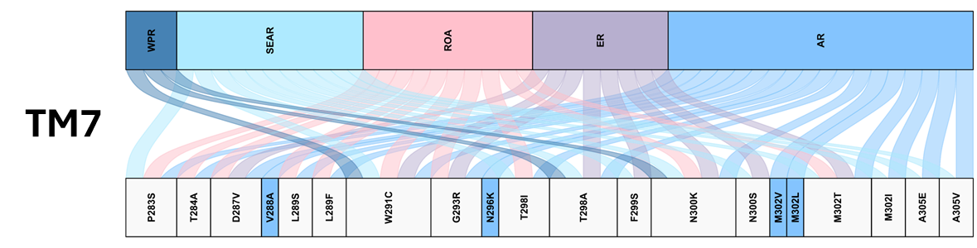

Supplementary figure 1: River plot demonstrating the demographic distribution of SNVs in TM 1-7. Top panel demonstrates the proportional burden of SNVs in WPR, AR, ROA, SEAR and ER. Bottom panels show the list of SNVs. The ribbons link each region with associated SNVs. Unique SNVs are colour matched with respective WHO region, and shared SNVs are coloured using light grey.

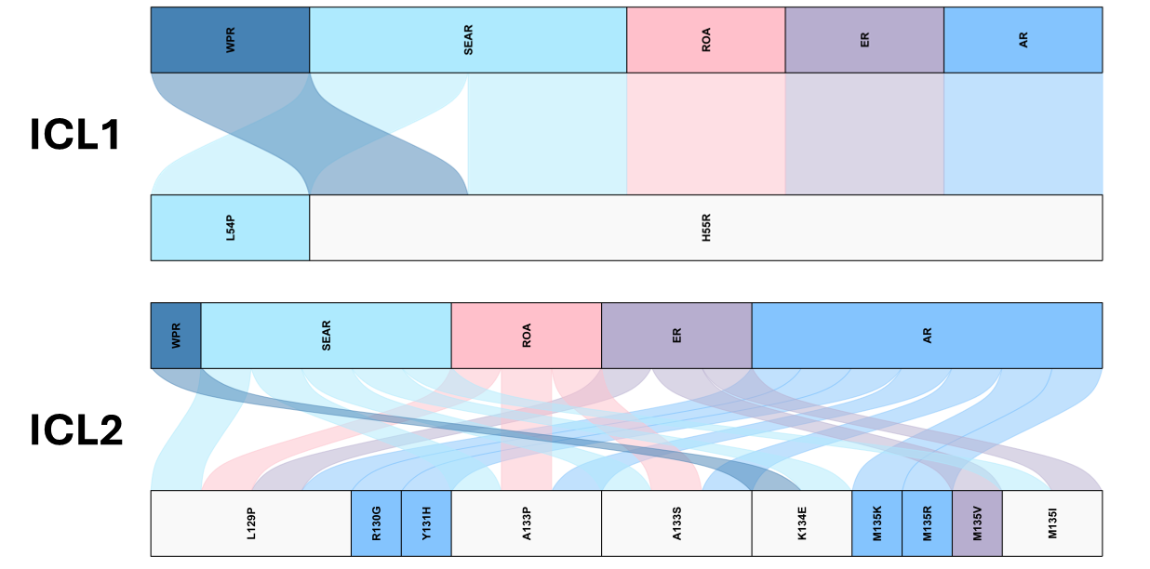

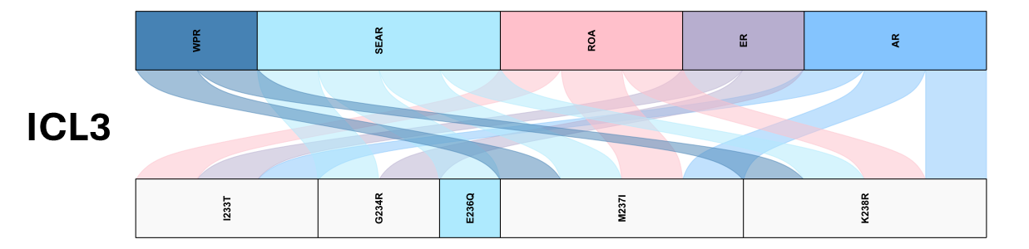

Supplementary figure 2: River plot demonstrating the demographic distribution of SNVs in ICL 1-3. Top panel demonstrates the proportional burden of SNVs in WPR, AR, ROA, SEAR and ER. Bottom panels show the list of SNVs. The ribbons link each region with associated SNVs. Unique SNVs are colour matched with respective WHO region, and shared SNVs are coloured using light grey.

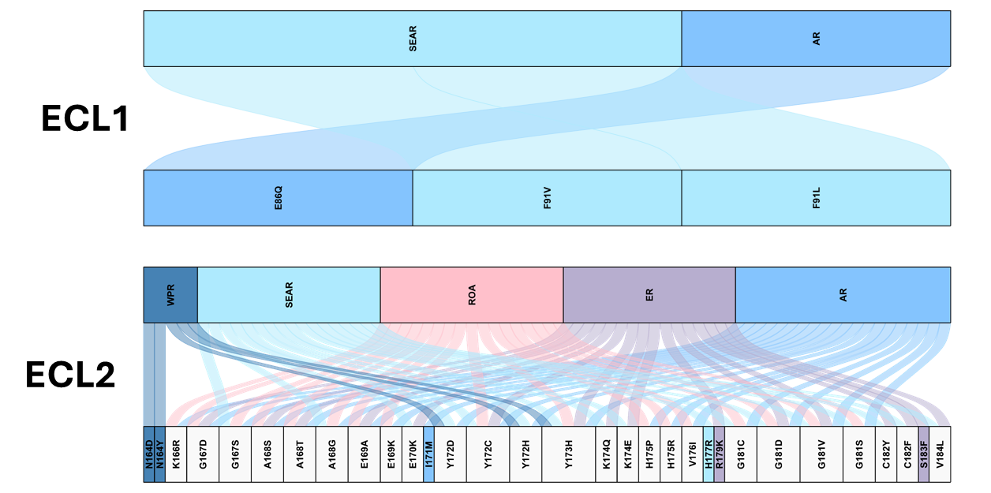

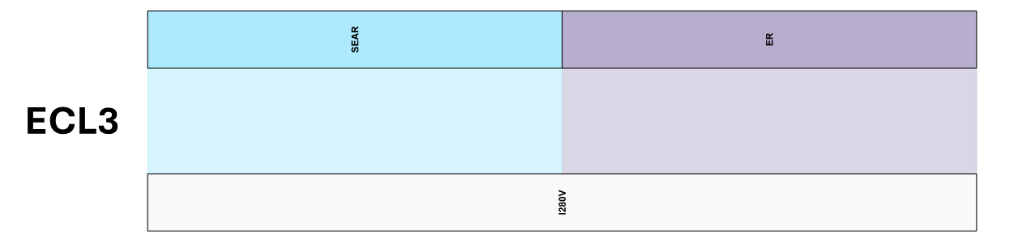

Supplementary figure 3: River plot demonstrating the demographic distribution of SNVs in ECL 1-3. Top panel demonstrates the proportional burden of SNVs in WPR, AR, ROA, SEAR and ER. Bottom panels show the list of SNVs. The ribbons link each region with associated SNVs. Unique SNVs are colour matched with respective WHO region, and shared SNVs are coloured using light grey.
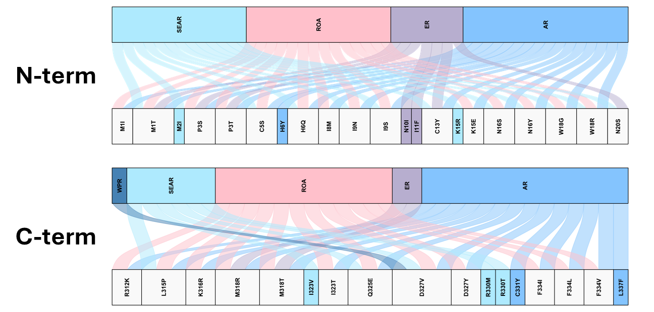

Supplementary figure 4: River plot demonstrating the demographic distribution of SNVs in N-term and C-term domains. Top panel demonstrates the proportional burden of SNVs in each region. Bottom panels list the SNVs. The ribbons link each region with associated SNVs. Unique SNVs are colour matched with respective WHO region, and shared SNVs are coloured using light grey.

