Supplementary Table S1. Assignment criteria and component details for LE8.
Domain | CVH Metric | Measurement | Quantification and Scoring of CVH Metric
Health Behaviors | Diet | HEI-2015 diet score percentile | Quantiles of HEI-2015  Scoring (Population):  Points Quantile  100 ≥95th percentile (top/ideal diet)  80 75th – 94th percentile  50 50th – 74th percentile  25 25th – 49th percentile  0 1st – 24th percentile (bottom/least ideal quartile)
Health Behaviors | Physical activity | Self-reported minutes of moderate or vigorous physical activity per week | Metric: Minutes of moderate (or greater) intensity activity per week  Scoring:  Points Minutes  100 ≥150  90 120 – 149  80 90 – 119  60 60 – 89  40 30 – 59  20 1 – 29  0 0
Health Behaviors | Nicotine exposure | Self-reported use of cigarettes or inhaled NDS | Metric: Combustible tobacco use and/or inhaled NDS use; or secondhand smoke exposure  Scoring:  Points Status  100 Never smoker  75 Former smoker, quit ≥5 yrs  50 Former smoker, quit 1 - 5 yrs  25 Former smoker, quit <1 year, or currently using inhaled NDS  0 Current smoker  Subtract 20 points (unless score is 0) for living with active indoor smoker in home
Health Behaviors | Sleep health | Self-reported average hours of sleep per night | Metric: Average hours of sleep per night  Scoring:  Points Level  100 7 – 9  90 9 –10  70 6 –7  40 5–6 or ≥10  20 4 –5  0 <4
Health Factors | BMI | Body weight (kg) divided by height squared (m2) | Metric: Body mass index (kg/m2)  Scoring:  Points Level  100 <25  70 25.0 – 29.9  30 30.0 – 34.9  15 35.0 – 39.9  0 ≥40.0
Health Factors | Blood lipids | Plasma total and HDL-cholesterol with calculation of non-HDL-cholesterol | Metric: Non-HDL-cholesterol (mg/dL)  Scoring:  Points Level  100 <130  60 130 – 159  40 160 – 189  20 190 – 219  0 ≥220  If drug-treated level, subtract 20 points
Health Factors | Blood glucose | FBG or casual hemoglobin A1c | Metric: FBG (mg/dL) or Hb A1c (%)  Scoring:  Points Level  100 No history of diabetes and FBG <100 (or HbA1c < 5.7)  60 No diabetes and FBG 100 – 125 (or HbA1c 5.7-6.4) (Pre-diabetes)  40 Diabetes with HbA1c <7.0  30 Diabetes with HbA1c 7.0 – 7.9  20 Diabetes with HbA1c 8.0 – 8.9  10 Diabetes with Hb A1c 9.0 – 9.9  0 Diabetes with HbA1c ≥10.0
Health Factors | Blood pressure | Appropriately measured systolic and diastolic blood pressure | Metric: Systolic and diastolic blood pressure (mm Hg)  Scoring:  Points Level  100 <120/<80 (Optimal)  75 120-129/<80 (Elevated)  50 130-139 or 80-89 (Stage I HTN)  25 140-159 or 90-99  0 ≥160 or ≥100  Subtract 20 points if treated level

Supplemental Table S2. Baseline analysis according to stroke status in FLI-NAFLD.
 | Total (n=8828) | Non-stroke (n=8379) | Stroke (n=449) | P-value
Age, year | 51.995±0.284 | 51.507±0.281 | 64.396±0.754 | < 0.0001
PIR | 3.091±0.037 | 3.122±0.038 | 2.324±0.102 | < 0.0001
eGFR | 89.414±0.383 | 90.104±0.381 | 71.909±1.373 | < 0.0001
HEI-2015 diet score | 36.352±0.481 | 36.537±0.517 | 31.652±1.768 | 0.016
Physical activity score | 66.525±0.729 | 67.406±0.755 | 44.177±2.874 | < 0.0001
Nicotine exposure score | 76.143±0.482 | 76.428±0.487 | 68.934±2.278 | 0.002
Sleep health score | 82.457±0.378 | 82.763±0.379 | 74.683±1.943 | < 0.0001
Body mass index score | 33.458±0.377 | 33.422±0.395 | 34.352±1.497 | 0.561
Blood lipids score | 54.655±0.518 | 54.642±0.538 | 54.991±1.854 | 0.859
Blood glucose score | 77.643±0.376 | 78.249±0.379 | 62.266±1.705 | < 0.0001
Blood pressure score | 60.427±0.447 | 61.028±0.472 | 45.172±1.797 | < 0.0001
LE8 | 60.957±0.203 | 61.309±0.206 | 52.029±0.757 | < 0.0001
LE8 behaviors factors | 56.545±0.208 | 56.835±0.213 | 49.196±0.996 | < 0.0001
LE8 metabolic factors | 65.369±0.315 | 65.783±0.328 | 54.862±1.175 | < 0.0001
Sex |  |  |  | 0.007
male | 4482(52.781) | 4264(53.068) | 218(45.493)
female | 4346(47.219) | 4115(46.932) | 231(54.507)
Race |  |  |  | 0.019
Mexican American | 1376(7.495) | 1332(7.598) | 44(4.888)
Non-Hispanic Black | 1892(10.409) | 1784(10.286) | 108(13.532)
Non-Hispanic White | 4158(72.140) | 3914(72.083) | 244(73.572)
Other Hispanic | 800(4.857) | 769(4.919) | 31(3.285)
Other Race | 602(5.098) | 580(5.113) | 22(4.723)
Marital Status |  |  |  | 0.05
non-single | 5687(69.854) | 5426(70.067) | 261(64.450)
single | 3141(30.146) | 2953(29.933) | 188(35.550)
Education |  |  |  | < 0.0001
<high school | 840(4.777) | 774(4.591) | 66(9.484)
high school | 3263(34.140) | 3068(33.695) | 195(45.439)
>high school | 4725(61.083) | 4537(61.714) | 188(45.077)
CHD |  |  |  | < 0.0001
No | 8294(94.606) | 7939(95.202) | 355(79.470)
Yes | 534(5.394) | 440(4.798) | 94(20.530)
Family history of CVD |  |  |  | < 0.001
No | 7467(83.961) | 7126(84.329) | 341(74.628)
Yes | 1361(16.039) | 1253(15.671) | 108(25.372)
Continuous variables were expressed as mean ± standard error and differences between groups were analyzed by weighted Student's t-test, while categorical variables were tested by weighted chi-square analysis and reported as number (percentage).

Supplementary Table S3. Association between LE8 and stroke in FLI-NAFLD.
 | Crude Model | P | Model 1 | P | Model 2 | P
LE8 | 0.946(0.937,0.954) | <0.0001 | 0.951(0.941,0.961) | <0.0001 | 0.962(0.951,0.972) | <0.0001
LE8
Low CVH | ref | ref | ref | ref | ref | ref
Moderate CVH | 0.298(0.229,0.388) | <0.0001 | 0.356(0.271,0.468) | <0.0001 | 0.461(0.347,0.614) | <0.0001
High CVH | 0.172(0.061,0.484) | 0.001 | 0.276(0.099,0.770) | 0.014 | 0.433(0.153,1.228) | 0.114
P for trend | <0.0001 |  | <0.0001 |  | <0.0001
LE8 metabolic factors | 0.967(0.958,0.976) | <0.0001 | 0.980(0.969,0.990) | <0.001 | 0.986(0.976,0.997) | 0.01
LE8 metabolic factors
Low CVH | ref | ref | ref | ref | ref | ref
Moderate CVH | 0.336(0.245,0.459) | <0.0001 | 0.495(0.356,0.686) | <0.0001 | 0.555(0.398,0.772) | <0.001
High CVH | 0.559(0.264,1.187) | 0.129 | 1.085(0.495,2.379) | 0.837 | 1.260(0.544,2.915) | 0.586
P for trend | <0.0001 |  | 0.017 |  | 0.083
LE8 behaviors factors | 0.971(0.964,0.977) | <0.0001 | 0.969(0.961,0.976) | <0.0001 | 0.975(0.967,0.983) | <0.0001
LE8 behaviors factors
Low CVH | ref | ref | ref | ref | ref | ref
Moderate CVH | 0.407(0.314,0.526) | <0.0001 | 0.426(0.325,0.559) | <0.0001 | 0.504(0.381,0.666) | <0.0001
High CVH | 0.267(0.183,0.391) | <0.0001 | 0.273(0.187,0.400) | <0.0001 | 0.350(0.238,0.515) | <0.0001
P for trend | <0.0001 |  | <0.0001 |  | <0.0001
The crude model did not adjust for any covariates; Model 1 was an age-, sex-, and race-adjusted model; and Model 2 was a fully adjusted model that additionally adjusted for education level, PIR, marital status, CHD, family history of CVD, and eGFR in addition to Model 1.
Supplementary Figure 1. RCS analysis of the association between LE8 and stroke in FLI-NAFLD.
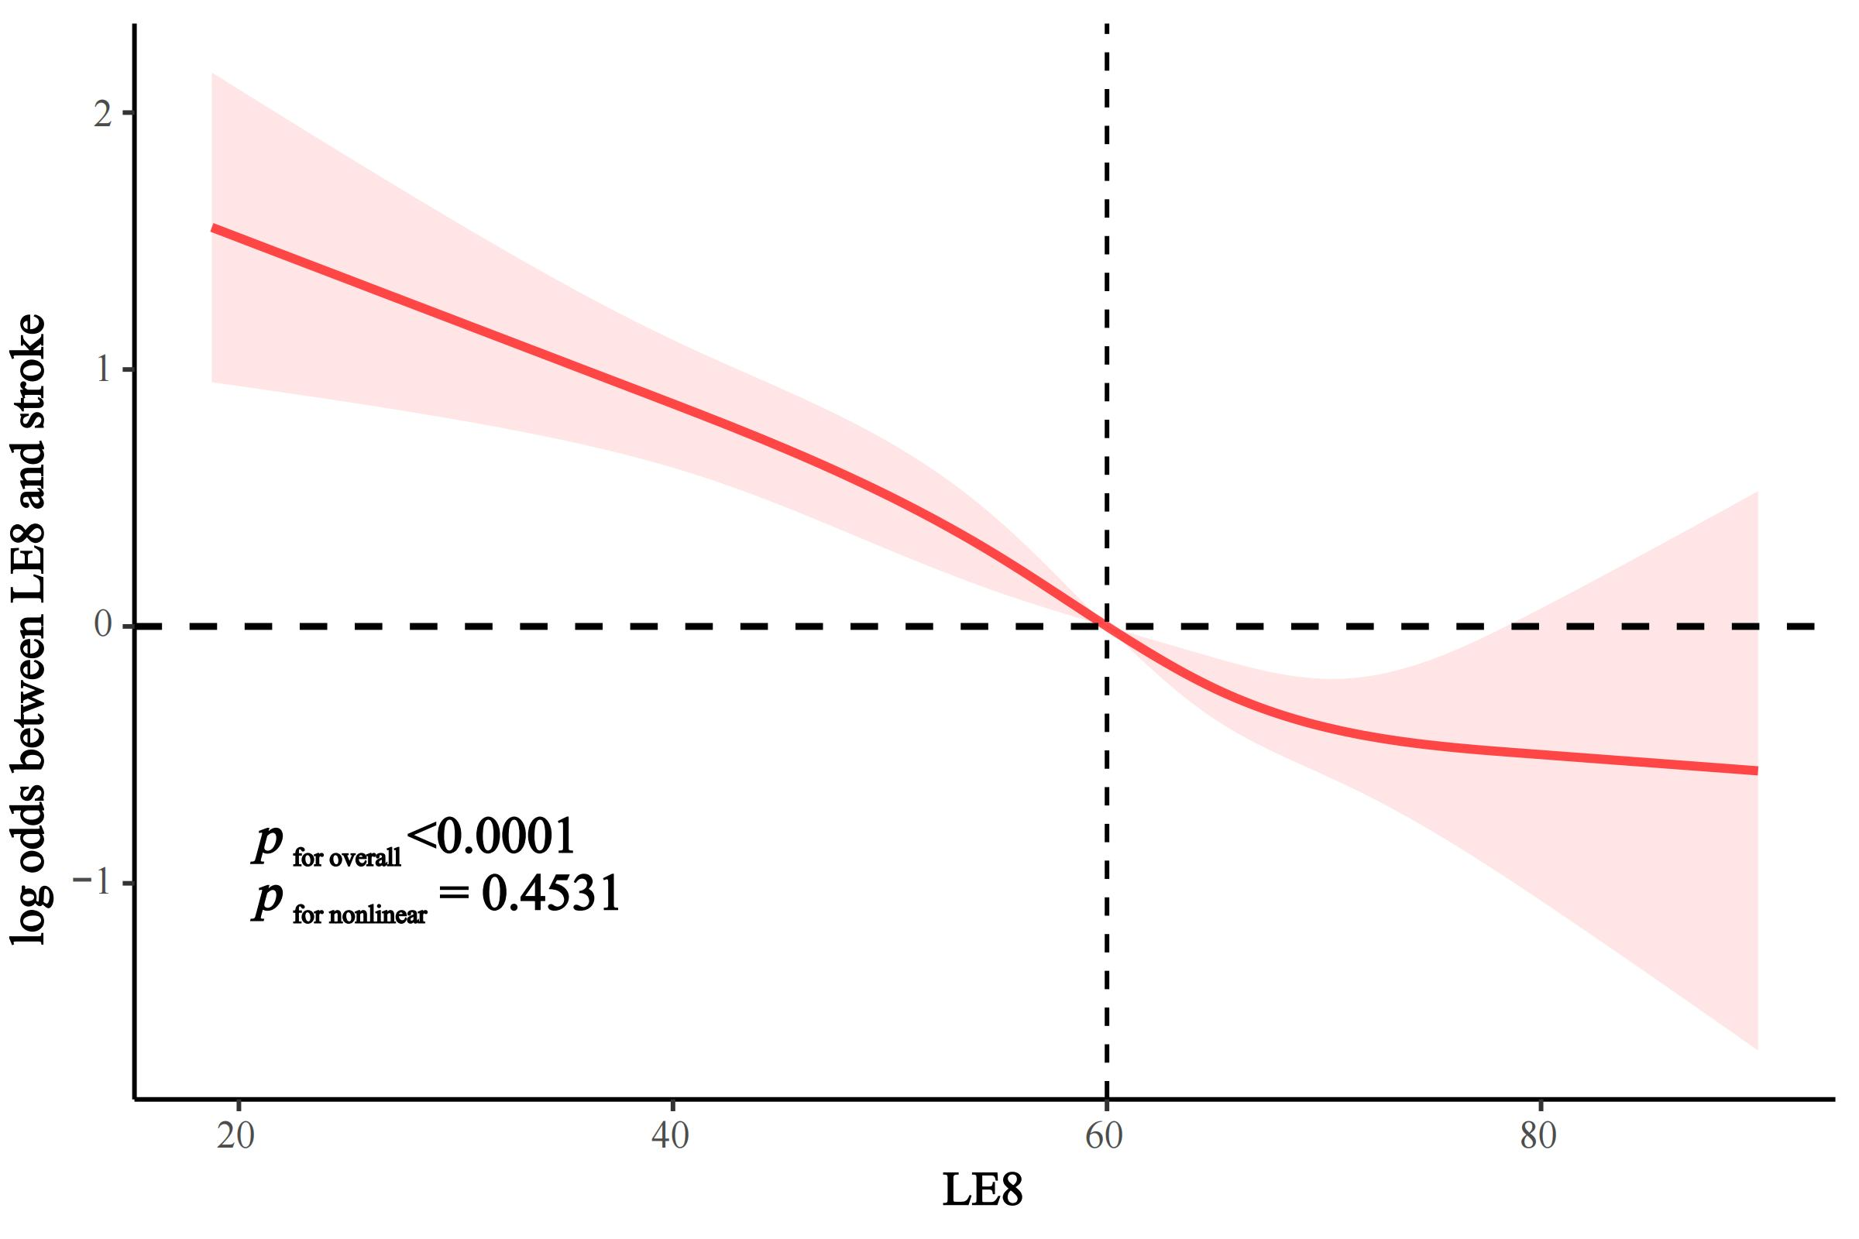

Supplementary Figure 2. RCS analysis of the association between LE8 metabolic factors and stroke in FLI-NAFLD.
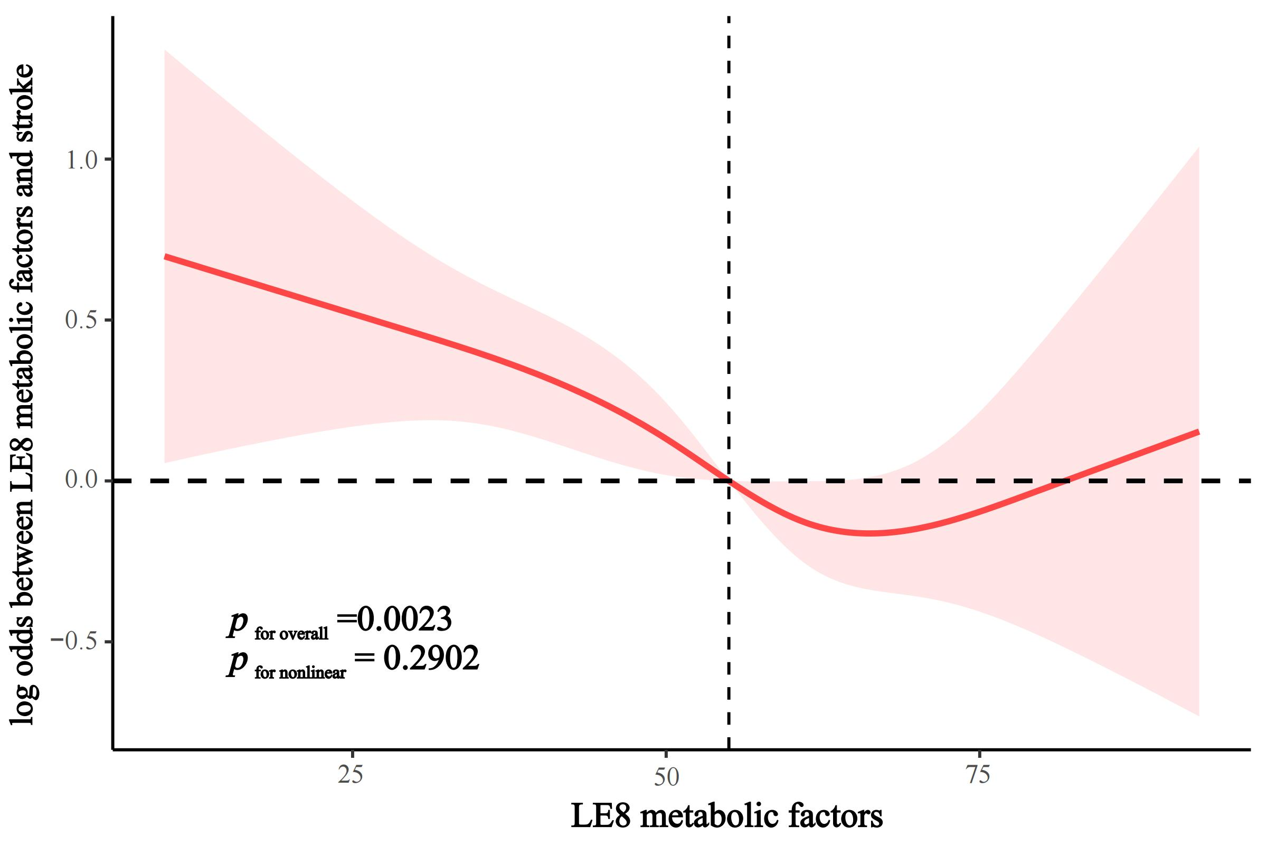

Supplementary Figure 3. RCS analysis of the association between LE8 behaviors factors and stroke in FLI-NAFLD.
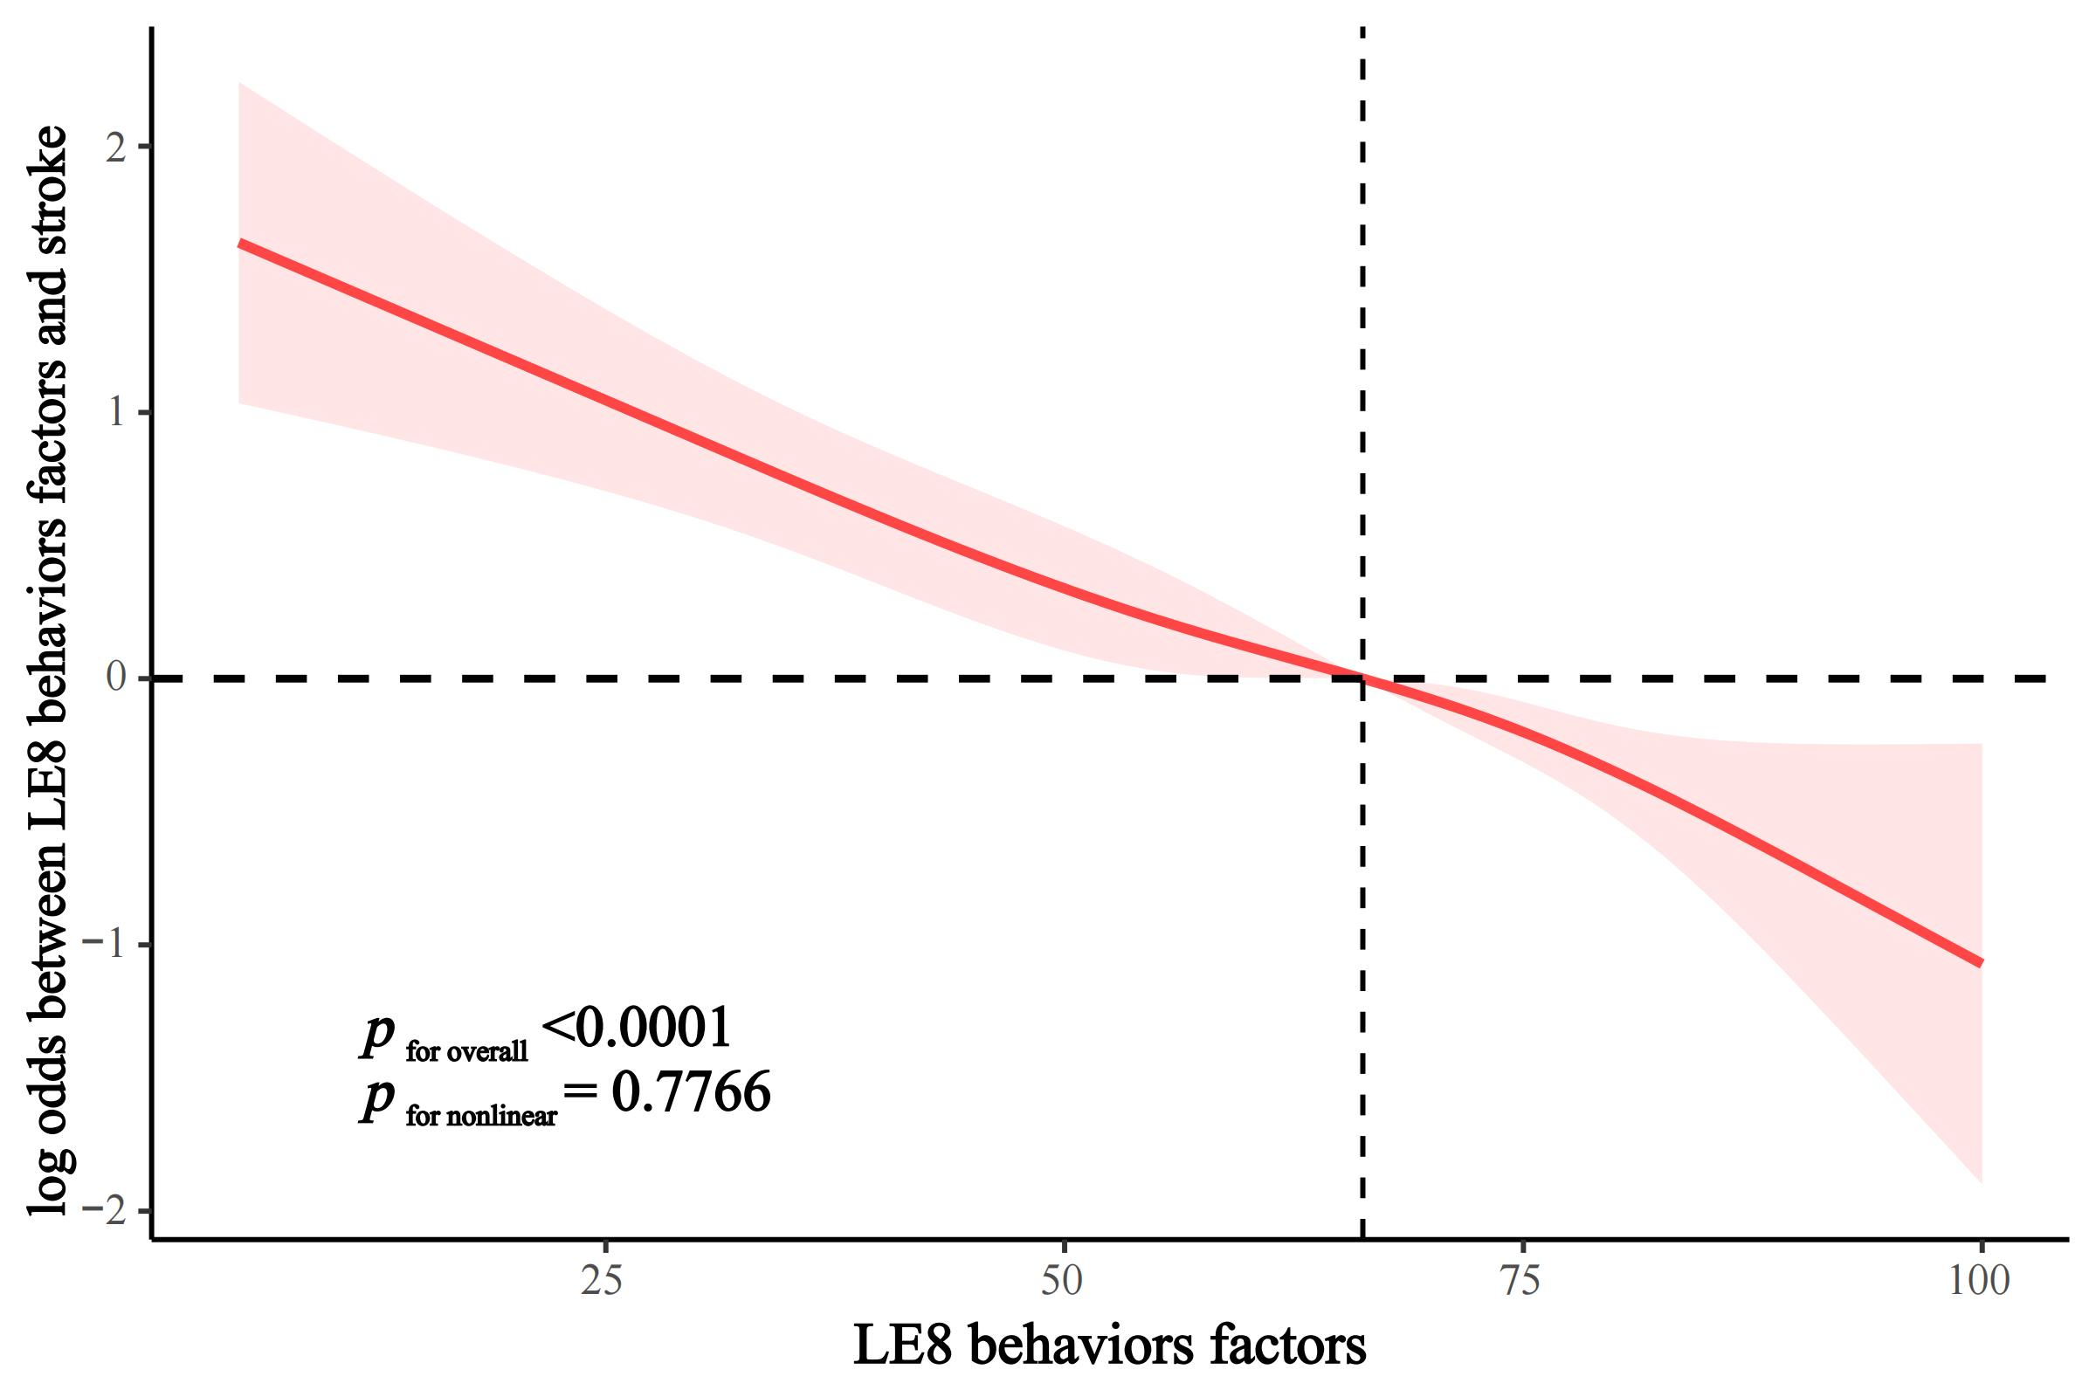

Supplementary Figure 4. Association between LE8 and stroke in FLI-NAFLD according to the number of ideal LE8 components.
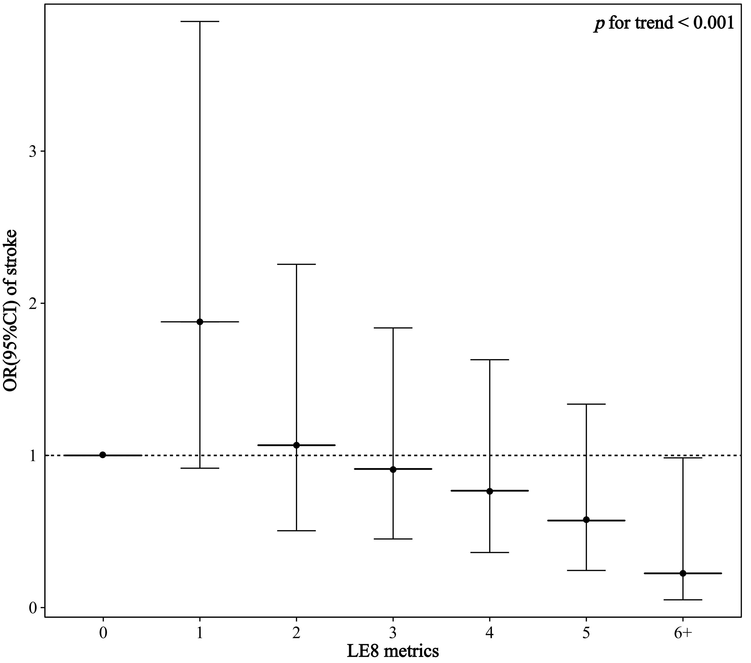

Supplementary Figure 5. Association of LE8 with stroke in FLI-NAFLD according to the number of ideal LE8 components in LE8 metabolic and behavioral factors.
