Extended data figures and tables for

Human tNeurons reveal aging-linked proteostasis deficits driving Alzheimer’s phenotypes

Ching-Chieh Chou, Ryan Vest, Miguel A. Prado, Joshua Wilson-Grady, Joao A. Paulo, Yohei Shibuya, Patricia Moran-Losada, Ting-Ting Lee, Jian Luo, Steven P. Gygi, Jeffery W. Kelly, Daniel Finley, Marius Wernig, Tony Wyss-Coray, Judith Frydman

Corresponding author: cchou6@stanford.edu (C.-C.C.), jfrydman@stanford.edu (J.F.)

The PDF file includes:

Extended Data Figure 1-14
Extended Data Table 1-4

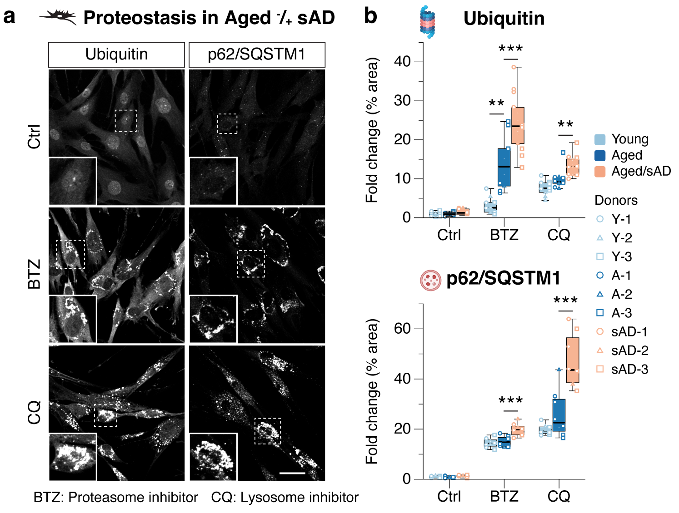

Extended Data Fig.1 Proteostasis signatures of aging and Alzheimer’s disease (AD) are present in human adult fibroblasts.
(a) Representative images of endogenous ubiquitin and p62/SQSTM1 in young fibroblasts treated with DMSO control (Ctrl), proteasome inhibitor Bortezomib (BTZ, 25 nM) or autophagy inhibitor Chloroquine (CQ, 25 µM) for 24 hr. Insert: higher magnification view of ubiquitin and p62/SQSTM1. Scale bar: 40 μm.
(b) Immunofluorescence (IF) quantification of proteostasis markers shown in panel (a) for changes in ubiquitin and p62/SQSTM1 by the treatment of BTZ and CQ, respectively, in young, aged and aged/sAD fibroblasts. Data represent as fold changes in ubiquitin and p62/SQSTM1 levels (% of area per image field) relative to young fibroblasts treated with DMSO Ctrl.

Data show box-and-whisker plots of 3 independent experiments and cells from 3 independent healthy control (HC) and AD donors. Box-and-whisker plots depict 5th, 25th, 50, 75th and 95th percentiles. Differences between groups are compared with Two-Way ANOVA followed by Bonferroni post-hoc analysis. **P < 0.01 and ***P < 0.001.

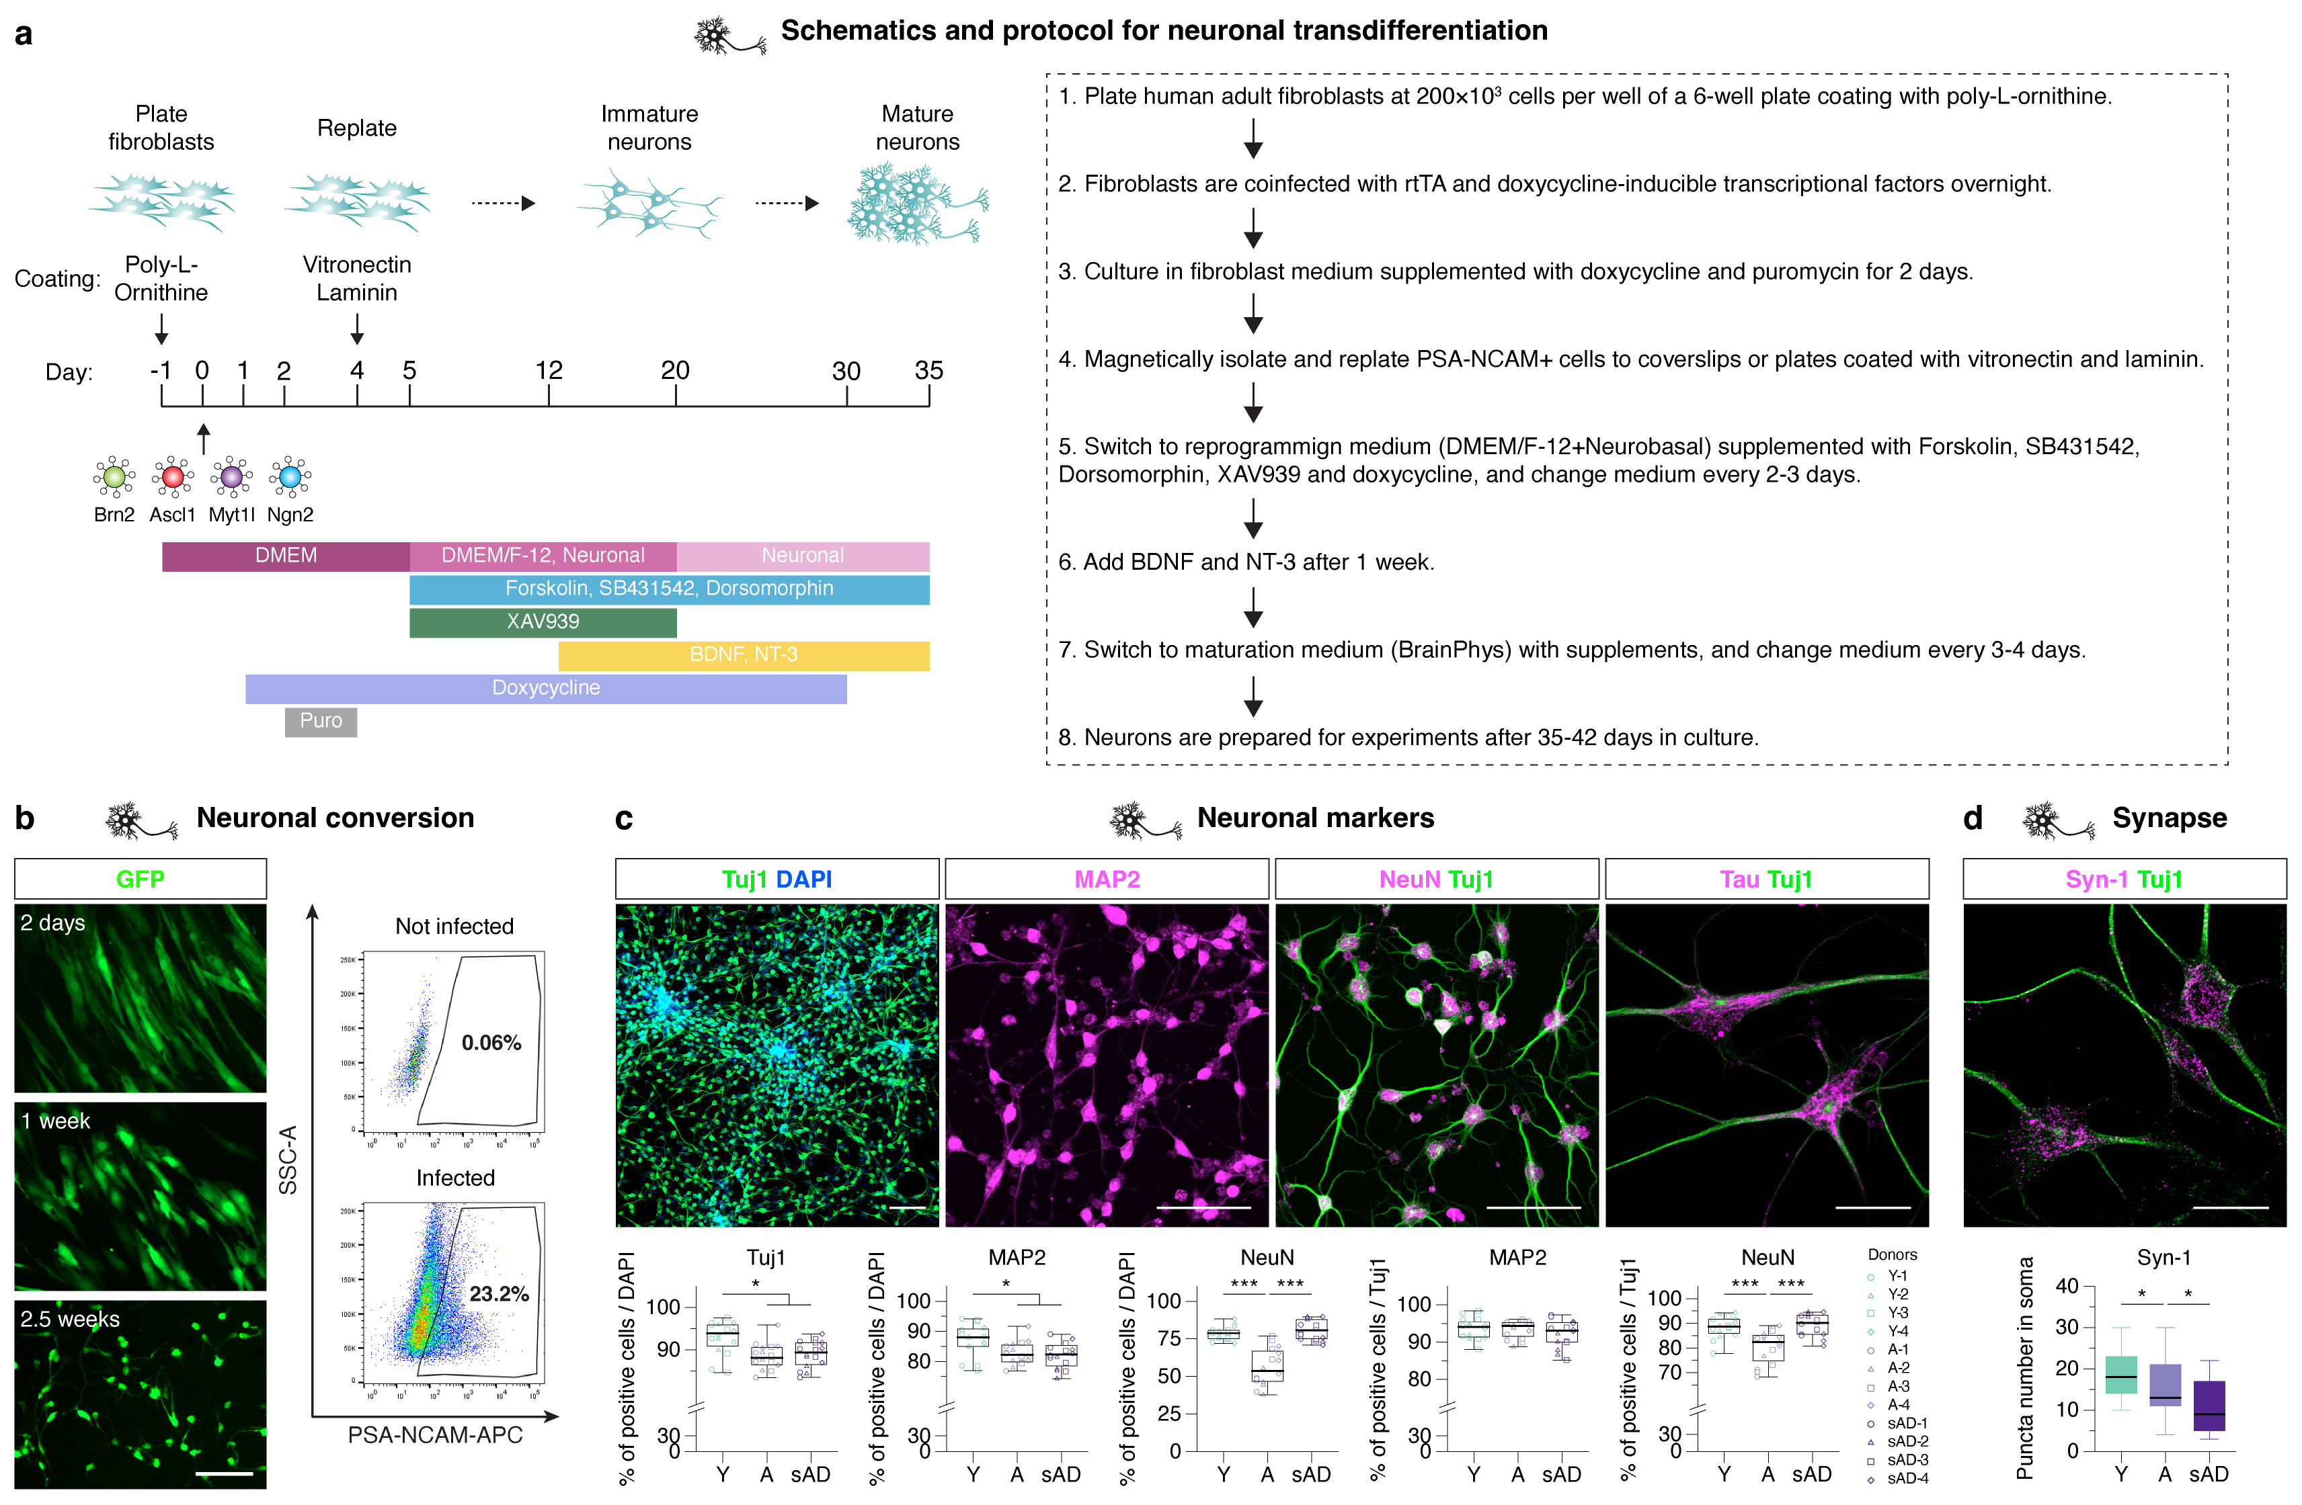

Extended Data Fig.2 Cortical neurons are generated directly from human adult fibroblasts using a combinatorial transcription-factor and small-molecule protocol.
(a) Transdifferentiation scheme using transcription factors Brn2, Ascl1, Myt1l, and Ngn2 (herein BAMN factors) that induces a global transcriptional change in fibroblasts to constitute a new neuronal cell state. Fibroblasts are plated one day before transdifferentiation. On Day 0, cells are infected with lentiviruses expressing BAMN factors and harvested four days after doxycycline-induction. Transduced cells expressing PSA-NCAM are magnetically isolated and replated to vitronectin/laminin-coated plates on Day 4 and switched to reprogramming medium (DMEM/F12/Neuronal) supplemented with small molecules 5 µM Forskolin, 10 µM SB 431542, 2 µM Dorsomorphin and 2 µM XAV939 on Day 5. BDNF and NT-3 are added into the reprogramming medium after one week. Cells are switched to maturation medium (Neuronal) on Day 20 and used for experiments after Day 35.
(b) Fibroblasts are infected with lentiviruses expressing BAMN factors and GFP and monitored for morphological changes after viral induction. Transduced cells undergo PSA-NCAM sorting by flow cytometry on Day 4. Scale bar: 200 μm.
(c-d) IF images of neuronal markers in tNeurons at PID 35. Quantification of the percentage of cells positive for both NeuN and Tuj1 (c) and the numbers of Syn-1 puncta in the soma (d). Scale bar: 100 μm (c); Scale bar: 20 μm (d).

Data show box-and-whisker plots of 2 to 4 independent experiments and cells from independent HC and AD patients. Box-and-whisker plots depict 5th, 25th, 50, 75th and 95th percentiles. Differences between groups are compared with One-Way ANOVA followed by Bonferroni post-hoc analysis. *P < 0.05 and ***P < 0.001.
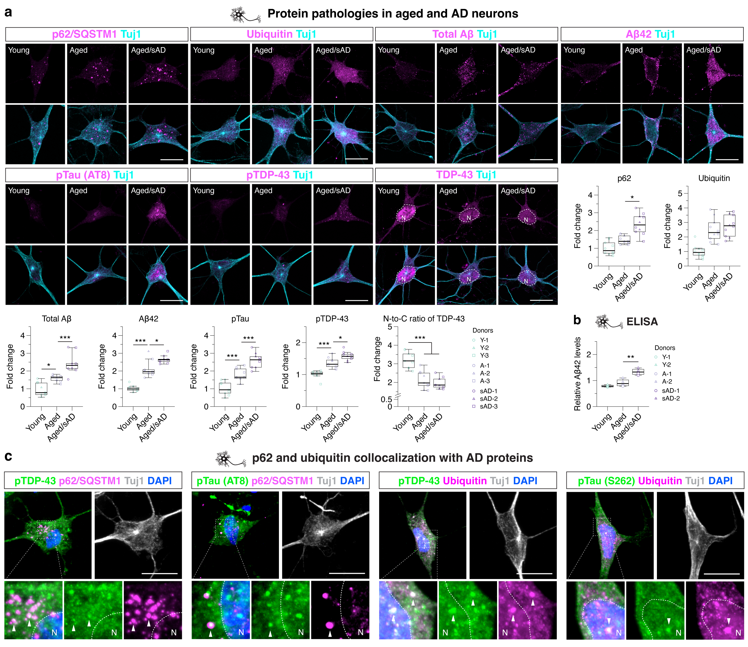

Extended Data Fig.3 Human tNeurons derived from sAD patients exhibit disease-related protein pathologies.
(a) IF images and quantification of proteostasis- and disease-associated protein markers, including autophagy adaptor p62/SQSTM1, ubiquitin, total Aβ, Aβ42, hyper-phosphorylated tau (pTau) and TDP-43 (pTDP-43) and nuclear-to-cytoplasmic (N-to-C) ratio of TDP-43 in tNeurons shown as full images for Fig. 1G. Cells are co-stained with Tuj1. White dash line represents the nuclear region (N). Scale bar: 20 μm.
(b) Sandwich ELISA assay for detecting endogenous Aβ42 in total cell lysates of tNeurons. The values are revealed by a fold change relative to young tNeurons.
(c) Immunostaining of pTau and pTDP-43 with p62/SQSTM1 and ubiquitin in aged/sAD tNeurons. Cells are co-stained with Tuj1 and DAPI. White dash line represents the nuclear region (N). Arrowhead: protein colocalization. Scale bar: 20 μm.

Data show box-and-whisker plots of 2 to 3 independent experiments and cells from independent HC and AD patients. Box-and-whisker plots depict 5th, 25th, 50, 75th and 95th percentiles. Differences between groups are compared with One-Way ANOVA followed by Bonferroni post-hoc analysis. *P < 0.05, **P < 0.01 and ***P < 0.001.
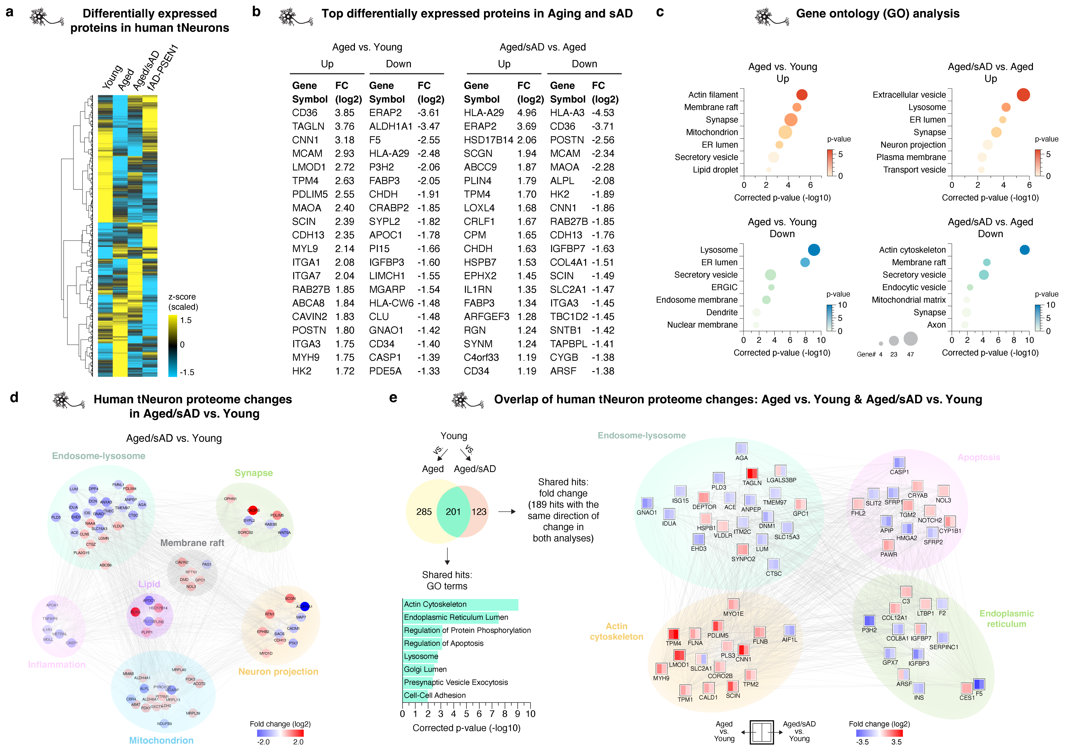

Extended Data Fig.4 Quantitative proteomic analysis of human tNeurons identifies proteins and pathways associated with aging and sAD.
(a) Heatmap of the differentially expressed proteins across tNeurons from young, aged, aged/sAD and fAD-PSEN1 donors.
(b) Top-ranked proteins (rows) changing with aging and sAD (columns) based on log-2 fold change (FC).
(c) GO analysis of the differentially expressed proteins between young, aged and aged/sAD tNeurons. Circle sizes reflect the number (#) of proteins.
(d) Network analysis of tNeuron proteomes, including proteins in the top-ranked pathways associated with young and sAD by GeneMANIA and GO. Comparison between healthy young (n = 3) and aged/sAD tNeurons (n = 6) at PID 40. Colored circles represent the enrichment of identified proteins revealing by log2-fold change: increase in red and decrease in blue.
(e) Venn diagram reveals an overlapping of differentially expressed proteins between tNeurons from aged and young donors, and between tNeurons from aged/sAD and young donors. The shared hits and assigned GO terms are showed in light green color. Interaction network for the shared hits that are either increased or decreased in aged and aged/sAD tNeurons as compared with young tNeurons. Each node representing an single protein that is divided to reflect the individual change for aged vs. young (left) and aged/sAD vs. young (right). Protein abundance increases are shown in red, and decreases shown in blue.

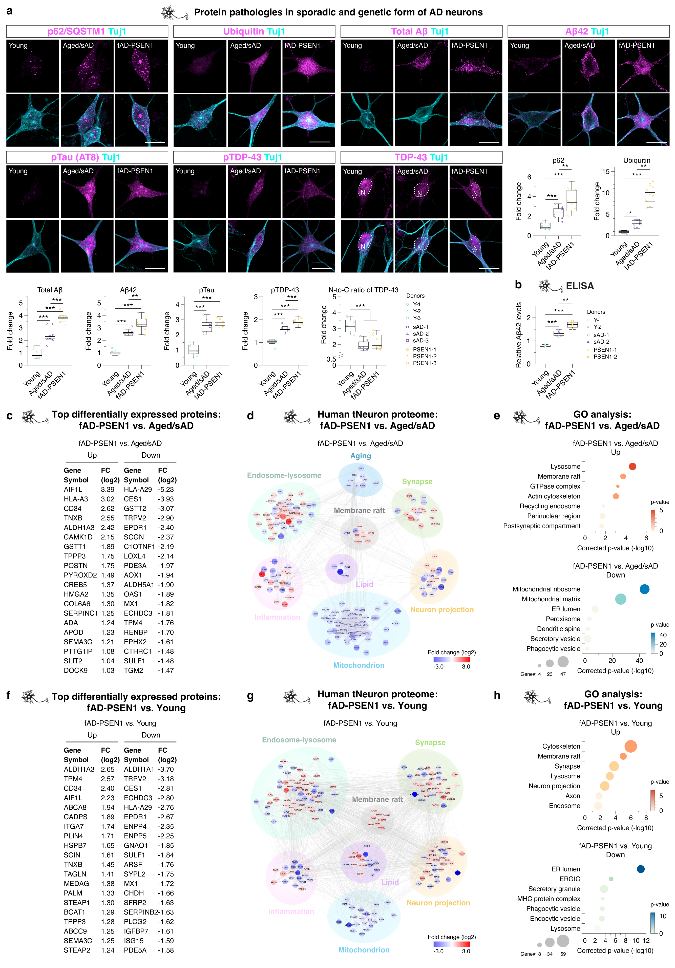
Extended Data Fig.5 Quantitative proteomic and molecular analysis of tNeurons identify signatures of pathogenic mutations in the PSEN1 gene in patient neurons.
(a) IF images and quantification of proteostasis- and disease-associated protein markers in tNeurons from healthy young donors as well as AD patients with aged/sAD and fAD-PSEN1. White dash line represents the nuclear region (N). Scale bar: 20 μm.
(b) Detection of endogenous Aβ42 in total cell lysates of tNeurons using sandwich ELISA assay. The values are revealed by a fold change relative to young tNeurons.
(c) Top-ranked proteins (rows) changing with aged/sAD and fAD-PSEN1 (columns) based on log-2 FC.
(d) Network analysis of tNeuron proteins in the top-ranked pathways associated with aged/sAD and fAD-PSEN1 by GeneMANIA and GO. Comparison between aged/sAD (n = 6) and fAD-PSEN1 (n = 2) at PID 40. Colored circles represent the enrichment of identified proteins revealing by log2-fold change: increase in red and decrease in blue.
(e) GO analysis of the differentially expressed proteins across aged/sAD and fAD-PSEN1 tNeurons. Circle sizes reflect the number (#) of proteins.
(f) Lists of top-ranked proteins (rows) changing with fAD-PSEN1 and young (columns) based on log-2 FC.
(g) Network analysis and differential expression of proteins detected in tNeurons from healthy young donors (n = 3) and patients with fAD-PSEN1 (n = 2) at PID 40. The top-ranked pathways for fAD-PSEN1 proteome are analyzed using GO databases. Colored circles represent the enrichment of identified proteins revealing by log2-fold change: increase in red and decrease in blue.
(h) GO analysis of the differentially expressed proteins across fAD-PSEN1 and young tNeurons. Circle sizes reflect the number (#) of proteins.

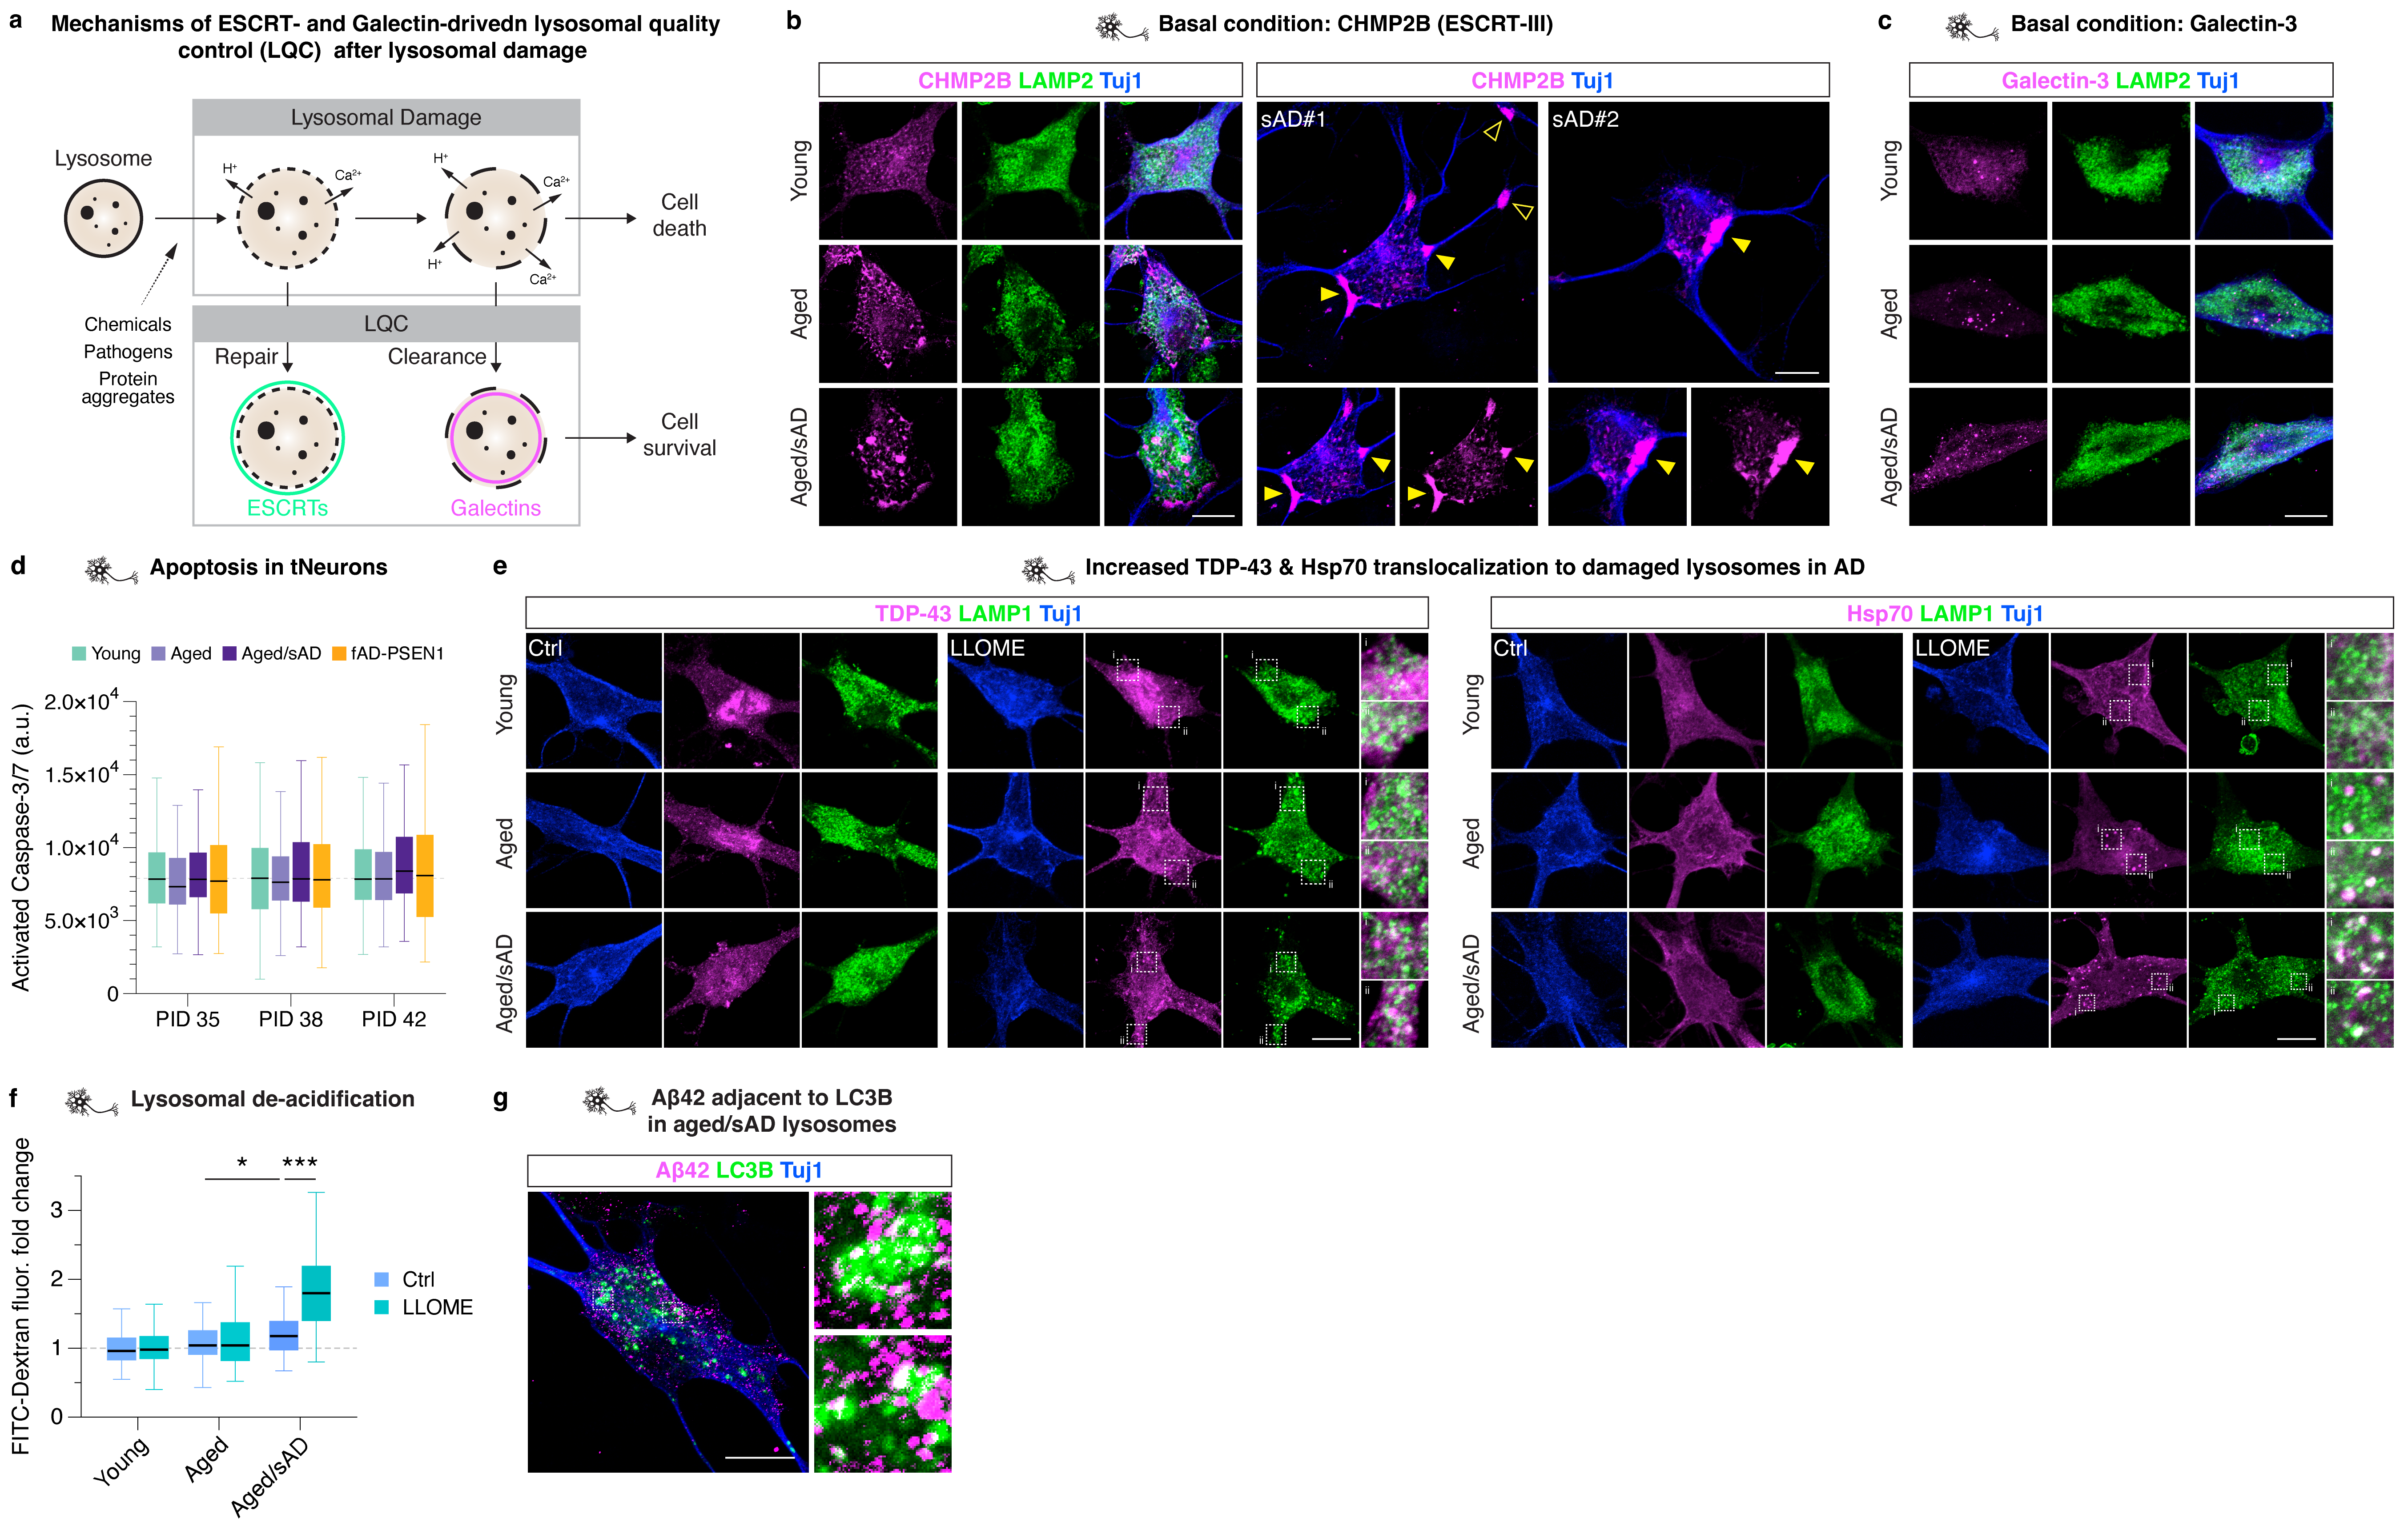

Extended Data Fig.6 Aberrant response to lysosomal damage at basal conditions and during LLOME treatment are prominent in aged/sAD tNeurons.
(a) Schematic for describing the ESCRT- and Galectin-mediated lysosomal quality control (LQC) machinery. When undergoing lysosomal damage stress, lysosomal membrane is subjected to rupture. To avoid the leakage of lysosomal contents and activation of cell death pathways, compromised lysosomes recruit ESCRT proteins (ESCRTs) to repair the small membrane wounds and Galectins to target the massively damaged lysosomes for lysophagy.
(b) Representative images for immunostaining of CHMP2B (magenta), LAMP2 (green) and Tuj1 (blue) in young, aged and aged/sAD tNeurons, related to Fig. 3C. Arrowhead: high-density accumulations of CHMP2B in the vicinity of plasma membrane and within neurites. Scale bar: 10 μm.
(c) Representative images for immunostaining of Galectin-3 (magenta), LAMP2 (green) and Tuj1 (blue) in young, aged and aged/sAD tNeurons, related to Fig. 3C. Scale bar: 10 μm.
(d) Measurement of spontaneous cell death, indicated by apoptosis markers (e.g. active Caspase-3/7), in young, aged, aged/sAD and fAD-PSEN1 tNeurons during in vitro culture at PID 35, 38 and 42.
(e) Immunostaining of TDP-43 and Hsp70 (magenta), LAMP1 (green) and Tuj1 (blue) during DMSO Ctrl or 0.25 mM LLOME treatment for 30 min in young, aged, aged/sAD tNeurons at PID 35. Scale bar: 10 μm.
(f) Changes in lysosomal acidification by detecting the intensity of preloaded pH-sensitive FITC-conjugated Dextran in tNeurons at basal conditions and during 0.25 mM LLOME treatment for 30 min.
(g) IF analysis of colocalization of Aβ42 with LC3B in aged/sAD tNeurons. Insert: higher magnification view of Aβ42, LAMP1 and LC3B. Scale bar: 10 μm.

Data show box-and-whisker plots of 3 independent experiments and 3 cell lines from independent HC and AD donors. Differences between groups are compared with Two-Way ANOVA followed by Bonferroni post-hoc analysis.

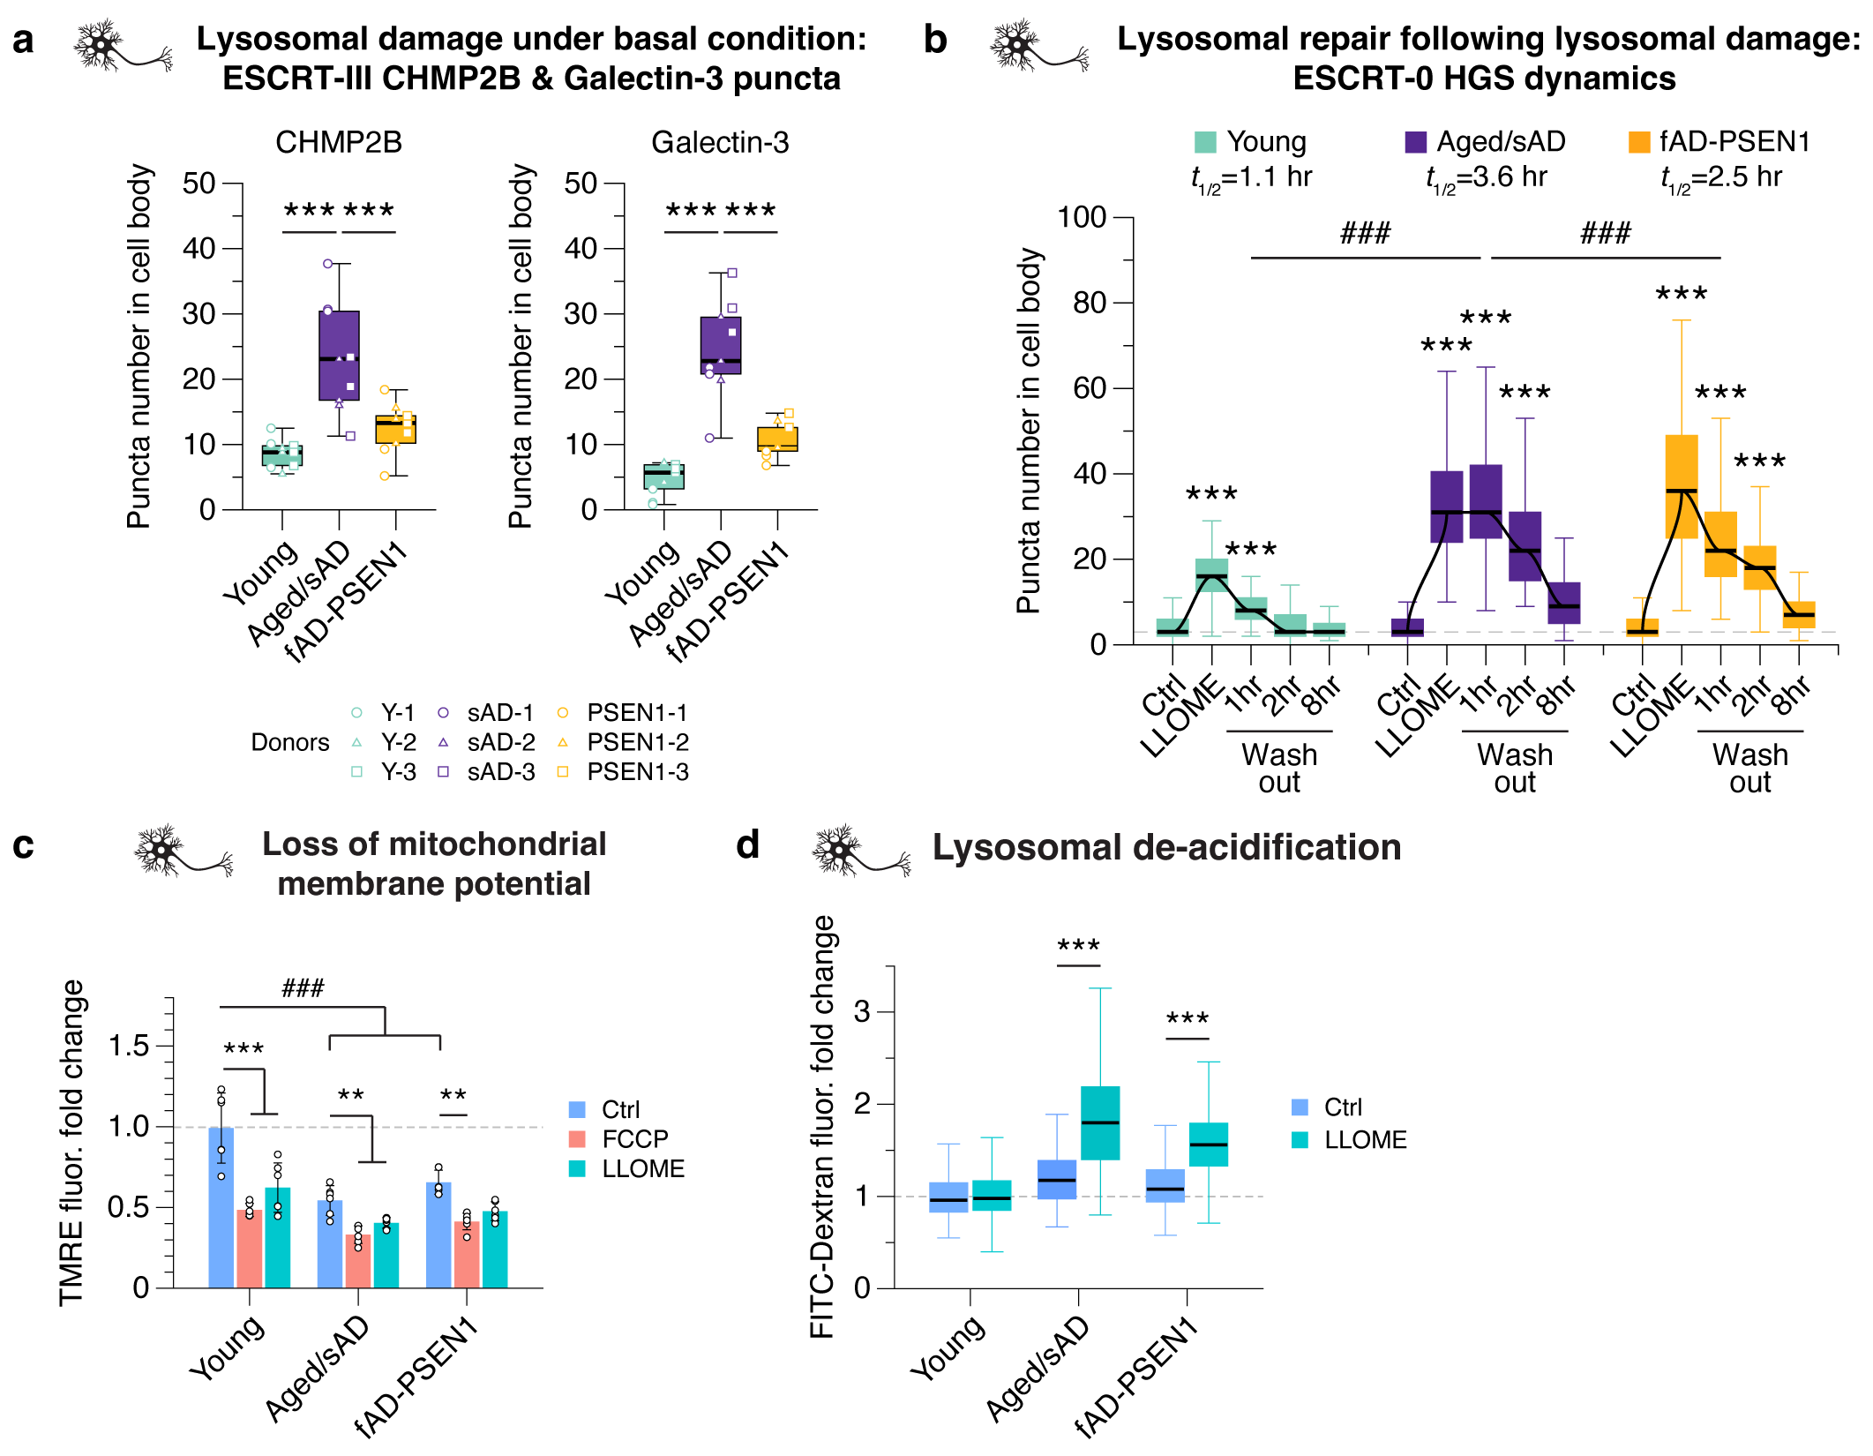

Extended Data Fig.7 Abnormal lysosomal damage response emerges in fAD-PSEN1 tNeurons, linking to defective organelle homeostasis in AD patient neurons.
(a) Quantification of numbers of ESCRT-III CHMP2B and Galectin-3 puncta in the cell body of young, aged/sAD and fAD-PSEN1 tNeurons in the absence of lysosomal damage insults.
(b) Quantification of numbers of ESCRT-0 HGS puncta in the cell body of young, aged/sAD and fAD-PSEN1 tNeurons during lysosomal damage insults mediated by LLOME treatment, and recovery from lysosomal damage after LLOME washout for up to 8 hr. The half-life (t_{1/2}) represents the time required for lysosomal repair.
(c) Quantification of changes in mitochondrial membrane potential in young, aged/sAD and fAD-PSEN1 tNeurons at basal conditions and after the treatment of DMSO Ctrl, 20 µM FCCP or 0.25 mM LLOME for 30 min by analyzing TMRE intensity. The values are revealed by a fold change relative to young tNeurons treated with DMSO.
(d) Changes in lysosomal acidification revealed by the intensity of preloaded pH-sensitive FITC-conjugated Dextran in young, aged/sAD and fAD-PSEN1 tNeurons at basal conditions or during 0.25 mM LLOME treatment for 30 min.

Data show mean and SD or box-and-whisker plots. Differences between groups are compared with One-Way or Two-Way ANOVA followed by Bonferroni post-hoc analysis. **P < 0.01 and ***P < 0.001. ###P < 0.001.

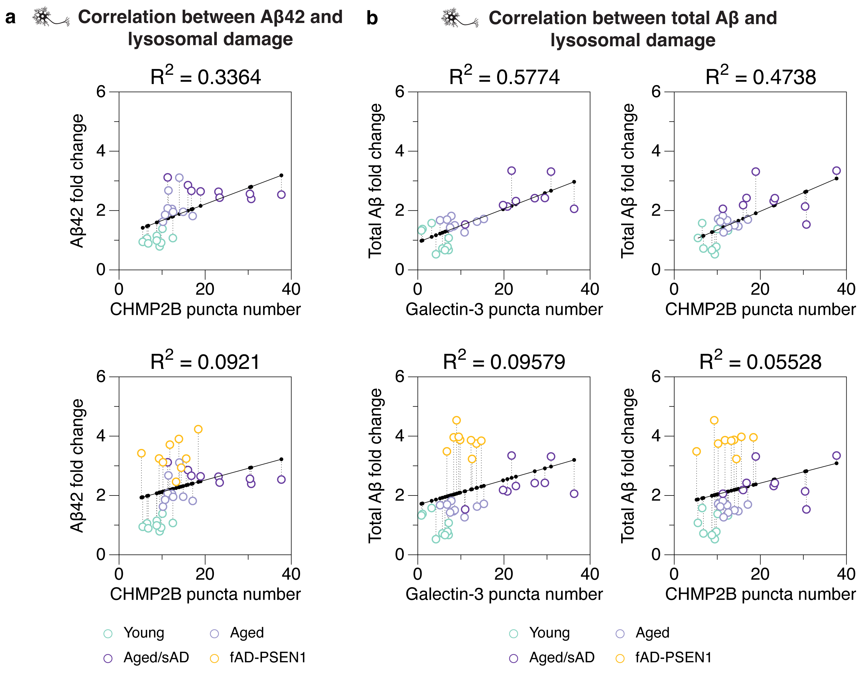

Extended Data Fig.8 Lysosomal damage positively correlates with aging and intrinsic disease properties in AD patient neurons.
(a) Analysis of correlation between intra-cellular Aβ42 level and CHMP2B puncta number in young, aged, aged/sAD and fAD-PSEN1 tNeurons.
(b) Analysis of correlation between intra-cellular total Aβ level and Galectin-3 or CHMP2B puncta number in young, aged, aged/sAD and fAD-PSEN1 tNeurons.
Black solid line represents the fitted linear correlation. Coefficient of Discrimination (R²) is calculated using Pearson’s correlation.

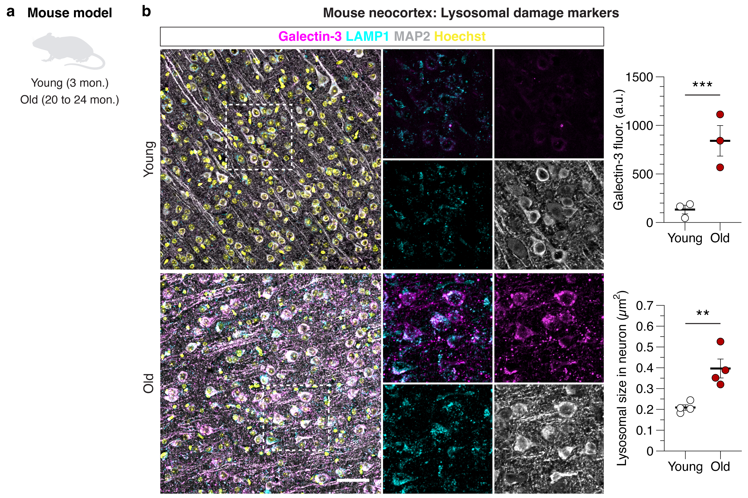

Extended Data Fig.9 Lysosomal damage markers are elevated in the cortex of old mice.
(a) Experimental schematic for wild-type young mice (3-month old) and old mice (20-24-month old).
(b) Representative images and IF quantification of Galectin-3 immunoreactivity and lysosomal size based on LAMP1 signals in neurons of wild-type young and old mice. Scale bar: 50 μm.

Data show mean and SD plots of independent experiments in mice (Galectin-3: n = 3; Lysosomal size: n = 4).

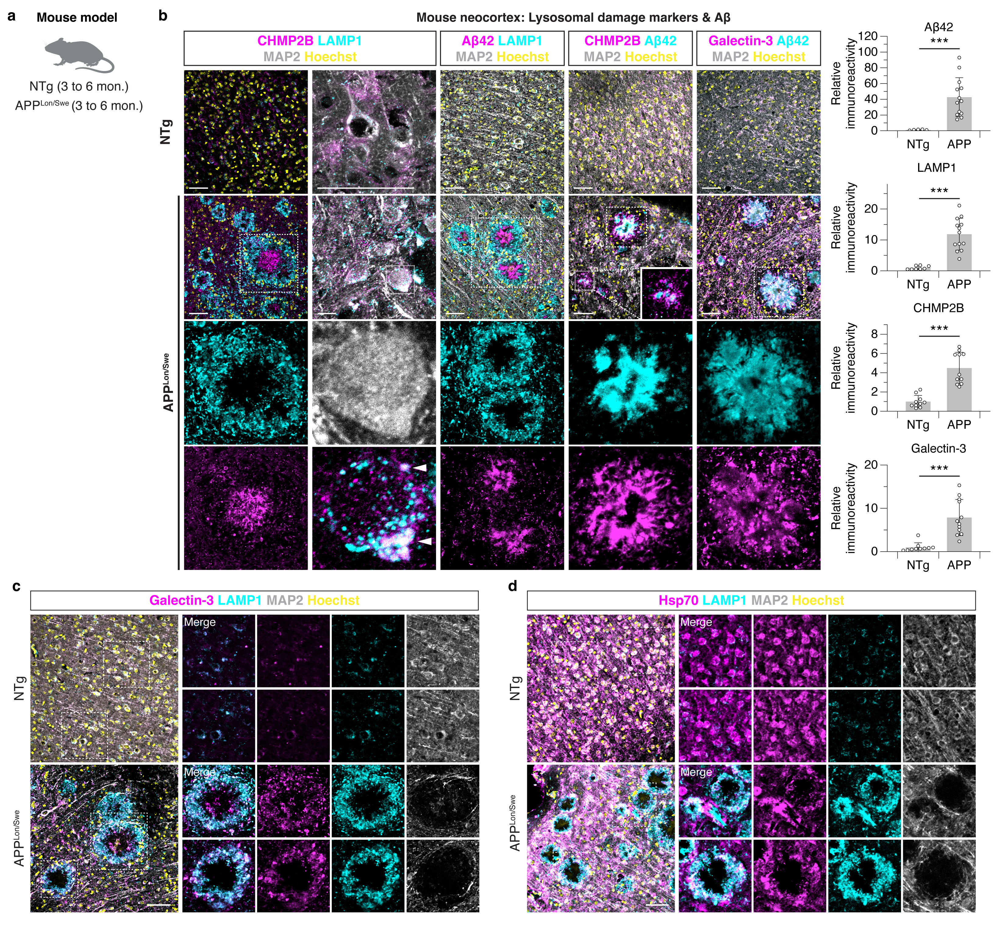

Extended Data Fig.10 Lysosomal damage markers are associated with neuropathological signatures of AD in the cortex of APP-transgenic mice.
(a) Experimental schematic for non-transgenic wild-type mice (NTg) and transgenic mice expressing mutant human APP with the Swedish (K670N/M671L) and London (V717I) mutations (APP^{Lon/Swe}) (3-6-month old).
(b) IF staining and quantification of Aβ42, LAMP1, CHMP2B and Galectin-3 in the neocortex of NTg and APP^{Lon/Swe} transgenic mice, related to Fig. 4B. Extra-cellular and intra-neuronal colocalization of CHPM2B with LAMP1 in the brain of APP^{Lon/Swe} mice. The brain tissue is co-stained with MAP2 and Hoechst. Insert: higher magnification view of colocalization between CHMP2B, Galectin-3, LAMP1 and Aβ42. Scale bar: 50 μm.
(c) Immunostaining of Galectin-3 (magenta), LAMP1 (cyan) and MAP2 (grey) counterstained with Hoechst (yellow) in the cortex of NTg and APP^{Lon/Swe} mice. Inset: higher magnification view of LAMP1-positive inclusions. Scale bar: 50 μm.
(d) Immunostaining of Hsp70 (magenta), LAMP1 (cyan) and MAP2 (grey) counterstained with Hoechst (yellow) in the cortex of NTg and APP^{Lon/Swe} mice. Inset: higher magnification view of LAMP1-positive inclusions. Scale bar: 50 μm.

Data show mean and SD plots of 3 independent experiments in mice (NTg: n = 8 to 10; APP^{Lon/Swe}: n = 10 to 13). Differences between groups are compared with unpaired t test. ***P < 0.001.

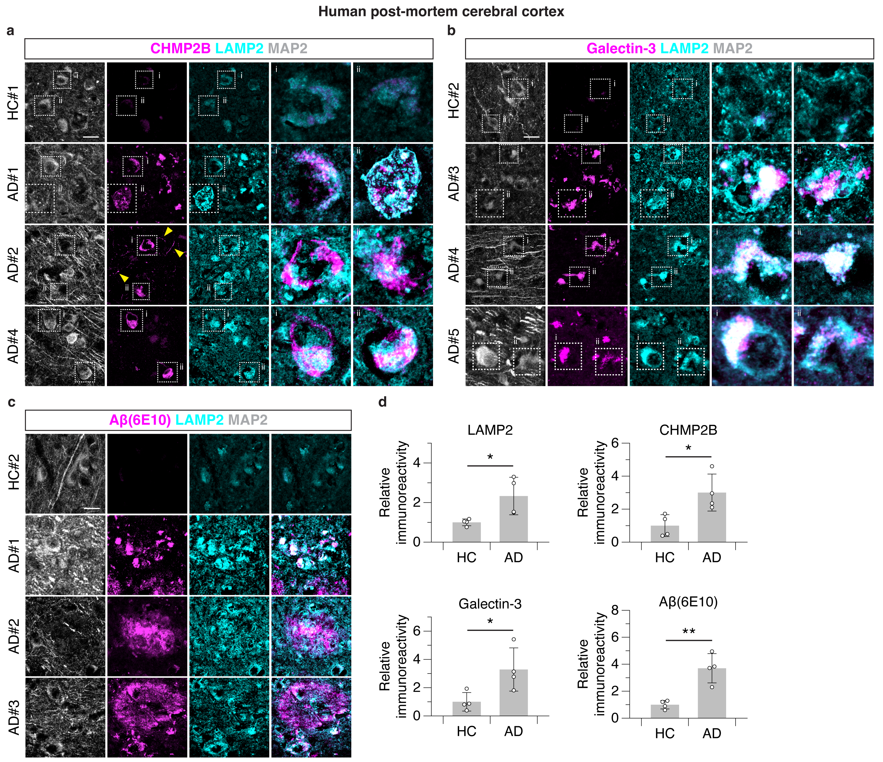

Extended Data Fig.11 Lysosomal damage phenotypes are prominent in brain tissue of AD patients.
(a-c) Immunostaining of LAMP2 (cyan) and MAP2 (grey) along with CHMP2B (a), Galectin-3 (b) or Aβ(6E10) (c) (magenta), in the post-mortem cerebral cortex of HC and AD donors, related to Fig.4c. #: indicates images acquired from different individuals. Scale bar: 20 μm.
(d) IF quantification of LAMP2, CHMP2B, Galectin-3 and Aβ(6E10) in the post-mortem cerebral cortex of HC and AD donors.

Data show mean and SD plots (HC: n = 4; AD: n = 4). Differences between groups are compared with unpaired t test. *P < 0.05, **P < 0.01.

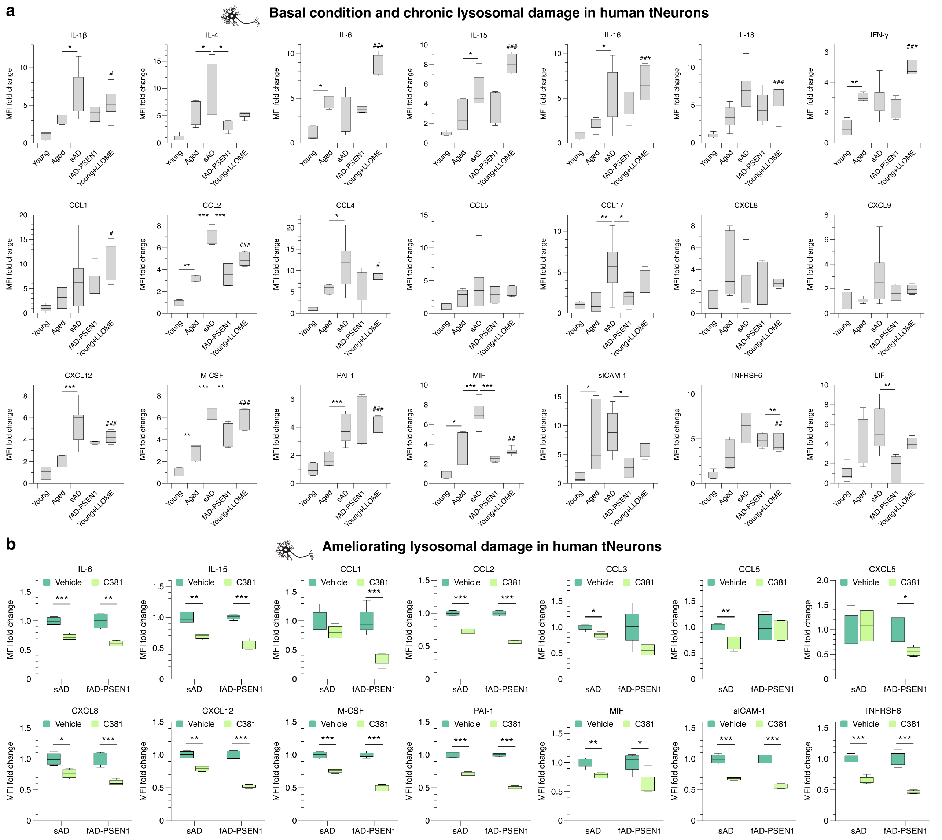

Extended Data Fig.12 Secretion of inflammatory factors from human tNeuron is linked to AD phenotypes and can be reduced by ameliorating lysosomal deficits.
(a) Plots with statistical analysis of changes in inflammatory factor levels in the conditioned medium from young, aged, aged/sAD and fAD-PSEN1 tNeurons at basal conditions and young tNeurons with the treatment with 0.1 mM LLOME for 7 days, related to Fig.5d,e.
(b) Plots with statistical analysis of changes in inflammatory factor levels in the conditioned medium from aged/sAD and fAD-PSEN1 tNeurons with the treatment of DMSO (vehicle) or 3.1 µM C381 for 7 days as shown in Fig.5g.

Data show box-and-whisker plots of inflammatory profiling conducted in technical replicates and 2 to 6 cell lines in tNeurons. Box-and-whisker plots depict 5th, 25th, 50, 75th and 95th percentiles. Differences between groups are compared with unpaired t test or One-Way ANOVA followed by Bonferroni post-hoc analysis. *P < 0.05, **P < 0.01 and ***P < 0.001. In panel (a), #P < 0.05, ##P < 0.01 and ###P < 0.001 as compared between young tNeurons with and without LLOME treatment.
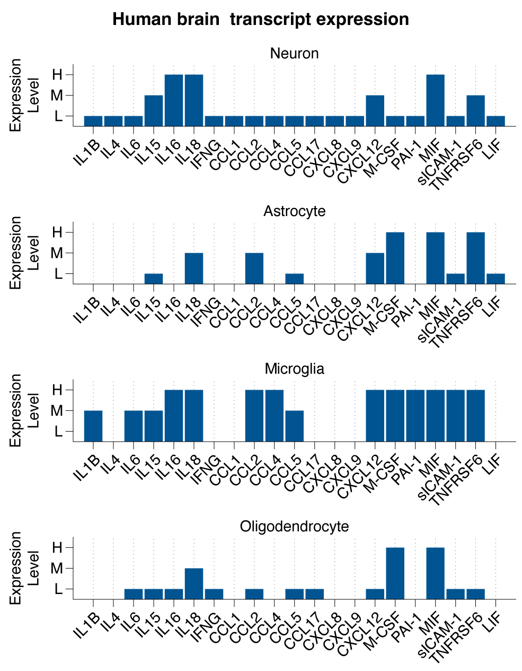

Extended Data Fig.13 Secreted inflammatory factors by human tNeurons are detected in human brain cells.
Single-cell transcriptomic analysis of selected cytokines and chemokines from Fig.5d,e in major cell types of human brain, including neuron, astrocyte, microglia and oligodendrocyte. The transcript expression scores (H: high; M: medium; L: low) is determined by the expression level of each transcript in public datasets retrieved from the Human Cell Atlas and Allen Brain Map.

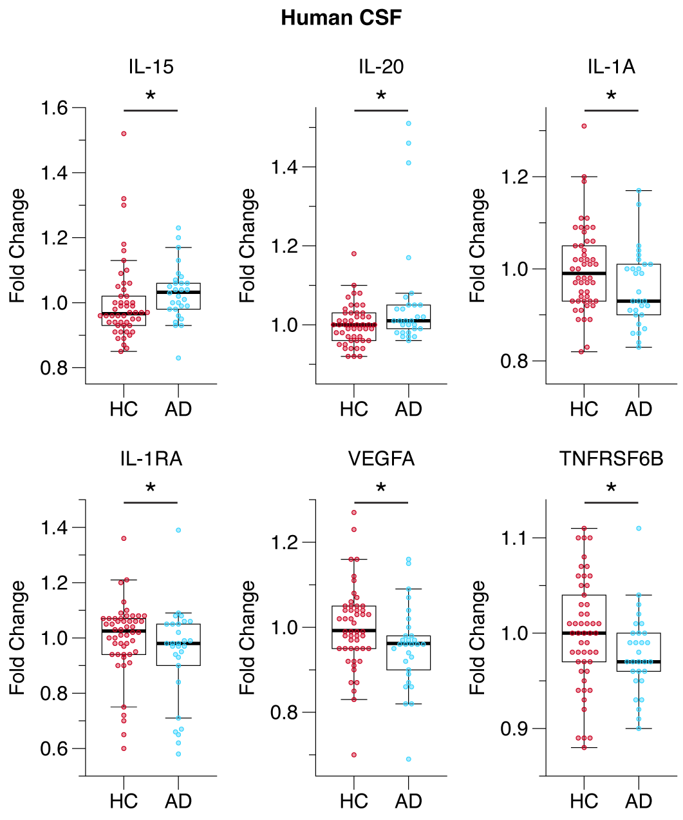

Extended Data Fig.14 Secreted inflammatory factors are elevated in CSF samples from AD patients.
Quantification of changes in the levels of inflammatory panel biomarkers measured in human CSF from HC and AD donors using the SOMAScan assay platform.

Data show box-and-whisker plots of inflammatory profiling conducted in human CSF (HC: n = 50; AD: n = 29). Box-and-whisker plots depict 5th, 25th, 50, 75th and 95th percentiles. Differences between groups are compared with unpaired t test. *P < 0.05.

Extended Data Table 1. List of human adult fibroblasts, tNeurons and post-mortem brain tissue used in this study and the sample information.
Sample ID | Diagnosis | Age, years | Sex | Source | Biospecimen samples | Passage at reprogramming | Derivatives
AG04062 | HC | 31 | M | Coriell | Fibroblast | P4 | tNeuron
AG09599 | HC | 30 | F | Coriell | Fibroblast | P4 | tNeuron
AG11732 | HC | 24 | F | Coriell | Fibroblast | P3 | tNeuron
AG11735 | HC | 25 | F | Coriell | Fibroblast | P8 | tNeuron
AG11747 | HC | 22 | M | Coriell | Fibroblast | P4 | tNeuron
CH01842 | HC | 31 | M | CHDI | Fibroblast | P7 | tNeuron
GM03651 | HC | 25 | F | Coriell | Fibroblast
AG06234 | HC | 17 | M | Coriell | Fibroblast
AG05095 | HC | 69 | M | Coriell | Fibroblast | P3 | tNeuron
AG11363 | HC | 74 | F | Coriell | Fibroblast | P4 | tNeuron
PIDN0749 | HC | 71 | F | ADRC | Fibroblast
PIDN0781 | HC | 68 | F | ADRC | Fibroblast
PIDN0144 | HC | 77 | F | ADRC | Fibroblast | P5 | tNeuron
PIDN0450 | HC | 79 | F | ADRC | Fibroblast | P4 | tNeuron
PIDN0477 | HC | 62 | M | ADRC | Fibroblast
PIDN0648 | HC | 72 | F | ADRC | Fibroblast | P3 | tNeuron
PIDN0717 | HC | 75 | M | ADRC | Fibroblast | P3 | tNeuron
PIDN0600 | HC | 64 | F | ADRC | Fibroblast
AG08379 | HC | 60 | F | Coriell | Fibroblast | P7 | tNeuron
AG04455 | HC | 72 | M | Coriell | Fibroblast | P8 | tNeuron
AG10788 | AD | 87 | F | Coriell | Fibroblast | P5 | tNeuron
AG11368 | AD | 77 | M | Coriell | Fibroblast
AG08243 | AD | 72 | M | Coriell | Fibroblast
AG06263 | AD | 67 | F | Coriell | Fibroblast | P12 | tNeuron
AG06869 | AD | 60 | F | Coriell | Fibroblast | P9 | tNeuron
AG07375 | AD | 71 | M | Coriell | Fibroblast | P10 | tNeuron
AG07376 | AD | 60 | M | Coriell | Fibroblast | P11 | tNeuron
PIDN0254 | AD | 70 | M | ADRC | Fibroblast | P3 | tNeuron
PIDN0340 | AD | 69 | F | ADRC | Fibroblast | P3 | tNeuron
PIDN0818 | AD | 76 | F | ADRC | Fibroblast
PIDN0932 | AD | 58 | F | ADRC | Fibroblast | P4 | tNeuron
PIDN1001 | AD | 71 | F | ADRC | Fibroblast
PIDN1034 | AD | 60 | F | ADRC | Fibroblast | P4 | tNeuron
PIDN0942 | AD | 61 | M | ADRC | Fibroblast
PIDN0953 | AD | 83 | M | ADRC | Fibroblast
PIDN1092 | AD | 84 | F | ADRC | Fibroblast | P3 | tNeuron
PIDN0690 | AD PSEN1 mutation (F386L) | 47 | F | ADRC | Fibroblast | P5 | tNeuron
PIDN0906 | AD PSEN1 mutation (A431E) | 46 | M | ADRC | Fibroblast | P5 | tNeuron
AG07768 | AD PSEN1 mutation (A246E) | 31 | F | Coriell | Fibroblast | P6 | tNeuron
AG08170 | AD PSEN1 mutation (A246E) | 56 | M | Coriell | Fibroblast | P11 | tNeuron
AG06848 | AD PSEN1 mutation (A246E) | 56 | F | Coriell | Fibroblast
15-34479 | HC | 78 | M | ADRC | Post-mortem cerebral cortex
15-34621 | HC | 69 | M | ADRC | Post-mortem cerebral cortex
15-34549 | HC | 68 | F | ADRC | Post-mortem cerebral cortex
15-34605 | HC | 80 | M | ADRC | Post-mortem cerebral cortex
15-34642 | HC | 49 | F | ADRC | Post-mortem cerebral cortex
15-35095 | HC | 41 | M | ADRC | Post-mortem cerebral cortex
15-34291 | HC | 63 | M | ADRC | Post-mortem cerebral cortex
15-34992 | HC | 68 | M | ADRC | Post-mortem cerebral cortex
15-34583 | AD | 89 | M | ADRC | Post-mortem cerebral cortex
15-34644 | AD | 80 | F | ADRC | Post-mortem cerebral cortex
15-34674 | AD | 79 | F | ADRC | Post-mortem cerebral cortex
16-34858 | AD | 93 | F | ADRC | Post-mortem cerebral cortex
17-34912 | AD | 89 | M | ADRC | Post-mortem cerebral cortex
17-34933 | AD | 80 | M | ADRC | Post-mortem cerebral cortex
17-34995 | AD | 65 | F | ADRC | Post-mortem cerebral cortex
17-35036 | AD | 92 | M | ADRC | Post-mortem cerebral cortex
17-35038 | AD | 88 | M | ADRC | Post-mortem cerebral cortex
18-35127 | AD | 76 | M | ADRC | Post-mortem cerebral cortex
Note: HC: Healthy control; AD: Alzheimer’s disease

Extended Data Table 2. Comparative analysis between this study and published AD genetics, transcriptomics and proteomics datasets.
Comparison between AD GWAS data (Grubman et al., 2019; Sims et al., 2020; Schwartzentruber et al., 2021; Wightman et al., 2021) and TMT-based aged/sAD tNeuron proteomics data
Overlapped Genes | Biological Function
ABCA8 | Lipid and cholesterol transport
CLU | Chaperone, lipid metabolism, apoptosis and immune response
HMCN1 | Cell cycle, cell-cell adhesion and stimulus response
HMGA2 | Cell cycle, DNA repair and transcription regulator
PLCG2 | Lipid metabolism, immune response and calcium signaling
GO Terms for AD GWAS data | P-value | GO Terms AD GWAS data | P-value
amyloid precursor protein catabolic process (GO:0042987) | 3.31E-08 | regulation of cell migration (GO:0030334) | 1.41E-06
regulation of amyloid fibril formation (GO:1905906) | 4.94E-08 | positive regulation of MAPK cascade (GO:0043410) | 4.57E-06
Notch receptor processing, ligand-dependent (GO:0035333) | 8.62E-08 | macrophage activation (GO:0042116) | 5.49E-06
positive regulation of supramolecular fiber organization (GO:1902905) | 2.89E-07 | regulation of gene expression (GO:0010468) | 8.42E-06
membrane protein intracellular domain proteolysis (GO:0031293) | 4.16E-07 | positive regulation of nucleic acid-templated transcription (GO:1903508) | 1.85E-05
microglial cell activation (GO:0001774) | 4.16E-07 | positive regulation of cholesterol efflux (GO:0010875) | 2.00E-05
regulation of ERK1 and ERK2 cascade (GO:0070372) | 1.17E-06 | negative regulation of receptor-mediated endocytosis (GO:0048261) | 3.31E-05
Comparison between AD PWAS data (Wingo et al., 2021) and TMT-based aged/sAD tNeuron proteomics data
Overlapped Genes | Biological Function
EPHX2 | Lipid metabolism, epoxide metabolic process and dephosphorylation
SNX32 | Endosome-to-Golgi transport and regulation of autophagy
Comparison between AD brain snRNA-seq data (differentially expressed between AD and HC neurons in the entorhinal cortex, Grubman et al., 2019) and TMT-based aged/sAD tNeuron proteomics data
Overlapped Genes
ABCA8, APOD, BCAR1, CADPS, CDC42EP1, CDH13, CSRP1, CYP27A1, DPP7, FLNA, KIAA1217, MYL6, NDRG1, PAM, PBXIP1, PDE10A, PDE3A, PPM1L, PREX1, PRNP, RTN1, SDC4, SLC38A2, SLC3A2, SLC7A5, ZCCHC3
GO Terms (Grubman et al., 2019) | P-value | GO Terms (Overlapped genes) | P-value
Nervous System Development (GO:0007399) | 5.08E-12 | Proline Transport (GO:0015824) | 1.09E-07
Central Nervous System Development (GO:0007417) | 2.05E-10 | L-amino Acid Transport (GO:0015807) | 4.97E-06
Chemical Synaptic Transmission (GO:0007268) | 2.17E-10 | Regulation of Amyloid-Beta Formation (GO:1902003) | 8.37E-04
Axon Development (GO:0061564) | 1.93E-09 | Regulation of Interleukin-17 Production (GO:0032660) | 8.89E-04
Anterograde Trans-Synaptic Signaling (GO:0098916) | 7.34E-09 | Platelet Aggregation (GO:0070527) | 9.42E-04
Modulation of Chemical Synaptic Transmission (GO:0050804) | 7.39E-09 | Response to Exogenous dsRNA (GO:0043330) | 9.42E-04
Axonogenesis (GO:0007409) | 2.39E-08 | Negative Regulation of T Cell Proliferation (GO:0042130) | 9.96E-04
Glial Cell Differentiation (GO:0010001) | 1.01E-07 | Muscle Tissue Development (GO:0060537) | 0.00105241
Myelination (GO:0042552) | 1.35E-07 | Positive Regulation of Exocytosis (GO:0045921) | 0.00105241
Neuron Projection Morphogenesis (GO:0048812) | 2.54E-07 | Amino Acid Transmembrane Transport (GO:0003333) | 0.00135513
Neuronal Ion Channel Clustering (GO:0045161) | 6.10E-07 | Homotypic Cell-Cell Adhesion (GO:0034109) | 0.0016238
Regulation of Synaptic Transmission, Glutamatergic (GO:0051966) | 8.57E-07 | Actin Cytoskeleton Reorganization (GO:0031532) | 0.00214989
Regulation of mRNA Splicing, Via Spliceosome (GO:0048024) | 2.29E-06 | Regulation of Smooth Muscle Cell Proliferation (GO:0048660) | 0.0022308
Cell Morphogenesis Involved In Neuron Differentiation (GO:0048667) | 2.70E-06 | Response to Metal Ion (GO:0010038) | 0.0031178
Modulation of Excitatory Postsynaptic Potential (GO:0098815) | 3.06E-06 | Sphingolipid Biosynthetic Process (GO:0030148) | 0.00447851
Comparison between AD iN bulk RNA-seq data (differentially expressed between AD and HC iNs, Mertens et al., 2021) and TMT-based aged/sAD tNeuron proteomics data
Overlapped Genes
APOD, ARFGEF3, CADPS, CLGN, CYBRD1, CYP1B1, FADS3, FUCA2, HMGA2, HSD17B14, ICAM1, IL1RN, KIAA1217, LPXN, LRRN4CL, MEDAG, MOCOS, MYL12A, MYL9, NAMPT, P4HA3, PDE3A, PRNP, PTGIS, RND3, SERPINB9, SERPINE2, SLC2A1, SLC3A2, SNTB1, SRGAP3, TMEM119, TPM2
GO Terms (Mertens et al., 2021) | P-value | GO Terms (Overlapped genes) | P-value
extracellular matrix organization (GO:0030198) | 2.35E-06 | negative regulation of protein maturation (GO:1903318) | 1.44E-04
substrate-dependent cell migration (GO:0006929) | 7.81E-06 | NAD biosynthesis via nicotinamide riboside salvage pathway (GO:0034356) | 2.37E-04
regulation of angiogenesis (GO:0045765) | 4.57E-05 | negative regulation of protein processing (GO:0010955) | 2.74E-04
negative regulation of proteolysis (GO:0045861) | 2.19E-04 | positive regulation of vasculature development (GO:1904018) | 6.29E-04
mesodermal cell differentiation (GO:0048333) | 2.45E-04 | negative regulation of antigen receptor-mediated signaling pathway (GO:0050858) | 7.73E-04
hemopoiesis (GO:0030097) | 2.82E-04 | cellular response to amyloid-beta (GO:1904646) | 0.001518228
positive regulation of protein phosphorylation (GO:0001934) | 3.09E-04 | positive regulation of apoptotic process (GO:0043065) | 0.001625074
positive regulation of neuron death (GO:1901216) | 4.14E-04 | negative regulation of DNA-binding transcription factor activity (GO:0043433) | 0.001668812
cellular protein catabolic process (GO:0044257) | 4.86E-04 | endothelial cell migration (GO:0043542) | 0.001882991
transmembrane receptor protein tyrosine kinase signaling pathway (GO:0007169) | 5.78E-04 | supramolecular fiber organization (GO:0097435) | 0.00255294
positive regulation of Wnt signaling pathway, planar cell polarity pathway (GO:2000096) | 0.001073747 | unsaturated fatty acid metabolic process (GO:0033559) | 0.003580659
regulation of extracellular exosome assembly (GO:1903551) | 0.001073747 | regulation of endopeptidase activity (GO:0052548) | 0.006110262
ephrin receptor signaling pathway (GO:0048013) | 0.001275793 | negative regulation of cell adhesion (GO:0007162) | 0.006448618
regulation of interleukin-17 production (GO:0032660) | 0.001531257 | negative regulation of NF-kappaB transcription factor activity (GO:0032088) | 0.007513763
NAD biosynthesis via nicotinamide riboside salvage pathway (GO:0034356) | 0.001664215 | anion homeostasis (GO:0055081) | 0.008223548
Comparison between TMT-based AD brain proteomics data (differentially expressed between AD and HC dorsolateral prefrontal cortex, Johnson et al., 2022) and TMT-based aged/sAD tNeuron proteomics data
Overlapped Genes
ALPL, CLU, CPM, CSRP1, DCTPP1, DES, FHL1, ICAM1, IDH2, OLFML3, PADI2, PBXIP1, RAB27B, RENBP, SCGN, SCIN, SDC4, SERPINE2, SLC38A2, SLC4A7, SPON1, SYNM, TP53I11
GO Terms (Johnson et al., 2022) | P-value | GO Terms (Overlapped genes) | P-value
regulated exocytosis (GO:0045055) | 1.43E-10 | ion homeostasis (GO:0050801) | 5.40E-04
extracellular matrix organization (GO:0030198) | 5.67E-08 | positive regulation of exocytosis (GO:0045921) | 8.22E-04
regulation of neurotransmitter receptor activity (GO:0099601) | 6.52E-07 | regulated exocytosis (GO:0045055) | 0.001111992
neutrophil activation involved in immune response (GO:0002283) | 1.45E-05 | receptor-mediated virion attachment to host cell (GO:0046813) | 0.005737289
positive regulation of cell differentiation (GO:0045597) | 2.67E-05 | DNA protection (GO:0042262) | 0.005737289
regulation of superoxide anion generation (GO:0032928) | 3.06E-05 | positive regulation of tau-protein kinase activity (GO:1902949) | 0.006880968
regulation of long-term synaptic potentiation (GO:1900271) | 3.43E-05 | regulation of chromatin assembly or disassembly (GO:0001672) | 0.00802339
nervous system development (GO:0007399) | 5.93E-05 | protein localization to presynapse (GO:1905383) | 0.009164555
intermediate filament bundle assembly (GO:0045110) | 6.74E-05 | regulation of chemokine-mediated signaling pathway (GO:0070099) | 0.009164555
glycosaminoglycan catabolic process (GO:0006027) | 7.38E-05 | regulation of leukocyte mediated cytotoxicity (GO:0001910) | 0.010304464
transport across blood-brain barrier (GO:0150104) | 1.10E-04 | response to misfolded protein (GO:0051788) | 0.010304464
regulation of cation channel activity (GO:2001257) | 1.36E-04 | sequestering of actin monomers (GO:0042989) | 0.01144312
synaptic vesicle exocytosis (GO:0016079) | 1.43E-04 | central nervous system myelination (GO:0022010) | 0.012580523
microglial cell activation (GO:0001774) | 1.53E-04 | chromatin-mediated maintenance of transcription (GO:0048096) | 0.012580523
interferon-gamma-mediated signaling pathway (GO:0060333) | 2.19E-04 | regulation of amyloid fibril formation (GO:1905906) | 0.017117631
regulated exocytosis (GO:0045055) | 1.43E-10 | ion homeostasis (GO:0050801) | 5.40E-04
Comparison between label-free AD iPS cell-derived neuron proteomics data (differentially expressed between AD and HC iPS cell-derived neurons, Lagomarsino et al., 2021) and TMT-based aged/sAD tNeuron proteomics data
Overlapped Genes
None
GO Terms (Lagomarsino et al., 2021) | P-value
SRP-dependent cotranslational protein targeting to membrane (GO:0006614) | 9.58E-12
cytoplasmic translation (GO:0002181) | 1.21E-11
protein targeting to ER (GO:0045047) | 2.52E-11
rRNA metabolic process (GO:0016072) | 3.07E-08
cellular macromolecule biosynthetic process (GO:0034645) | 6.05E-08
ribosome biogenesis (GO:0042254) | 8.44E-08
ncRNA processing (GO:0034470) | 1.11E-07
regulation of amyloid precursor protein catabolic process (GO:1902991) | 9.04E-05
regulation of protein localization to plasma membrane (GO:1903076) | 0.004118894
regulation of cell cycle G2/M phase transition (GO:1902749) | 0.004636346
retrograde vesicle-mediated transport, Golgi to endoplasmic reticulum (GO:0006890) | 0.004636346
spliceosomal conformational changes to generate catalytic conformation (GO:0000393) | 0.005986139
Note: GWAS: Genome-wide association study; PWAS: Proteome-Wide Association Study; iN: directly induced neuron; HC: Healthy control; AD: Alzheimer’s disease

Extended Data Table 3. List of human cerebrospinal fluid (CSF) sample information.
Sample ID | Diagnosis | Age, years | Sex | Source | Sample ID | Diagnosis | Age, years | Sex | Source
0978 | HC | 71 | F | ADRC | 121351 | MCI-AD | 72 | M | Kerchner
1213 | HC | 79 | M | ADRC | 141214 | MCI-AD | 64 | F | Kerchner
0990 | HC | 75 | F | ADRC | 1034 | AD | 60 | F | ADRC
0615 | HC | 86 | M | ADRC | 1251 | AD | 67 | M | ADRC
0781 | HC | 68 | F | ADRC | 1001 | AD | 70 | F | ADRC
1182 | HC | 76 | F | ADRC | 111188 | MCI-AD | 72 | F | Kerchner
1210 | HC | 65 | F | ADRC | 141171 | AD | 68 | F | Kerchner
0885 | HC | 72 | M | ADRC | 0773 | AD | 61 | F | ADRC
1175 | HC | 70 | M | ADRC | 1285 | AD | 64 | F | ADRC
1200 | HC | 63 | M | ADRC | 1237 | AD | 73 | M | ADRC
0619 | HC | 75 | M | ADRC | 121091 | MCI-AD | 75 | M | Kerchner
1180 | HC | 63 | F | ADRC | 141064 | MCI-AD | 68 | M | Kerchner
0989 | HC | 67 | F | ADRC | 141019 | MCI-AD | 72 | M | Kerchner
1207 | HC | 78 | M | ADRC | 1052 | AD | 71 | F | ADRC
0181 | HC | 67 | M | ADRC | 141168 | AD | 68 | M | Kerchner
1028 | HC | 65 | M | ADRC | 121235 | MCI-AD | 75 | M | Kerchner
1229 | HC | 69 | F | ADRC | 141124 | MCI-AD | 73 | M | Kerchner
0780 | HC | 70 | F | ADRC | 1205 | AD | 63 | F | ADRC
1174 | HC | 70 | F | ADRC | 141006 | MCI-AD | 76 | F | Kerchner
1118 | HC | 63 | F | ADRC | 1168 | AD | 81 | F | ADRC
0784 | HC | 71 | F | ADRC | 1236 | AD | 82 | F | ADRC
0994 | HC | 69 | M | ADRC | 0738 | AD | 74 | F | ADRC
1113 | HC | 73 | M | ADRC | 131134 | MCI-AD | 66 | M | Kerchner
1007 | HC | 62 | F | ADRC | 141002 | MCI-AD | 82 | M | Kerchner
0896 | HC | 81 | M | ADRC | 0942 | AD | 61 | M | ADRC
1206 | HC | 76 | F | ADRC | 121151 | MCI-AD | 64 | M | Kerchner
0915 | HC | 69 | F | ADRC | 1241 | AD | 76 | F | ADRC
0841 | HC | 72 | M | ADRC | 0340 | AD | 69 | F | ADRC
1255 | HC | 70 | M | ADRC | 131432 | MCI-AD | 73 | M | Kerchner
0871 | HC | 77 | F | ADRC
1248 | HC | 82 | M | ADRC
0846 | HC | 62 | F | ADRC
0739 | HC | 77 | M | ADRC
1189 | HC | 72 | F | ADRC
0732 | HC | 87 | M | ADRC
1279 | HC | 68 | F | ADRC
1273 | HC | 79 | M | ADRC
1132 | HC | 73 | F | ADRC
1167 | HC | 67 | F | ADRC
1209 | HC | 72 | M | ADRC
1010 | HC | 72 | F | ADRC
0891 | HC | 71 | F | ADRC
0970 | HC | 69 | M | ADRC
0669 | HC | 73 | F | ADRC
1145 | HC | 78 | M | ADRC
0631 | HC | 66 | M | ADRC
1015 | HC | 64 | M | ADRC
1148 | HC | 74 | M | ADRC
0849 | HC | 64 | M | ADRC
0869 | HC | 67 | M | ADRC
Note: HC: Healthy control; MCI: Mild cognitive impairment; AD: Alzheimer’s disease

Extended Data Table 4. TMT quantitative proteomics analysis of human tNeurons from young, aged and AD donors.

(1) Mass spectrometry data acquisition parameters
(2) Sample information of human tNeurons utilized for mass spectrometry analysis
(3) List of all protein quants of young, aged, aged/sAD and fAD-PSEN1 tNeurons

