Supplementary Figure

Figure S1: Venn diagram of significant gene expression from four datasets, including GSE12771, GSE13255, GSE20189 and GSE39345.
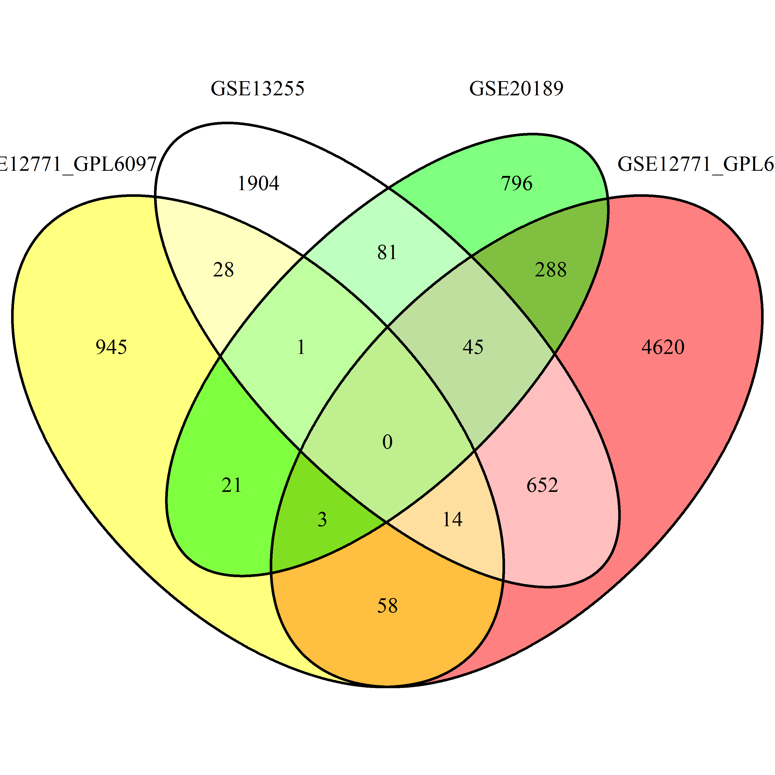
Figure S2 Overlapping significant up-regulation genes. More than 3 datasets (1807 genes) were retrieved for biological functions using the PANTHER (Protein ANalysis THrough Evolutionary Relationships) classification system (available at http://www.pantherdb.org)
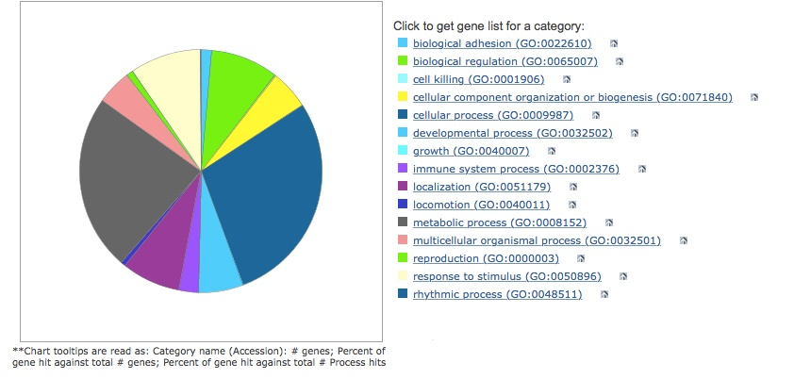
Figure S3 Five significant up-regulated genes which the presence of antibody-specific, immunohistochemistry-based protein expression of on tumor-infiltrating lymphocytes (TILs) in tumor specimen but not in normal lymphoid tissue in the Human Protein Atlas were selected (available at https://www.proteinatlas.org).

Proteins | Non-malignant lymph nodes | Lung cancer tissues
CLEC4A | 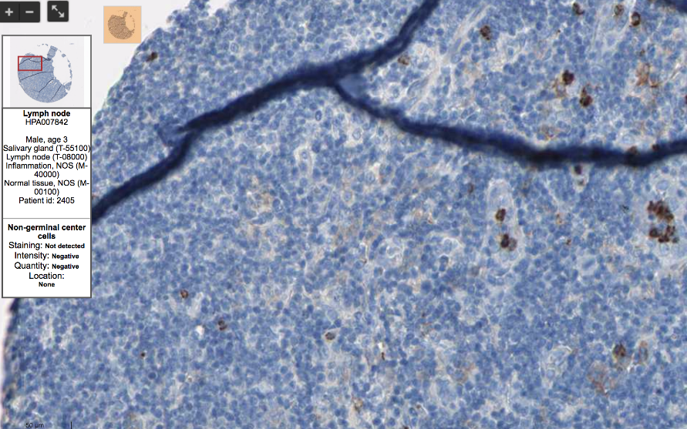 | 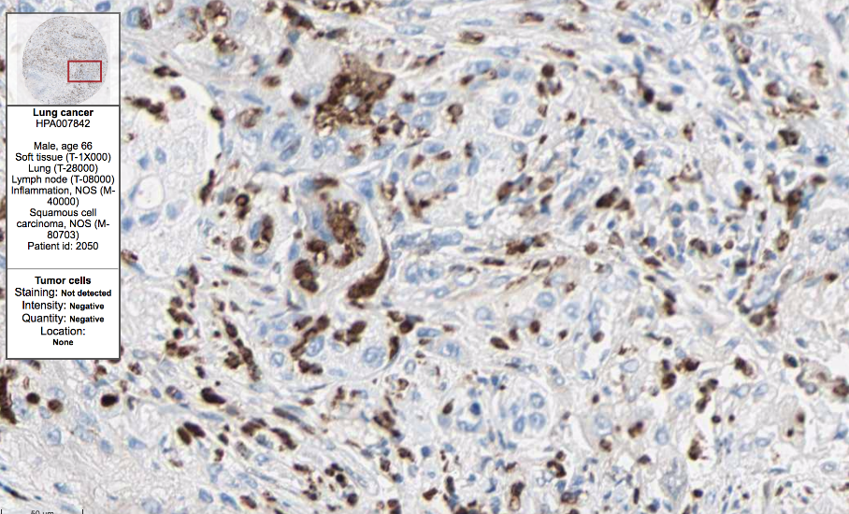
C5AR1 | 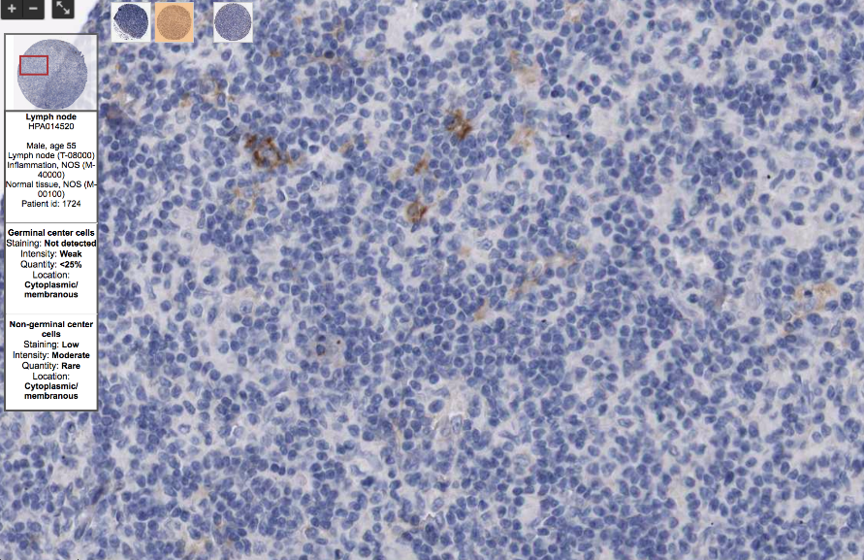 | 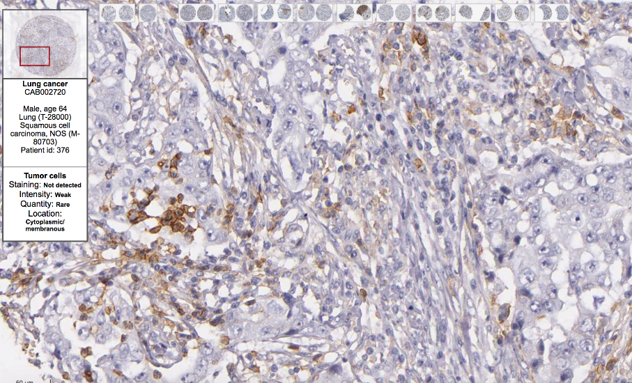
NLRP3 | 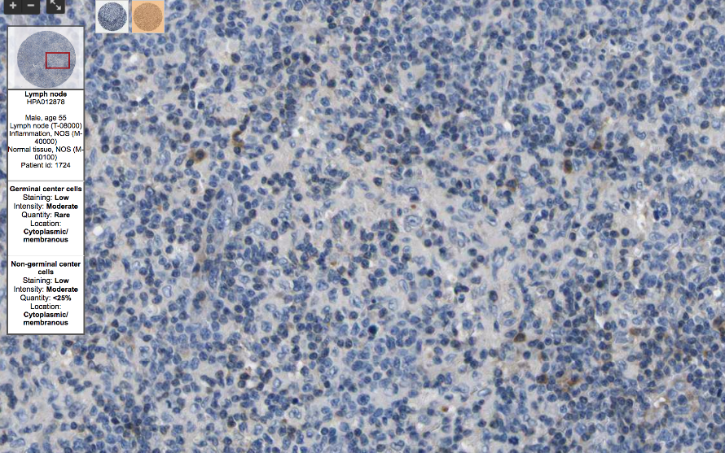 | 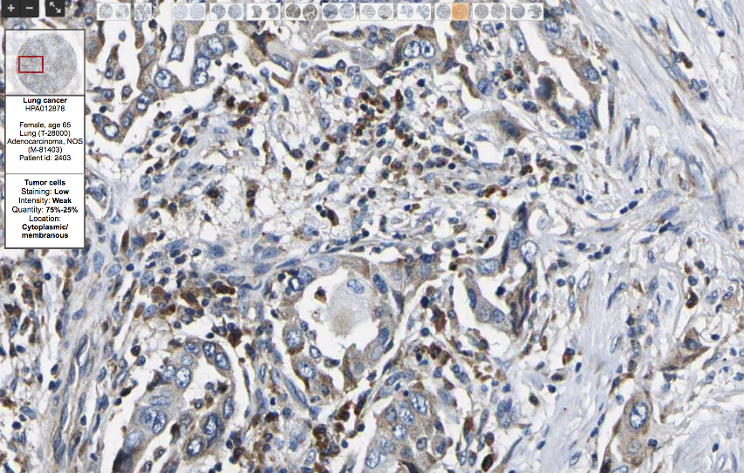
Source: The Human Protein Atlas (https://www.proteinatlas.org/)

Figure S4 Immunofluorescence staining of specific antibodies to CLEC4A, C5AR1 and NLRP3 in positive control with fluorescein isothiocyanate (FITC)-labeled antibody, appears as apple-green signals. Anti-CD45 antibody represents T-lymphocytes (red) while nuclei was counterstained with DAPI (blue)
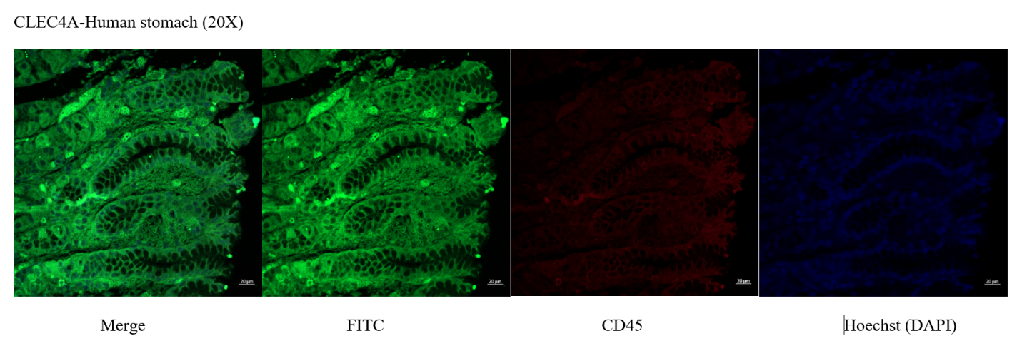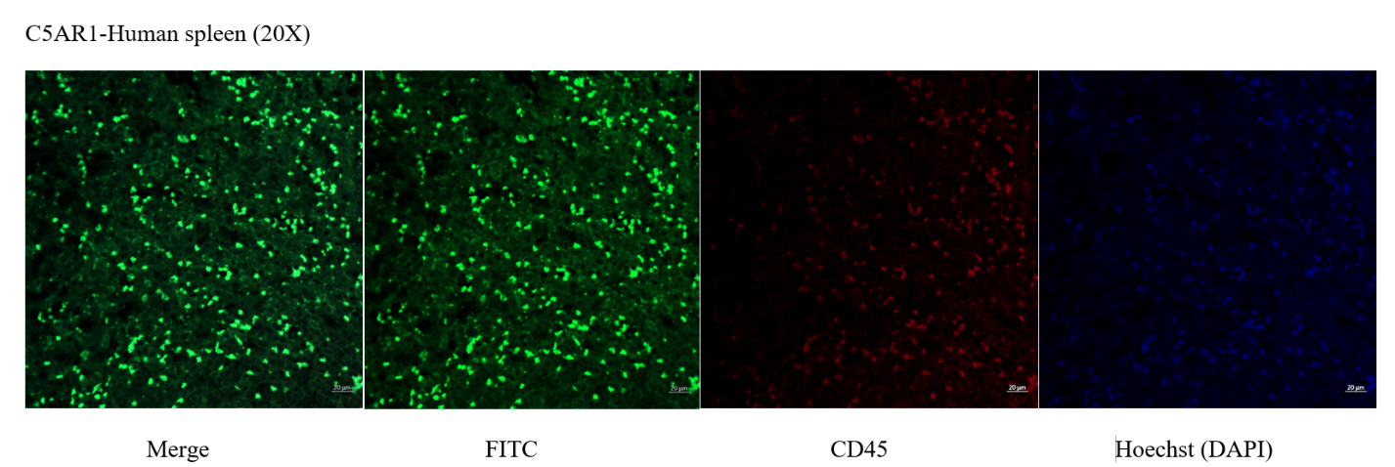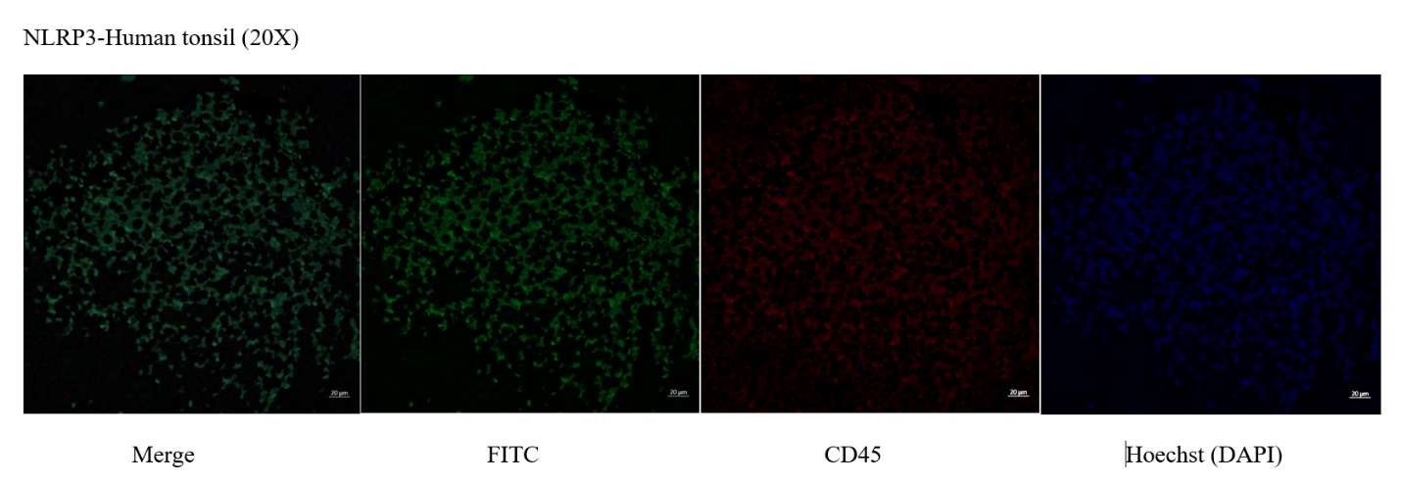
Figure S5 Example of two-parameter dot-plot fluorescence of FITC+ (C5AR1) and CD3+ cell marker (Left) and selected FITC+CD3+ and FITC-CD3- population was selected, respectively (Right). Composite image of 2 fluorescence dyes (C5AR1 and CD3) (below).
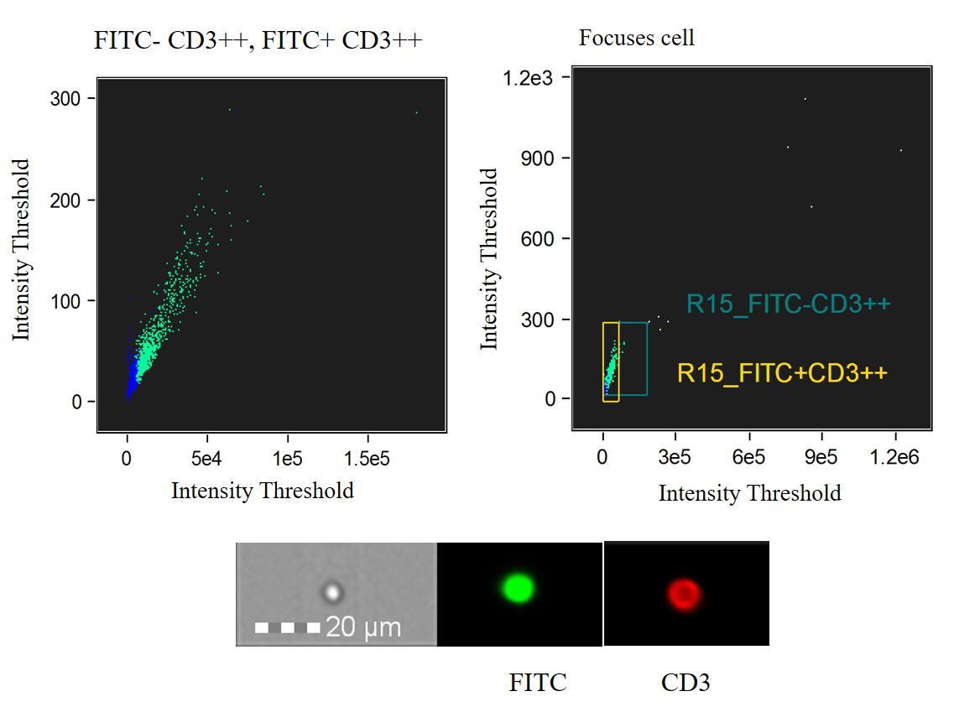
Table S3 Gene ontology of CLEC4A, C5AR1 and NLRP3 in Homo sapiens species based on the Protein ANalysis THrough Evolutionary Relationships classification system (available at http://www.pantherdb.org).

Gene | PANTHER family | PANTHER subfamily | Protein class | Pathway categories
CLEC4A | C-type lectin superfamily member | C-type lectin domain family 4 member A | Cell adhesion molecule, immunoglobulin receptor superfamily | N/A
C5AR1 | Chemotactic receptor | C5A anaphylatoxin chemotactic receptor 1 | G-protein coupled receptor | Inflammation mediated by chemokine and cytokine signaling pathway
NLRP3 | Family not named | NOD-, LRR- and pyrin domain-containing 3 | N/A | N/A
N/A, not applicable

