Supplementary Material

Figure S1
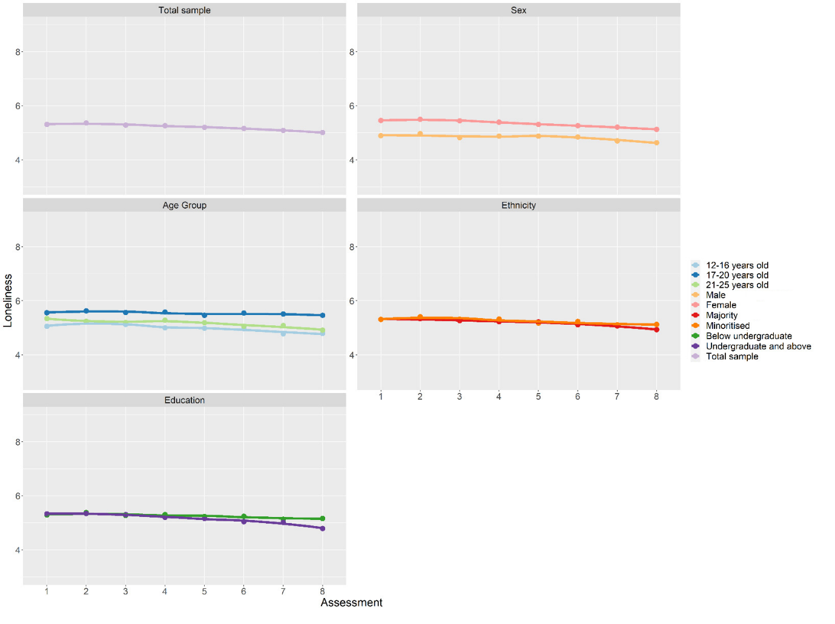
Mean loneliness score trajectory between Assessment 1 and 8 grouped by demographic categories
Age groups are divided into groups based on percentile, 12-16 years olds (34%), 17-20 years olds (36%), 21-25 years old (30%); age is used as a continuous variable in all other analyses.

Table S1
Themes and examples of coping strategies recommended by young people.
Coping strategy | Description and themes | Examples | Percentage of participants recommending coping strategy (%)
Contact Seeking | - Reach out to people like friends and family  - Seek new contacts for social support or sense of closeness | - “Call your family or friends”  - “Keep in touch with others using technology”  - “Stay connected”  - “Connect online and try to meet people face to face” | 51.7
Distraction | - Keeping yourself busy with (existing, routine, “default”) activities or hobbies  - Not necessarily for the purpose of achieving a sense of closeness or achievement  - Avoidance of boredom | - “Watch TV”  - “Do what you enjoy”  - “Keep busy”  - “Play videogames as a distraction”  - “Try to distract yourself” | 23.2
Approach | - Explicit learning  - Mastering a new hobby or skill  - Restart an old hobby or skill that previously didn’t have time for  - Explicitly setting goals to improve at something previously taken on | - “Find a new hobby”  - Volunteering  - “Learn a new language”  - “Try to be creative”  - “Educate yourself”  - “Do something meaningful” | 19.0
Self-care | - Making/maintaining healthier lifestyle choices (diet, exercise, walking, sleep, routines)  - Creating a schedule to provide structure  - Abstaining from negative habits (that are generally known to have a negative effect on health) | - “Plan your days”  - “Take breaks”  - “Get outside and exercise”  - “Be productive”  - “Don’t spend too much time on screens”  - “Not listening to news” | 35.8
Self-talk or self-assurance | - An attitude or mindset that takes the edge off the current situation or to get through it  - A sense that what you’re going through helps yourself or others get through the situation  - A sense of acceptance and reminder that everyone is in the same situation | - “It will be okay”  - “Things will get better soon”  - “Be positive”  - “Don’t worry”  - “We’re all in this together” | 20.3
Self-compassion | - Being kind to yourself, cutting yourself some slack / accepting yourself  - Avoiding activities that make you feel bad/worse about yourself | - “You’re trying your best”  - “Focus on yourself”  - “Just take time to adjust to things slowly”  - “Do things to make yourself feel better about yourself”  - “Be yourself”  - “Avoid contact with people who aren’t good for you” | 12.7
Gratitude or re-appraisal | - Appreciating what you currently have and the positive aspects offered by the present situation  - Re-appraising the situation to have a more balanced outlook (has to be specific, not generic “look at the positives”) | - “This is an opportunity to relax”  - “You’ll never have so much time again to do the things you love”  - “Quality time with family”  - “Taking this time to learn to enjoy one’s own company/thrive in isolation” | 9.4
None or vague | - Indicates uncertainty or lack of coping strategy | - “I don’t know”  - “Can’t give any” | 5.8

Table S2
Model fit indices for the latent class growth analysis
Classes | Parameters | Convergence | Trajectories | Entropy | AIC | BIC | aBIC |  | Group n (%) | BLR | df (BLR) | p (BLR)
2 | 13 | Yes | Distinct | 0.875 | 38,529.157 | 38,599.261 | 38,557.962 | 1 | 940 (58) | -21,522.188 | 3 | <.001
 |  |  |  |  |  |  |  | 2 | 684 (42)
3 | 16 | Yes | Distinct | 0.856 | 37,306.356 | 37,392.638 | 37,341.809 | 1 | 310 (19) | -19,251.578 | 3 | <.001
 |  |  |  |  |  |  |  | 2 | 658 (41)
 |  |  |  |  |  |  |  | 3 | 654 (40)
4 | 19 | Yes | Distinct | 0.792 | 37,020.717 | 37,123.178 | 37,062.818 | 1 | 482 (30) | -18,637.178 | 3 | <.001
 |  |  |  |  |  |  |  | 2 | 559 (34)
 |  |  |  |  |  |  |  | 3 | 177 (11)
 |  |  |  |  |  |  |  | 4 | 406 (25)
5 | 22 | Yes | Distinct | 0.770 | 36,778.285 | 36,896.923 | 36,827.033 | 1 | 264 (16) | -18,491.359 | 3 | <.001
 |  |  |  |  |  |  |  | 2 | 574 (35)
 |  |  |  |  |  |  |  | 3 | 172 (11)
 |  |  |  |  |  |  |  | 4 | 243 (15)
 |  |  |  |  |  |  |  | 5 | 371 (23)
6 | 25 | Yes | Distinct | 0.756 | 36,658.305 | 36,793.121 | 36,713.701 | 1 | 100 (6) | -18,367.142 | 3 | <.001
 |  |  |  |  |  |  |  | 2 | 565 (35)
 |  |  |  |  |  |  |  | 3 | 289 (18)
 |  |  |  |  |  |  |  | 4 | 238 (15)
 |  |  |  |  |  |  |  | 5 | 264 (16)
 |  |  |  |  |  |  |  | 6 | 168 (10)
Note. Loneliness scores are adjusted for baseline survey date and total study duration.
AIC = Akaike information criterion; BIC = Bayesian information criterion; aBIC = Sample size adjusted Bayesian information criterion; BLR = Bootstrapped likelihood ratio test.

Table S3
Mean wellbeing and standard error by loneliness class
Outcome | Loneliness class
Outcome | High stable  (n = 172) | Low stable  (n = 574) | Moderate stable  (n = 371) | Moderate decreasing  (n = 243) | Low Increasing  (n = 264)
Outcome | M (SE) | M (SE) | M (SE) | M (SE) | M (SE)
Initial Wellbeing | 17.15 (0.31) | 24.27 (0.16) | 19.97 (0.17) | 20.80 (0.24) | 23.15 (0.20)
Final Wellbeing | 17.08 (0.41) | 24.68 (0.20) | 20.06 (0.25) | 23.61 (0.34) | 20.32 (0.35)
Note. M = Estimated Means, SE = Standard Error.

