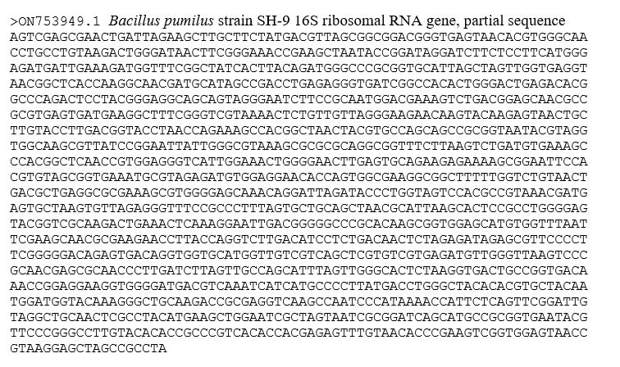
Supplementary Figure 1. The partial sequence of SH-9 16S ribosomal RNA gene.

