Supplementary Information

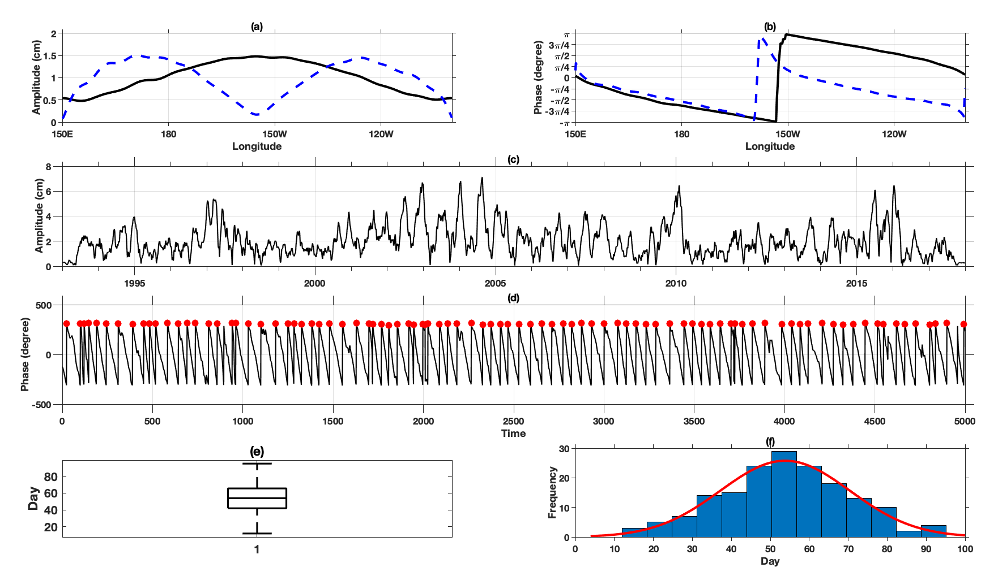
Figure S1 The CEOF analysis result of intraseasonal sea level anomaly η along the equatorial Pacific Ocean between 150 °E and 100 °W observed during 1993-2017. Color-coded lines show (a) amplitude, (b) phase of the first two CEOF spatial modes. (c) The phase of the first CEOF temporal mode. (d) The phase of first 5000 time points in the first CEOF temporal mode. The boxplot (e) shows the period of phase speeds. The histogram (f) shows the distribution of the period of phase speeds. The central period is 54 days.

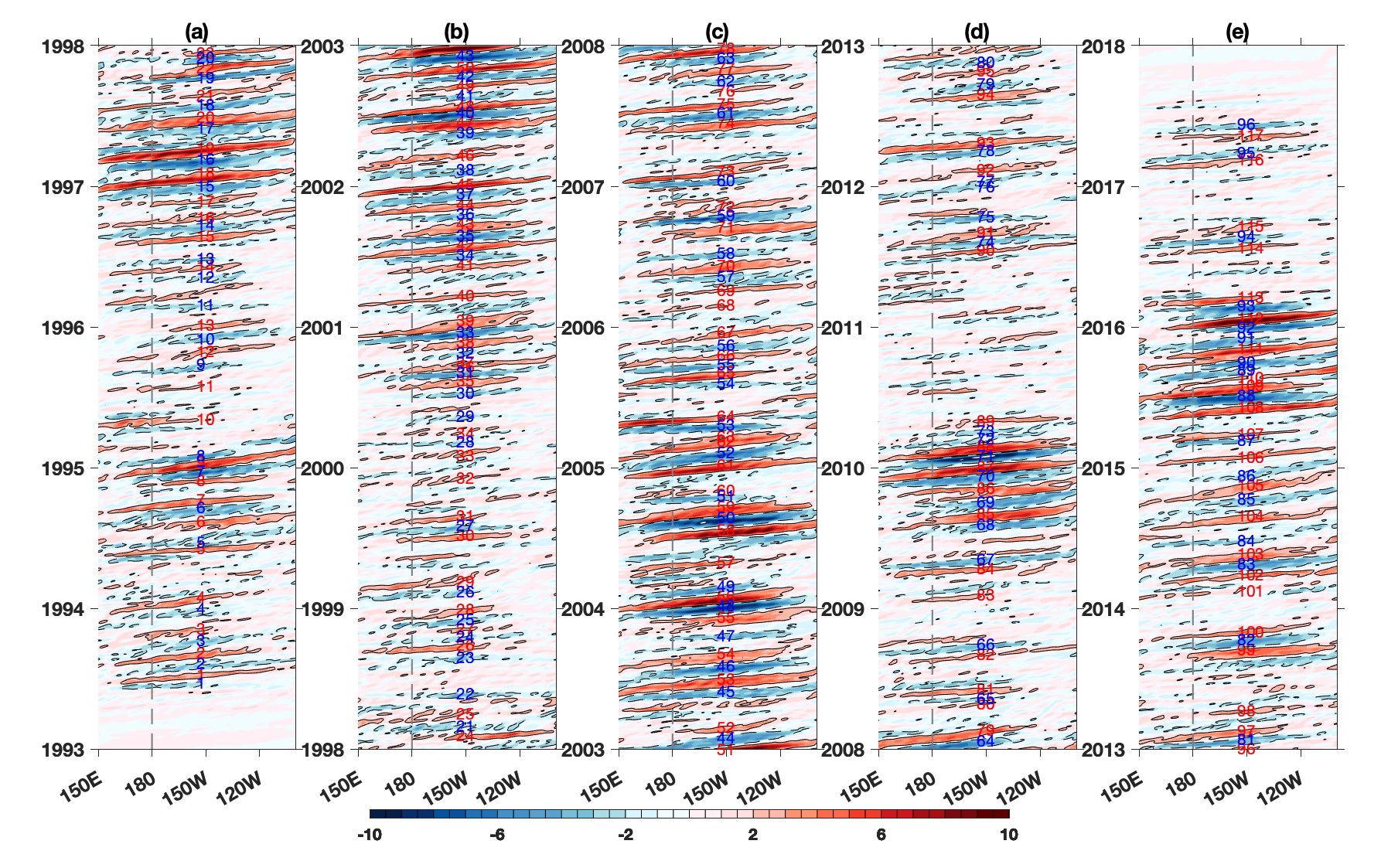
Figure S2 η based on the CEOF first mode during 1993-2017. Solid (dashed) contours indicate η = 2 cm (η = -2 cm), and color numbers mark downwelling (red) and upwelling (blue) Kelvin wave events. The sea level anomaly is from Aviso Topex/Poseidon dataset.

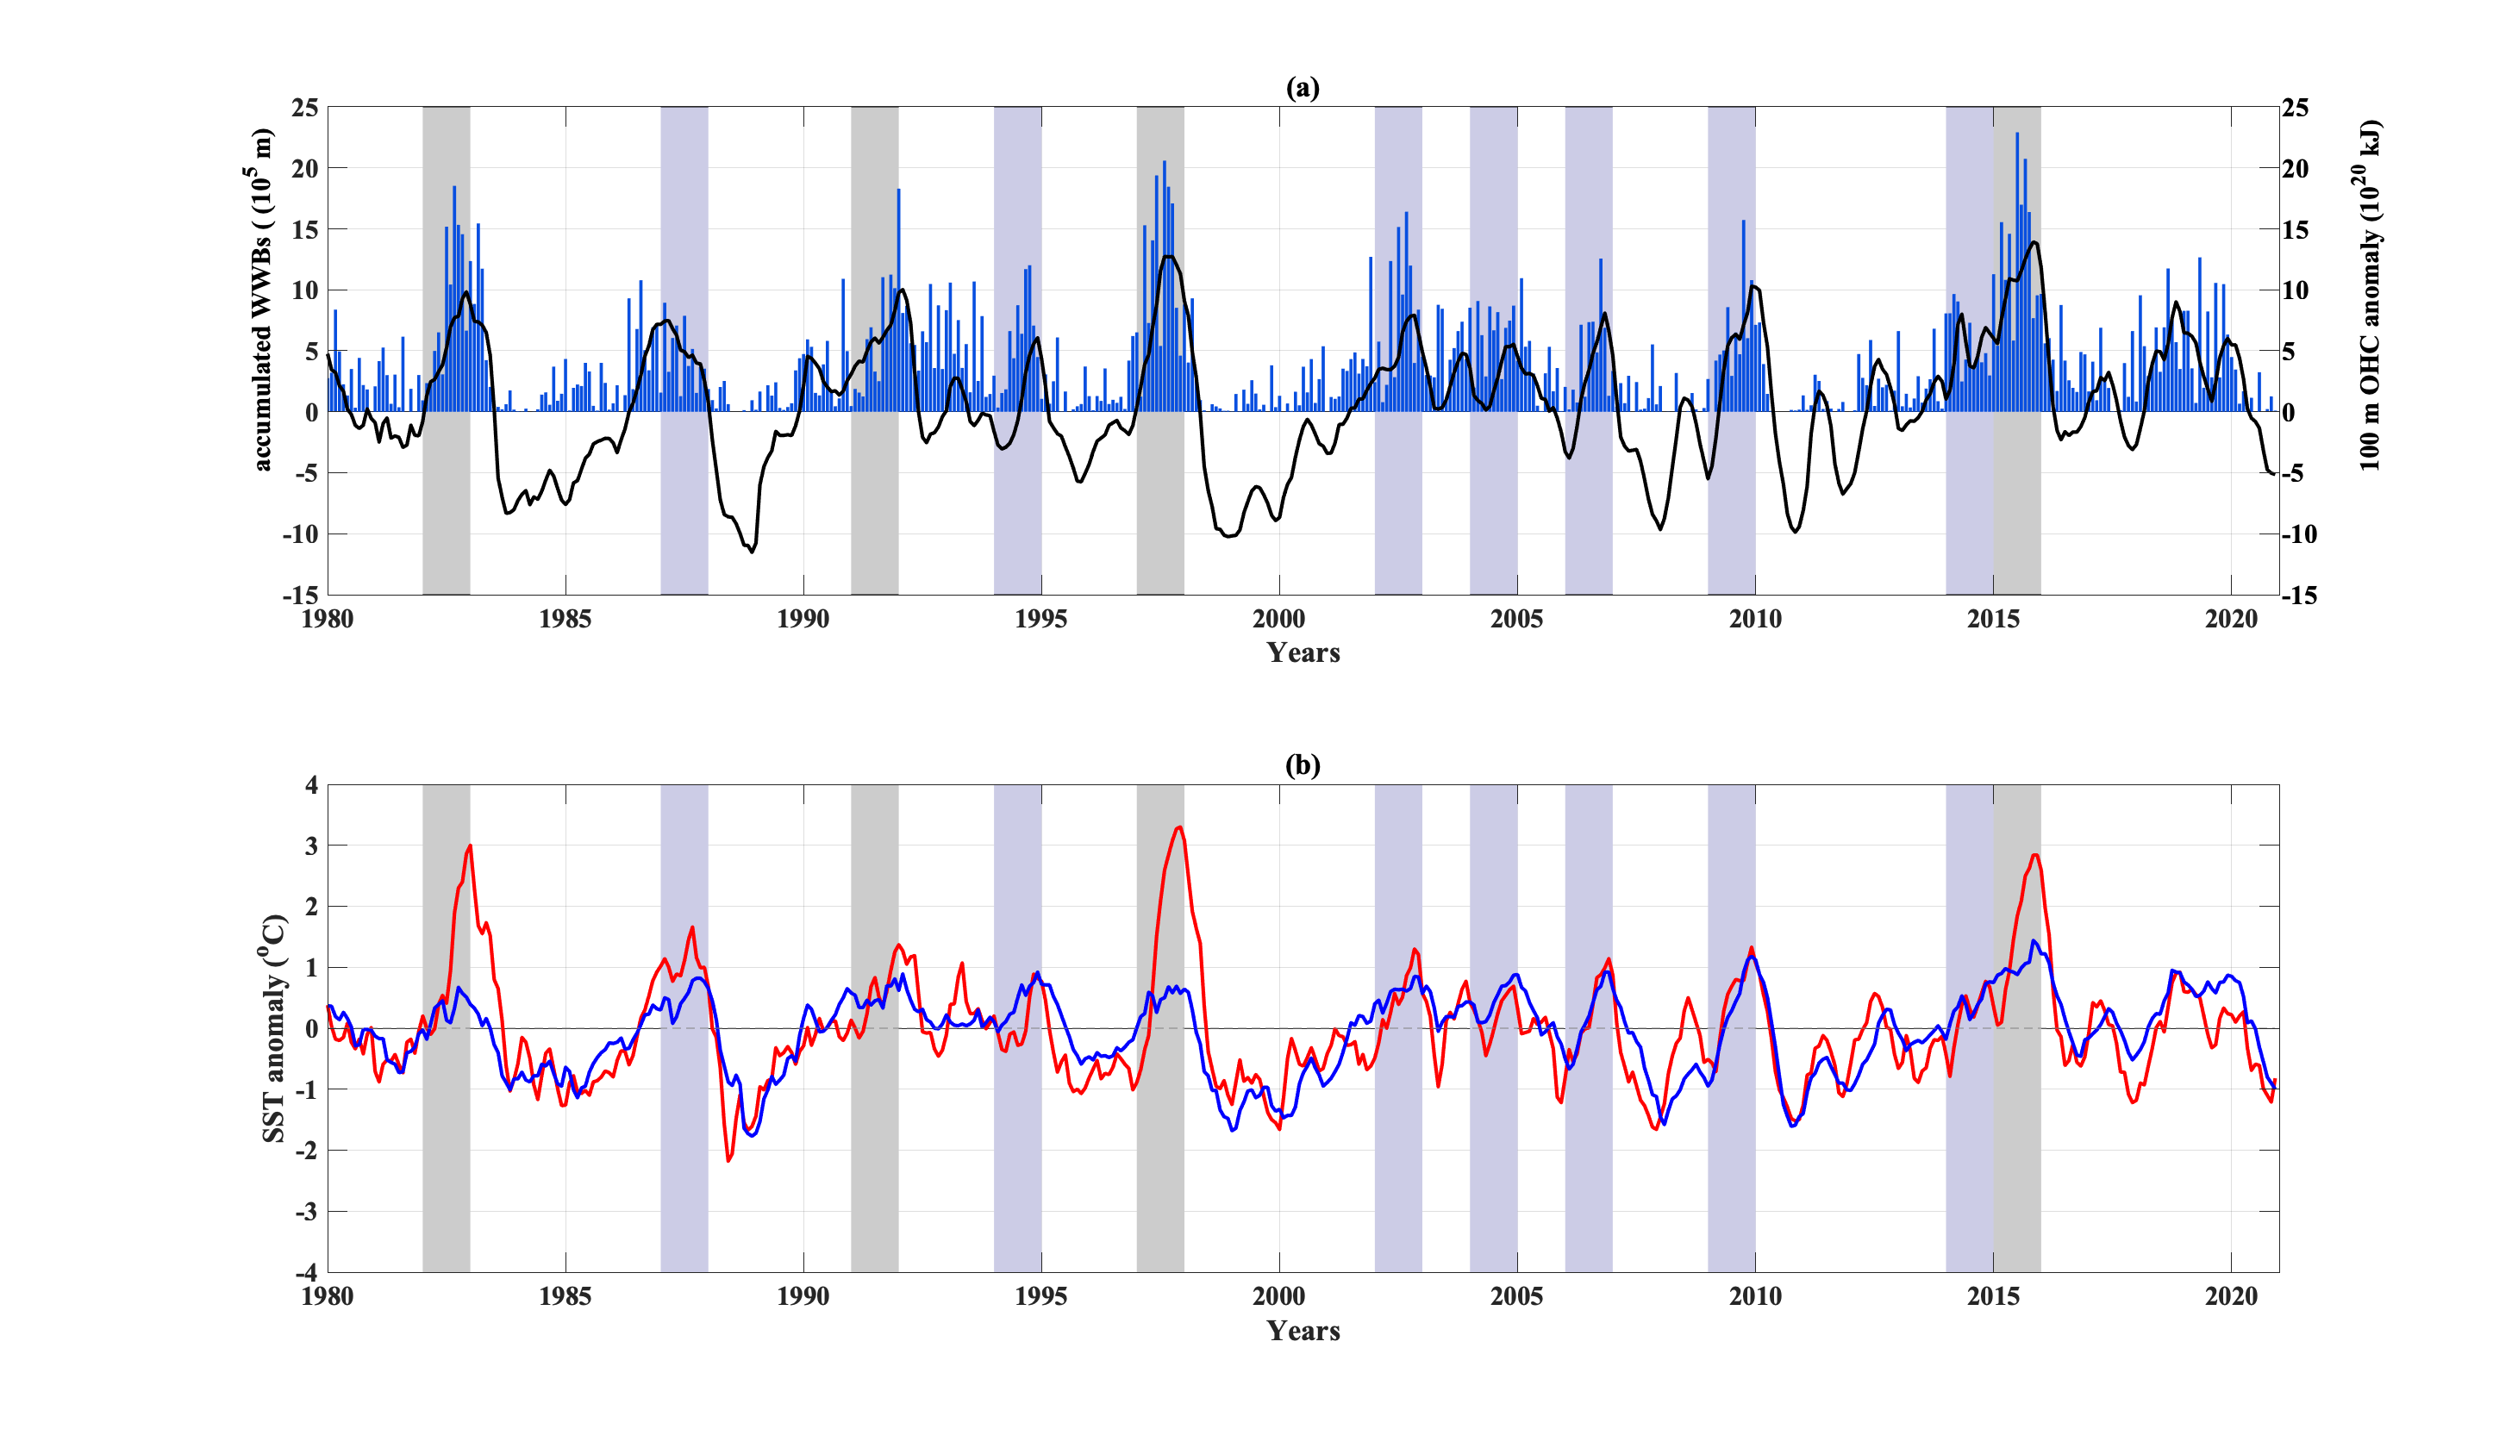
Figure S3 The time series of (a) accumulated WWBs (unit: 10⁵ m, blue bar) and OHC anomaly (unit: 10²⁰ kJ, black line), (b) Niño 3 SST anomaly (unit: °C, red line) and Niño 4 SST anomaly (°C, blue line).

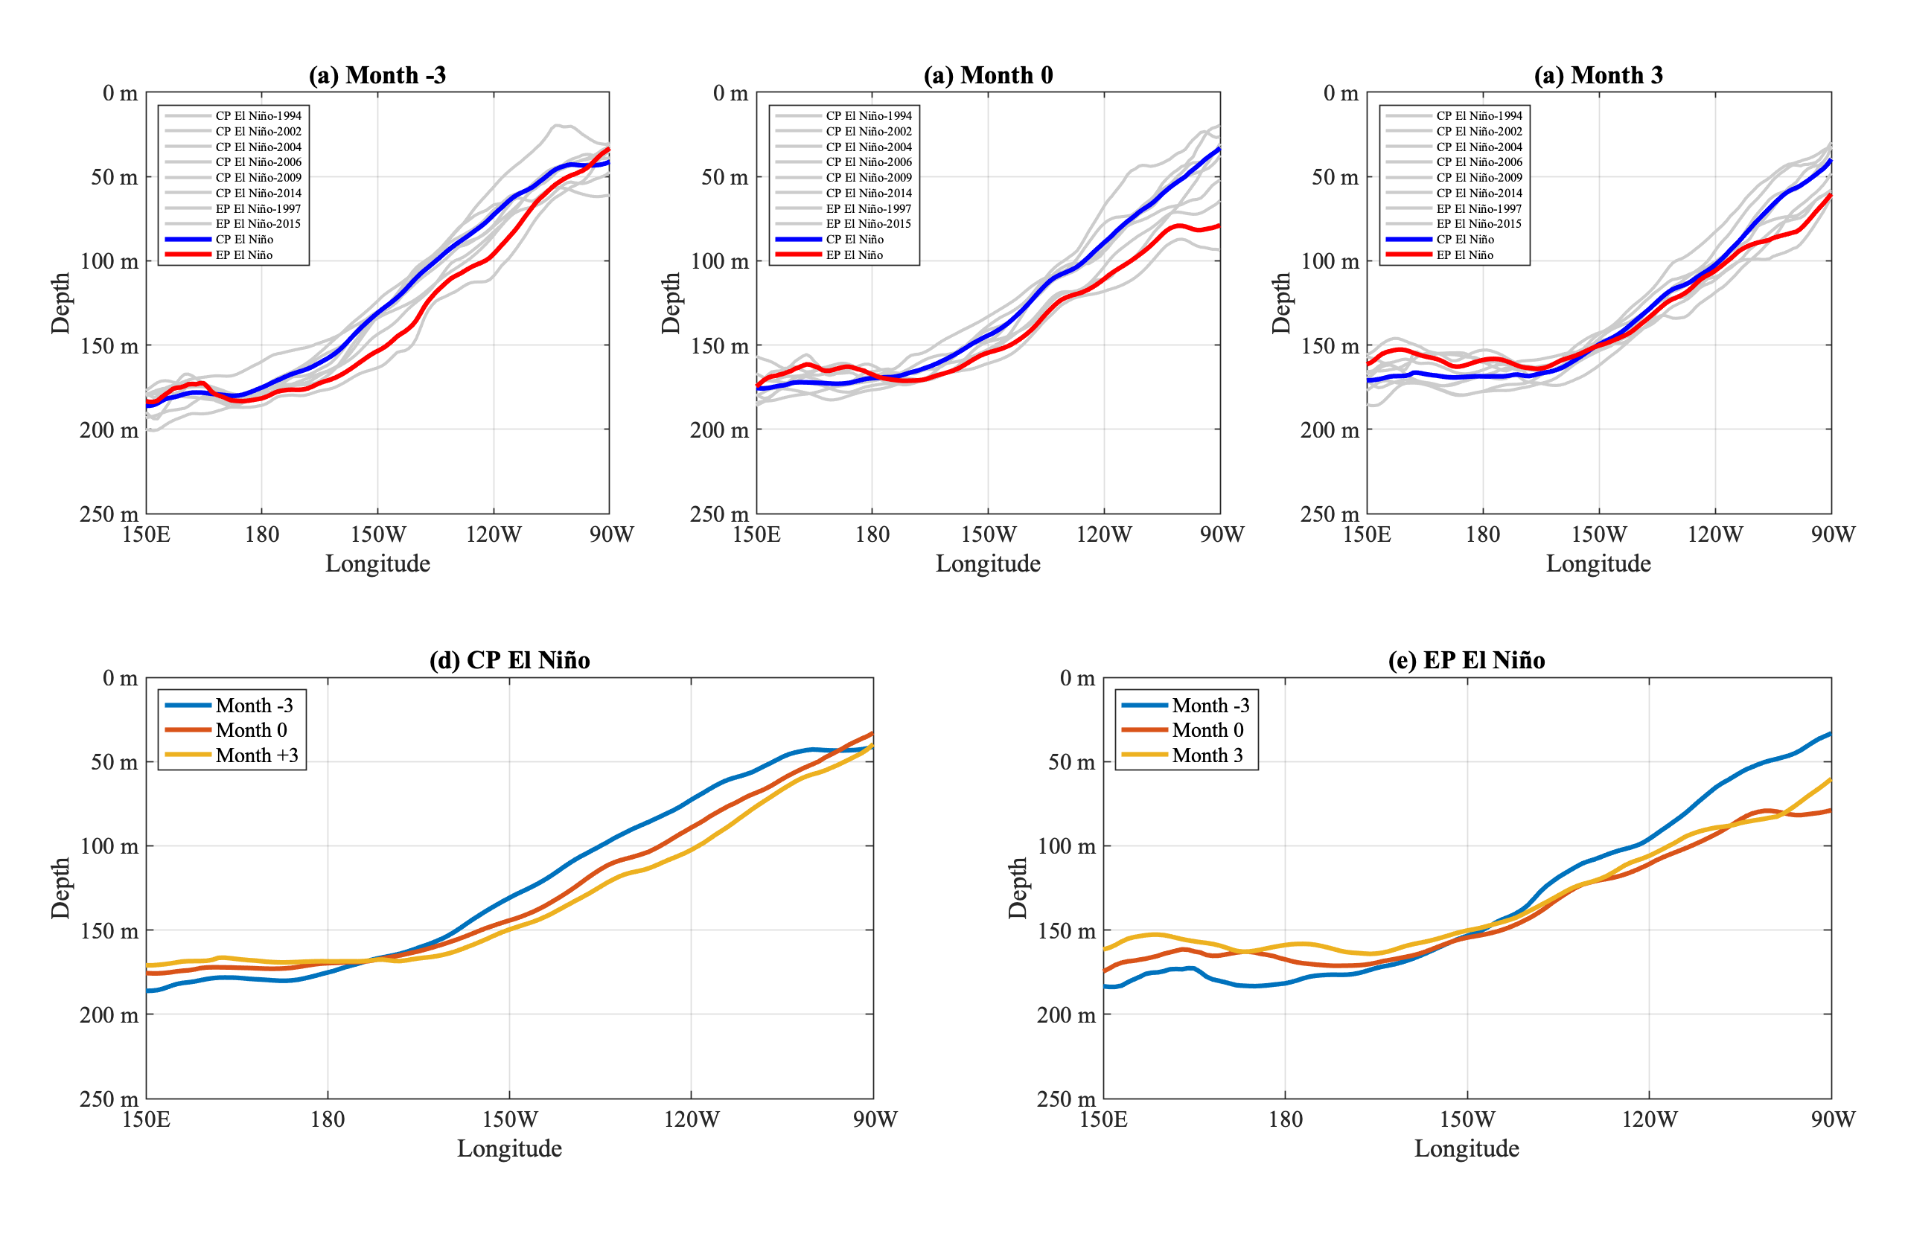
Figure S4 The thermocline depth along equatorial Pacific Ocean (2°S-2°N,150°E-90°W) in El Niño years based on GODAS dataset. In (a) 3 months before, (b) El Niño formed, (c) 3 months later, grey lines indicate El Niño years. The blue lines indicate the average depth of thermocline in CP El Niño years (1994-1995, 2002-2003, 2004-2005, 2006-2007, 2009-2010, 2014-2015). The red lines indicate the average depth of thermocline in EP El Niño years (1997-1998, 2015-2016). The evolution of average thermocline depth of (d) CP El Niño years and (e) EP El Niño years from 3 months before to 3 months later.
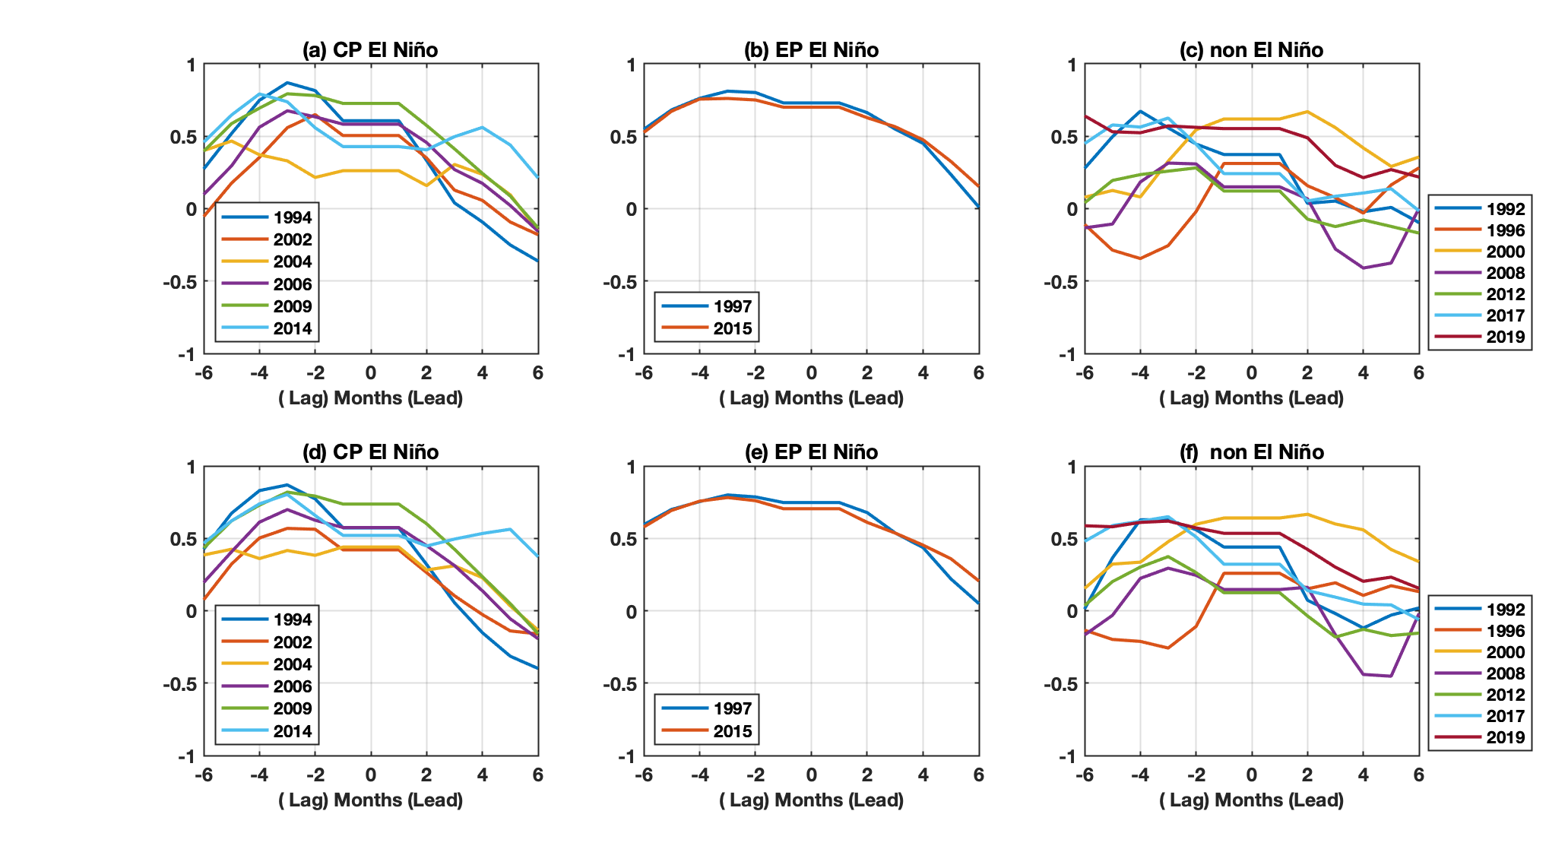
Figure S5 The lead-lag correlation between westerly wind anomalies and 100 m OHC (a,b,c) in CP El Niño years, EP El Niño years, non-El Niño years. (d-f) same as (a-c), but for westerly wind anomalies and 100 m OHC anomaly.

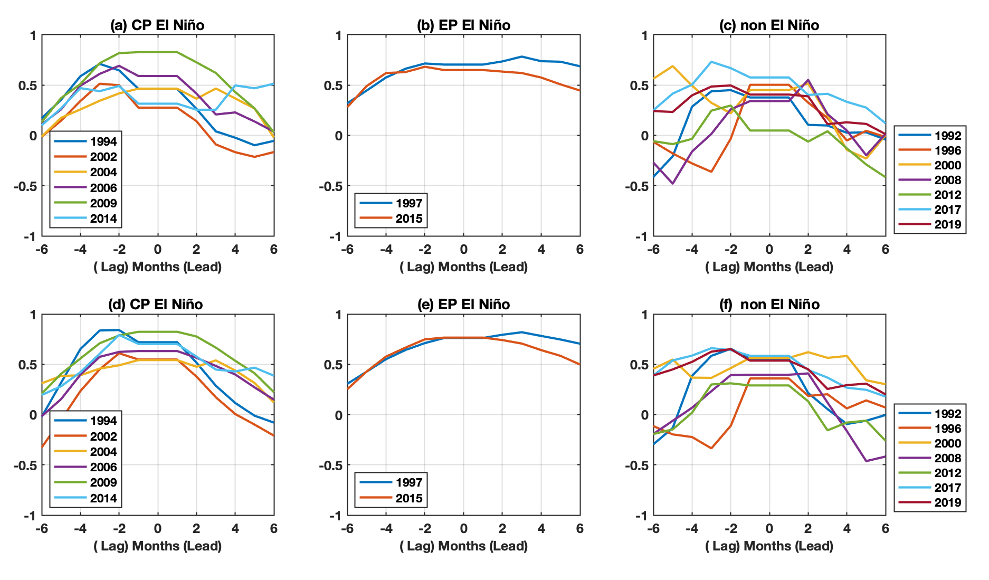
Figure S6 Same as Fig. 5, but for westerly wind anomalies and 300 m OHC, (c)(d) westerly wind anomalies and 300 m OHC anomaly in CP El Niño years, EP El Niño years and non-El Niño years.

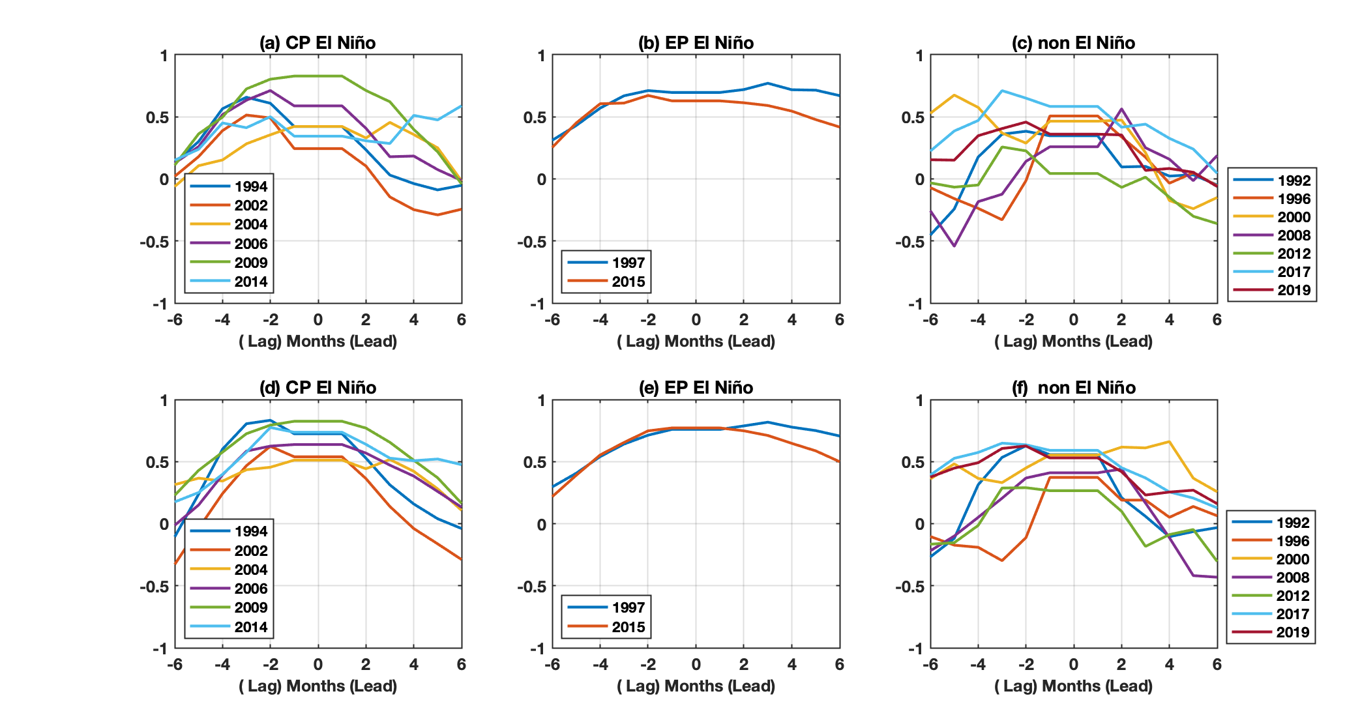
Figure S7 The lead-lag correlation between (a)(b) westerly wind anomalies and 700 m OHC, (c)(d) westerly wind anomalies and 700 m OHC anomaly in CP El Niño years, EP El Niño years and non-El Niño years.

