Supplementaries materials:
Supplementary material 1: The dendrogram (additional document) of grouping of the strains
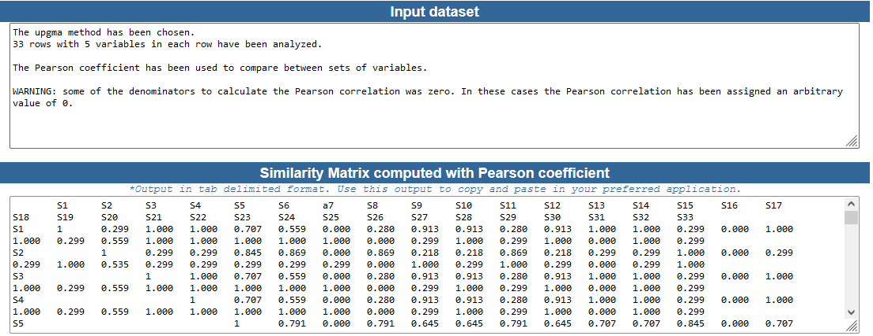
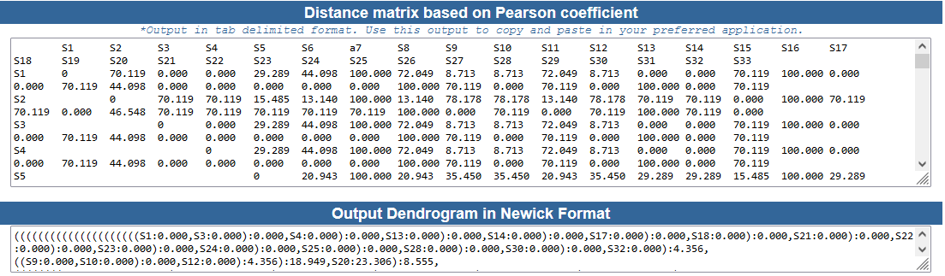
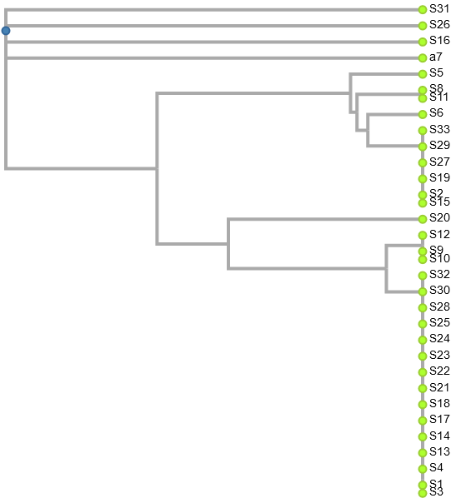
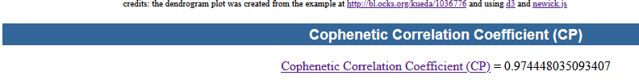

Supplementary material 2: Detailed information on S. aureus strains in this study
Order number | Laboratory code | Strain origin | Cefoxitin profile | SARM Profile | mecA gene profile | SCCmec Profile
S1 | SAPus5T | Clinical | Sensitive | ND | mecA- | None
S2 | SAUro433 | Clinical | Resistant | SASM | mecA- | None
S3 | SAUro3815 | Clinical | Sensitive | ND | mecA- | None
S4 | SAPV45 | Clinical | Sensitive | ND | mecA- | None
S5 | SAPus400 | Clinical | Resistant | SARM | mecA- | None
S6 | SAPV395 | Clinical | Sensitive | ND | mecA- | None
S7 | SAUro5T | Clinical | Resistant | SARM | mecA+ | SCCmec IVa
S8 | SAYO3 | Environment | Resistant | SASM | mecA- | None
S9 | SAYO1 | Environment | Sensitive | ND | mecA- | None
S10 | SABOG2 | Environment | Sensitive | ND | mecA- | None
S11 | SAKOS3 | Environment | Resistant | SASM | mecA- | None
S12 | SABOG5 | Environment | Sensitive | ND | mecA- | None
S13 | SAPus9B | Clinical | Sensitive | ND | mecA- | None
S14 | SAUro23B | Clinical | Sensitive | ND | mecA- | None
S15 | SAPus295 | Clinical | Resistant | SASM | mecA+ | SCCmec IVa
S16 | SAPus42T | Clinical | Resistant | SARM | mecA+ | SCCmec IVa
S17 | SAPus80T | Clinical | Sensible | ND | mecA- | None
S18 | SAUro3832 | Clinical | Sensitive | ND | mecA- | None
S19 | SAUro239 | Clinical | Resistant | SASM | mecA- | None
S20 | SAUro3543 | Clinical | Resistant | SARM | mecA- | SCCmec IVa
S21 | SAUro3620 | Clinical | Sensitive | ND | mecA- | None
S22 | SAPV85 | Clinical | Sensitive | ND | mecA- | None
S23 | SAUro… | Clinical | Sensitive | ND | mecA- | None
S24 | SAUro3812 | Clinical | Sensitive | ND | mecA- | None
S25 | SAUro3B | Clinical | Sensitive | ND | mecA- | None
S26 | SAPus22 | Clinical | Resistant | SARM | mecA+ | SCCmec IVa
S27 | SAUro455 | Clinical | Resistant | SASM | mecA+ | SCCmec IVa
S28 | SAPus50T | Clinical | Sensitive | ND | mecA- | None
S29 | SAPV75 | Clinical | Resistant | SASM | mecA- | None
S30 | SAUro2014 | Clinical | Sensitive | ND | mecA- | None
S31 | SAUro2710 | Clinical | Resistant | SARM | mecA+ | SCCmec IVa
S32 | SAPus423 | Clinical | Sensitive | ND | mecA- | None
S33 | SAPus294 | Clinical | Resistant | SASM | mecA- | None

Legend: mecA+ means that the strain harbors the mecA gene, otherwise mecA-. ND: not determined

