- SEARCH MEDICAL SUBJECT HEADING (MESH) TERMS

English:
((Orofacial pain) OR (toothache) OR (odontalgia) OR (pulpitis) OR (oral pain) OR (facial pain) OR (mouth pain) OR (temporomandibular joint disease) OR (TMD) OR (jaw pain)) AND ((Herbal extracts) OR (herbal medicines) OR (herbs) OR (herbal medicinal product) OR (herbal remedies) OR (herbal therapies) OR (botanical medicines) OR (medicinal plants) OR (plant-derived therapies) OR (plant-based therapies) OR (phytotherapeutical preparations) OR (phytotherapy) OR (phytotherapeutic) OR (phytochemicals) OR (phytomedicines) OR (natural products) OR (natural medicaments) OR (alternative medicaments) OR (homeopathy) OR (naturopathy) OR (pharmacognosy) OR (ethnopharmacology) OR (biopharmaceutics) OR (nutraceutical) OR (allelochemical metabolites) OR (traditional medicine)) AND ((analgesia) OR (antinociceptive) OR (anti-inflammatory) OR (pain relief))

Spanish:
((Dolor orofacial) OR (dolor dental) OR (odontalgia) OR (pulpitis) OR (dolor oral) OR (dolor facial) OR (dolor bucal) OR (dolor temporomandibular) OR (enfermedad temporomandibular) OR (dolor mandibular)) AND ((extractos herbales) OR (medicinas herbales) OR (hierbas) OR (producto medicinal herbal) OR (remedios herbales) OR (terapia herbal) OR (medicina botanica) OR (plantas medicinales) OR (terapias derivadas de plantas) OR (terapias basadas en plantas) OR (preparaciones fitoterapeuticas) OR (fitoterapia) OR (fitoterapeutico) OR (fitoquimico) OR (fitomedicina) OR (producto natural) OR (medicamento natural) OR (terapia alternativa) OR (medicamento alternativo) OR (homeopatia) OR (naturopatia) OR (farmacognosia) OR (etnofarmacologia) OR (biofarmaceuticos) OR (nutraceutico) OR (metabolitos aleloquimicos) OR (medicina tradicional)) AND ((analgesia) OR (antinociceptivo) OR (antiinflamatorio) OR (disminucion del dolor))

Portuguese:
((Dor orofacial) OR (dor de dente) OR (odontalgia) OR (pulpite) OR (dor oral) OR (dor facial) OR (dor na boca) OR (dor na boca) OR (articulação temporomandibular) OR (doença temporomandibular) OR (dor mandíbula)) AND ((extratos de ervas) OR (medicamentos à base de plantas) OR (ervas) OR (medicamento à base de plantas) OR (remédios à base de plantas) OR (fitoterapia) OR (medicina botânica) OR (plantas medicinais) OR (terapias derivadas de plantas) OR (terapias à base de plantas) OR (preparações fitoterápicas) OR (fitoterapia) OR (fitoterápicos) OR (fitoquímico) OR (fitomedicina) OR (produto natural) OR (medicina natural) OR (terapia alternativa) OR (medicina alternativa) OR (homeopatia) OR (naturopatia) OR (farmacognosia) OR (etnofarmacologia) OR (biofarmacêuticos) OR (nutracêutico) OR (metabólitos aleloquímicos) OR (medicina tradicional)) AND ((analgesia) OR (antinociceptivo) OR (anti-inflamatório) OR (redução da dor))

French:
((Douleur orofaciale) OR (douleur dentaire) OR (odontalgie) OR (pulpite) OR (douleur orale) OR (douleur faciale) OR (douleur buccale) OR (douleur temporo-mandibulaire) OR (maladie temporo-mandibulaire) OR (douleur à la mâchoire)) AND ((extraits de plantes) OR (médicaments à base de plantes) OR (herbes) OR (produit phytothérapie) OR (remèdes à base de plantes) OR (thérapie à base de plantes) OR (médecine botanique) OR (plantes médicinales) OR (thérapies dérivées de plantes) OR (thérapies à base de plantes) OR (préparations phytothérapeutique) OR (phytothérapie) OR (phytothérapie) OR (phytochimique) OR (phytomédecine) OR (produit naturel) OR (médecine naturelle) OR (thérapie alternative) OR (médecine alternative) OR (homéopathie) OR (naturopathie) OR (pharmacognosie) OR (ethnopharmacologie) OR (biopharmaceutiques) OR (nutraceutique) OR (métabolites allochimiques) OR (médecine traditionnelle)) AND ((analgésie) OR (antinociceptif) OR (anti-inflammatoire) OR (réduction de la douleur)

FIGURE 1. INDIVIDUAL RISK OF BIAS ASSESSMENT OF INCLUDED STUDIES

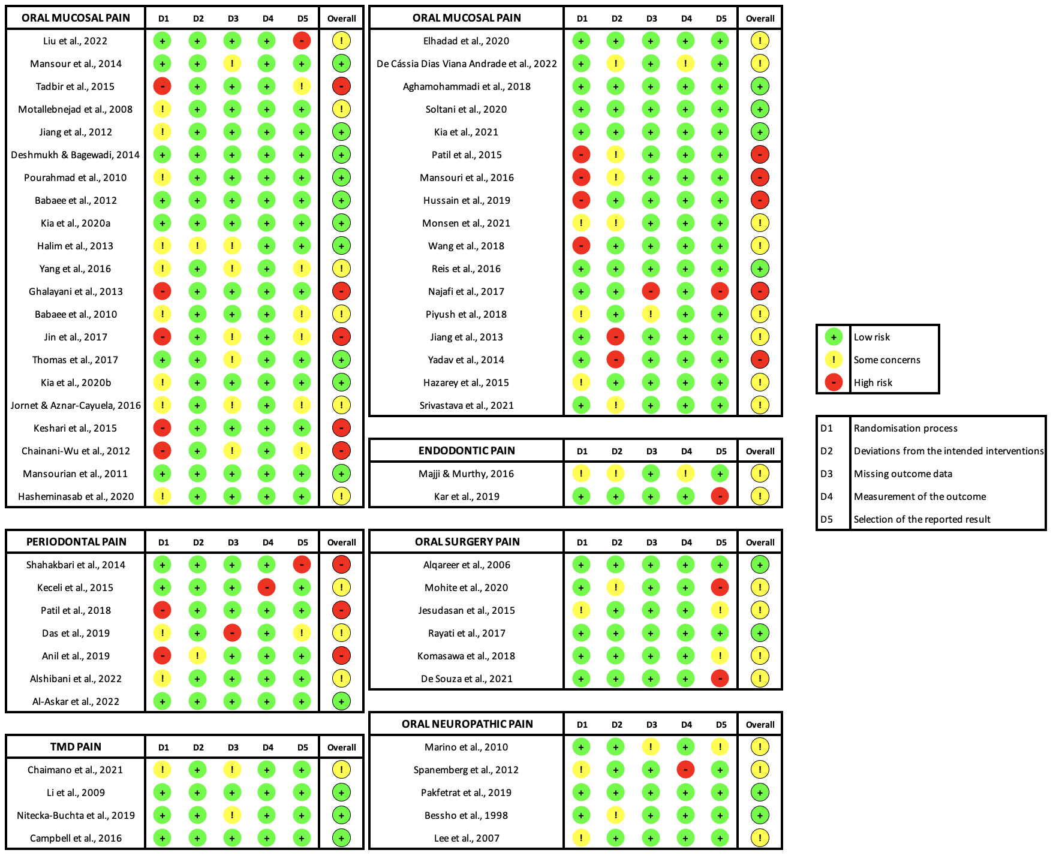

FIGURE 2. NUMBER OF STUDIES BY PLANTS SPECIES AND TYPE OF OROFACIAL PAIN
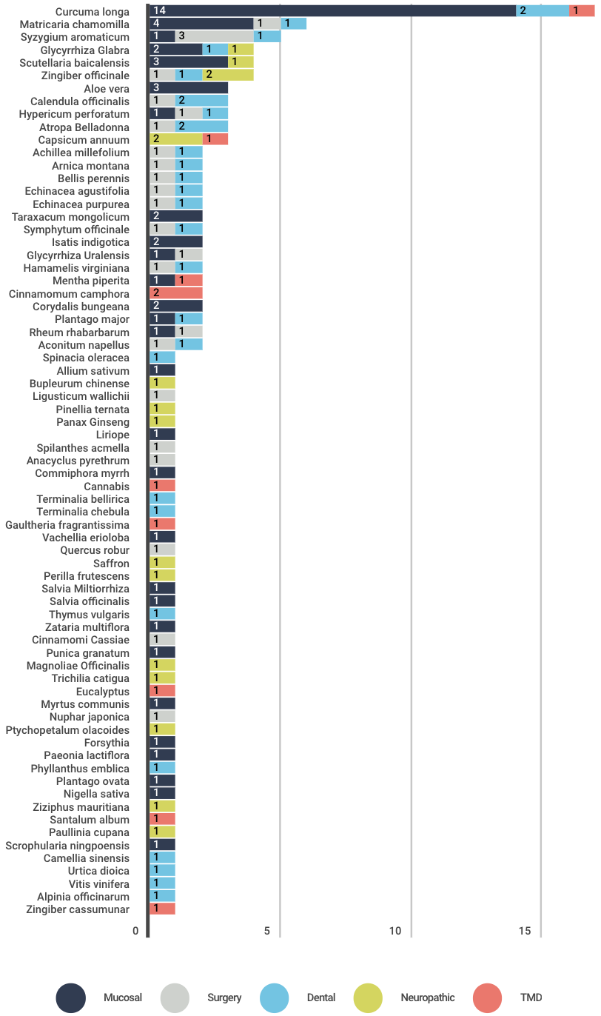

FIGURE 3. NUMBER OF STUDIES BY PLANT SPECIES AND PLANT FAMILIES IDENTIFIED

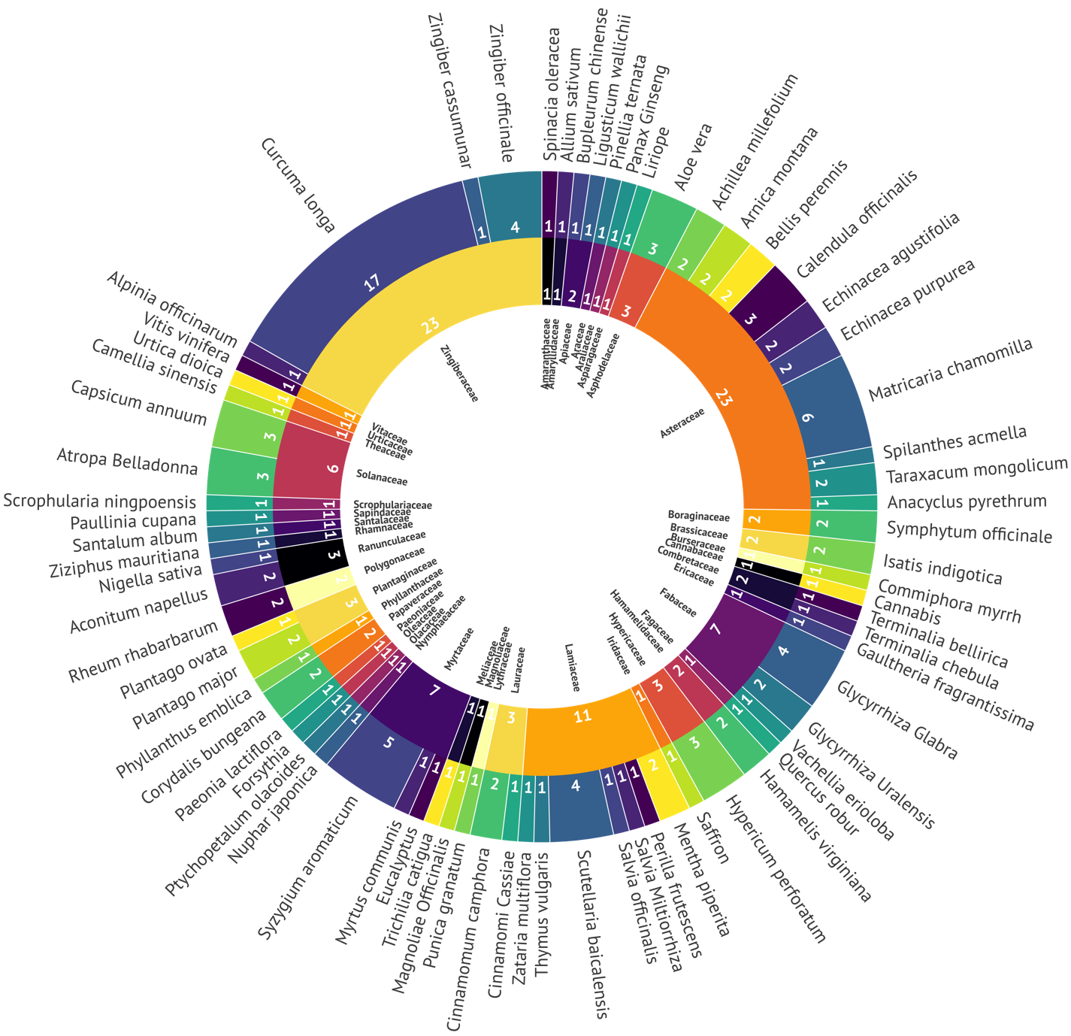

FIGURE 4. SURFACE UNDER THE CUMULATIVE RANKING SCORE OF HERBAL EXTRACTS FOR PERIODONTAL PAIN, ORAL SURGERY PAIN AND ORAL NEUROPATHIC PAIN.

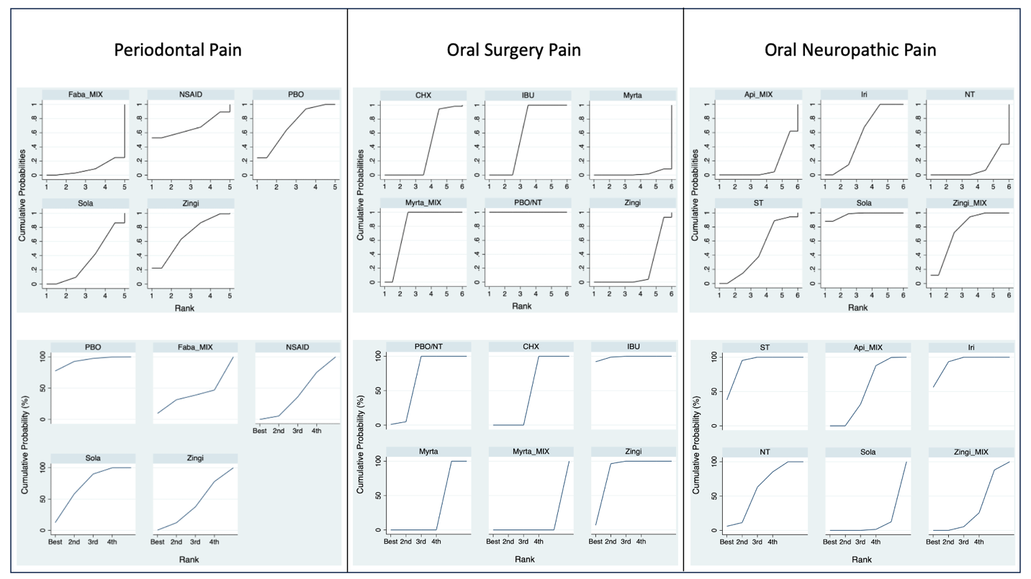

FIGURE 5. SURFACE UNDER THE CUMULATIVE RANKING SCORE OF HERBAL EXTRACTS FOR ENDODONTIC PAIN, ORAL MUCOSAL PAIN AND TMD PAIN.

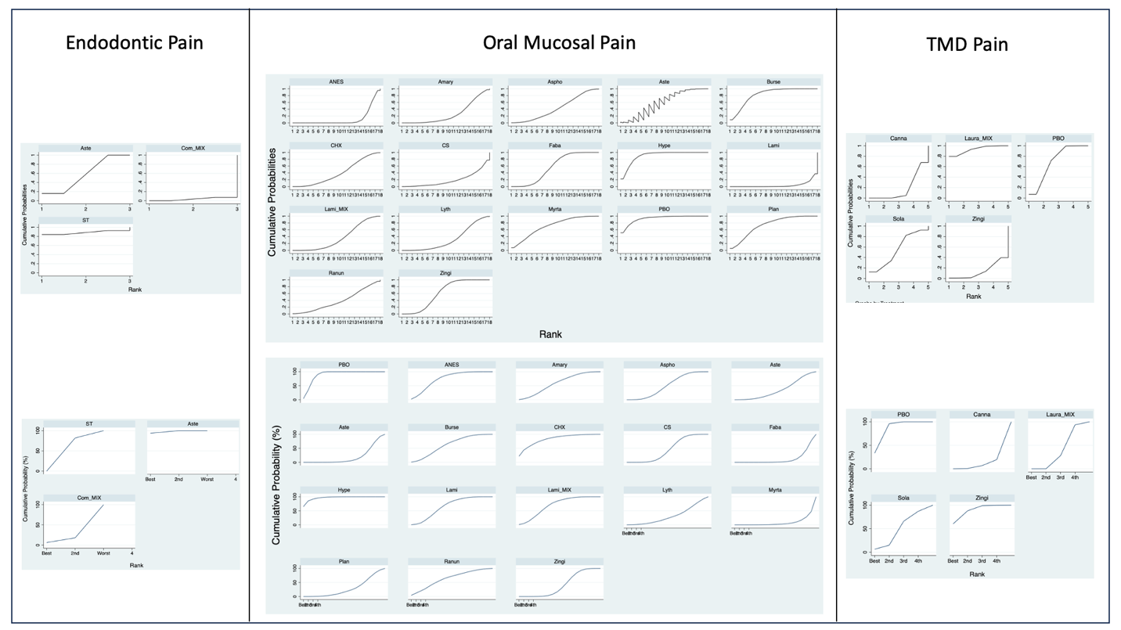

FIGURE 6. HERBAL EXTRACTS VS NEGATIVE CONTORL OR PLACEBO FOR PERIODONTAL PAIN, ORAL SURGERY PAIN AND ORAL NEUROPATHIC PAIN FOREST PLOTS
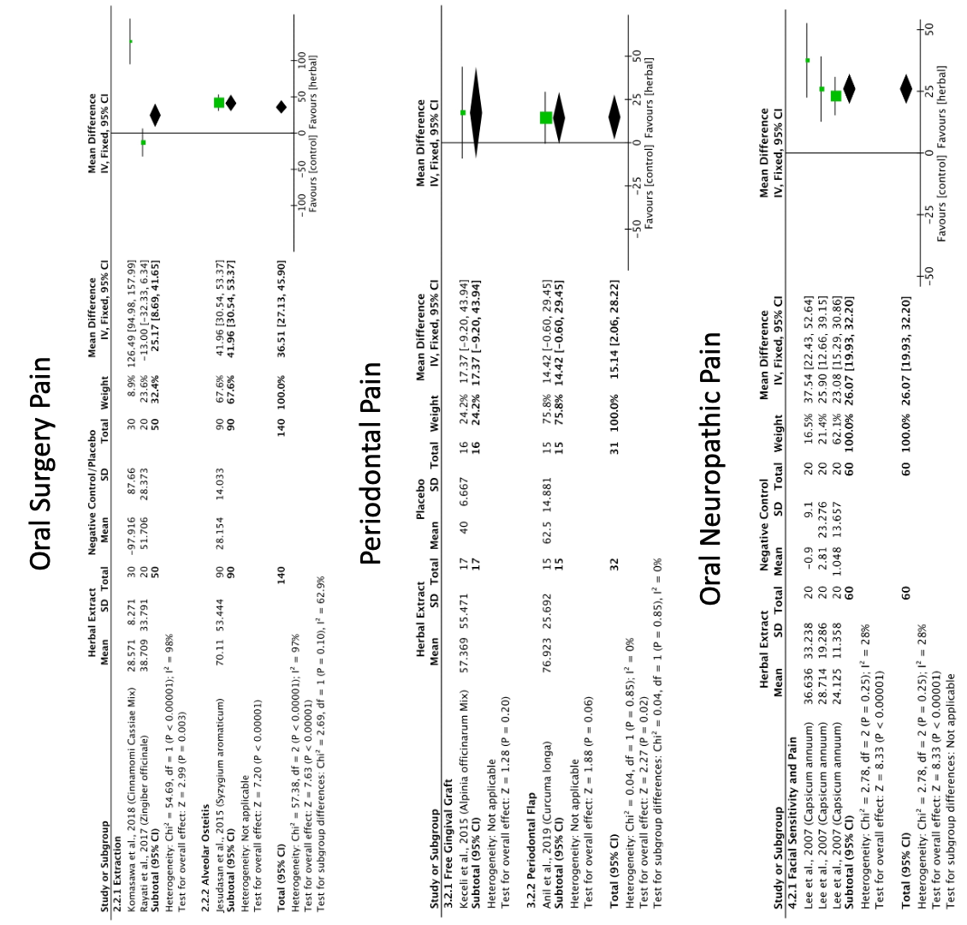

FIGURE 7. HERBAL EXTRACTS VS PLACEBO FOR ORAL MUCOSAL PAIN FOREST PLOT
